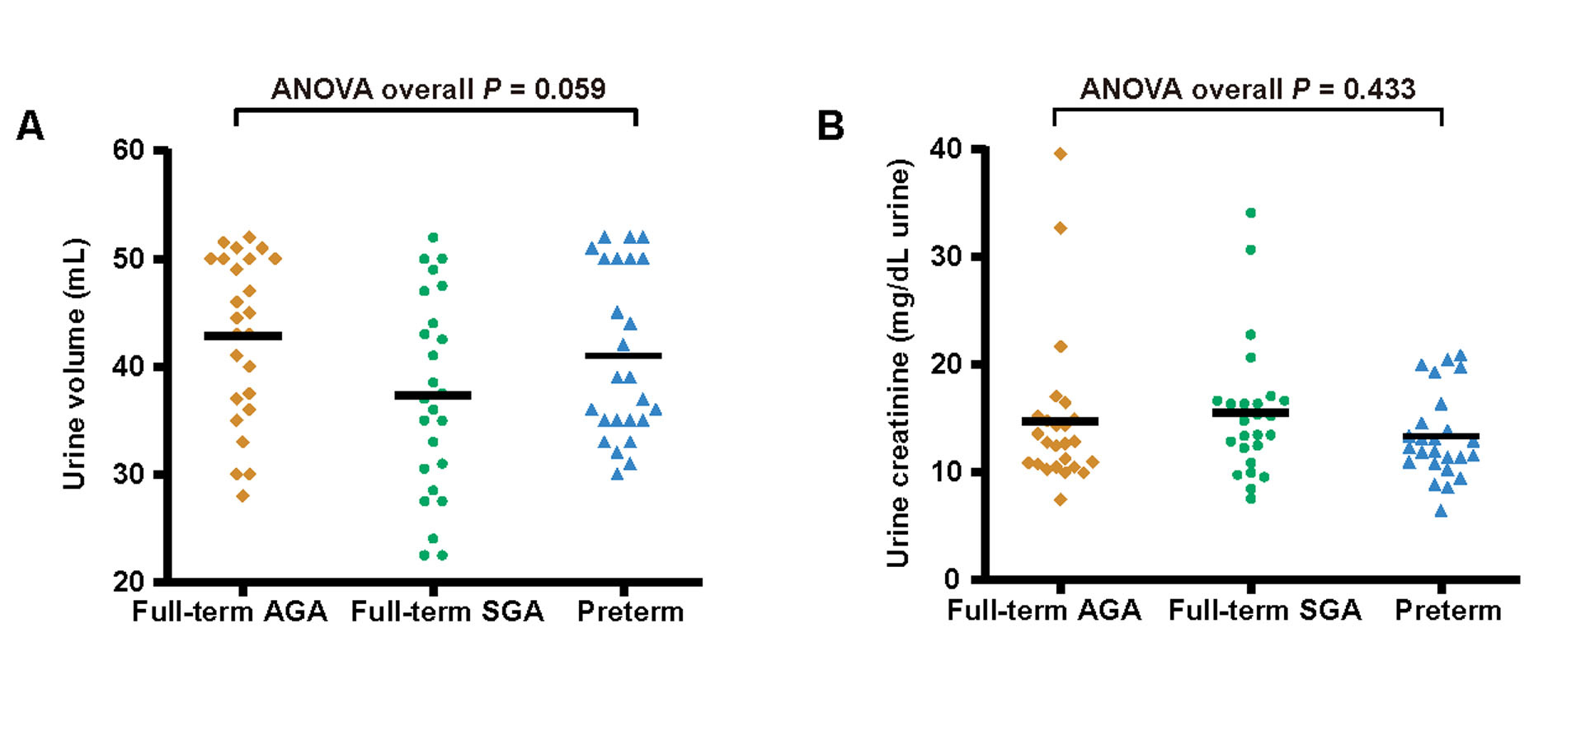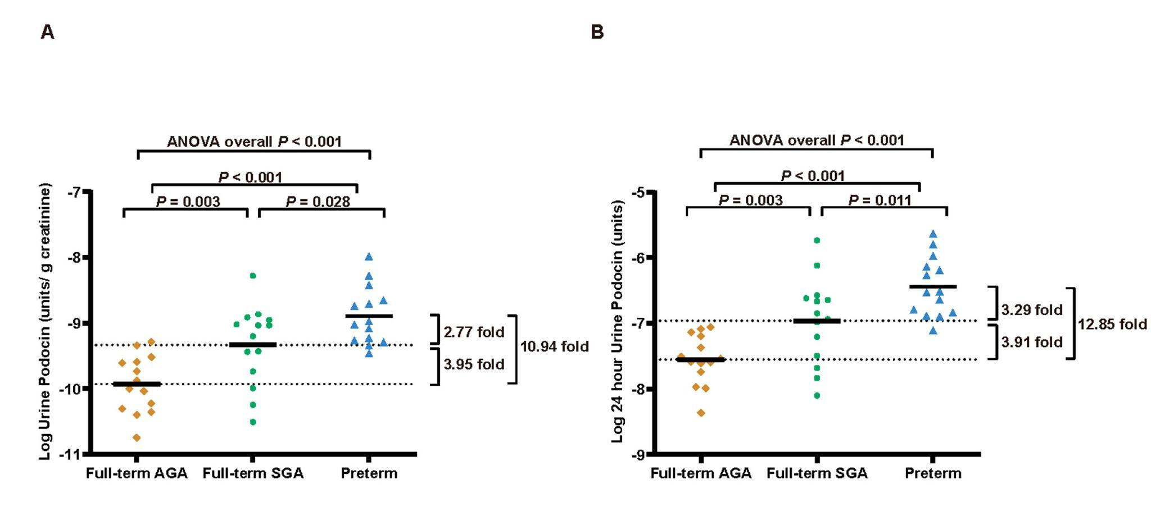Supplemental Figure legends

Supplemental Figure 1. Urine volume and creatinine levels in preterm, full-term SGA, and full-term AGA infants.
Urine volume and urine creatinine did not differ significantly among groups. One-way ANOVA showed no significant overall group differences for urine volume (P = 0.059) or urine creatinine (P = 0.433).
Supplemental Figure 2. The UpodCR decreased progressively across preterm, full-term SGA, and full-term AGA infants (excluding cases with diabetic mothers).
Urinary podocin mRNA levels were compared among three groups: full-term appropriate for gestational age (AGA), full-term small for gestational age (SGA), and preterm infants (n = 14 per group). Podocyte loss, measured in the urine pellet, were quantified using either (A) the podocin mRNA-to-creatinine ratio, analogous to the protein-to-creatinine ratio, or (B) the 24-hour excretion of podocin mRNA.
(A) Full-term SGA infants exhibited a 2.77-fold decrease in podocin mRNA-to-creatinine ratio compared to birth weight-matched preterm infants (full-term SGA vs. preterm: 4.656E–10 units vs. 1.288E–9 units, P = 0.028), and a 3.95-fold increase compared to gestational age-matched full-term AGA infants (full-term SGA vs. full-term AGA: 4.656E–10 units vs. 1.178E–10 units, P = 0.003). (B) Full-term SGA infants also showed a 3.29-fold decrease in 24-hour podocin mRNA excretion compared to preterm infants (full-term SGA vs. preterm: 1.096E–7 units vs. 3.606E–7 units, P = 0.011), and a 3.91-fold increase compared to full-term AGA infants (full-term SGA vs. full-term AGA: 1.096E–7 units vs. 2.805E–8 units, P = 0.003). Solid black horizontal lines indicate the mean values for each group. Overall group differences were significant for both the podocin mRNA-to-creatinine ratio and 24-hour podocin mRNA excretion (one-way ANOVA, both P < 0.001). Post-hoc two-group comparisons were performed using paired t-tests.

