Supplementary information file
FESEM images revealed that in some regions, the TiO₂ nanoparticles appeared brighter. This raised the possibility that the brightness of these regions might be associated with silver loading on the TiO₂ surface. Accordingly, the FESEM operator decided to re-evaluate several points in terms of their elemental composition. The results were as follows: at two points, designated A and B, the silver weight percentages were 1.16% and 10.58%, respectively, both higher than the overall silver content in the total volume of silver on the TiO₂ (0.87%). This clearly indicates that the bright regions correspond to the coating of TiO₂ with silver. However, it is noteworthy that silver overloading occurred only at limited points on the TiO₂ surface, while the majority of the TiO₂ surface was coated with silver at approximately 1% or less (0.87%), which is desirable.
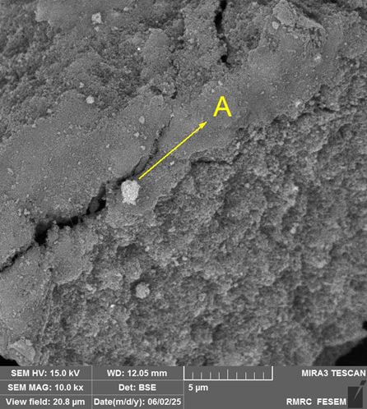 | 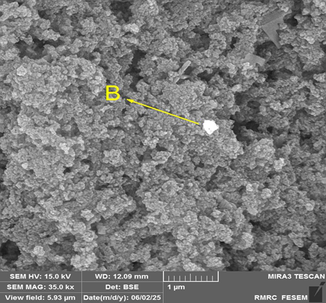
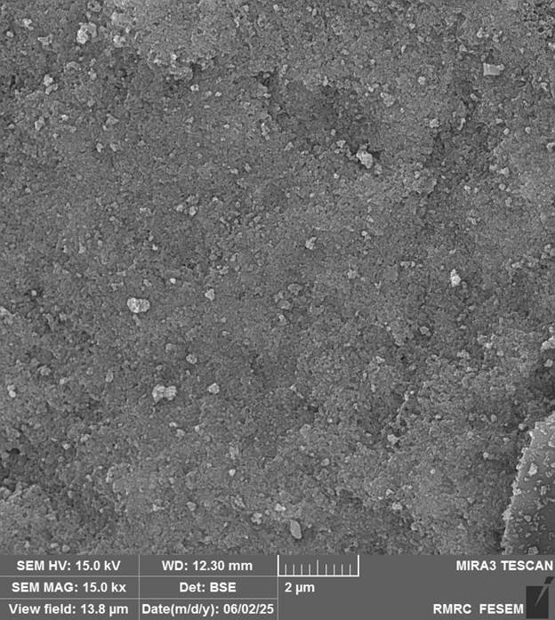
Furthermore, separate elemental mapping images are also provided, the necessary explanations for which are presented in the main text of the article.
 | 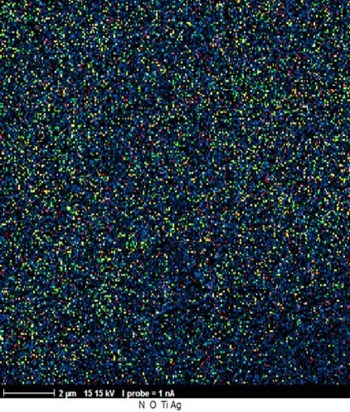 | 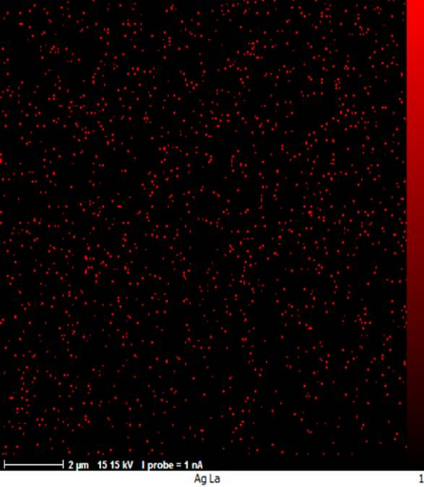
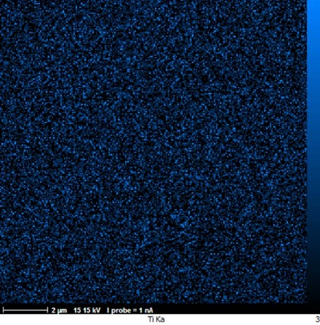 | 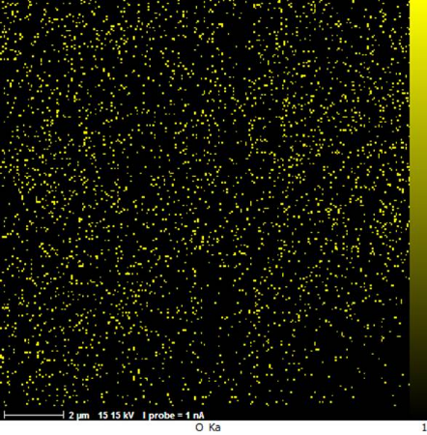 | 