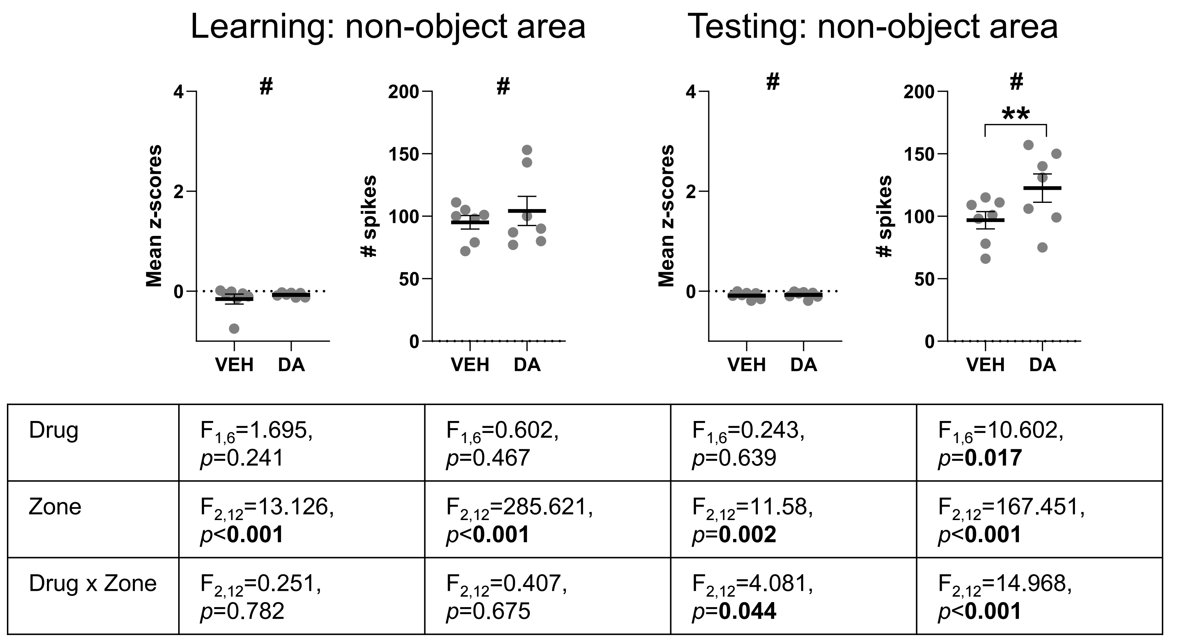
Supplementary Figure 1. Analysis of calcium dynamics across spatial zones. Two-way repeated ANOVA, with “drug” treatment (VEH or DA) and “zone” (object 1/old, object 2/novel, or non-object area) as within-subject factors, revealed significant main effects of “zone” on the mean z-score and number of calcium spikes during the learning trial. During the testing trial, significant “drug × zone” interactions and main effects of “zone” were observed for both measures. A significant main effect of “drug” was also detected for the number of calcium spikes during the testing trial. # significant differences versus the object zones (overall comparison; see Figure 3c); **p<0.01, paired t-test.

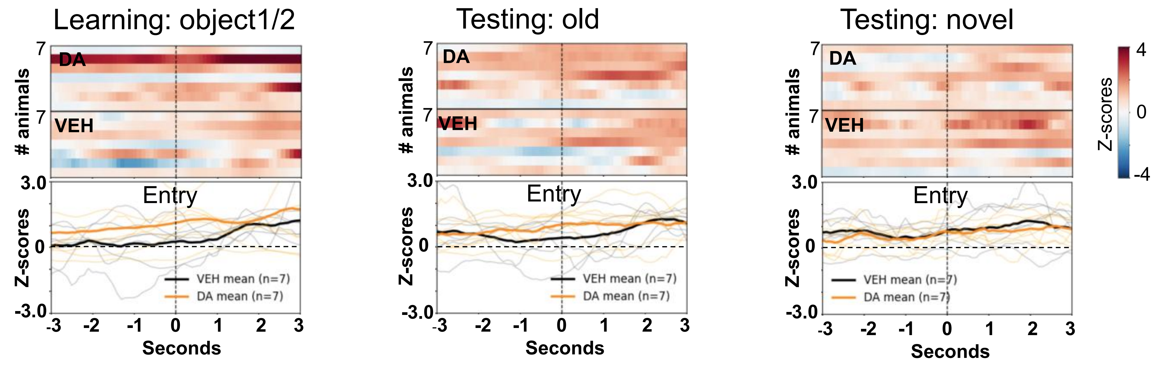
Supplementary Figure 2. Raw calcium traces aligned to entry events for individual subjects in the peri-event analyses.

