Supplementary Materials
Table S1. Baseline characteristics of the included and excluded cohorts in patients with pneumonia;
Table S2. Missing data patterns for variables;
Table S3. Univariate and multivariate Cox regression analyses for clinical outcomes in patients with Pneumonia;
Table S4. Variance inflation factor analysis for the multivariable Cox proportional hazards regression model;
Figure S1. Density distribution maps of weight before and after multiple imputation;
Figure S2. Schoenfeld residual plots for assessing the proportional hazards assumption in the multivariable Cox regression model.

Table S1. Baseline characteristics of the included and excluded cohorts in patients with pneumonia
Characteristics | Overall | Excluded cohort | Included cohort | p-value
Characteristics | N = 11722 | N = 7673 | N =4049 | p-value
Age, (year) | 65.56 ± 16.66 | 65.47 ± 16.77 | 65.76 ± 16.43 | 0.285
Gender, n(%) | 6626 (56.53) | 4380 (57.08) | 2246 (55.47) | 0.094
Race, n (%) |  |  |  | 0.141
Other | 4073 (34.75) | 2630 (34.28) | 1443 (35.64)
White | 7649 (65.25) | 5043 (65.72) | 2606 (64.36)
Marital status, n (%) |  |  |  | 0.051
Divorced | 823 (7.02) | 543 (7.08) | 280 (6.92)
Married | 4764 (40.64) | 3143 (40.96) | 1621 (40.03)
Single | 3311 (28.25) | 2193 (28.58) | 1118 (27.61)
Unknown | 1443 (12.31) | 894 (11.65) | 549 (13.56)
Widowed | 1381 (11.78) | 900 (11.73) | 481 (11.88)
Weight, (Kg) | 83.39 ± 24.74 | 83.28 ± 24.39 | 83.50 ± 25.21 | 0.650
Heart rate, (bpm) | 89.52 ± 16.86 | 89.63 ± 16.84 | 89.41 ± 16.86 | 0.502
SBP, (mmHg) | 115.53 ± 16.00 | 115.48 ± 16.47 | 115.65 ± 14.99 | 0.487
DBP, (mmHg) | 62.63 ± 10.91 | 62.53 ± 11.09 | 62.77 ± 10.55 | 0.892
Respiratory rate, (bpm) | 21.76 ± 4.45 | 21.84 ± 4.35 | 21.67 ± 4.56 | 0.475
Temperature, (℃) | 36.95 ± 0.61 | 36.93 ± 0.60 | 36.96 ± 0.62 | 0.158
SpO2, (%) | 96.22 ± 2.58 | 96.26 ± 2.60 | 96.17 ± 2.41 | 0.147
LODS | 5.82 ± 3.18 | 5.78± 3.16 | 5.89 ± 3.18 | 0.074
SOFA | 2.11 ± 2.33 | 2.09 ± 2.26 | 2.13 ± 2.46 | 0.359
CCI | 5.45 ± 3.04 | 5.46 ± 3.03 | 5.44 ± 3.06 | 0.768
RBC (10⁹/L) | 3.56 ± 0.76 | 3.57 ± 0.76 | 3.53 ± 0.77 | 0.125
Platelet (10⁹/L) | 209.99 ± 117.84 | 210.87 ± 114.90 | 208.37 ± 123.11 | 0.286
Sodium, (mmol/L) | 138.38 ± 5.51 | 138.42 ± 5.48 | 138.30 ± 5.56 | 0.277
Potassium, (mmol/L) | 4.21 ± 0.61 | 4.20 ± 0.61 | 4.22 ± 0.61 | 0.078
BUN, (mg/dL) | 31.70 ± 23.84 | 31.64 ± 23.32 | 31.79 ± 24.68 | 0.750
Creatinine, (mg/dL) | 1.56 ± 1.53 | 1.55 ± 1.52 | 1.58 ± 1.54 | 0.214
INR | 1.53 ± 0.79 | 1.52 ± 0.79 | 1.54 ± 0.79 | 0.186
PT, (S) | 16.70 ± 8.27 | 16.61 ± 8.23 | 16.85 ± 8.33 | 0.159
PTT, (S) | 38.86 ± 19.52 | 38.88 ± 19.95 | 38.83 ± 18.81 | 0.905
Urine output, (mL) | 1733.99 ± 1348.63 | 1719.34 ± 1322.21 | 1759.05 ± 1394.68 | 0.208
Congestive heart failure, n (%) | 3913 (33.36) | 2470 (33.15) | 1443 (35.64) | 0.912
Liver disease, n (%) | 1733 (14.78) | 1108 (14.44) | 625 (15.44) | 0.149
Diabetes, n (%) | 3525 (30.07) | 2317 (30.20) | 1208 (29.83) | 0.684
Hypertension, n (%) | 7363 (61.84) | 4873 (62.55) | 2490 (61.50) | 0.329
Norepinephrine, n (%) | 3682 (35.33) | 2186 (33.36) | 1496 (36.95) | 0.628
Glucocorticoids, n (%) | 3753 (36.27) | 2228 (35.43) | 1525 (37.66) | 0.187
Antibiotics, n (%) | 10166 (91.87) | 6395 (89.04) | 3771 (93.13) | 0.082
Mechanical ventilation, n (%) | 10259 (90.67) | 6553 (88.10) | 3706 (91.53) | 0.742
CRRT, n (%) | 947 (9.91) | 536 (9.72) | 411 (10.15) | 0.148
Hospital Mortality, n (%) | 2385 (21.09) | 1467 (20.73) | 918 (22.67) | 0.389
ICU Mortality, n (%) | 1532 (13.98) | 898 (12.57) | 634 (15.66) | 0.097
30-day hospital Mortality, n (%) | 2255 (24.65) | 1207 (23.94) | 1048 (25.88) | 0.078
360-day hospital Mortality, n (%) | 4865 (42.08) | 3090 (41.62) | 1775 (43.84) | 0.149
LODS, Logistic organ dysfunction score; SOFA, Sequential organ failure assessment; CCI, Charlson Comorbidity Index; SpO₂, Saturation of peripheral oxygen; SBP, Systolic blood pressure; DBP, Diastolic blood pressure; PT, prothrombin time; PTT, partial thromboplastin time; WBC, White blood cell count; RBC, Red blood cell count; INR, International normalized ratio; CRRT, Continuous renal replacement therapy.

Table S2. Missing data patterns for variables.
Variable | Missing n (%) | Completeness (%)
Weight | 581 (4.96) | 95.04
Heart rate | 10 (0.09) | 99.91
SBP | 10 (0.09) | 99.91
DBP | 10 (0.09) | 99.91
Respiratory rate | 10 (0.09) | 99.91
Temperature | 71 (0.61) | 99.39
SpO₂ | 11 (0.09) | 99.91
SpO₂, Saturation of peripheral oxygen; SBP, Systolic blood pressure; DBP, Diastolic blood pressure.

Table S3. Univariate and multivariate Cox regression analyses for clinical outcomes in patients with Pneumonia
Characteristic | 30-day mortality |  |  |  | 360-day mortality
Characteristic | Univariate |  | Multivariate |  | Univariate |  | Multivariate
Characteristic | HR (95%CI) | p | HR (95%CI) | p | HR (95%CI) | p | HR (95%CI) | p
Age | 1.02 (1.02 – 1.03) | <.001 | 1.01 (1.01 – 1.02) | <.001 | 1.03 (1.02 – 1.03) | <.001 | 1.02 (1.01 – 1.02) | <.001
Gender
Female | 1.00 (Reference) |  |  |  | 1.00 (Reference)
Male | 1.01 (0.90 – 1.15) | 0.827 |  |  | 1.04 (0.95 – 1.15) | 0.363
Race
Other | 1.00 (Reference) |  | 1.00 (Reference) |  | 1.00 (Reference)
White | 0.86 (0.76 – 0.97) | 0.016 | 0.84 (0.73 – 0.97) | 0.016 | 1.00 (0.90 – 1.10) | 0.943
Marital status
Divorced | 1.00 (Reference) |  | 1.00 (Reference) |  | 1.00 (Reference) |  | 1.00 (Reference)
Married | 1.12 (0.87 – 1.46) | 0.382 | 0.95 (0.73 – 1.24) | 0.723 | 1.03 (0.85 – 1.25) | 0.729 | 0.88 (0.72 – 1.07) | 0.194
Single | 0.92 (0.70 – 1.21) | 0.551 | 1.06 (0.80 – 1.40) | 0.689 | 0.83 (0.67 – 1.01) | 0.063 | 0.97 (0.79 – 1.19) | 0.76
Unknown | 1.57 (1.19 – 2.09) | 0.002 | 1.47 (1.09 – 1.97) | 0.012 | 1.19 (0.96 – 1.48) | 0.108 | 1.36 (1.10 – 1.69) | 0.005
Widowed | 1.39 (1.04 – 1.86) | 0.027 |  |  | 1.34 (1.08 – 1.67) | 0.007 | 0.85 (0.68 – 1.06) | 0.149
Weight | 0.99 (0.99 – 0.99) | <.001 | 1.00 (1.00 – 1.00) | 0.382 | 0.99 (0.99 – 0.99) | <.001 | 0.99 (0.99 – 0.99) | 0.008
Heart rate | 1.01 (1.01 – 1.01) | <.001 | 1.01 (1.01 – 1.01) | <.001 | 1.01 (1.01 – 1.01) | <.001 | 1.01 (1.01 – 1.01) | <.001
SBP | 0.99 (0.99 – 0.99) | <.001 | 1.01 (1.01 – 1.01) | 0.024 | 0.99 (0.99 – 0.99) | <.001 | 1.00 (1.00 – 1.01) | 0.355
DBP | 0.98 (0.97 – 0.99) | <.001 | 0.99 (0.99 – 1.00) | 0.203 | 0.98 (0.98 – 0.99) | <.001 | 1.00 (1.00 – 1.01) | 0.343
RR | 1.04 (1.02 – 1.05) | <.001 | 1.01 (0.99 – 1.03) | 0.211 | 1.02 (1.01 – 1.03) | <.001 | 1.01 (1.00 – 1.02) | 0.182
Temperature | 0.73 (0.66 – 0.79) | <.001 | 0.90 (0.81 – 1.00) | 0.057 | 0.72 (0.67 – 0.77) | <.001 | 0.87 (0.80 – 0.94) | <.001
SpO2 | 0.91 (0.89 – 0.93) | <.001 | 0.92 (0.90 – 0.94) | <.001 | 0.96 (0.94 – 0.97) | <.001 | 0.96 (0.94 – 0.98) | <.001
APSIII | 1.08 (1.05 – 1.10) | <.001 | 0.98 (0.96 – 1.01) | 0.175 | 1.02 (1.02 – 1.02) | <.001 | 1.01 (1.01 – 1.01) | <.001
LODS | 1.17 (1.15 – 1.19) | <.001 | 1.05 (1.02 – 1.08) | 0.004 | 1.14 (1.12 – 1.15) | <.001 | 1.04 (1.01 – 1.06) | 0.006
GCS | 0.94 (0.93 – 0.96) | <.001 | 1.02 (1.00 – 1.05) | 0.093 | 0.96 (0.94 – 0.97) | <.001 | 1.01 (0.99 – 1.03) | 0.217
SOFA | 1.02 (1.02 – 1.03) | <.001 | 1.01 (1.01 – 1.02) | <.001 | 1.07 (1.05 – 1.09) | <.001 | 0.99 (0.97 – 1.01) | 0.54
CCI | 1.16 (1.14 – 1.19) | <.001 | 1.14 (1.11 – 1.18) | <.001 | 1.19 (1.18 – 1.21) | <.001 | 1.12 (1.10 – 1.15) | <.001
RBC | 0.76 (0.70 – 0.83) | <.001 | 0.93 (0.85 – 1.02) | 0.112 | 0.72 (0.68 – 0.77) | <.001 | 0.87 (0.81 – 0.94) | <.001
WBC | 1.01 (1.01 – 1.01) | <.001 | 1.00 (1.00 – 1.01) | 0.058 | 1.01 (1.01 – 1.01) | <.001 | 1.00 (1.00 – 1.01) | 0.077
Platelet | 0.99 (0.99 – 0.99) | 0.001 | 1.00 (1.00 – 1.00) | 0.536 | 0.99 (0.99 – 0.99) | <.001 | 1.00 (1.00 – 1.00) | 0.197
Sodium | 1.01 (1.00 – 1.02) | 0.204 |  |  | 1.00 (0.99 – 1.01) | 0.916
Potassium | 1.26 (1.14 – 1.38) | <.001 | 1.00 (0.90 – 1.11) | 0.935 | 1.23 (1.14 – 1.32) | <.001 | 1.01 (0.93 – 1.09) | 0.835
BUN | 1.01 (1.01 – 1.01) | <.001 | 1.01 (1.01 – 1.01) | <.001 | 1.01 (1.01 – 1.01) | <.001 | 1.01 (1.01 – 1.01) | <.001
Creatinine | 1.08 (1.05 – 1.12) | <.001 | 0.90 (0.84 – 0.95) | <.001 | 1.07 (1.05 – 1.10) | <.001 | 0.90 (0.86 – 0.94) | <.001
INR | 1.22 (1.16 – 1.28) | <.001 | 0.91 (0.63 – 1.30) | 0.595 | 1.24 (1.19 – 1.29) | <.001 | 1.06 (0.77 – 1.48) | 0.71
PT | 1.02 (1.01 – 1.02) | <.001 | 1.01 (0.98 – 1.05) | 0.481 | 1.02 (1.02 – 1.02) | <.001 | 1.00 (0.97 – 1.03) | 0.957
PTT | 1.01 (1.01 – 1.01) | <.001 | 1.00 (1.00 – 1.01) | 0.051 | 1.01 (1.01 – 1.01) | <.001 | 1.01 (1.01 – 1.01) | 0.002
Urineoutput | 0.99 (0.99 – 0.99) | <.001 | 0.99 (0.99 – 0.99) | <.001 | 0.99 (0.99 – 0.99) | <.001 | 0.99 (0.99 – 0.99) | <.001
Myocardial infarct
No | 1.00 (Reference) |  |  |  | 1.00 (Reference) |  | 1.00 (Reference)
Yes | 1.13 (0.97 – 1.32) | 0.108 |  |  | 1.21 (1.08 – 1.36) | <.001 | 0.94 (0.83 – 1.06) | 0.313
Congestive heart failure
No | 1.00 (Reference) |  |  |  | 1.00 (Reference) |  | 1.00 (Reference)
Yes | 1.06 (0.94 – 1.20) | 0.347 |  |  | 1.23 (1.12 – 1.35) | <.001 | 0.85 (0.76 – 0.95) | 0.003
Cerebrovascular disease
No | 1.00 (Reference) |  | 1.00 (Reference) |  | 1.00 (Reference) |  | 1.00 (Reference)
Yes | 1.29 (1.10 – 1.53) | 0.002 | 1.14 (0.95 – 1.36) | 0.151 | 1.25 (1.10 – 1.42) | <.001 | 1.12 (0.97 – 1.28) | 0.119
Chronic pulmonary disease
No | 1.00 (Reference) |  |  |  | 1.00 (Reference)
Yes | 1.00 (0.88 – 1.14) | 0.944 |  |  | 1.09 (0.99 – 1.20) | 0.089
Liver disease
No | 1.00 (Reference) |  | 1.00 (Reference) |  | 1.00 (Reference) |  | 1.00 (Reference)
Yes | 1.38 (1.18 – 1.61) | <.001 | 1.01 (0.85 – 1.21) | 0.877 | 1.23 (1.09 – 1.39) | <.001 | 1.01 (0.87 – 1.16) | 0.944
Malignant cancer
No | 1.00 (Reference) |  | 1.00 (Reference) |  | 1.00 (Reference) |  | 1.00 (Reference)
Yes | 1.94 (1.70 – 2.21) | <.001 | 1.22 (1.02 – 1.46) | 0.033 | 2.22 (2.00 – 2.46) | <.001 | 1.50 (1.31 – 1.71) | <.001
Diabetes
No | 1.00 (Reference) |  |  |  | 1.00 (Reference)
Yes | 0.91 (0.80 – 1.04) | 0.173 |  |  | 0.99 (0.89 – 1.10) | 0.845
Hypertension
No | 1.00 (Reference) |  |  |  | 1.00 (Reference) |  | 1.00 (Reference)
Yes | 1.11 (0.98 – 1.26) | 0.092 |  |  | 1.15 (1.04 – 1.26) | 0.006 | 0.85 (0.77 – 0.95) | 0.003
Norepinephrine
No | 1.00 (Reference) |  | 1.00 (Reference) |  | 1.00 (Reference) |  | 1.00 (Reference)
Yes | 1.74 (1.54 – 1.96) | <.001 | 1.38 (1.19 – 1.59) | <.001 | 1.52 (1.39 – 1.67) | <.001 | 1.33 (1.19 – 1.49) | <.001
Glucocorticoids
No | 1.00 (Reference) |  |  |  | 1.00 (Reference)
Yes | 1.12 (0.99 – 1.26) | 0.077 |  |  | 1.03 (0.94 – 1.14) | 0.502
Antibiotics
No | 1.00 (Reference) |  | 1.00 (Reference) |  | 1.00 (Reference) |  | 1.00 (Reference)
Yes | 1.61 (1.21 – 2.15) | 0.001 | 1.22 (0.90 – 1.64) | 0.195 | 1.40 (1.14 – 1.71) | 0.001 | 1.13 (0.92 – 1.40) | 0.242
Mechanical ventilation
No | 1.00 (Reference) |  |  |  | 1.00 (Reference)
Yes | 0.90 (0.73 – 1.12) | 0.345 |  |  | 0.87 (0.74 – 1.03) | 0.098
CRRT
No | 1.00 (Reference) |  | 1.00 (Reference) |  | 1.00 (Reference) |  | 1.00 (Reference)
Yes | 2.20 (1.88 – 2.58) | <.001 | 1.14 (0.93 – 1.39) | 0.218 | 1.93 (1.69 – 2.21) | <.001 | 1.20 (1.02 – 1.41) | 0.03
APSIII, Acute physiology score III; LODS, Logistic organ dysfunction score; GCS, Glasgow coma scale; SOFA, Sequential organ failure assessment; CCI, Charlson Comorbidity Index; SpO₂, Saturation of peripheral oxygen; SBP, Systolic blood pressure; DBP, Diastolic blood pressure; PT, prothrombin time; PTT, partial thromboplastin time; WBC, White blood cell count; RBC, Red blood cell count; INR, International normalized ratio; CRRT, Continuous renal replacement therapy.

Table S4. Variance inflation factor analysis for the multivariate Cox proportional hazards regression model
Characteristics | GVIF | Df | GVIF^(1/2Df)
Gender | 1.198 | 1 | 1.094
Race | 1.268 | 1 | 1.126
Myocardial infarct | 1.214 | 1 | 1.102
Marital status | 1.656 | 4 | 1.065
Congestive heart failure | 1.368 | 1 | 1.17
Cerebrovascular disease | 1.155 | 1 | 1.075
Chronic pulmonary disease | 1.158 | 1 | 1.076
Liver disease | 1.284 | 1 | 1.133
Malignant cancer | 1.721 | 1 | 1.312
Diabetes | 1.319 | 1 | 1.148
Hypertension | 1.306 | 1 | 1.143
Norepinephrine | 1.392 | 1 | 1.18
Glucocorticoids | 1.091 | 1 | 1.044
Antibiotics | 1.067 | 1 | 1.033
Mechanical Ventilation | 1.041 | 1 | 1.02
CRRT | 1.403 | 1 | 1.184
Weight | 1.225 | 1 | 1.107
Age | 2.575 | 1 | 1.605
Heart rate | 1.573 | 1 | 1.254
SBP | 1.692 | 1 | 1.301
DBP | 1.922 | 1 | 1.386
Respiratory Rate | 1.356 | 1 | 1.164
Temperature | 1.251 | 1 | 1.119
SpO₂ | 1.252 | 1 | 1.119
APSIII | 4.163 | 1 | 2.04
LODS | 3.237 | 1 | 1.799
GCS | 1.869 | 1 | 1.367
SOFA | 1.413 | 1 | 1.189
CCI | 3.423 | 1 | 1.85
RBC | 1.339 | 1 | 1.157
WBC | 1.074 | 1 | 1.036
Platelet | 1.175 | 1 | 1.084
Sodium | 1.166 | 1 | 1.08
Potassium | 1.267 | 1 | 1.126
BUN | 2.474 | 1 | 1.573
Creatinine | 2.163 | 1 | 1.471
INR | 26.899 | 1 | 5.186
PT | 26.963 | 1 | 5.193
PTT | 1.119 | 1 | 1.058
Urine output | 1.25 | 1 | 1.118
GVIF, generalized variance inflation factor; Df, degrees of freedom; APSIII, Acute physiology score III; LODS, Logistic organ dysfunction score; GCS, Glasgow coma scale; SOFA, Sequential organ failure assessment; CCI, Charlson Comorbidity Index; SpO₂, Saturation of peripheral oxygen; SBP, Systolic blood pressure; DBP, Diastolic blood pressure; PT, prothrombin time; PTT, partial thromboplastin time; WBC, White blood cell count; RBC, Red blood cell count; INR, International normalized ratio; CRRT, Continuous renal replacement therapy.

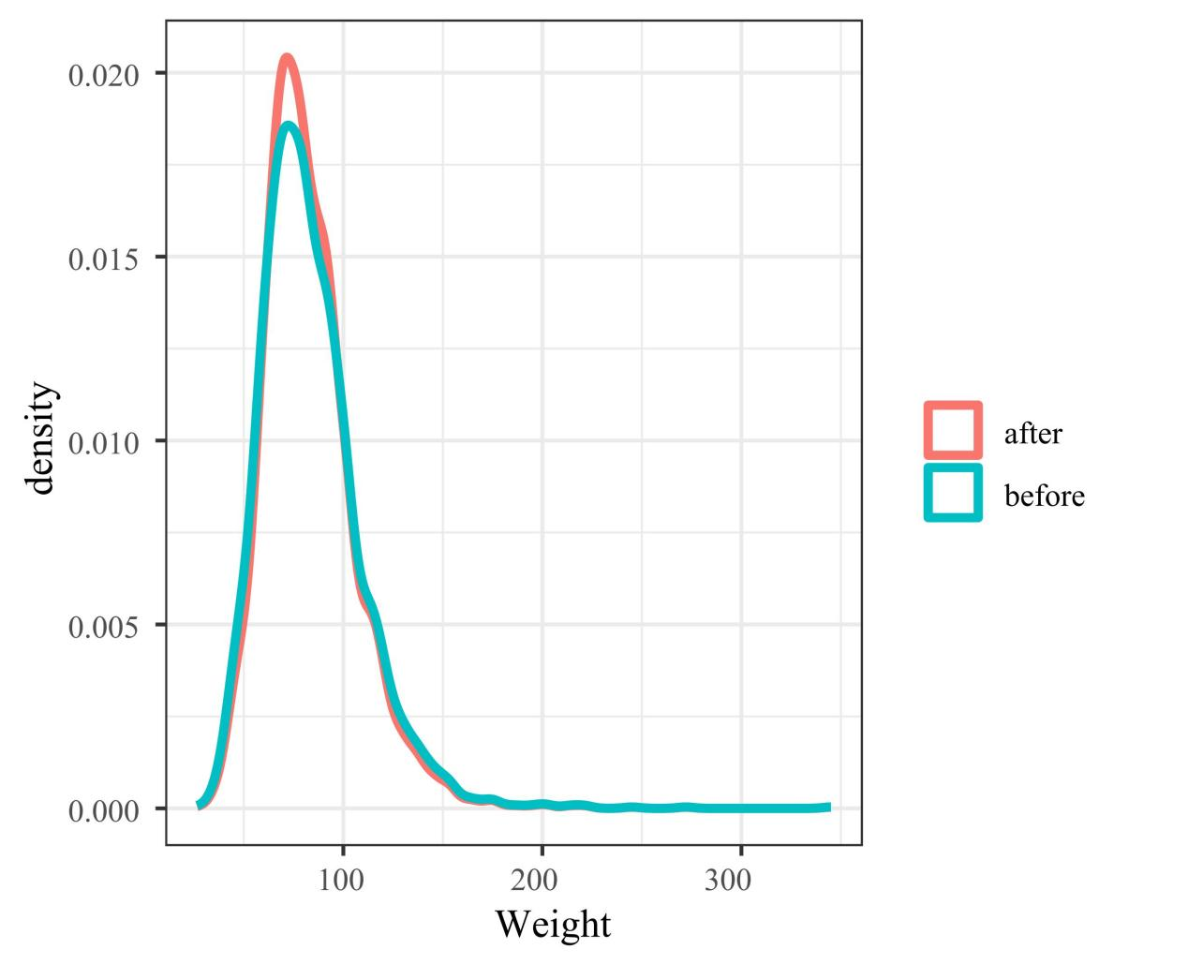
Figure S1. Density distribution maps of weight before and after multiple imputation.
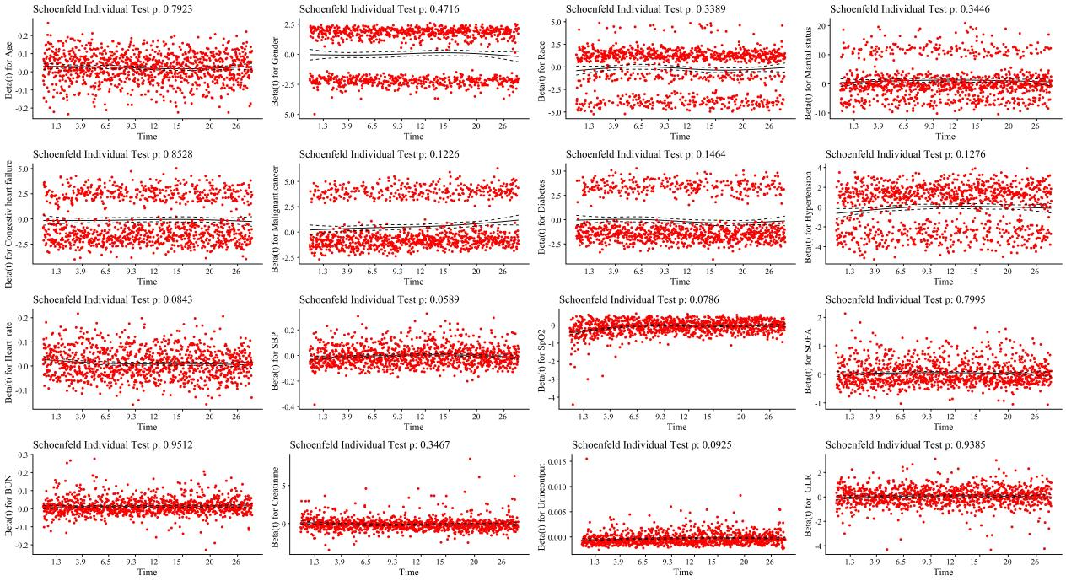
Figure S2. Schoenfeld residual plots for assessing the proportional hazards assumption in the multivariable Cox regression model.

