Supplementary Figures:

Supplementary Figure S1: The distribution of microcytic and normocytic anemia across the age categories in women and men.
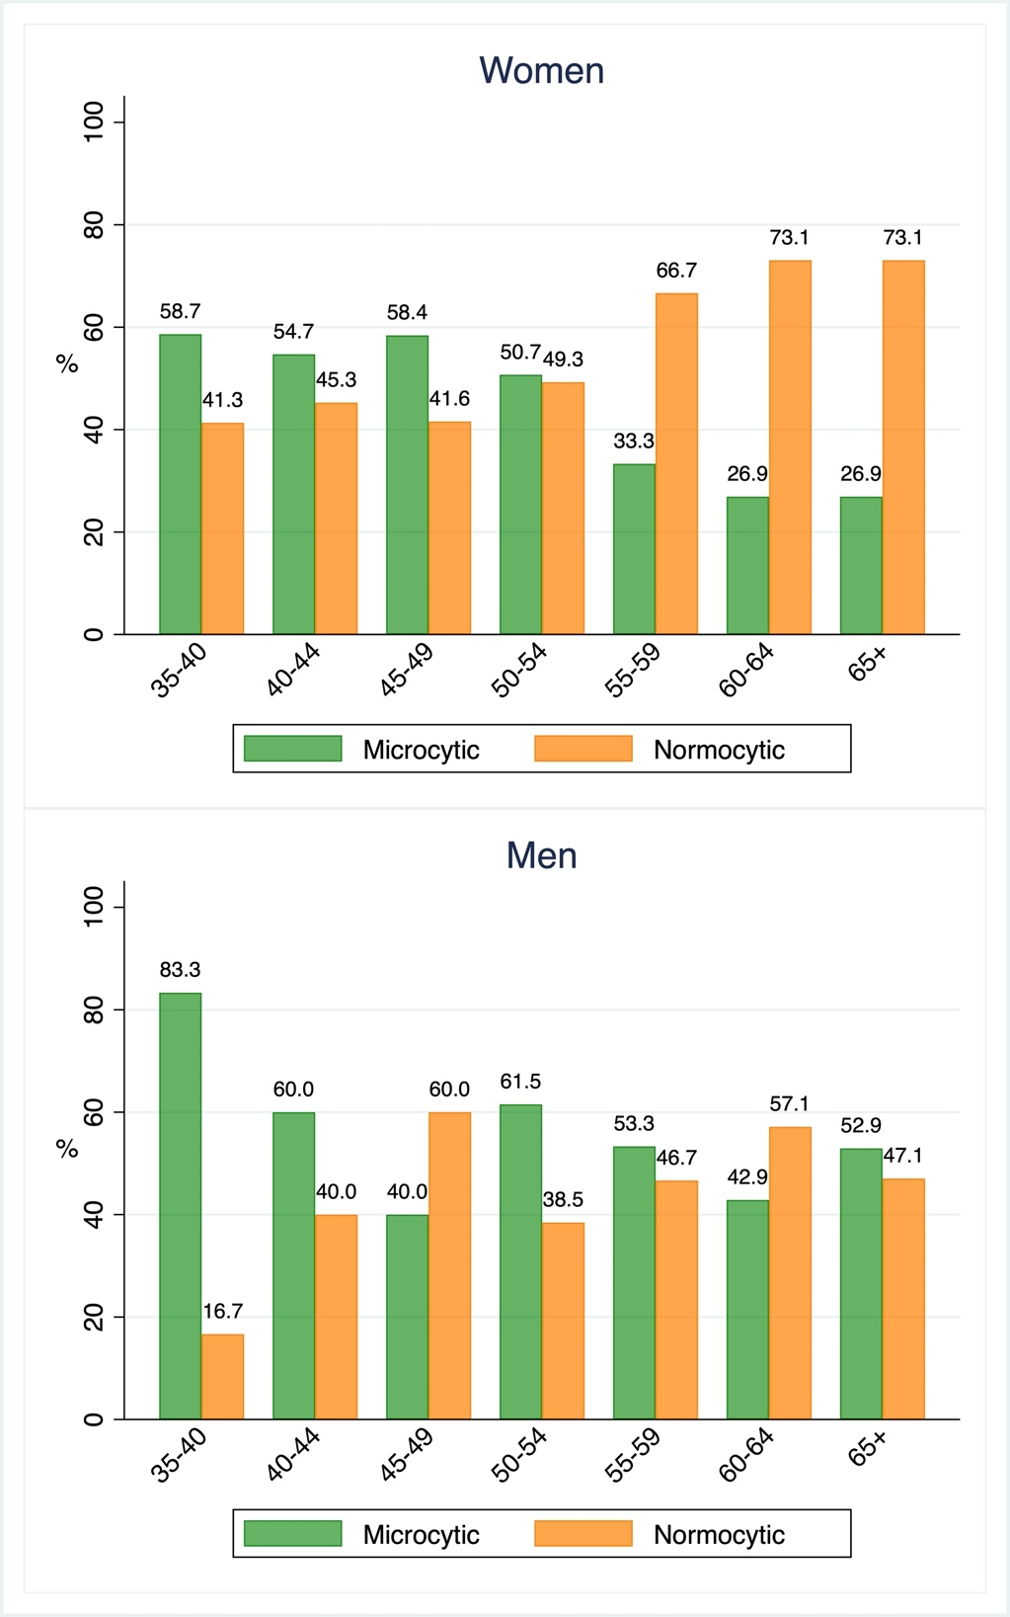

Supplementary Figure S2: Severity of anemia in women and men

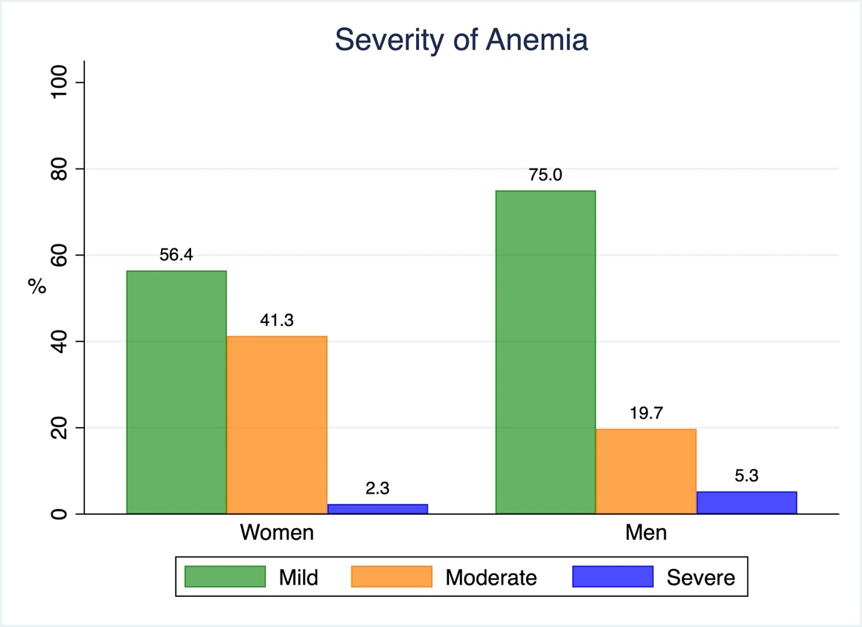

Supplementary Figure S3: The distribution of anemia types according to mean corpuscular volume in women and men.

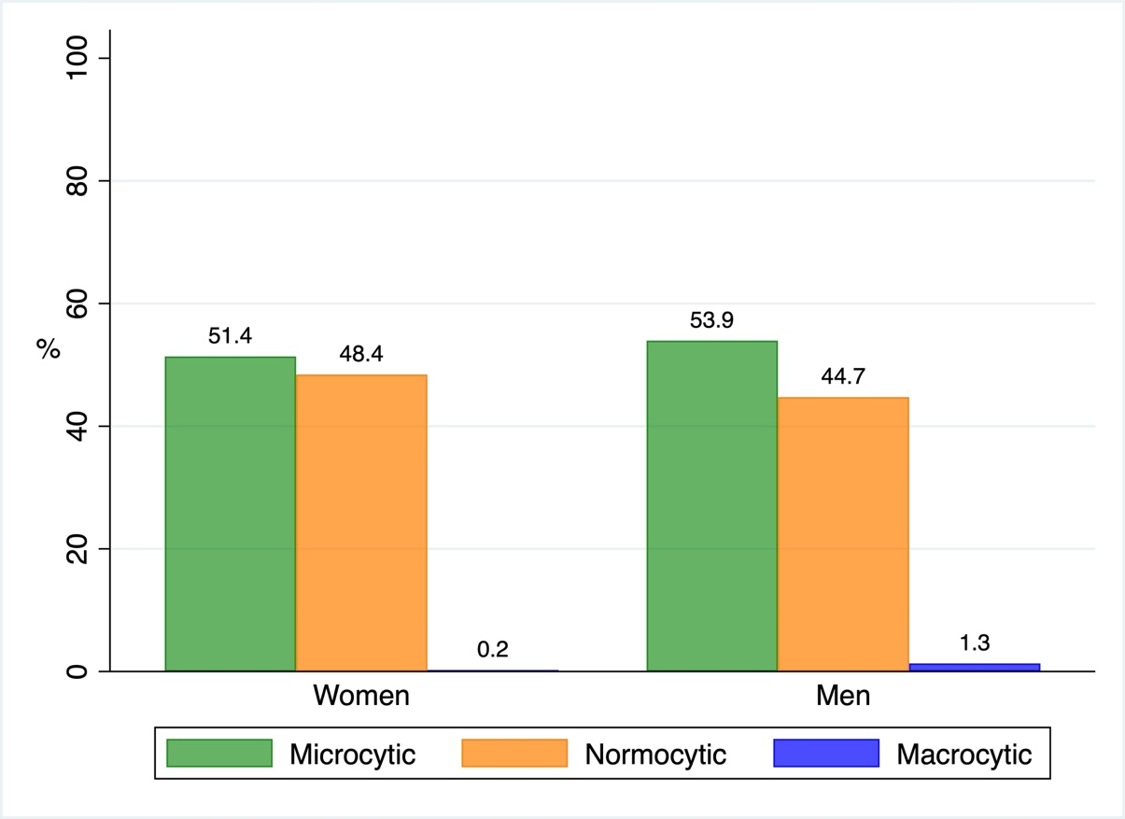

Supplementary Figure S4: Distribution of anemia subgroups based on mean corpuscular volume and mean corpuscular hemoglobin concentration in women and men.

Supplementary Figure S5: The distribution of anemia types according to mean corpuscular hemoglobin concentration in women and men
