Gold and Cadmium Nanoclusters Embedded BSA Nanoparticles as Two‐Color Imaging and Anti-Cancer Agent for Human Breast Cancer Cell Line

Shayan Shahsavari¹‡, Mohammad Behnam Rad²‡*, Fatemeh Sadat Mahdavi³, Hamideh Fouladiha⁴, Asadollah Kalantarian⁵, Arghavan Fattahi⁶, Dina Morshedi⁶

¹ Iran Nanotechnology Initiative Council, Nanoclub Elites Association, Tehran, Iran.
² Department of Biophysics, Institute of Biochemistry and Biophysics, University of Tehran, Tehran, Iran.
³ Department of Poultry Science, College of Agricultural and Environmental Sciences, University of Georgia, Athens, USA.
⁴ Department of Biotechnology, College of Science, University of Tehran, Tehran, Iran.
⁵ Institute for Convergence Science & Technology, Center for Nanoscience and Nanotechnology, Sharif University of Technology, Tehran, Iran.
⁶ National Institute of Genetic Engineering and Biotechnology, Tehran, Iran.

‡ These authors contributed equally.

*Corresponding author:
Behnamrad@ut.ac.ir

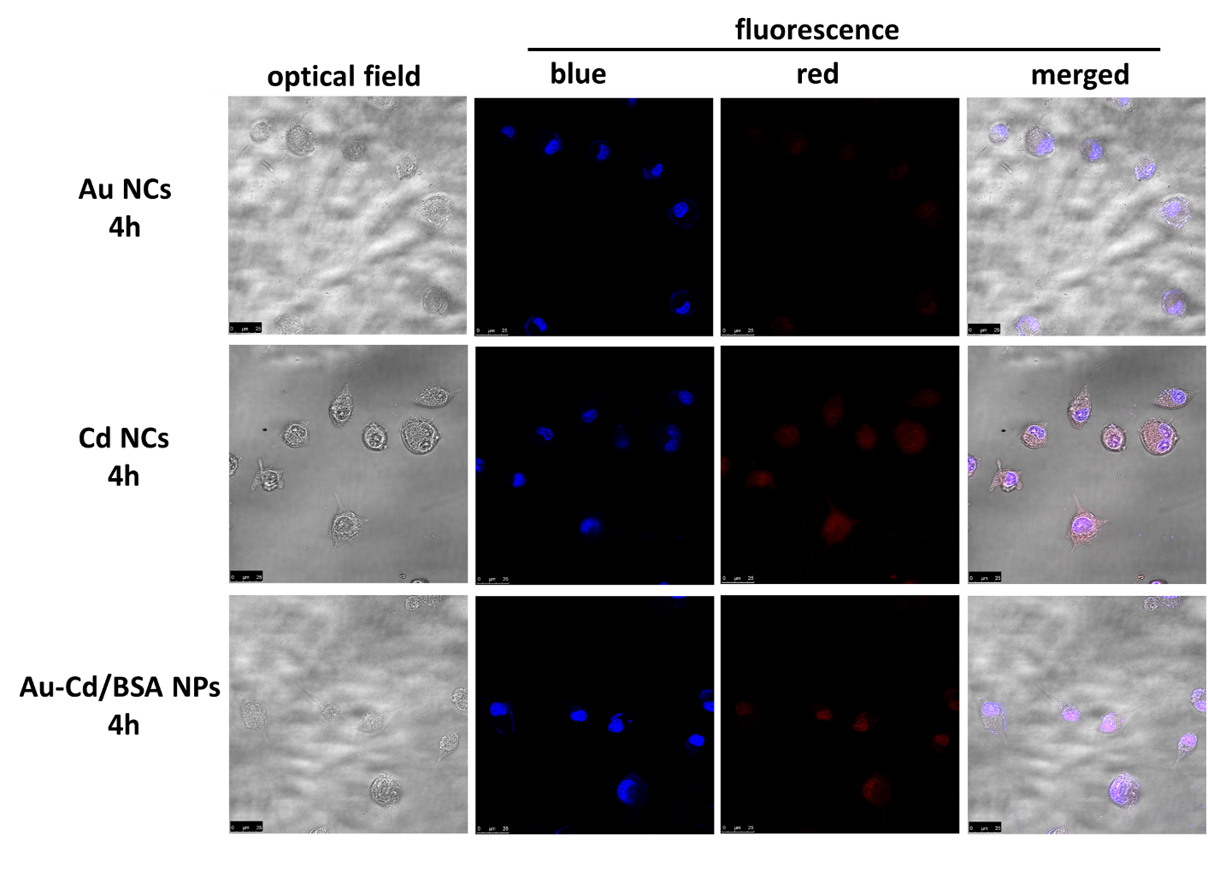
Figure S1. Cellular uptake analysis. Fluorescence images of MDA-MB-231 cells treated with Au NCs, Cd NCs, and Au-Cd/BSA NPs after 4 hours of incubation.

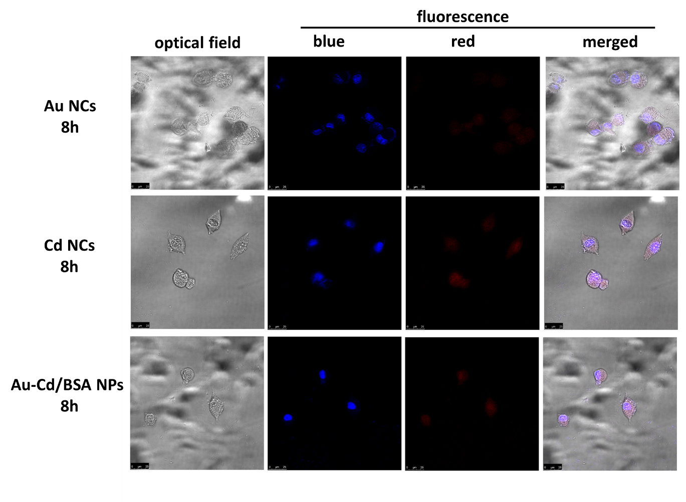
Figure S2. Cellular uptake analysis. Fluorescence images of MDA-MB-231 cells treated with Au NCs, Cd NCs, and Au-Cd/BSA NPs after 8 hours of incubation.

Figure S3. MTT test assay plot of NPs on adipose mesenchymal stem cells after 24 h.

