Supplementary Tables
Supplementary Table 1 Summary of basecalling and quality-filtered reads (Q ≥ 10) generated by Dorado
Supplementary Table 2 Summary of transcript isoform classification by SQANTI3
Supplementary Table 3 Candidate differentially expressed genes between control and GDM groups
Supplementary Table 4 Results of GO analysis
Supplementary Table 5 Results of KEGG pathway enrichment analysis
Supplementary Table 6 The transcript proportion data for significant differential transcript usage
Supplementary Table 7 Top 10 candidate novel genes identified and ranked according to differential gene expression score
Supplementary Table 8 Differential transcript usage genes involving novel isoforms
Supplementary Table 9 Gene-level differential RNA base modification analysis results

Supplementary Figures
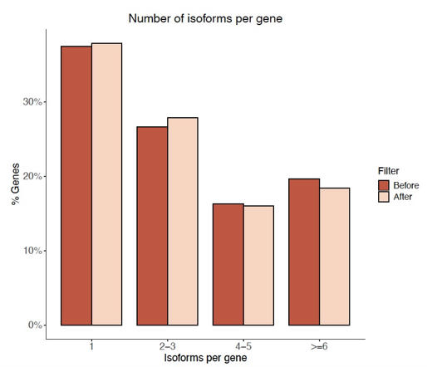
Supplementary Figure 1: Distribution of the number of isoforms per gene. Different color shades correspond to data before and after artifact filtering. Plot obtained from SQANTI3 report.

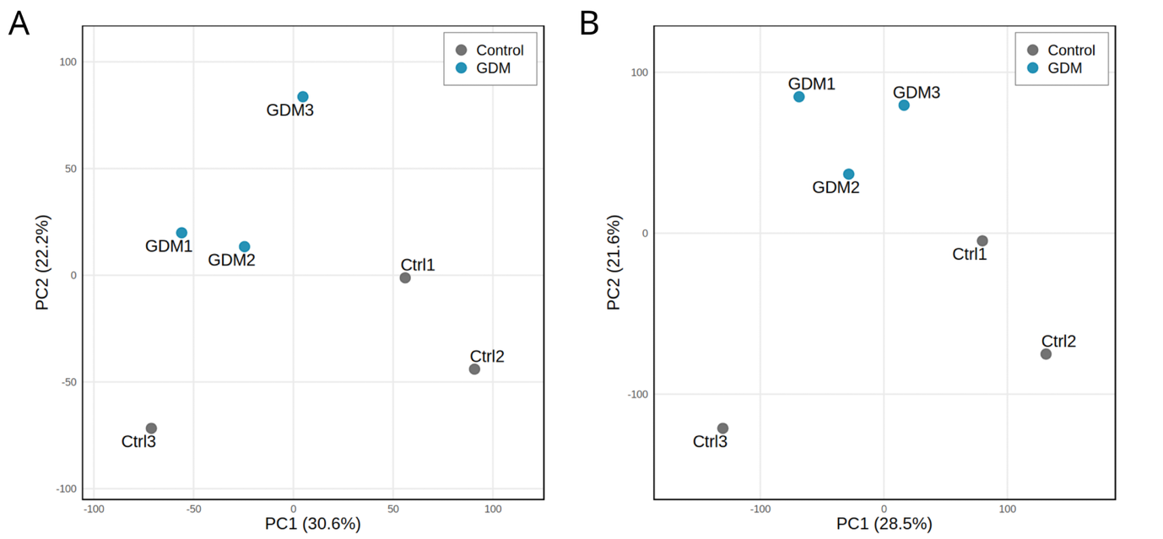
Supplementary Figure 2: Principal component analysis (PCA) of gene and transcript expression.
(A) PCA of normalized gene-level expression values. (B) PCA of normalized transcript-level expression values. Control represents healthy pregnant individuals and GDM represents individuals with GDM.

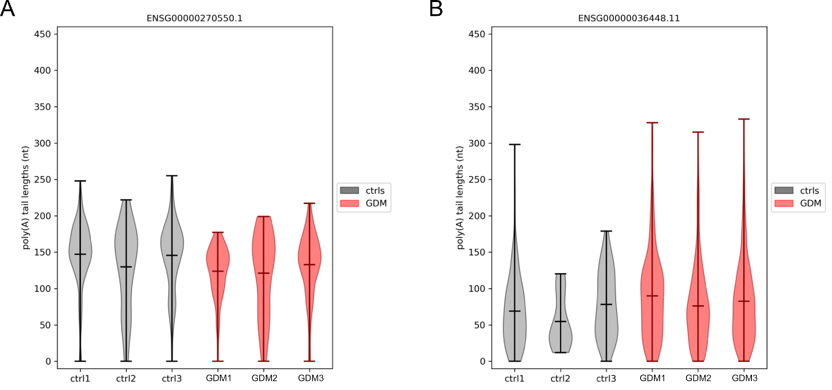
Supplementary Figure 3: Comparative analysis of mRNA poly(A) tail length in selected genes.
(A) IGHV3-30.
(B) MYOM2.

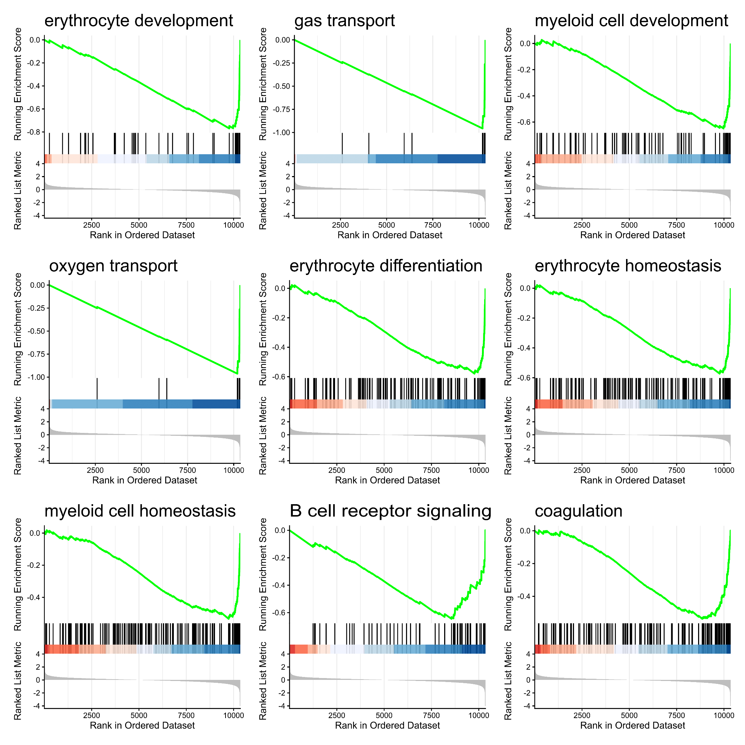
Supplementary Figure 4: Top gene sets enriched by GSEA.

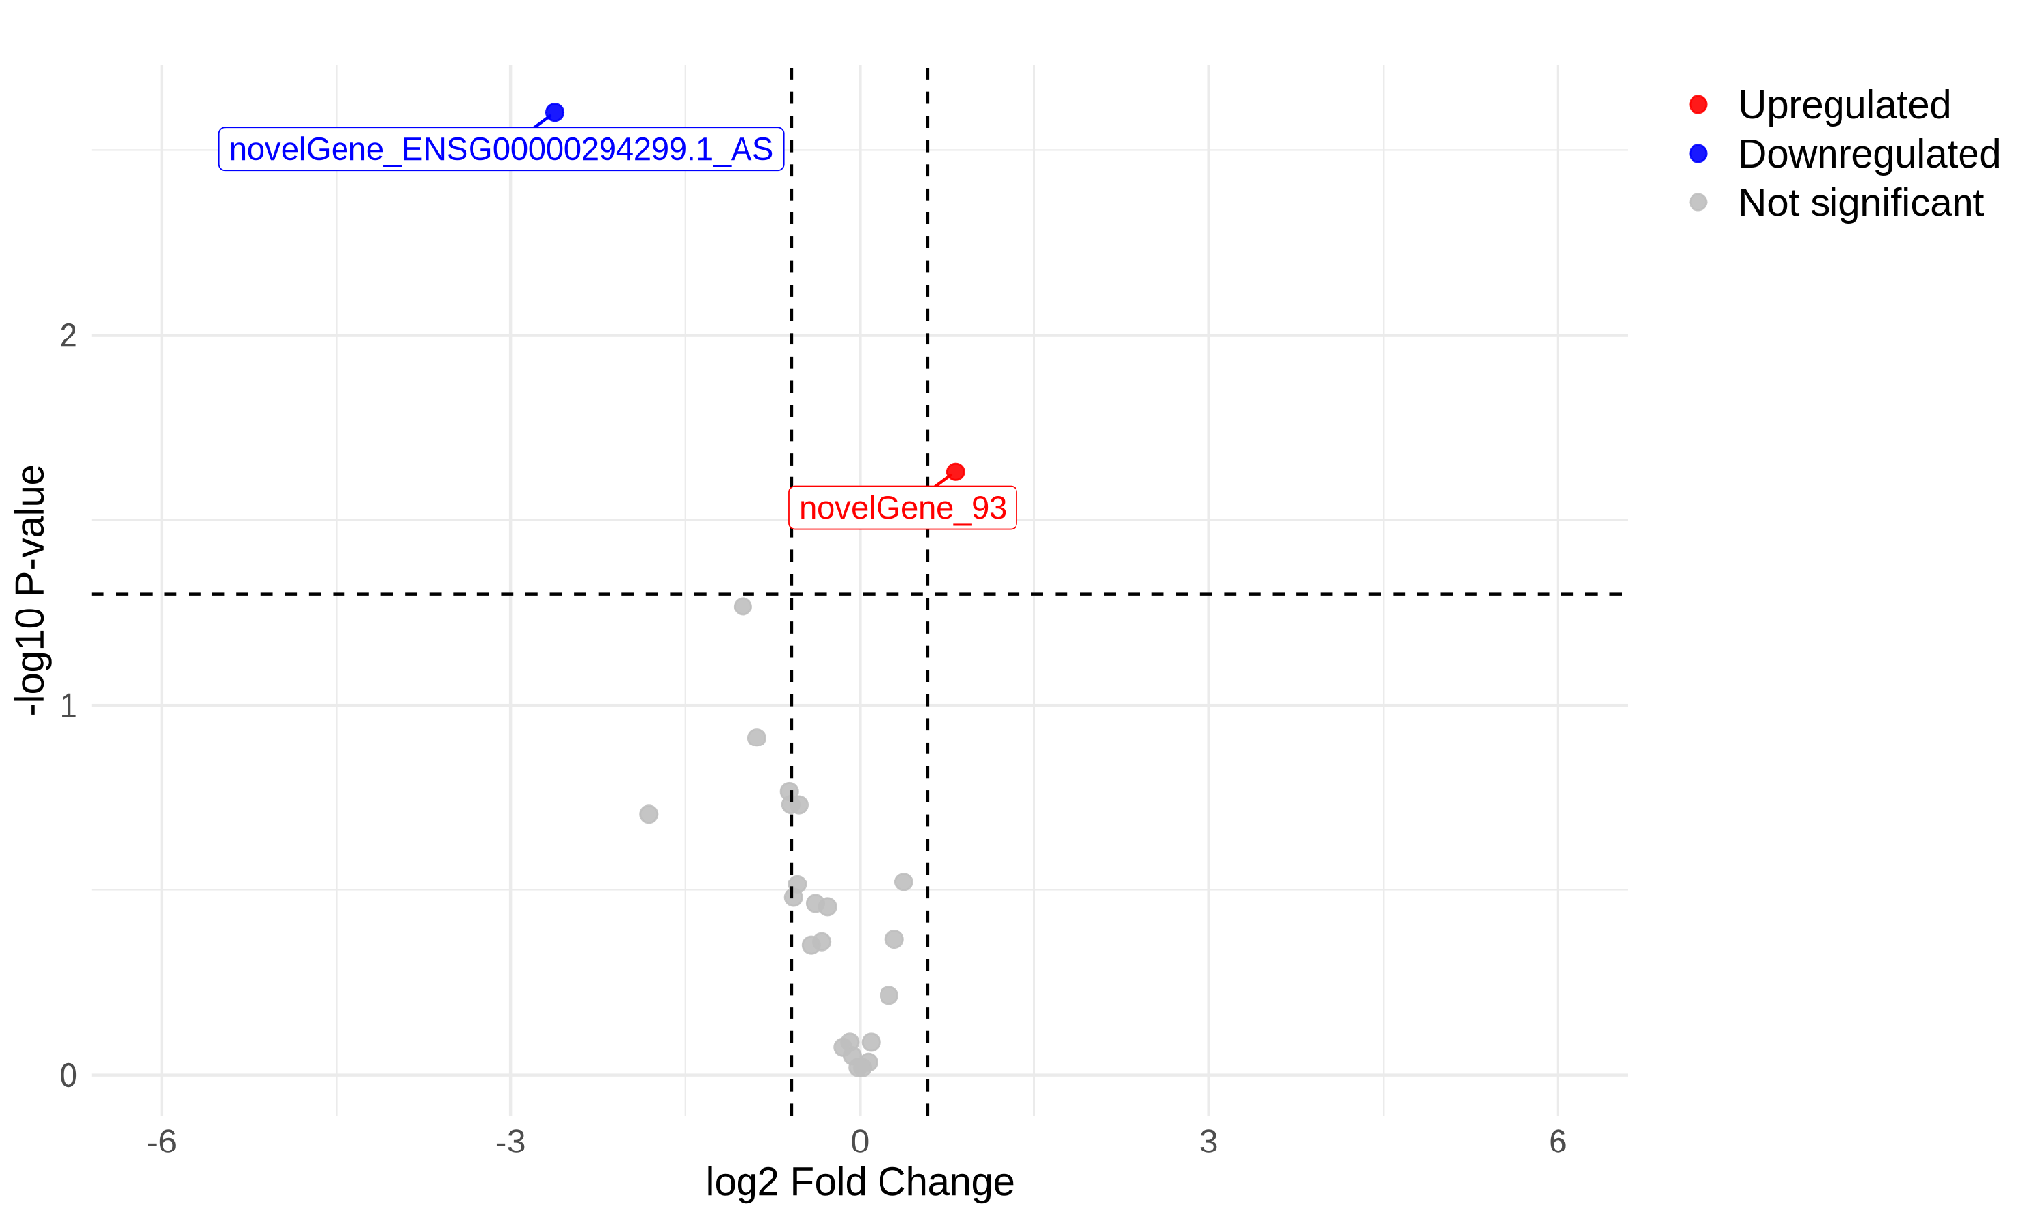
Supplementary Figure 5: Differential expression analysis of novel genes.
Volcano plot illustrating candidate differentially expressed novel genes between study groups. Upregulated genes are shown in red and downregulated genes in blue. Candidate genes were identified by absolute fold change ≥ 1.5 and P-value < 0.05.

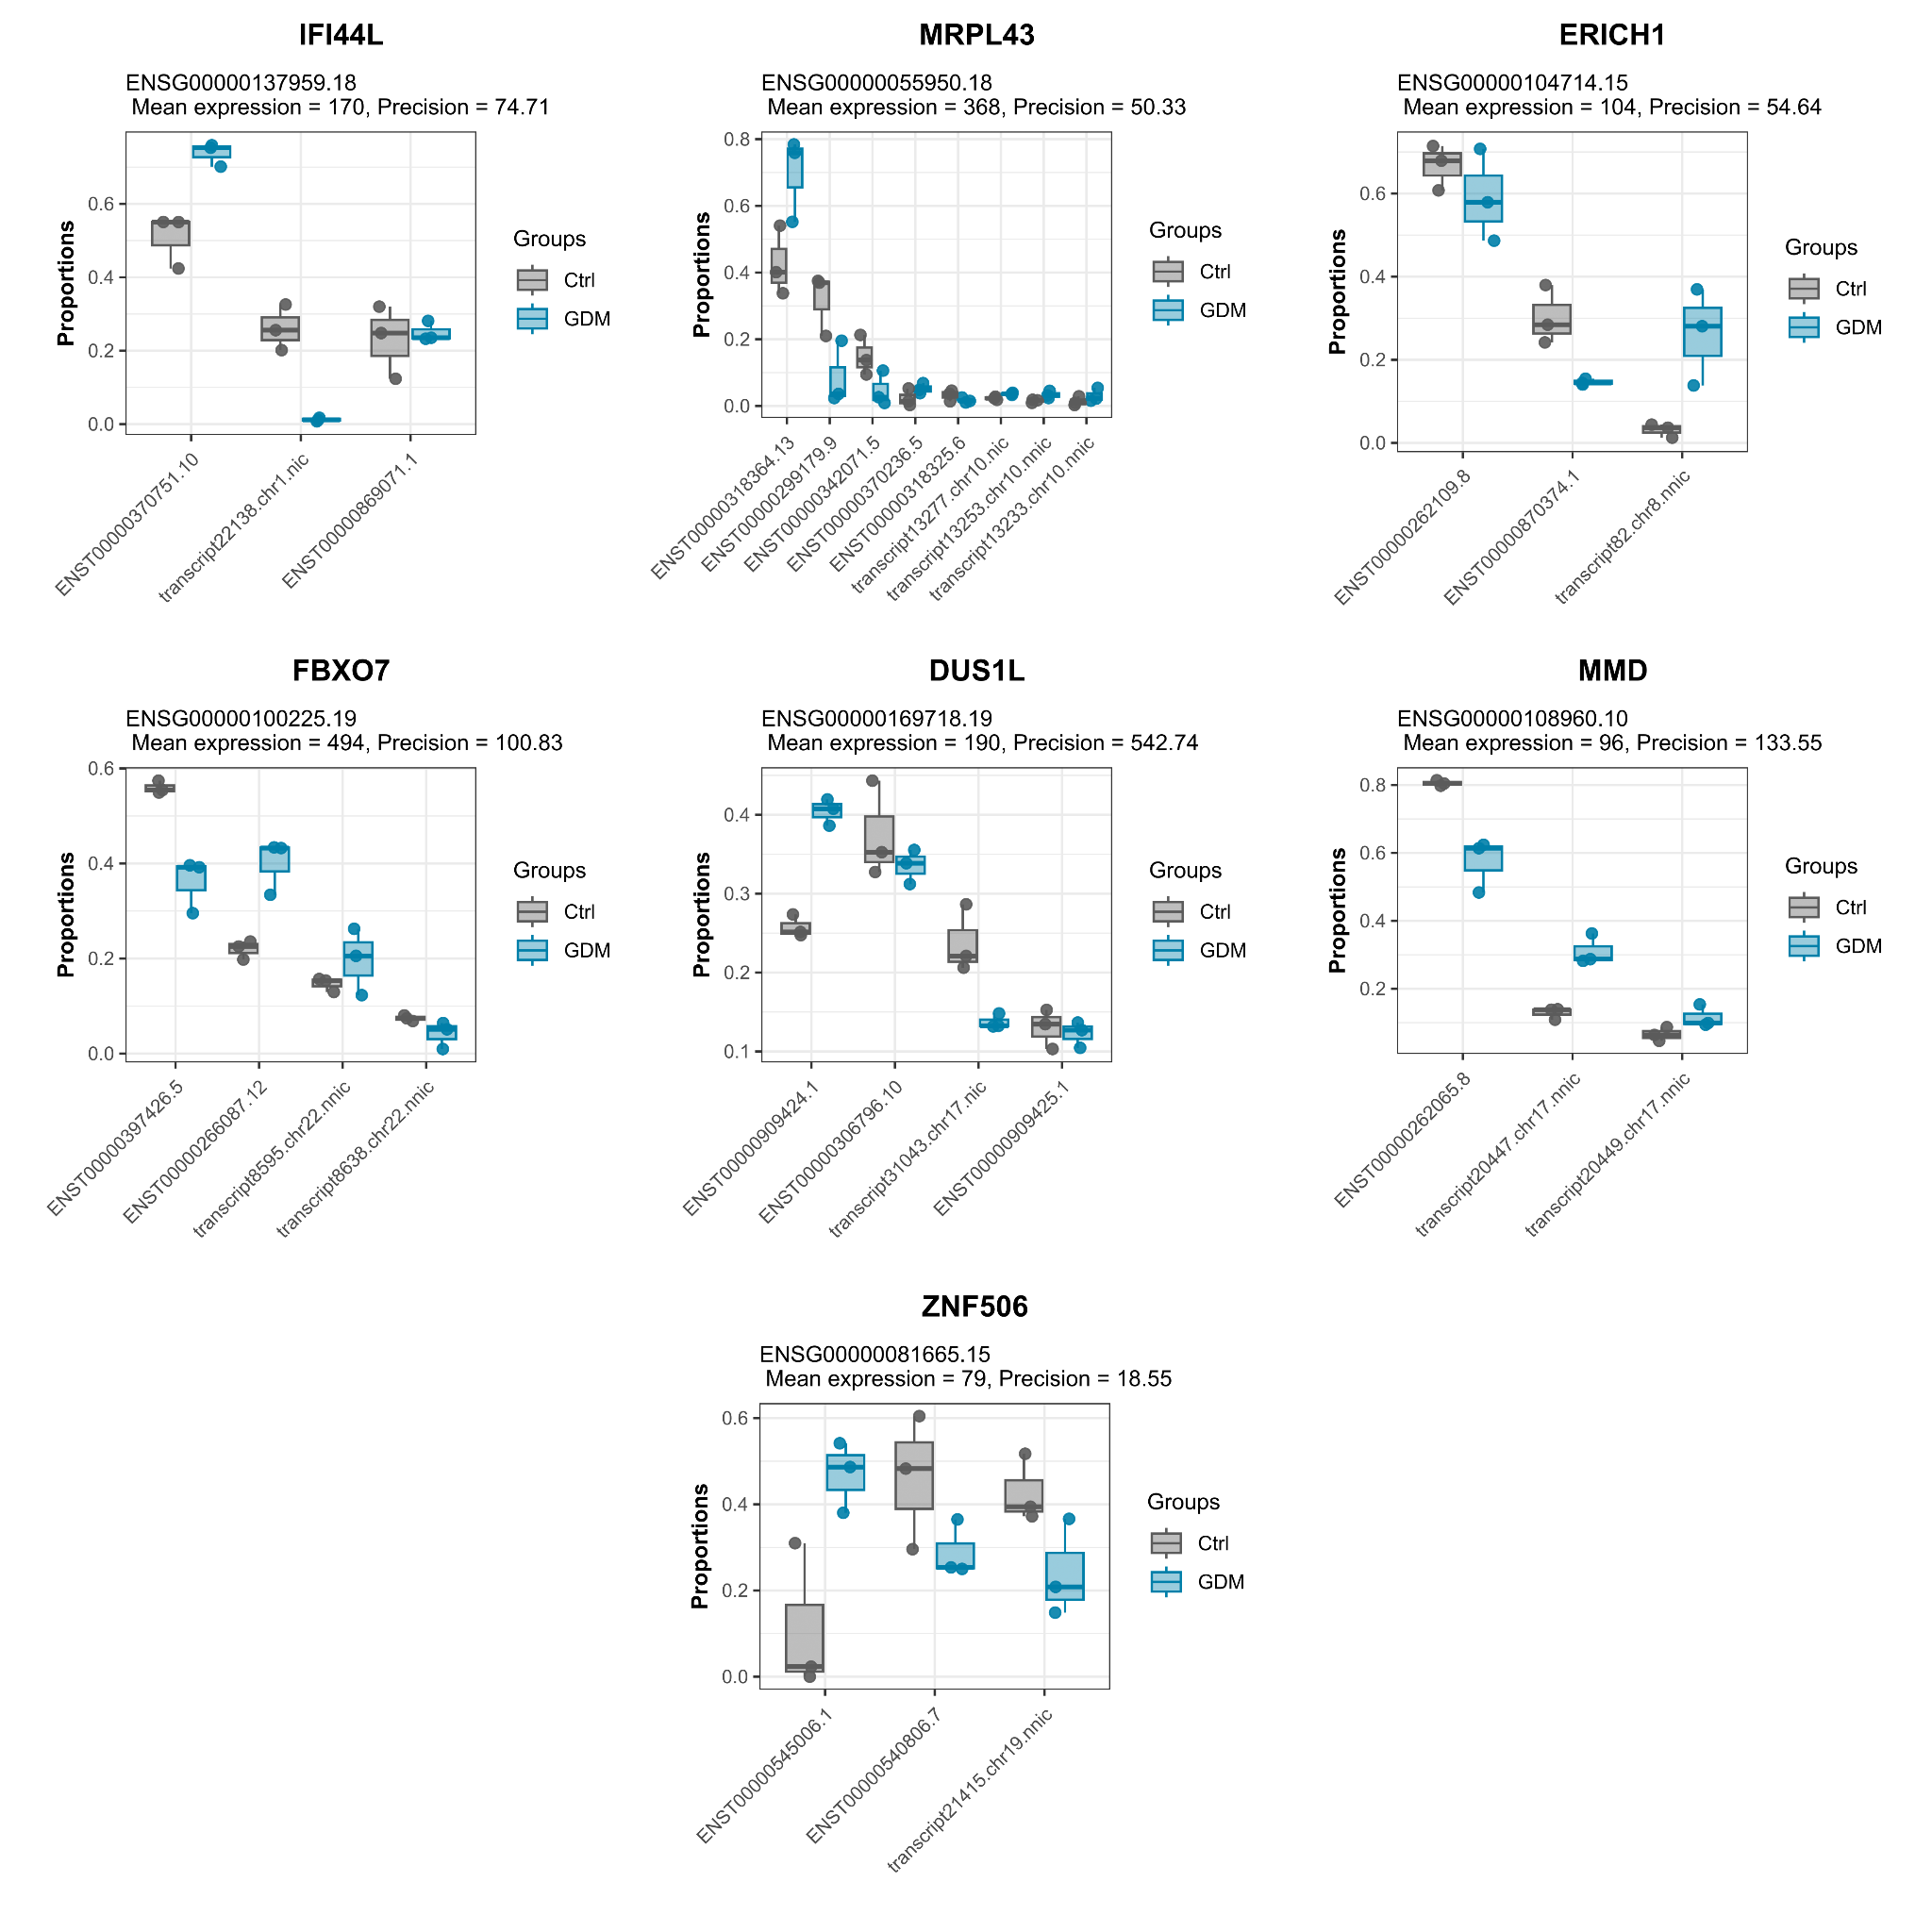
Supplementary Figure 6: Isoform usage proportions of seven genes that include novel isoforms.
Transcript identifiers beginning with “transcript” denote novel isoforms identified in this study.
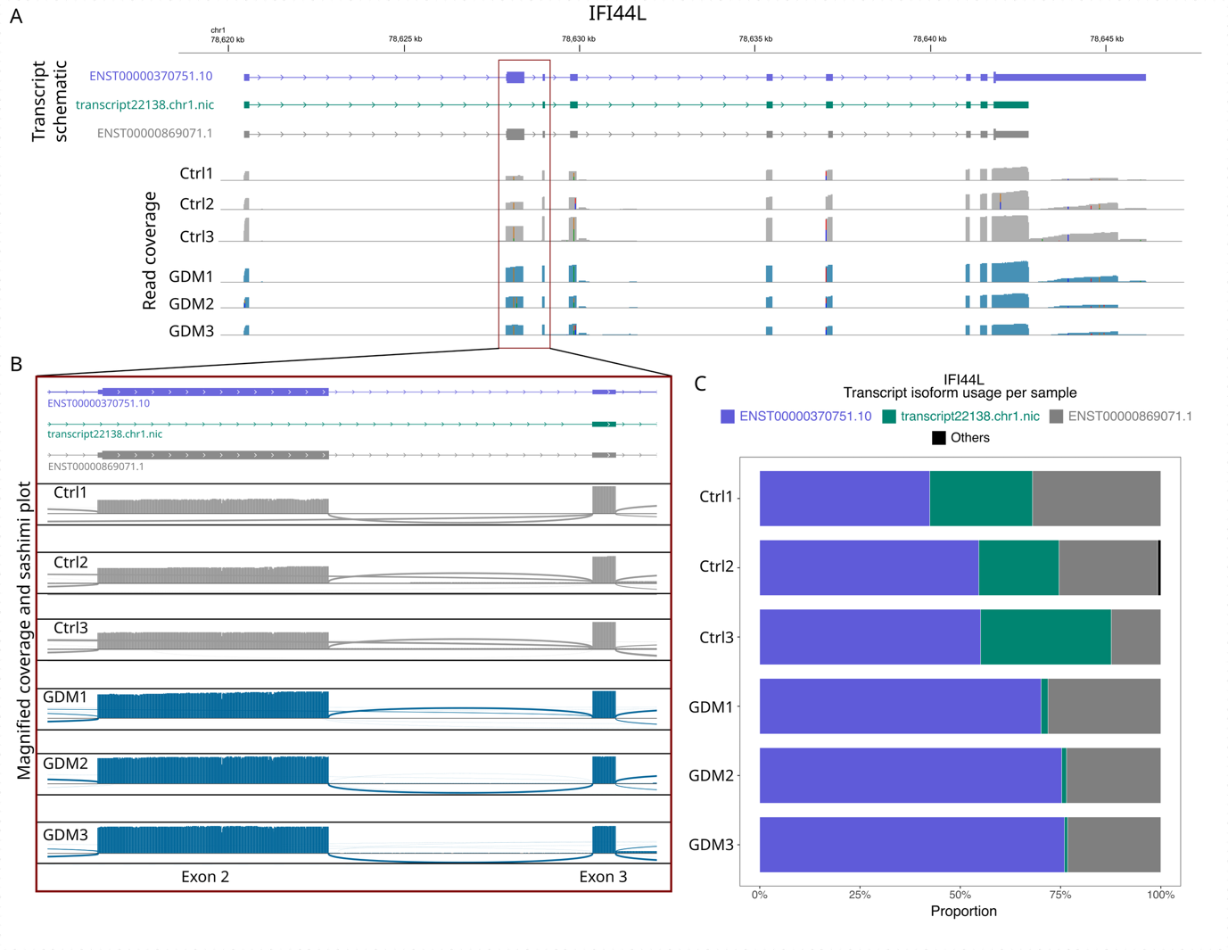
Supplementary Figure 7: Differential transcript usage for the IFI44L gene involving a novel isoform.
- Read coverage of all samples across the IFI44L gene obtained from IGV. Schematics on top show the structure of different transcript isoforms, including the novel isoform “transcript22138.chr1.nic”; isoforms are color-coded to match the rest of the figure. Rectangular blocks within each transcript schematic represent exons, and the thin line between them represents introns, with arrows defining the 5'-3' directionality of the transcript. Thinner blocks represent the untranslated regions (UTRs).
- Magnified read coverage and sashimi plot at exon 2/3 of the IFI44L gene, showing the difference in relative coverages among exons 2 and 3 between control and GDM samples. The reduced coverage in exon 2 compared to exon 3 in control samples implies the expression of the novel transcript, which skips exon 2.
- Stacked bar plots showing the difference in isoform usage proportion between control and GDM samples. The novel isoform (green) is expressed at a 20-35% proportion for control samples, while almost negligible in GDM samples.

