A Randomized Crossover Clinical Study Comparing Free Flow Helmet CPAP with Full Face Mask CPAP in Acute Hypoxemic Respiratory Failure
(Online Data Supplement)
Andrey I. Yaroshetskiy, MD, PhD¹, Maxim I. Savelenok, MD^{1,2}, Igor A. Zakharchenko², Sergey M. Kondratyuk², Sergey N. Avdeev, MD, PhD¹, and Giacomo Bellani MD, PhD^{3,4}

Affiliations
¹Pulmonology Department, Sechenov First Moscow State Medical University (Sechenov University), Moscow, Russia
² Medical Intensive Care Unit#6, City clinical hospital named after F.I. Inozemtsev, Moscow, Russia
³ Centre for Medical Sciences (CISMed), University of Trento, Trento, Italy
⁴ Department of Anesthesia and Intensive Care, Santa Chiara Hospital, APSS Trento, Trento, Italy

Methods
Exclusion Criteria were:
- Unstable hemodynamics (systolic blood pressure <90 mm Hg or mean arterial pressure <65 mm Hg) and/or lactic acidosis (lactate >5 mmol/l and/or clinically diagnosed shock) and/or life-threatening arrhythmia,
- Metabolic acidosis (pH <7.30),
- Expectancy of ICU stay for less than 24 hours for any reason,
- pre-existing lung disorder (exacerbation of chronic obstructive pulmonary disease (COPD), asthma, interstitial lung diseases, metastatic lung disease),
- Clinically suspected cardiogenic pulmonary edema,
- Chronic diseases in the stage of decompensation with the development of extrapulmonary organ dysfunction (liver cirrhosis, progression of cancer, heart failure),
- Glasgow Coma Scale score <14 points,
- Swallowing disorders,
- Hypercapnia (PaCO₂>45 mmHg),
- Need for urgent tracheal intubation for any reason,
- Recent head surgery or anatomy that prevents the placement of a helmet or full face mask on the patient,
- Pregnancy,
- Inability to cooperate with staff,
- Inability to tolerate short oxygen disconnection (Borg dyspnea score 6 and more during disconnection, patient complaints of fatigue, increase in heart rate > 30% from baseline, increase in systolic blood pressure by 40 mmHg or diastolic blood pressure by 20 mmHg or more from baseline, new onset of cardiac arrhythmia, agitation).
- Lack of consent to participate in the study.

Esophageal catheter insertion and checking
We used the following technique for esophageal catheter placement: 1) after unpacking the catheter (CooperSurgical), the investigator connected the catheter to 3-way stopcock and then inflated ballon up to 3 ml of air to check for balloon integrity; 2) complete ballon deflation; 3) assessment of ballon insertion depth by measuring the distance between the nose tip and xiphoid process through earlobe; 4) checking the esophageal pressure curve on the ventilator monitor (normal range zero±0.5cmH₂O); 5) connection of the catheter to the ventilator measuring port (Hamilton S1, Switzerland); 6) insertion of the catheter up to 50-60 cm into the stomach; 6) inflation of the ballon through 3-way stopcock up to 3 ml and then deflation to 1 ml to avoid overestimation of P_{ES} due to balloon overinflation (1-2); 7) closing the stopcock to the syringe; 8) correct positioning of the catheter, which was confirmed by negative pressure swings during patient inspiration and cardiac oscillations on the oesophageal pressure waveform (usually around 40 cm); 9) checking the correctness of measurements by comparison of delta P_{ES} to delta P_{AW} in occluded circuit during patient inspiratory effort, which should not exceed 20% (occlusion test); 8) correct ballon inflation volume was then checked by assessment of delta P_{ES} during tidal ventilation - with the aim to obtain maximal variation of P_{ES} (1-2).
Figure S1. Measurement of P_{ES}- simplified pressure-time-product technique.
Abbreviations: P_{ES} - esophageal pressure, PTP_{ES} - P_{ES}- simplified pressure-time-product, P_{L} - transpulmonary pressure.
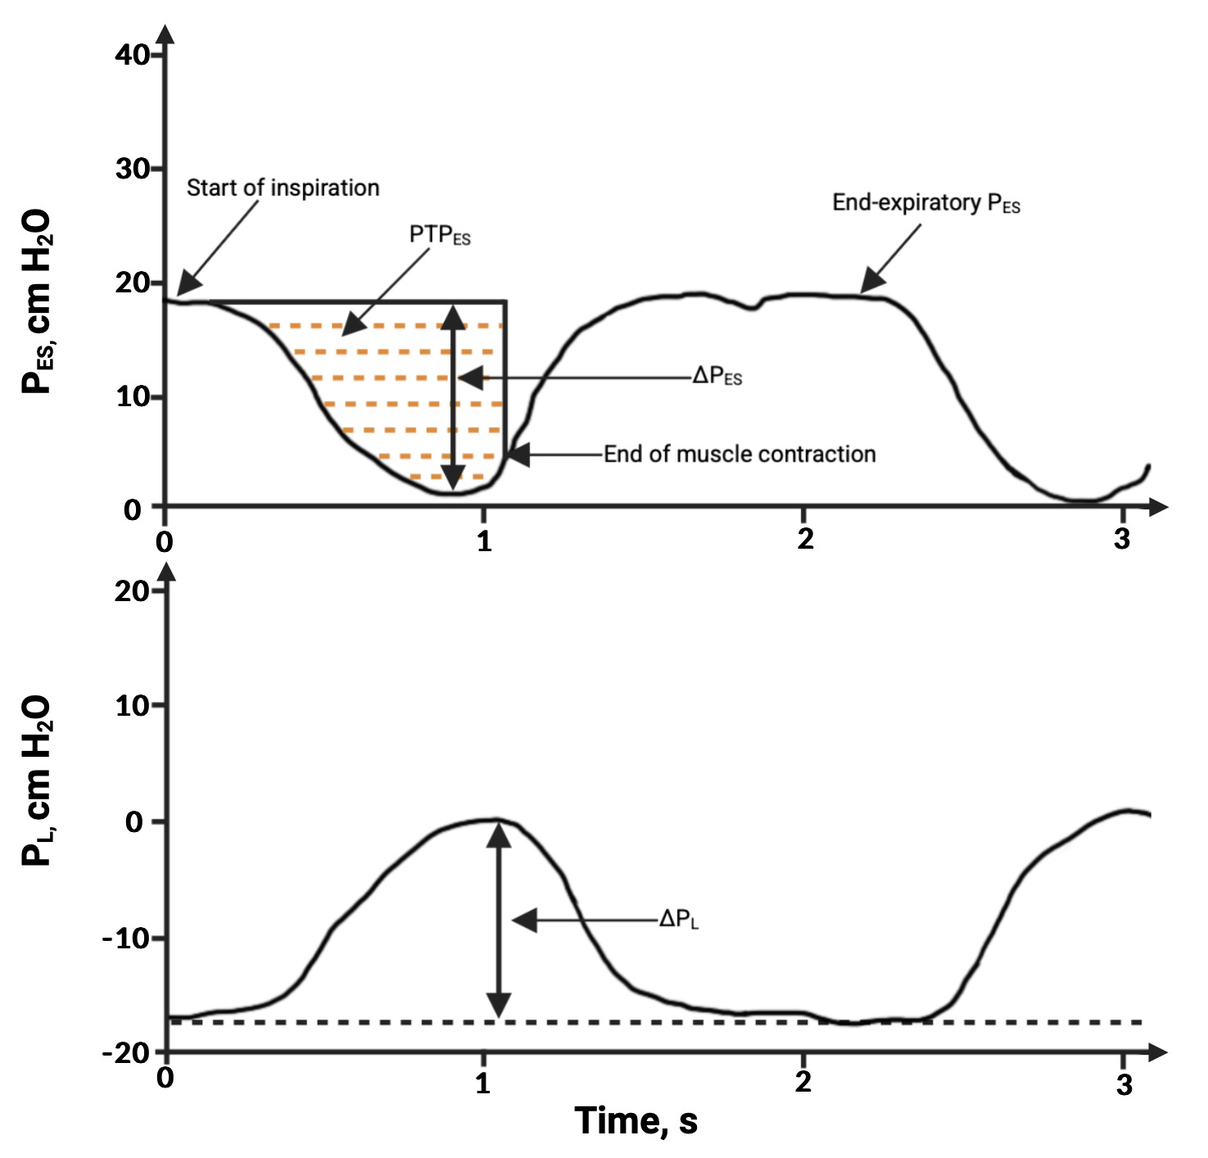

Online monitoring during H-CPAP phase
For simultaneous online monitoring of esophageal, airway, and transpulmonary pressures during H-CPAP we used the ICU ventilator (Hamilton S1, Hamilton Medical, Switzerland). For airway pressure measurements we connected the expiratory port of the helmet to an inspiratory port of the ventilator by a 22F tube. Between the expiratory port of the helmet and 22F tube we inserted the proximal flow sensor (Hamilton Medical, Switzerland), connected to the ventilator flow sensor port, and the T-piece connected to the PEEP valve (C-PEEP, Intersurgical, the UK). Esophageal pressure probe was connected to the auxiliary port of the ventilator (Figure S2).
Offline analysis
Online data were transferred to a PC and analysed offline using DataLogger v.5.0 Software (Hamilton Medical, Switzerland). Data were analyzed on a breath-by-breath basis and averaged over 30 seconds period, at the end of each step, free of artifacts. To minimize the selection bias data were analyzed by two researchers (MIS and AIY) independently.
Figure S2. Online monitoring technique during H-CPAP phase.
Mindray SV 300 ventilator served as a flow source in high-flow oxygen therapy mode. Hamilton S1 ventilator served as a monitoring device in spontaneous ventilation mode with zero CPAP pressure and zero pressure support level.
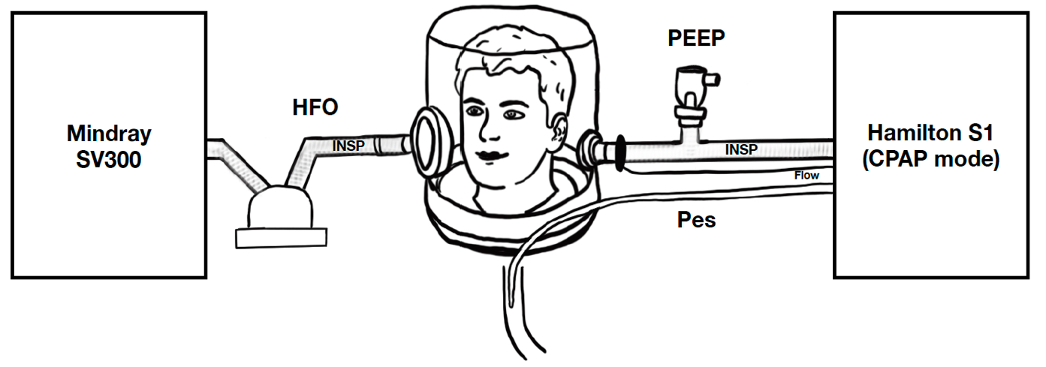
Abbreviations: INSP - tubes, connected to the inspiratory port of the ventilator (Mindray SV 300 and Hamilton S1); Flow - proximal flow sensor; HFO - high flow oxygen (at the flow rate 50 L/min); P_{ES} - esophageal pressure, PEEP - positive end-expiratory pressure valve (C-PEEP, Hamilton Medical, Switzerland).

Calculation of elastance-derived pleural and transpulmonary pressures
Elastance-derived inspiratory pleural (P_{pl}i) and transpulmonary (P_{L-El}i) pressures were calculated by the following equations (3-4):
P_{pl}i = P_{AW}i * E_{CW}/E_{RS} (1),
P_{L-El}i = P_{AW}i - P_{pl}i (2).
For these calculations we have taken mean chest-wall elastance-to-respiratory system elastance (E_{CW}/E_{RS}) validated in previous studies in non-obese patients with predominantly pulmonary ARDS (equal to 0.27), and also presented minimum (0.11) and maximum (0.37) values from these studies (5-7).
We also calculated elastance-derived expiratory pleural (P_{pl}e) and transpulmonary (P_{L-El}e) pressures assuming that constant expiratory distending pressure during CPAP-therapy was close to inspiratory (plateau) pressure, and pleural pressure at expiration equals zero, also taking into account absence of validation of the method (21, 26-27). For calculations we used P_{pl}e equals to 2.7 cmH₂O (P_{pl}e = CPAP level * E_{CW}/E_{RS} = 10 cmH₂O * 0.27 = 2.7 cmH₂O), and elastance-derived expiratory transpulmonary pressure (P_{L-El}e) equals to 7.3 cmH₂O: P_{L-El}e = CPAP level - P_{pl}e = 10 cmH₂O - 2.7 cmH₂O = 7.3 cmH₂O. Elastance-derived driving transpulmonary pressure (∆P_{L-El}) was calculated as P_{L-El}i minus P_{L-El}e. We also presented minimum and maximum values for P_{pl}e and P_{L-El}e from minimum and maximum E_{CW}/E_{RS} validated in previous studies (5-7).

Results
Figure S3. Flow-chart.
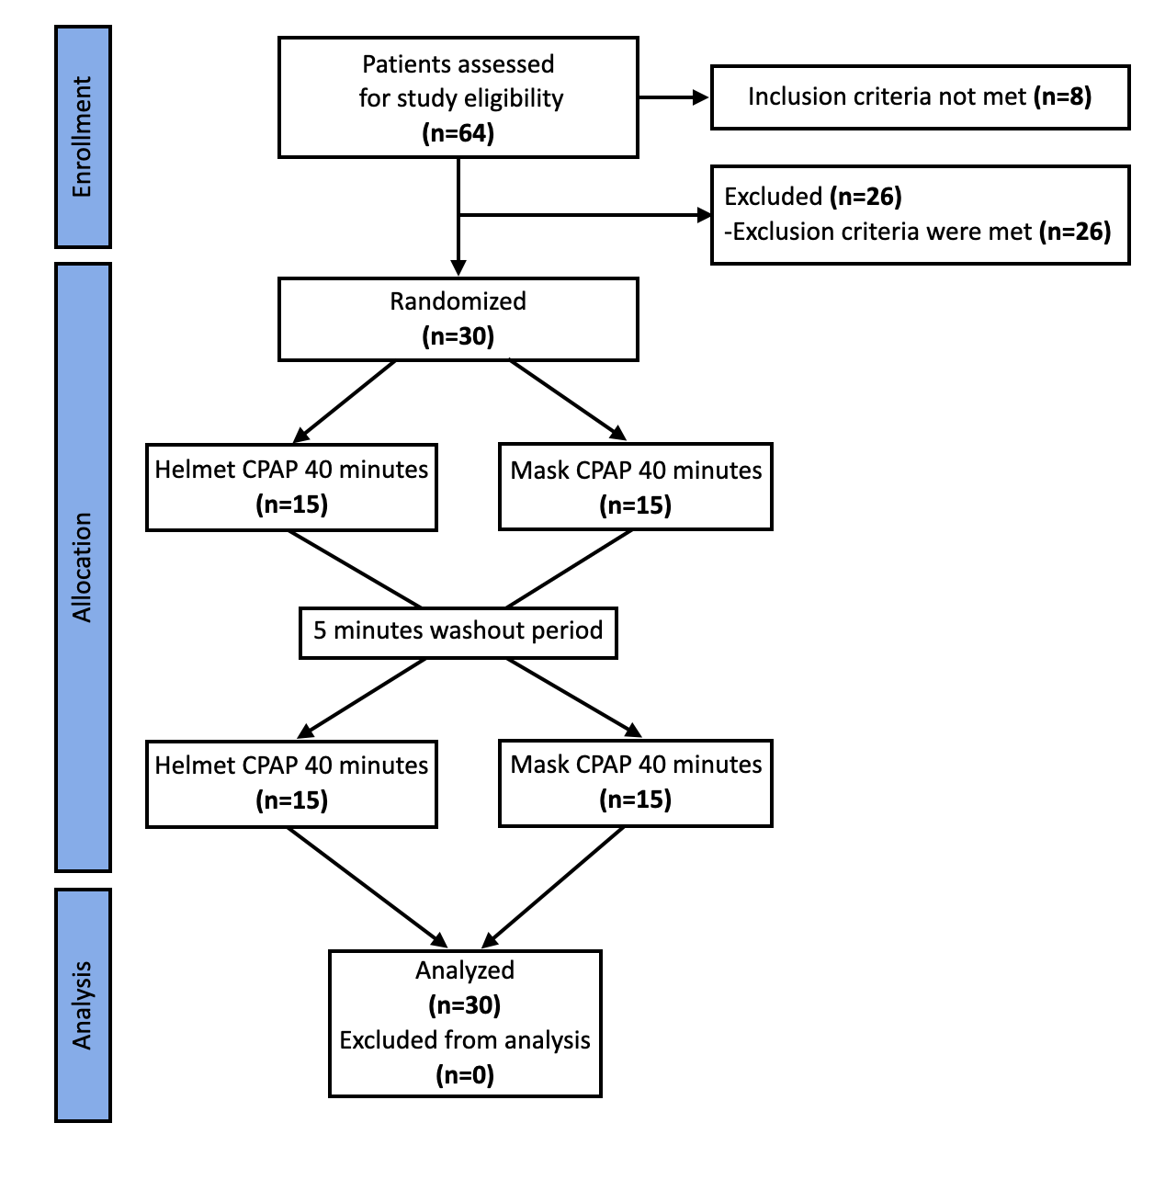

Table S1. Baseline characteristics of the included patients overall and depending on the randomisation sequence.
 | Overall  (n=30) | Mask first  (n=15) | Helmet first  (n=15) | p
Demographics
Age, years | 81.5  (67.8-85.0) | 72 (65-85) | 82 (76-89) | 0.098
Males, n (%) | 13 (43.3) | 9 (60.0) | 4 (26.7) | 0.139
BMI, kg/m² | 26.1 (22.8-29.6) | 24.8 (22.7-30.1) | 28.0 (24.7-29.4) | 0.412
Diagnosis
COVID-19, n (%) | 22 (73.3) | 12 (80) | 10 (66.7) | 0.341
Community-acquired pneumonia, n (%) | 8 (26.7) | 3 (20) | 5 (33.3) | 0.341
Clinical Frailty Score, points | 4 (3-4) | 4 (3-4) | 4 (3-4) | 0.564
Days from disease onset, days | 3 (2-6) | 4 (2-7) | 2 (2-4) | 0.539
Days from hospital admission to ICU | 0.5 (0.0-4.0) | 0.0 (0.0-4.0) | 1.0 (0.0-3.0) | 1.000
Comorbidities, n (%)
Hypertension | 28 (93.3) | 14 (93.3) | 14 (93.3) | 0.759
Diabetes Mellitus | 14 (46.7) | 4 (26.7) | 10 (66.7) | 0.033
Ischemic heart disease | 14 (46.7) | 5 (33.3) | 9 (60.0) | 0.136
Congestive heart failure | 11 (36.7) | 4 (26.7) | 7 (46.7) | 0.225
Atrial fibrillation | 4 (13.3) | 1 (6.7) | 3 (20.0) | 0.299
History of stroke | 5 (16.7) | 1 (6.7) | 4 (26.7) | 0.165
History of Cancer | 3 (10.0) | 1 (6.7) | 2 (13.3) | 0.500
History of MI | 3 (10.0) | 0 (0) | 3 (20.0) | 0.112
Clinical data
RR, min⁻¹ | 29 (25-33) | 30 (25-33) | 29 (24-32) | 0.231
SpO₂, % | 76 (66-80) | 75 (66-80) | 77 (61-80) | 0.967
ROX-index, AU* | 11.9 (10.1-14.2) | 11.5 (8.6-13.7) | 12.2 (10.8-15.9) | 0.177
Patrick score, points | 3.0 (2.8-4.0) | 3.0 (3.0-5.0) | 3.0 (2.0-4.0) | 0.089
VAS comfort, points | 4.0 (3.0-4.3) | 4.0 (3.0-5.0) | 4.0 (3.0-4.0) | 0.967
RASS, points | 2.0 (2.0-3.0) | 2.0 (2.0-3.0) | 2.0 (2.0-3.0) | 0.806
BPsyst, mmHg | 125 (111-150) | 120 (105-149) | 140 (115-151) | 0.267
BPdyast, mmHg | 74 (66-80) | 76 (67-80) | 72 (64-77) | 0.285
Heart rate, min⁻¹ | 94 (87-106) | 102 (89-110) | 90 (82-100) | 0.106
Vasoactive agents, n (%) | 0 | 0 | 0 | -
SOFA score | 4 (3-5) | 4 (3-6) | 4 (2-5) | 0.137
Chest computed tomography
Right lung involvement, % | 50 (40-56.3) | 50 (40-70) | 50 (40-50) | 0.412
Left lung involvement, % | 50 (30-60) | 50 (35-60) | 50 (30-60) | 0.486
Arterial blood gas
PaO₂, mmHg | 44 (40-49) | 42 (39-50) | 45 (41-49) | 0.902
PaO₂/FiO₂, mmHg | 210 (183-228) | 198 (180-223) | 214 (195-233) | 0.567
PaCO₂, mmHg | 36 (29-41) | 35 (28-42) | 36 (30-40) | 0.870
pH | 7.41 (7.35-7.46) | 7.43 (7.35-7.49) | 7.41 (7.33-7.45) | 0.879
Base Excess, mmol/L | -2.0 (-5.4;-0.7) | -1.8 (-6.0;-0.6) | -2.2 (-4.3;-0.8) | 0.902
Laboratory values
WBC, 10⁹/L | 7.7 (5.1-12.7) | 9.9 (4.2-19.3) | 7.6 (5.1-11.0) | 0.436
Lymphocytes, 10⁹/L | 0.7 (0.4-1.4) | 0.9 (0.5-1.4) | 0.7 (0.4-1.9) | 0.838
Platelets, 10⁹/L | 191 (114-300) | 151 (113-345) | 198 (114-296) | 0.624
Creatinine, mcg/L | 117 (86-167) | 117 (96-166) | 118 (85-170) | 1.000
D-dimer, mcg/mL | 1.5 (1.1-4.7) | 1.4 (1.1-3.7) | 1.5 (1.2-4.8) | 0.653
Fibrinogen, g/L | 5.4 (4.1-5.9) | 5.6 (4.4-6.3) | 4.6 (4.0-5.8) | 0.217
LDH, U/L | 351 (254-484) | 342 (201-464) | 374 (258-542) | 0.567
CRP, mg/L | 148 (82-188) | 175 (70-307) | 145 (86-165) | 0.285
Treatment, n (%)
Dexamethasone 16 mg/day, n (%) | 4 (13.3) | 2 (13.3) | 2 (13.3) | 0.701
Enoxiparine 1 mg/kg/day, n (%) | 30 (100.0) | 15 (100.0) | 15 (100.0) | -
Interleukin-6 inhibitors, n (%) | 4 (13.3) | 2 (13.3) | 2 (13.3) | 0.701
Antibiotics, n (%) | 8 (26.7) | 3 (20) | 5 (33.3) | 0.341
Data presented as medians (interquartile range) or n (%) where appropriate. Differences between groups Mann-Whitney U-test or Fisher exact test where appropriate.
Lung involvement is defined as the proportion of the lung infiltrates including ground-glass opacities, crazy paving, and consolidation on high-resolution CT scan to whole lung volume. Lung consolidation is defined as the proportion of the lung consolidation volume to lung infiltrates volume.
Abbreviations: BMI: body mass index; ICU: intensive care unit; MI: myocardial infarction; RR: respiratory rate; SaO₂: oxygen saturation in arterial blood; ROX-index - SaO₂/FiO₂/RR; AU: arbitrary units; RASS: Richmond Agitation-Sedation Score; VAS: visual-analog scale; BPsyst: noninvasive systolic blood pressure; BPdiast: noninvasive diastolic blood pressure; SOFA: sequential organ failure assessment; PaO₂: oxygen partial pressure in arterial blood; FiO₂: inspired oxygen fraction; PaCO₂: carbon dioxide partial pressure in arterial blood; WBC: white blood cells; LDH: lactate dehydrogenase; CRP: C-reactive protein.

Figure S4. Changes in oxygenation after switching from room air to a constant positive airway pressure. A: during helmet phase, B: during mask phase.
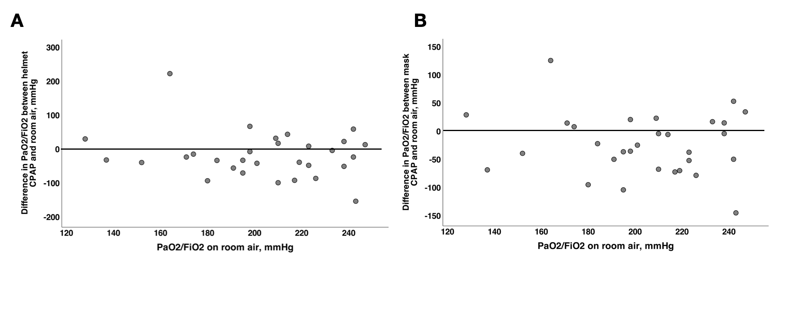
Computed elastance-derived pleural and transpulmonary pressures (hypothesis-generating part)
Computed P_{pl}e was significantly lower than P_{ES}e (as directly measured surrogate of pleural pressure in the lower lung regions) during both CPAP phases, but computed P_{pl}i was lower than P_{ES}i during H-CPAP and higher the P_{ES}i during M-CPAP though difference between H- and M-CPAP was perhaps clinically irrelevant (Table S2).
Computed P_{L-El}e was higher than P_{L}e during both CPAP phases, P_{L-El}i was higher than P_{L}i during H-CPAP and showed significant though unpredictable changes during M-CPAP, and ∆P_{L-El} was significantly lower than ∆P_{L} during both CPAP phases (p<0.001 for all comparisons) (Table S2, Figure S5A). ∆P_{L-El} increased after switching from H-CPAP to M-CPAP (Table S3).
The difference between P_{L-El}e and P_{L}e was positive during all CPAP phases, without significant difference between interfaces (Table S2, Figure S5B). The difference between P_{L-El}i and P_{L}i was positive during H-CPAP and mostly negative during M-CPAP, difference between interfaces was statistically significant (Table S2, Figures S5B). A switch from M- to H-CPAP increased the difference between P_{L-El}i and P_{L}i, the opposite direction had the opposite effect (Table S3). Switching the interfaces did not affect the difference between P_{L-El}e and directly measured P_{L}e (Table S3). Possible gas pendelluft is pictured on Figure S6.

Table S2. Estimated and computed elastance-derived pressures and differences between directly measured and elastance-derived pressures
 | Helmet (n=30) | Mask (n=30) | p
Computed elastance-derived pleural and transpulmonary pressures
Computed P_{pl}i, cmH₂O | 2.3 (2.1-2.5) # | 2.8 (2.0-3.5) # | 0.021
Estimated P_{pl}e, cmH₂O | 2.7 (min 1.1, max 3.7) # | 2.7 (min 1.1, max 3.7) # | NA
Computed P_{L-El}i, cmH₂O | 6.3 (5.7-6.7) # | 7.7 (5.3-9.5) # | 0.021
Estimated P_{L-El}e, cmH₂O | 7.3 (min 6.3, max 8.9) # | 7.3 (min 6.3, max 8.9) # | NA
Computed ∆P_{L-El}, cmH₂O | 1.1 (0.6-1.6)# | 1.9 (0.6-3.0)# | 0.031
The difference between elastance-derived and directly measured P_{L} during inspiration and expiration
Inspiration | 3.5 (2.2-5.3) | -2.1 (-6.2;1.4) | <0.001
Expiration | 9.3 (7.6-10.7) | 9.9 (8.1-13.7) | 0.084
Data presented as medians (interquartile range). Within group comparisons were made using the Friedman test (with Bonferroni correction for multiple comparisons). One-sample t-test was applied for comparison with a value from previous studies.
Abbreviations: P_{L}: transpulmonary pressure; P_{L}i: direct dynamic end-inspiratory P_{L}; P_{L}e: direct dynamic end-expiratory P_{L}; DP_{L}: driving P_{L}; P_{pl}i: elastance-derived inspiratory pleural pressure; P_{pl}e: elastance-derived expiratory pleural pressure; P_{L-El}i: elastance-derived inspiratory P_{L}; P_{L-El}e: elastance-derived expiratory P_{L}; ∆P_{L-El}: elastance-derived driving P_{L.}
# p<0.001 as compared to directly measured

Figure S5. Directly measured and elastance-derived transpulmonary pressures. A: driving transpulmonary pressures, B: End-inspiratory and end-expiratory differences between directly measured and elastance-derived transpulmonary pressure during helmet and mask CPAP phases.
Abbreviations: CPAP - constant positive airway pressure.
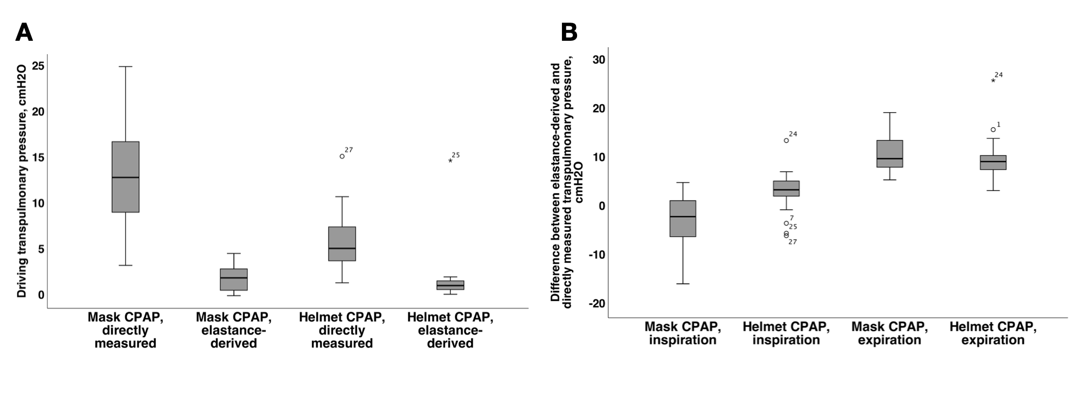

Figure S6. Possible pendelluft between non-dependent and dependent lung regions based on directly measured and computed elastance-derived transpulmonary pressures during helmet and mask CPAP phases.
Abbreviations: CPAP - constant positive airway pressure, Ppl - pleural pressure, P_{L} - transpulmonary pressure, i - end-inspiratory, e - end-expiratory.

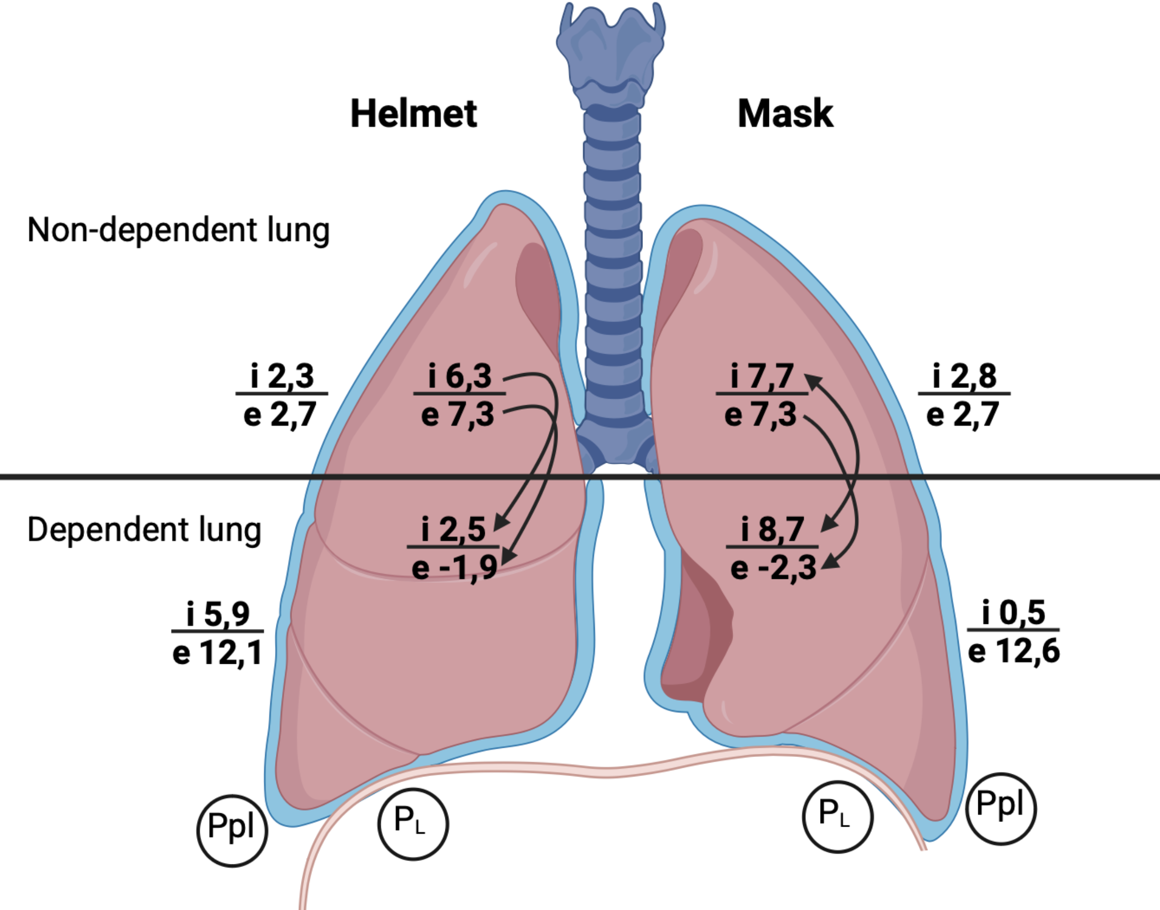

Potential carry-over effects
Table S3. Cross-over data between groups and potential carry-over effects.
 | Mask first group (n=15) |  |  | Helmet first group (n=15) |  |  | Differences between groups
 | Mask | Helmet | p | Helmet | Mask | p | p  Helmet phase | p  Mask phase
Gas exchange
RR, min⁻¹ | 28 (25-30) | 25 (22-28) | 0.052 | 22 (20-25) | 25 (23-28) | 0.004 | 0.045 | 0.102
SO₂, % | 95 (92-96) | 95 (93-97) | 0.109 | 95 (92-96) | 93 (92-94) | 0.052 | 0.512 | 0.116
ROX-index, AU* | 7.48 (6.34-10.75) | 8.85 (6.18-11.14) | 0.439 | 9.90 (7.76-11.95) | 9.20 (6.48-10.74) | 0.071 | 0.202 | 0.461
PaO₂/FiO₂, mmHg | 178  (144-220) | 162  (127-263) | 0.796 | 164 (149-234) | 190  (142-234) | 0.071 | 0.713 | 0.935
PaCO₂, mmHg | 34 (31-41) | 33 (30-35) | 0.071 | 35 (31-37) | 36 (32-39) | 1.000 | 0.436 | 0.838
Patient comfort and agitation
RASS, points | 2 (1-3) | 2 (1-2) | 0.005 | 1 (1-2) | 2 (1-2) | 0.007 | 0.539 | 0.843
VAS comfort, points | 4 (3-5) | 7 (6-8) | <0.001 | 7 (7-8) | 5 (4-5) | <0.001 | 0.624 | 0.250
Respiratory mechanics
Inspiratory effort and work of breathing
Patrick score, points | 3 (2-3) | 2 (1-2) | 0.001 | 2 (1-2) | 2 (2-3) | 0.014 | 0.539 | 0.056
P_{ES}i, cmH₂O | 0.5 (-5.1;4.1) | 5.2 (4.4-8.6) | 0.001 | 6.2 (4.1-6.8) | 0.4 (-3.5; 3.5) | 0.005 | 0.935 | 0.838
P_{ES}e, cmH₂O | 12.7 (12.4-17.1) | 12.7 (10.9-17.2) | 0.197 | 11.6 (10.8-13.7) | 11.4 (10.7-14.0) | 0.796 | 0.367 | 0.187
∆P_{ES}, cmH₂O | 14.1 (11.7-17.9) | 8.5 (6.3-11.2) | 0.001 | 5.6 (3.6-8.3) | 13.8 (8.3-14.8) | 0.001 | 0.026 | 0.174
T_{MUS}, s | 1.05 (0.79-1.16) | 1.05 (0.95-1.06) | 0.527 | 1.05 (0.95-1.15) | 1.15 (1.05-1.26) | 0.013 | 1.000 | 0.189
P_{ES}-PTP, cmH₂O*s*min⁻¹ | 279 (201-362) | 172 (108-236) | 0.005 | 103 (53-163) | 260 (185-368) | <0.001 | 0.009 | 0.539
Directly measured airway and transpulmonary pressures
P_{AW}i, cmH₂O | 10.8 (6.1-14.0) | 8.7 (7.8-9.5) | 0.065 | 8.6 (8.0-9.0) | 10.0 (7.6-12.9) | 0.177 | 0.713 | 0.412
P_{L}i, cmH₂O | 8.8 (6.5-15.2) | 3.0 (0.8-4.0) | 0.001 | 2.4 (1.3-3.2) | 8.5 (6.3-12.0) | <0.001 | 0.775 | 0.436
P_{L}e, cmH₂O | -2.6 (-7.0;-1.8) | -2.5 (-4.4;-1.8) | 0.197 | -1.0 (-2.8;-0.2) | -1.4 (-6.3;0.2) | 0.071 | 0.202 | 0.305
∆P_{L}, cmH₂O | 14.7 (11.3-17.8) | 5.2 (4.8-8.5) | <0.001 | 3.8 (2.7-6.4) | 12.3 (8.6-15.3) | <0.001 | 0.061 | 0.067
Computed elastance-derived pleural and transpulmonary pressures
Computed  P_{pl}i, cmH₂O | 2.9 (1.6-3.8) | 2.3 (2.1-2.6) | 0.065 | 2.3 (2.2-2.4) | 2.7 (2.1-3.5) | 0.177 | 0.713 | 0.412
Estimated P_{pl}e, cmH₂O | 2.7  (min 1.1, max 3.7) | 2.7  (min 1.1, max 3.7) | NA | 2.7  (min 1.1, max 3.7) | 2.7  (min 1.1, max 3.7) | NA | NA | NA
Computed  P_{L-El}i, cmH₂O | 7.9 (4.5-10.2) | 6.4 (5.7-6.9) | 0.065 | 6.3 (5.8-6.8) | 7.3 (5.5-9.4) | 0.177 | 0.713 | 0.412
Estimated  P_{L-El}e, cmH₂O | 7.3  (min 6.3, max 8.9) | 7.3  (min 6.3, max 8.9) | NA | 7.3  (min 6.3, max 8.9) | 7.3  (min 6.3, max 8.9) | NA | NA | NA
Computed  ∆P_{L-El}, cmH₂O | 2.8 (0.6-3.1)# | 1.2 (0.6-1.6)# | 0.293 | 1.0 (0.7-1.5)# | 1.7 (0.6-2.9) | 0.044 | 0.838 | 0.744
The difference between elastance-derived and directly measured transpulmonary pressure during inspiration and expiration
Inspiration | -2.5 (-6.7; 2.0) | 3.2 (2.1; 6.1) | 0.001 | 4.2 (2.2; 4.4) | -2.0 (-6.2; 0.6) | 0.001 | 0.683 | 0.744
Expiration | 9.9 (9.1; 14.3) | 9.8 (9.1; 11.7) | 0.334 | 8.3  (7.5; 10.1) | 8.7 (7.1; 13.6) | 0.111 | 0.191 | 0.300
Data presented as medians (interquartile range). Comparisons between randomization groups were performed using the Mann-Witney U test. Within group comparisons were made using the Friedman test (with Bonferroni correction for multiple comparisons). One-sample t-test was applied for comparison with a value from previous studies.
Abbreviations: RR: respiratory rate; SaO₂: oxygen saturation in arterial blood; ROX-index - SaO₂/FiO₂/RR; AU: arbitrary units; PaO₂: oxygen partial pressure in arterial blood; FiO₂: inspired oxygen fraction; PaCO₂: carbon dioxide partial pressure in arterial blood; RASS: Richmond Agitation-Sedation Score; VAS: visual-analog scale; P_{ES}i: minimal inspiratory esophageal pressure; P_{ES}e: maximum expiratory esophageal pressure; ∆P_{ES}: delta oesophageal pressure; T_{MUS}: muscular effort time; P_{ES}-PTP: P_{ES} simplified pressure-time product; P_{AW}i: maximal inspiratory airway pressure; P_{L}: transpulmonary pressure; P_{L}i: direct dynamic end-inspiratory P_{L}; P_{L}e: direct dynamic end-expiratory P_{L}; DP_{L}: driving P_{L}; P_{pl}i: elastance-derived inspiratory pleural pressure; P_{pl}e: elastance-derived expiratory pleural pressure; P_{L-El}i: elastance-derived inspiratory P_{L}; P_{L-El}e: elastance-derived expiratory P_{L}; DP_{L-El}: elastance-derived driving P_{L}; BPsyst: noninvasive systolic blood pressure; BPdiast: noninvasive diastolic blood pressure.
# p<0.001 as compared to directly measured

Table S4. Potential carry-over effects between helmet and mask phases using linear mixed-effects model analysis

Variable | Sequence  (H-CPAP first or MCPAP-first) | Period  (1 or 2) | Treatment  (H-CPAP or M-CPAP)
RR | 0.007 | 0.480 | 0.008
PaO₂/FiO₂ | 0.740 | 0.842 | 0.663
ROX-index | 0.125 | 0.981 | 0.478
∆P_{ES} | 0.009 | 0.842 | <0.001
∆P_{L} | 0.011 | 0.553 | <0.001
P_{ES-}PTP | 0.017 | 0.422 | <0.001
Patrick score | 0.125 | 0.223 | <0.001
RASS | 0.495 | 0.891 | 0.044
VAS comfort | 0.173 | 0.751 | <0.001
Data presented as p values for the fixed effects (sequence, period and treatment) in the linear mixed-effects model. P<0.05 considered significant.
Abbreviations: H: helmet phase; M - mask phase; RR: respiratory rate; CPAP - constant airway pressure; PaO₂: oxygen partial pressure in arterial blood; FiO₂: inspired oxygen fraction; ROX-index: SaO₂/FiO₂/RR; ∆P_{ES}: delta oesophageal pressure; ∆P_{L}: driving transpulmonary pressure; P_{ES-}PTP: P_{ES} simplified pressure-time product; RASS: Richmond Agitation-Sedation Score; VAS - visual-analog scale.

References:
- Cammarota G, Lauro G, Santangelo E, Sguazzotti I, Perucca R, Verdina F, Boniolo E, Tarquini R, Bignami E, Mongodi S, Arisi E, Orlando A, Della Corte F, Vaschetto R, Mojoli F. Mechanical Ventilation Guided by Uncalibrated Esophageal Pressure May Be Potentially Harmful. Anesthesiology. 2020 Jul;133(1):145-153. doi: 10.1097/ALN.0000000000003327.
- Hotz JC, Sodetani CT, Van Steenbergen J, Khemani RG, Deakers TW, Newth CJ. Measurements Obtained From Esophageal Balloon Catheters Are Affected by the Esophageal Balloon Filling Volume in Children With ARDS. Respir Care. 2018 Feb;63(2):177-186. doi: 10.4187/respcare.05685.
- Gattinoni L, Chiumello D, Carlesso E, Valenza F. Bench-to-bedside review: chest wall elastance in acute lung injury/acute respiratory distress syndrome patients. Crit Care. 2004 Oct;8(5):350-5. doi: 10.1186/cc2854.
- Yoshida T, Amato MBP, Grieco DL, Chen L, Lima CAS, Roldan R, Morais CCA, Gomes S, Costa ELV, Cardoso PFG, Charbonney E, Richard JM, Brochard L, Kavanagh BP. Esophageal Manometry and Regional Transpulmonary Pressure in Lung Injury. Am J Respir Crit Care Med. 2018 Apr 15;197(8):1018-1026. doi: 10.1164/rccm.201709-1806OC.
- Chen L, Grieco DL, Beloncle F, Chen GQ, Tiribelli N, Madotto F, Fredes S, Lu C, Antonelli M, Mercat A, Slutsky AS, Zhou JX, Brochard L. Partition of respiratory mechanics in patients with acute respiratory distress syndrome and association with outcome: a multicentre clinical study. Intensive Care Med. 2022 Jul;48(7):888-898. doi: 10.1007/s00134-022-06724-y.
- Chiumello D, Bonifazi M, Pozzi T, Formenti P, Papa GFS, Zuanetti G, Coppola S. Positive end-expiratory pressure in COVID-19 acute respiratory distress syndrome: the heterogeneous effects. Crit Care. 2021 Dec 16;25(1):431. doi: 10.1186/s13054-021-03839-4.
- Haudebourg AF, Perier F, Tuffet S, de Prost N, Razazi K, Mekontso Dessap A, Carteaux G. Respiratory Mechanics of COVID-19- versus Non-COVID-19-associated Acute Respiratory Distress Syndrome. Am J Respir Crit Care Med. 2020 Jul 15;202(2):287-290. doi: 10.1164/rccm.202004-1226LE.

