Competing Geochemical Drivers and Probabilistic Health Risks of Groundwater in the Semi-Arid Voltaian Sedimentary Basin, Ghana
Dickson Abdul-Wahabª, Emmanuel Daanoba Sunkari^{b,c,d*}, Celestina Akasi Yalley^{e}, Ebenezer Aquisman Asare^{f}, Cynthia Laar^{g}, Tulika Chakrabarti^{b, h}, & Abayneh Ataro Ambushe^{d}
ªDepartment of Nuclear Science and Applications, School of Nuclear and Allied Sciences, University of Ghana, Atomic-Kwabenya, Accra, Ghana
^{b}Centre of Excellence in Environmental Science and Sustainability, Directorate of Environment and Ecology, Sir Padampat Singhania University, Udaipur 313 601, Rajasthan, India
^{c}Mining Engineering, Department of Integrated and Advanced Technology, School of Engineering and Sciences, Sir Padampat Singhania University, Udaipur 313601, Rajasthan, India
^{d}Department of Chemical Sciences, Faculty of Science, University of Johannesburg, Auckland Park 2006, P.O. Box 524, Johannesburg, South Africa
^{e}Department of Geological Engineering, Faculty of Geosciences and Environmental Studies, University of Mines and Technology, P.O. Box 237, Tarkwa, Ghana
^{f}Nuclear Chemistry and Environmental Research Centre, National Nuclear Research Institute (NNRI), Ghana Atomic Energy Commission (GAEC), Box LG 80, Legon, Accra, Ghana
^{g}Water Resources Research Centre, National Nuclear Research Institute, Ghana Atomic Energy Commission, Box LG 80, Legon, Accra, Ghana
^{h}Chemistry, Department of Sciences, School of Engineering and Sciences, Sir Padampat Singhania University, Udaipur 313601, Rajasthan, India
^{i}Computer Science and Engineering, Department of Computing and Informatics, School of Engineering and Sciences, Sir Padampat Singhania University, Udaipur 313601, Rajasthan, India
*Corresponding Author: emmanueldaanobasunkari@gmail.com
*ORCID: 0000-0002-0898-2286

Supplementary Information
Supplementary Methodology

S1. Neutrosophic Partial Least Squares Groundwater Quality Index (NPLS-GWQI): Full Mathematical Derivation

S1.1 Conceptual Motivation
Conventional arithmetic water quality indices (WQI) assign fixed, expert-specified weights to hydrochemical parameters and apply hard thresholds to define compliance, producing a single scalar that collapses genuine ambiguity into an overconfident class membership ^{1,2}. NPLS-GWQI replaces this architecture with three structural innovations: (i) a neutrosophic representation of threshold uncertainty that formally distributes each sample’s membership across truth, indeterminacy, and falsity; (ii) a data-driven PLS-derived weighting scheme that recalibrates variable contributions from the observed hydrochemical variance structure rather than from subjective expert assignment; and (iii) a bootstrapped stability envelope that quantifies how sensitively the weight vector responds to sample-level perturbation ³.

S1.2 Step 1 — Parameter Normalisation Against Guideline Values
For each hydrochemical parameter $i∈1,…,p$ and sample $s∈1,…,n$, the raw concentration $C_{i,s}$ (mg/L) is normalised against the adopted guideline standard S_i to produce a dimensionless hazard ratio:
$$q_{i,s}=\frac{C_{i,s}}{S_{i}}$$ | (S1)
where $S_{i}$ is the lower of the (World Health Organization (WHO), 2019) and Ghana Standards Authority (GSA) drinking-water guideline values for parameter $i$. The guideline values applied in this study are listed in Table S-A. A value of $q_{i,s}=1$ represents the threshold; $q_{i,s}<1$ indicates compliance; $q_{i,s}>1$ indicates exceedance.

Table S-A. Guideline values ($S_{i}$) used for NPLS-GWQI normalisation
Parameter | WHO/GSA $S_{i}$ (mg/L) | Adopted standard
pH | 6.5–8.5 | Bipolar (see §S1.3)
EC | 1500 µS/cm | WHO
TDS | 1000 | WHO/GSA
Na | 200 | WHO
K | 12 | WHO
Mg | 150 | WHO
Ca | 200 | WHO
Cl | 250 | WHO
SO₄ | 250 | WHO
HCO₃ | 500 | WHO
NO₃ | 50 | WHO
F | 1.5 | WHO/GSA

S1.3 Step 2 — Bipolar pH Treatment
pH exhibits a bilateral hazard: both acid deviation ($\text{pH}<6.5$) and alkaline deviation ($\text{pH}>8.5$) represent water quality concerns. Applying a simple upper-threshold ratio would be physically misleading for this parameter. Instead, two unidirectional hazard scores are computed, and the maximum is taken as the effective normalised hazard:
$$q_{\text{pH},s}^{\text{acid}}=\frac{7.0-{\text{pH}}_{s}}{7.0-6.5}=\frac{7.0-{\text{pH}}_{s}}{0.5}$$ | (S2)
$$q_{\text{pH},s}^{\text{alk}}=\frac{{\text{pH}}_{s}-7.0}{8.5-7.0}=\frac{{\text{pH}}_{s}-7.0}{1.5}$$ | (S3)
$$q_{\text{pH},s}=\max\left(q_{\text{pH},s}^{\text{acid}},q_{\text{pH},s}^{\text{alk}}\right)|_{≥0}$$ | (S4)

This formulation returns zero hazard at neutral pH (7.0) and increases monotonically toward either extreme, reaching unity at the regulatory limits of 6.5 and 8.5. The result replaces the standard ratio for pH in all subsequent steps.

S1.4 Step 3 — Neutrosophic Membership Functions
Neutrosophic set theory extends classical fuzzy logic by partitioning membership into three independently valued components: truth ($T$), indeterminacy ($I$), and falsity ($F$), where $T + I + F$ need not equal unity, allowing incomplete and indeterminate states to coexist ⁵. Applied to water quality assessment, these components characterise, respectively, clear compliance, ambiguous transition near the guideline threshold, and clear violation.
For each parameter $i$ and sample $s$, the three components are defined as continuous functions of $q_{i,s}$:
$$T_{i,s}=\exp\left(-,1.5;q_{i,s}\right)$$ | (S5)
$$F_{i,s}=\frac{1}{1+\exp\left(-10,\left(q_{i,s}-1\right)\right)}$$ | (S6)
$$I_{i,s}=\exp\left(-\frac{1}{2}{\left(\frac{q_{i,s}-1}{0.2}\right)}^{2}\right)$$ | (S7)
Interpretation. The truth function (S5) is an exponential decay that takes $T = 1$ when $q = 0$ (zero concentration) and approaches zero monotonically as $q$ increases, with the decay constant $λ= 1.5$ chosen so that $T ≈0.22$ at the guideline limit ($q = 1$). The falsity function (S6) is a logistic sigmoid centred at $q = 1$, with steepness parameter k = 10, that approaches 0 for fully compliant samples and 1 for strongly violating samples. The indeterminacy function (S7) is a Gaussian kernel centred at $q = 1$ with bandwidth $σ_{I}=0.20$, concentrating ambiguity in the transition zone $\left[0.80,1.20\right]$ and decaying rapidly outside it.
The three functions generate bounded, non-negative outputs for all $q ≥0$ and do not require explicit normalisation constraints.

S1.5 Step 4 — Neutrosophic Multi-Channel Predictor Construction
To encode the neutrosophic state structure into a form suitable for PLS regression, three channel-specific predictor matrices are constructed by modulating the raw concentration matrix with each membership component:
$$X_{T}={\left[C_{i,s}⋅T_{i,s}\right]}_{n×p} X_{I}={\left[C_{i,s}⋅I_{i,s}\right]}_{n×p} X_{F}={\left[C_{i,s}⋅F_{i,s}\right]}_{n×p}$$ | (S8)

The unified predictor matrix passed to PLS is the element-wise sum of the three channels:
$$X_{\text{cmie}}=X_{T}+X_{I}+X_{F}$$ | (S9)
This construction ensures that the PLS decomposition operates on a single matrix whose entries carry physical concentration units scaled by the neutrosophic state of each measurement, so that the variance structure extracted by PLS reflects genuine hydrochemical differentiation rather than raw compositional magnitude alone. The three-dimensional stack $X_{TIF}∈R^{n×p×3}$ (with slices $X_{T},X_{I},X_{F}$) is retained for the channel-decomposed N-VIP computation described in §S1.6. The response matrix supplied to PLS is the $n ×p$ hazard matrix $Q=\left[q_{i},s\right]$.

S1.6 Step 5 — Channel-Decomposed Neutrosophic Variable Importance in Projection (N-VIP)
Standard VIP scores in PLS measure each predictor’s contribution to the total explained variance across retained latent components ⁶. N-VIP extends this to the three neutrosophic channels, computing channel-specific VIP scores that separately quantify the truth-channel, indeterminacy-channel, and falsity-channel contributions to the latent structure, then aggregating them via the $L^{2}$ norm.
Let the fitted PLS model have $A=\min\left(3,p\right)$ latent components. Denote by $W∈R^{p×A}$ the matrix of x-weight vectors and by $Q^{*}∈R^{A×1}$ the vector of y-loading norms across components. Before channel-specific projections, each channel matrix is mean-centred and scaled by the model’s fitted x-standard deviations $\hat{σ_{x}}∈R^{p}$ (inherited from the sklearn PLSRegression fit):
$$\tilde{X_{T}}=\frac{X_{T}-\overline{X_{T}}}{\hat{σ}x}, {\tilde{X}}_{I}=\frac{X_{I}-\overline{X_{I}}}{\hat{σ}x}, {\tilde{X}}_{F}=\frac{X_{F}-\overline{X_{F}}}{\hat{σ_{x}}}$$ | (S10)
The latent score matrices for each channel under the PLS weight vectors are:
$$T_{\text{ch}}=\tilde{X_{ch}},W \text{ch}∈T,I,F$$ | (S11)
The sum of squares of the response explained by component a via each channel is:
$${SS}_{ch,a}={\left|T_{ch,⋅a}\right|}^{2}⋅{\left| {Q^{*}}_{a}\right|}^{2}, {SS}_{ch}∈R^{A}$$ | (S12)
The total explained sum of squares across all channels and components is:
$${SS}_{\text{total}}=\sum{\text{ch}}\sum_{a=1}^{A}{{\text{SS}}_{\text{ch},a}}$$ | (S13)

The channel-specific VIP score for variable $j$ via channel $ch$ is:
$${VIP}_{j,\text{ch}}=\sqrt{p⋅\frac{\sum{a=1^{A}w_{ja}^{2}}⋅{SS}_{\text{ch},a}}{{SS}_{\text{total}}}}$$ | (S14)
where $w_{ja}$ is element $(j,a)$ of $W$. The aggregate N-VIP score for variable j is:
$${N-VIP}_{j}=\sqrt{{VIP}_{j,T}^{2}+{VIP}_{j,I}^{2}+{VIP}_{j,F}^{2}}$$ | (S15)
This $L^{2}$ aggregation preserves information from all three neutrosophic channels without allowing any single channel to dominate, and guarantees non-negativity. The aggregate N-VIP vector is then normalised to unit sum to produce dynamic weights:
$$w_{j}=\frac{{\text{N-VIP}}_{j}}{\sum_{j=1}^{p}{{\text{N-VIP}}_{j}}}$$ | (S16)

S1.7 Step 6 — Bootstrap Stabilisation of Dynamic Weights
To guard against sensitivity to the particular 34-sample dataset, the weight vector is estimated via B = 50 bootstrap resamples. On each resample $b$:
- Draw $n = 34$ indices with replacement from $1,…,34$ to form bootstrap dataset $D_{b}$.
- Fit PLS on ($X_{\text{cmie},b},,Q_{b}$) with $A=\min\left(3,p\right)$ components.
- Compute ${\text{N-VIP}}^{\left(b\right)}$ via Equations (S10)–(S15) on the bootstrap channel matrices.
- Normalise to $w^{\left(b\right)}$ via Equation (S17).
The final dynamic weight vector is the bootstrap mean:
$$\hat{w}j=\frac{1}{B}\sum{b=1^{B}w_{j}^{\left(b\right)}}$$ | (S17)
The resulting weights, reported in Table 3, reflect the expected contribution of each parameter across plausible realisations of the dataset. The complete bootstrapped weight distribution for the 12 parameters is:
Parameter | $$\hat{w_{j}}$$ | Rank
EC | 0.1019 | 1
Cl | 0.1012 | 2
TDS | 0.1011 | 3
Ca | 0.0996 | 4
K | 0.0956 | 5
Na | 0.0945 | 6
F | 0.0907 | 7
HCO₃ | 0.0729 | 8
NO₃ | 0.0714 | 9
Mg | 0.0704 | 10
SO₄ | 0.0602 | 11
pH | 0.0405 | 12

S1.8 Step 7 — Sub-Index Construction and Sensory Penalty
A neutrosophic scalar that amplifies the hazard ratio by the degree of ambiguity and violation is defined as:
$$Ψ_{i,s}=1+F_{i,s}-T_{i,s}$$ | (S18)
This scalar equal unity when a sample is perfectly compliant $\left(T→1,F→0\right)$, exceeds unity as the sample approaches and crosses the guideline threshold, and attains a maximum of approximately 2 for strongly violating samples $\left(T→0,F→1\right)$. The per-parameter sub-index is:
$$SI_{i,s} =q_{i,s} × 100 × Ψ_{i,s}$$ | (S19)
An aesthetic–sensory penalty $Π_{s}$ is applied to account for impairment in palatability and household acceptability that is not captured by the strict health-guideline ratio:
$$Π_{s}=\left\{\begin{matrix}1.10 & \text{if }{\text{TDS}}_{s}>500\text{ mg}\text{/}\text{L} \\ 1.00 & \text{otherwise}\end{matrix}\right.$$ | (S20)
An additional factor of 1.25 applies when dissolved iron exceeds 0.3 mg/L (aesthetic staining threshold); iron was not measured in this study and the iron pathway was inactive.

S1.9 Step 8 — NPLS-GWQI Score and Classification
The NPLS-GWQI for sample s is the weighted sum of sub-indices, modified by the sensory penalty:
$${\text{NPLS-GWQI}}_{s}=Π_{s}⋅\sum_{i=1}^{p}{\hat{w_{i}}}⋅{\text{SI}}_{i,s}$$ | (S21)
Final scores are classified according to the following thresholds, which correspond to the standard neutrosophic groundwater quality classification scheme:
Class | NPLS-GWQI Range | Interpretation
Excellent | $≤$ 50 | Fully compliant; no treatment required
Good | (50,; 100] | Minor deviations; generally acceptable
Poor | (100,; 200] | Significant deviations; treatment advisable
Very Poor | (200,; 300] | Multiple exceedances; treatment required
Unsuitable | > 300 | Severe impairment; not suitable for drinking
The class-resolved results, together with neutrosophic component means, are reported in Table 4.

S2. Hierarchical Bayesian Multipathway Risk Assessment (HBMPRA): Full Model Specification

S2.1 Deterministic Baseline — Average Daily Dose and Hazard Quotient
Non-carcinogenic risk for contaminant c and demographic group k is expressed through the hazard quotient (HQ), which compares the estimated average daily ingestion dose to the contaminant-specific reference dose:
$${\text{ADD}}_{c,k}=\frac{C_{c}⋅{\text{IR}}_{k}⋅\text{EF}⋅{\text{ED}}_{k}}{{\text{BW}}_{k}⋅{\text{AT}}_{k}}$$ | (S22)
$${\text{HQ}}_{c,k}=\frac{{\text{ADD}}_{c,k}}{{\text{RfD}}_{c}}$$ | (S23)
All deterministic exposure parameters are listed in Table S-B. The organ-specific hazard index aggregates HQ values over contaminants sharing the same target organ:
$${\text{HI}}_{organ,k}=\sum_{c∈C_{organ}}{{\text{HQ}}_{c,k}}$$ | (S24)
where $C_{organ}$ is the subset of contaminants acting on that organ system.

Table S-B. Fixed deterministic exposure parameters
Parameter | Adults (k=1) | Children (k=2) | Teens (k=3) | Unit
Body weight (BW) | 60.0 | 15.0 | 45.0 | kg
Ingestion rate (IR) | 2.5 | 1.0 | 1.5 | L/day
Exposure duration (ED) | 30 | 6 | 16 | years
Skin surface area (SA) | 18,000 | 6,600 | 12,000 | cm²
Exposure time (ET) | 0.58 | 1.0 | 0.70 | h/day
Exposure frequency (EF) | 365 | 365 | 365 | days/year
Averaging time (AT = ED × 365) | 10,950 | 2,190 | 5,840 | days

Table S-C. Contaminant-specific toxicological reference values
Contaminant | RfD_\text{oral} (mg/kg/day) | Target organ | Source
Fluoride (F) | 0.06 | Skeletal–dental | ⁷
Nitrate (NO₃) | 1.60 | Haematological | ⁷
Dermal and inhalation pathways were inactive in this study; the model architecture accommodates them for future extensions.

S2.2 Bayesian Model Structure — Rationale for Hierarchical Priors
The deterministic approach in §S2.1 treats BW, IR, and ED as fixed constants, which ignores the inter-individual variability that characterises population-level exposure. HBMPRA addresses this by modelling BW and IR as group-level random variables whose distributions are informed by published physiological data, thereby propagating exposure uncertainty into posterior distributions of HI rather than single-point estimates ^{8,9}.
Concentration variability is propagated via a sample-informed truncated-normal prior, acknowledging that the 34-sample dataset is a finite realisation of a spatially variable groundwater system. The full model operates simultaneously across the three demographic groups, with each group sharing the functional form of the prior while having its own group-specific hyperparameters.

S2.3 Prior Distributions for Exposure Parameters

S2.3.1 Body Weight (BW)
Body weight is modelled on the log scale to enforce positivity and accommodate right-skewed population distributions. The coefficient of variation (CV) for adult and adolescent body weight is set at 21%, consistent with published population anthropometric surveys. The log-normal parameterisation for group k is:
$$σ_{\ln{B}W}=\sqrt{\ln\left(1+CV_{BW}^{2}\right)}, CV_{BW}=0.21$$ | (S25)
$$\begin{aligned}μ_{\ln{B}W,k}=\ln\left({\overline{BW}}_{k}\right)-\frac{1}{2}\ln\left(1+CV_{BW}^{2}\right)\end{aligned}$$ | (S26)
A non-centred parameterisation is used to improve NUTS sampler geometry:
$$z_{k}^{\text{BW}}∼N\left(0,1\right)$$ | (S27)
$$BW_{g,k}=\exp\left(μ_{\ln{B}W,k}+z_{k}^{BW}⋅σ_{\ln{B}W}\right)$$ | (S28)

Table S-D. Log-normal BW prior hyperparameters
Group | ${\overline{\text{BW}}}_{k}$ (kg) | $$μ_{ln{\text{BW}},k}$$ | $$σ_{ln{\text{BW}}}$$
Adults | 60.0 | 4.0891 | 0.2088
Children | 15.0 | 2.6645 | 0.2088
Teens | 45.0 | 3.7842 | 0.2088

S2.3.2 Ingestion Rate per Unit Body Weight (IR/BW)
Ingestion rate per unit body weight (${\text{IR}}_{\text{bw},k}$, L/kg/day) is modelled on the log scale with standard deviation $σ\ln{\text{IR}}=0.6nats$, consistent with the substantial inter-individual variability documented in water ingestion surveys:
$$μ_{\ln{I}R,k}=\ln\left(\frac{{\overline{IR}}_{k}}{{\overline{BW}}_{k}}\right)$$ | (S29)
$$z_{k}^{IR}∼N\left(0,1\right)$$ | (S30)
$$IR_{bw,g,k}=\exp\left(μ_{\ln{I}R,k}+z_{k}^{IR}⋅σ_{\ln{I}R}\right)$$ | (S31)

Table S-E. Log-normal IR/BW prior hyperparameters
Group | ${\overline{\text{IR}}}_{k}/{\overline{\text{BW}}}_{k}$ (L/kg/day) | $$μ_{ln\left(\text{IR}\text{/}\text{BW}\right),k}$$ | $$σ_{ln{\text{IR}}}$$
Adults | 0.04167 | −3.1781 | 0.60
Children | 0.06667 | −2.7081 | 0.60
Teens | 0.03333 | −3.4012 | 0.60

S2.3.3 Contaminant Concentration ($C_{c}$)
Each contaminant concentration is modelled as a truncated normal random variable informed by the 34-sample dataset:
$$C_{c}∼TN\left(μ_{c}=\overline{C_{c}},σ_{c}=\hat{s_{c}}+ε, \text{lower}=0\right)$$ | (S32)
where $\overline{C_{c}}$ and $\hat{s_{c}}$ are the sample mean and standard deviation from the observed data, and $ε={10}^{-6}$ prevents degenerate zero-variance priors. The truncation at zero enforces physical non-negativity.

Table S-F. Concentration prior parameters
Contaminant | $\overline{C_{c}}$ (mg/L) | $\hat{s_{c}}$ (mg/L)
Fluoride (F) | ~0.82 | ~0.51
Nitrate (NO₃) | ~1.08 | ~0.75
(Means and standard deviations computed from the 34 observed values.)

S2.4 Likelihood and Derived Quantities
The chronic daily intake via ingestion for contaminant c and group k is computed from the stochastic exposure variables:
$${\text{CDI}}_{ing,c,k}=C_{c}⋅{\text{IR}}_{bw,g,k}⋅{\text{EF}}_{v}⋅{\text{ED}}_{k}$$ | (S33)
where ${\text{EF}}_{v}=\text{EF}/365=1.0$(daily exposure assumed throughout the year) and ED is in years. The ingestion hazard quotient for each group is:
$${\text{HQ}}_{c,k}=\frac{{\text{CDI}}_{ing,c,k}}{{\text{RfD}}_{c}}$$ | (S34)
The organ-specific hierarchical hazard index is then:
$${\text{HI}}_{organ,k}=\sum_{c∈C_{organ}}{{\text{HQ}}_{c,k}}$$ | (S35)
No explicit observation-level likelihood is specified: the model propagates prior uncertainty through the deterministic exposure pathway to produce posterior predictive distributions of HI. This design, in which the uncertainty is carried by the prior rather than a data-conditional likelihood, is appropriate because the risk model is a forward calculation rather than a parameter-inference problem ¹⁰.

S2.5 MCMC Sampling Configuration
The posterior was approximated by NUTS (No-U-Turn Sampler) as implemented in PyMC v5:
Sampler setting | Value
Algorithm | NUTS (adaptive Hamiltonian Monte Carlo)
Draws per chain | 2,000
Tuning steps | 500
Chains | 2
Target acceptance rate ($δ$) | 0.90
Random seed | Fixed (reproducibility)
Cores | 1
Log-likelihood storage | Disabled

Total posterior draws: $2×2,000=4,000$. Chain convergence was assessed by inspecting $\hat{R}$ (potential scale reduction factor) and effective sample size (ESS); all parameters achieved $\hat{R}<1.01$ and $\text{ESS}>400$.
Posterior summaries reported in Table 11 include: posterior mean HI, 2.5th and 97.5th percentiles (95% credible interval), and the posterior exceedance probability $P\left(\text{HI}>1 ∣ y\right)$, computed as the fraction of posterior draws exceeding unity.

S3. Neutrosophic Irrigation Suitability Index (N-ISI): Full Mathematical Derivation

S3.1 Irrigation Index Formulas (meq/L)
All seven indices are computed from ion concentrations converted to milliequivalents per litre (meq/L) via valence-based stoichiometric factors. The formulas and their agronomic interpretation are as follows.

S3.1.1 Sodium Adsorption Ratio (SAR)
$$\text{SAR}=\frac{\left[Na^{+}\right]}{\sqrt{\frac{\left[Ca^{2+}\right]+\left[Mg^{2+}\right]}{2}}}$$ | (S36)
SAR quantifies the relative sodium hazard relative to divalent cation competition; high values favour irreversible Na-clay deflocculation ¹¹.

S3.1.2 Soluble Sodium Percentage (SSP)
$$\text{SSP}=\frac{\left[Na^{+}\right]+\left[K^{+}\right]}{\left[Ca^{2+}\right]+\left[Mg^{2+}\right]+\left[Na^{+}\right]+\left[K^{+}\right]}×100$$ | (S37)
SSP captures the combined alkali hazard of sodium and potassium expressed as a percentage of total dissolved cations ¹².

S3.1.3 Magnesium Hazard (MH)
$$\text{MH}=\frac{\left[Mg^{2+}\right]}{\left[Ca^{2+}\right]+\left[Mg^{2+}\right]}×100$$ | (S38)
MH assesses the relative proportion of magnesium: high Mg relative to Ca adversely affects soil structure and crop uptake ¹³.

S3.1.4 Kelly’s Ratio (KR)
$$\text{KR}=\frac{\left[Na^{+}\right]}{\left[Ca^{2+}\right]+\left[Mg^{2+}\right]}$$ | (S39)
KR measures the ratio of sodium to the combined divalent cation pool; values greater than unity indicate excess sodium hazard ¹⁴.

S3.1.5 Permeability Index (PI) — Doneen (1964)
$$\text{PI}=\frac{\left[Na^{+}\right]+\sqrt{\left[HCO_{3}^{-}\right]}}{\left[Ca^{2+}\right]+\left[Mg^{2+}\right]+\left[Na^{+}\right]}×100$$ | (S40)
PI integrates bicarbonate contribution to soil permeability; unlike the other six indices, higher PI is better (Class I: > 75; Class II: 25–75; Class III: < 25).

S3.1.6 Residual Sodium Carbonate (RSC)
$$\text{RSC}=\left(\left[HCO_{3}^{-}\right]+\left[CO_{3}^{2-}\right]\right)-\left(\left[Ca^{2+}\right]+\left[Mg^{2+}\right]\right)$$ | (S41)
RSC quantifies residual alkalinity after precipitation of calcium and magnesium carbonates; positive values indicate progressive soil sodification ¹⁵.

S3.1.7 Potential Salinity (PS)
$$\text{PS}=\left[Cl^{-}\right]+0.5\left[SO_{4}^{2-}\right]$$ | (S42)
PS reflects the combined salinity contribution of the most soluble anions; sulphate contributes at half weight because its salt-formation propensity is intermediate between chloride and carbonate ¹⁶.

S3.2 Individual Index Thresholds and Classification
Index | Threshold $S_{j}$ | Criterion | Classification boundaries
SAR | $$10 {\text{(meq}\text{/}\text{L)}}^{0.5}$$ | Lower is better | $≤10$: Excellent; 10–18: Good; 18–26: Doubtful; >26: Unsuitable
SSP | 60 % | Lower is better | $≤$20: Excellent; 20–40: Good; 40–60: Permissible; 60–80: Doubtful; >80: Unsuitable
MH | 50 % | Lower is better | $≤50$: Suitable; >50: Unsuitable
KR | 1.0 | Lower is better | $≤1$: Suitable; >1: Unsuitable
PI | 75 % | Higher is better | >75: Excellent; 25–75: Good; <25: Unsuitable
RSC | 1.25 meq/L | Lower is better | $≤1.25$: Safe; 1.25–2.5: Marginal; >2.5: Unsuitable
PS | 5 meq/L | Lower is better | Guideline adapted from Doneen (1954)

S3.3 Hazard Normalisation
Each index value $I_{j,s}$ is normalised to a dimensionless hazard ratio $Y_{j,s}$ with respect to its guideline threshold $S_{j}$. Because PI is a benefit index (higher is better), its hazard direction is reversed:
For all indices except PI:
$$Y_{j,s}=\frac{I_{j,s}}{S_{j}}$$ | (S43)
For PI:
$$Y_{PI,s}=\frac{100-I_{PI,s}}{100-S_{PI}}=\frac{100-PI_{s}}{25}$$ | (S44)
All hazard ratios are clamped at zero: $Y_{j,s}←\max\left(Y_{j,s},;0\right)$. Under this convention, Y = 0 corresponds to perfect compliance, Y = 1 to the guideline boundary, and Y > 1 to exceedance.

S3.4 Neutrosophic Membership Functions for Irrigation Indices
The neutrosophic membership functions for the N-ISI are calibrated differently from those in the NPLS-GWQI, reflecting that the truth function should attain T = 0.5 exactly at the guideline boundary (Y = 1) to create a balanced suitability characterisation:
$$T_{j,s}=\exp\left(-0.693⋅Y_{j,s}\right)$$ | (S45)
$$F_{j,s}=\frac{1}{1+\exp\left(-10\left(Y_{j,s}-1\right)\right)}$$ | (S46)
$$I_{j,s}=\exp\left(-\frac{1}{2}{\left(\frac{Y_{j,s}-1}{0.2}\right)}^{2}\right)$$ | (S47)
The decay constant in (S45) is $λ=\ln{2}≈0.693$, which ensures $T_{j,s}\left(Y=1\right)=e^{-0.693}=0.5$. This makes the truth-falsity crossover occur exactly at the guideline threshold, providing a symmetric suitability characterisation around Y = 1.

S3.5 Entropy-Based Objective Weighting
Weights for the seven indices are derived from the Shannon entropy of the normalised hazard distribution, assigning higher weight to indices whose values are more dispersed across the sample set (i.e., indices that are more discriminatory):
Step 1: Min–max normalisation of the hazard matrix:
$$\tilde{Y_{j,s}}=\frac{Y_{j,s}-\min_{s}{Y_{j,s}}}{\max_{s}{Y_{j,s}}-\min_{s}{Y_{j,s}}+ε}, ε={10}^{-10}$$ | (S48)
Step 2: Probability matrix:
$$p_{j,s}=\frac{\tilde{Y_{j,s}}}{\sum_{s=1}^{n}{\tilde{Y_{j,s}}}+ε}$$ | (S49)

Step 3: Shannon entropy for index j:
$$e_{j}=-\frac{1}{\ln{n}}\sum_{s=1}^{n}{p_{j,s}}\ln\left(p_{j,s}+ε\right)$$ | (S50)
where the $1/\ln{n}$ factor normalises entropy to the interval [0,1] and n = 34.

Step 4: Degree of diversification:
$$d_{j}=1-e_{j}$$ | (S51)

Step 5: Normalised weight:
$$w_{j}=\frac{d_{j}}{\sum_{j=1}^{m}{d_{j}}+ε}, m=7$$ | (S52)

The resulting entropy-derived weights are:
Index | Entropy weight $w_{j}$ | Rank
PI | 0.3459 | 1
PS | 0.2742 | 2
KR | 0.2632 | 3
SAR | 0.0668 | 4
MH | 0.0141 | 5
RSC | 0.0293 | 6
SSP | 0.0065 | 7
PI, PS, and KR account for 88.3% of the composite weight, reflecting their substantially greater spread across the 34 samples compared with SSP and MH.

S3.6 N-ISI Score Construction and Classification
The per-index suitability score $η_{j,s}$ is derived from the truth and falsity components:
$$η_{j,s}=\frac{1+T_{j,s}-F_{j,s}}{2}$$ | (S53)
This quantity maps to [0,1]: when Y = 0 (perfect compliance), $T →1$ and $F →0$, giving $η→1$; at the threshold Y = 1, T = F = 0.5, giving $η= 0.5$; for strongly violating samples $T →0$ and $F →1$, giving $η→0$.
The composite N-ISI score for sample $s$ is:
$${\text{N-ISI}}_{s}=100⋅\sum_{j=1}^{m}{w_{j}η_{j,s}}$$ | (S54)
Scores are bounded to [0, 100] by construction. Classification uses the following thresholds:
N-ISI Score | Class | Interpretation
> 85 | Excellent | Suitable for all irrigation uses
70–85 | Good | Suitable with minor management
50–70 | Marginal | Restricted use; monitoring required
$≤$ 50 | Unsuitable | Not recommended for irrigation
The class distribution across the 34 samples was: Excellent — 5 (14.7%); Good — 3 (8.8%); Marginal — 23 (67.6%); Unsuitable — 3 (8.8%).

S4. Bayesian Measurement-Error Class-Probability Analysis
To quantify classification uncertainty arising from laboratory analytical error, a Bayesian measurement-error propagation analysis was performed for both the NPLS-GWQI and N-ISI frameworks. Let $x_{s,j}^{obs}$ denote the observed concentration of parameter $j$ in sample $s$. Each observation was modelled as a noisy measurement of an unobserved latent true concentration $x_{s,j}^{true}$ under a 5% relative analytical-error assumption, with posterior sampling constrained to physically admissible positive values.
Mathematically:
$$x_{s,j}^{obs}∼N(x_{s,j}^{true},σ_{s,j}^{2}), σ_{s,j}=0.05 x_{s,j}^{obs}$$ | (S55)
with $x_{true}>0$.

Posterior draws of the latent concentration matrix were then propagated through the complete NPLS-GWQI and N-ISI workflows, yielding a posterior class assignment for every sample at every draw. For sample s and class k, posterior class probability was defined as
$$p_{s,k}=\frac{1}{D}\sum_{d=1}^{D}{1}\left(C_{s}^{\left(d\right)}=k\right),$$ | (S56)
where $D$ is the total number of posterior draws and $C_{s}^{\left(d\right)}$ is the class assigned to sample s at draw $d$. The most probable class and confidence were then defined as
$$\hat{C_{s}}=\arg{\max_{k}{p_{s,k}}}, \text{Confidenc}{\text{e}}_{\text{s}}=100×\max_{k}{p_{s,k}}.$$ | (S57)
This procedure does not constitute a separate Bayesian classifier; rather, it quantifies the stability of the deterministic class assignment under plausible analytical uncertainty. The full posterior class-probability outputs are reported in Supplementary Table S3 for NPLS-GWQI and Supplementary Table S4 for N-ISI.

S5. Glossary of Mathematical Symbols
Symbol | Definition
$C_{i,s}$ | Measured concentration of parameter $i$ in sample $s$ (mg/L)
$S_{i}$ | WHO/GSA guideline value for parameter $i$ (mg/L)
$q_{i,s}$ | Dimensionless hazard ratio (normalised sub-index)
$T_{i,s},I_{i,s},F_{i,s}$ | Neutrosophic truth, indeterminacy, falsity for parameter $i$, sample $s$
$Ψ_{i,s}$ | Neutrosophic scalar amplifier
$\hat{w_{i}}$ | Bootstrap-mean dynamic weight for parameter $i$
${\text{N-VIP}}_{j}$ | Aggregate neutrosophic variable importance in projection for variable $j$
$Π_{s}$ | Sensory–aesthetic penalty factor for sample $s$
${\text{ADD}}_{c,k}$ | Average daily dose, contaminant $c$, group $k$ (mg/kg/day)
${\text{HQ}}_{c,k}$ | Hazard quotient, contaminant $c$, group $k$
${\text{HI}}_{\text{organ},k}$ | Hazard index for target organ, group $k$
${\text{RfD}}_{c}$ | Oral reference dose for contaminant $c$ (mg/kg/day)
${\text{BW}}_{g,k}$ | Bayesian body weight draw for group $k$
${\text{IR}}_{\text{bw},g,k}$ | Bayesian ingestion rate per unit BW for group $k$ (L/kg/day)
$Y_{j,s}$ | Irrigation hazard ratio for index $j$, sample $s$
$η_{j,s}$ | Per-index neutrosophic suitability score
$w_{j}$ | Entropy-derived weight for irrigation index $j$
$e_{j}$ | Shannon entropy of index $j$
$p$ | Number of quality parameters in NPLS-GWQI (p = 12)
$m$ | Number of irrigation indices in N-ISI (m = 7)
$n$ | Number of groundwater samples (n = 34)
$B$ | Number of bootstrap resamples (B = 500)
$A$ | Number of PLS latent components (A = 3)

Supplementary Tables

Table S1. Summary statistics for charge-balance error
Metric | Value
N samples | 34
Mean CBE (%) | -7.26
Median CBE (%) | -2.32
Min CBE (%) | -30.57
Max CBE (%) | 2.06
Percentage within ±5 | 64.71
Percentage within ±10 | 76.47

Table S2. CBE-filtered ILR-basis rotation sensitivity for CLR loading interpretation
Basis variant | Mean abs corr best match | Min abs corr best match | Sample set | N samples
Rotation 1 | 1 | 1 | CBE valid abs $≤10$ percent | 26
Rotation 2 | 1 | 1 | CBE valid abs $≤10$ percent | 26

Table S3. Bayesian horseshoe endpoint-model diagnostics, including R-hat, ESS, PSIS-LOO, WAIC, and in-sample R² .
Diagnostic Parameter | NPLS-GWQI Endpoint | Fluoride (F⁻) Endpoint
MCMC Configuration
Total Draws (per chain) | 1500 | 1500
Tuning Steps | 1500 | 1500
Number of Chains | 2 | 2
Target Acceptance Rate | 0.99 | 0.99
Model Specification
Likelihood Function | Student-T | Student-T
Regularized Horseshoe Prior | TRUE | TRUE
Global Shrinkage ($τ$) | 0.5 | 0.5
Shrinkage Family | Normal | Normal
Convergence & Stability
Maximum $\hat{R}$ | 1.00 | 1.01
Minimum ESS (Bulk) | 545 | 579
Minimum ESS (Tail) | 529 | 485
Predictive Information Criteria
LOO-CV (elpd) | -7.53 | -48.43
LOO-CV ($p_{eff}$) | 23.95 | 21.00
WAIC (elpd) | -5.26 | -46.88
WAIC ($p_{eff}$) | 21.68 | 19.45
Model Performance
In-sample $R^{2}$ | 0.978 | 0.260
Pareto $k$ max | 1.26 | 1.20
Observations with $k > 0.7$ | 4 | 1
Feature Selection
Count (pd > 95%) | 2 | 0

Table S4. Horseshoe prior-scale sensitivity for endpoint-driver model stability.
endpoint | Tau beta | Rank spearman rho | N selected pd get 95
NPLS-GWQI | 0.5 | 0.96 | 1
NPLS-GWQI | 2 | 0.98 | 1
F | 0.5 | 0.96 | 0
F | 2 | 0.98 | 0

Table S5. Performance Metrics for NPLS-GWQI and Comparative Models
Endpoint | Model Type | Predictor Block | Features (n) | Key Feature Drivers | In-Sample R² | CV R² (Mean) | Permutation p
NPLS GWQI | Bayesian Horseshoe | Augmented Field + Comp. | 2 | Aug EC; Aug Silicate Proxy | 0.978 | — | —
F | Bayesian Horseshoe | Augmented Field + Comp. | 0 | — | 0.260 | — | —
F SPLS | Sparse PLS | Augmented Field + Comp. | 8 | Na-Cl, K, CAI-1, pH, Mg-Ca, TDS, EC | 0.288 | -3.023 | 0.619

Table S 6. Per-sample irrigation index outputs and classical index classes
Sample ID | N-ISI  Score | N-ISI  Class | SAR | SAR  Class | SSP | SSP  Class | RSC | RSC  Class | SAR  (C4) | SSP  (C4) | RSC  (C4)
KAY1 | 63.96 | M | 13.51 | G | 95.86 | U | 4.05 | U | G | U | U
NYI4 | 60.94 | M | 31.58 | U | 98.09 | U | 8.33 | U | U | U | U
SUS3 | 62.67 | M | 17.89 | G | 97.14 | U | 4.42 | U | G | U | U
GBG8 | 61.72 | M | 32.49 | U | 98.34 | U | 7.91 | U | U | U | U
TOT1 | 39.93 | U | 68.98 | U | 99.21 | U | 0.26 | S | U | U | E
NAN1 | 61.28 | M | 31.30 | U | 98.16 | U | 7.82 | U | U | U | U
NAN4 | 61.98 | M | 24.09 | D | 97.61 | U | 6.35 | U | M | U | U
MAM8 | 62.34 | M | 20.53 | D | 96.90 | U | 5.98 | U | M | U | U
BIB4 | 62.86 | M | 23.43 | D | 97.48 | U | 6.88 | U | M | U | U
MAM10 | 36.71 | U | 52.30 | U | 93.63 | U | -5.42 | S | U | U | E
ZAZ165 | 93.64 | E | 0.14 | E | 93.47 | U | 7.42 | U | E | U | U
TAT170 | 93.50 | E | 0.14 | E | 94.25 | U | 7.33 | U | E | U | U
BAF195 | 93.33 | E | 0.16 | E | 95.77 | U | 7.64 | U | E | U | U
NYG170 | 92.98 | E | 0.17 | E | 95.70 | U | 7.50 | U | E | U | U
LAL85 | 94.28 | E | 0.12 | E | 84.82 | U | 3.43 | U | E | U | U
TUT4 | 64.45 | M | 11.07 | G | 91.81 | U | 6.46 | U | G | U | U
NYC5 | 66.27 | M | 8.94 | E | 89.97 | U | 4.88 | U | E | U | U
SUJ7 | 67.50 | M | 7.05 | E | 86.95 | U | 4.36 | U | E | U | U
ISJ2 | 60.43 | M | 19.12 | D | 96.04 | U | 6.08 | U | M | U | U
DAN4 | 62.72 | M | 20.85 | D | 98.63 | U | 2.64 | U | M | U | U
KPK6 | 70.34 | G | 4.69 | E | 96.40 | U | 0.63 | S | E | U | E
BIB9 | 65.11 | M | 41.20 | U | 99.97 | U | 0.32 | S | U | U | E
KAP2 | 74.40 | G | 2.55 | E | 61.51 | D | 0.70 | S | E | M | E
GBG2 | 62.61 | M | 22.49 | D | 98.03 | U | 4.72 | U | M | U | U
NAN6 | 68.57 | M | 4.78 | E | 75.04 | D | 5.69 | U | E | M | U
GAG7 | 61.80 | M | 1.49 | E | 31.80 | G | -0.48 | S | E | G | E
TUT9 | 62.48 | M | 16.08 | G | 95.27 | U | 5.64 | U | G | U | U
NYG8 | 62.92 | M | 30.13 | U | 98.62 | U | 6.04 | U | U | U | U
NYG9 | 70.42 | G | 0.16 | E | 15.61 | E | 0.34 | S | E | E | E
ZOZ1 | 66.69 | M | 8.57 | E | 88.16 | U | 4.68 | U | E | U | U
NYY1 | 36.99 | U | 38.07 | U | 96.41 | U | 2.72 | U | U | U | U
KUK9 | 66.60 | M | 7.66 | E | 87.54 | U | 4.11 | U | E | U | U
NYN97 | 61.02 | M | 20.19 | D | 97.21 | U | 4.85 | U | M | U | U
SUG03 | 57.05 | M | 97.30 | U | 99.85 | U | 3.39 | U | U | U | U
E: Excellent, G: Good, M: Marginal, U: Unsuitable, S: Safe, D: Doubtful, C4: Standard 4-class categorization (USSL or Wilcox terminology used in literature)

Table S 7. Disagreement between N-ISI and classical irrigation index classifications
Criterion | Disagree Count | Disagree (%)
SAR | 19 | 55.88
SSP | 30 | 88.24
RSC | 33 | 97.06

Table S 8. Conventional WQI, fuzzy WQI, and NPLS-GWQI benchmarking by sample.
SampleID | WQI Conventional | WQI Fuzzy | NPLS GWQI | Class Conventional | Class Fuzzy | Class NPLS
KAY1 | 29.74 | 30.46 | 21.54 | Excellent | Excellent | Excellent
NYI4 | 35.85 | 33.39 | 48.87 | Excellent | Excellent | Excellent
SUS3 | 29.38 | 30.33 | 20.64 | Excellent | Excellent | Excellent
GBG8 | 38.29 | 35.32 | 47.51 | Excellent | Excellent | Excellent
TOT1 | 105.14 | 50.84 | 231.07 | Poor | Good | Very Poor
NAN1 | 40.86 | 36.50 | 51.07 | Excellent | Excellent | Good
NAN4 | 34.34 | 33.42 | 34.47 | Excellent | Excellent | Excellent
MAM7 | 33.39 | 33.12 | 32.15 | Excellent | Excellent | Excellent
BIB4 | 34.36 | 33.10 | 36.96 | Excellent | Excellent | Excellent
MAM7 | 322.75 | 52.85 | 842.80 | Unsuitable | Good | Unsuitable
ZAZ165 | 140.50 | 34.20 | 294.65 | Poor | Excellent | Very Poor
TAT170 | 153.33 | 36.99 | 327.99 | Poor | Excellent | Unsuitable
BAF195 | 178.59 | 40.52 | 380.27 | Poor | Excellent | Unsuitable
NYG170 | 165.32 | 37.03 | 355.07 | Poor | Excellent | Unsuitable
LAL85 | 79.93 | 30.95 | 148.11 | Good | Excellent | Poor
TUT4 | 30.92 | 30.47 | 38.64 | Excellent | Excellent | Excellent
NYC5 | 25.80 | 28.08 | 23.01 | Excellent | Excellent | Excellent
SUJ7 | 25.03 | 27.44 | 19.79 | Excellent | Excellent | Excellent
ISJ2 | 39.53 | 37.98 | 46.96 | Excellent | Excellent | Excellent
DAN4 | 20.71 | 23.81 | 9.47 | Excellent | Excellent | Excellent
KPK6 | 17.57 | 13.60 | 12.88 | Excellent | Excellent | Excellent
BIB9 | 20.80 | 13.74 | 16.34 | Excellent | Excellent | Excellent
KAP2 | 21.39 | 24.13 | 11.88 | Excellent | Excellent | Excellent
GBG2 | 26.97 | 27.48 | 20.21 | Excellent | Excellent | Excellent
NAN6 | 40.42 | 38.43 | 46.71 | Excellent | Excellent | Excellent
GAG7 | 38.32 | 40.65 | 40.36 | Excellent | Excellent | Excellent
TUT9 | 36.17 | 36.32 | 37.09 | Excellent | Excellent | Excellent
NYG8 | 30.39 | 31.32 | 32.54 | Excellent | Excellent | Excellent
NYG9 | 27.00 | 27.83 | 28.69 | Excellent | Excellent | Excellent
ZOZ1 | 31.83 | 32.50 | 29.80 | Excellent | Excellent | Excellent
NYY1 | 127.47 | 58.26 | 297.72 | Poor | Good | Very Poor
KUK9 | 29.37 | 31.60 | 22.19 | Excellent | Excellent | Excellent
NYN97 | 30.47 | 31.54 | 27.63 | Excellent | Excellent | Excellent
SUG03 | 35.98 | 34.94 | 36.09 | Excellent | Excellent | Excellent

Table S 9. Conventional-WQI class uncertainty under Monte Carlo weight perturbation
SampleID | Excellent | Good | Poor | Very Poor | Unsuitable | Most Probable Class | Confidence (%)
KAY1 | 100 | 0 | 0 | 0 | 0 | Excellent | 100
NYI4 | 100 | 0 | 0 | 0 | 0 | Excellent | 100
SUS3 | 100 | 0 | 0 | 0 | 0 | Excellent | 100
GBG8 | 100 | 0 | 0 | 0 | 0 | Excellent | 100
TOT1 | 0 | 26.02 | 73.98 | 0 | 0 | Poor | 73.98
NAN1 | 99.98 | 0.02 | 0 | 0 | 0 | Excellent | 99.98
NAN4 | 100 | 0 | 0 | 0 | 0 | Excellent | 100
MAM8 | 100 | 0 | 0 | 0 | 0 | Excellent | 100
BIB4 | 100 | 0 | 0 | 0 | 0 | Excellent | 100
MAM10 | 0 | 0 | 0 | 23.74 | 76.26 | Unsuitable | 76.26
ZAZ165 | 0 | 3.3 | 95.64 | 1.06 | 0 | Poor | 95.64
TAT170 | 0 | 0.58 | 96.1 | 3.32 | 0 | Poor | 96.1
BAF195 | 0 | 0.02 | 78.2 | 21.78 | 0 | Poor | 78.2
NYG170 | 0 | 0.1 | 91.04 | 8.86 | 0 | Poor | 91.04
LAL85 | 0.12 | 94.26 | 5.62 | 0 | 0 | Good | 94.26
TUT4 | 100 | 0 | 0 | 0 | 0 | Excellent | 100
NYC5 | 100 | 0 | 0 | 0 | 0 | Excellent | 100
SUJ7 | 100 | 0 | 0 | 0 | 0 | Excellent | 100
ISJ2 | 100 | 0 | 0 | 0 | 0 | Excellent | 100
DAN4 | 100 | 0 | 0 | 0 | 0 | Excellent | 100
KPK6 | 100 | 0 | 0 | 0 | 0 | Excellent | 100
BIB9 | 100 | 0 | 0 | 0 | 0 | Excellent | 100
KAP2 | 100 | 0 | 0 | 0 | 0 | Excellent | 100
GBG2 | 100 | 0 | 0 | 0 | 0 | Excellent | 100
NAN6 | 100 | 0 | 0 | 0 | 0 | Excellent | 100
GAG7 | 100 | 0 | 0 | 0 | 0 | Excellent | 100
TUT9 | 100 | 0 | 0 | 0 | 0 | Excellent | 100
NYG8 | 100 | 0 | 0 | 0 | 0 | Excellent | 100
NYG9 | 100 | 0 | 0 | 0 | 0 | Excellent | 100
ZOZ1 | 100 | 0 | 0 | 0 | 0 | Excellent | 100
NYY1 | 0 | 0.02 | 99.98 | 0 | 0 | Poor | 99.98
KUK9 | 100 | 0 | 0 | 0 | 0 | Excellent | 100
NYN97 | 100 | 0 | 0 | 0 | 0 | Excellent | 100
SUG03 | 100 | 0 | 0 | 0 | 0 | Excellent | 100

Table S10. CBE-filtered PHREEQC-compatible saturation-index screening for calcite, dolomite, and fluorite across 20-30 degrees ºC
Sample ID | SI Calcite (Range) | SI Dolomite (Range) | SI Fluorite (Range)
BIB4 | -0.67 to -0.54 | -1.29 to -0.90 | -2.48 to -2.60
DAN4 | -2.15 to -2.01 | -3.71 to -3.32 | -3.57 to -3.70
GAG7 | 0.11 to 0.25 | 0.70 to 1.09 | -1.12 to -1.25
GBG2 | -0.97 to -0.85 | -1.48 to -1.10 | -4.77 to -4.90
GBG8 | -0.71 to -0.58 | -1.28 to -0.89 | -2.56 to -2.69
ISJ2 | -1.28 to -1.14 | -2.12 to -1.73 | -2.39 to -2.51
KAP2 | -1.19 to -1.05 | -2.45 to -2.05 | -2.75 to -2.87
KAY1 | -0.98 to -0.84 | -1.86 to -1.46 | -2.27 to -2.40
KUK9 | -1.34 to -1.20 | -2.18 to -1.78 | -2.15 to -2.27
MAM7 | -0.69 to -0.35 | -3.14 to -0.59 | -0.78 to -2.66
NAN1 | -0.39 to -0.27 | -0.58 to -0.21 | -2.58 to -2.71
NAN4 | -0.50 to -0.38 | -0.90 to -0.52 | -2.72 to -2.85
NYC5 | -2.19 to -2.05 | -2.90 to -2.51 | -3.64 to -3.77
NYG8 | -1.10 to -0.96 | -2.54 to -2.15 | -3.43 to -3.56
NYG9 | 0.06 to 0.20 | -0.09 to 0.30 | -2.18 to -2.31
NYI4 | -0.69 to -0.56 | -1.36 to -0.97 | -3.44 to -3.57
NYN97 | -1.89 to -1.75 | -2.80 to -2.41 | -3.18 to -3.30
NYY1 | -0.64 to -0.51 | -2.19 to -1.79 | -0.51 to -0.64
SUG03 | -3.12 to -2.99 | -5.67 to -5.27 | -3.66 to -3.78
SUJ7 | -1.25 to -1.11 | -1.96 to -1.56 | -2.35 to -2.48
SUS3 | -1.03 to -0.90 | -1.73 to -1.34 | -2.72 to -2.85
TOT1 | -1.71 to -1.58 | -4.27 to -3.88 | -0.87 to -0.99
TUT4 | -1.94 to -1.81 | -2.81 to -2.41 | -2.91 to -3.04
TUT9 | -1.10 to -0.96 | -1.48 to -1.09 | -2.65 to -2.78
ZOZ1 | -0.84 to -0.71 | -1.28 to -0.88 | -1.85 to -1.98

Table S 11. CBE-filtered health-risk sensitivity analysis using samples within +/-10% charge-balance error
Demographic Group | Adults | Adults | Children | Children | Teens | Teens
Organ System | hemato | skeletal dental | hemato | skeletal dental | hemato | skeletal dental
Mean HI_ All samples (n=34) | 0.409 | 1.414 | 0.653 | 2.263 | 0.324 | 1.122
Mean HI CBE abs<=10% (n=26) | 0.437 | 1.282 | 0.697 | 2.052 | 0.346 | 1.018
P HI > 1 All samples (n=34) | 0.079 | 0.513 | 0.201 | 0.685 | 0.045 | 0.413
P HI >1 CBE abs<=10% (n=26) | 0.094 | 0.471 | 0.222 | 0.652 | 0.055 | 0.369
$Δ$ Mean HI | 0.028 | -0.132 | 0.045 | -0.211 | 0.022 | -0.105
$Δ$ P HI >1 | 0.015 | -0.042 | 0.021 | -0.033 | 0.01 | -0.044

Table S 12. Health-risk uncertainty decomposition for concentration, ingestion-rate, and body-weight components
Metric / Component | Adults | Children | Teens
Skeletal-Dental Health Index ($HI_{SD}$)
Mean Posterior $HI$ | 1.32 | 2.16 | 1.20
Exceedance Probability $P\left(HI>1\right)$ | 0.46 | 0.69 | 0.40
Variance Share: Log Concentration (%) | 56.66 | 69.96 | 57.41
Variance Share: Log $IR$ per $kg$ (%) | 43.34 | 30.04 | 42.59
Haematological Health Index ($HI_{hemato}$)
Mean Posterior $HI$ | 0.36 | 0.56 | 0.32
Exceedance Probability $P\left(HI>1\right)$ | 0.05 | 0.16 | 0.08
Variance Share: Log Concentration (%) | 61.98 | 74.39 | 62.70
Variance Share: Log $IR$ per $kg$ (%) | 38.02 | 25.61 | 37.30

Table S 13. Health-risk threshold exceedance probabilities at HI > 0.5, HI > 1, and HI > 2
Group | P($HI_{SD}$  >0.5) | P($HI_{Hemato}$  >0.5) | P($HI_{SD}$  >1.0) | P($HI_{Hemato}$  >1.0) | P($HI_{SD}$  >2.0) | P($HI_{Hemato}$  >2.0)
Adults | 0.688 | 0.275 | 0.463 | 0.050 | 0.213 | 0
Children | 0.875 | 0.425 | 0.688 | 0.163 | 0.363 | 0.025
Teens | 0.650 | 0.200 | 0.400 | 0.075 | 0.225 | 0

Table S 14. Sample-level NPLS-GWQI scores, classes, and neutrosophic membership components for all analysed groundwater samples.
SampleID | NPLS-GWQI | Quality Class | Truth Mean | Indeterminacy Mean | Falsity Mean
KAY1 | 21.5 | Excellent | 0.68 | 0.15 | 0.03
NYI4 | 48.9 | Excellent | 0.65 | 0.09 | 0.15
SUS3 | 20.6 | Excellent | 0.68 | 0.13 | 0.03
GBG8 | 47.5 | Excellent | 0.63 | 0.15 | 0.14
TOT1 | 231.1 | Very Poor | 0.48 | 0.12 | 0.39
NAN1 | 51.1 | Good | 0.62 | 0.19 | 0.16
NAN4 | 34.5 | Excellent | 0.65 | 0.14 | 0.10
MAM7 | 32.1 | Excellent | 0.65 | 0.13 | 0.09
BIB4 | 37.0 | Excellent | 0.65 | 0.11 | 0.10
MAM7 | 842.8 | Unsuitable | 0.44 | 0.08 | 0.45
ZAZ165 | 294.6 | Very Poor | 0.64 | 0.03 | 0.17
TAT170 | 328.0 | Unsuitable | 0.61 | 0.01 | 0.25
BAF195 | 380.3 | Unsuitable | 0.58 | 0.02 | 0.25
NYG170 | 355.1 | Unsuitable | 0.61 | 0.02 | 0.25
LAL85 | 148.1 | Poor | 0.67 | 0.08 | 0.10
TUT4 | 38.6 | Excellent | 0.67 | 0.06 | 0.09
NYC5 | 23.0 | Excellent | 0.69 | 0.08 | 0.06
SUJ7 | 19.8 | Excellent | 0.70 | 0.10 | 0.05
ISJ2 | 47.0 | Excellent | 0.60 | 0.20 | 0.11
DAN4 | 9.5 | Excellent | 0.75 | 0.02 | 0.00
KPK6 | 12.9 | Excellent | 0.86 | 0.00 | 0.08
BIB9 | 16.3 | Excellent | 0.86 | 0.00 | 0.08
KAP2 | 11.9 | Excellent | 0.72 | 0.07 | 0.02
GBG2 | 20.2 | Excellent | 0.71 | 0.16 | 0.06
NAN6 | 46.7 | Excellent | 0.58 | 0.18 | 0.12
GAG7 | 40.4 | Excellent | 0.53 | 0.25 | 0.09
TUT9 | 37.1 | Excellent | 0.62 | 0.13 | 0.09
NYG8 | 32.5 | Excellent | 0.67 | 0.09 | 0.08
NYG9 | 28.7 | Excellent | 0.67 | 0.09 | 0.07
ZOZ1 | 29.8 | Excellent | 0.65 | 0.16 | 0.08
NYY1 | 297.7 | Very Poor | 0.39 | 0.11 | 0.48
KUK9 | 22.2 | Excellent | 0.66 | 0.12 | 0.04
NYN97 | 27.6 | Excellent | 0.67 | 0.14 | 0.05
SUG03 | 36.1 | Excellent | 0.64 | 0.18 | 0.07

Table S 15. Sample-level posterior class probabilities for NPLS-GWQI under Bayesian measurement-error propagation, including the most probable class and classification confidence.
Sample | Excellent | Good | Poor | Very Poor | Unsuitable | Most Probable Class | Confidence %
KAY1 | 100.0 | 0.0 | 0.0 | 0.0 | 0.0 | Excellent | 100.0
NYI4 | 57.0 | 43.0 | 0.0 | 0.0 | 0.0 | Excellent | 57.0
SUS3 | 100.0 | 0.0 | 0.0 | 0.0 | 0.0 | Excellent | 100.0
GBG8 | 66.2 | 33.8 | 0.0 | 0.0 | 0.0 | Excellent | 66.2
TOT1 | 0.0 | 0.0 | 0.2 | 99.8 | 0.0 | Very Poor | 99.8
NAN1 | 37.3 | 62.7 | 0.0 | 0.0 | 0.0 | Good | 62.7
NAN4 | 99.8 | 0.2 | 0.0 | 0.0 | 0.0 | Excellent | 99.8
MAM7 | 99.8 | 0.2 | 0.0 | 0.0 | 0.0 | Excellent | 99.8
BIB4 | 99.3 | 0.7 | 0.0 | 0.0 | 0.0 | Excellent | 99.3
MAM7 | 0.0 | 0.0 | 0.0 | 0.0 | 100.0 | Unsuitable | 100.0
ZAZ165 | 0.0 | 0.8 | 7.3 | 45.8 | 46.0 | Unsuitable | 46.0
TAT170 | 0.0 | 0.0 | 5.5 | 24.0 | 70.5 | Unsuitable | 70.5
BAF195 | 0.0 | 0.0 | 2.5 | 9.3 | 88.2 | Unsuitable | 88.2
NYG170 | 0.0 | 0.0 | 2.8 | 14.2 | 83.0 | Unsuitable | 83.0
LAL85 | 1.2 | 7.0 | 91.3 | 0.5 | 0.0 | Poor | 91.3
TUT4 | 97.8 | 2.2 | 0.0 | 0.0 | 0.0 | Excellent | 97.8
NYC5 | 100.0 | 0.0 | 0.0 | 0.0 | 0.0 | Excellent | 100.0
SUJ7 | 100.0 | 0.0 | 0.0 | 0.0 | 0.0 | Excellent | 100.0
ISJ2 | 76.5 | 23.5 | 0.0 | 0.0 | 0.0 | Excellent | 76.5
DAN4 | 100.0 | 0.0 | 0.0 | 0.0 | 0.0 | Excellent | 100.0
KPK6 | 100.0 | 0.0 | 0.0 | 0.0 | 0.0 | Excellent | 100.0
BIB9 | 100.0 | 0.0 | 0.0 | 0.0 | 0.0 | Excellent | 100.0
KAP2 | 100.0 | 0.0 | 0.0 | 0.0 | 0.0 | Excellent | 100.0
GBG2 | 100.0 | 0.0 | 0.0 | 0.0 | 0.0 | Excellent | 100.0
NAN6 | 63.5 | 36.5 | 0.0 | 0.0 | 0.0 | Excellent | 63.5
GAG7 | 99.2 | 0.8 | 0.0 | 0.0 | 0.0 | Excellent | 99.2
TUT9 | 99.7 | 0.3 | 0.0 | 0.0 | 0.0 | Excellent | 99.7
NYG8 | 99.8 | 0.2 | 0.0 | 0.0 | 0.0 | Excellent | 99.8
NYG9 | 100.0 | 0.0 | 0.0 | 0.0 | 0.0 | Excellent | 100.0
ZOZ1 | 100.0 | 0.0 | 0.0 | 0.0 | 0.0 | Excellent | 100.0
NYY1 | 0.0 | 0.0 | 0.0 | 44.2 | 55.8 | Unsuitable | 55.8
KUK9 | 100.0 | 0.0 | 0.0 | 0.0 | 0.0 | Excellent | 100.0
NYN97 | 100.0 | 0.0 | 0.0 | 0.0 | 0.0 | Excellent | 100.0
SUG03 | 100.0 | 0.0 | 0.0 | 0.0 | 0.0 | Excellent | 100.0

Table S 16. Sample-level posterior class probabilities for N-ISI under Bayesian measurement-error propagation, including the most probable irrigation class and classification confidence.
Sample | Excellent | Good | Marginal | Unsuitable | Most Probable Class | Confidence %
KAY1 | 0 | 0 | 100 | 0 | Marginal | 100
NYI4 | 0 | 0 | 100 | 0 | Marginal | 100
SUS3 | 0 | 0 | 100 | 0 | Marginal | 100
GBG8 | 0 | 0 | 100 | 0 | Marginal | 100
TOT1 | 0 | 0 | 0 | 100 | Unsuitable | 100
NAN1 | 0 | 0 | 100 | 0 | Marginal | 100
NAN4 | 0 | 0 | 100 | 0 | Marginal | 100
MAM7 | 0 | 0 | 100 | 0 | Marginal | 100
BIB4 | 0 | 0 | 100 | 0 | Marginal | 100
MAM7 | 0 | 0 | 0 | 100 | Unsuitable | 100
ZAZ165 | 100 | 0 | 0 | 0 | Excellent | 100
TAT170 | 100 | 0 | 0 | 0 | Excellent | 100
BAF195 | 100 | 0 | 0 | 0 | Excellent | 100
NYG170 | 100 | 0 | 0 | 0 | Excellent | 100
LAL85 | 100 | 0 | 0 | 0 | Excellent | 100
TUT4 | 0 | 0 | 100 | 0 | Marginal | 100
NYC5 | 0 | 0 | 100 | 0 | Marginal | 100
SUJ7 | 0 | 0 | 100 | 0 | Marginal | 100
ISJ2 | 0 | 0 | 100 | 0 | Marginal | 100
DAN4 | 0 | 0 | 100 | 0 | Marginal | 100
KPK6 | 0 | 89.8 | 10.2 | 0 | Good | 89.8
BIB9 | 0 | 0 | 100 | 0 | Marginal | 100
KAP2 | 0 | 100 | 0 | 0 | Good | 100
GBG2 | 0 | 0 | 100 | 0 | Marginal | 100
NAN6 | 0 | 0 | 100 | 0 | Marginal | 100
GAG7 | 0 | 0 | 100 | 0 | Marginal | 100
TUT9 | 0 | 0 | 100 | 0 | Marginal | 100
NYG8 | 0 | 0 | 100 | 0 | Marginal | 100
NYG9 | 0 | 89.2 | 10.8 | 0 | Good | 89.2
ZOZ1 | 0 | 0 | 100 | 0 | Marginal | 100
NYY1 | 0 | 0 | 0 | 100 | Unsuitable | 100
KUK9 | 0 | 0 | 100 | 0 | Marginal | 100
NYN97 | 0 | 0 | 100 | 0 | Marginal | 100
SUG03 | 0 | 0 | 100 | 0 | Marginal | 100

Supplementary Figures

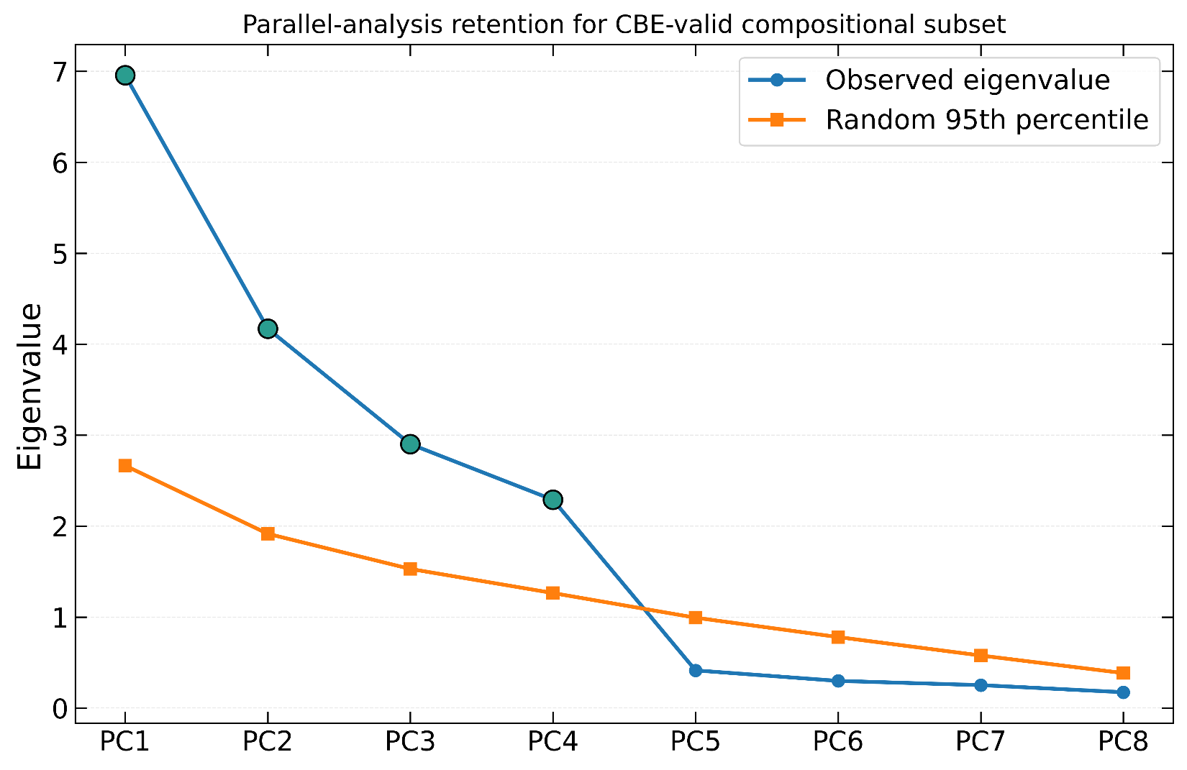
Figure S 1. CBE-filtered parallel-analysis scree plot comparing observed eigenvalues with random expectations for retention of latent hydrochemical components.
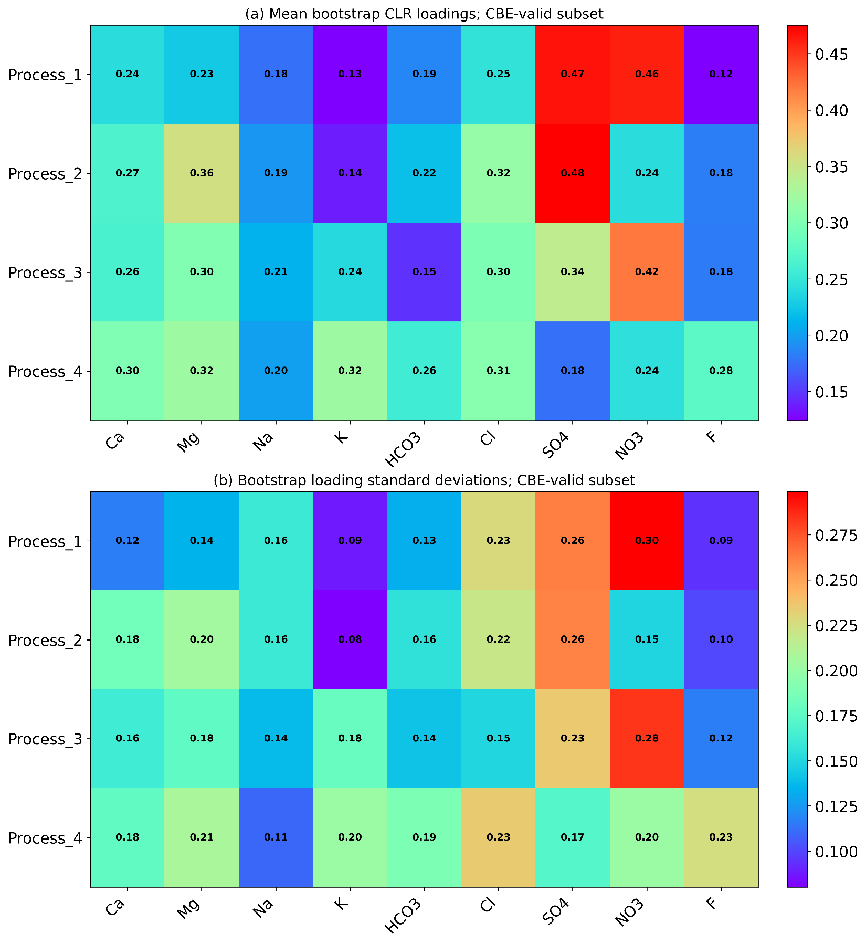
Figure S 2. Bootstrap mean and standard deviation of absolute CLR loadings for the four retained CBE-valid latent hydrochemical processes.

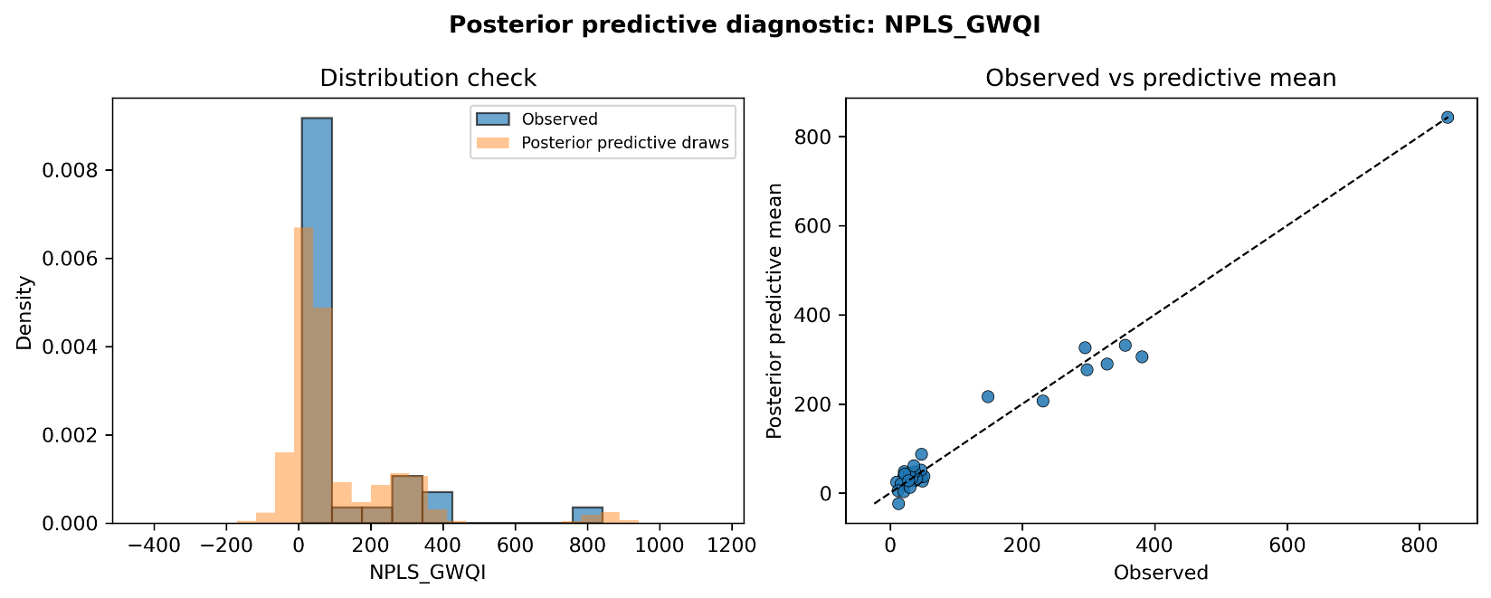
Figure S 3. Posterior predictive check for the NPLS-GWQI Bayesian endpoint-driver model.

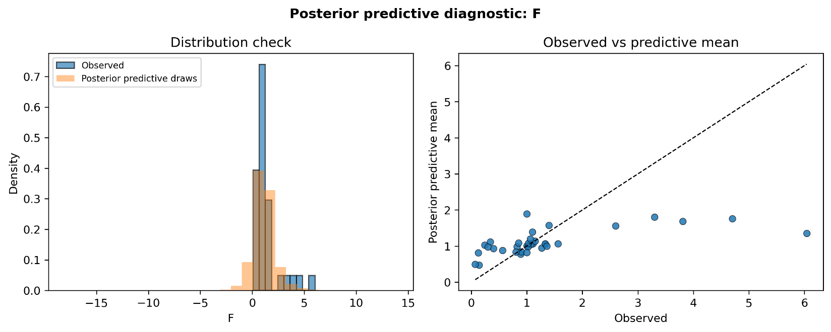
Figure S 4. Posterior predictive check for the fluoride Bayesian endpoint-driver model.

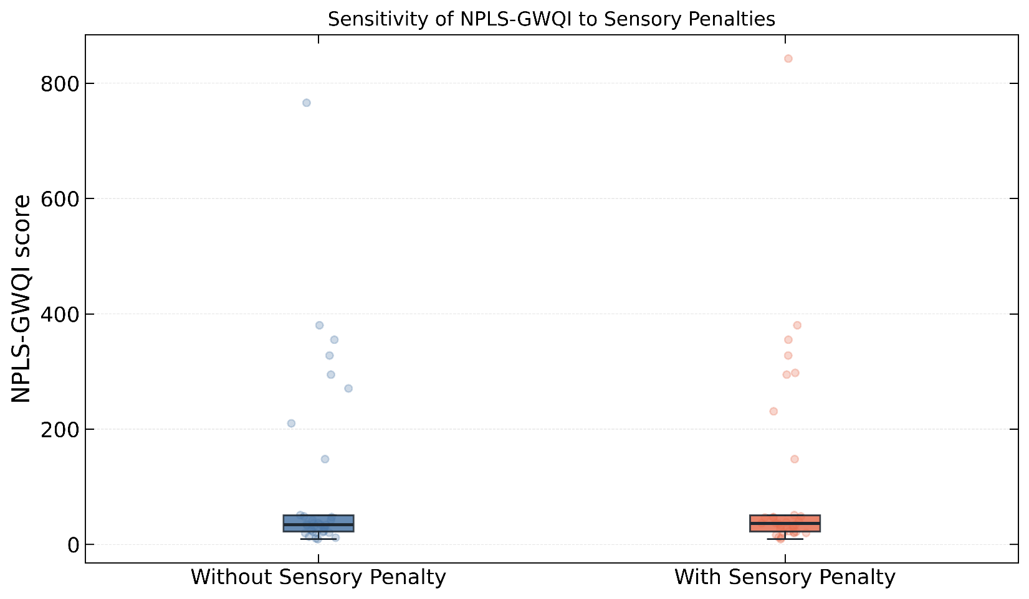
Figure S 5. Sensitivity of NPLS-GWQI scores to inclusion of the TDS-based sensory penalty term.

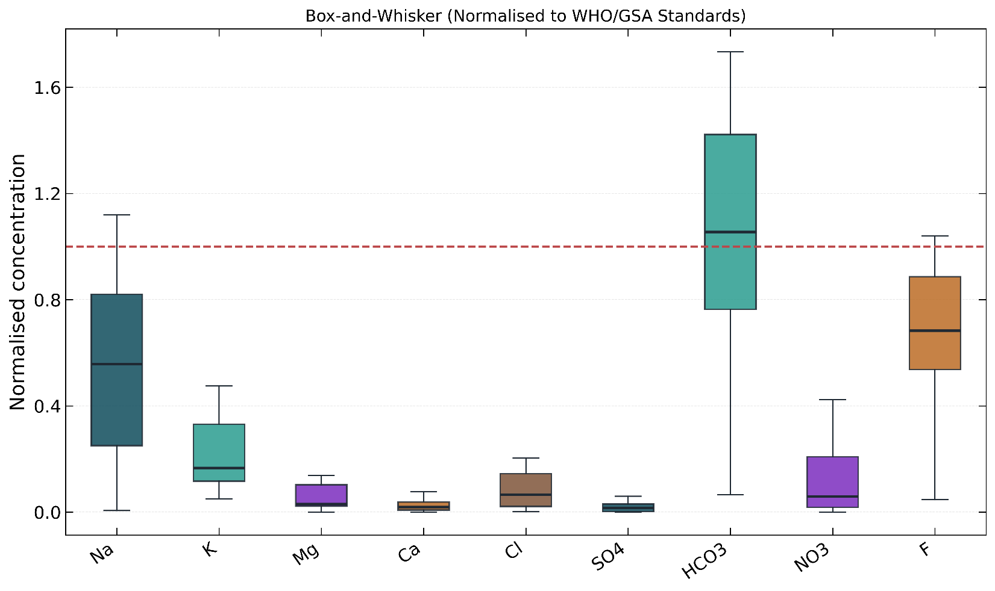
Figure S 6. Box-and-whisker comparison of major groundwater parameters after normalisation to WHO/GSA guideline values.

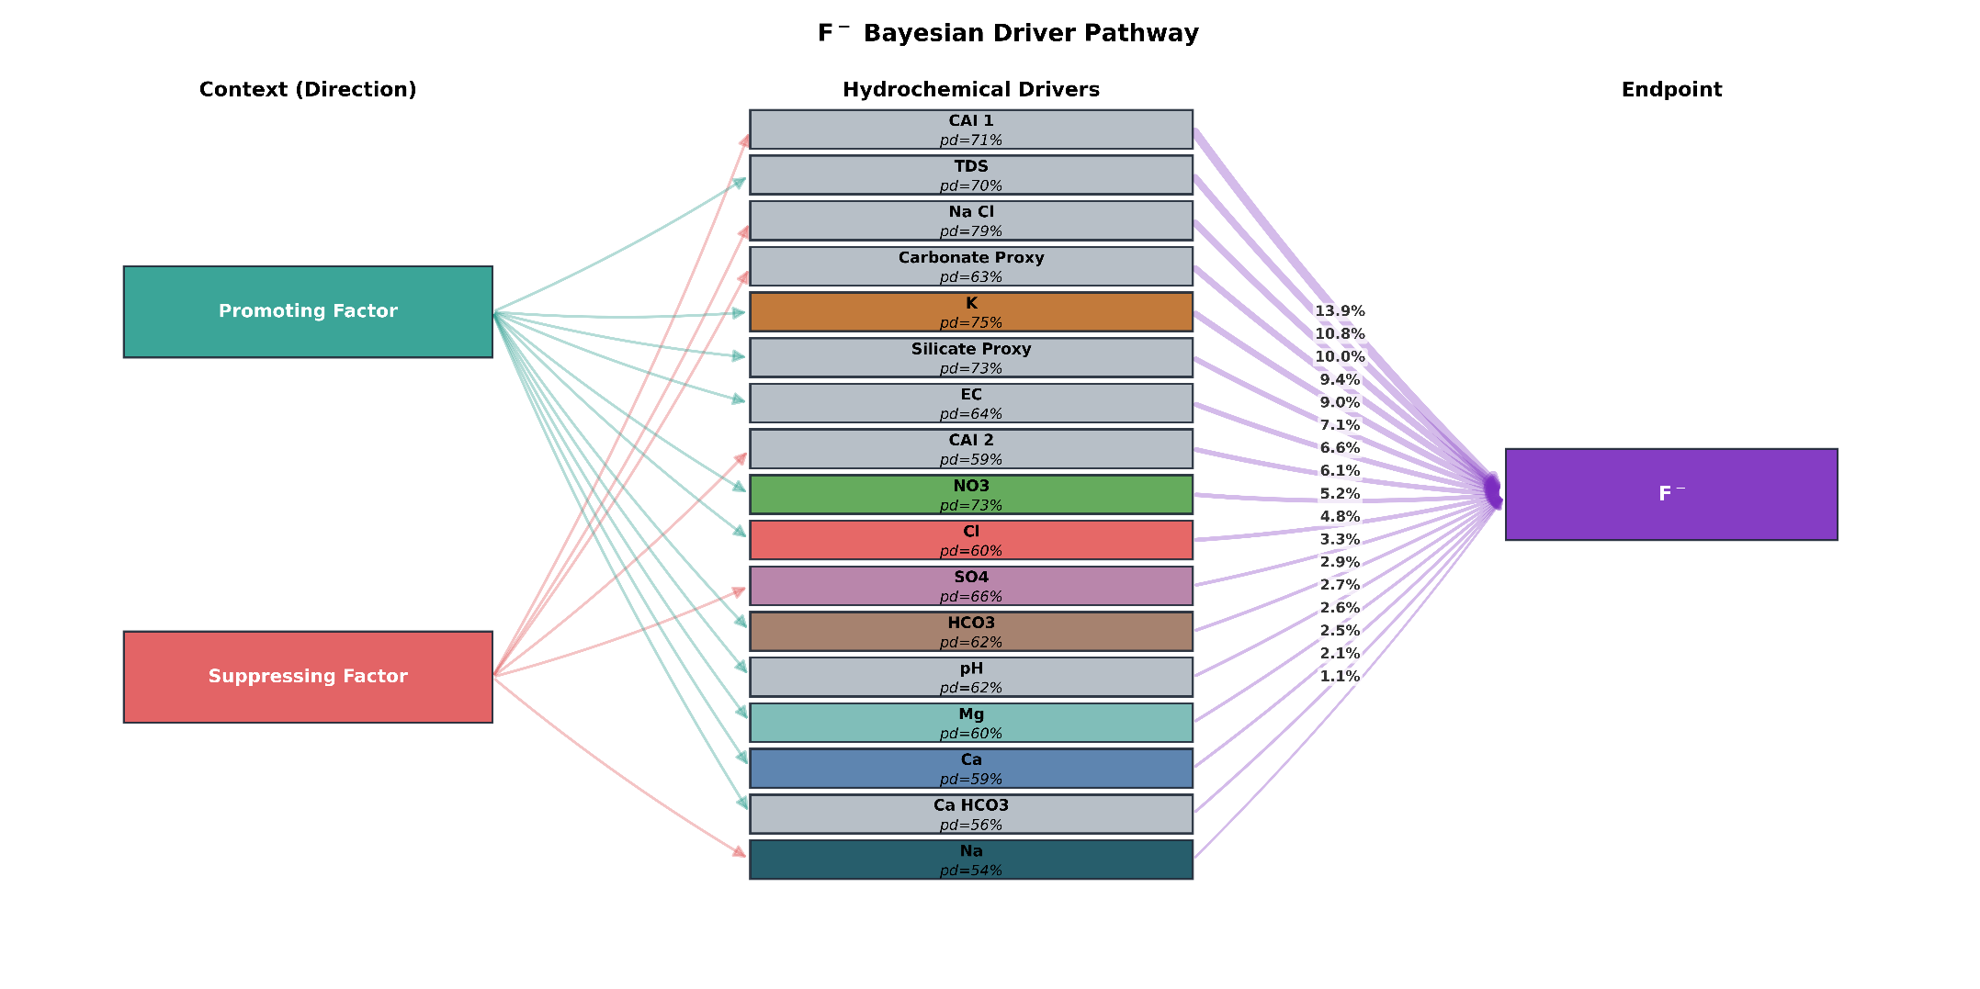
Figure S 7. Fluoride endpoint-safe pathway diagram showing the predictor block used after excluding fluoride itself from the fluoride endpoint model.

References
1. Chidiac, S., El Najjar, P., Ouaini, N., El Rayess, Y. & El Azzi, D. A comprehensive review of water quality indices (WQIs): history, models, attempts and perspectives. Rev. Environ. Sci. Biotechnol. 22, 349–395 (2023).
2. Seifi, A., Dehghani, M. & Singh, V. P. Uncertainty analysis of water quality index (WQI) for groundwater quality evaluation: Application of Monte-Carlo method for weight allocation. Ecol. Indic. 117, (2020).
3. Asare, E. A. & Abdul-Wahab, D. Neutrosophic Partial Least Squares (N-PLS). at https://doi.org/10.5281/zenodo.18131413 (2026).
4. World Health Organization. Inadequate or excess fluoride: a major public health concern-Revision. Who 1–5 at https://www.who.int/teams/environment-climate-change-and-health/chemical-safety-and-health/inadequate-or-excess-fluoride (2019).
5. Smarandache, F. Introduction to Neutrosophy, Neutrosophic Set, Neutrosophic Probability, Neutrosophic Statistics and Their Applications to Decision Making. in Neutrosophic Paradigms: Advancements in Decision Making and Statistical Analysis. Studies in Fuzziness and Soft Computing 3–21 (Infinite Study, 2025). doi:10.1007/978-3-031-78505-4_1.
6. Wold, S. PLS for multivariate linear modeling. Chemom. methods Mol. Des. 195–218 (1995).
7. (U.S. EPA) United States Enivronmental Protection Agency. Risk assessment guidance for superfund (RAGS). Volume I. Human health evaluation manual (HHEM). Part E. Supplemental guidance for dermal risk assessment. U.S. EPA Supplemental Guidance vol. 1 (2004).
8. Yan, Y. et al. Optimized groundwater quality evaluation using unsupervised machine learning, game theory and Monte-Carlo simulation. J. Environ. Manage. 371, (2024).
9. Ma, Z. et al. Groundwater Health Risk Assessment Based on Monte Carlo Model Sensitivity Analysis of Cr and As—A Case Study of Yinchuan City. Water (Switzerland) 14, 2419 (2022).
10. Gao, Y. et al. Cumulative health risk assessment of multiple chemicals in groundwater based on deterministic and Monte Carlo models in a large semiarid basin. J. Clean. Prod. 352, (2022).
11. Richards, L. A. Diagnosis and improvement of saline and alkali soils. (US Government Printing Office, 1954).
12. Wilcox, L. V. Classification and Use of Irrigation Waters - L. V. Wilcox - Google Books. (US Department of Agriculture, 1955).
13. Szabolcs I. The influence of irrigation water of high sodium carbonate content on soils. Agrokémia és Talajt. 13, 237–246 (1964).
14. Kelley, W. P. Use of saline irrigation water. Soil Sci. 95, 385–391 (1963).
15. Eaton, F. M. Significance of Carbonates in Irrigation Waters. Soil Sci. 69, (1950).
16. Doneen, L. D. Salination of soil by salts in the irrigation water. Eos, Trans. Am. Geophys. Union 35, 943–950 (1954).

