Computational Identification of Multi-Targeted Bioactive Phytocompounds as Candidate Drug Molecules against Nipah Virus Infection

Ovi Sharma^{1, 2†}, Md. Feroj Ahmed^{1†}, Dipu Sharma ³, Tasfia Noor^{1, 4}, Md. Nurul Haque Mollah^{1,}*

¹Department of Statistics, Bioinformatics Lab (Dry), University of Rajshahi, Rajshahi-6205, Bangladesh.
² MBBS, TMSS Medical College, Rangpur Road, Thengamara, Bogura, Bangladesh
³Department of Chemistry, University of Rajshahi, Rajshahi-6205, Bangladesh.
⁴Department of Computer Science & Engineering, Rajshahi University of Engineering & Technology, Rajshahi-6204, Bangladesh.
Supporting Items | Pages
Supplementary Figure
Fig.1: Absinthin and targeted NiV proteins interaction analysis highlighted the most stable active residue in the 3D and 2D diagrams. | 2
Fig.2: Diosgenin and targeted NiV proteins interaction analysis highlighted the most stable active residue in the 3D and 2D diagrams. | 3
Supplementary Tables
Table 1: Top 50 ranked phytochemicals (out of 2271) Binding Affinity Score with NiV proteins | 3-4
Table 2: Rank table of selected phytochemicals based on ADMET criteria | 5
Table 3: Rank table of selected phytochemical based on drug likeliness property | 6
Table 4: Network Pharmacology and Pathway Enrichment Analysis of suggested 3 phytochemicals | 6-9
Table 5: Comparison of ADMET properties of selected phytochemicals and reference antiviral drugs. | 9-10
Table 6. Validation of Predicted Binding Pockets Using DoGSiteScorer and (P2Rank) | 10

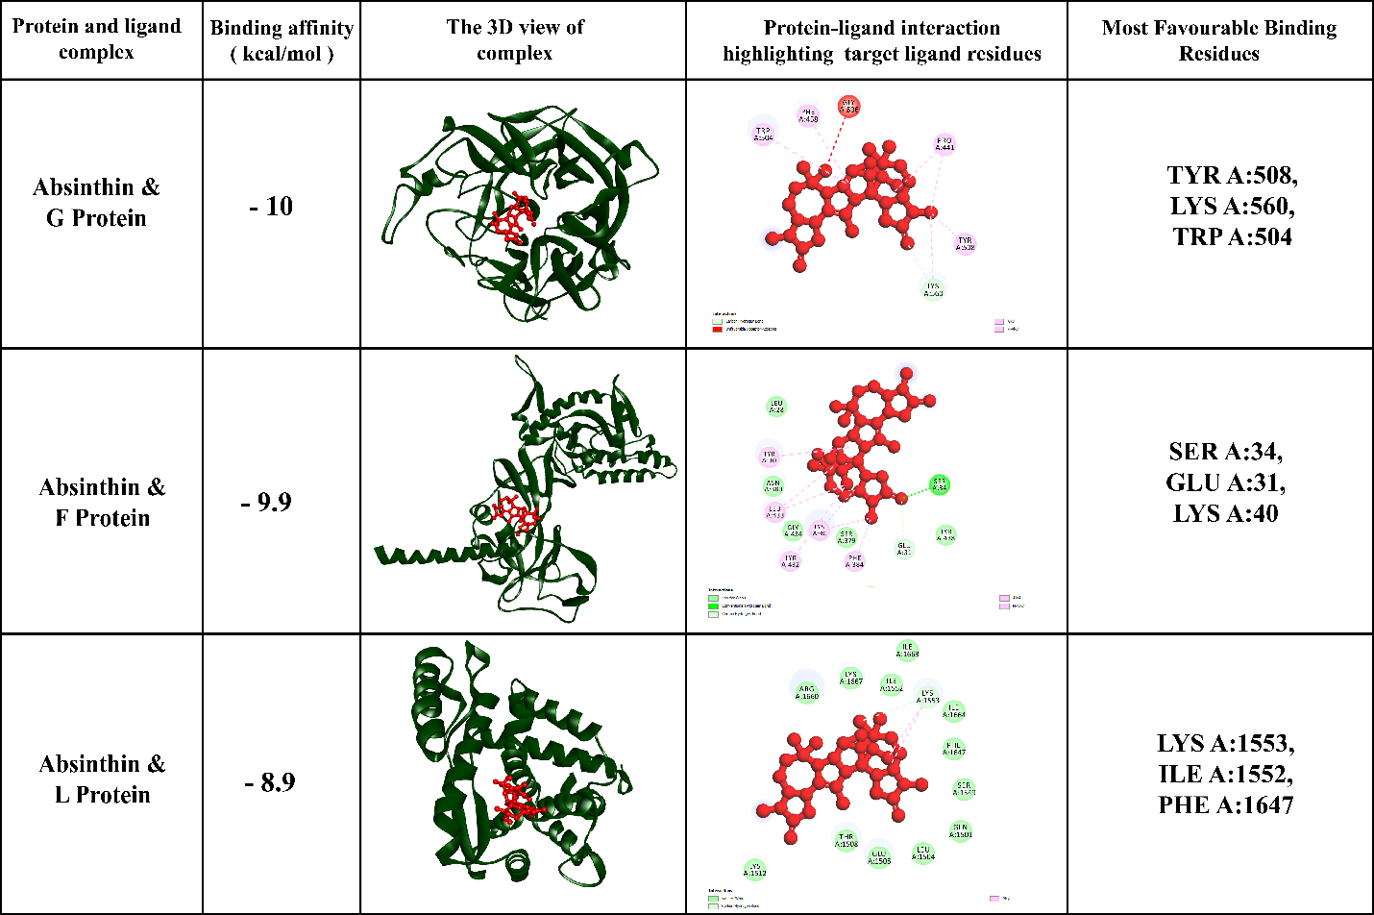
Supporting Figures
Fig.1: Absinthin and targeted NiV proteins interaction analysis highlighted there most stable active residue in the 3D and 2D diagram.

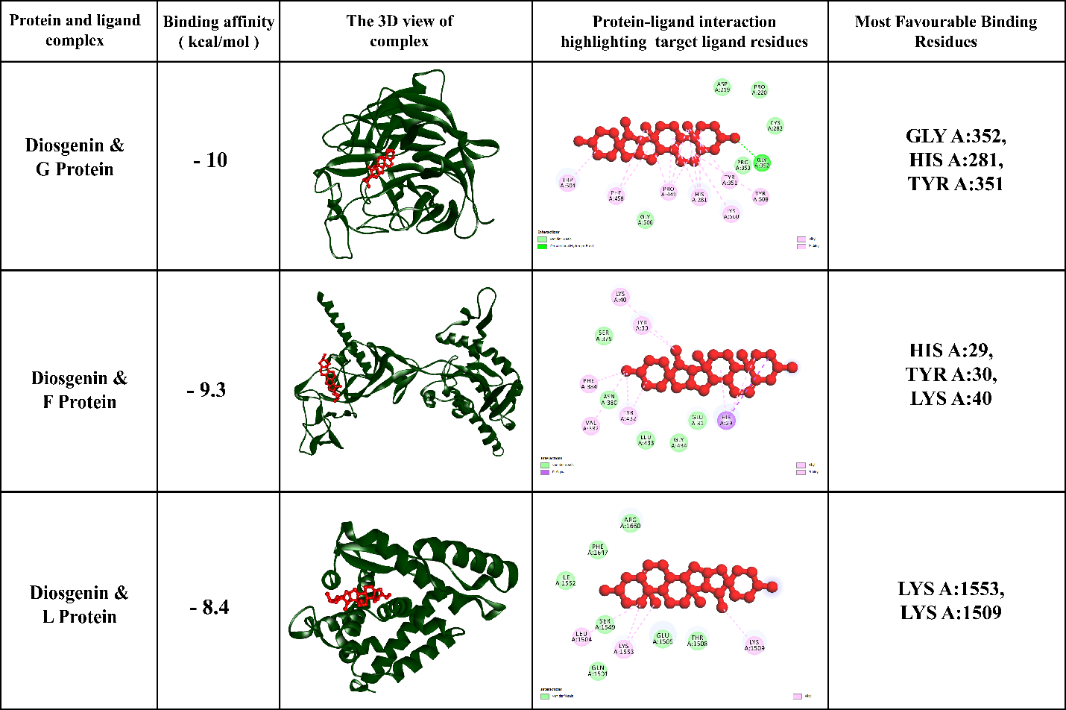
Fig.2: Diosgenin and targeted NiV proteins interaction analysis highlighted there most stable active residue in the 3D and 2D diagram.

Supporting Tables
Table 1: Top 50 ranked phytochemicals (out of 2271) Binding Affinity Score with NiV proteins
 | L Protein | G Protein | F Protein
Absinthin | -8.9 | -10 | -9.9
Ergotoxine | -9.6 | -9.7 | -9.4
Robustaflavone | -8.9 | -10.2 | -9.4
Belladonnine | -9.4 | -9.7 | -8.9
Cycloepiatalantin | -9.5 | -9.2 | -9.2
Diosgenin | -8.4 | -10.1 | -9.3
Yamogenin | -8.3 | -10.3 | -9.1
Abruslactone A | -8.9 | -9.6 | -9.1
Sarsasapogenin | -8.8 | -9 | -9.4
Hecogenin | -7.7 | -10.4 | -9.1
Aegicerin | -9.3 | -8.8 | -9
Agathisflavone | -8.1 | -9.7 | -9.2
Diosmin | -8.9 | -9.2 | -8.9
Limonin | -8.8 | -9.6 | -8.6
Taraxasterol | -8.9 | -9.3 | -8.7
Narirutin | -8.5 | -9.8 | -8.6
Friedelin | -9.1 | -8.4 | -9.2
Taraxasterol acetate | -8 | -9.1 | -9.6
Taraxerol | -9.5 | -8.5 | -8.7
Deoxytubulosine | -8.9 | -9.3 | -8.4
Glutinone | -9.1 | -8.6 | -8.9
Asclepin | -8.9 | -9.2 | -8.4
Ursane | -8.4 | -9.1 | -9
Taraxerone | -10.1 | -8.3 | -8.1
Alangimarckine | -9.4 | -8.8 | -8.3
Promoline | -8.3 | -9.2 | -9
25-O-Acetylcimigenol | -8.2 | -9.4 | -8.8
Multiflorenol | -9.1 | -8.4 | -8.9
Ursadiol | -8.9 | -8.9 | -8.6
Methyl oleanolate | -8.9 | -8.3 | -9.2
Gitogenin | -8 | -9.4 | -9
Inophyllum G-2 | -8.3 | -9 | -9
Methyl betulonate | -9 | -8.4 | -8.9
26-Deoxyactein | -8.1 | -9.3 | -8.9
(2s,4As,6as,8ar,10s,12as,14as,14br)-10-hydroxy-2,4a,6a,9,9,12a,14a-heptamethyl-1,2,3,4,4a,5,6,6a,7,8,8a,9,10,11,12,12a,13,14,14a,14b-icosahydropicene-2-carboxylic acid | -8.2 | -8.1 | -10
Olean-12-en-3-one | -9.4 | -8.5 | -8.4
Berbamine | -8.5 | -8.7 | -9.1
Cedrelone | -8.6 | -8.6 | -9
Tigogenin | -8 | -9.3 | -8.9
Sanguinarine | -7.7 | -10.5 | -8
Corilagin | -8.2 | -9.6 | -8.4
Lupeol | -8.6 | -8.4 | -9.1
Deacetylgedunin | -8.6 | -9 | -8.5
Cucurbitacin I | -8.4 | -8.9 | -8.8
Sophoradiol | -8.5 | -8.5 | -9.1
beta-Amyrin acetate | -8.6 | -8.9 | -8.6
Procyanidin B2 | -8.2 | -9.1 | -8.8
Calactin | -8.7 | -8.8 | -8.5
alpha-Glutinol | -8.7 | -8.7 | -8.6
Strychnine | -8.5 | -8.4 | -9

Table 2: Rank table of selected phytochemicals based on ADMET criteria
Compounds | Caco2  log (cm/s) | HIA | Pgp | BBB | CYP3A4 | CYP2D6 | CYP1A2 | AMES | ADMET Score | Rank
Absinthin | -4.95 | Absorbed | Non-Inhibitor | Penetrable | Non-Inhibitor | Non-Inhibitor | Non-Inhibitor | Safe | 8 | 1
Diosgenin | -4.79 | Absorbed | Non-Inhibitor | Penetrable | Non-Inhibitor | Non-Inhibitor | Non-Inhibitor | Safe | 8 | 2
Yamogenin | -4.81 | Absorbed | Non-Inhibitor | Penetrable | Non-Inhibitor | Non-Inhibitor | Non-Inhibitor | Safe | 8 | 3
Taraxasterol | -4.79 | Absorbed | Non-Inhibitor | Penetrable | Non-Inhibitor | Non-Inhibitor | Non-Inhibitor | Safe | 8 | 4
Friedelin | -4.76 | Absorbed | Non-Inhibitor | Penetrable | Non-Inhibitor | Non-Inhibitor | Non-Inhibitor | Safe | 8 | 5
Taraxasterol acetate | -4.82 | Absorbed | Non-Inhibitor | Penetrable | Non-Inhibitor | Non-Inhibitor | Non-Inhibitor | Safe | 8 | 6
Taraxerol | -4.76 | Absorbed | Non-Inhibitor | Penetrable | Non-Inhibitor | Non-Inhibitor | Non-Inhibitor | Safe | 8 | 7
Deoxytubulosine | -5.18 | Absorbed | Non-Inhibitor | Penetrable | Non-Inhibitor | Non-Inhibitor | Non-Inhibitor | Safe | 8 | 8
Cycloepiatalantin | -5.19 | Absorbed | Non-Inhibitor | Penetrable | Non-Inhibitor | Non-Inhibitor | Non-Inhibitor | Safe | 8 | 9
Aegicerin | -4.71 | Absorbed | Inhibitor | Penetrable | Non-Inhibitor | Non-Inhibitor | Non-Inhibitor | Safe | 7 | 10
Belladonnine | -4.91 | Absorbed | Inhibitor | Penetrable | Non-Inhibitor | Non-Inhibitor | Non-Inhibitor | Safe | 7 | 11
Sarsasapogenin | -4.82 | Absorbed | Non-Inhibitor | Non-Penetrable | Non-Inhibitor | Non-Inhibitor | Non-Inhibitor | Safe | 7 | 12
Hecogenin | -4.69 | Absorbed | Inhibitor | Penetrable | Non-Inhibitor | Non-Inhibitor | Non-Inhibitor | Safe | 7 | 13
Abruslactone A | -4.81 | Absorbed | Inhibitor | Penetrable | Non-Inhibitor | Non-Inhibitor | Non-Inhibitor | Safe | 7 | 14
limonin | -5.23 | Absorbed | Inhibitor | Penetrable | Inhibitor | Non-Inhibitor | Non-Inhibitor | Safe | 6 | 15
Ergotoxine | -5.59 | Absorbed | Inhibitor | Non-Penetrable | Inhibitor | Non-Inhibitor | Non-Inhibitor | Safe | 4 | 16
Diosmin | -6.64 | non-absorbed | Non-Inhibitor | Non-Penetrable | Non-Inhibitor | Non-Inhibitor | Non-Inhibitor | Safe | 4 | 17
Narirutin | -6.75 | non-absorbed | Non-Inhibitor | Non-Penetrable | Non-Inhibitor | Non-Inhibitor | Non-Inhibitor | Safe | 4 | 18
Agathisflavone | -5.97 | non-absorbed | Inhibitor | Non-Penetrable | Non-Inhibitor | Non-Inhibitor | Non-Inhibitor | Safe | 3 | 19
Robustaflavone | -6.01 | non-absorbed | Inhibitor | Non-Penetrable | Inhibitor | Non-Inhibitor | Non-Inhibitor | Safe | 2 | 20

Table 3: Rank table of selected phytochemicals based on drug likeliness property
Compounds | Molecular Weight | LogP | HBA | HBD | Lipinski Violations | Lipinski Score | Rank
Absinthin | 496.644 | 3.802 | 6 | 2 | 0 | 3 | 1
Cycloepiatalantin | 468.502 | 2.302 | 8 | 1 | 0 | 3 | 2
Hecogenin | 430.629 | 4.973 | 4 | 1 | 0 | 3 | 3
limonin | 470.518 | 3.1374 | 8 | 0 | 0 | 3 | 4
Diosgenin | 414.63 | 4.714 | 3 | 1 | 0 | 3 | 5
Ergotoxine | 519.602 | 1.016 | 10 | 3 | 1 | 2 | 6
Yamogenin | 414.63 | 5.714 | 3 | 1 | 1 | 2 | 7
Abruslactone A | 454.695 | 6.684 | 3 | 1 | 1 | 2 | 8
Sarsasapogenin | 416.646 | 5.794 | 3 | 1 | 1 | 2 | 9
Aegicerin | 456.711 | 6.5607 | 3 | 1 | 1 | 2 | 10
Taraxasterol | 426.729 | 8.0248 | 1 | 1 | 1 | 2 | 11
Friedelin | 426.729 | 8.457 | 1 | 0 | 1 | 2 | 12
Taraxasterol acetate | 468.766 | 8.5956 | 2 | 0 | 1 | 2 | 13
Taraxerol | 426.729 | 8.1689 | 1 | 1 | 1 | 2 | 14
Deoxytubulosine | 459.634 | 5.4075 | 4 | 2 | 1 | 2 | 15
Belladonnine | 542.72 | 5.187 | 6 | 0 | 2 | 1 | 16
Robustaflavone | 538.464 | 5.134 | 10 | 6 | 3 | 0 | 17
Agathisflavone | 538.464 | 5.134 | 10 | 6 | 3 | 0 | 18
Diosmin | 608.549 | -1.0897 | 15 | 8 | 3 | 0 | 19
Narirutin | 580.539 | -1.1652 | 14 | 8 | 3 | 0 | 20

Table 4: Network Pharmacology and Pathway Enrichment Analysis of suggested 3 phytochemicals:
Term | P-value | Adjusted P-value | Genes
YERSINIA INFECTION | 2.17E-09 | 1.84E-07 | IKBKB;IL1B;NLRP3;TLR4
INFLUENZA A | 5.16E-09 | 1.98E-07 | IKBKB;IL1B;NLRP3;TLR4
NOD-LIKE RECEPTOR SIGNALING PATHWAY | 7.09E-09 | 1.98E-07 | IKBKB;IL1B;NLRP3;TLR4
PATHOGENIC ESCHERICHIA COLI INFECTION | 9.32E-09 | 1.98E-07 | IKBKB;IL1B;NLRP3;TLR4
LIPID AND ATHEROSCLEROSIS | 1.27E-08 | 2.17E-07 | IKBKB;IL1B;NLRP3;TLR4
CORONAVIRUS DISEASE - COVID-19 | 1.70E-08 | 2.30E-07 | IKBKB;IL1B;NLRP3;TLR4
SHIGELLOSIS | 2.09E-08 | 2.30E-07 | IKBKB;IL1B;NLRP3;TLR4
SALMONELLA INFECTION | 2.16E-08 | 2.30E-07 | IKBKB;IL1B;NLRP3;TLR4
PERTUSSIS | 2.19E-07 | 2.07E-06 | IL1B;NLRP3;TLR4
CYTOSOLIC DNA-SENSING PATHWAY | 2.65E-07 | 2.25E-06 | IKBKB;IL1B;NLRP3
CHAGAS DISEASE | 5.29E-07 | 3.56E-06 | IKBKB;IL1B;TLR4
NF-KAPPA B SIGNALING PATHWAY | 5.44E-07 | 3.56E-06 | IKBKB;IL1B;TLR4
C-TYPE LECTIN RECEPTOR SIGNALING PATHWAY | 5.44E-07 | 3.56E-06 | IKBKB;IL1B;NLRP3
TOLL-LIKE RECEPTOR SIGNALING PATHWAY | 6.27E-07 | 3.81E-06 | IKBKB;IL1B;TLR4
MEASLES | 1.28E-06 | 7.10E-06 | IKBKB;IL1B;TLR4
ALCOHOLIC LIVER DISEASE | 1.34E-06 | 7.10E-06 | IKBKB;IL1B;TLR4
NECROPTOSIS | 1.92E-06 | 9.62E-06 | IL1B;NLRP3;TLR4
MALARIA | 3.66E-05 | 1.73E-04 | IL1B;TLR4
LEGIONELLOSIS | 4.60E-05 | 2.06E-04 | IL1B;TLR4
INFLAMMATORY BOWEL DISEASE | 5.84E-05 | 2.48E-04 | IL1B;TLR4
LEISHMANIASIS | 8.51E-05 | 3.44E-04 | IL1B;TLR4
PD-L1 EXPRESSION AND PD-1 CHECKPOINT PATHWAY IN CANCER | 1.14E-04 | 4.41E-04 | IKBKB;TLR4
RHEUMATOID ARTHRITIS | 1.25E-04 | 4.52E-04 | IL1B;TLR4
IL-17 SIGNALING PATHWAY | 1.28E-04 | 4.52E-04 | IKBKB;IL1B
AMOEBIASIS | 1.48E-04 | 5.02E-04 | IL1B;TLR4
TH17 CELL DIFFERENTIATION | 1.66E-04 | 5.42E-04 | IKBKB;IL1B
TOXOPLASMOSIS | 1.75E-04 | 5.52E-04 | IKBKB;TLR4
TNF SIGNALING PATHWAY | 2.05E-04 | 6.24E-04 | IKBKB;IL1B
OSTEOCLAST DIFFERENTIATION | 2.65E-04 | 7.77E-04 | IKBKB;IL1B
FLUID SHEAR STRESS AND ATHEROSCLEROSIS | 2.81E-04 | 7.96E-04 | IKBKB;IL1B
NON-ALCOHOLIC FATTY LIVER DISEASE | 3.50E-04 | 9.59E-04 | IKBKB;IL1B
HEPATITIS B | 3.82E-04 | 0.001016 | IKBKB;TLR4
TUBERCULOSIS | 4.72E-04 | 0.001207 | IL1B;TLR4
HERPES SIMPLEX VIRUS 1 INFECTION | 4.83E-04 | 0.001207 | IKBKB;IL1B
HUMAN IMMUNODEFICIENCY VIRUS 1 INFECTION | 6.49E-04 | 0.001577 | IKBKB;TLR4
HUMAN CYTOMEGALOVIRUS INFECTION | 7.32E-04 | 0.001728 | IKBKB;IL1B
MAPK SIGNALING PATHWAY | 0.001284 | 0.00295 | IKBKB;IL1B
PI3K-AKT SIGNALING PATHWAY | 0.001841 | 0.004118 | IKBKB;TLR4
ALZHEIMER DISEASE | 0.002095 | 0.004567 | IKBKB;IL1B
AFRICAN TRYPANOSOMIASIS | 0.00738 | 0.015682 | IL1B
GRAFT-VERSUS-HOST DISEASE | 0.008374 | 0.016946 | IL1B
TYPE I DIABETES MELLITUS | 0.008374 | 0.016946 | IL1B
VASOPRESSIN-REGULATED WATER REABSORPTION | 0.008573 | 0.016946 | NLRP3
TYPE II DIABETES MELLITUS | 0.009368 | 0.018096 | IKBKB
ACUTE MYELOID LEUKEMIA | 0.013334 | 0.025014 | IKBKB
EPITHELIAL CELL SIGNALING IN HELICOBACTER PYLORI INFECTION | 0.013928 | 0.025014 | IKBKB
ADIPOCYTOKINE SIGNALING PATHWAY | 0.013928 | 0.025014 | IKBKB
RIG-I-LIKE RECEPTOR SIGNALING PATHWAY | 0.014125 | 0.025014 | IKBKB
CHRONIC MYELOID LEUKEMIA | 0.015115 | 0.026031 | IKBKB
PANCREATIC CANCER | 0.015312 | 0.026031 | IKBKB
B CELL RECEPTOR SIGNALING PATHWAY | 0.0163 | 0.027167 | IKBKB
TH1 AND TH2 CELL DIFFERENTIATION | 0.018077 | 0.029308 | IKBKB
SMALL CELL LUNG CANCER | 0.018275 | 0.029308 | IKBKB
INFLAMMATORY MEDIATOR REGULATION OF TRP CHANNELS | 0.019261 | 0.029766 | IL1B
HEMATOPOIETIC CELL LINEAGE | 0.019261 | 0.029766 | IL1B
AGE-RAGE SIGNALING PATHWAY IN DIABETIC COMPLICATIONS | 0.019852 | 0.030132 | IL1B
PROSTATE CANCER | 0.020443 | 0.030485 | IKBKB
INSULIN RESISTANCE | 0.02123 | 0.031113 | IKBKB
HIF-1 SIGNALING PATHWAY | 0.021821 | 0.031437 | TLR4
T CELL RECEPTOR SIGNALING PATHWAY | 0.02359 | 0.032871 | IKBKB
NEUROTROPHIN SIGNALING PATHWAY | 0.02359 | 0.032871 | IKBKB
FOXO SIGNALING PATHWAY | 0.025749 | 0.035006 | IKBKB
VASCULAR SMOOTH MUSCLE CONTRACTION | 0.025945 | 0.035006 | NLRP3
APOPTOSIS | 0.026926 | 0.035467 | IKBKB
INSULIN SIGNALING PATHWAY | 0.027122 | 0.035467 | IKBKB
PHOSPHOLIPASE D SIGNALING PATHWAY | 0.029079 | 0.037451 | NLRP3
PHAGOSOME | 0.029862 | 0.037855 | TLR4
MTOR SIGNALING PATHWAY | 0.030448 | 0.037855 | IKBKB
HEPATITIS C | 0.03123 | 0.037855 | IKBKB
NEUTROPHIL EXTRACELLULAR TRAP FORMATION | 0.031425 | 0.037855 | TLR4
MICRORNAS IN CANCER | 0.03162 | 0.037855 | IKBKB
CHEMOKINE SIGNALING PATHWAY | 0.037659 | 0.044458 | IKBKB
KAPOSI SARCOMA-ASSOCIATED HERPESVIRUS INFECTION | 0.038436 | 0.044596 | IKBKB
PROTEOGLYCANS IN CANCER | 0.038824 | 0.044596 | TLR4
EPSTEIN-BARR VIRUS INFECTION | 0.039989 | 0.045321 | IKBKB
HORMONE SIGNALING | 0.042895 | 0.047566 | NLRP3
HUMAN T-CELL LEUKEMIA VIRUS 1 INFECTION | 0.043089 | 0.047566 | IKBKB
CHEMICAL CARCINOGENESIS - REACTIVE OXYGEN SPECIES | 0.043669 | 0.047588 | IKBKB
RAS SIGNALING PATHWAY | 0.045409 | 0.048858 | IKBKB
PRION DISEASE | 0.052536 | 0.055819 | IL1B

Table 5: Comparison of ADMET properties of selected phytochemicals and reference antiviral drugs.
Compound | HIA | BBB | CYP3A4 | CYP2D6 | AMES | Remarks
Absinthin | Absorbed | Penetrable | Non-inhibitor | Non-inhibitor | Safe | Favorable ADMET profile
Diosgenin | Absorbed | Penetrable | Non-inhibitor | Non-inhibitor | Safe | Favorable ADMET profile
Cycloepiatalantin | Absorbed | Penetrable | Non-inhibitor | Non-inhibitor | Safe | Favorable ADMET profile
Ribavirin | Absorbed | Penetrable | ND | ND | Safe | Approved broad-spectrum antiviral
Favipiravir | Absorbed | Penetrable | ND | ND | Safe | Approved RNA-virus antiviral
Remdesivir | Absorbed | Penetrable | ND | ND | Predicted Toxic* | Approved antiviral for RNA viruses

Table 6. Validation of Predicted Binding Pockets Using DoGSiteScorer and (P2Rank).

Protein | DoGSiteScorer Pocket | DoGSite Volume (Å³) | DoGSite Druggability | PrankWeb Rank | PrankWeb Score | PrankWeb Probability | No. of Residues | Representative Shared Residues*
G Glycoprotein (3D11) | P0 | 777.28 | 0.85 | 1 | 24.78 | 0.883 | 31 | THR218, ASP219, ARG236, ASP302, TYR351, TYR508, LYS560
F Protein (5EVM) | P0 | 787.28 | 0.86 | 1 | 14.88 | 0.745 | 29 | A175, A177, A178, A201, A202, A205, A206, A209, A233, A235, A236, A238
L Protein (9FTF) | P0 | 798.34 | 0.82 | 1 | 10.68 | 0.611 | 12 | A1507, A1511, A1553, A1554, A1557, A1573, A1576, A1577, A1580, A1584, A1585, A1628

