Supplementary Information
Efficacy and Safety Profile of Multi-Depth Microfocused Ultrasound and Microneedle Radiofrequency for Facial Tightening: A Prospective Split-Face Randomized Trial
Jiafang Zhu, M.D.1#, Yue Han, M.D.1#, Wei Gao, M.D.1#, Rui Chang, M.D.2, Ying Shang, M.S.1, Wenxin Yu, M.D., Ph.D.1, Linting Huang, M.D., Ph.D.1, Xianglei Wu M.D., Ph.D.1, Wei Fang, M.D., Ph.D.1, Zhen Zhang, M.D., Ph.D.1, Dongze Lyu, M.D.2, Lingyue Shen, M.D., Ph.D.1*, Xiaoxi Lin M.D., Ph.D.1*
1Department of Laser and Aesthetic Medicine, Shanghai Ninth People’s Hospital, Shanghai Jiao Tong University School of Medicine, Shanghai, 200011, China
2Department of Plastic and Reconstructive Surgery, Shanghai Ninth People's Hospital, Shanghai Jiao Tong University School of Medicine, Shanghai, 200011, China.
#These authors contributed equally to this work and should be considered co-first authors.
Contents
• Supplementary Methods
• Supplementary Results
• Supplementary Figure S1. Anatomical definition of areas of interest (AOIs) and ultrasound measurement points.
• Supplementary Figure S2. Thermal Coagulation Profiles and Histological Validation of Ultrasound Transducers.
• Supplementary Table S1. Treatment parameters and target tissue layers of MFUS handpieces
• Supplementary Table S2. Comparison of neural adverse events reported after MFUS-based facial tightening treatments
• Supplementary Table S3. Changes in the six prespecified VISIA-derived skin-quality parameters

Supplementary Methods

Silica gel phantom and histometric evaluation
The safety and spatial distribution of thermal coagulation points (TCPs) produced by the MFUS device were evaluated using a silica gel phantom and ex vivo histometric assessment. TCP spatial distribution was analyzed for six transducers (6.8 W for the 4.5-mm and 3.0-mm transducers; 3 W for the 2.0-mm transducer) on a homogeneous phantom. Focal depths of TCPs were measured using a ruler-referenced method and high-speed photography.
For histology, donated excised full-thickness skin specimens from a 23-year-old patient with a café-au-lait macule were treated with the M2.0 handpiece and subjected to hematoxylin and eosin staining to assess thermal coagulation.

Supplementary Results
The silica gel phantom experiments consistently demonstrated wedge-shaped thermal coagulation profiles across all transducer configurations. Quantitative depth analysis showed that the M4.5/D4.5 transducers produced coagulation zones spanning 2.0–5.5 mm, with maximal focusing at 2.0–4.0 mm. The M3.0/D3.0 variants achieved 1.5–5.0 mm and 1.0–5.0 mm penetration, respectively, with maximal focusing at 1.5/1.0–3.0 mm. The M2.0/D2.0 system produced the most superficial effect, with a total depth of 1.0–3.0 mm and maximal focusing at 1.0–2.0 mm (Supplementary Figure S2).
Histopathological evaluation confirmed that the M2.0 handpiece produced selective dermal coagulation columns measuring approximately 1,480 μm in depth and 782 μm in length while completely preserving the epidermis (Supplementary Figure S2). Partial injury to intradermal adipose tissue was observed (Supplementary Figure S2).

Supplementary Figures
Supplementary Figure S1. Anatomical definition of areas of interest (AOIs) and ultrasound measurement points.
- Submental Area of Interest (AOI).
The submental AOI was delineated using the mandibular angle (MA) and the submental point (SM). An additional landmark, the mentocervical point (MC), was placed at the natural crease where the chin meets the neck, and a secondary reference point (P) was positioned 10 mm inferior to the MA.
- Mandibular Area of Interest (AOI).
The mandibular AOI was defined using the intertragal incisura (I), oral commissure (OC), premaxillary point (PM), earlobe apex (E), and MA. The PM–MA connecting line followed each participant’s native submandibular contour to ensure anatomical consistency. The mandibular AOI was delineated independently within each hemiface and did not cross the facial midline.
(C–D) Ultrasound Measurement Points.
Point A (located 1 cm superior to the eyebrow and aligned with the pupil center) was used to quantify frontal soft-tissue thickness. Point B (defined as the intersection of the vertical line bisecting the temporal region and the horizontal line through the oral commissure) was used to assess lower facial soft-tissue thickness. Point B was positioned laterally within the lower-face region and was anatomically separated from the contralateral hemiface.

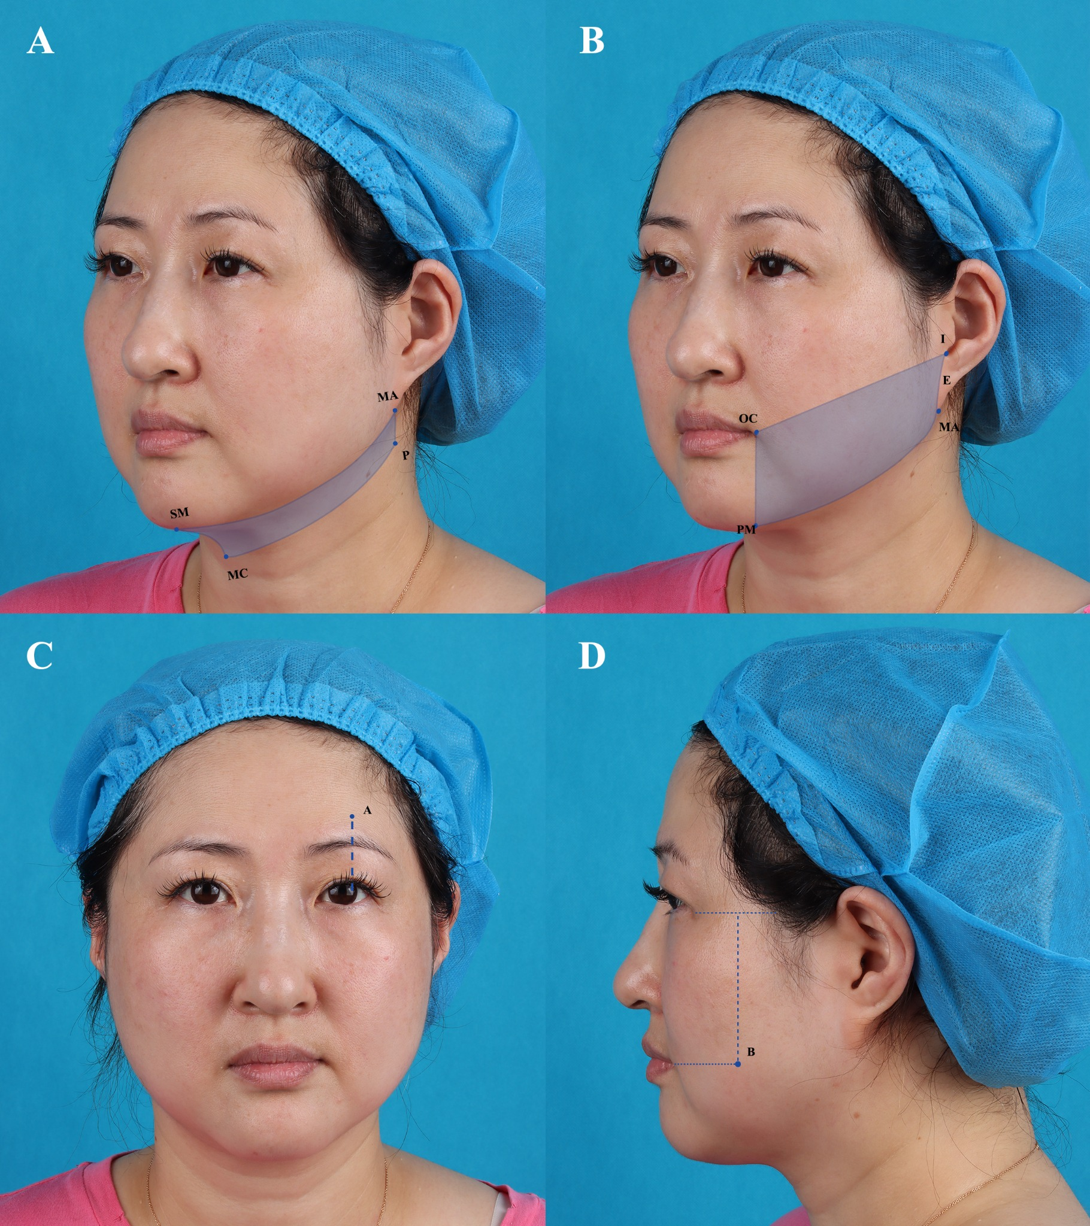
Supplementary Figure S2. Thermal Coagulation Profiles and Histological Validation of Ultrasound Transducers.
A-F. Thermal coagulation points (TCPs) generated by the focused ultrasound transducers demonstrated a characteristic wedge-shaped morphology. Quantitative depth profiling showed that the M4.5 and D4.5 transducers produced coagulation zones ranging from 2.0 to 5.5 mm in total depth (with maximal focal intensities located between 2.0 and 4.0 mm). The M3.0 and D3.0 transducers achieved penetration depths of 1.5–5.0 mm and 1.0–5.0 mm, respectively (maximal focal zones: 1.5–3.0 mm and 1.0–3.0 mm). The M2.0 and D2.0 transducers generated the most superficial effects, with total depths of 1.0–3.0 mm and focal maxima between 1.0 and 2.0 mm.
G-H. Histological analysis demonstrated well-defined thermal coagulation within the dermis when the TCP intersected this layer. Microscopic evaluation confirmed that the M2.0 handpiece created selective dermal coagulation columns measuring approximately 1,480 μm in depth and 782 μm in length, while the epidermis remained entirely preserved.
I. Thermally damaged fat cells were observed in the intradermal fat layer. The epidermis was unaffected.

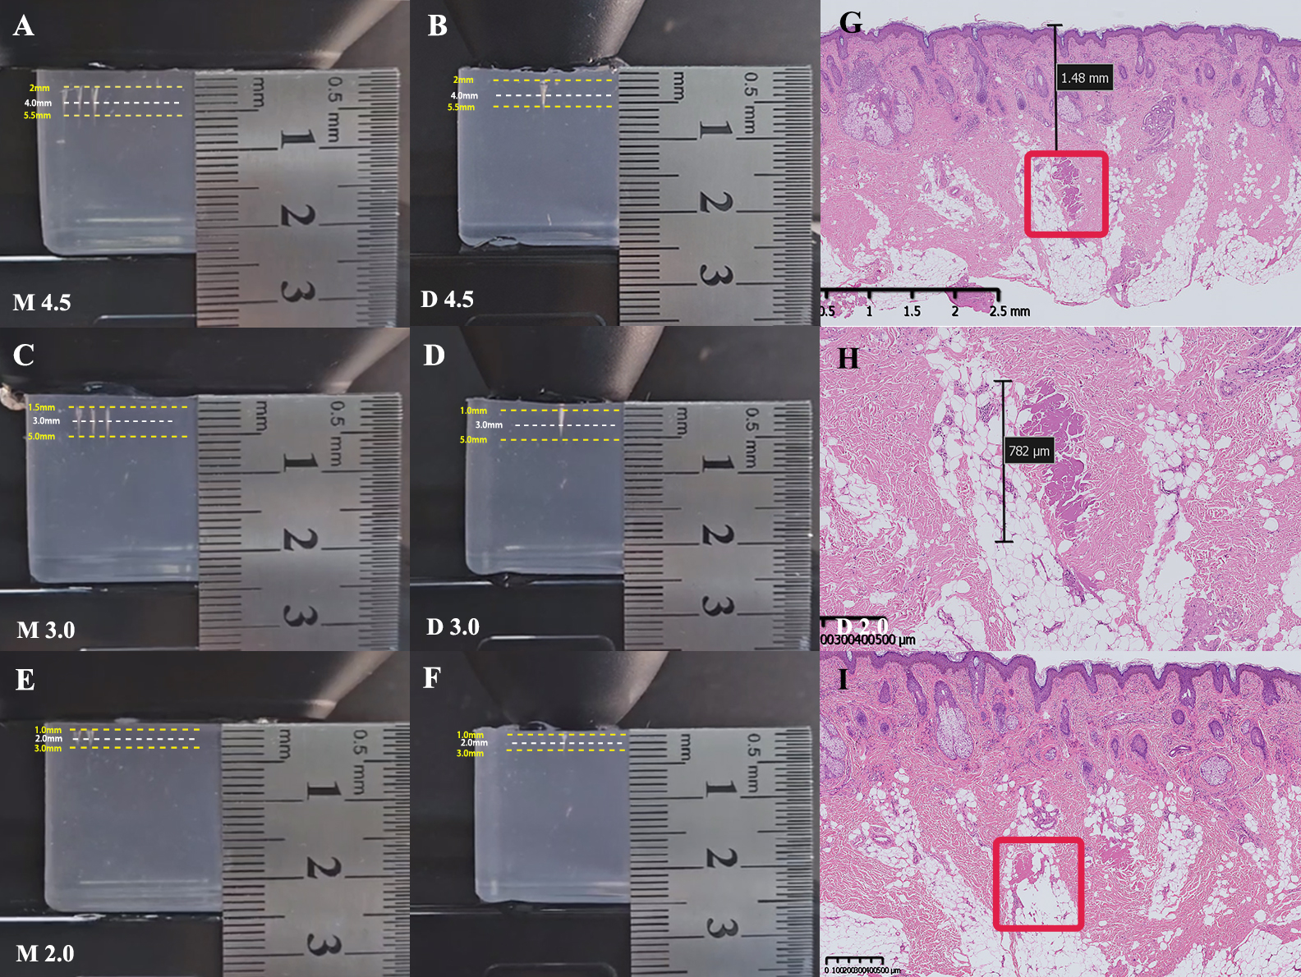

Supplementary Tables
Supplementary Table S1. Treatment parameters and target tissue layers of MFUS handpieces

Handpiece | Nominal focal depth | Frequency | Output range | Dose unit | Treatment dose used in this study | Treatment region | Intended target tissue layer
M4.5 | 4.5 mm | N/A | 5.2–8.4 W | Lines | 150–200 lines | Midface / lower face / submental region | Deep subcutaneous fibroseptal layer and SMAS-related plane
D4.5 | 4.5 mm | 35 Hz | 8.4–10 W | Dots × Hz × treatment duration | 11,550 dots; 5.5 min | Midface / lower face / submental region | Deep subcutaneous fibroseptal layer and SMAS-related plane; broader dispersed thermal exposure around the 4.5-mm depth
M3.0 | 3.0 mm | N/A | 5.2–8.4 W | Lines | 150–200 lines | Midface / lower face / submental region | Deep dermis and subdermal connective tissue
D3.0 | 3.0 mm | 35 Hz | 8.4–10 W | Dots × Hz × treatment duration | 11,550 dots; 5.5 min | Midface / lower face / submental region | Deep dermis and subdermal connective tissue; broader dispersed thermal exposure around the 3.0-mm depth
M2.0 | 2.0 mm | N/A | 2–3 W | Lines | 50–60 lines | Frontotemporal region | Superficial-to-mid dermis and intradermal fat
D2.0 | 2.0 mm | 35 Hz | 3 W | Dots × Hz × treatment duration | 14,700 dots; 7 min | Entire hemiface | Superficial-to-mid dermis and intradermal fat; broader dispersed superficial thermal exposure

Table note: “M” denotes the microfocused mode, which delivers focused, discrete thermal coagulation points along treatment lines and is therefore dosed by the number of lines delivered. “D” denotes the dot-mode handpiece, which provides broader and more dispersed point-based thermal exposure at a preset emission frequency and is therefore dosed by dots, frequency, and treatment duration. The number following M or D indicates the nominal focal depth in millimeters. The listed target layers refer to intended anatomical treatment planes based on nominal focal depth; actual thermal distribution may vary because MFUS coagulation zones extend over a vertical depth range rather than a single fixed plane. Abbreviations: MFUS, microfocused ultrasound; SMAS, superficial musculoaponeurotic system; N/A, not applicable.

Supplementary Table S2. Comparison of neural adverse events reported after MFUS-based facial tightening treatments

Data source | Study / data type | Device / treatment protocol | Sample size / treatment denominator | Reported sensory symptoms | Reported motor impairment | Resolution / comments
Hitchcock and Dobke, 2014 | Manufacturer post-market surveillance and literature-based safety review | Earlier-generation MFU-V / Ultherapy; conventional MFU-V protocols mainly using 4.5-mm and 3.0-mm treatment depths | >350,000 MFU-V treatments worldwide at the time of publication | Nerve-related effects, including transient paresthesia/numbness and sensory nerve paresis, were reported at approximately 0.07% in market experience. Temporary numbness was also described in the published literature, with rates up to 18% in selected reports. | Transient motor nerve paresis was described as rare; facial motor or sensory nerve issues were reported to resolve without sequelae. | Most events were mild and transient. The review emphasized correct technique, avoidance of danger zones, and treatment-depth awareness.
Zhu et al., 2024 | Prospective, randomized, controlled split-face study | Novel MFUS using 4.5-mm and 3.0-mm transducers; single-session unilateral facial tightening treatment | 20 participants | No participants reported paresthesia, numbness, or tingling after treatment. All participants had slight erythema and edema; allodynia was reported and usually lasted about 14 days. | No motor impairment reported. | The prior study suggested a favorable safety profile under a protocol without the additional 2.0-mm transducer.
Current study | Prospective, evaluator-blinded, split-face randomized trial | Updated multi-depth MFUS, including 4.5-mm, 3.0-mm, and additional 2.0-mm transducer, with or without MRF; higher lower-face output settings of 8.4–10 W in MFUS-containing groups | 30 participants: MFUS+MRF, n = 10; MFUS, n = 10; MRF, n = 10 | Patient-reported transient numbness/paresthesia occurred in 60% of MFUS+MRF, 70% of MFUS, and 10% of MRF-treated participants. | Two participants showed transient mild air leakage from the oral commissure during cheek puffing, interpreted as possible temporary buccal motor impairment/neurapraxia: one in MFUS+MRF and one in MFUS; overall rate 6.7% among all participants and 10% among MFUS-containing groups. | All sensory and motor symptoms resolved spontaneously within 1–4 weeks. No permanent complications were observed. The higher rate may relate to expanded multi-depth energy delivery, the additional 2.0-mm handpiece, higher MFUS output, and cumulative thermal exposure near facial sensory and motor nerve branches.

Table note: In the current study, numbness/paresthesia was recorded as a patient-reported sensory symptom rather than an objectively confirmed nerve injury. Therefore, comparisons across studies should be interpreted cautiously because post-market surveillance, retrospective safety reviews, and prospective clinical trials differ in adverse-event collection methods and denominators. Abbreviations: AE, adverse event; MFUS, microfocused ultrasound; MFU-V, microfocused ultrasound with visualization; MRF, microneedle radiofrequency.

Supplementary Table S3. Changes in the six prespecified VISIA-derived skin-quality parameters.

Tables are organized by treatment group. No treatment–control difference remained statistically significant after FDR correction.

MFUS+MRF group
VISIA parameter | Follow-up | Treated-side change from baseline, mean ± SD | Control-side change from baseline, mean ± SD | Treatment–control difference in change, mean (95% CI) | Nominal P value | FDR-adjusted P value
Wrinkles | 1 month | -5.5 ± 30.2 | -13.1 ± 28.7 | 7.6 (-8.9 to 24.1) | 0.324 | 0.870
Wrinkles | 3 months | -6.9 ± 32.7 | -12.8 ± 23.5 | 5.9 (-16.2 to 28.0) | 0.561 | 0.924
Wrinkles | 6 months | 7.0 ± 32.1 | -3.0 ± 36.4 | 10.0 (-13.3 to 33.3) | 0.356 | 0.875
Texture | 1 month | -215.7 ± 359.2 | -54.1 ± 291.9 | -161.6 (-517.5 to 194.3) | 0.331 | 0.870
Texture | 3 months | -115.2 ± 426.0 | -37.7 ± 283.4 | -77.5 (-295.9 to 140.9) | 0.443 | 0.896
Texture | 6 months | -126.5 ± 300.0 | -64.5 ± 259.7 | -62.0 (-214.5 to 90.5) | 0.382 | 0.896
Pores | 1 month | 3.7 ± 152.5 | 13.1 ± 127.5 | -9.4 (-124.1 to 105.3) | 0.857 | 0.948
Pores | 3 months | 2.6 ± 134.9 | 13.6 ± 137.1 | -11.0 (-107.5 to 85.5) | 0.802 | 0.948
Pores | 6 months | -50.0 ± 177.3 | -49.5 ± 211.6 | -0.5 (-58.7 to 57.7) | 0.985 | 0.997
Brown spots | 1 month | -0.9 ± 13.8 | -11.4 ± 14.9 | 10.5 (-6.0 to 27.0) | 0.183 | 0.870
Brown spots | 3 months | 5.6 ± 12.8 | -0.5 ± 14.4 | 6.1 (-6.2 to 18.4) | 0.290 | 0.870
Brown spots | 6 months | 11.3 ± 17.1 | -1.7 ± 14.0 | 13.0 (-0.8 to 26.8) | 0.062 | 0.870
Red areas | 1 month | -5.8 ± 10.0 | -5.0 ± 11.9 | -0.8 (-4.3 to 2.7) | 0.618 | 0.936
Red areas | 3 months | -3.4 ± 10.6 | -6.1 ± 12.2 | 2.7 (-0.7 to 6.1) | 0.105 | 0.870
Red areas | 6 months | -0.7 ± 8.4 | -0.4 ± 10.0 | -0.3 (-3.9 to 3.3) | 0.855 | 0.948
Porphyrins | 1 month | 143.5 ± 436.7 | 171.8 ± 420.2 | -28.3 (-174.6 to 118.0) | 0.672 | 0.941
Porphyrins | 3 months | -59.1 ± 471.7 | -79.6 ± 358.0 | 20.5 (-123.7 to 164.7) | 0.755 | 0.948
Porphyrins | 6 months | 211.3 ± 399.1 | 172.0 ± 430.1 | 39.3 (-130.7 to 209.3) | 0.614 | 0.936

MFUS group
VISIA parameter | Follow-up | Treated-side change from baseline, mean ± SD | Control-side change from baseline, mean ± SD | Treatment–control difference in change, mean (95% CI) | Nominal P value | FDR-adjusted P value
Wrinkles | 1 month | -7.3 ± 24.0 | -5.8 ± 32.1 | -1.5 (-16.4 to 13.4) | 0.825 | 0.948
Wrinkles | 3 months | -13.1 ± 30.4 | -11.7 ± 33.2 | -1.4 (-13.0 to 10.2) | 0.790 | 0.948
Wrinkles | 6 months | -1.1 ± 23.6 | -5.1 ± 29.2 | 4.0 (-13.8 to 21.8) | 0.624 | 0.936
Texture | 1 month | -56.1 ± 227.2 | 44.3 ± 260.1 | -100.4 (-249.0 to 48.2) | 0.161 | 0.870
Texture | 3 months | -132.1 ± 214.6 | -121.4 ± 180.6 | -10.7 (-131.3 to 109.9) | 0.845 | 0.948
Texture | 6 months | -210.6 ± 171.8 | -146.9 ± 138.6 | -63.7 (-196.6 to 69.2) | 0.307 | 0.870
Pores | 1 month | -35.1 ± 128.5 | -70.7 ± 131.7 | 35.6 (-21.9 to 93.1) | 0.195 | 0.870
Pores | 3 months | 24.8 ± 162.3 | -42.6 ± 117.4 | 67.4 (-55.7 to 190.5) | 0.247 | 0.870
Pores | 6 months | -61.3 ± 213.7 | -84.3 ± 232.2 | 23.0 (-20.5 to 66.5) | 0.262 | 0.870
Brown spots | 1 month | -9.4 ± 9.0 | -10.8 ± 12.9 | 1.4 (-5.5 to 8.3) | 0.657 | 0.941
Brown spots | 3 months | -5.1 ± 19.9 | -4.2 ± 13.1 | -0.9 (-15.9 to 14.1) | 0.895 | 0.948
Brown spots | 6 months | 6.0 ± 32.3 | 29.9 ± 93.6 | -23.9 (-98.2 to 50.4) | 0.486 | 0.896
Red areas | 1 month | -2.7 ± 5.0 | -0.9 ± 5.5 | -1.8 (-7.2 to 3.6) | 0.472 | 0.896
Red areas | 3 months | -3.0 ± 3.8 | -2.0 ± 3.3 | -1.0 (-4.8 to 2.8) | 0.565 | 0.924
Red areas | 6 months | 0.4 ± 5.5 | -0.8 ± 4.9 | 1.2 (-2.6 to 5.0) | 0.498 | 0.896
Porphyrins | 1 month | -136.8 ± 422.7 | -142.7 ± 369.6 | 5.9 (-71.9 to 83.7) | 0.868 | 0.948
Porphyrins | 3 months | -6.8 ± 289.9 | 18.2 ± 401.2 | -25.0 (-172.6 to 122.6) | 0.711 | 0.948
Porphyrins | 6 months | -3.0 ± 366.6 | 73.5 ± 348.0 | -76.5 (-186.8 to 33.8) | 0.151 | 0.870

MRF group
VISIA parameter | Follow-up | Treated-side change from baseline, mean ± SD | Control-side change from baseline, mean ± SD | Treatment–control difference in change, mean (95% CI) | Nominal P value | FDR-adjusted P value
Wrinkles | 1 month | -1.9 ± 30.9 | -8.5 ± 24.3 | 6.6 (-5.2 to 18.4) | 0.236 | 0.870
Wrinkles | 3 months | 9.0 ± 27.5 | 7.7 ± 23.2 | 1.3 (-12.0 to 14.6) | 0.831 | 0.948
Wrinkles | 6 months | -0.2 ± 27.8 | -6.2 ± 27.7 | 6.0 (-6.0 to 18.0) | 0.288 | 0.870
Texture | 1 month | 44.4 ± 305.4 | 80.2 ± 300.0 | -35.8 (-158.6 to 87.0) | 0.526 | 0.916
Texture | 3 months | -131.5 ± 369.6 | -51.4 ± 355.9 | -80.1 (-241.5 to 81.3) | 0.291 | 0.870
Texture | 6 months | -91.9 ± 310.7 | -79.5 ± 291.5 | -12.4 (-219.4 to 194.6) | 0.895 | 0.948
Pores | 1 month | 67.3 ± 254.6 | 77.8 ± 217.1 | -10.5 (-66.1 to 45.1) | 0.679 | 0.941
Pores | 3 months | -76.6 ± 160.6 | -76.5 ± 191.7 | -0.1 (-50.8 to 50.6) | 0.997 | 0.997
Pores | 6 months | -104.0 ± 286.8 | -43.4 ± 246.3 | -60.6 (-134.7 to 13.5) | 0.097 | 0.870
Brown spots | 1 month | -1.1 ± 10.9 | 4.0 ± 9.5 | -5.1 (-12.7 to 2.5) | 0.164 | 0.870
Brown spots | 3 months | 1.6 ± 11.5 | 1.5 ± 14.4 | 0.1 (-10.6 to 10.8) | 0.984 | 0.997
Brown spots | 6 months | 0.4 ± 18.0 | -3.5 ± 10.9 | 3.9 (-7.7 to 15.5) | 0.468 | 0.896
Red areas | 1 month | -1.4 ± 4.5 | -2.8 ± 4.3 | 1.4 (-1.6 to 4.4) | 0.322 | 0.870
Red areas | 3 months | -4.6 ± 4.4 | -2.1 ± 3.4 | -2.5 (-6.0 to 1.0) | 0.143 | 0.870
Red areas | 6 months | -1.9 ± 5.0 | 1.8 ± 13.7 | -3.7 (-13.2 to 5.8) | 0.403 | 0.896
Porphyrins | 1 month | 260.4 ± 594.7 | 326.4 ± 509.1 | -66.0 (-213.6 to 81.6) | 0.338 | 0.870
Porphyrins | 3 months | 156.5 ± 300.7 | 219.6 ± 297.6 | -63.1 (-236.1 to 109.9) | 0.431 | 0.896
Porphyrins | 6 months | 257.0 ± 356.3 | 352.5 ± 372.9 | -95.5 (-194.9 to 3.9) | 0.058 | 0.870

Table note: Values are presented as mean ± SD unless otherwise indicated.
For each VISIA parameter, the treatment effect is summarized as the treatment–control difference in change from baseline, expressed as mean difference with 95% CI. Nominal P values were derived from paired t tests comparing the treatment–control difference in change with zero, corresponding to the reported mean differences and 95% CIs. Multiplicity-adjusted P values were calculated using the Benjamini–Hochberg false discovery rate procedure across all prespecified VISIA treatment–control comparisons. FDR correction was applied across 54 prespecified treatment–control comparisons, comprising 6 VISIA-derived parameters, 3 treatment groups, and 3 follow-up time points. Sensitivity analyses using Wilcoxon signed-rank tests yielded similar conclusions, with no VISIA parameter remaining significant after FDR correction.
Abbreviations: FDR, false discovery rate; MFUS, microfocused ultrasound; MRF, microneedle radiofrequency; VISIA, VISIA skin analysis system.

Brown spots were selected as the representative pigmentation-related VISIA parameter. Standard spots and UV spots were not included because they were not prespecified endpoints and partially overlap with brown spots while reflecting broader visible marks and UV-induced pigmentation, respectively.

