Impact of prolonged continuous exposure to stress on immune function and gut microbiome in a perpetual avoidance of water on a wheel mouse model

Papawee Saiki ^{1#}, Dieter M. Tourlousse², Nanako Itoh¹, Yuji Sekiguchi², Koyomi Miyazaki¹

¹Cellular and Molecular Biotechnology Research Institute, National Institute of Advanced Industrial Science and Technology, Tsukuba, Ibaraki 305-8566, Japan
²Molecular Biosystems Research Institute, National Institute of Advanced Industrial Science and Technology, Tsukuba, Ibaraki 305-8566, Japan

# Correspondence and requests for materials should be addressed to Papawee Saiki (E-mail: papawee-saiki@aist.go.jp) and Dieter M. Tourlousse (E-mail: dieter.tourlousse@aist.go.jp)

Supplementary information

Table S1. Primer sequences used for quantitative real-time PCR.
Target Gene | Direction | Primer Sequence (5’–3’) | Reference
IL-10 | Forward | GACAACATACTGCTAACCGACTCC | Prapaipat et al. (2020)ª
 | Reverse | GCTCCTTGATTTCTGGGCCATG
IL-1RA | Forward | AAGCTGTGCCTGTCTTGTGC | This study^{b}
 | Reverse | GACTCAAAGCTGGTGGTGGG
IL-6 | Forward | GTCAATTCCAGAAACCGCTATG | Saiki et al. (2017)^{c}
 | Reverse | GTATCCTCTGTGAAGTCTCCTCT
IL-1β | Forward | CCAGGATGAGGACATGAGCAC | Saiki et al. (2017)^{c}
 | Reverse | GGAACGTCACACACCAGCAG
NFkB | Forward | TCAGAGGCCAGAAGAGGGTG | Saiki et al. (2017)^{c}
 | Reverse | GTAGGGATCATCGTCTGCCAT
TNF-α | Forward | TCTCAGCCTCTTCTCATTCCTGC | Saiki et al. (2017)^{c}
 | Reverse | CTGGGCCATAGAACTGATGAGAGG
36B4 | Forward | CTTCATTGTGGGAGCAGACA | Saiki et al. (2020)^{d}
 | Reverse | TCTCCAGAGCTGGGTTGTTC
ª World Journal of Advanced Research and Reviews 5(3):149–162.
^{b} Designed based on NM_001039701 (GenBank accession number).
^{c} Saiki P, Kawano Y, Van Griensven LJLD, Miyazaki K. 2017. The anti-inflammatory effect of Agaricus brasiliensis is partly due to its linoleic acid content. Food & function 8:4150–4158.
^{d} Saiki P, Kawano Y, Ogi T, Klungsupya P, Muangman T, Phantanaprates W, Kongchinda P, Pinnak N, Miyazaki K. 2020. Purified Gymnemic Acids from Gymnema inodorum Tea Inhibit 3T3-L1 Cell Differentiation into Adipocytes. Nutrients 12(9): 2851.

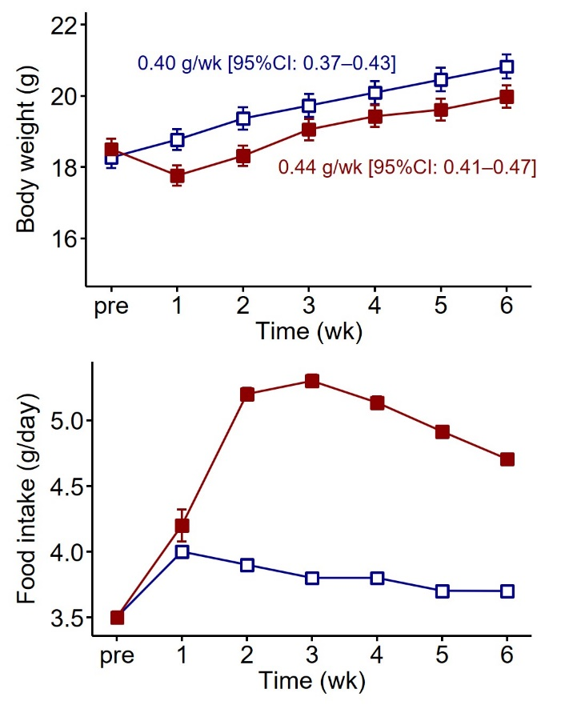
Figure S1. Body weight (top) and daily food intake (bottom) for mice in the control (dark blue) and stress (dark red) groups. Data are shown as the mean (symbols) and SEM (error bars, if visible) for six mice per group. Weekly weight gains shown in the upper panel were estimated using a linear mixed-effects model with week (wk), treatment, and their interaction as fixed effects and mouse as a random effect.
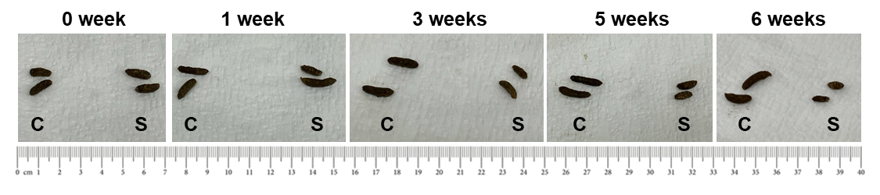
Figure S2. Representative photographs of fecal samples from mice in the control (C) and stress (S) groups. Collection time points are indicated.

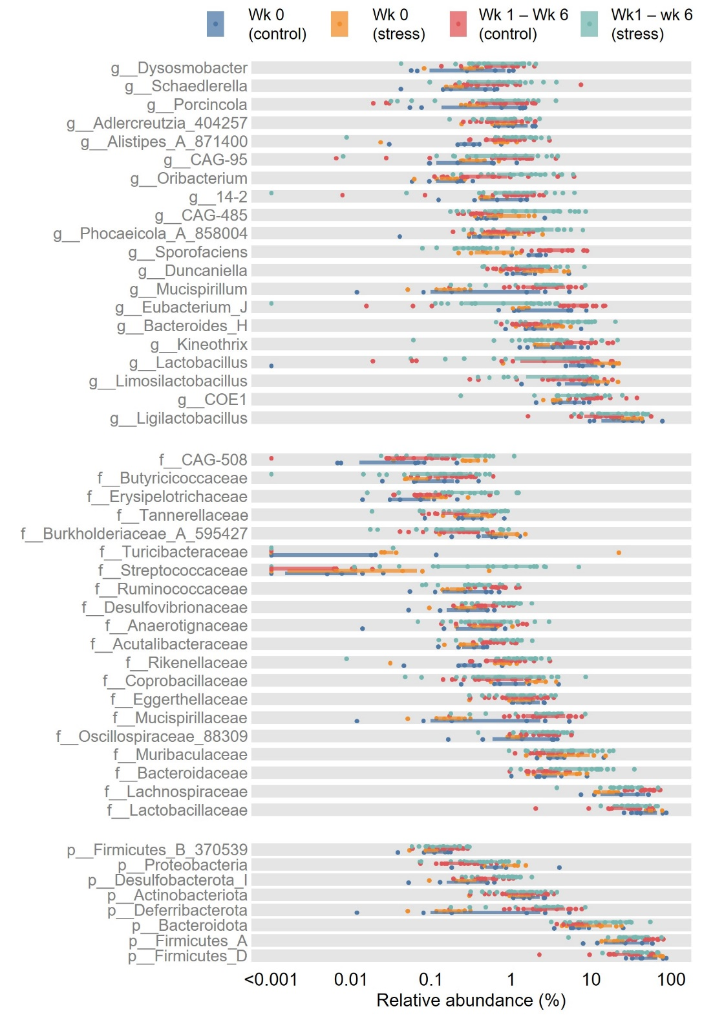
Figure S3. Overview of the most abundant phyla (bottom panel; top 8 by mean relative abundance), families (middle panel; top 20), and genera (top panel; top 20) across all fecal samples analyzed in this study. Line segments indicate the interquartile range, and symbols represent individual samples. Data are stratified according to the categories shown in the legend. This figure provides a descriptive overview of community composition across all sample categories, including week (wk) 0 and weeks 1–6 samples from both groups.
Figure S4. Compositional ordination plots (PCA based on Aitchison distances), as shown in the main text. Each facet represents an individual mouse (dark blue, control; dark red, stress). Numbers indicate sampling time points (weeks), and solid lines connect samples from the same mouse.
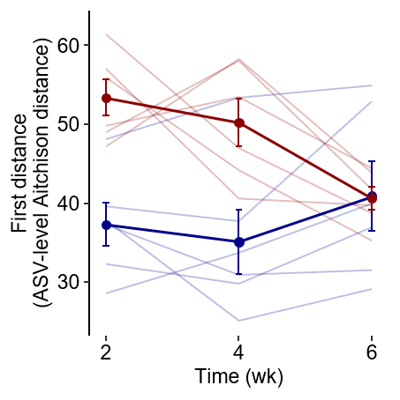
Figure S5. Community-level volatility of the gut microbiota in mice from the control (dark blue) and stress (dark red) groups, expressed as ASV-level Aitchison distances between samples collected at successive time points. Data are shown as mean (symbols) and SEM (error bars, if visible) for six mice per group. Thin lines represent individual mice.
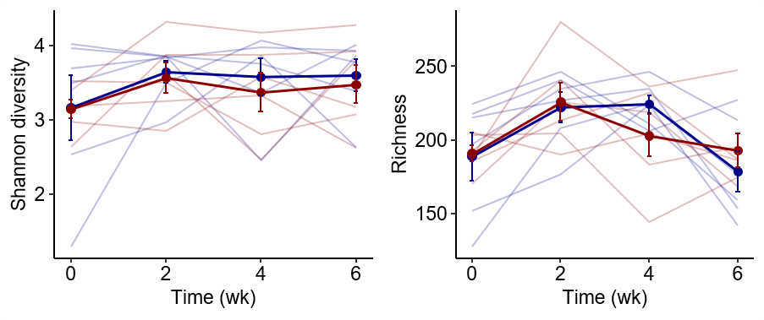
Figure S6. Gut microbiota alpha diversity in terms of ASV-level Shannon diversity (left panel) and richness (right panel). Colors indicate the control (blue) and stress (red) groups. Data are shown as mean (symbols) and SEM (error bars, if visible) for six mice per group. Thin lines represent individual mice.
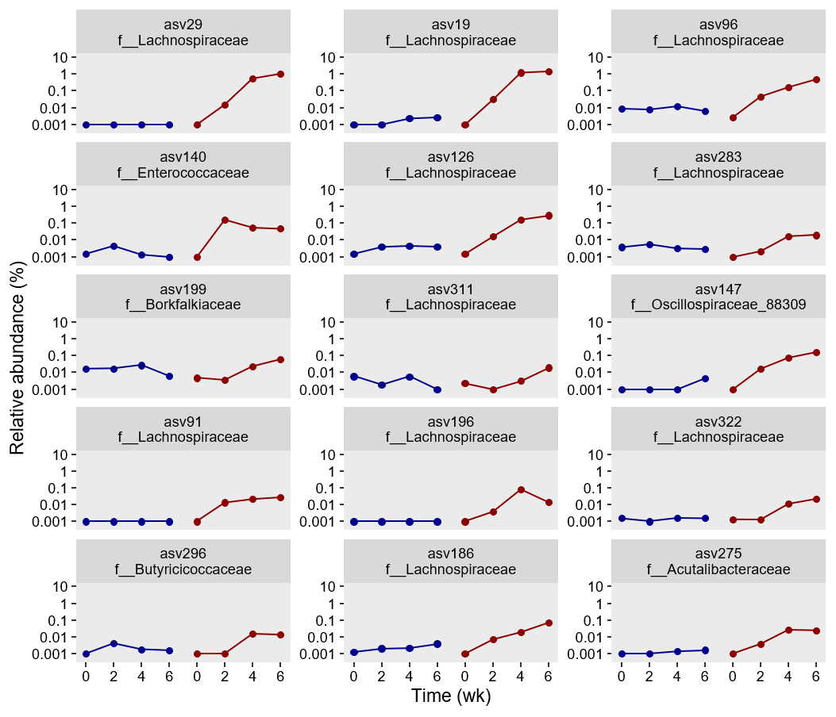
Figure S7. Relative abundances of ASVs with a significant interaction term (adjusted p-value < 0.1, effect size < 0). Thin lines indicate individual mice, and thick lines and symbols represent the geometric mean (with a pseudo-count of 0.001% for the relative abundances). Dark blue and dark red represent the control and stress groups, respectively.
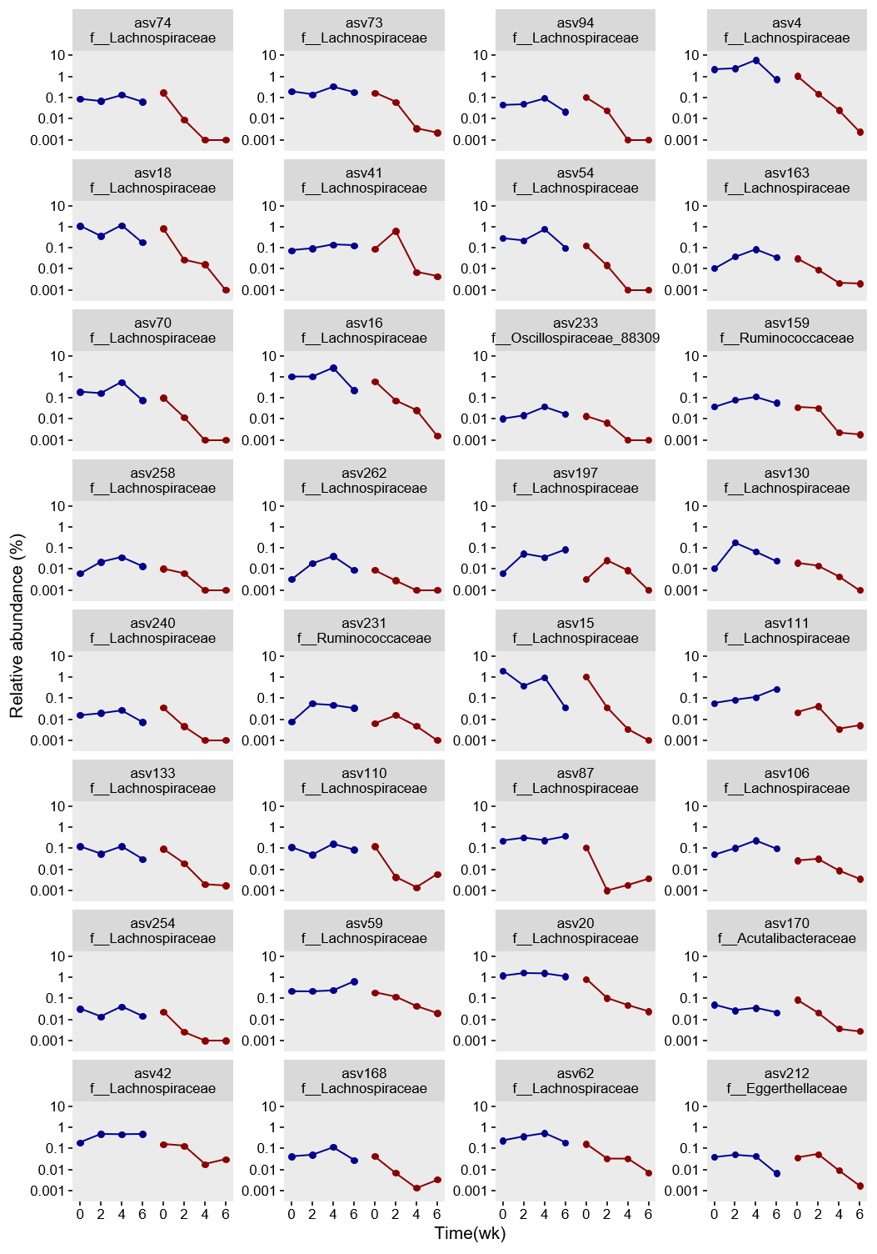
Figure S8. Relative abundances of ASVs with a significant interaction term (adjusted p-value < 0.1, effect size > 0). Thin lines indicate individual mice, and thick lines and symbols represent the geometric mean (with a pseudo-count of 0.001% for the relative abundances). Dark blue and dark red represent the control and stress groups, respectively.
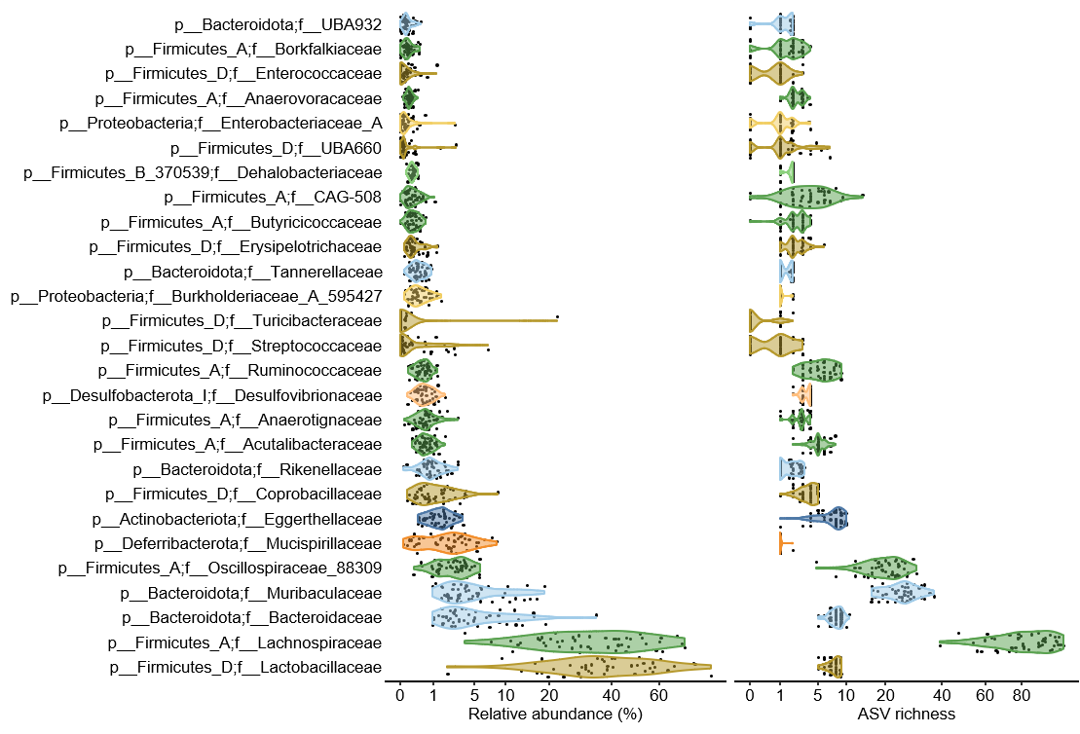
Figure S9. Overview of abundant and feature-rich families across samples. Displayed families represent the union of the 25 most abundant families and the 25 families with the highest feature richness (i.e., number of ASVs). Violin plots show the distribution of family abundances across samples and are colored according to phylum-level taxonomic affiliation; family names are indicated on the y-axis. Black symbols represent individual samples.

