Comprehensive profiling of bee venom metabolites by multiplatform metabolomics highlighting melittin and cytotoxic assessment against breast cancer cells
Sova Yadav¹, Vaibhav Arya², Vedant Gautam³, Debanjan Guin², and Samantapudi Venkata Satyanarayana Raju¹*
¹Department of Entomology and Agricultural Zoology, Institute of Agricultural Sciences, Banaras Hindu University, Varanasi, Uttar Pradesh, 221005, India
²Department of Chemistry, Institute of Science, Banaras Hindu University, Varanasi-221005, Uttar Pradesh, India
³Department of Mycology and Plant Pathology, Institute of Agricultural Sciences, Banaras Hindu University, Varanasi, Uttar Pradesh, 221005, India
Corresponding author:
*Vedant Gautam

Supporting information
Sample Preparation
Bee Species Identification (cox1 Barcoding)
Five worker bees were collected near the hive using a sweep net and immediately preserved in 70% ethanol. Genomic DNA was extracted from hind legs using the Qiagen DNeasy® Blood & Tissue Kit (Qiagen, Hilden, Germany) following the manufacturer's protocol for insect tissue. DNA concentration and purity were assessed using a Thermo Scientific NanoDrop 2000 spectrophotometer (A260/A280 > 1.8, A260/A230 > 2.0). The mitochondrial cox1 barcode region was PCR-amplified in 25 µL reactions using 12.5 µL 2X Thermo Scientific PCR Master Mix (Thermo Fisher Scientific), 9.5 µL nuclease-free water, and 0.5 µL of each primer: LCO-1490 (5′-GGT CAA CAA ATC ATA AAG ATA TTG G-3′) and HCO-2198 (5′-TAA ACT TCA GGG TGA CCA AAA AAT CA-3′) and 2 µL template DNA (~20 ng). PCR was performed on an Applied Biosystems Veriti Dx 96-well thermal cycler with the following program: initial denaturation 94°C/5 min; 35 cycles of 94°C/30 s, 47°C/40 s, 72°C/40 s; final extension 72°C/8 min. Amplicons were electrophoresed on 2% TAE agarose gels stained with ethidium bromide (Merck-Millipore) and visualized using a Syngene InGenius3 gel documentation system. Bands of ~650 bp were excised, purified, and subjected to Sanger sequencing by Eurofins Genomics India Pvt. Ltd. (Bangalore, India). Consensus sequences were identified using NCBI nBLAST (https://blast.ncbi.nlm.nih.gov/) against the nucleotide database (e-value < 1e−100, >98% identity) and deposited in NCBI GenBank
NMR Analysis.
Crude bee venom (15 mg) or synthetic melittin was accurately weighed into 2 mL Eppendorf tubes and solubilized in 500 µL D₂O with TSP as an internal standard (prepared at 1 mg/10 mL or 2 mg/20 mL in Milli-Q water). The mixture was vortexed (30 s) and centrifuged (5000 rpm, 2 min) to remove particulates. The clear supernatant (no turbidity observed) was transferred to a 5 mm Wilmad® NMR tube using a Pasteur pipette.
GC-MS Analysis
Samples (10 ± 0.1 mg) were solubilized in 1 mL HPLC-grade methanol, vortexed for 3 minutes, then centrifuged at 10,000 RPM for 6 minutes at 8°C. The supernatant was collected, passed through a 0.22 µm PTFE syringe filter, and transferred to a 2 mL GC-MS vial containing a micro-insert.
LC-MS Analysis
500 ± 5 mg sample underwent Soxhlet extraction with 10 mL methanol for 24 h. The extract was concentrated to near-dryness using a rotary evaporator (Büchi Rotavapor R-100) at 40°C under vacuum, reconstituted in 1 mL methanol, vortexed, and centrifuged (12,000 RPM, 6 min). The supernatant was transferred to an LC-MS vial.

Results
Confirmation of Apis mellifera via cox1 Barcoding
The following species was identified to be Apis mellifera, which was supported by NCBI accession number SUB15450413.
Metabolite Profiling of Bee Venom by NMR Spectroscopy
Identified compounds include amino acids, peptides, biogenic amines, indole derivatives, and small organic acids. Annotation was performed using HMDB, PubChem, and KEGG databases.
Table S1 NMR-based metabolite profiling of bee venom.
Metabolite | ppm | Intensity | HMDB | PubChem | KEGG | Class
Alanine | 1.5 | 1.2782 | HMDB0000109 | 605 | C00041 | Amino acid
Aspartate | 2.8 | 1.8609 | HMDB0000188 | 5860 | C00049 | Amino acid
Glycylproline | 3.9 | 1.2844 | HMDB0000940 | 114757 | C01229 | Dipeptide
Histidine | 7.1 | 0.4876 | HMDB0000189 | 6274 | C00135 | Amino acid, Aromatic amino acid
Histamine | 7.1 | 0.5978 | HMDB0000057 | 774 | C00388 | Biogenic amine, Amine, Histidine derivative
Isoleucine | 3.7 | 0.8364 | HMDB0000693 | 790 | C00407 | Amino acid, Branched-chain amino acid
Leucine | 1 | 0.3755 | HMDB0000687 | 6106 | C00123 | Amino acid, Branched-chain amino acid
Valine | 1 | 0.5038 | HMDB0000843 | 6287 | C00140 | Amino acid, Branched-chain amino acid
Isobutyrate | 1 | 0.6115 | HMDB0000624 | 260 | C00232 | Monocarboxylic acid and derivative
Isovalerate | 2 | 0.3186 | HMDB0000623 | 8899 | C00673 | Monocarboxylic acid and derivative
Serotonin | 7.3 | 0.3143 | HMDB0000216 | 5202 | C00569 | Biogenic amine, Indole, Neurotransmitter
5-Hydroxytryptophan | 7.3 | 0.196 | HMDB0001550 | 18512 | C00983 | Amino acid, Tryptophan derivative
N-Acetylserotonin | 1.9 | 0.3827 | HMDB0001238 | 903 | C00978 | Acyl amine, Indole derivative
Melatonin (trace) | 1.9 | 0.3761 | HMDB0000860 | 896 | C00827 | N-acetylamine, Indole derivative
γ-Methylhistidine | 3.7 | 0.6736 | HMDB0000479 | 50920 | C01188 | Amino acid derivative
Homovanillate (dopamine metabolite) | 3.9 | 0.3494 | HMDB0000118 | 7858 | C00401 | Methoxyphenol, Catecholamine metabolite
Acetate | 1.9 | 0.4635 | HMDB0000071 | 174 | C00033 | Carboxylate, Fatty acid
Acetoin | 2.2 | 0.3114 | HMDB0000593 | 179 | C00263 | Ketone, Alcohol
Acetone | 2.2 | 0.1318 | HMDB0000148 | 180 | C00079 | Ketone, Solvent

GC-MS
Table S2 Relative chromatographic peak distribution of HBV obtained by GC-MS
Peak No. | Retention Time (min) | Relative Peak Area (%)
1 | 3.72 | 1.86
2 | 5.04 | 0.24
3 | 5.39 | 8.95
4 | 5.82 | 1.04
5 | 6.18 | 3.52
6 | 6.51 | 1.58
7 | 6.92 | 7.54
8 | 7.12 | 1.68
9 | 7.51 | 3.98
10 | 8.07 | 0.41
11 | 9.14 | 2.32
12 | 9.27 | 6.31
13 | 9.75 | 0.12
14 | 10.02 | 28.63

LC-MS Survey scan
The LC-MS survey spectra reveal 40 additional essential compounds matching the NIST library, confirmed by their MS spectra.
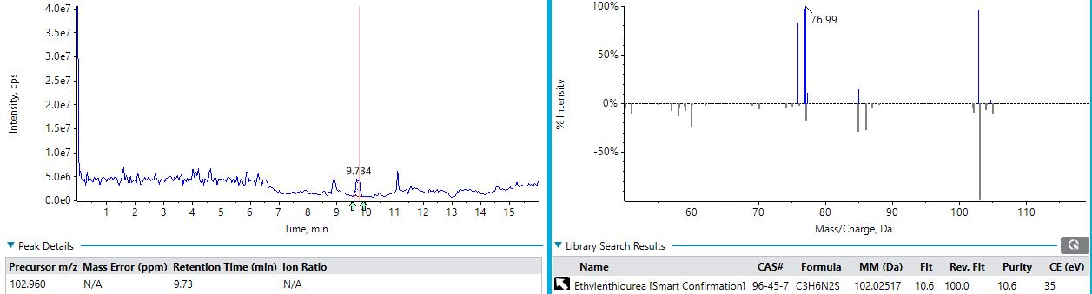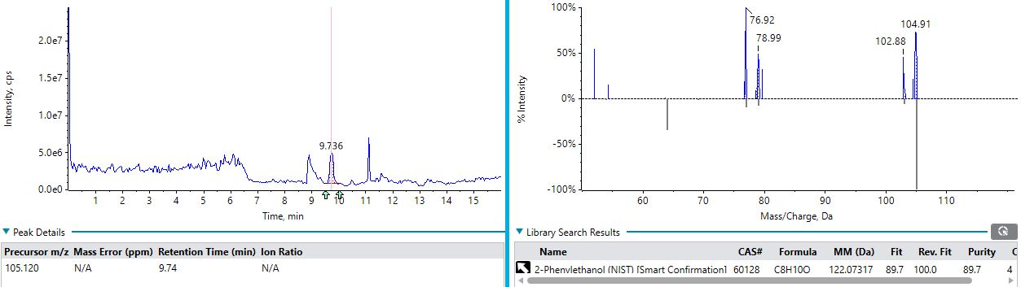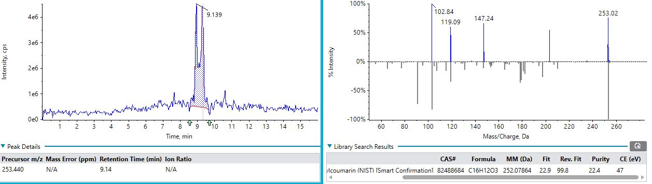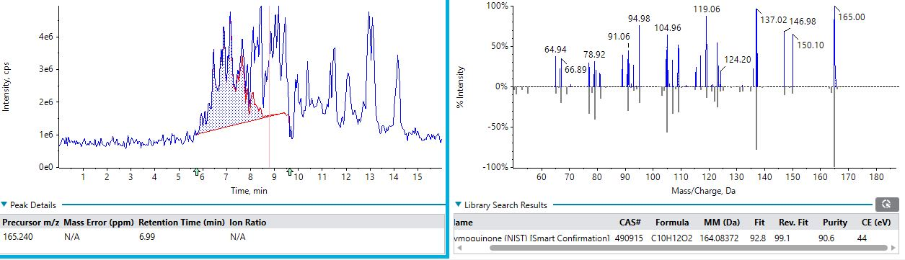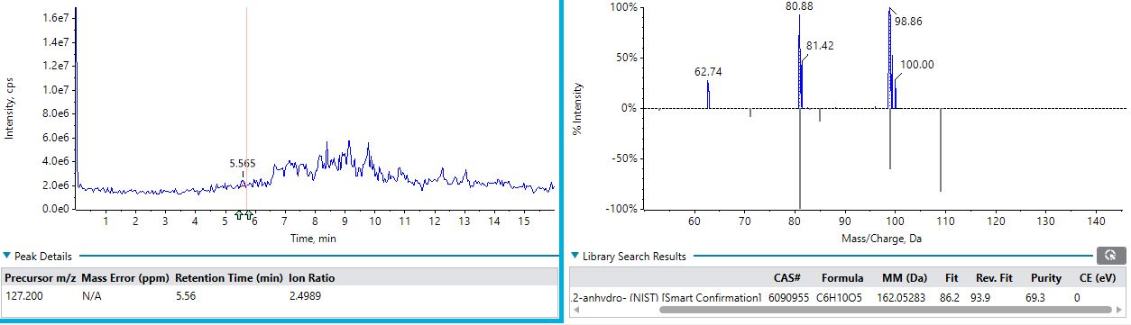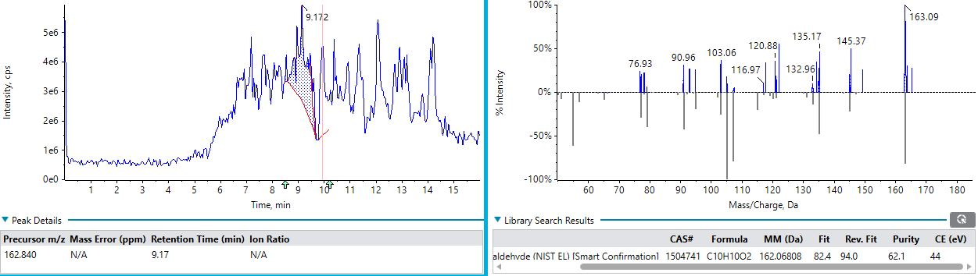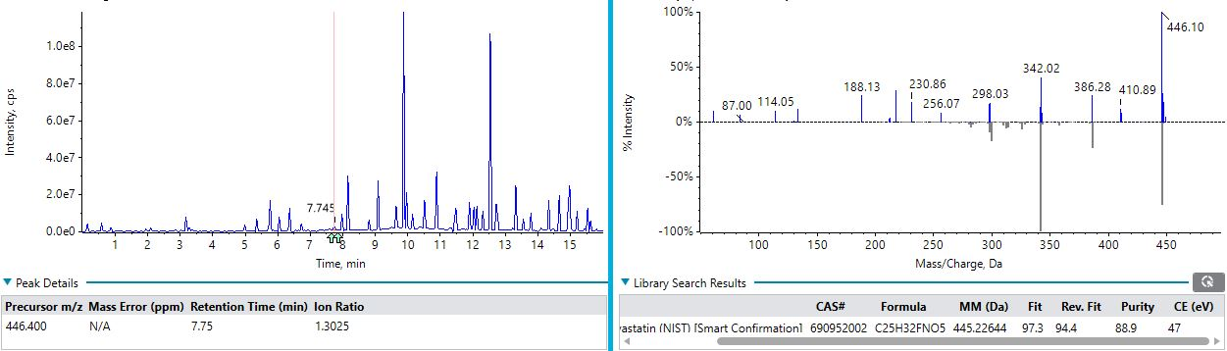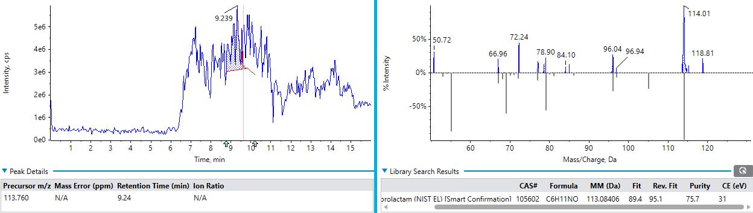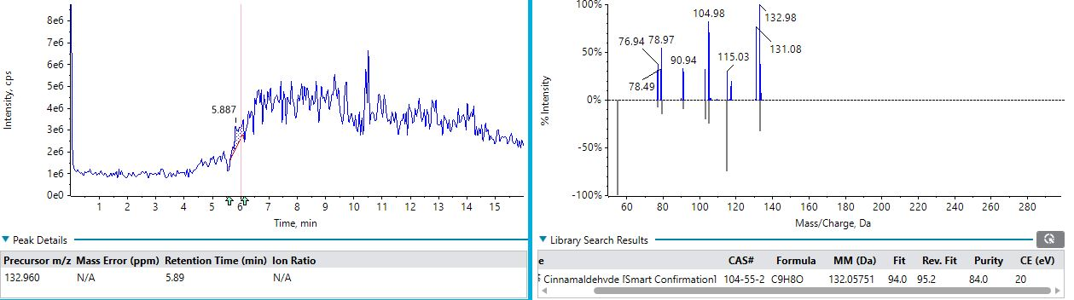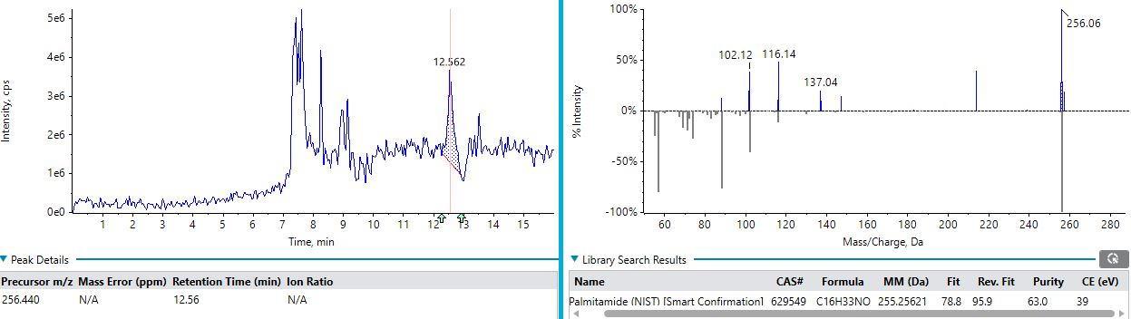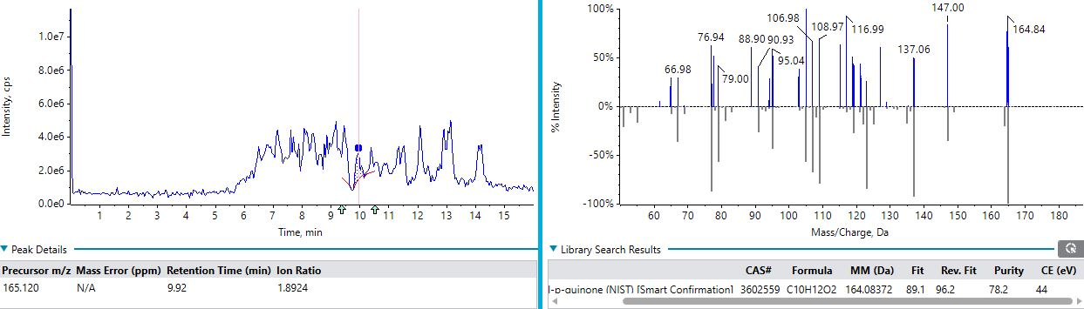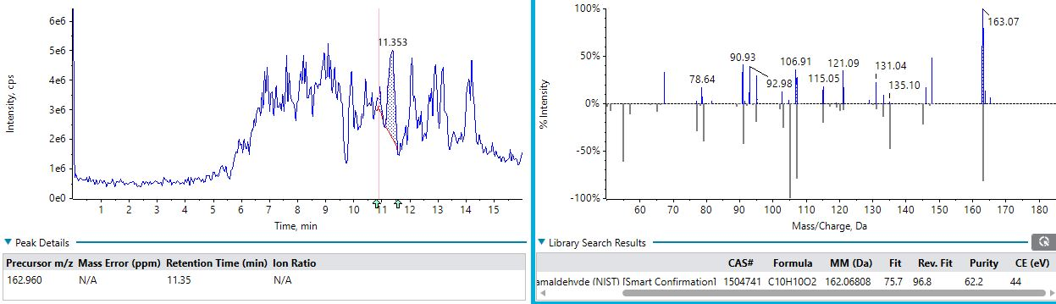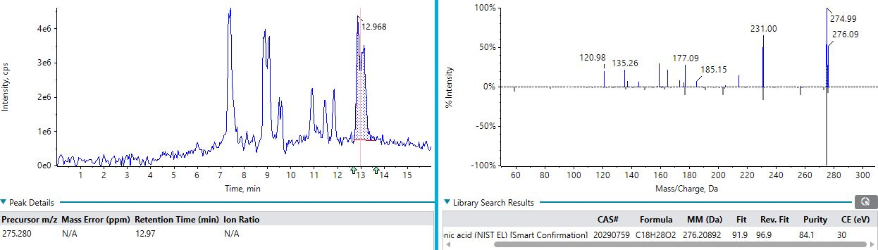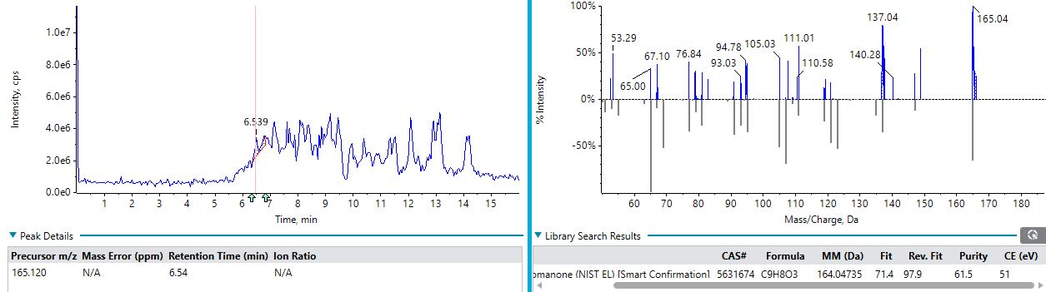
Fig. S1. Shows LC-MS survey scan and their respective MS spectra.
Table S3 LC-MS survey analysis of Bee venom
S.No. | Area | Retention Time | Found At Mass | Library Hit | Library Score | Proposed MSI level
1 | 39078061 | 5.91 | 256.9916 | Monolaurin | 96.6 | Level 2
2 | 3342846973 | 6.43 | 419.3811 | Isobutyryl coenzyme A | 91.8 | Level 2
3 | 14646683 | 5.31 | 108.1368 | N-Methylaniline | 91.1 | Level 2
4 | 4070444 | 14.79 | 315.3641 | Triethylamine | 86.2 | Level 2
5 | 100228968 | 4.47 | 345.185 | 7(S),17(S)-Dihydroxy-8(E),10(Z),13(Z),15(E),19(Z)-docosapentaenoic acid | 85 | Level 2
6 | 131742386 | 10.44 | 105.2619 | 4-Methylbenzyl alcohol | 84.7 | Level 2
7 | 11682336 | 14.35 | 149.4309 | Phthalic anhydride | 83.8 | Level 2
8 | 59724959 | 8.24 | 149.4205 | Anise oil | 83.2 | Level 2
9 | 1910281 | 0.16 | 153.5768 | .alpha.,.beta.-Thujone | 74.9 | Level 3
10 | 201773110 | 7.64 | 105.1705 | 2-Phenylethanol | 64.9 | Level 3
11 | 400558002 | 3.77 | 349.3328 | 5.beta.-Pregnan-3.alpha.,17,20.beta.,21-tetrol-11-one | 60.9 | Level 3
12 | 7061928 | 14.41 | 149.455 | cinnamic acid | 60.7 | Level 3
13 | 4770119 | 4.74 | 115.2164 | Peimine | 59.3 | Level 3
14 | 143942996 | 5.49 | 405.3098 | Ibuprofen .beta.-D-glucuronid | 58.3 | Level 3
15 | 69764487 | 4.52 | 432.4986 | Cyanidin-3-O-rhamnoside cation | 57 | Level 3
16 | 137881296 | 2.54 | 102.3036 | L-.alpha.-Amino-.gamma.-butyrolactone | 51.4 | Level 3
17 | 229026980 | 10.44 | N/A | 2-Pyridinemethanamine, N-4-(1,4,8,11-tetraazacyclotetradec-1-ylmethyl)phenylmethyl | 55.7 | Level 3
18 | 301483400 | 9.97 | 121.9186 | 2,6-Xylidine | 55.4 | Level 3
19 | 4722688 | 0.07 | 149.3305 | 4-Dimethylaminobenzaldehyde | 53.9 | Level 3
20 | 99259413 | 3.18 | 124.6107 | 1,2,3-Benzenetriol | 53.2 | Level 3
21 | 17991272 | 15.63 | 107.6027 | Methylhydroquinone | 52.6 | Level 3
22 | 14768866 | 6.42 | 129.6222 | 2-Hydroxy-N-methylsuccinimide | 52 | Level 3
23 | 30609241 | 7.64 | 279.297 | Triphenylphosphine oxide | 51.5 | Level 3
24 | 37052700 | 3.24 | N/A | 2-(4-Amino-1-piperidinyl)acetamide | 51.4 | Level 3
25 | 23645983 | 9.23 | 148.8892 | 5-Aminooxindole | 49.7 | Level 3 (low confidence)
26 | 84904703 | 1.24 | 281.1591 | 6-Hydroxy-3-(4-methoxyphenyl)-4-methylcoumarin | 48.7 | Level 3 (low confidence)
27 | 54138574 | 3.16 | 183.8824 | 4-Methoxy-3-nitrobenzyl alcohol | 47.3 | Level 3 (low confidence)
28 | 29741818 | 6.66 | 138.7071 | 2,3-Dimethylhydroquinone | 46.8 | Level 3 (low confidence)
29 | 7783628 | 2.3 | 104.6657 | Choline cation | 46.1 | Level 3 (low confidence)
30 | 17253702 | 7.62 | 149.4229 | Phthalic anhydride | 43.5 | Level 3 (low confidence)
31 | 43830667 | 6.24 | 316.5074 | Decanoyl-L-carnitine | 42.4 | Level 3 (low confidence)
32 | 66347681 | 2.54 | 191.3939 | Quinic acid | 41.6 | Level 3 (low confidence)
33 | 2887112 | 14,57 | 108.9292 | m-Cresol | 41.1 | Level 3 (low confidence)
34 | 4060637 | 4.81 | 283.0694 | Artemisinin | 40.5 | Level 3 (low confidence)
35 | 11260678 | 10.22 | 104.9745 | Ethyl glycolate | 40.4 | Level 3 (low confidence)
36 | 116916666 | 4.14 | 120.4125 | S-(2-Aminoethyl)isothiourea | 38.5 | Level 3 (low confidence)
37 | 3203214 | 13.43 | N/A | D-Erythronic acid .gamma.-lactone | 37.6 | Level 3 (low confidence)
38 | 6031703 | 14.73 | 121.2894 | 2,4-Dimethylphenol | 36.9 | Level 3 (low confidence)
39 | 24536328 | 9.27 | 117.1204 | 2-Deoxy-D-ribose | 35.9 | Level 3 (low confidence)
40 | 359755460 | 3.86 | 121.7925 | N,N-Dimethylaniline | 31.6 | Level 3 (low confidence)

Global Honey Bee Venom Metabolites Quantification
Table S4 Global Honey Bee Venom Metabolites Quantification Table
S.No | Continent/ Region | Country | Honey Bee Species | Major Quantified Components | Reported Values / Findings | Method | Reference
1 | Asia | China | Apis mellifera | Melittin, Apamin | Melittin 46–53%, Apamin 2.2–3.7% dry wt | HPLC-DAD-MS/MS | Zhou et al., 2010
2 | Asia | China | Apis cerana | Melittin | 33.9–46.23% dry wt | UPLC-QqTOF-MS | Huang et al., 2020
3 | Europe / Asia | Turkey | Apis mellifera anatoliaca | Melittin, Apamin, PLA₂ | Melittin 40.57%, Apamin 2.12%, PLA₂ 13.67% | HPLC / Biochemical assay | Tanuğur-Samanc et al., 2021
4 | Europe | Poland | Apis mellifera | 138 metabolites quantified | Amino acids, organic acids, sugars, biogenic amines, nucleosides detected | LC-MS / GC-MS metabolomics | Klupczynska et al., 2020
5 | Europe | Croatia | Apis mellifera | Melittin, PLA₂, Apamin | Review confirms melittin major peptide (40–60%) | Review | Gajski et al., 2024
6 | Middle East | Iran | Apis mellifera meda | Melittin, PLA₂, Hyaluronidase | Similar global ranges; melittin dominant | HPLC / Protein profiling | Sadek et al.,2024
7 | Middle East | Iraq | Apis mellifera | General venom composition | ≥18 active compounds reported | Review | Jaafar et al., 2025
8 | Africa | Egypt | Apis mellifera lamarckii | Melittin, PLA₂, Apamin | Regional studies report melittin as dominant peptide | HPLC / Electrophoresis | Sadek et al.,2024
9 | Africa | South Africa | Apis mellifera capensis | Peptides + enzymes | Species-specific venom variability noted | Proteomics | Reumont et al.,2022
10 | North America | USA | Apis mellifera | Melittin, PLA₂ | Standard composition widely used in biomedical studies | Commercial purified venom / LC methods | Fletcher et al., 1990; Reviews
11 | North America | Canada | Apis mellifera | Peptides, enzymes | Similar western honey bee profile | Analytical reviews | El Mehdi etal., 2022
12 | South America | Brazil | Africanized Apis mellifera | Melittin, Apamin, PLA₂ | Geographic variation reported | Proteomic / LC-MS | Sadek et al.,2024
13 | South America | Argentina | Apis mellifera | Melittin-rich venom | Similar global range | HPLC | El Mehdi etal., 2022
14 | Oceania | Australia | Apis mellifera | Melittin, PLA₂ | Typical western honey bee venom composition | LC-MS / Protein assay | Sadek et al.,2024
15 | Europe | Germany | Apis mellifera carnica | Peptides, enzymes | Chemotype differences with season/location | Proteomics | Reumont et al.,2022
16 | Europe | Italy | Apis mellifera ligustica | Melittin, PLA₂ | Similar European range | LC-MS | El Mehdi etal., 2022
17 | Europe | Spain | Apis mellifera iberiensis | Venom proteins & peptides | Geographic variability reported | Proteomics | Reumont et al.,2022
18 | Asia | India | Apis cerana indica, Apis mellifera | Melittin, PLA₂, Apamin | Limited quantified studies; expected species variation | HPLC / Future need highlighted | Sadek et al.,2024

Table S5 Melittin Quantification Worldwide
Species | Melittin (%) | Method | Area | Reference
Apis dorsata | 95.8 | HPLC | Muang District, (Thailand) | Somwongin et al., 2018
Apis mellifera | 76.5 | HPLC | Chiang Mai (Thailand) | Somwongin et al., 2018
Apis florea | 66.3 | HPLC | Mae Rim District (Thailand) | Somwongin et al., 2018
Apis cerana | 56.8 | HPLC | Saraphi District (Thailand) | Somwongin et al., 2018
Apis cerana | 33.9-46.2 | UPLC-QqTOF-MS | Wuhan (China) | Huang et al., 2020
Apis cerana F. | 59.3 | RP-HLPC | Sonargaon  (Bangladesh) | Mumu et al., 2017
Apis mellifera | 48.5 | LCMS | Varanasi, (India) | Current research

Reference:
- Zhou, J., Zhao, J., Zhang, S., Shen, J., Qi, Y., Xue, X., Li, Y., Wu, L., Zhang, J., Chen, F. and Chen, L., (2010). Quantification of melittin and apamin in bee venom lyophilized powder from Apis mellifera by liquid chromatography–diode array detector–tandem mass spectrometry. Anal Biochem 404(2): pp.171-178.
- Huang, S., Wang, J., Guo, Z., Wang, Y. and Liu, C., (2020). Quantitative measurement of melittin in Asian honeybee venom using a new method including UPLC-QqTOF-MS. Toxins, 12(7): p.437.
- Tanuğur-Samanc, A.E. and Kekeçoğlu, M., (2021). An evaluation of the chemical content and microbiological contamination of Anatolian bee venom. PLoS One, 16(7), p.e0255161.
- Klupczynska, A., Plewa, S., Dereziński, P., Garrett, T.J., Rubio, V.Y., Kokot, Z.J. and Matysiak, J., (2020). Identification and quantification of honeybee venom constituents by multiplatform metabolomics. Scientific Reports, 10(1), p.21645.
- Gajski, G., Leonova, E. and Sjakste, N., (2024). Bee venom: composition and anticancer properties. Toxins, 16(3), p.117.
- Sadek, K.M., Shib, N.A., Taher, E.S., Rashed, F., Shukry, M., Atia, G.A., Taymour, N., El-Nablaway, M., Ibrahim, A.M., Ramadan, M.M. and Abdelkader, A., (2024). Harnessing the power of bee venom for therapeutic and regenerative medical applications: an updated review. Frontiers in pharmacology, 15, p.1412245.
- Jaafar, F.S. and Albushabaa, S.H.H., (2025). General study of honey bee venom Apis mellifera: A Review. J. Appl. Health Sci. Med, 5(1), pp.12-18.
- von Reumont, B.M., Anderluh, G., Antunes, A., Ayvazyan, N., Beis, D., Caliskan, F., Crnković, A., Damm, M., Dutertre, S., Ellgaard, L. and Gajski, G., (2022). Modern venomics—Current insights, novel methods, and future perspectives in biological and applied animal venom research. GigaScience, 11, p.giac048.
- Fletcher, J.E., Michaux, K. and Jiang, M.S., (1990). Contribution of bee venom phospholipase A2 contamination in melittin fractions to presumed activation of tissue phospholipase A2. Toxicon, 28(6), pp.647-656.
- El Mehdi, I., Falcão, S.I., Boujraf, S., Mustapha, H., Campos, M.G. and Vilas-Boas, M., (2022). Analytical methods for honeybee venom characterization. Journal of advanced pharmaceutical technology & research, 13(3), pp.154-160.
- Somwongin, S., Chantawannakul, P. and Chaiyana, W., (2018). Antioxidant activity and irritation property of venoms from Apis species. Toxicon, 145, pp.32-39.
- Mumu, N.N., Sarker, M., Islam, M.R., Akand, S. and Bashar, M.A., (2017). Some morphological aspects of Asian honey bee (Apis cerana) and isolation of its melittin content. Journal of Biodiversity Conservation and Bioresource Management, 3(2), pp.77-84.
- Huang, S., Wang, J., Guo, Z., Wang, Y. and Liu, C., (2020). Quantitative measurement of melittin in Asian honeybee venom using a new method including UPLC-QqTOF-MS. Toxins, 12(7), p.437.

