Supplementary Figure 1. DeLong test correlation heatmap of 11 base models and their corresponding Stacking ensemble models.
Supplementary Figure 2. Decision curve analysis (DCA) of 11 base models and their corresponding Stacking ensemble models.

Supplementary Figure 1. DeLong test correlation heatmap of 11 base models and their corresponding Stacking ensemble models.
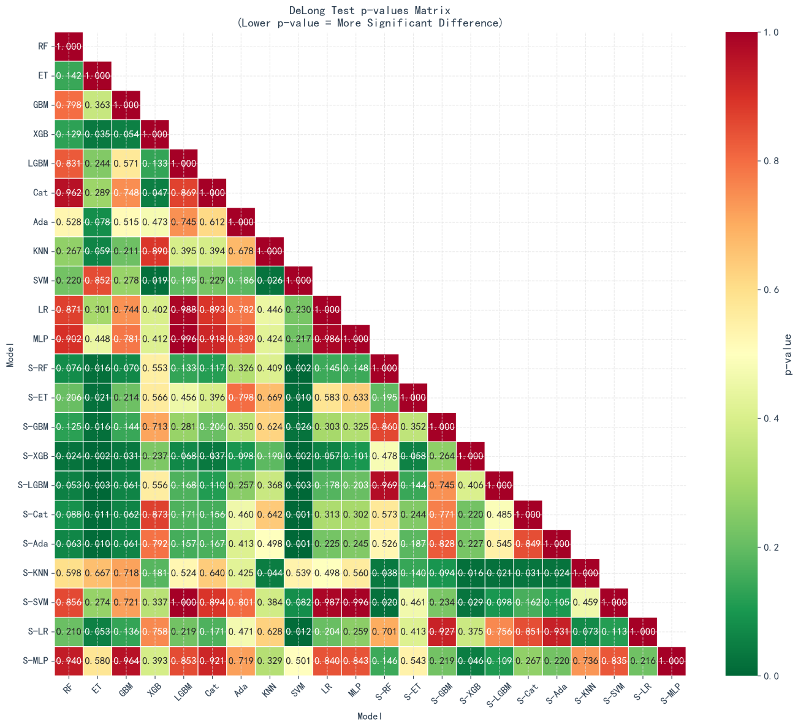

Supplementary Figure 2. Decision curve analysis (DCA) of 11 base models and their corresponding Stacking ensemble models.
