Specific targeting of cancer cell mitochondria with a malaria drug improves
pancreatic cancer outcome

Yan Ou, Adrian Lim, Ruoxiang Wang, Nora Mir, Vinicius F. Calsavara, Qiang Wang, Yi Zhang, Stephen J. Pandol, Mouad Edderkaoui

Supplementary Material:

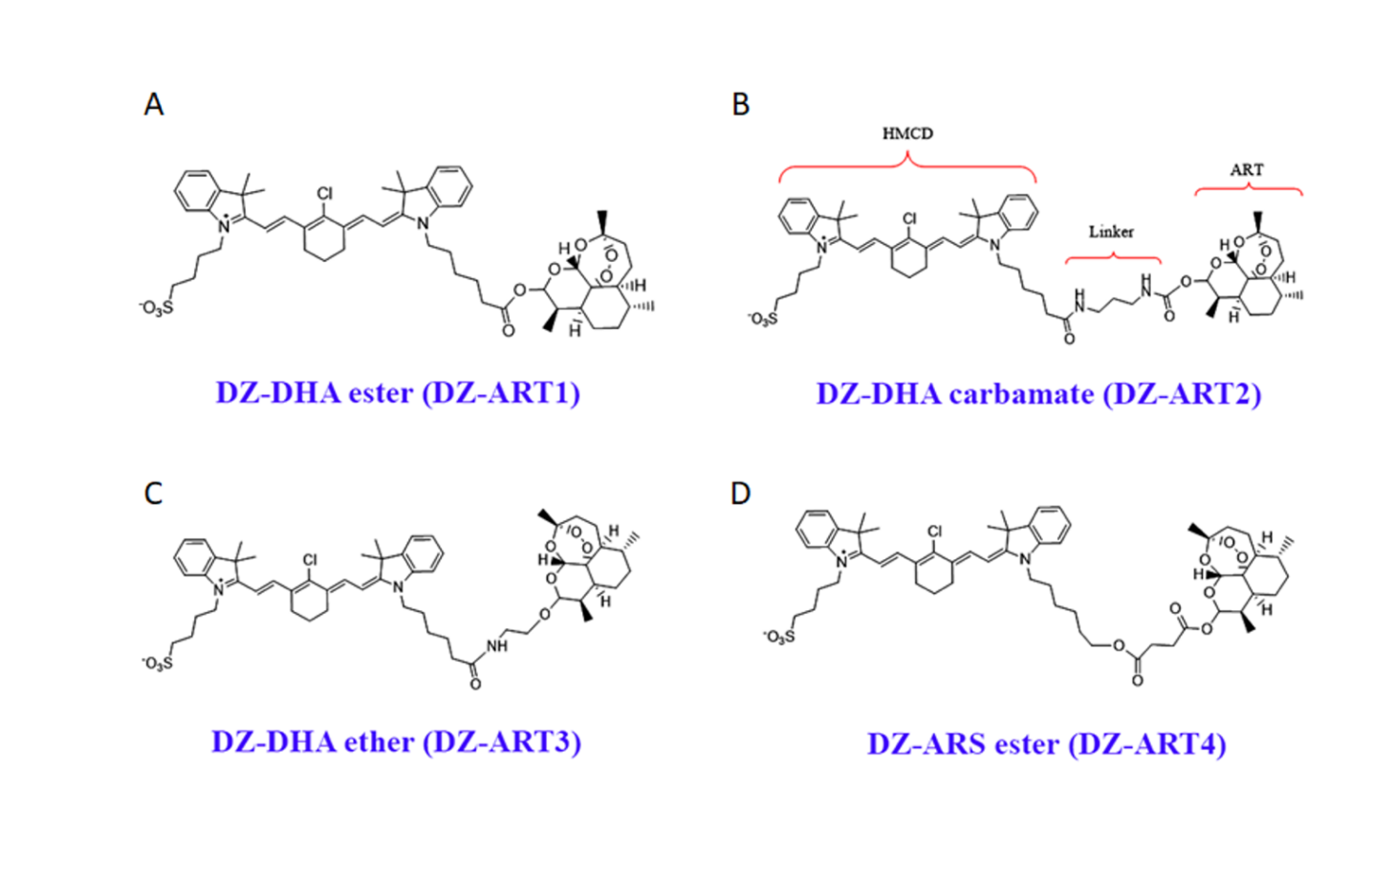

Supplementary Figure 1: Chemical structures of DZ-ART1, 2, 3, and 4.

Supplementary Figure 2: DZ-ART1 does not affect ferroptosis in PDAC cells.
Ferroptosis was assessed by measuring the level of Lipid peroxidation using the fluorescent probe BODIPY™ 581/591 C11. MIA PaCa-2 and BxPC3 cells were seeded in 6-well plates and cultured under standard conditions overnight. Cells were then treated with the vehicle, DZ-ART1 (5 µM), or with RSL3 (5 µM) used as a positive control to induce ferroptosis and lipid peroxidation. Following treatment for 48 hours, cells were incubated with BODIPY 581/591 C11 at a final concentration of 5 μM for 60 minutes at 37°C in the dark. Cells were then washed with PBS to remove excess dye, and fluorescence signals were detected using the SA7000 imaging system. Data is representative of 3 repetitive experiments.

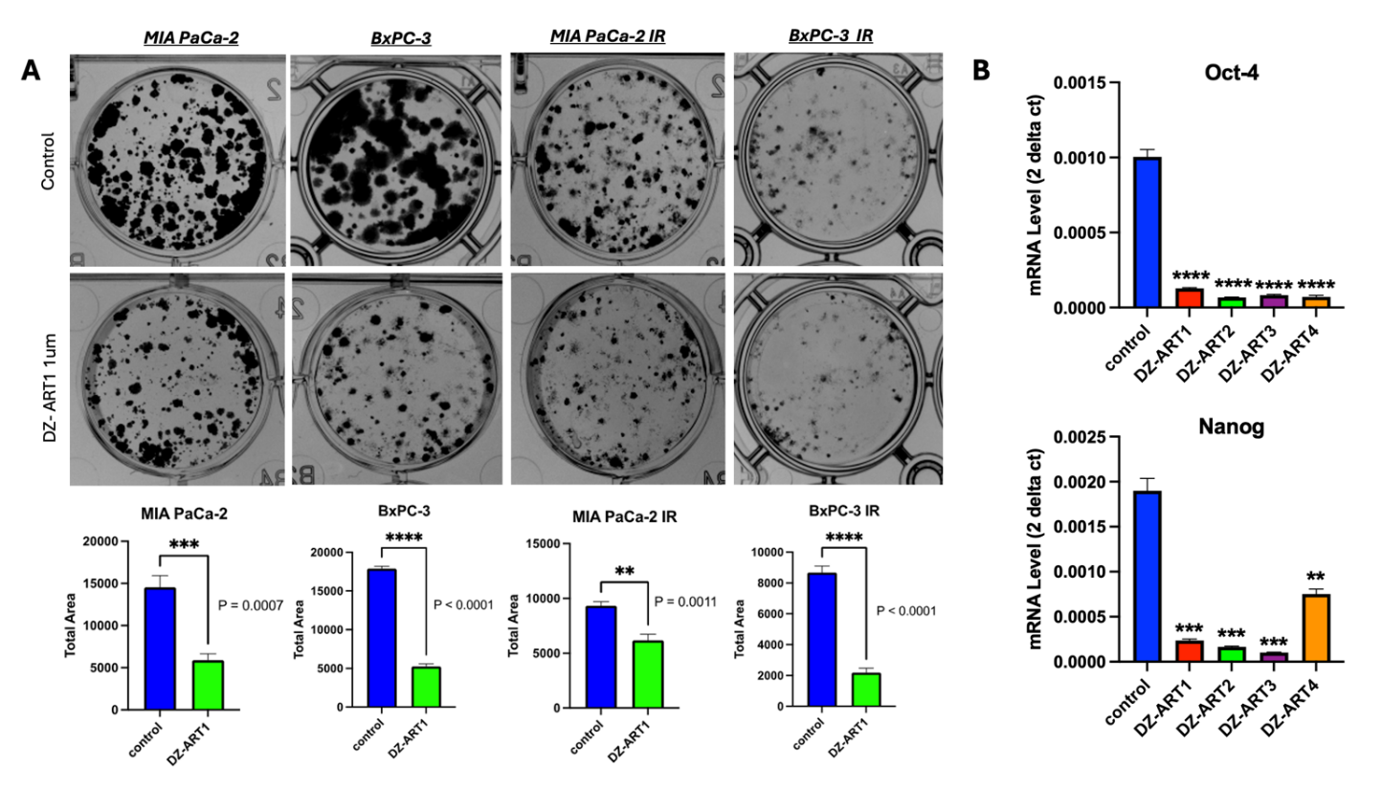

Supplementary Figure 3: DZ-ART1 decreases PDAC cells colony formation and the mRNA level of cancer stemness markers.
Human MIA PaCa-2 (A, B) and BxPC3 (A) wild type and Irinotecan-resistant (IR) PDAC cells were cultured for 1 week with 1 µM of DZ-ART1 or with control vehicle. In A, Colony formation was quantified and represented. In B, mRNA levels of Oct-4 and Nanog were measured by RT-PCR. Each experiment was repeated 3 times. **, p <0.01, ***, p <0.005, ****, p <0.001 vs. control.

Supplementary Figure 4: DZ-ART1 decreases PDAC cell migration.
Cell migration measured by the scratch test in MIA PaCa-2 and BxPC3 cell lines with and without IR and treated with DZ-ART1 (1µM) for indicated times (A-D). Each experiment was repeated 3 times.

Supplementary Figure 5: DZ-ARTs accumulate in PDAC cells significantly more than in normal cells.
Quantification of the NIR fluorescence in PDAC cells and normal pancreatic ductal cells (HPDE) treated with indicated doses of DZ-ARTs for the indicated times. Following treatment with DZ-ARTs for 1 hour, cells were washed with phosphate-buffered saline (PBS) to remove excess extracellular compound and kept with media without DZ-ART. Each experiment was repeated 3 times.

Supplementary Figure 6: Inhibitors of OATPs decreases the level of DZ-ART1 accumulated in PDAC cells.
Quantification of the NIR fluorescence in PDAC cells treated with DZ-ART1 (5 µM) for indicated times with and without OATP inhibitors ursonic acid (50 µM), Ursodeoxycholic acid (25 µM), Mulberrin (10 µM), and Benzbromarone (25 µM). Following treatment with DZ-ART1, cells were washed with phosphate-buffered saline (PBS) to remove excess extracellular compound and kept with media without DZ-ART1. Each experiment was repeated 3 times.

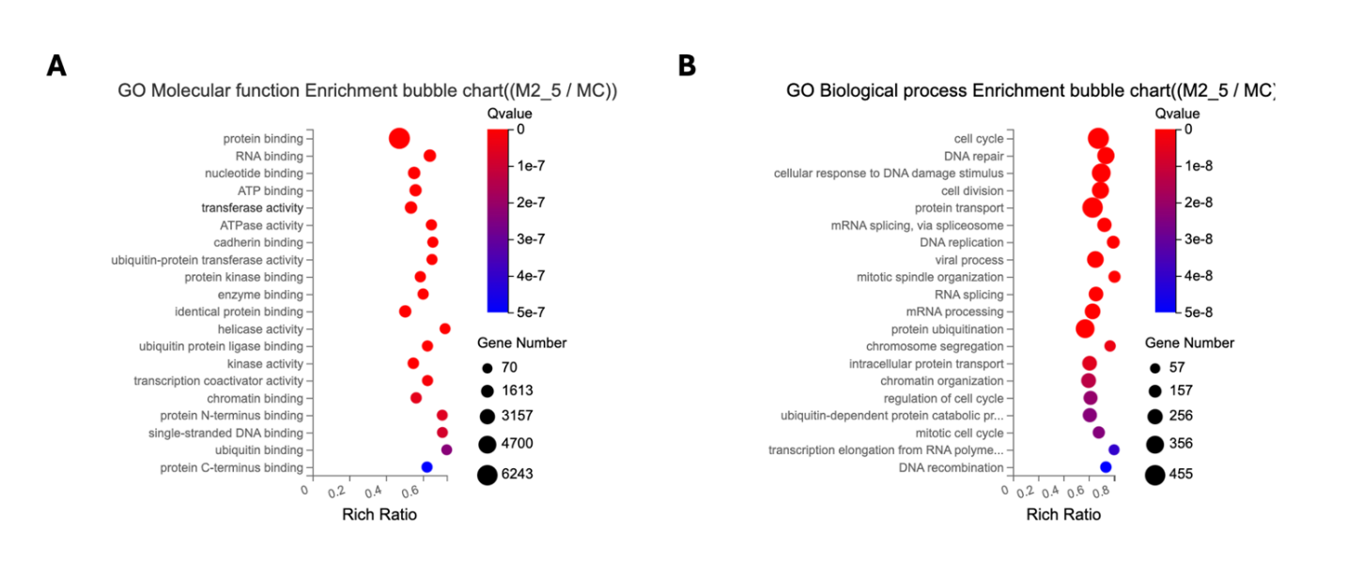

Supplementary Figure 7: Gene Ontology enrichment analyses of DZ-ART1-regulated genes.
Gene Ontology Molecular Function enrichment showing top functional categories of DEGs (A). Gene Ontology Biological Process enrichment highlighting key pathways such as cell cycle regulation and DNA repair (B). Bubble size indicates gene count, and color reflects adjusted q-value significance.

