Supplementary Information

IFI30 Protects Against Atherosclerotic Progression by Reducing Macrophage Foam Cell Formation and Oxidative Stress

Supplemental Tables

Table S1 siRNA sequence list
Name | Species |  | sequence,5'-3'
CY3 siRNA NC |  | Human | F: CY3-UUCUCCGAACGUGUCACGUTT
 |  |  | R: ACGUGACACGUUCGGAGAATT
siRNA NC  siIFI30-1  CY3 siRNA NC  siRNA NC  siIFI30 |  | Human  Human  Mice  Mice  Mice | F: UUCUCCGAACGUGUCACGUTT  R: ACGUGACACGUUCGGAGAATT  F: GCGUUAGACUUCUUUGGGAAUTT  R: AUUCCCAAAGAAGUCUAACGCTT  F: CY3-UUCUCCGAACGUGUCACGUTT  R: ACGUGACACGUUCGGAGAATT  F: UUCUCCGAACGUGUCACGUTT  R: ACGUGACACGUUCGGAGAATT  F: AGUAAAGGCAUAACCUCAAACTT  R: GUUUGAGGUUAUGCCUUUACUTT

Table S2 Western blot antibody information
Antibodies | Source |  | Item number
IFI30 |  | Proteintech |  | 11597-1-AP
IFI30 |  | Immunoway |  | YN3048
CD36  SR-A1  LOX-1  ABCA1  ABCG1  ACAT1  NRF2  KEAP1  HO-1  xCT  SOD2  Tublin |  | Abcam  Abways  Bioss  Immunaway  Proteintech  Abways  Proteintech  Abways  Abways  Abways  Abways  Affinity Biosciences |  | AB252923  CY7027  bsm-63648R  YN2847  13578-1-AP  DY1745  66504-1-Ig  CY8804  CY8761  CY7046  CY5977  T0033

Table S3 Primer information.

Primers | Species |  | Sequence, 5'-3'
IFI30 |  | human | Forward: GCTGTCGCCAGACACTATCA
 |  |  | Reverse: TGGCAGACAAGGGTAAGGAG
GAPDH  IFI30  GAPDH  CD36  SRA  LOX-1  ACAT1  ABCG1  ABCA1  SOD2  KEAP1  NRF-2  HO-1  xCT |  | human  mice  mice  human  human  human  human  human  human  human  human  human  human  human | Forward: ACACCCACTCCTCCACCTTTG  Reverse: TCCACCACCCTGTTGCTGTAG  Forward: TTCTGCTTCTGCTGTTCCCACTC  Reverse: CGGACGAGGAAGTAGCGACAAG  Forward: GACTCCACTCACGGCAAATTCAAC  Reverse: GACACCAGTAGACTCCACGACATAC  Forward: GTGATGATGAACAGCAGCAACATTC  Reverse: GTCCTCAGCGTCCTGGGTTAC  Forward: TGCACAAGGCAGCTCACTTTGG  Reverse: GTGCAAGTGACTCCAGCATCTTC  Forward: GAAACCCTTGCTCGGAAGCTGA  Reverse: CAGATCCAGTCTTGCGGACAAG  Forward: CTGACGCTGCTGTAGAACCTATTG  Reverse: GGCTTCATTTACTTCCCACATTGC  Forward: ATTCAGGGACCTTTCCTATTCGG  Reverse: CTCACCACTATTGAACTTCCCG  Forward: TGGTGTTCTTCCTCATTACTGTTCTG  Reverse: CCGCCTCACATCTTCATCTTCATC  Forward: GGCCTACGTGAACAACCTGAA  Reverse: CTGTAACATCTCCCTTGGCCA  Forward: ATCTTCGAGGAGCTCACCCT  Reverse: CTGGGGTTGTAAGCCTCCAG  Forward: CACATCCAGTCAGAAACCAGTGG  Reverse: GGAATGTCTGCGCCAAAAGCTG  Forward: AAGACTGCGTTCCTGCTCAAC  Reverse: AAAGCCCTACAGCAACTGTCG  Forward: GGTCCATTACCAGCTTTTGTACG  Reverse: AATGTAGCGTCCAAATGCCAG

Table S4 Immunofluorescence antibody information
Antibodies | Source |  | Item number
IFI30  IFI30 |  | NSJ Bioreagents  Proteintech |  | RQ5820  11597-1-AP
CD68 |  | Servicebio |  | GB153109
F4/80  vWF  α-SMA  AlexaFluor®488  AlexaFluor®594 |  | Servicebio  Servicebio  Servicebio  Abcam  Abcam |  | GB113373  GB11020  GB111364  AB150077  Ab150120

Table S5 GSE100927 IFI30 expression summary
Group | n | mean | sd | median | IQR
Control | 12 | 9.391666667 | 1.064611182 | 9.635 | 1.9275
Atherosclerosis | 29 | 11.18896552 | 0.349727903 | 11.21 | 0.27

Table S6 GSE100927 IFI30 limma result
 | logFC | AveExpr | t | P.Value | adj.P.Val | B
IFI30 | 1.797298851 | 10.66292683 | 8.553594126 | 8.45E-11 | 1.77E-09 | 14.47413789

Table S7 GSE159677 IFI30 expression in celltypes
celltype | gene | p_val | avg_log2FC | pct.1 | pct.2 | p_val_adj
Macrophages | IFI30 | 5.12E-12 | 0.1962765 | 0.724 | 0.585 | 1.16E-07
NK cells | IFI30 | 2.80E-01 | 0.6217134 | 0.017 | 0.014 | 1.00E+00
B cells | IFI30 | 1.12E-01 | 0.4638494 | 0.146 | 0.122 | 1.00E+00
Fibroblasts | IFI30 | 1.03E-05 | 2.0800006 | 0.037 | 0.01 | 2.34E-01
Endothelial cells | IFI30 | 1.14E-02 | -0.1818804 | 0.024 | 0.035 | 1.00E+00
VSMCs | IFI30 | 5.47E-01 | 0.9224815 | 0.018 | 0.016 | 1.00E+00
Mast cells | IFI30 | 9.30E-02 | 2.8817908 | 0.036 | 0 | 1.00E+00
pDC | IFI30 | 8.53E-01 | -0.1310724 | 0.383 | 0.345 | 1.00E+00

Table S8 Bodyweights and lipids of the mice in each group
Item | AAV-control |  | AAV-shIfi30 |  | P-value
Bodyweight (g)  TC (mmol/L)  TG (mmol/L)  LDL-C (mmol/L) |  | 34.60±0.76  13.21±0.53  1.77±0.18  10.82±0.69 |  | 35.04±1.09  14.60±1.05  1.85±0.30  9.88±0.52 | 0.7432  0.2625  0.8183  0.3001
HDL-C (mmol/L) |  | 2.31±0.14 |  | 2.03±0.10 | 0.1310
Note: The data are expressed as the mean± standard error of the mean (SEM). P-values are shown in the table. Two-tailed unpaired t-test. (n = 7)

Supplemental Figures

Fig. S1 Immunofluorescence staining of IFI30 in aortic root of ND- and HFD-fed ApoE⁻/⁻ mice
(A) IFI30 (red) and DAPI (blue) staining in aortic root sections of ND-and HFD-fed mice. Scale bar: 50 μm.

Fig. S2 Establishment of THP-1-derived macrophage foam cell model. (A) Representative images of ORO staining in THP-1-derived macrophages are shown (n = 6). (B) Quantification of ORO staining in THP-1-derived macrophages are shown (n = 6). Scale bar: 20 μm. Note: Data are presented as mean ± SEM. **p < 0.01.

Fig. S3 Validation of knockdown efficiency and overexpression efficiency in THP-1-derived macrophage and THP-1cells. (A)Knockdown efficiency of siIFI30-1/2/3 in THP-1-derived macrophage (n = 4). (B) Overexpression efficiency in THP-1cells (n = 6). Note: All RT-qPCR data were normalized to GAPDH. Data are presented as mean ± SEM. ****p < 0.0001.

Fig. S4 IFI30 expression negatively correlates with ACAT1 and positively correlates with KEAP1/NRF2 pathway activity. THP-1-derived macrophages were treated with ox‑LDL (80 μg/ml, 48 h) and divided into: siNC (ox‑LDL + negative control siRNA), siIFI30 (ox‑LDL + IFI30‑specific siRNA), EV (ox‑LDL + empty vector), and OE‑IFI30 (ox‑LDL + IFI30 expression vector). (A) Lipid metabolism-related mRNAs (CD36, SR-A1, LOX-1, ABCA1, ABCG1 and ACAT1) in siNC and siIFI30 groups. (B). Lipid metabolism-related mRNAs (CD36, SR-A1, LOX-1, ABCA1, ABCG1 and ACAT1) in EV and OE-IFI30 groups. (C) Oxidative stress-related mRNAs (NRF2, KEAP1, xCT, HO-1 and SOD2) in siNC and siIFI30 groups. (D) Oxidative stress-related mRNAs (NRF2, KEAP1, xCT, HO-1 and SOD2) in EV and OE-IFI30 groups. Note:
All RT-qPCR data were normalized to GAPDH (n = 4). Data are presented as mean ± SEM. *p < 0.05, ns p>0.05.

Fig. S5 siRNA screening and knockdown efficiency verification
(A) Knockdown efficiency of siIFI30-1/2/3 in BMDMs and RT-qPCR data were normalized to GAPDH (n = 3). (B, C) IFI30 protein expression was assessed by western blot (B) and quantification normalized to β‑actin (C) (n = 6).

Original gels in main figures

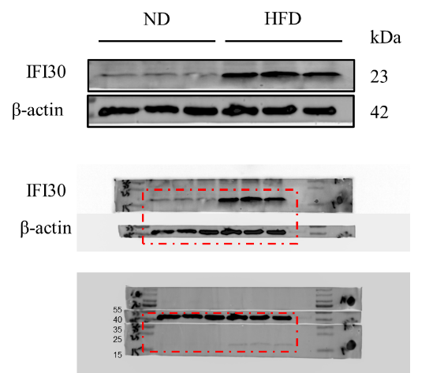
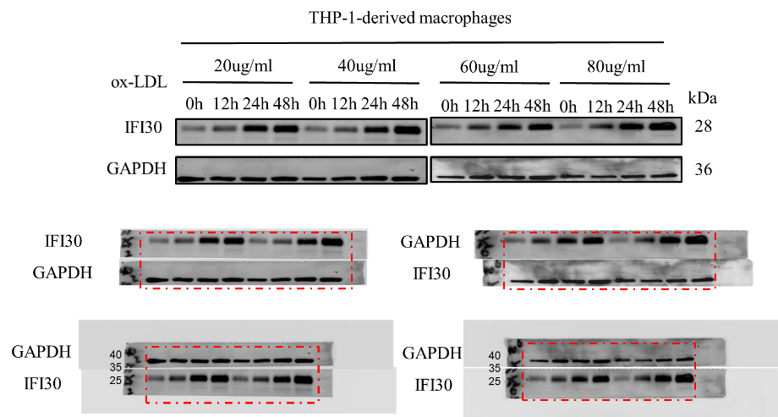
The original gels for Fig.1D The original gels for Fig.2A

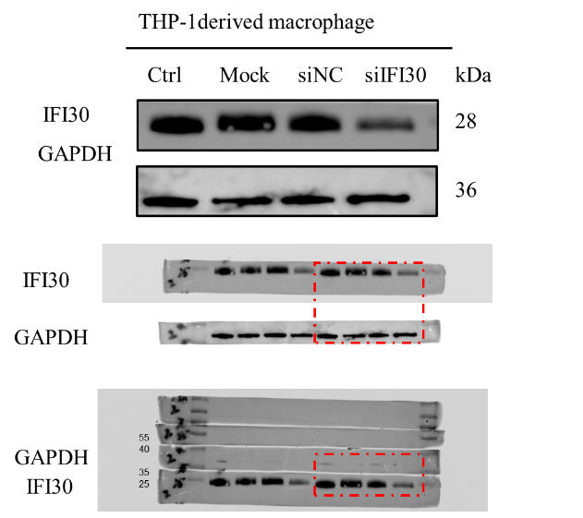
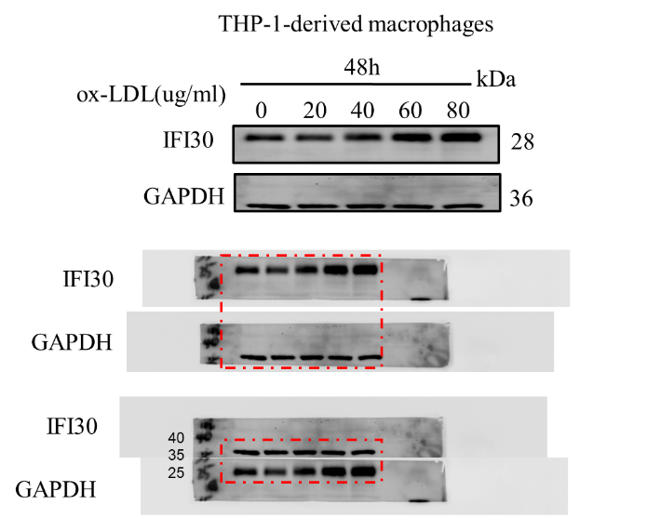
The original gels for Fig.2C The original gels for Fig.3A

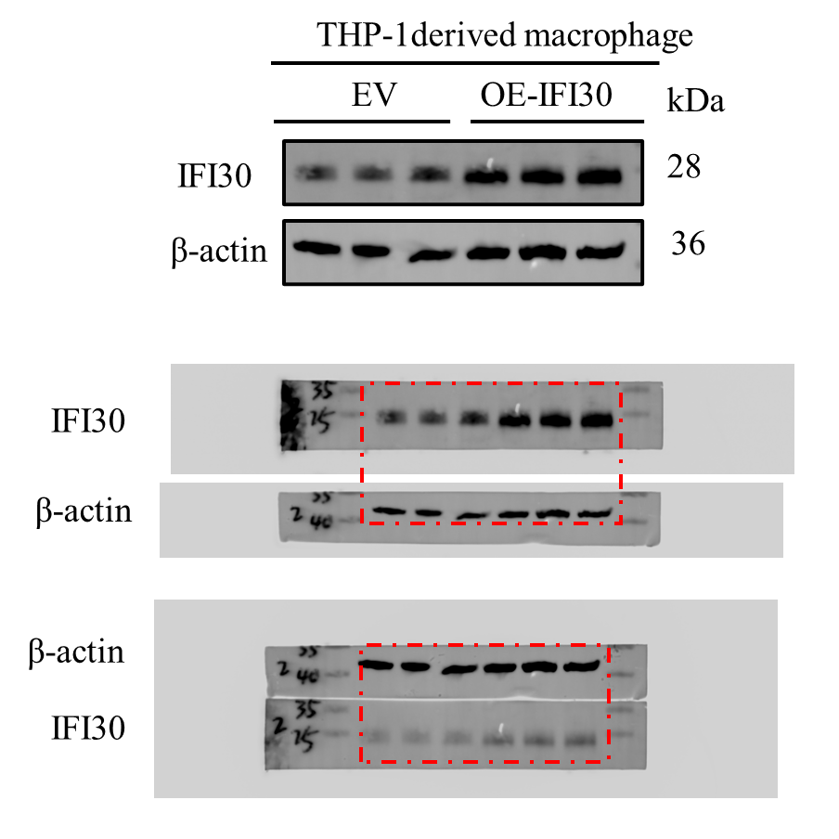
The original gels for Fig.3C
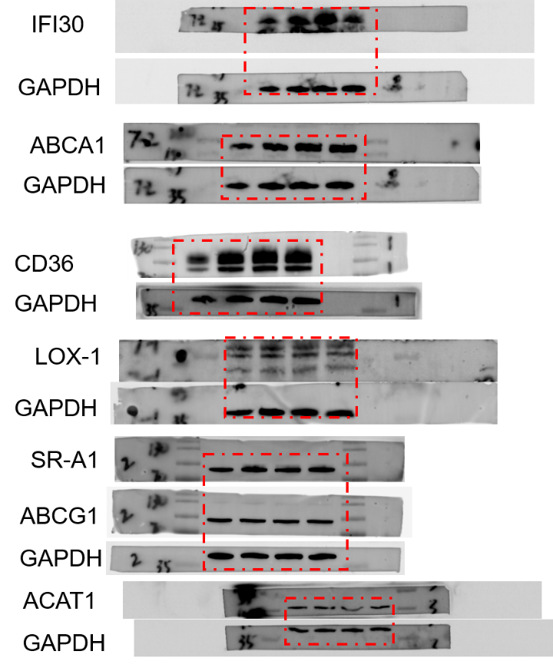
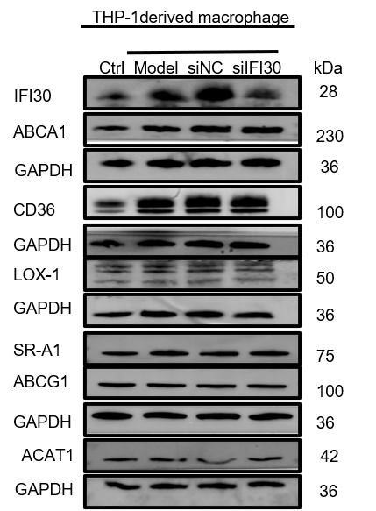
The original gels for Fig.4A

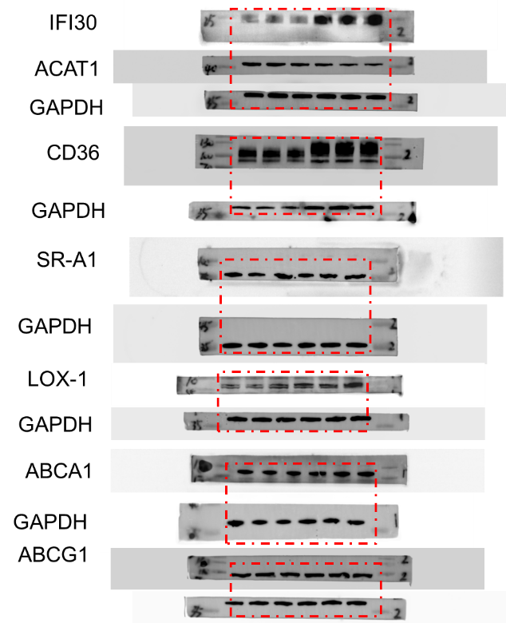
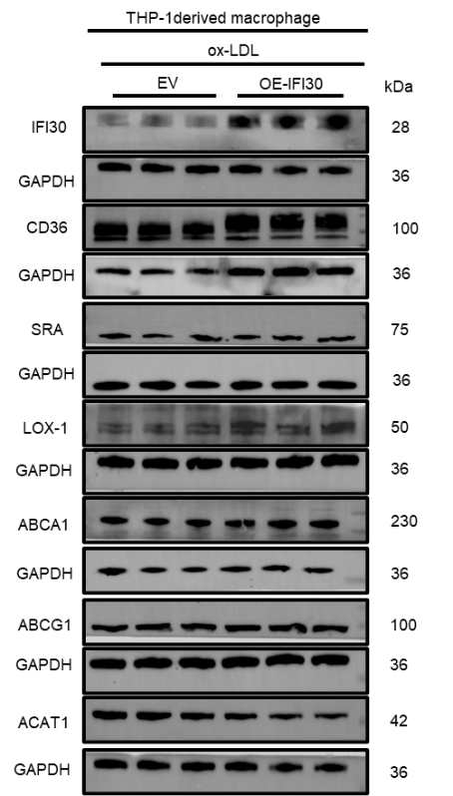
The original gels for Fig.4C

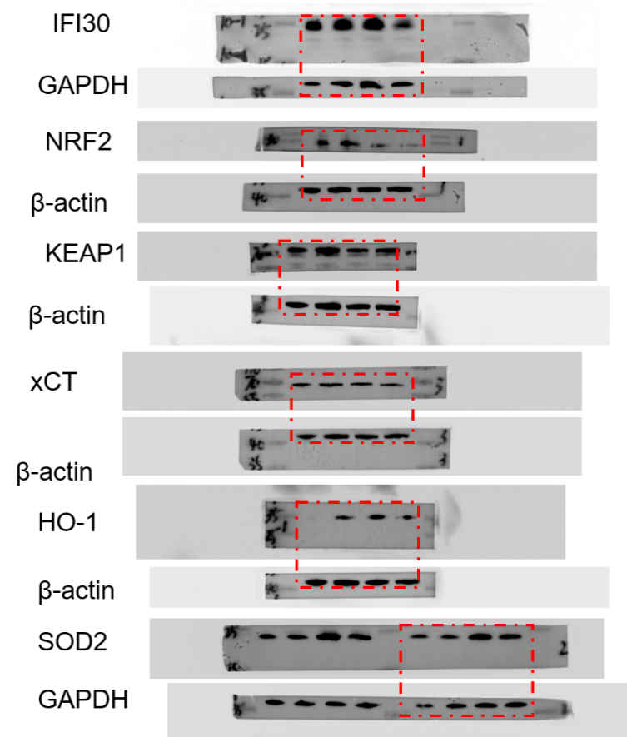
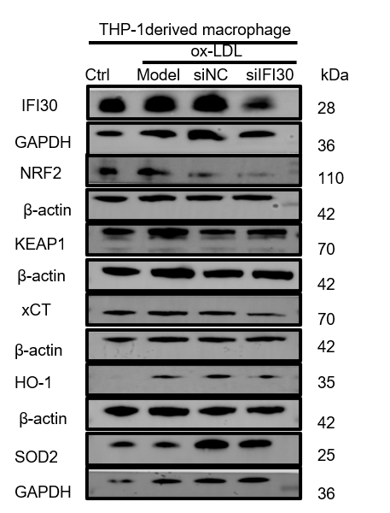
The original gels for Fig.4E

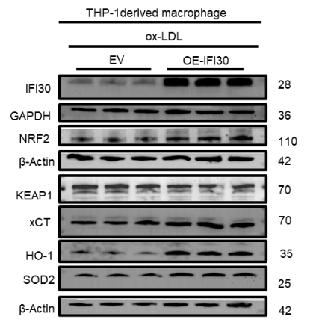
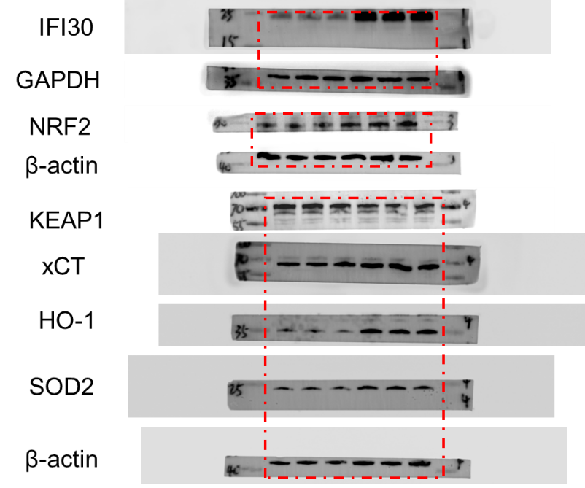
The original gels for Fig.4H

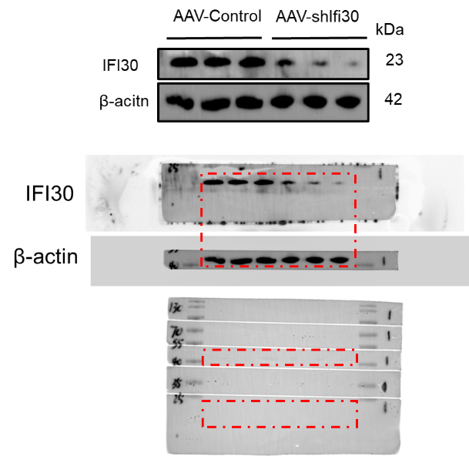
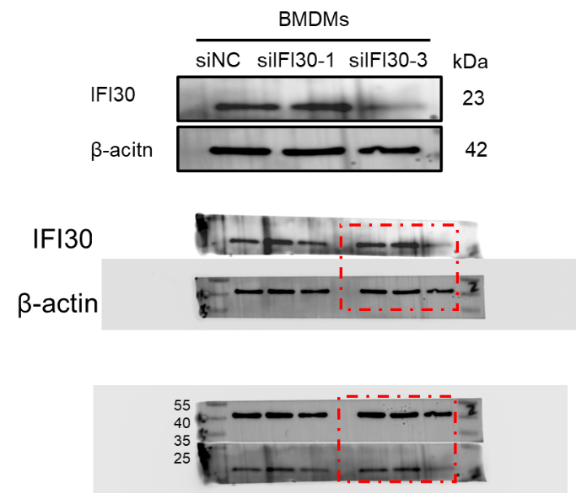
The original gels for Fig.5B The original gels for Fig.5F

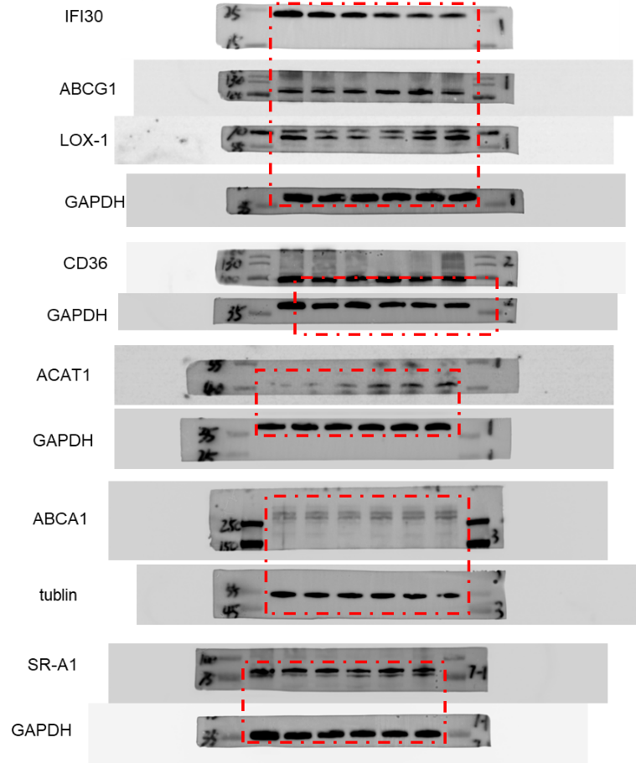
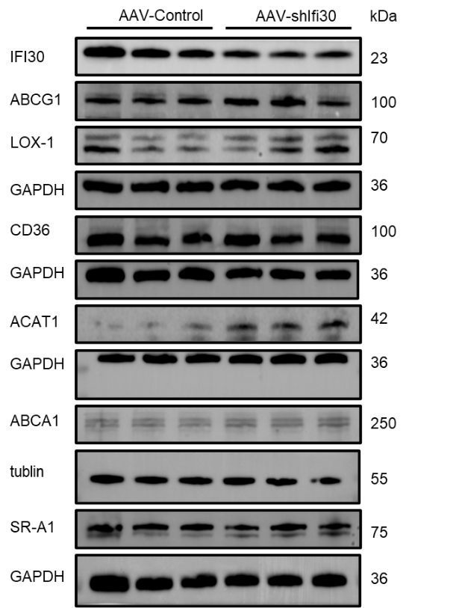
The original gels for Fig.6D

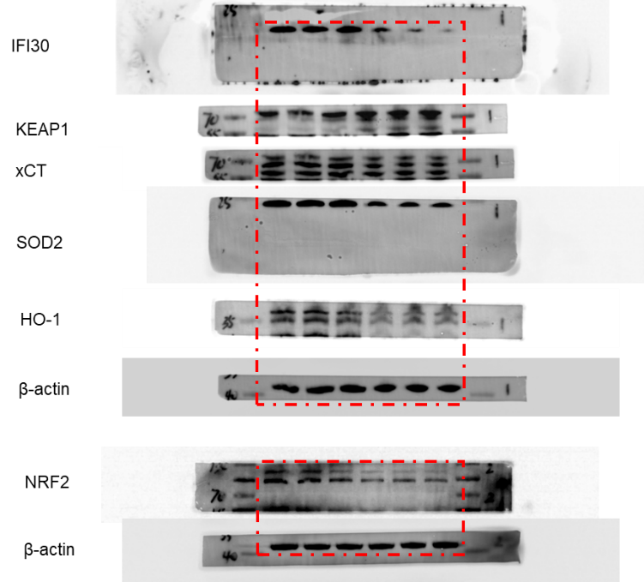
The original gels for Fig.6F
