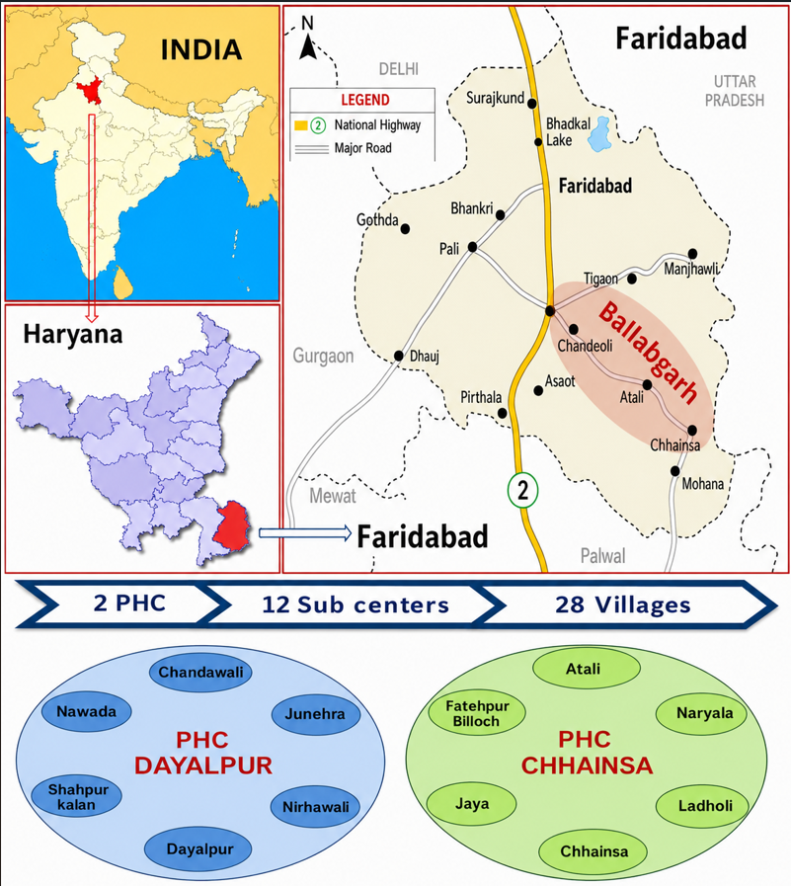

Figure S1: Geographic Map of IFPA Ballabgarh [19]

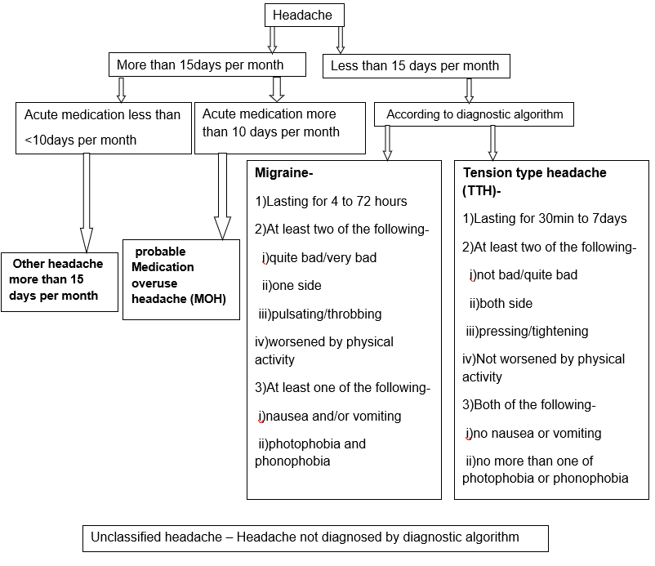
Figure S2: Diagnostic algorithm for headache disorder (ICHD-3) [2]

