Supplementary Material

Age-Dependent Effective Connectivity between Functionally Anticorrelated Networks Under Partial Sleep Deprivation
Vida Feizi^{1†}, Kiana Orangi^{2†}, Armineh Oloumibayki³, Farnoosh Vosough², Armin Toghi⁴, Arash Zare Sadeghi^{5*}

¹ Faculty of Electrical and Computer Engineering, University of Tabriz, Tabriz, Iran.
² Mental Health Research Center, Psychosocial Health Research Institute, Iran University of Medical Sciences, Tehran, Iran
³ School of Medicine, Xiamen University, China
⁴ School of Medicine, Iran University of Medical Sciences, Tehran, Iran
⁵ Institute for Cognitive and Brain Sciences, Shahid Beheshti University, Tehran, Iran
^{6*} Finetech in Medicine Research Center, Medical Physics Department, School of Medicine
† These authors contributed equally to this work.

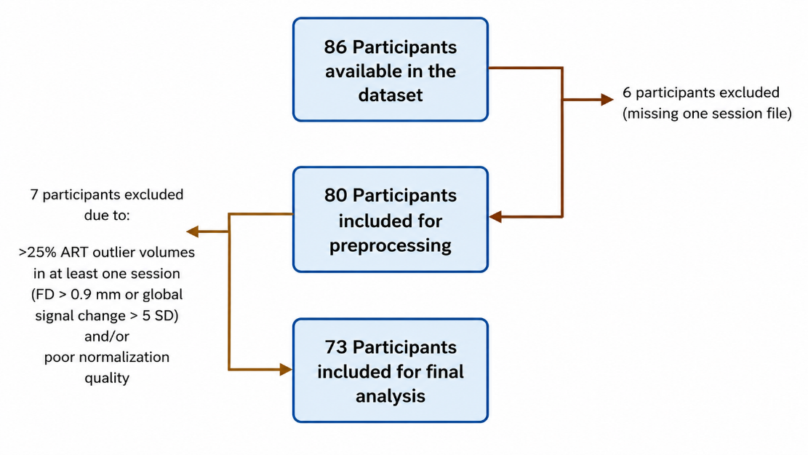
Figure S1. Participant inclusion and exclusion flowchart showing the final sample used for analysis.

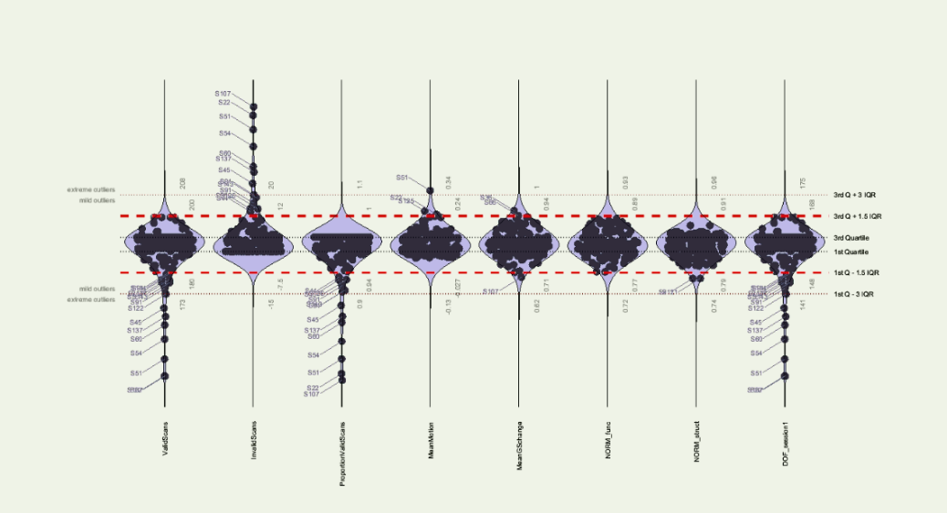

Figure S2. Quality assurance metrics used for participant-level exclusion. Extreme outliers were identified using a sample-specific threshold of Q3 + 3IQR or Q1 − 3IQR across CONN QA metrics, including NORManat, NORMfunc, PVS, MeanMotion, and DOF. NORManat and NORMfunc reflect the similarity of the normalized anatomical and functional images, respectively, to the reference MNI template. PVS represents the proportion of valid scans retained after outlier detection, and MeanMotion represents the mean framewise displacement across non-outlier scans. DOF represents the effective degrees of freedom of the BOLD time series after denoising, calculated from the total number of scans after accounting for nuisance regressors and temporal filtering. Seven participants were excluded from the final analysis because at least one session had excessive motion and/or poor normalization quality.
Supplementary Table S1. Group-wise mean framewise displacement.
Group | Condition | Mean FD (mean ± SD)
Younger adults | PSD | 0.136 ± 0.062
Older adults | PSD | 0.150 ± 0.045
Younger adults | FS | 0.125 ± 0.074
Older adults | FS | 0.143 ± 0.044
Note. Mean FD was derived from the first-level CONN covariates and represents the average framewise displacement across non-outlier scans.. After exclusion of participants with excessive motion and/or poor normalization quality, mean FD was not significantly different between older and younger adults (old-minus-young contrast: t = 1.5007, p = 0.1382).

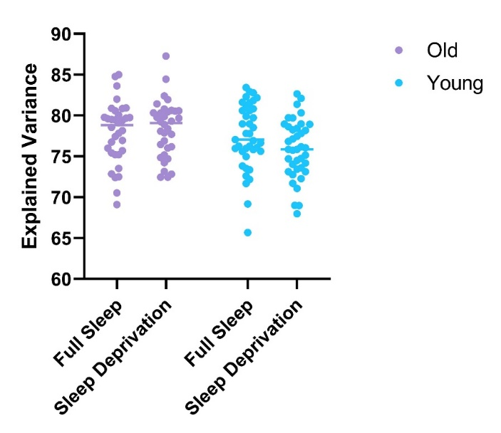
Figure S3. Explained Variance Across Groups
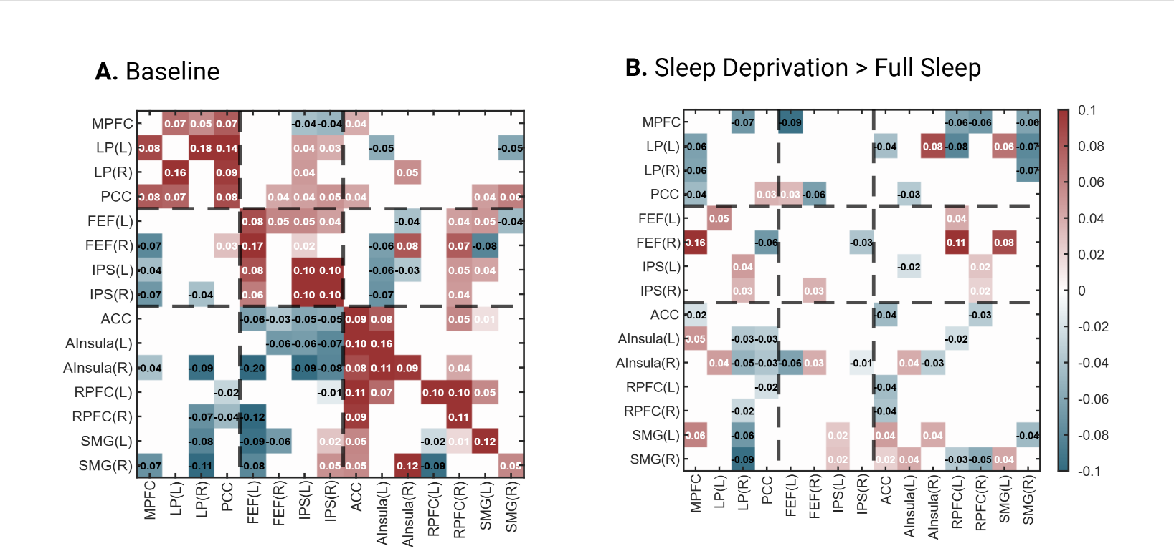
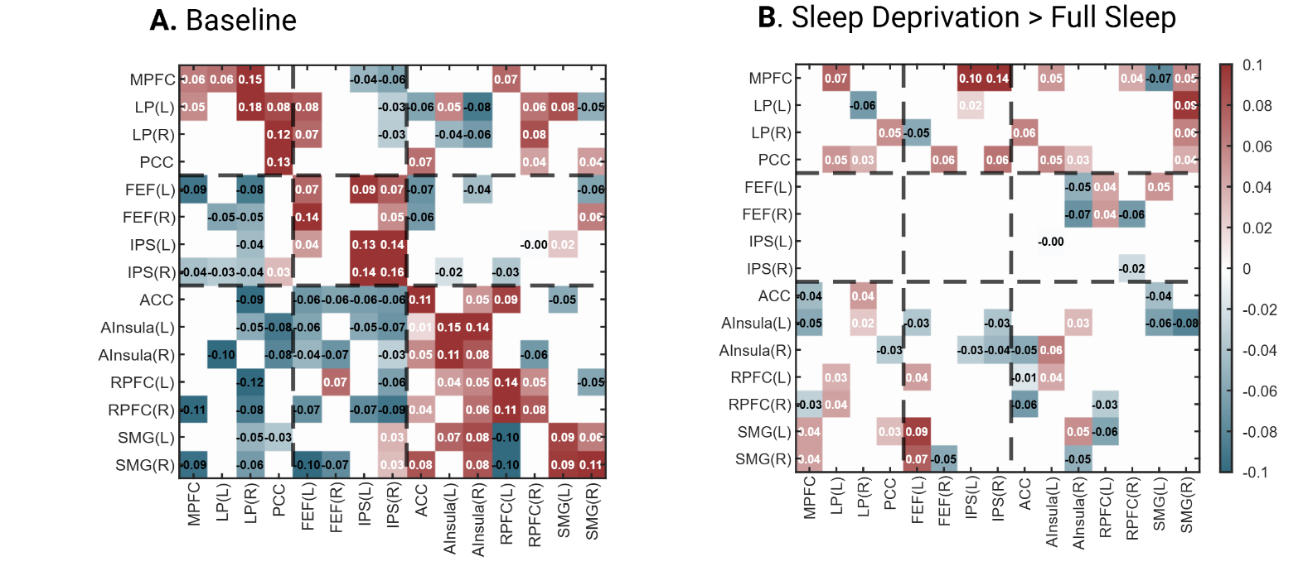
Figure S4. Effective connectivity matrices for younger adults (red = excitatory, blue = inhibitory). (A) Baseline. (B) Sleep deprivation > full sleep contrast. FD was included as a covariate in the first-level PEB model.
Figure S5. Effective connectivity matrices for older adults (red = excitatory, blue = inhibitory). (A) Baseline. (B) Sleep deprivation > full sleep contrast. FD was included as a covariate in the first-level PEB model

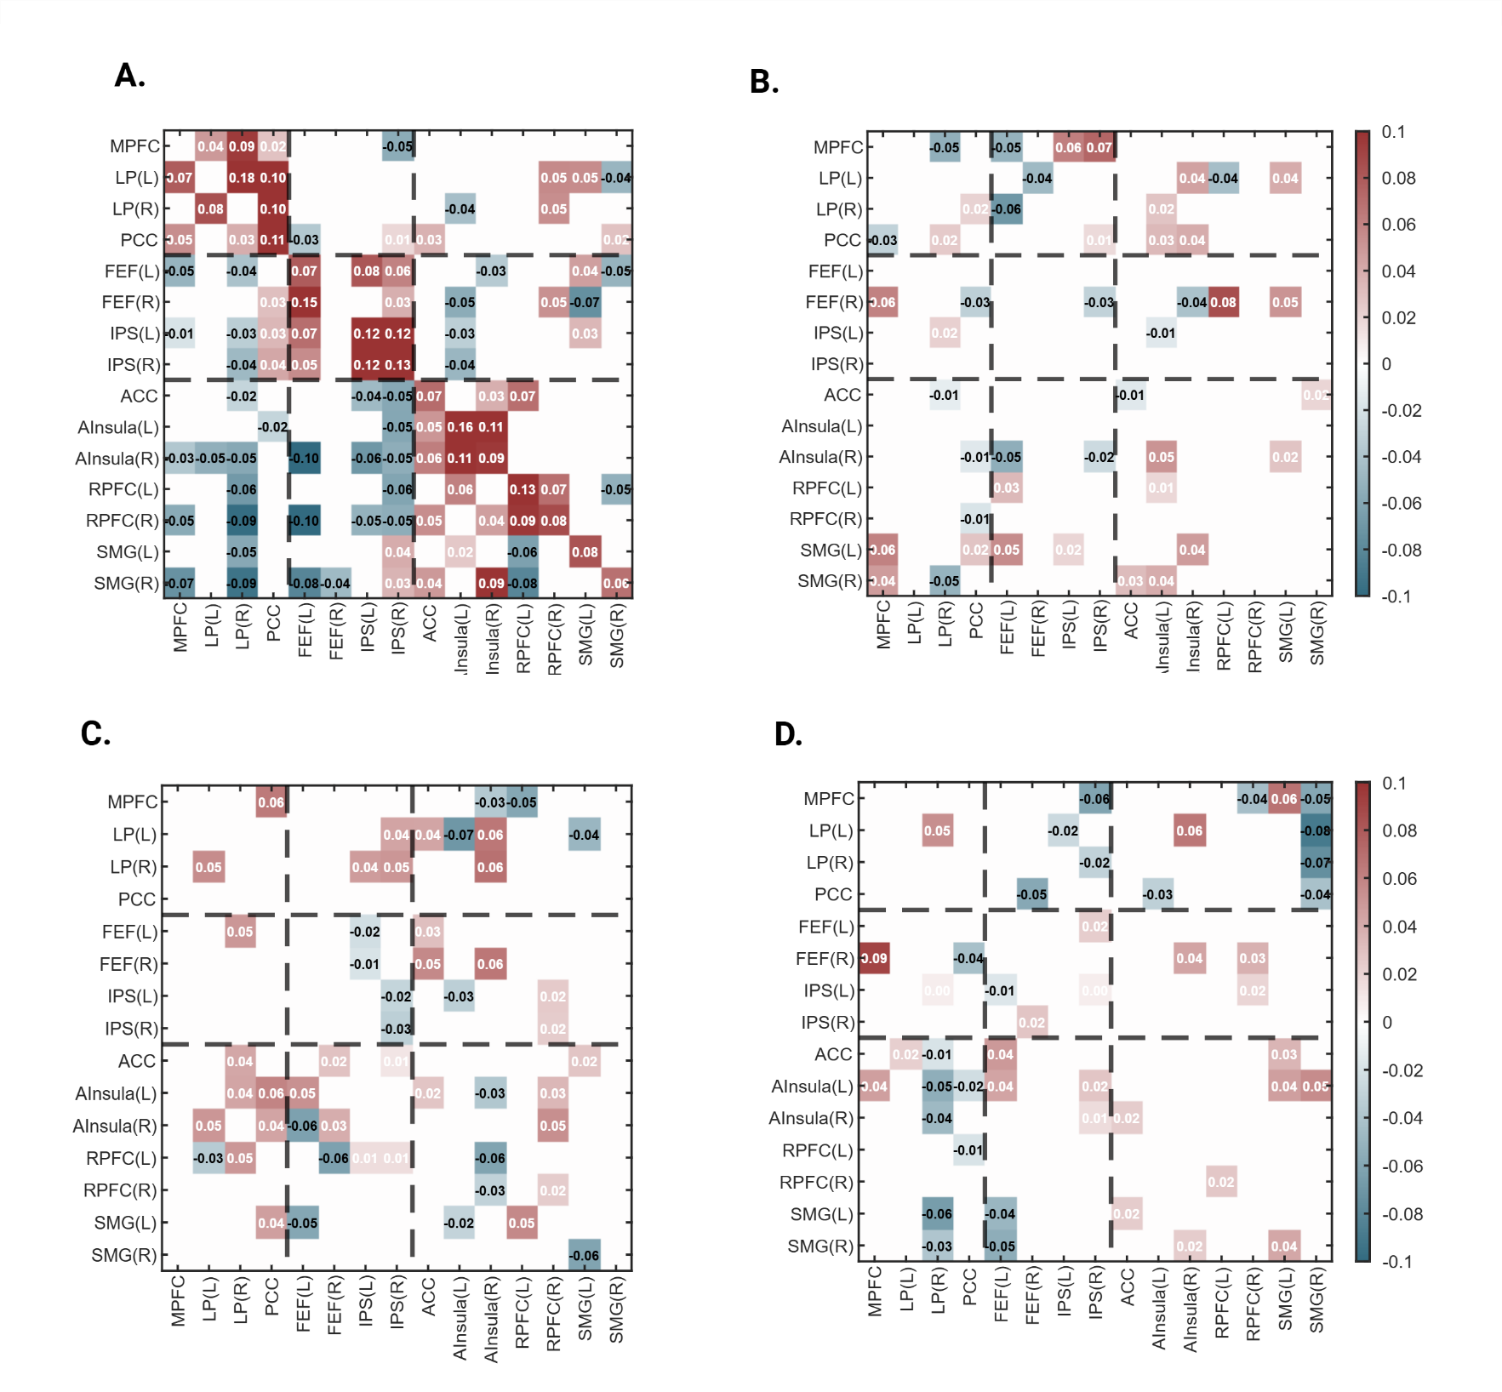
Figure S6. Hierarchical PEB analysis of effective connectivity across all regions.
Connectivity matrices show posterior parameter estimates from the hierarchical PEB analysis across the full 15-region model: (A) overall mean effect, (B) main effect of partial sleep deprivation, (C) main effect of age, and (D) Age × Sleep Deprivation interaction. The sleep-deprivation effect represents partial sleep deprivation > full sleep, the age effect represents older adults > younger adults, and the interaction represents (older adults > younger adults) × (sleep deprivation > full sleep). Rows indicate target regions and columns indicate source regions. Red cells indicate positive parameter estimates, whereas blue cells indicate negative parameter estimates. Only parameters with posterior probability Pp > 0.99 are displayed.

Supplementary Table S2. Sleep-deprivation-related effective connectivity changes in younger adults with a posterior probability > 0.99
From | To | Excitatory(+) / Inhibitory(-) | Increased (↑) / Decreased (↓) | Ep
MPFC | ACC | - | ↓ | −0.04
MPFC | l-AInsula | - | ↓ | −0.05
MPFC | r-RPFC | - | ↓ | −0.03
MPFC | l-SMG | + | ↑ | +0.04
MPFC | r-SMG | - | ↑ | +0.04
l-LP | MPFC | + | ↑ | +0.07
l-LP | PCC | + | ↑ | +0.05
l-LP | l-RPFC | + | ↑ | +0.03
l-LP | r-RPFC | + | ↑ | +0.04
r-LP | l-LP | + | ↓ | −0.06
r-LP | PCC | + | ↑ | +0.03
r-LP | ACC | - | ↑ | +0.04
r-LP | l-AInsula | - | ↑ | +0.02
PCC | r-LP | + | ↑ | +0.05
PCC | r-AInsula | - | ↓ | −0.03
PCC | l-SMG | - | ↑ | +0.03
l-FEF | r-LP | + | ↓ | −0.05
l-FEF | l-AInsula | - | ↓ | −0.03
l-FEF | l-RPFC | + | ↑ | +0.04
l-FEF | l-SMG | + | ↑ | +0.09
l-FEF | r-SMG | - | ↑ | +0.07
r-FEF | PCC | + | ↑ | +0.06
r-FEF | r-SMG | - | ↓ | −0.05
l-IPS | MPFC | - | ↑ | +0.10
l-IPS | l-LP | + | ↑ | +0.02
l-IPS | r-AInsula | - | ↓ | −0.03
r-IPS | MPFC | - | ↑ | +0.14
r-IPS | PCC | + | ↑ | +0.06
r-IPS | l-AInsula | - | ↓ | −0.03
r-IPS | r-AInsula | - | ↓ | −0.04
ACC | l-LP | + | ↑ | +0.06
ACC | r-AInsula | + | ↓ | −0.05
ACC | l-RPFC | - | ↓ | −0.01
ACC | r-RPFC | + | ↓ | −0.06
l-AInsula | MPFC | + | ↑ | +0.05
l-AInsula | PCC | + | ↑ | +0.05
l-AInsula | r-AInsula | + | ↑ | +0.06
l-AInsula | l-RPFC | + | ↑ | +0.04
r-AInsula | PCC | + | ↑ | +0.03
r-AInsula | l-FEF | - | ↓ | −0.05
r-AInsula | r-FEF | - | ↓ | −0.07
r-AInsula | l-AInsula | + | ↑ | +0.03
r-AInsula | l-SMG | + | ↑ | +0.05
r-AInsula | r-SMG | + | ↓ | −0.05
l-RPFC | l-FEF | + | ↑ | +0.04
l-RPFC | r-FEF | + | ↑ | +0.04
l-RPFC | r-RPFC | + | ↓ | −0.03
l-RPFC | l-SMG | - | ↓ | −0.06
r-RPFC | MPFC | + | ↑ | +0.04
r-RPFC | r-FEF | - | ↓ | −0.06
r-RPFC | r-RPFC | - | ↓ | −0.02
l-SMG | MPFC | - | ↓ | −0.07
l-SMG | l-FEF | + | ↑ | +0.05
l-SMG | ACC | - | ↓ | −0.04
l-SMG | l-AInsula | - | ↓ | −0.06
r-SMG | MPFC | + | ↑ | +0.05
r-SMG | l-LP | - | ↑ | +0.09
r-SMG | r-LP | + | ↑ | +0.06
r-SMG | PCC | + | ↑ | +0.04
r-SMG | l-AInsula | - | ↓ | −0.08
Note. The table summarizes key effective connectivity changes following partial sleep deprivation in younger adults. “From” and “To” indicate the direction of the connection. Excitatory (+) and inhibitory (−) indicate the sign of the corresponding baseline effective connectivity. Increased (↑) and decreased (↓) indicate the direction of change following partial sleep deprivation relative to the full-sleep condition. Ep represents the posterior expectation of the sleep-deprivation effect. Only connections with posterior probability Pp > 0.99 are reported.

Supplementary Table S3. Sleep-deprivation-related effective connectivity changes in older adults with a posterior probability > 0.99.
From | To | Excitatory(+) / Inhibitory(-) | Increased (↑) / Decreased (↓) | Ep
MPFC | l-LP | + | ↓ | −0.06
MPFC | r-LP | - | ↓ | −0.06
MPFC | PCC | + | ↓ | −0.04
MPFC | r-FEF | - | ↑ | +0.16
MPFC | ACC | - | ↓ | −0.02
MPFC | L-AInsula | + | ↑ | +0.05
MPFC | l-SMG | + | ↑ | +0.06
l-LP | l-FEF | + | ↑ | +0.05
l-LP | r-AInsula | + | ↑ | +0.04
r-LP | MPFC | + | ↓ | −0.07
r-LP | l-IPS | + | ↑ | +0.04
r-LP | r-IPS | - | ↑ | +0.03
r-LP | l-AInsula | - | ↓ | −0.03
r-LP | r-AInsula | - | ↓ | −0.05
r-LP | r-RPFC | - | ↓ | −0.02
r-LP | l-SMG | - | ↓ | −0.06
r-LP | r-SMG | - | ↓ | −0.09
PCC | PCC | + | ↑ | +0.03
PCC | r-FEF | + | ↓ | −0.06
PCC | l-AInsula | - | ↓ | −0.03
PCC | r-AInsula | - | ↓ | −0.03
PCC | l-RPFC | - | ↓ | −0.02
l-FEF | MPFC | - | ↓ | −0.09
l-FEF | PCC | + | ↑ | +0.03
l-FEF | r-AInsula | - | ↓ | −0.06
r-FEF | PCC | + | ↓ | −0.06
r-FEF | r-IPS | + | ↑ | +0.03
r-FEF | r-AInsula | + | ↑ | +0.03
l-IPS | l-SMG | + | ↑ | +0.02
l-IPS | r-SMG | + | ↑ | +0.02
r-IPS | r-FEF | - | ↓ | −0.03
r-IPS | r-AInsula | - | ↓ | −0.01
ACC | l-LP | - | ↓ | −0.04
ACC | ACC | + | ↓ | −0.04
ACC | l-RPFC | + | ↓ | −0.04
ACC | r-RPFC | + | ↓ | −0.04
ACC | l-SMG | + | ↑ | +0.04
ACC | r-SMG | + | ↑ | +0.02
l-AInsula | PCC | - | ↓ | −0.03
l-AInsula | l-IPS | - | ↓ | −0.02
l-AInsula | r-AInsula | + | ↑ | +0.04
l-AInsula | r-SMG | + | ↑ | +0.04
r-AInsula | l-LP | + | ↑ | +0.08
r-AInsula | r-AInsula | + | ↓ | −0.03
r-AInsula | l-SMG | + | ↑ | +0.04
l-RPFC | MPFC | - | ↓ | −0.06
l-RPFC | l-LP | - | ↓ | −0.08
l-RPFC | l-FEF | + | ↑ | +0.04
l-RPFC | r-FEF | + | ↑ | +0.11
l-RPFC | l-AInsula | - | ↓ | −0.02
l-RPFC | r-SMG | - | ↓ | −0.03
r-RPFC | MPFC | - | ↓ | −0.06
r-RPFC | l-IPS | + | ↑ | +0.02
r-RPFC | r-IPS | + | ↑ | +0.02
r-RPFC | ACC | + | ↓ | −0.03
r-RPFC | r-SMG | - | ↓ | −0.05
l-SMG | l-LP | + | ↑ | +0.06
l-SMG | r-FEF | - | ↑ | +0.08
l-SMG | r-SMG | + | ↑ | +0.04
r-SMG | MPFC | - | ↓ | −0.06
r-SMG | l-LP | - | ↓ | −0.07
r-SMG | r-LP | - | ↓ | −0.07
r-SMG | l-SMG | - | ↓ | −0.04
Note. The table summarizes key effective connectivity changes following partial sleep deprivation in older adults. “From” and “To” indicate the direction of the connection. Excitatory (+) and inhibitory (−) indicate the sign of the corresponding baseline effective connectivity. Increased (↑) and decreased (↓) indicate the direction of change following partial sleep deprivation relative to the full-sleep condition. Ep represents the posterior expectation of the sleep-deprivation effect. Only connections with posterior probability Pp > 0.99 are reported.

Supplementary Table S4. Age × Sleep Deprivation interaction effects on effective connectivity with posterior probability > 0.99
From | To | Excitatory(+) / Inhibitory(-) | Increased (↑) / Decreased (↓) | Ep
MPFC | r-FEF | + | ↑ | +0.09
MPFC | l-AInsula | + | ↑ | +0.04
l-LP | ACC | + | ↑ | +0.02
r-LP | l-LP | + | ↑ | +0.05
r-LP | ACC | - | ↓ | −0.01
r-LP | l-AInsula | - | ↓ | −0.05
r-LP | r-AInsula | - | ↓ | −0.04
r-LP | l-SMG | - | ↓ | −0.06
r-LP | r-SMG | - | ↓ | −0.03
l-FEF | l-IPS | + | ↓ | −0.01
l-FEF | ACC | + | ↑ | +0.04
l-FEF | l-AInsula | + | ↑ | +0.04
l-FEF | l-SMG | - | ↓ | −0.04
l-FEF | r-SMG | - | ↓ | −0.05
r-FEF | PCC | - | ↓ | −0.05
r-FEF | r-IPS | + | ↑ | +0.02
l-IPS | l-LP | - | ↓ | −0.02
r-IPS | MPFC | - | ↓ | −0.06
r-IPS | r-LP | - | ↓ | −0.02
r-IPS | l-FEF | + | ↑ | +0.02
r-IPS | l-AInsula | - | ↑ | +0.02
r-IPS | r-AInsula | - | ↑ | +0.01
ACC | r-AInsula | + | ↑ | +0.02
ACC | l-SMG | + | ↑ | +0.02
l-AInsula | PCC | - | ↓ | −0.03
r-AInsula | l-LP | + | ↑ | +0.06
r-AInsula | r-FEF | + | ↑ | +0.04
r-AInsula | r-SMG | + | ↑ | +0.02
l-RPFC | r-RPFC | + | ↑ | +0.02
r-RPFC | MPFC | - | ↓ | −0.04
r-RPFC | r-FEF | + | ↑ | +0.03
r-RPFC | l-IPS | + | ↑ | +0.02
l-SMG | MPFC | + | ↑ | +0.06
l-SMG | ACC | + | ↑ | +0.03
l-SMG | l-AInsula | + | ↑ | +0.04
l-SMG | r-SMG | + | ↑ | +0.04
r-SMG | MPFC | - | ↓ | −0.05
r-SMG | l-LP | - | ↓ | −0.08
r-SMG | r-LP | - | ↓ | −0.07
r-SMG | PCC | + | ↑ | +0.04
r-SMG | l-AInsula | + | ↑ | +0.05
Note. The table summarizes key Age × Sleep Deprivation interaction effects on effective connectivity. “From” and “To” indicate the direction of the connection. Excitatory (+) and inhibitory (−) indicate the sign of the corresponding baseline effective connectivity. Increased (↑) and decreased (↓) indicate the direction of the interaction effect, defined as (older adults > younger adults) × (partial sleep deprivation > full sleep). Ep represents the posterior expectation of the interaction effect. Only connections with posterior probability Pp > 0.99 are reported.

