SUPPLEMENTAL FIGURES
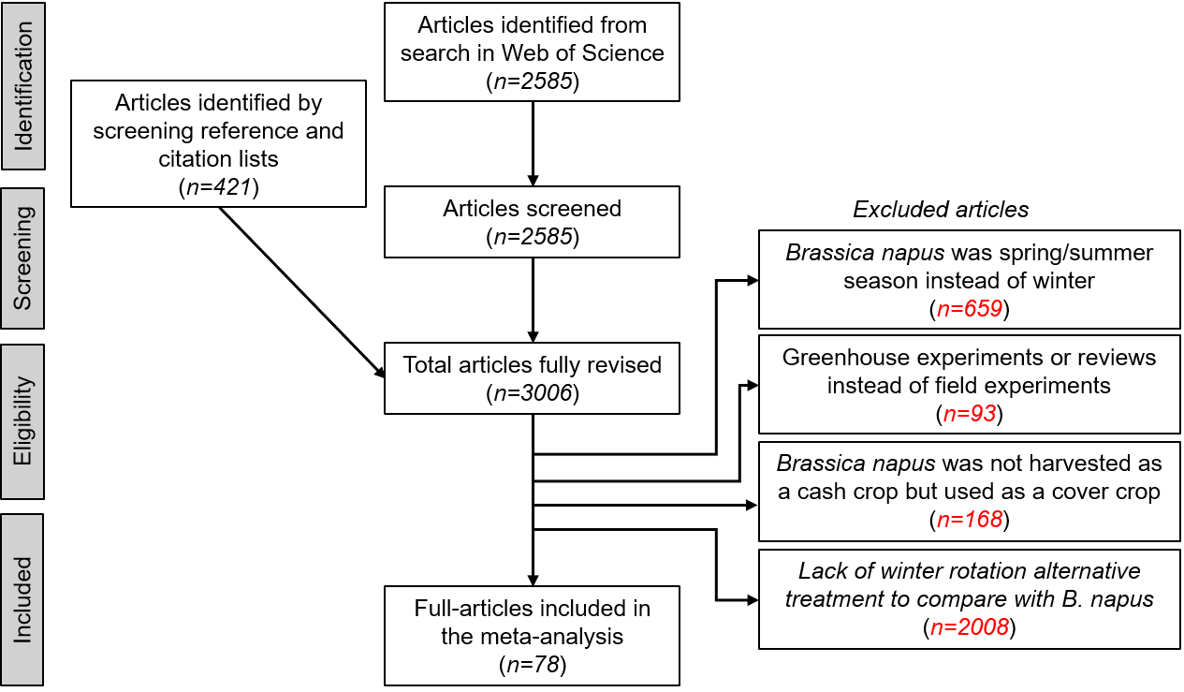
Supplemental Fig. 1. Description of the steps followed for inclusion of articles in
the current meta-analysis.

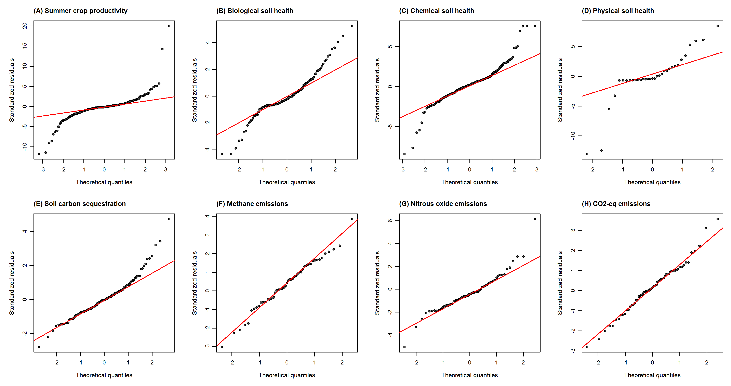

Supplemental Fig. 2. Normal quantile–quantile (Q–Q) plots of the standardized residuals from the multilevel random-effects meta-analytic models (rma.mv) for each response variable: (A) summer-crop productivity, (B) biological soil health, (C) chemical soil health, (D) physical soil health, (E) soil carbon sequestration, (F) methane (CH₄) emissions, (G) nitrous oxide (N₂O) emissions, and (H) carbon dioxide-equivalent (CO₂-eq) emissions. In each panel, points represent the ordered standardized residuals plotted against their theoretical quantiles under a normal distribution, and the red line indicates the expected 1:1 relationship. Points falling close to the line indicate that the assumption of residual normality is reasonably met; departures in the distribution tails reflect the small number of larger residuals expected given the high between-study heterogeneity.

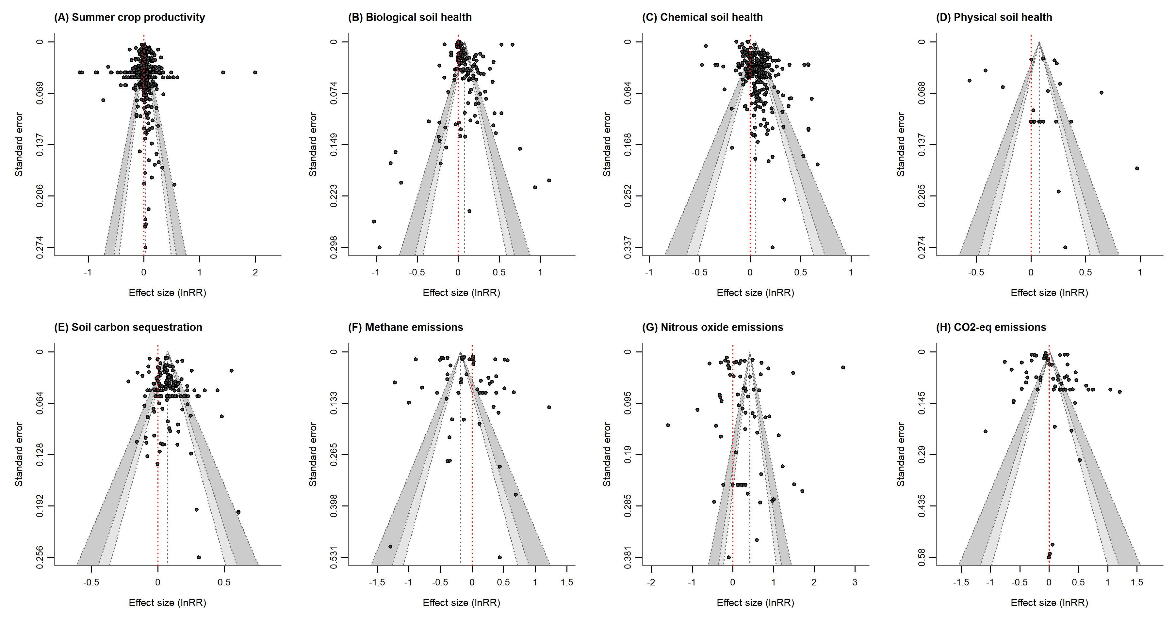

Supplemental Fig. 3. Funnel plots of effect size (log response ratio, lnRR) against its standard error for each response variable: (A) summer-crop productivity, (B) biological soil health, (C) chemical soil health, (D) physical soil health, (E) soil carbon sequestration, (F) methane (CH₄) emissions, (G) nitrous oxide (N₂O) emissions, and (H) carbon dioxide-equivalent (CO₂-eq) emissions. Each point represents an individual effect size; more precise estimates (smaller standard error) appear toward the top of each plot. The vertical dashed red line marks the pooled effect, and the shaded regions denote the 90%, 95%, and 99% pseudo-confidence limits. A symmetrical, two-sided distribution of points with no systematic absence of studies in the lower corners indicates no strong evidence of publication bias or small-study effects.

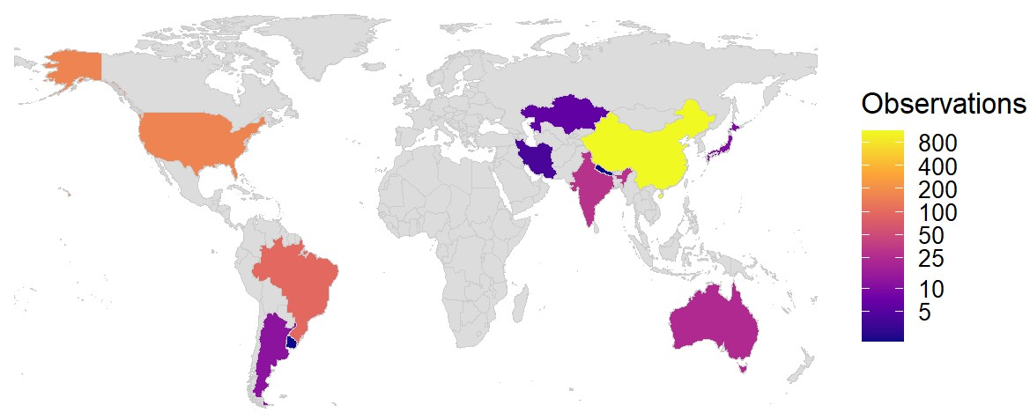

Supplemental Fig. 4. Global distribution of observations included in the meta-analysis, shown as a choropleth map. Countries are shaded according to the number of observations retrieved from literature, with color intensity increasing from purple (few observations) to yellow (many observations) as indicated by the legend. This map highlights the geographic coverage and relative contribution of each country to the dataset.

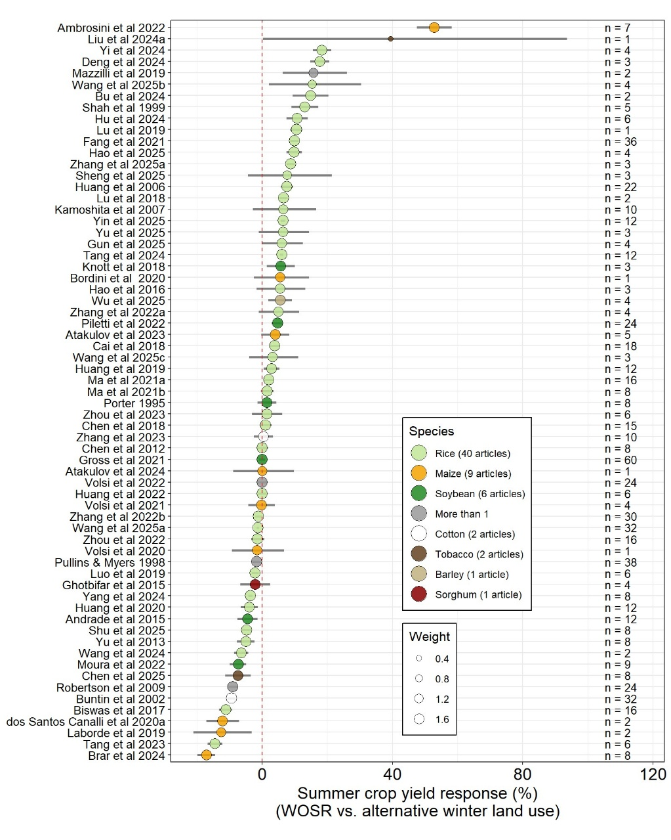

Supplemental Fig. 5. Individual study estimates of summer crop yield responses following winter oilseed rape (WOSR) compared with alternative winter land uses. Each point represents a study‑specific effect size, with point size proportional to its weight and point color indicating the summer crop species (rice, maize, soybean, cotton, tobacco, barley, sorghum, or multiple species). Horizontal bars show 95% confidence intervals, and sample sizes (n) for each study are displayed on the right. Effect sizes were calculated as the relative difference between summer crop yield after WOSR and yield after the alternative winter land use. The vertical dashed line marks zero effect; positive values indicate higher yields following WOSR, whereas negative values indicate yield reductions.

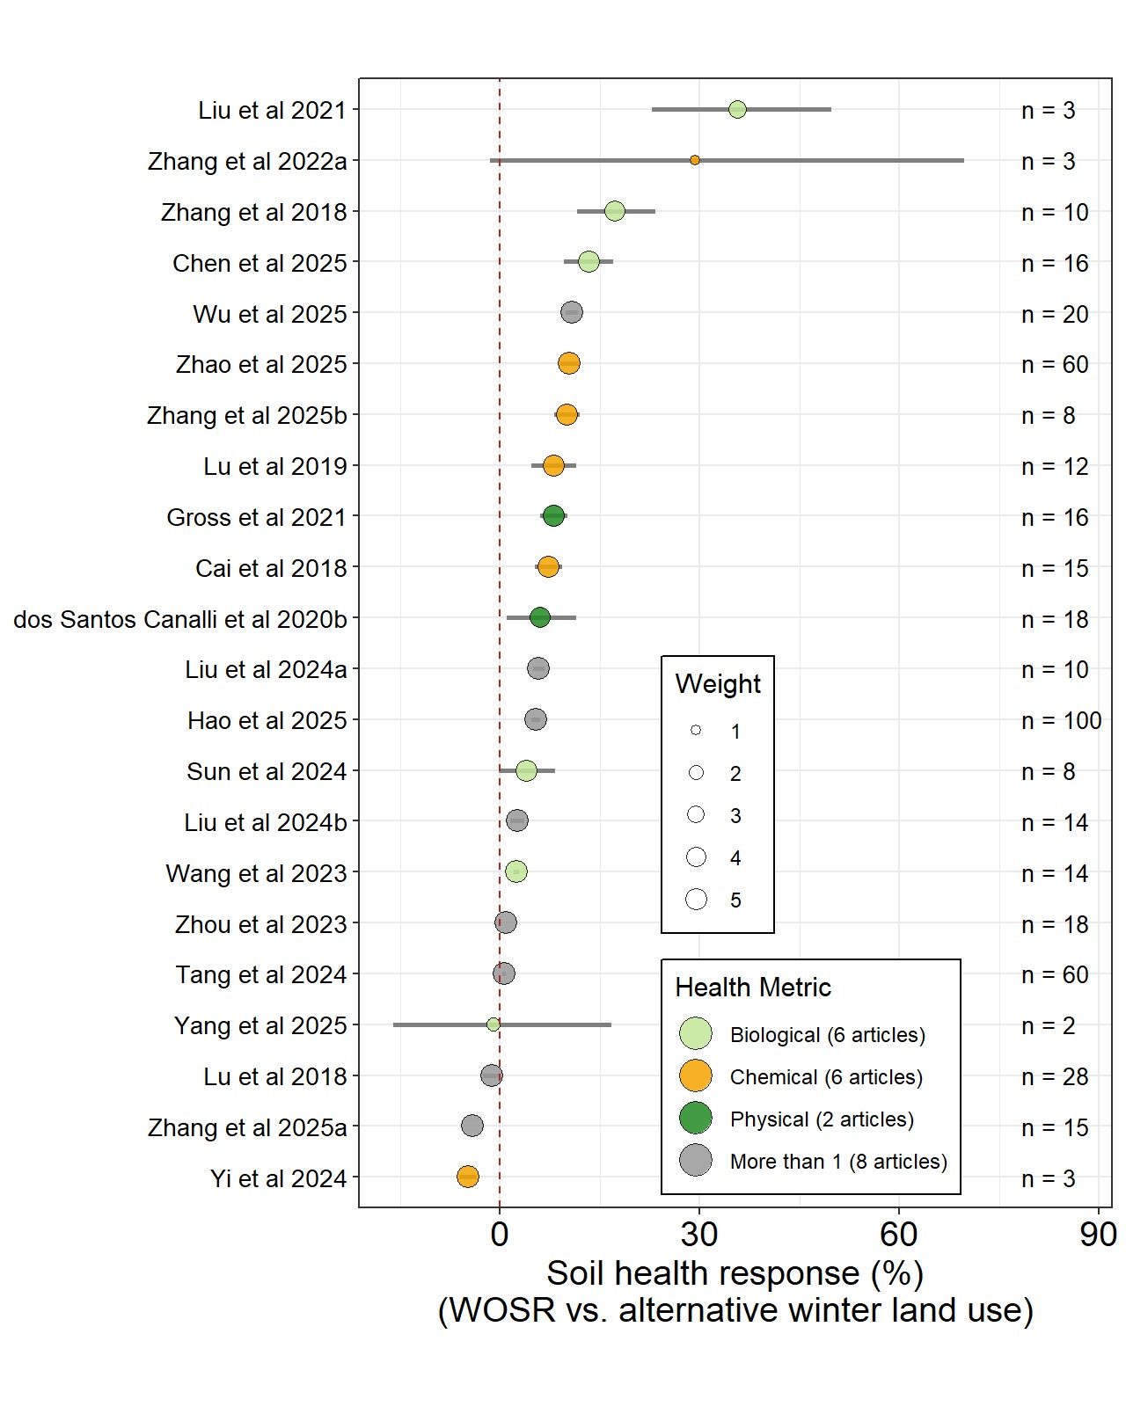

Supplemental Fig. 6. Study-level estimates of soil health responses following winter oilseed rape (WOSR) compared with alternative winter land uses. Each point represents a study-specific effect size, with point size indicating study weight and colors denoting the type of soil health metric assessed (biological, chemical, physical, or multiple metrics). Horizontal bars show 95% confidence intervals, and sample sizes (n) for each study are given on the right. Effect sizes were calculated as the relative difference between soil health following WOSR and soil health following the alternative winter land use. The vertical dashed line marks zero effect; positive values indicate improved soil health following WOSR, whereas negative values indicate declines.

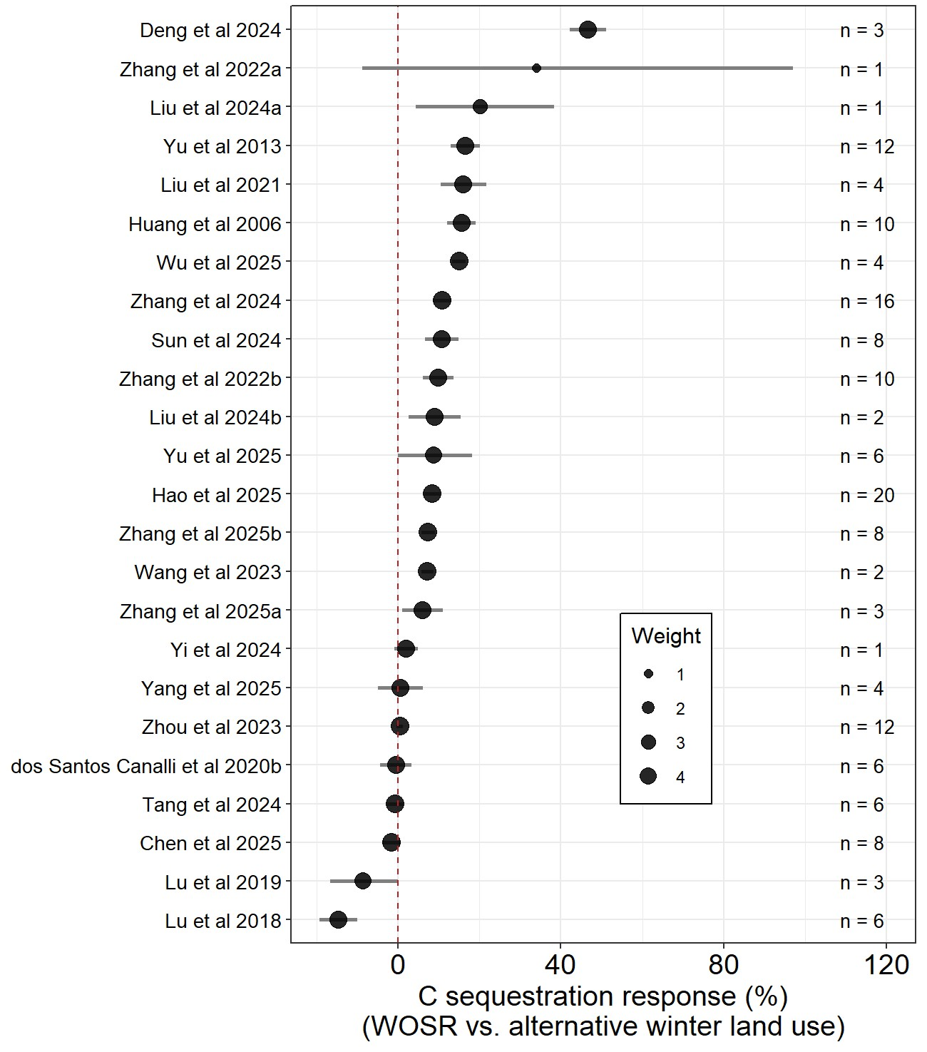
Supplemental Fig. 7. Study‑level estimates of soil carbon sequestration responses following winter oilseed rape (WOSR) compared with alternative winter land uses. Each point represents a study‑specific effect size, with point size indicating study weight and horizontal bars showing 95% confidence intervals; sample sizes (n) for each study are listed on the right. Effect sizes were calculated as the relative difference between soil C sequestration after WOSR and sequestration after the alternative winter land use. The vertical dashed line marks zero effect; positive values indicate greater C sequestration following WOSR, whereas negative values indicate reductions.

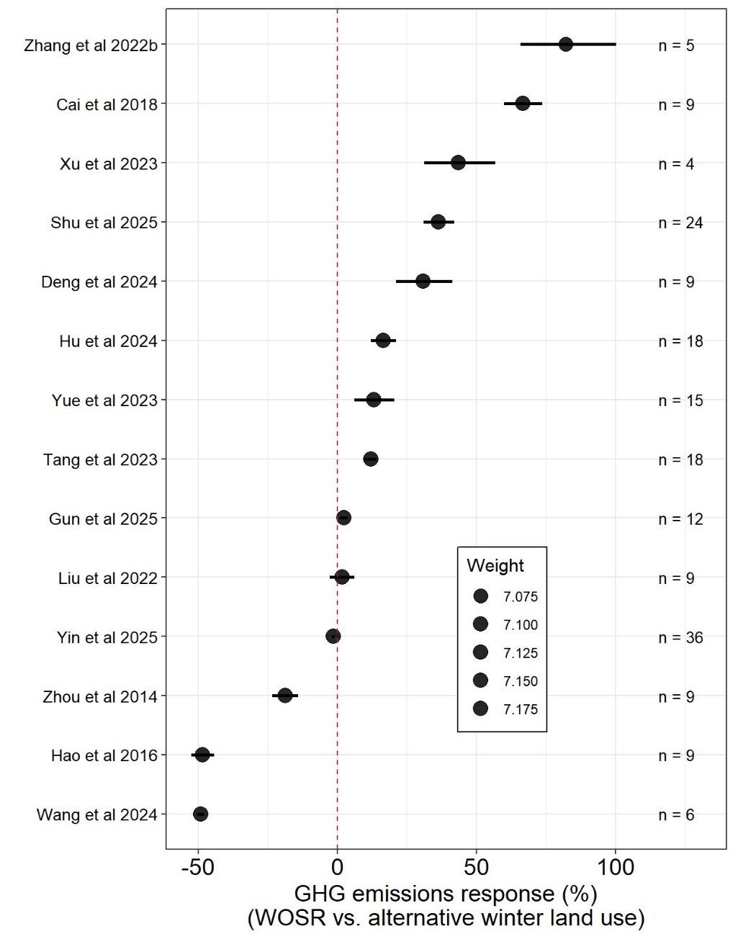

Supplemental Fig. 8. Study‑level estimates of greenhouse gas (GHG) emission responses following winter oilseed rape (WOSR) compared with alternative winter land uses. Each point represents a study‑specific effect size, with point size indicating study weight and horizontal bars showing 95% confidence intervals; sample sizes (n) for each study are listed on the right. Effect sizes were calculated as the relative difference between GHG emissions after WOSR and emissions after the alternative winter land use. The vertical dashed line marks zero effect; positive values indicate higher emissions following WOSR, whereas negative values indicate reductions.

SUPPLEMENTAL TABLES
Supplemental Table 1. Meta-analysis results for subsequent summer crop productivity following winter rapeseed rotation. Categories are organized by overall effect, type of preceding winter rotation, and type of winter rotation by individual summer crops. For each group, the table reports the number of observations (n), effect size as percent yield change, 95% confidence interval (CI 95), heterogeneity statistics (Qt, Qm) and their significance (P value). Positive effect sizes indicate increased summer crop yield following winter rapeseed rotation, while negative values indicate reductions. Statistical significance is denoted by asterisks (***).
Category |  | n | Effect size (%) | CI 95 | Qt | P value | Qm | P value
Overall |  | 673 | 2.1 | -0.2 to 4.5 | 15625 | *** | -- | --
Type of winter rotation |  |  |  |  | 14440 | *** | 585 | ***
 | Winter Cereal | 289 | 3.4 | 1.2 to 5.7
 | Fallow | 201 | 3.3 | 1.1 to 5.6
 | Winter Legume | 98 | 0.0 | -2.2 to 2.2
 | Winter Dicot | 35 | -0.5 | -2.8 to 1.8
 | Other Brassica | 33 | -6.3 | -8.4 to -4.1
 | Other Winter crop | 17 | -1.4 | -3.8 to 0.9
Type of winter rotation by summer crop |  |  |  |  | 11754 | *** | 2787 | ***
Rice | Winter Cereal | 115 | 3.3 | 0.3 to 6.4
 | Fallow | 128 | 5.9 | 2.8 to 9.1
 | Winter Legume | 77 | 1.4 | -1.5 to 4.5
 | Winter Dicot | 31 | 1.1 | -2 to 4.2
 | Other Brassica | 11 | -8.2 | -11 to -5.3
 | Other Winter crop | 17 | 0.3 | -2.8 to 3.5
Soybean | Winter Cereal | 82 | 2.8 | -2.2 to 8.1
 | Fallow | 35 | -0.4 | -5.4 to 4.9
 | Winter Legume | 9 | -1.5 | -7 to 4.4
 | Other Brassica | 5 | 2.1 | -4.2 to 8.7
 | Other Winter crop | 4 | 2.9 | -3.7 to 10
Maize | Winter Cereal | 37 | -2.1 | -6.9 to 2.9
 | Other Brassica | 7 | -4.5 | -10.1 to 1.6
 | Other Winter crop | 2 | 1.9 | -11.5 to 17.3
Cotton | Winter Cereal | 26 | -6.8 | -18.1 to 6.2
 | Fallow | 16 | 1.6 | -11 to 15.8
Sorghum | Winter Cereal | 8 | -10.8 | -21.9 to 2
 | Fallow | 4 | -20.0 | -30.3 to -8.2
 | Winter Legume | 2 | 14.1 | -1.7 to 32.4
 | Other Brassica | 6 | -6.9 | -18.8 to 6.7
Sunflower | Winter Cereal | 4 | 37.7 | 28.5 to 47.6
 | Fallow | 4 | 14.0 | 6.4 to 22.2
Tobacco | Fallow | 1 | 39.4 | -4.3 to 103
 | Winter Legume | 8 | -7.5 | -23.3 to 11.5
Amaranth | Winter Cereal | 4 | 27.9 | 19.4 to 37.1
 | Fallow | 4 | -8.8 | -14.9 to -2.3
Barley | Winter Cereal | 2 | 2.3 | -15.2 to 23.5
 | Fallow | 2 | 9.8 | -9.1 to 32.8
Buckwheat | Winter Cereal | 4 | 31.2 | 22.4 to 40.6
 | Fallow | 4 | 9.1 | 1.8 to 16.9
Mungbean | Winter Cereal | 4 | -14.4 | -25.7 to -1.4
 | Other Brassica | 4 | -5.9 | -18.3 to 8.3
Pearl Millet | Winter Cereal | 3 | 187.8 | 167 to 209
 | Fallow | 3 | 1.2 | -5.9 to 8.9

Supplemental Table 2. Meta-analysis results for soil health responses following winter rapeseed rotation. Categories are organized by biological, chemical, and physical soil health metrics, with subgroup analyses by type of preceding winter rotation and nutrient. For each group, the table reports the number of observations (n), effect size as percent change, 95% confidence interval (CI 95), heterogeneity statistics (Qt, Qm) and their significance (P value). Positive effect sizes indicate improvements in soil health following winter rapeseed rotation, while negative values indicate reductions. Statistical significance is denoted by asterisks (***).
Category |  | n | Effect size (%) | CI 95 | Qt | P value | Qm | P value
BIOLOGICAL SOIL HEALTH
Overall |  | 145 | 8.2 | 1.6 to 17.3 | 56835 | *** | -- | --
Type of winter rotation |  |  |  |  | 34251 | *** | 17353 | ***
 | Fallow | 59 | 9.5 | 2.3 to 17.1
 | Winter Cereal | 52 | 7.8 | 0.7 to 15.3
 | Winter Legume | 30 | 8.8 | 1.7 to 16.4
 | Winter dicot | 2 | -1.0 | -26 to 32.5
 | Other winter crop | 2 | 7.9 | 0.8 to 15.4
CHEMICAL SOIL HEALTH
Overall |  | 274 | 5.5 | 2 to 9 | 152286 | *** | -- | --
Type of winter rotation by nutrient |  |  |  |  | 150288 | *** | 167 | ***
Nitrogen | Fallow | 56 | 8.9 | 3.7 to 14.4
 | Winter Cereal | 108 | 4.4 | -0.7 to 9.7
 | Winter Legume | 18 | 1.8 | -3.3 to 7.2
 | Other winter crop | 4 | 1.8 | -3.7 to 7.5
Phosphorus | Fallow | 49 | 8.2 | 3 to 13.7
 | Winter Cereal | 35 | 1.4 | -3.6 to 6.6
 | Winter Legume | 4 | 24.8 | 10.3 to 41.1
PHYSICAL SOIL HEALTH
Overall |  | 34 | 7.8 | 5.9 to 9.7 | 564 | *** | -- | --
Type of winter rotation |  |  |  |  | 559 | *** | 5 | ***
 | Fallow | 8 | 10.6 | 7.4 to 13.9
 | Winter Cereal | 26 | 6.2 | 3.9 to 8.6

Supplemental Table 3. Meta-analysis results for soil carbon sequestration following winter rapeseed rotation. Categories are organized by overall effect and by type of preceding winter rotation. For each group, the table reports the number of observations (n), effect size as percent change, 95% confidence interval (CI 95), heterogeneity statistics (Qt, Qm) and their significance (P value). Positive effect sizes indicate increased soil-carbon sequestration following winter rapeseed rotation, while negative values indicate reductions. Statistical significance is denoted by asterisks (***).
Category | n | Effect size (%) | CI 95 | Qt | P value | Qm | P value
SOIL CARBON SEQUESTRATION
Overall | 156 | 7.6 | 3.1 to 12.3 | 1712 | *** | -- | --
Type of winter rotation |  |  |  | 1317 | *** | 93 | ***
Winter Cereal | 66 | 6.5 | 1.8 to 11.4
Fallow | 54 | 10.2 | 5.4 to 15.2
Winter Legume | 28 | 5.4 | 0.6 to 10.4
Winter Dicot | 4 | 0.5 | -18.4 to 23.7
Other Winter crop | 4 | 1.5 | -3.2 to 6.4

Supplemental Table 4. Meta-analysis results for greenhouse gas (GHG) emissions following winter rapeseed rotation. For each group, the table reports the number of observations (n), effect size as percent change, 95% confidence interval (CI 95), heterogeneity statistics (Qt, Qm) and their significance (P value). Negative effect sizes indicate reductions in GHG emissions following winter rapeseed rotation, while positive values indicate increases. Statistical significance is denoted by asterisks (***).
Category |  | n | Effect size (%) | CI 95 | Qt |  | P value |  | Qm |  | P value
METHANE EMISSIONS
Overall |  | 55 | -17.3 | -32.7 to 1.6 | 6686 |  | *** |  | -- |  | --
Type of winter rotation |  |  |  |  | 3347 |  | *** |  | 3629 |  | ***
 | Fallow | 16 | -25.1 | -39.5 to -7.3
 | Winter Cereal | 14 | -29.9 | -43.4 to -13.2
 | Winter Legume | 16 | -3 | -21.7 to 20.2
 | Winter dicot | 4 | 75.2 | 38 to 122.3
 | Other Brassicas | 4 | 63.8 | 32.1 to 103
 | Other winter crop | 1 | 2.7 | NA
NITROUS OXIDE EMISSIONS
Overall |  | 68 | 51.5 | 21.9 to 88.3 | 14831 |  | *** |  | -- |  | --
Type of winter rotation |  |  |  |  | 9924 |  | *** |  | 5898 |  | ***
 | Fallow | 16 | 158.5 | 107.3 to 222.3
 | Winter Cereal | 27 | 22.1 | -1.1 to 50.3
 | Winter Legume | 16 | 105.4 | 64.7 to 156.2
 | Winter dicot | 4 | -49.5 | -59.6 to -36.7
 | Other Brassicas | 4 | 40 | 12.2 to 74.6
 | Other winter crop | 1 | -45.4 | NA
CARBON DIOXIDE EQUIVALENTS
Overall |  | 60 | 0.9 | -16.8 to 22.4 | 7263 |  | *** |  | -- |  | --
Type of winter rotation |  |  |  |  | 1983 |  | *** |  | 5426 |  | ***
 | Fallow | 17 | 7.1 | -14.6 to 34.3
 | Winter Cereal | 16 | -30.2 | -44.5 to -12.3
 | Winter Legume | 18 | 28.6 | 2.6 to 61.3
 | Winter dicot | 4 | 124.1 | 77 to 183.6
 | Other Brassicas | 4 | 75.7 | 40 to 120.3
 | Other winter crop | 1 | -6.9 | NA

Supplemental reference list. Complete bibliography of all primary studies included in the meta-analysis. These references provided the data used to evaluate the effects of winter oilseed rape (Brassica napus) on subsequent crop productivity, soil health, soil carbon sequestration, and greenhouse gas emissions.
Ambrosini, V.G., de Almeida, J.L., de Araujo, E.A., Alves, L.A., Filippi, D., Flores, J.P.M., Fostim, M.L., Fontoura, S.M.V., Bortoluzzi, E.C., Bayer, C., Tiecher, T., 2022. Effect of diversified cropping systems on crop yield, legacy, and budget of potassium in a subtropical Oxisol. Field Crops Res. 275.
Andrade, J.F., Poggio, S.L., Ermácora, M., Satorre, E.H., 2015. Productivity and resource use in intensified cropping systems in the Rolling Pampa, Argentina. European Journal of Agronomy 67, 37–51.
Atakulov, T., Kaldybaev, S., Erzhanova, K., Zholamanov, K., Zhuniskhan, D., Tolekov, A., Kusmangazinov, A., 2024. Use of intermediate crops to increase productivity of irrigated arable land in southeastern Kazakhstan. Journal of Ecological Engineering 25, 217–228.
Atakulov, T., Kaldybayev, S., Yerzhanova, K., Zholamanov, K., Smanov, A., Seytzhan, A., 2023. Evaluating the potential for multicropping in SE Kazakhstan: Double-cropping corn after winter triticale and winter oilseed rape. Eurasian Journal of Soil Science 12, 79–84.
Biswas, B., 2017. Cropping system analysis for agricultural sustainability - productivity, economy, ecology and energy use efficiency. Journal of Experimental Biology and Agricultural Sciences 5, 294–301.
Bordin, I., dos Santos Silva, N., Benetoli da Silva, T., dos Santos, J.B., Gil, L.G., dos Santos Canalli, L.B., Hojo, R.H., Llanillo, R.F., 2020. Soybean cropping systems on sandy soil of the Caiuá Sandstone formation in Northwestern Paraná, Brasil. Semina: Ciências Agrárias, 2061–2070.
Brar, N.S., Kaur, S., Mandal, K., Kaur, M., Sandhu, A.K., Saini, K.S., 2023. Weed flora in spring maize and atrazine residues in its green fodder and silage under three maize-based rotations. Phytoparasitica 52, 1–10.
Bu, R., Han, S., Cheng, W., Wu, Y., Tang, S., Li, M., Wang, H., Ge, Z., Wu, J., 2024. Deciphering the role of particulate organic matter in soil nitrogen transformation in rice–rapeseed and rice–wheat rotation systems. Applied Soil Ecology 193.
Buntin, G.D., Raymer, P.L., Bednarz, C.W., Phillips, D.V., Baird, R.E., 2002. Winter Crop, Tillage, and Planting Date Effects on Double‐Crop Cotton. Agron. J. 94, 273–280.
Cai, S., Pittelkow, C.M., Zhao, X., Wang, S., 2018. Winter legume-rice rotations can reduce nitrogen pollution and carbon footprint while maintaining net ecosystem economic benefits. Journal of Cleaner Production 195, 289–300.
Chen, D., Zhou, Y., Wang, G., Dai, K., Li, J., Song, X., Xu, Y., Cui, Y., Yang, X., 2025. Biochar-based organic fertilizer application promotes the alleviation of tobacco (Nicotiana tabacum L.) continuous cropping obstacles by improving soil chemical properties and microbial community structure. BMC Plant Biol. 25, 271.
Chen, S., Liu, S., Zheng, X., Yin, M., Chu, G., Xu, C., Yan, J., Chen, L., Wang, D., Zhang, X., 2018. Effect of various crop rotations on rice yield and nitrogen use efficiency in paddy–upland systems in southeastern China. The Crop Journal 6, 576–588.
Chen, S., Zheng, X., Wang, D., Chen, L., Xu, C., Zhang, X., 2012. Effect of long-term paddy-upland yearly rotations on rice (Oryza sativa) yield, soil properties, and bacteria community diversity. The Scientific World Journal 2012, 279641.
Deng, Z., Ren, X., Han, J., Cui, K., Han, K., Yue, Q., Zhou, J., Zhai, Z., Xiong, D., Yuan, S., Huang, J., Peng, S., 2024. Identifying a sustainable rice-based cropping system via on-farm evaluation of grain yield, carbon sequestration capacity and carbon footprints in Central China. Field Crops Res. 316.
Dos Santos Canalli, L.B., Costa, G.V.d., Volsi, B., Leocádio, A.L.M., Neves, C.S.V.J., Telles, T.S., 2020a. Production and profitability of crop rotation systems in southern Brazil. Semina: Ciencias Agraias 41, 2541–2541.
Dos Santos Canalli, L.B., Santos, J.B.d., Benassi, D.A., Francisco, A.L.O.d., Benassi, C., Aguiar, A.N.d., Cordeiro, E., Mendes, R.S., 2020b. Soil Carbon and Structural Quality in Crop Rotations under No-tillage System. Brazilian Archives of Biology and Technology 63, e20190603.
Fang, Y., Ren, T., Zhang, S., Liu, Y., Liao, S., Li, X., Cong, R., Lu, J., 2021. Rotation with oilseed rape as the winter crop enhances rice yield and improves soil indigenous nutrient supply. Soil and Tillage Research 212.
Ghotbifar, E., Yarnia, M., 2015. Effect of density on weeds seed production and biomass and sorghum yield rotated with different plants. Journal of Agricultural and Biological Science 10, 186–191.
Gross, M.R., Vann, R.A., Woodley, A.L., Jordan, D., 2022. Winter crop effect on soybean production in the Southeast United States. Agron. J. 114, 662–677.
Gun, S., Liu, J., Huang, F., Wang, J., Cheng, H., Li, Q., Jiang, Z., Zhu, Y., Ma, N., 2025. Optimizing the rotation cycle of previous crops increases crop yield and environmental sustainability in paddy field rotation. The Crop Journal 13, 1281–1290.
Hao, P., Lin, B., Yi, K., Xue, B., Hua, S., 2025. Comprehensive illustration of the improvement of soil conditions and rice production through paddy-upland rotations for sustainable agricultural development. Soil and Tillage Research 248.
Hao, Q., Jiang, C., Chai, X., Huang, Z., Fan, Z., Xie, D., He, X., 2016. Drainage, no-tillage and crop rotation decreases annual cumulative emissions of methane and nitrous oxide from a rice field in Southwest China. Agric., Ecosyst. Environ. 233, 270–281.
Hu, Z., Liu, H., Zhang, Y., Chen, J., Wang, X., Yang, D., Sheng, J., Chen, L., Zheng, J., 2024. Greenhouse Gas Emissions, Carbon Footprint, and Grain Yields of Rice-Based Cropping Systems in Eastern China. Agronomy 14.
Huang, J., Yu, X., Zhang, Z., Peng, S., Liu, B., Tao, X., He, A., Deng, N., Zhou, Y., Cui, K., Wang, F., Huang, J., 2022. Exploration of feasible rice-based crop rotation systems to coordinate productivity, resource use efficiency and carbon footprint in central China. European Journal of Agronomy 141.
Huang, M., Tian, A., Zhou, X., Gao, W., Li, Z., Chen, G., Li, Z., Chen, Y., Liu, L., Yin, X., Zou, Y., 2019. Yield performance of machine-transplanted double-season rice grown following oilseed rape. Scientific Reports 9, 6818.
Huang, S., Rao, G., Ashraf, U., He, L., Zhang, Z., Zhang, H., Mo, Z., Pan, S., Tang, X., 2020. Application of inorganic passivators reduced Cd contents in brown rice in oilseed rape-rice rotation under Cd contaminated soil. Chemosphere 259, 127404.
Huang, X.X., Gao, M., Wei, C.F., Xie, D.T., Pan, G.X., 2006. Tillage Effect on Organic Carbon in a Purple Paddy Soil. Pedosphere 16, 660–667.
Kamoshita, A., Ishikawa, M., Abe, J., Imoto, H., 2007. Evaluation of water-saving rice-winter crop rotation system in a suburb of Tokyo. Plant Production Science 10, 219–231.
Knott, C.A., Swiggart, E.M., Grove, J.H., Haramoto, E.R., 2018. Double-crop soybean germination, seedling growth, and seed yield differences when preceded by different winter annuals. Agron. J. 110, 1430–1438.
Laborde, J.P., Wortmann, C.S., Blanco‐Canqui, H., McDonald, A.J., Baigorria, G.A., Lindquist, J.L., 2019. Shortterm impacts of conservation agriculture on soil physical properties and productivity in the midhills of Nepal. Agron. J. 111, 2128–2139.
Liu, L., Miao, Q., Guo, Y., Wang, C., Sun, J., Fan, Z., Wang, D., Hu, Y., Li, J., Cui, Z., 2024a. Bacterial and fungal communities regulated directly and indirectly by tobacco-rape rotation promote tobacco production. Frontiers in Microbiology 15, 1418090.
Liu, M., Xue, R., Wang, D., Hu, Y., Gu, K., Yang, L., Zhao, J., Guan, S., Su, J., Jiang, Y., 2024b. Variations in different preceding crops on the soil environment, bacterial community richness and diversity of tobacco-planting soil. Frontiers in Microbiology 15, 1389751.
Liu, T., Guo, L., Cao, C., Tan, W., Li, C., 2021. Long-term rice-oilseed rape rotation increases soil organic carbon by improving functional groups of soil organic matter. Agric., Ecosyst. Environ. 319.
Liu, Y., Wang, K., Liao, S., Ren, T., Li, X., Cong, R., Lu, J., 2022. Differences in responses of ammonia volatilization and greenhouse gas emissions to straw return and paddy-upland rotations. Environmental Science and Pollution Research 29, 25296–25307.
Lu, S., Lepo, J.E., Song, H.-X., Guan, C.-Y., Zhang, Z.-H., 2018. Increased rice yield in long-term crop rotation regimes through improved soil structure, rhizosphere microbial communities, and nutrient bioavailability in paddy soil. Biol. Fertility Soils 54, 909–923.
Lu, S., Song, H., Guan, C., Lepo, J.E., Wu, Z., He, X., Zhang, Z., 2019. Long-term rice-rice-rape rotation optimizes 1,2-benzenediol concentration in rhizosphere soil and improves nitrogen-use efficiency and rice growth. Plant Soil 445, 23–37.
Luo, M., Wang, Z., Yang, B., Zheng, L., Yao, Z., Ahmet Seyrek, U., Chung, H., Wei, H., 2019. Effects of winter cover cops on rice pests, natural enemies, and grain yield in a rice rotation system. Journal of Insect Science 19, 1–8.
Ma, P., Lan, Y., Lv, X., Fan, P., Yang, Z., Sun, Y., Zhang, R., Ma, J., 2021a. Reasonable nitrogen fertilizer management improves rice yield and quality under a rapeseed/wheat–rice rotation system. Agriculture 11.
Ma, P., Lan, Y., Lyu, T., Li, F., Yang, Z., Sun, Y., Ma, J., 2021b. Nitrogen fate and efficiency of fertilizer application under a rapeseed–wheat–rice rotation system in southwest China. Agronomy 11.
Mazzilli, S.R., Ernst, O.R., 2019. Rapeseed‐to‐wheat yeld ratio in different production environments and effects on subsequent summer crops yelds. Agrosystems, Geosciences & Environment 2, 190017.
Moura, N.B., Carvalho, I.R., Da Silva, J.A.G., Conceição, G.M., Uhde, L.T., Schiavo, J., Bernardo, B., Bernardi, N.D.C., Da Silva, T.S., Lautenchleger, F., Da Rosa, L.N., 2022. Crop succession and its reflections on soybean performance. Bioscience Journal 38.
Piletti, L.M.M.d.S., Souza, L.C.F.d., Secretti, M.L., Ortiz, T.A., Costa, A.M., Neto, A.L.V., Junior, I.d.S.d.L., 2022. Agronomic performance of soybean in crop rotation systems. Australian Journal of Crop Science 16, 64–72.
Porter, P.M., 1995. Doublecropping soybean after canola and wheat. J. Prod. Agric. 8, 222–226.
Pullins, E.E., Myers, R.L., 1998. Agronomic and economic performance of wheat and canola-based double-crop systems. American Journal of Alternative Agriculture, 13, 124–131.
Robertson, M., Holland, J.F., Bambach, R., 2009. Canola residues do not reduce establishment, growth, and yield of following summer crops. Crop and Pasture Science 60, 640–645.
Shah, M.H., Khan, G.M., Bali, A.S., Singh, K.N., Bali, A.S., Kanth, R., 1999. Productivity potential of rice (Oryza sativa) - based cropping sequences under temperate environment. Indian Journal of Agronomy 44, 12–15.
Sheng, Q., Ren, T., Fang, Y., Zhao, J., Zhu, J., Zhang, W., Lu, J., 2025. Comparison of phosphorus application on crop yield and soil phosphorus pool in rapeseed/wheat-rice rotations: An 8-year field experiment. Field Crops Res. 332.
Shu, C., Liu, B., Li, Y., Chen, Q., Li, L., Shi, Y., Xie, H., Wang, Z., Liao, Q., Cheng, Q., Li, F., Li, N., Chen, Z., Sun, Y., Yang, Z., Ma, J., 2025. Returning low C/N crop straw to the paddy field can achieve the dual benefits of reduced methane emissions and enhanced yield stability. Agric., Ecosyst. Environ. 393.
Sun, X., Qian, L., Cao, Y., Wang, M., Li, N., Pang, R., Si, T., Yu, X., Zhang, X., Zuza, E.J., Zou, X., 2024. Exploration of the optimal low-carbon peanut rotation system in South China. Agricultural Systems 221.
Tang, H., Huang, Y., Yuan, J., Hassan, M.U., Liu, N., Yang, B., 2023. Effects of typical cropping patterns of paddy-upland multiple cropping rotation on rice yield and greenhouse gas emissions. Agronomy 13.
Tang, H., Liu, Y., Yang, X., Huang, G., Liang, X., Shah, A.N., Nawaz, M., Hassan, M.U., Qumsani, A.T., Qari, S.H., 2024. Multiple cropping effectively increases soil bacterial diversity, community abundance and soil fertility of paddy fields. BMC Plant Biol. 24, 715.
Volsi, B., Bordin, I., Higashi, G.E., Telles, T.S., 2020. Economic profitability of crop rotation systems in the Caiuá sandstone area. Ciencia Rural 50, e20190264.
Volsi, B., Higashi, G.E., Bordin, I., Telles, T.S., 2021. Production and profitability of diversified agricultural systems. Anais da Academia Brasileira de Ciencias 93, e20191330.
Volsi, B., Higashi, G.E., Bordin, I., Telles, T.S., 2022. The diversification of species in crop rotation increases the profitability of grain production systems. Scientific Reports 12, 19849.
Wang, H., Zhou, Q., Wang, S., Zhang, P., Wang, L., Wang, Z., Zhang, L., Huang, G., 2025a. Effects of long-term winter cropping on paddy rice yield, soil properties and rhizosphere bacterial community in Southern China. Field Crops Res. 322.
Wang, L., Liu, Q., Fu, J., Xiao, Y., Yang, J., Liao, X., 2025b. Sustainable remediation of Cd-contaminated farmland through the rotation of rapeseed-rice varieties with different Cd accumulation potentials. Ecotoxicol. Environ. Saf. 289, 117453.
Wang, L., Liu, Q., Zhao, F., Yang, J., Fu, J., Liao, X., 2025c. An integrated three-crop rotation of oilseed rape−rice−rice enables the safe utilization and sustainable remediation of Cd-contaminated farmland. Environmental Technology & Innovation 38.
Wang, T., Ji, C., Zhou, W., Chen, H., Chen, Y., Liu, Q., Cao, T., Jin, C., Song, W., Deng, F., Lei, X., Tao, Y., Fu, S., Ren, W., 2024. Greenhouse gas emissions during the rice season are reduced by a low soil C:N ratio using different upland-paddy rotation systems. Field Crops Res. 317.
Wang, Y., Zhang, H., Zhang, Y., Fei, J., Xiangmin, R., Peng, J., Luo, G., 2023. Crop rotation-driven changes in rhizosphere metabolite profiles regulate soil microbial diversity and functional capacity. Agric., Ecosyst. Environ. 358.
Wu, H., Liu, E., Jin, T., Liu, B., Gopalakrishnan, S., Zhou, J., Shao, G., Mei, X., Delaplace, P., De Clerck, C., 2025. Crop rotation increases Tibetan barley yield and soil quality on the Tibetan Plateau. Nature Food 6, 151–160.
Xu, P., Jiang, M., Khan, I., Shaaban, M., Zhao, J., Yang, T., Hu, R., 2023. The effect of upland crop planting on field N2O emission from rice-growing seasons: A case study comparing rice-wheat and rice-rapeseed rotations. Agric., Ecosyst. Environ. 347.
Yang, B., Liu, Q., Liu, N., Huang, Y., Huang, G., 2025. Effects on Soil Aggregates and Organic Carbon Under a Triple-Cropping System in the Middle Reaches of the Yangtze River. Agronomy 15.
Yang, H., Chen, G., Li, Z., Li, W., Zhang, Y., Li, C., Hu, M., He, X., Zhang, Q., Zhu, C., Qing, F., Wei, X., Li, T., Li, X., Ouyang, Y., 2024. Responses of Yield and Photosynthetic Characteristics of Rice to Climate Resources under Different Crop Rotation Patterns and Planting Methods. Plants (Basel) 13, 526.
Yi, W., Luo, H., Zhang, M., Sun, Z., Gu, Q., Deng, S., Wu, Y., Yan, Y., Chen, Z., Qi, J., Liu, D., Tang, X., 2024. Impact of Rapeseed Sequential Follow Paddy Crop on Its 2-Acetyl-1-pyrroline Biosynthesis and Economic Yield under the Double-Cropping System. Agronomy 14.
Yin, X., Li, Q., Zhang, X., Wang, Z., Li, Q., Wei, L., Huang, T., Gao, M., 2025. Paddy–Upland Rotation Improves Rice Growth and Reduces Greenhouse Gas Emissions in Winter Paddy Fields. Agronomy 15.
Yu, Y., Xue, L., Yang, L., 2013. Winter legumes in rice crop rotations reduces nitrogen loss, and improves rice yield and soil nitrogen supply. Agronomy for Sustainable Development 34, 633–640.
Yu, Y., Zhu, N., Ren, Y., Dong, M., Sun, G., Virk, A.L., Li, F.-M., Yang, H., Kan, Z.-R., 2025. Effects of crop rotation on plant- and microbial-derived carbon within particulate and mineral fractions in paddy soils. Agric., Ecosyst. Environ. 380.
Yue, Q., Sheng, J., Cheng, K., Zhang, Y., Guo, Z., Sun, G., Wang, S., 2023. Sustainability assessment on paddy-upland crop rotations by carbon, nitrogen and water footprint integrated analysis: A field scale investigation. J. Environ. Manage. 339, 117879.
Zhang, L., Huang, W., Xiao, W., Hu, H., Shao, J., Yao, B., 2018. Comparison of soil enzyme activity and microbial community structure between rapeseed–rice and rice–rice plantings. International Journal of Agriculture and Biology 20, 1801–1808.
Zhang, Q., Yu, W., Li, M., Cheng, W., Huai, S., Jin, Y., Li, G., Wu, J., Lu, C., 2025a. Phosphorus functional genes control rice yield via microbial biomass phosphorus and plant phosphorus uptake in a rice–oilseed rape rotation system compared with a rice–wheat rotation system. Agronomy 15.
Zhang, S., Lu, J., Zhu, Y., Fang, Y., Cong, R., Li, X., Ren, T., 2022a. Rapeseed as a previous crop reduces rice N fertilizer input by improving soil fertility. Field Crops Res. 281.
Zhang, S., Ren, T., Cong, W.-F., Fang, Y., Zhu, J., Zhao, J., Cong, R., Li, X., Lu, J., 2024. Oilseed rape-rice rotation with recommended fertilization and straw returning enhances soil organic carbon sequestration through influencing macroaggregates and molecular complexity. Agric., Ecosyst. Environ. 367.
Zhang, S., Ren, T., Fang, Y., Zhao, J., Zhu, J., Cong, W.-f., Lambers, H., Lu, J., 2025b. Enhancing soil labile organic matter through oilseed rape-rice rotation and straw returning in paddy-upland systems. Plant Soil.
Zhang, X., Chen, T., Qi, Y., Yang, R., Deng, A., Wang, T., Zheng, C., Zhang, J., Shang, Z., Song, Z., Zhang, W., 2022b. Optimization of Rice-Based Double-Cropping System with Conservation Practice Mitigates Carbon Emission While Ensuring Profitability. Agronomy 12.
Zhang, Y., Mei, H., Yan, Z., Hu, A., Wang, S., Feng, C., Chen, K., Li, W., Zhang, X., Ji, P., Yang, G., 2023. Year-Round Production of Cotton and Wheat or Rapeseed Regulated by Different Nitrogen Rates with Crop Straw Returning. Agronomy 13.
Zhao, J., Ren, T., Fang, Y., Zhang, S., Cong, R., Li, X., Lu, Z., Zhu, J., Lu, J., 2025. Soil organic nitrogen sequestrated more in oilseed rape-rice rotation than in wheat-rice rotation under different fertilizations. Agric., Ecosyst. Environ. 381.
Zhou, M., Zhu, B., Butterbach-Bahl, K., Wang, X., Zheng, X., 2014. Nitrous oxide emissions during the non-rice growing seasons of two subtropical rice-based rotation systems in southwest China. Plant Soil 383, 401–414.
Zhou, Q., Zhang, P., Wang, Z., Wang, L., Wang, S., Yang, W., Yang, B., Huang, G., 2023. Winter crop rotation intensification to increase rice yield, soil carbon, and microbial diversity. Heliyon 9, e12903.
Zhou, W., Wang, T., Fu, Y., Yang, Z., Liu, Q., Yan, F., Chen, Y., Tao, Y., Ren, W., 2022. Differences in Rice Productivity and Growth Attributes Under Different Paddy-Upland Cropping Systems. International Journal of Plant Production 16, 299–312.

