Supplementary

Comparative evaluation of calcined paper mill sludge, montmorillonite, and their composite adsorbents for mature landfill leachate treatment

Elham Falahati Naghibi¹, Mohammad Shirmardi^{2,3}, Abdoliman Amouei^{2,3*}, Seyed Mahmoud Mehdinia^{2,3*}, Neda Ahmadzadeh Tori², Hajar Tabarinia³
¹ Student Research Committee, Babol University of Medical Sciences, Babol, Iran
² Social Determinants of Health Research Center, Health Research Institute, Babol University of Medical Sciences, Babol, Iran
³ Department of Environmental Health Engineering, School of Public Health, Babol University of Medical Sciences, Babol, Iran

*Corresponding authors:

A. Amouei: i.amouei@mubabol.ac.ir
efn2208@gmail.com

S.M. Mehdinia: smmehdinia@yahoo.ca

Adsorbent | Treated matrix | Initial concentration of pollutants | Main / Optimal conditions | Removal performance | Adsorption capacity | Regeneration | Main limitation / relevance
Natural zeolite | Raw sanitary landfill leachate | COD ≈ 1537.50 ± 36.55 mg L⁻¹; Color ≈ NR* | pH 8; 133 g L⁻¹; particle size 0.93 mm | Simultaneous NH₄⁺-N, COD, and color removal; NH₄⁺-N removal 51.6% | - | 0.5 M NaCl regeneration (63.8% efficiency); suitable mainly for NH₄⁺-N reuse. | Effective ion-exchange material, mainly for ammonium rather than refractory organic matter¹.
Activated carbon–zeolite mixture | Anaerobic landfill leachate | COD ≈ 3100 mg L⁻¹ | Batch and column adsorption | >70% color and >80% COD removal in column tests | Batch adsorption: 232.6 mg g⁻¹ (COD); 522.2 mg g⁻¹ (color) | - | Combines carbon adsorption with zeolite ion exchange, but relies partly on commercial activated carbon².
Waste paper sludge (WPS)/activated carbon (AC) composite | Stabilized landfill leachate | COD ≈ 2540–2995 mg L⁻¹ | pH 7; AC:WPS ratio 1:1; 120 min; 57 g/100 mL; 200 rpm | COD removal 73.83%; NH₃-N removal 63.57% | 38.26 mg g⁻¹ (COD); 24.60 mg g⁻¹ (NH₃–N) | - | Demonstrates paper-sludge potential, but performance depends on activated carbon addition³.
Waste paper sludge/activated carbon composite (WPS:AC = 1:3) | Raw landfill leachate | COD ≈ 2880 mg L⁻¹; NH₃–N ≈ 1008 mg L⁻¹ | pH 8.64; 5 g adsorbent/200 mL; 200 rpm; 300 min | 82.8% COD removal; 13.7% NH₃–N removal at the optimum WPS:AC ratio (1:3) | - | - | Demonstrates the potential of paper sludge as a partial substitute for activated carbon; however, the system still relies on commercial AC⁴.
Paper waste sludge (PWS) | Stabilized landfill leachate | COD ≈ 2993 mg L⁻¹; NH₃–N ≈ 2040 mg L⁻¹ | pH 7; 2.0 g/100 mL; 120 min; 200 rpm | COD removal 62%; NH₃–N removal 52% | - | - | Demonstrates that paper waste sludge can serve as a low-cost adsorbent for stabilized landfill leachate; however, the removal efficiencies remain moderate and regeneration was not evaluated⁵.
Montmorillonite/hematite nanocomposite | Landfill leachate | NH₄⁺–N ≈ 30 mg L⁻¹, COD ≈ 18000 mg L⁻¹ | pH 8.05; 0.167 g L⁻¹; 82 min; 117 rpm | NH₄⁺-N removal 80% | - | - | Clay-based nanocomposite optimized for ammonium removal⁶.
*NR: not reported in the cited study or not directly comparable because of differences in matrix, target pollutant, or reporting format.
Table S1. Comparative summary of selected low-cost adsorbents and composites reported for landfill leachate treatment.

Site characteristic | Value
Geographic Coordinates | 36°34′15″ N, 52°44′20″ E
Land Area | 29 hectares
Waste Processing Capacity | 70 t/d
Incoming Waste Volume | ~300 t/d
Waste Sources | Household and industrial waste from the surrounding cities, including Babol, Amir Kala, Gatab, Galugah, Marzikola, and Zargarmahale.
Composting Method | Windrow composting with manual and mechanical aeration
Carbon to Nitrogen Ratio (C:N) | 25:1 to 30:1
Leachate Generation | 150 to 200 m³/d
Table S2: Specifications of the Anjilsi Composting Facility.

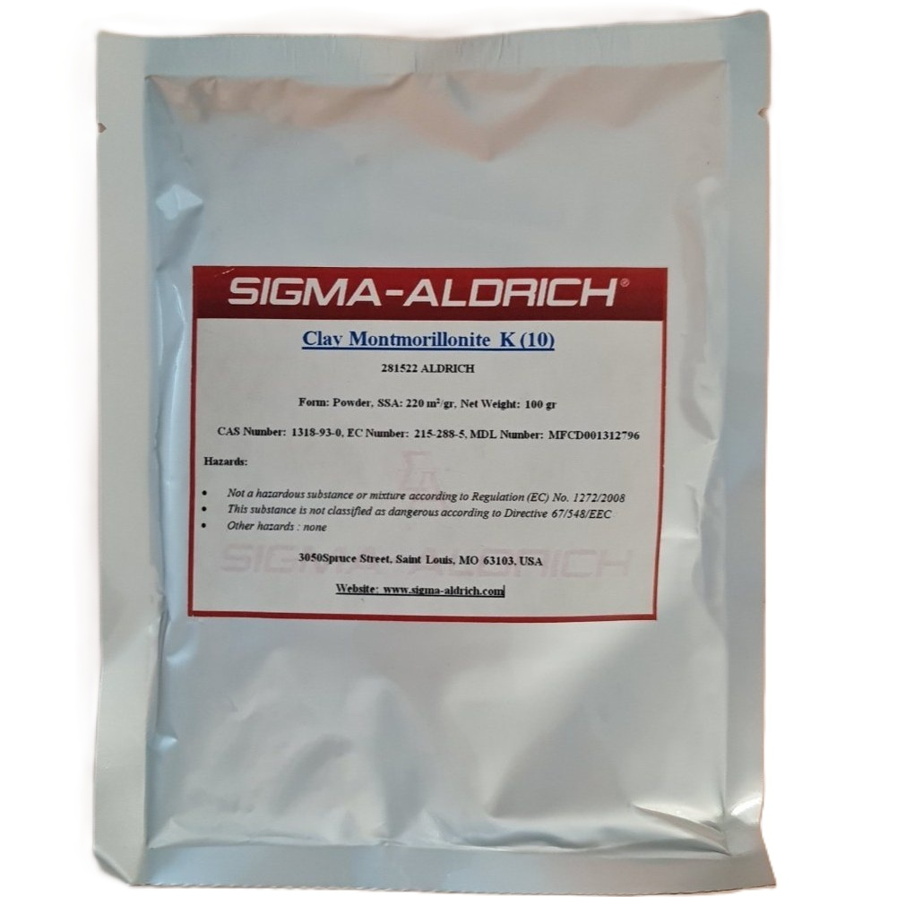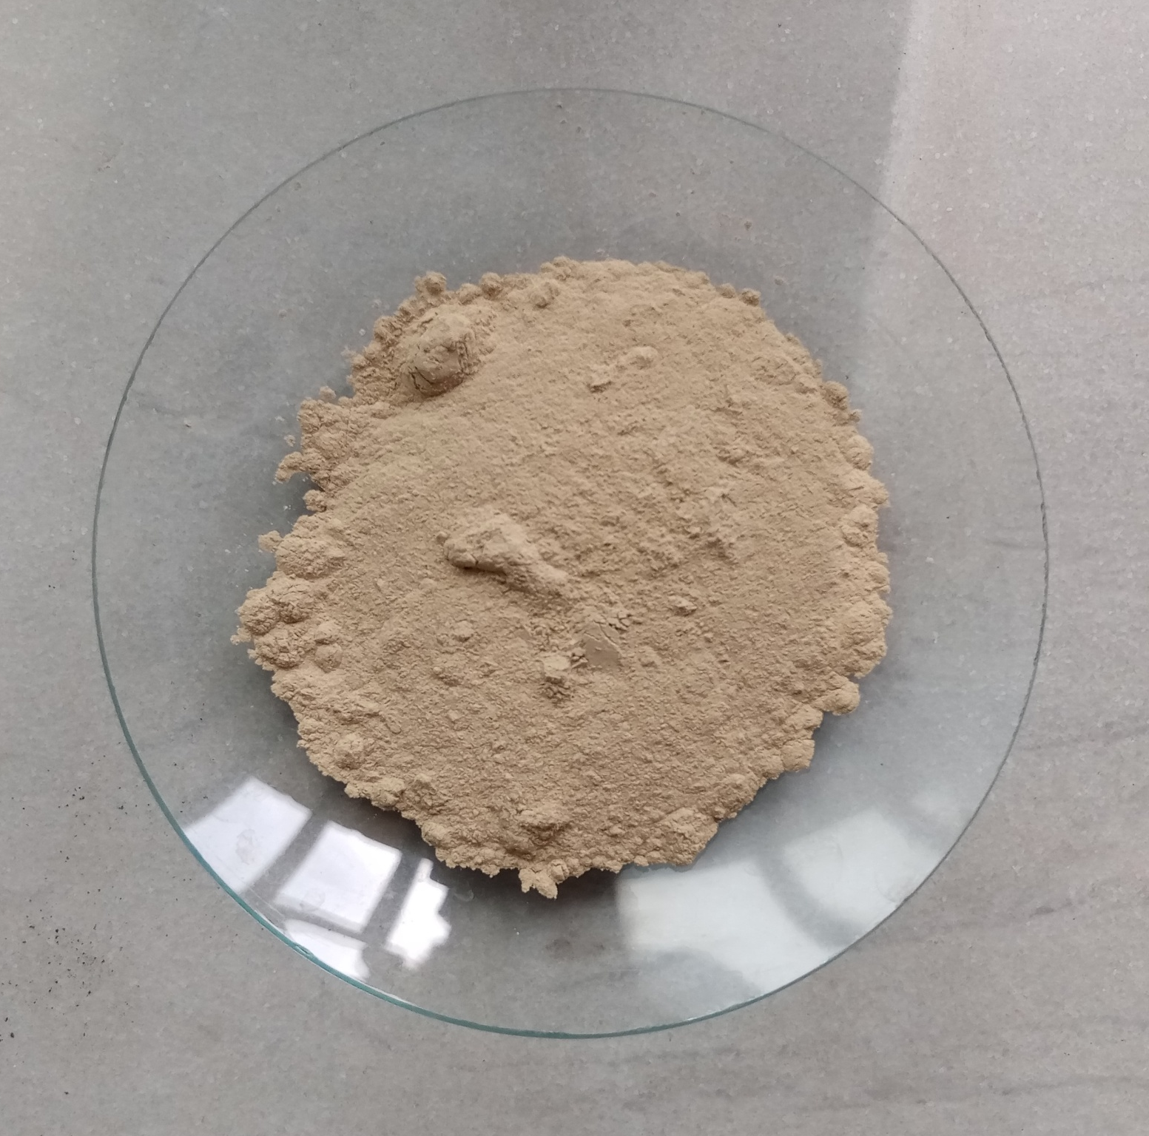
Fig. S1. Montmorillonite used in this study.

Property | Value
CAS Number | 1318-93-0
Grade | K10
Chemical Formula | H₂Al₂O₆Si
Physical Appearance | Powder
Surface Type | Unmodified/Hydrophilic
Color | Pale yellow
Density | 0.5 – 0.7 g/cm³
Particle Size | 1 – 2 nm
Specific Surface Area | 250 m²/g
Moisture Content | 1% – 2%
Cation Exchange Capacity | 48 meq/100 g
Interlayer Spacing | 60 A^{º}
Electrical Conductivity (EC) | 25 mV
Table S3. Physicochemical Properties of Montmorillonite.

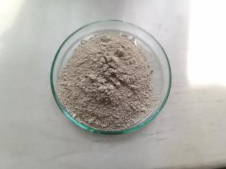
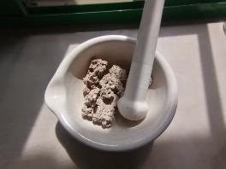
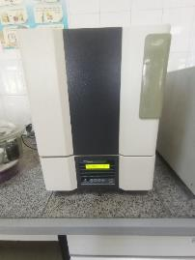
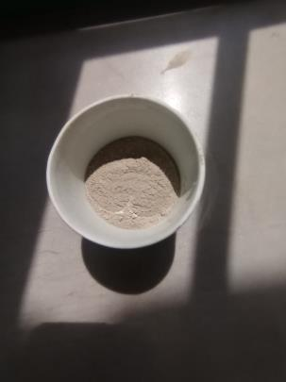
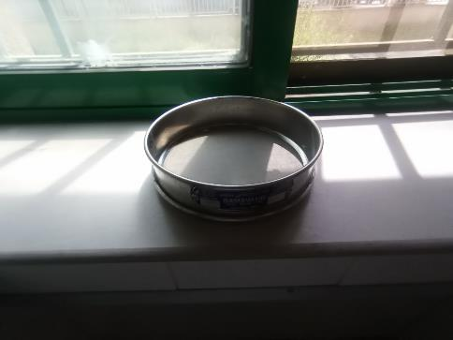
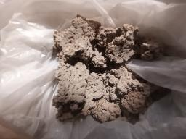
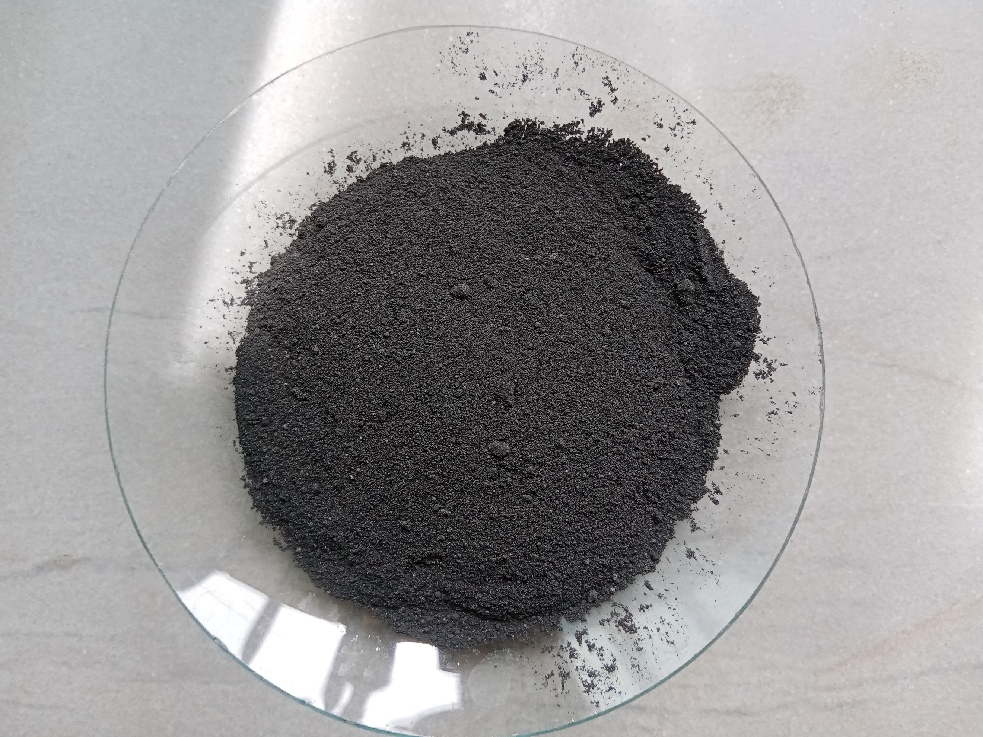
1
2
3
4
5
6
7
PMS-A

Fig. S2. Schematic representation of the synthesis steps for the PMS-A adsorbent.

Element name | Chemical symbol | Weight % (PMS-A) | Weight % (Mt) | Weight % (composite) | Atomic % (PMS-A) | Atomic % (Mt) | Atomic % (composite)
Calcium | Ca | 54.30 | 0.80 | 42.60 | 35.09 | – | 26.57
Oxygen | O | 20.23 | 62.30 | 23.65 | 32.74 | – | 36.96
Carbon | C | 6.54 | – | 5.10 | 14.10 | – | 10.62
Silicon | Si | 6.20 | 16.30 | 13.29 | 5.72 | – | 11.83
Aluminum | Al | 4.07 | 10.00 | 6.27 | 3.91 | – | 5.81
Sulfur | S | 2.05 | – | 1.22 | 1.88 | – | 0.96
Magnesium | Mg | 2.02 | 3.00 | 3.07 | 2.15 | – | 3.16
Sodium | Na | 1.04 | 2.30 | 0.80 | 1.17 | – | 0.88
Phosphorus | P | 1.46 | – | 0.79 | 1.22 | – | 0.64
Nitrogen | N | 0.81 | – | 0.71 | 1.51 | – | 1.26
Potassium | K | 0.62 | 0.90 | 0.98 | 0.41 | – | 0.63
Iron | Fe | 0.39 | 3.80 | 1.25 | 0.18 | – | 0.56
Titanium | Ti | 0.28 | 0.60 | 0.26 | 0.15 | – | 0.13
Total | – | 100 | 100 | 100 | 100 | – | 100
Table S4: EDAX analysis for the three adsorbents: PMS-A, Mt, and the composite.

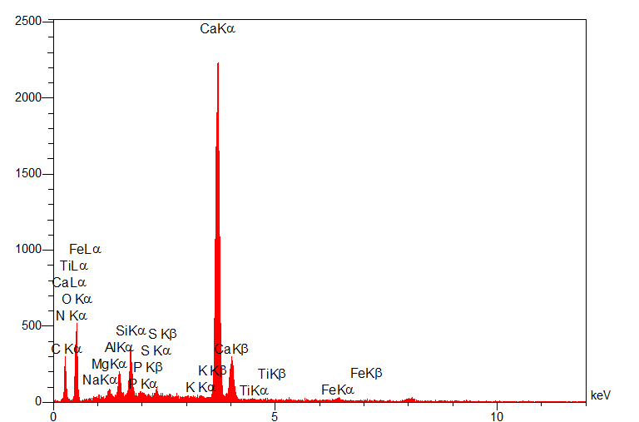
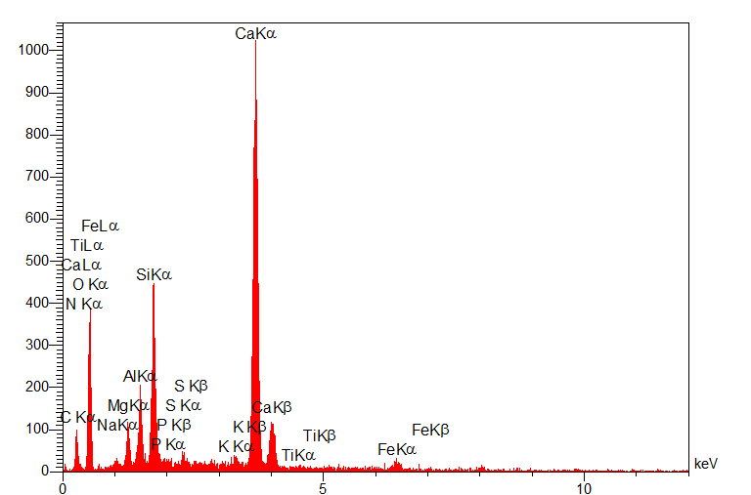
PMS-A
composite
Mt

Fig. S3. EDAX spectra illustrating the elemental composition of PMS-A, the composite, and Mt.

BET plot
V_{m} | 2.5778 | cm³(STP) g⁻¹
a_{s,BET} | 11.22 | m² g⁻¹
C | 584.03
Total pore volume(p/p₀=0.981) | 0.057805 | cm³ g⁻¹
Average pore diameter | 20.608 | nm
Langmuir plot
V_{m} | 4.1874 | cm³(STP) g⁻¹
a_{s,Lang} | 18.226 | m² g⁻¹
B | 0.2556
t plot
Plot data | Adsorption branch
a₁ | 12.012 | m² g⁻¹
V₁ | 0 | cm³ g⁻¹
a₂ | 17.191 | m² g⁻¹
V₂ | -0.0040093 | cm³ g⁻¹
2t | 1.5389 | nm
as plot
a₁ | 12.018 | m² g⁻¹
V₁ | 0 | cm³ g⁻¹
a₂ | 10.414 | m² g⁻¹
V₂ | 0.01087 | cm³ g⁻¹
BJH plot
Plot data | Adsorption branch
V_{p} | 0.056151 | cm³ g⁻¹
r_{p,peak}(Area) | 1.72 | nm
a_{p} | 12.74 | m² g⁻¹
CI plot
Plot data | Adsorption branch
V_{p} | 0.054767 | cm³ g⁻¹
r_{p,peak}(Area) | 1.64 | nm
a_{p} | 9.7783 | m² g⁻¹
Table S5. Surface area and pore structure characteristics of PMS-A obtained from BET analysis

BET plot
V_{m} | 1.3029 | cm³(STP) g⁻¹
a_{s,BET} | 5.671 | m² g⁻¹
C | 143.52
Total pore volume(p/p₀=0.981) | 0.047144 | cm³ g⁻¹
Average pore diameter | 33.253 | nm
Langmuir plot
V_{m} | 2.2271 | cm³(STP) g⁻¹
a_{s,Lang} | 9.6935 | m² g⁻¹
B | 0.1904
t plot
Plot data | Adsorption branch
a₁ | 5.5997 | m² g⁻¹
V₁ | 0 | cm³ g⁻¹
a₂ | 14.834 | m² g⁻¹
V₂ | -0.0061235 | cm³ g⁻¹
2t | 1.3182 | nm
as plot
a₁ | 5.5646 | m² g⁻¹
V₁ | 0 | cm³ g⁻¹
a₂ | 8.6487 | m² g⁻¹
V₂ | 0.0082246 | cm³ g⁻¹
BJH plot
Plot data | Adsorption branch
V_{p} | 0.046928 | cm³ g⁻¹
r_{p,peak}(Area) | 1.72 | nm
a_{p} | 9.2489 | m² g⁻¹
CI plot
Plot data | Adsorption branch
V_{p} | 0.04639 | cm³ g⁻¹
r_{p,peak}(Area) | 1.64 | nm
a_{p} | 7.6804 | m² g⁻¹

Table S6. Surface area and pore structure characteristics of Composite obtained from BET analysis.

Control Experiments (Without Adsorbent)
To evaluate whether pH adjustment alone could contribute to the removal of color and COD from the landfill leachate, control experiments were conducted without the addition of any adsorbent. The leachate pH was adjusted over the range of 3–11 and then subjected to the same experimental procedures as the adsorption tests, including stirring, centrifugation, and filtration (Fig. S4). The results showed that pH adjustment alone did not result in significant removal of color or COD. A slight decrease was observed only at pH 3; however, the reduction was negligible compared with that achieved in the adsorption experiments.
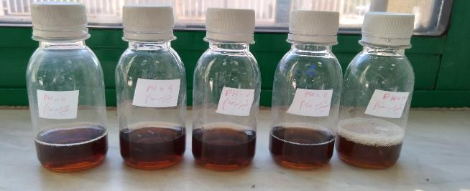
11
9
5
3
7

Fig. S4. Control experiments performed at different pH values (3–11) without adsorbent addition under the same experimental conditions as the adsorption tests.

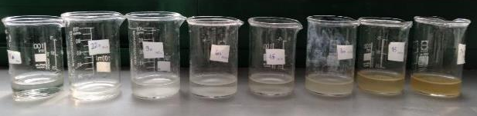
180
120
90
60
45
30
15
10
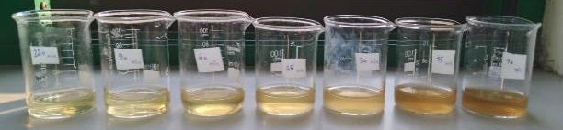
90
45
30
120
60
15
10
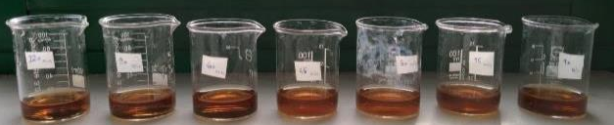Fig. S5. Effect of contact time (10–120 min) on color removal from landfill leachate by PMS-A, the composite, and Mt under optimal conditions (pH ≈ 7, adsorbent dosage = 80 g L⁻¹) and stirring speed = 250 rpm at ambient temperature. The subfigures are arranged from top to bottom for PMS-A, the composite, and Mt, respectively, illustrating the comparative adsorption kinetics of the three adsorbents.
30
120
45
60
90
15
10

 | Model | Parameter | Pollutant
 | Model | Parameter | Color |  |  | COD
 | Model | Parameter | PMS-A | composite | Mt | PMS-A | composite | Mt
Kinetic | Pseudo-First-Order | k₁  q_{e}  h₀  SD  $$R_{adj}^{2}$$ | 0.14±0.02  40.37±0.92  5.63±0.80  2.379  0.965 | 0.16±0.23  37.24±0.69  6.04±0.81  1.823  0.976 | 0.14±0.03  23.08±0.67  3.27±0.60  1.725  0.945 | 0.97±0.05  25.73±0.23  2.49±0.11  0.570  0.995 | 0.057±0.005  19.77±0.45  1.12±0.09  0.973  0.978 | 0.068±0.017  13.502±0.720  0.923±0.204  1.642  0.868
Kinetic | Pseudo-Second-Order | k₂  q_{e}  h₀  SD  $$R_{adj}^{2}$$ | 0.006±0.001  42.61±0.73  11.33±1.68  1.365  0.989 | 0.0089±0.0014  38.93±0.50  13.47±1.81  0.958  0.993 | 0.011±0.003  24.38±0.64  6.52±1.48  1.192  0.974 | 0.006±0.0007  27.58±0.43  4.49±0.43  0.742  0.992 | 0.004±0.0005  22.06±0.54  1.75±0.17  0.751  0.987 | 0.006±0.0018  15.13±0.77  1.38±0.31  0.691  0.937
Kinetic | Elovich | α  β  SD  $$R_{adj}^{2}$$ | 2309±2213  0.27±0.027  1.079  0.993 | 17285±12903  0.352±0.022  0.518  0.998 | 927±1059  0.453±0.057  0.798  0.988 | 116.60±131.90  0.320±0.054  1.523  0.966 | 6.834±2.764  0.270±0.029  1.155  0.969 | 6.275±2.843  0.410±0.046  0.783  0.970
Kinetic | Intra-particle diffusion | k_{id}  C  $$R_{adj}^{2}$$ | 11.086±1.44  7.065±3.91  0.865 | 10.024±1.46  7.36±3.97  0.835 | 6.414±0.800  3.876±2.16  0.875 | 7.192±0.876  3.41±2.37  0.880 | 5.90±0.46  0.54±1.25  0.947 | 4.126±0.234  0.48±0.63  0.971
Isotherm | Langmuir | k_{L}  Q_{max}  SD  $$R_{adj}^{2}$$ | 0.013±0.002  74.35±7.75  1.75  0.981 | 0.015±0.002  38.68±1.30  1.42  0.982 | 0.0036±0.0007  20.03±1.12  1.18  0.925 | 0.0022±0.0007  52.41±11.60  1.19  0.971 | 0.0019±0.0005  32.55±4.96  1.12  0.964 | 0.0027±0.0005  15.70±1.10  0.66  0.956
Isotherm | Freundlich | k_{F}  n_{F}  SD  $$R_{adj}^{2}$$ | 2.40±0.50  1.58±0.12  2.15  0.976 | 4.13±0.57  2.86±0.20  1.64  0.976 | 1.50±0.33  3.02±0.29  0.94  0.952 | 0.35±0.08  1.40±0.08  0.82  0.986 | 0.35±0.12  1.64±0.16  1.08  0.961 | 0.524±0.12  2.23±0.18  0.56  0.968
Isotherm | Temkin | b_{T}  A_{T}  SD  $$R_{adj}^{2}$$ | 14.37±1.26  0.16±0.02  2.93  0.948 | 7.73±0.15  0.18±0.01  0.57  0.997 | 4.12±0.35  0.04±0.01  0.96  0.950 | 8.01±0.85  0.040±0.008  1.90  0.925 | 6.23±0.65  0.02±0.005  1.48  0.928 | 3.51±0.26  0.02±0.005  0.63  0.960

Table S7. Kinetic and isotherm model fitting parameters for color and COD adsorption on PMS-A, the composite, and Mt under the experimental conditions (pH ≈ 7, adsorbent dosage = 80 g L⁻¹, stirring speed = 250 rpm, and ambient temperature). Adjusted R² and SD values were used to evaluate model-fitting performance.

References
1. Genethliou, C. et al. Simultaneous removal of ammonium nitrogen, dissolved chemical oxygen demand and color from sanitary landfill leachate using natural zeolite. J. Hazard. Mater. 406, 124679, doi:https://doi.org/10.1016/j.jhazmat.2020.124679 (2021).
2. Aziz, H. A., Foul, A. A., Isa, M. H. & Hung, Y.-T. Physico-chemical treatment of anaerobic landfill leachate using activated carbon and zeolite: Batch and column studies. Int. J. Environ. Waste Manag. 5, 269–285 (2010).
3. Detho, A., Kadir, A. A., Memon, A. A. & Laghari, A. N. Experimental Approach for Ammonia and COD Removal from Leachate via Adsorption by Carbon Mineral Adsorbent. Waste Biomass Valor. 14, 3529–3538, doi:10.1007/s12649-023-02207-3 (2023).
4. Yahaya, I., Daud, Z. & Fauzi, B. Absorption Capacity using Waste Paper Sludge as an Alternative Adsorbent for Treatment of Landfill Leachate. IOP Conf. Ser.: Earth Environ. 616, 012024, doi:10.1088/1755-1315/616/1/012024 (2020).
5. Detho, A., Kadir, A. A. & Rassem, H. H. Isotherm-kinetic equilibrium investigations on absorption remediation potential for COD and ammoniacal nitrogen from leachate by the utilization of paper waste sludge as an eco-friendly composite filler. Sci. Rep. 14, 10599, doi:10.1038/s41598-024-61392-w (2024).
6. Hashemi, H., Bahrami, S., Emadi, Z., Shariatipor, H. & Nozari, M. Optimization of ammonium adsorption from landfill leachate using montmorillonite/hematite nanocomposite: Response surface method based on central composite design. Desalin. Water Treat. 232, 39–54 (2021).

