

Supplemental Information for

Late Miocene capybara in the Atacama Desert reveals a wetter climate and a transcontinental dispersal pathway

Carolina S. Gutstein^{a,b}
Priscilla R. Martinez^{c}
Barbara Carrapa^{c}
Mark Clementz^{d}
Jorge J. Cherem^{e}
Mario A. Cozzuol^{f}
Caroline A.E. Strömberg^{g}
Mario E. Suárez^{h}
Catalina Carreño Chavarría^{i}
Jacobus P. Le Roux^{j}

ªEscuela de Geología, Universidad Santo Tomás, Santiago, Chile.
^{b}Fosfatos de Caldera SpA., Caldera, Atacama, Chile.
^{c}Department of Geosciences, University of Arizona, Tucson, AZ, USA
^{d}Department of Geology and Geophysics, University of Wyoming, Laramie, WY, USA
^{e}Caipora Cooperativa para a Conservação da Natureza, Av. Desembargador Vítor Lima, 260/513, 88040-400, Florianópolis, SC, Brazil
^{f}Universidade Federal de Minas Gerais, Instituto de Ciências Biológicas, Departamento de Zoologia, Av. Antônio Carlos, 6627, Pampulha, 31270-910 - Belo Horizonte, MG – Brasil
^{g}Department of Biology & Burke Museum of Natural History and Culture, University of Washington, Seattle WA, USA.
^{h}Laboratorio de Ontogenia y Filogenia, Departamento de Biología, Facultad de Ciencias, Universidad de Chile, Santiago, Chile
^{i}Departamento de Geología, Facultad de Ciencias Físicas y Matemáticas, Universidad de Chile, Plaza Ercilla 803, Santiago
^{j}Departamento de Geología, Facultad de Ciencias Físicas y Matemáticas, Universidad de Chile / Centro de Excelencia en Geotermia de los Andes, Plaza Ercilla 803, Santiago

Contents of this file
Text S1. Detailed taphonomic description of the El Morro bonebed.
Text S2. Zircon U-Pb geochronology detailed methods for Element2 HR ICPMS and iCAP RQ Single Quad ICPMS.
Text S3. U-Pb Geochronologic analyses of zircon using E2/iCAPAgeCalcML.

Figure S1. Orientation of fossil long-bone axes at Point 62, El Morro site, Bahía Inglesa Formation.
Figure S2. Field photographs and taphonomic detail of the El Morro bonebed.
Figure S3. Zircon U-Pb maximum depositional ages (MLA radial plots).
Figure S4. Zircon U-Pb maximum depositional ages (YC2σ, YC1σ, YSG MDA plots).
Figure S5. Representative phytoliths from CB-06.

Additional Supplemental Tables
Table S1. Long-axis orientation measurements of fossil bones, Point 62, El Morro site, Bahía Inglesa Formation.
Table S2. Specimens excavated at El Morro locality in the gray sandstone bonebed after (Gutstein et al 2007, Rubilar-Rogers et al. 2009).
Table S3. Measurements of MPC3000 tooth specimen compared to published Cardiatherium data.
Table S4. Analytical Settings for U-Pb Geochronology at the Arizona LaserChron Center (Element 2 and iCAP Single Collectors) — For detrital zircon sample analyses
Table S5. U-Pb zircon data for sample EMSSTBASE used for maximum depositional age calculation.
Table S6. U-Pb zircon data for sample EM1DZASH used for maximum depositional age calculation.
Table S7. U-Pb zircon data for sample CGSST used for maximum depositional age calculation. Table S8. Stable isotopic analyses from Atacama soil carbonate nodules from the Caldera basin, northern Chile.
Table S9. Carbon isotope (δ¹³C) compilation of modern C₃ plant tissue (Kohn et al. 2020; O'Leary 1988), modern western Amazonian rainforest mammal tooth enamel (Tejada et al. 2020), and Miocene Atacama Desert soil carbonate nodules (this study).
Table S10. Phytolith assemblage counts from Peru sample (CB-06): Raw counts, summary % data, and other sample information.

Introduction
This supplemental information includes descriptions of the analytical techniques applied in this study and supplemental figures and data tables supporting results and interpretations in the main text.
- Data files herein include text describing analytic methods and approaches, figures supporting analytical results, tables detailing sample information and modeling parameters, and datasets containing detailed analytic data used in this study.
- Data for this study were produced between 2023 and 2025 using multiple laboratory facilities at the University of Arizona, Tucson, Arizona, USA.

Text S1. Detailed taphonomic description of the El Morro bonebed.

Prior to formal survey, the El Morro site had yielded specimens through informal collection by local fossil hunters. Among these was Pelagornis chilensis, the most complete and best-preserved pelagornithid known to science, extracted from the gray sandstone by Mr. Hector Mauna and his son, Mr. Rodrigo Mauna. The excavation, commercialization, and eventual repatriation of that specimen is documented in several informal publications (https://www.youtube.com/watch?v=5NE5pofsdeE), produced in collaboration with local, regional, and national museums, along with the National Monuments Council. It was under separate circumstances, at the same general locality, that Mr. Rodrigo Mauna also extracted the capybara tooth described here (MPC-3000), reportedly in situ from the gray sandstone just a few meters from the P. chilensis recovery site.

Formal taphonomic investigation of the gray sandstone horizon began with a preliminary survey in 2009, which documented moderate transport and current activity with moderate orientation consistency (n = 50 measured skeletal elements) (Fig. S1; Rubilar-Rogers et al., 2009). Field documentation during this campaign followed standard taphonomic protocols: each specimen was assigned a GPS-referenced field number, and its orientation, size, and spatial position were recorded in situ prior to plaster-jacket collection, with multi-specimen localities additionally mapped via detailed sketches and grids. A total of 118 paleontological samples were recovered during the 2009 campaign alone, including a pelagornithid humerus, a partial porpoise skeleton, and numerous elasmobranch teeth and cetacean tympanic bullae (Fig. S2B); these are now curated at the Área de Paleontología, Museo Nacional de Historia Natural (MNHN), Santiago. Analysis of fossil long-bone axes from this collection (n = 50) yielded a mean axial orientation of 67.6°–247.6° and a mean resultant vector length (R) of 0.28, indicating a preferred ENE–WSW/NE–SW trend, albeit with considerable dispersion (Table S1). Skeletal elements were found concentrated within the basal portion of the gray sandstone across two primary excavation localities, with the P. chilensis recovery site situated between them; these limited excavations, covering a combined area of under 15 m × 3 m, yielded the full diversity of taxa detailed in Table S2.

This gray sandstone unit lies stratigraphically above the phosphatic conglomerate "bonebed" (Walsh and Hume, 2001; Walsh & Suárez, 2005; LeRoux et al., 2016), which at the Bahía Inglesa type locality (Mina Fosforita) concentrates the great majority of isolated, fragmentary, reworked vertebrate remains (Gutstein et al., 2007; 2008, 2021). In contrast, the 2009 survey confirmed that the El Morro gray sandstone is dominated by articulated and associated vertebrate skeletons preserving fine anatomical detail and excellent surface quality, with no shell material observed in this layer (Figure S2A; Gutstein et al., 2007). This taphonomic signature—near-complete skeletal articulation, minimal abrasion, and an absence of coarse bioclastic admixture—is consistent with predominantly autochthonous to para-autochthonous burial, in contrast to the allochthonous, current-winnowed assemblages typical of the underlying phosphorite bonebed facies.

Among the specimens documented were articulated or semi-articulated skeletons recovered within a few meters, and in some cases centimeters, of one another, including penguins (Spheniscidae), billfish (Istiophoridae), true seals (Phocidae), the pelagornithid P. chilensis, a nearly complete baleen whale (Cetotheriidae), and a partial porpoise (cranial and postcranial elements; Figure S2B–C). Isolated but spatially associated baleen whale elements (scapula, tympanic bulla, and periotic–tympanic complex; Balaenopteroidea) co-occurred with isolated shark teeth. Notably, the baleen whale skeleton was spatially coincident with a denser accumulation of isolated, complete skeletal elements arranged in a "dam-like" configuration, suggesting that the whale carcass locally acted as a hydrodynamic obstruction around which smaller, isolated elements preferentially accumulated during moderate current activity. Fine-detail preservation was also evident in the zygomatic process of the porpoise specimen (Phocoenidae)—a millimeter-thin, several-centimeter-long fragile bone that is lost in many extant museum specimens owing to its extreme fragility and susceptibility to disarticulation and breakage—and in the pelagornithid humerus (nearly a meter long but only a few centimeters wide, an element usually recovered only as small fragments due to its fragility; Fig. S2B). Given this combination of exceptional articulation, high taxonomic diversity, and preservation of typically fragile elements, the El Morro gray sandstone horizon has previously been proposed as a candidate fossil Lagerstätte (Seilacher et al., 1985; Gutstein et al., 2007).

The complete whale skeleton, initially consolidated and protected at the site, was revisited and re-examined during a subsequent field trip in 2019. On this occasion, Mr. Rodrigo Mauna was invited back to the field and indicated precisely the place and stratigraphic level at which MPC-3000 had been recovered, along with the circumstances and observations surrounding its extraction, as recounted above.

Subsequent laboratory examination of the capybara tooth (MPC-3000) showed a low degree of abrasion and breakage between the fourth and fifth laminae, with the proximal portion preserved as four complete laminae plus an additional cement layer (Table S3). Given its laminated, gracile architecture, this structure is inherently fragile and prone to detachment from the alveolus. The tooth shows fine anatomical preservation, with no evidence of postdepositional exhumation (e.g., discoloration or sun-exposure marks) or intense transport (e.g., strong abrasion or rounding). The minor abrasion observed was localized to the more fragile portions of the labial margin—specifically, the labial projections of the laminae—consistent with minimal reworking or local (intrabasinal) transport prior to final burial, and indicating that the specimen was not exposed for a prolonged period to the high-energy conditions typical of active fluvial or beach environments. Taxa associated with coastal or emergent settings recovered from the site include penguins, crocodiles, seals, and the capybara (Table S2)—all species linked to an intertidal biocenosis and found either in the sea or on the beach.

References Cited

Gutstein, C.S., Rubilar-Rogers, D., and Suárez, M.E., 2007, Nuevo yacimiento con vertebrados fósiles del Neógeno en el Desierto de Atacama: Geosur, Abstract v. 70.
Gutstein, C.S., Yury-Yañez, R.E., Soto-Acuña, S., Suárez, M.E., and Rubilar-Rogers, D., 2008, Fauna de vertebrados y aspectos tafonómicos del 'bonebed' (Mioceno Tardío) de la Formación Bahía Inglesa, in I Simposio - Paleontología en Chile - 2008: Libro de Actas, p. 102-108.
Gutstein, C.S., Cozzuol, M.A., Vargas, A.O., Suárez, M.E., Schultz, C.L., and Rubilar-Rogers, D., 2009, Patterns of Skull Variation of Brachydelphis (Cetacea, Odontoceti) from the Neogene of the Southeastern Pacific: Journal of Mammalogy, v. 90, p. 504–519, doi:10.1644/07-MAMM-A-081.1.
Rubilar-Rogers, D., Gutstein, C.S., and Amaro Mourgues, F., 2009, Nuevo yacimiento con vertebrados fósiles de la Formación Bahía Inglesa (Mioceno-Plioceno), del norte de Chile, in Fondo de Apoyo a la Investigación Patrimonial 2009, Informes de Ciencias Naturales: Santiago, Chile, Consejo de Monumentos Nacionales, p. 7–13, ISSN 0717-487X.
Seilacher, A., Reif, W.-E., and Westphal, F., 1985, Sedimentological, ecological and temporal patterns of fossil Lagerstätten: Philosophical Transactions of the Royal Society of London, Series B, Biological Sciences, v. 311, no. 1148, p. 5–23.
Walsh, S.A., and Hume, J.P., 2001, A new Neogene marine avian assemblage from north-central Chile: Journal of Vertebrate Paleontology, v. 21, p. 484–491, doi:10.1671/0272-4634(2001)021[0484:ANNMAA]2.0.CO;2.
Walsh, S.A., and Suárez, M.E., 2006, New penguin remains from the Pliocene of Northern Chile: Historical Biology, v. 18, p. 119–130, doi:10.1080/08912960600640796.
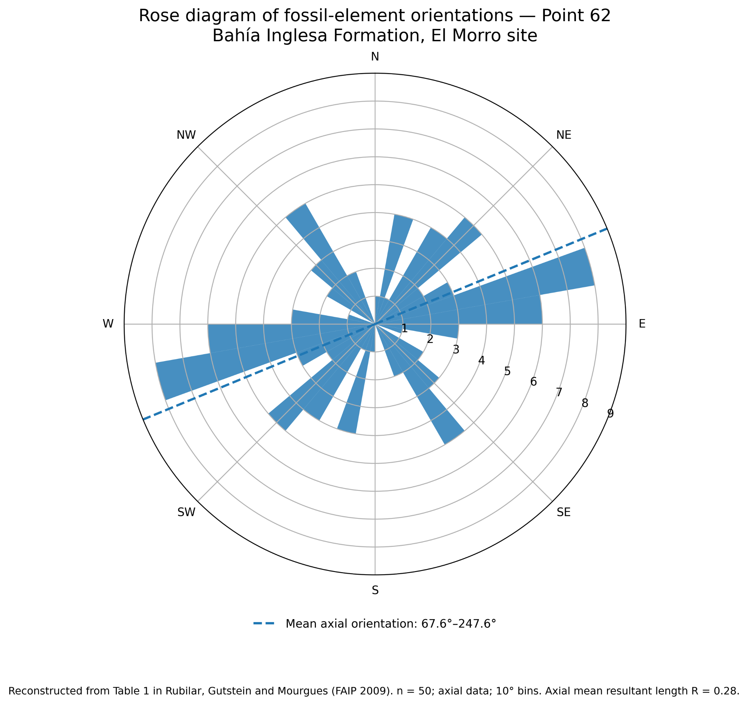

Figure S1. Rose diagram of fossil bone long-axis orientations at Point 62 of excavation (Gutstein et al. 2007, Rubilar-Rogers et al. 2009) at El Morro locality, Bahía Inglesa Formation (n = 50). Measurements were treated as axial data, grouped into 10° intervals, and represented bidirectionally. The dashed line marks the mean axial orientation (67.6°–247.6°; mean resultant length (R) = 0.28), indicating a preferred ENE-WSW/NE-SW trend with considerable dispersion. Each fossil bone fragment was treated as an independent observation and assigned equal statistical weight. Records lacking directional information were excluded from the analysis. Constructed using data in Supplementary Table S2.

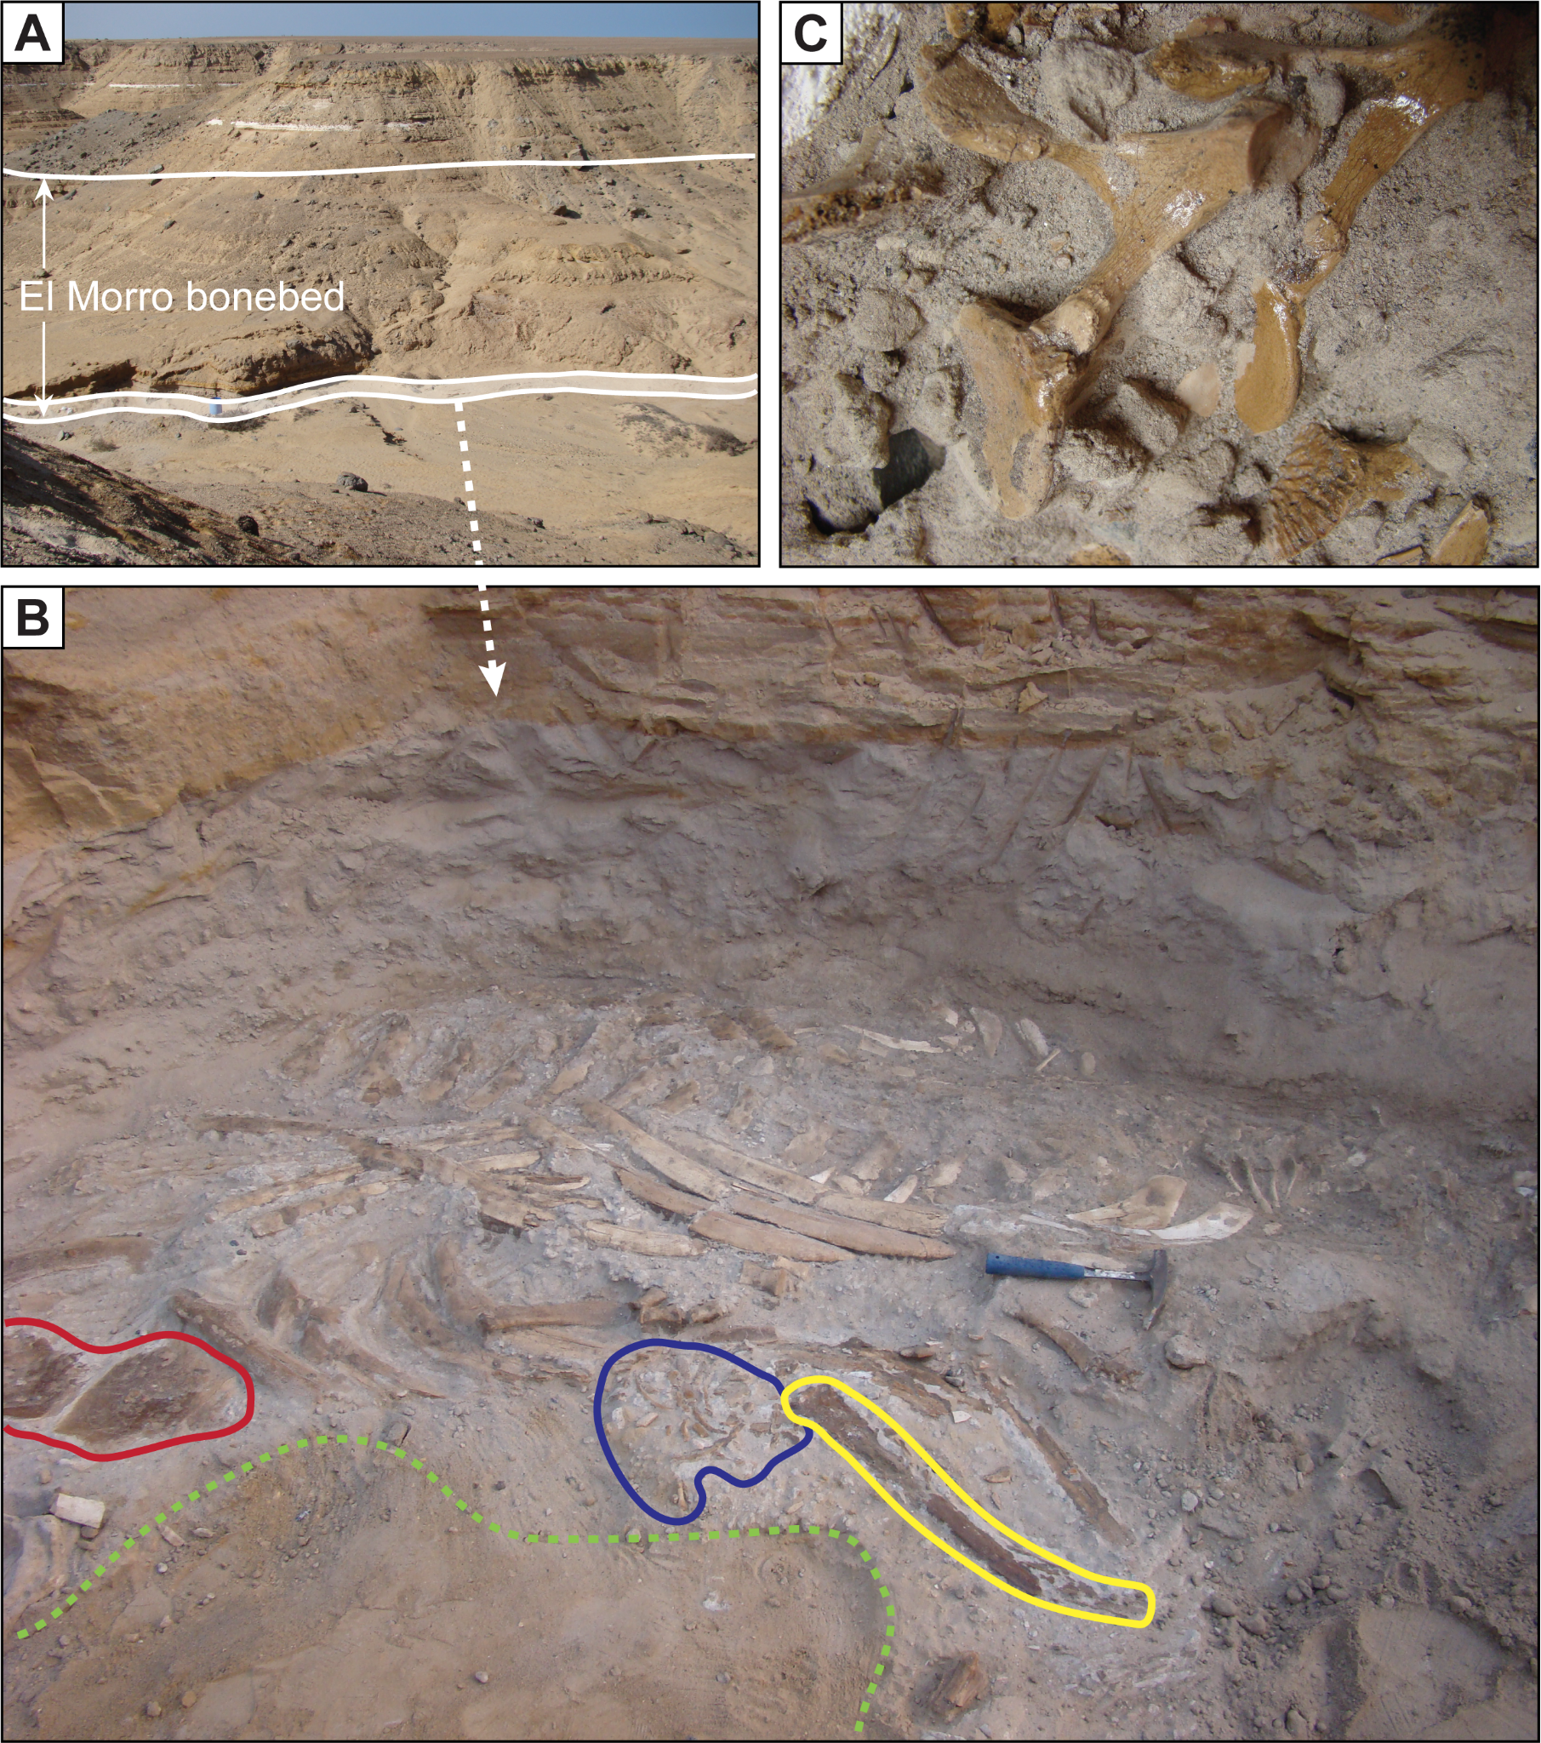
Figure S2. Field photographs of the El Morro bonebed, Bahía Inglesa Formation. A) Outcrop view of the El Morro bonebed exposure, showing the stratigraphic interval (solid white lines) that yielded the fossil accumulation. Vertebrate bones are mostly, but not exclusively, concentrated within the basal 20 cm of the bonebed. The dashed arrow indicates the location of the close-up view shown in (C). B) Close-up view of the dense accumulation of articulated fossil partial skeletons within the bonebed. Detail of the bonebed showing multiple taxa (skeletons and isolated bones) in taphonomic association: a Pelagornis humerus outlined in yellow; a partially articulated dolphin skeleton (cranial and postcranial elements); and postcranial remains (scapula) and a tympanic bulla of balaenopteroid mysticete. The associated complete skeleton is of a Cetotheridae mysticete. Green dashed line marks the boundary of modern ravine erosion. Hammer for scale. C). Close-up view of the articulated postcranial skeleton of the mysticete in (B).

Text S2: U-Pb Geochronologic analyses of zircon utilizing the Element2 HR ICPMS
Zircon crystals are extracted from samples by traditional methods of crushing and grinding, followed by separation with a Wilfley table, heavy liquids, and a Frantz magnetic separator. Samples are processed such that all zircons are retained in the final heavy mineral fraction. For detrital analyses, a large split of grains (generally thousands of grains) is incorporated into a 1” epoxy mount together with fragments or loose grains of Sri Lanka, FC-1, and R33 zircon crystals that are used as primary standards. For igneous samples, ~50 high-quality grains are selected and mounted with standards, generally with four samples per mount. The mounts are sanded down to a depth of ~20 microns, polished, imaged, and cleaned prior to isotopic analysis.

Grains of interest are imaged to provide a guide for locating analysis pits in optimal locations, and to assist in interpreting results. BSE and color CL Images are generated with a Hitachi 3400N SEM and a Gatan CL2 detector system (www.laserchron.org).

U-Pb geochronologic analyses are conducted by laser ablation inductively coupled plasma mass spectrometry (LA-ICPMS) at the Arizona LaserChron Center (www.laserchron.org). Methods for U-Pb geochronology have been described by Gehrels et al. (2006, 2008), Gehrels and Pecha (2014), Pullen et al. (2018), and Sundell et al. (2021). The analyses involve ablation of zircon with a Teledyne/Photon Machines Analyte G2 excimer laser equipped with HelEx2 ablation cell, or an Iridia excimer laser equipped with a Cobalt cell, using a spot diameter of 20-30 microns. The ablated material is carried in helium into the plasma source of an Element2 HR ICPMS and iCAP RQ ICP-MS, which sequences rapidly through the U, Th, Pb, and Hg isotopes. Signal intensities are measured with an SEM that operates in pulse counting mode for signals less than 50K cps, in both pulse-counting and analog mode for signals between 50K and 5M cps, and in analog mode above 5M cps. The calibration between pulse-counting and analog signals is determined line-by-line for signals between 50K and 5M cps, and is applied to >5M cps signals. Because 235U is measured (rather than 238U), it is rare for intensities to be above 5M cps.

With the laser set at an energy density of ~5.6 J/cm2, a repetition rate of 7 Hz, and an ablation time of ~15 seconds, ablation pits are ~15 microns in depth. Sensitivity with these settings is approximately ~8,000 cps/ppm. Each analysis consists of ~5 seconds on peaks with the laser off (for backgrounds), ~15 seconds with the laser firing (for peak intensities), and a ~10 second delay to purge the previous sample.

One intensity is determined on each mass, with dwell times as follows:
- Hg202 0.021 sec
- Hg+Pb204 = 0.031 sec
- Pb206 = 0.081 sec
- Pb207 = 0.150 sec
- Pb208 = 0.010 sec
- Th232 = 0.010 sec
- U235 = 0.150 sec

These dwell times have been established to generate U-Th-Pb ages that are accurate to 2% (2-sigma SE) for a zircon similar in composition and age to FC-1. Total scan time is approximately 0.5 sec including all dwell and settle times.

Data are acquired with an acquisition that consists of 56 scans. These include:
- 11 scans on backgrounds prior to laser firing
- 32 scans with laser firing
- 13 scans after laser is no longer firing (for signal washout)

Data are acquired in Time-Resolved mode, such that data are continuously acquired by the mass spectrometer and the laser sequences through the analyses. The onset of each analysis is set when the 232U signal rises above a threshold intensity (default = 3000 cps) -- this time is referred to as Tzero.

Following analysis, data reduction is performed with a Python decoding routine and a MATLAB program (AgeCalcML; v GGmod68e). The first step is to extract the measured ion intensities from the Thermo output (.dat) files utilizing a decoder that was written by John Dr. Hartman (University of Arizona; Hartman et al., 2017). Details of this decoding routine are available from the Dat File Decoder link on the ALC web page (under Tools). This decoding routine generates .csv and .xls files that include all ion intensities for each scan. These ion intensities and the list of spot names are imported into AgeCalcML_E2_TRA.

Following are the calculations performed by AgeCalcML to reduce U-Th-Pb data.

- The Browser function first creates the graphical user interface.
- The Data Import function imports analysis names from the scancsv file (created by the laser software) and all of the raw data from the decoded xls file. Pulse-mode intensities are used for <5M cps signals, whereas analog-mode intensities are used for >5M cps signals. Measured ion intensities are stored in the original "numbers" array.
- The Reduce Data function performs the initial data reduction and generates the plots shown on the interface. Main steps are as follows:
  - Sets values for all variables.
  - Subtracts 204Hg from the measured 204 intensities by using the measured 202Hg signal and the natural 202Hg/204Hg of 4.3. This yields intensities for 204Pb. Note that this Hg correction is not significant for most analyses because our Hg backgrounds are low (<100 cps at mass 202).
  - Finds Tzero for each analysis by searching for the initial 232Th or 206Pb intensity above 3000 cps (default value).
  - Populates the AnalysisValues array with values for each analysis. Registration is based on Tzero. 238U intensities are calculated from 235U * 137.818.
  - Creates arrays for background values and peak values for each analysis. Backgrounds are calculated from the average of seven scans, minus max and min values. Peaks are calculated from the measured ion intensities while the laser is firing, minus the background values.
  - Calculates preliminary 206/238 ratios determined from the on-peak, background-corrected ion intensities.
  - Generates a preliminary fractionation factor for 206/238 for each standard by comparing measured 206/238 values with reported 206/238 values from Paces and Miller (1993) for FC-1, Gehrels et al. (2008) for SF, and Black et al. (2004) for R33. Note that ID-TIMS (not CA-TIMS) values are used given that our zircon grains have not been chemically abraded.
  - Creates a sliding-window average from the ~8 closest values (minus max and min values).
  - Calculates preliminary 206/238 ages based on the sliding-window average values of fractionation- and background-corrected 206/238.
  - Preliminary 206/238 ages used to determine the composition of initial Pb based on Stacey and Kramers (1975).
  - Initial Pb subtracted from 206, 207, and 208, resulting in background- and common-Pb-corrected 206/238, 206/207, and 208/232 ratios.
  - Preliminary fractionation factors are applied to background- and common-Pb-corrected 206/238, 206/207, and 208/232 ratios, and resulting ratios of standards are compared with known values.
  - Standard analyses are rejected if the ratios differ from known values by more than 5% (default value).
  - Accepted standards are used to generate final fractionation factors for 206/238, 206/207, and 208/232. Corrections are generally ~5% for 206/238, <2% for 206/207, and ~20% for 208/232.
  - A sliding window average (of ~8 closest values) is used to determine the fractionation factors that are used to correct the background- and common-Pb-corrected ratios for standards and unknowns. Sliding-window values and uncertainties for the final fractionation factor are shown on the fractionation plots with a solid line. The initial fractionation factor is shown with a dashed line (to show impact of filtering).
  - Uncertainties are determined for isotope ratios based on the standard error of the mean of on-peak values for 206/207, 206/204, and 208/204. Uncertainties for 206/238 and 208/232 are calculated from the standard error of a regression through the on-peak values (using the polyfit and polyval functions in MATLAB).
  - Overdispersion factors are applied to the uncertainties for 206/238, 206/207, and 208/232 ratios. These factors have been determined from multiple analyses of secondary standards.
  - Calculates concentrations of U and Th for unknowns based on the measured intensities and known concentrations of FC-1 and R33.
  - A U-Th disequilibrium correction is applied to 206/238 ages based on the methods of Crowley et al. (2007).
  - Ages and uncertainties are calculated from the background-, fractionation-, and common-Pb-corrected 206/238, 206/207, and 208/232 ratios.
  - Determines a “Best Age” for each analysis, which is the 206/238 age for <900 Ma ages and the 206/207 age for >900 Ma ages (default values).
  - Analyses are automatically filtered based on default cutoffs for uncertainty, discordance, reverse discordance, 204Pb counts, 235U intensity, and on-peak signal stability. On-peak stability is based on comparison of eight values while the laser is firing. Analyses that exceed these cutoff values (default value = 5%) are rejected.
  - Error correlations and uncertainty ellipses are generated for 206/238-207/235 and 206/238-208/232 concordia diagrams.
  - Information shown in the list of analysis names (lower left) is generated. This includes a concordia ellipse for each analysis and information about the status of each analysis (whether accepted or rejected, and why rejected).
  - Calculates external (systematic) uncertainties for 206/238, 206/207, and 208/232, which include contributions from (a) the scatter of primary standard analyses, (b) uncertainties in the ages of the primary standard (FC1), (c) uncertainties in the composition of common Pb, (d) uncertainties in the decay constants for 235U, 238U, and 232Th, and (e) long-term variance of secondary standards. These are the systematic uncertainty terms recognized by Horstwood et al. (2016).
- The Reduce Data function also calls a variety of functions that do all the data-reduction calculations and update all of the plots shown on the user interface.
- Once initial data reduction has been completed, the operator can analyze the data using various plots and settings. Following is a list of the available plots:
1 - Concordia All
2 - Concordia Rejected (with sample names)
3 - Concordia All - Young/Log
4 - Concordia All - 206/238 vs 208/232
5 - Concordia FC-SL-R33
6 - Concordia FC
7 - Concordia SL
8 - Concordia R33
9 - Offset Plot 206/238
10 - Offset Plot 206/207
11 - Offset Plot 208/232
12 - Weighted Mean Unknowns
13 - Weighted Mean FC1
14 - Weighted Mean SLM
15 - Weighted Mean R33
16 - Age vs U Concentration
17 - Age vs Radiation Dosage
18 - Age vs U/Th
19 - Age vs Concordance
The suggested flow for data analysis is as follows:
- Evaluation of standards:
  - In upper left window, enter higher and lower values for Min 235 (cps) and monitor the number of rejected unknowns and standards. Leave at setting with lowest numbers rejected. Go for minimum value (down to 300 cps) that does not exclude lots of analyses.
  - Do the same with Max 204 (cps), and leave with lowest numbers of standards and unknowns rejected. Go for minimum value (down to 300 cps) that does not exclude lots of analyses.
  - Adjust Stability Cutoff value, and leave with just a few unknowns rejected. Go for minimum value (down to 4%) that does not exclude lots of analyses. Note that the timing of each of the eight measurements is shown in the beam trace window.
  - Select "Concordia Young/Log" Plot in upper right window. Adjust 206/204 factor so that concordance (lower right) ends up close to 100%. This adjusts the 206/204 and 208/204 used for common-Pb correction based on the assumption that young analyses (especially R33 standard) are discordant.
  - Select "Offset Plot for 206/238" in upper right window. Adjust Low-int and Linear sliders so that standards and unknowns cluster along zero offset line. Standards are shown relative to known values. Unknowns are show relative to concordia. This adjusts the 235U intensity to correct for non-linearities in the measurement of low- and high-intensity signals.
  - Do the same with 'Offset Plot 207/207" and "Offset Plot 208/232".
  - Adjust the allowed offsets for 206/238 and 206/207 ages of standards. 5% is the default value. Few standards should be rejected.
  - In upper-left window, click off Use SL 68, Use SL 67, and Use R33 68 so that only FC is used for fractionation correction. This is because FC-1 is our Primary Standard, and SL and R33 are used as secondary standards.
  - Go back and fine-tune all settings.
- Evaluation of unknowns:
  - Evaluate numbers of unknowns rejected for each of the settings in the upper left window. Note that some analyses may be unacceptable for multiple reasons (e.g., large uncertainty and high discordance). Change settings only if necessary.
  - Scan down through each analysis in the beam trace window (lower left), evaluating the down-hole pattern of intensities. Reject any analyses that show an unusual pattern (e.g., changes in values, increasing slope). Accept analyses (especially standards) that have been rejected only if there is a good reason. Note that timing is shown for Tzero (red diamond), start and end of the PeakValue array (black diamonds), and the eight stability measurements (vertical lines).
- Cycle back through adjustments, making sure that each is set correctly.
- Press Export Tables to save tables with reduced data (in the folder with the raw data files). Tables include:
  - AnalysisValues Data Table: Array that contains initial ion intensities for each analysis. Values for backgrounds, peaks, Tzero, and stability criteria are indicated.
  - PeakValues Data Table: Array that contains background-corrected ion intensities for each analysis. Values for peaks, Tzero, and stability criteria are indicated.
  - Geochron Data Table: Table that can be used to import results into the Geochron Data Base. All information about session is included.
  - Detailed Data Table: Table that includes all relevant information about each analysis.
- Press Export Figures to save a copy of all figures. Figures are saved as pdf files in the folder with the raw data files. Close files one-by-one, or save each in a different format before you close them.

References:

Black, L., Kamo, S., Allen, C., Davis, D., Aleinikoff, J., Valley, J., Mundil, R., Campbell, I., Korsch, R., Williams, I., and Foudoulis, C., 2004, Improved 206Pb/238U microprobe geochronology by the monitoring of a trace-element-related matrix effect; SHRIMP, ID–TIMS, ELA–ICP–MS and oxygen isotope documentation for a series of zircon standards: Chemical Geology, v. 205, p. 115-140.

Crowley, J.L., Schoene, B., and Bowring, S., 2007, U-Pb dating of zircon in the Bishop Tuff at the millennial scale: Geology, v. 35 (12), p. 1123-1126.

Gehrels, G.E., Valencia, V., Pullen, A., 2006, Detrital zircon geochronology by Laser-Ablation Multicollector ICPMS at the Arizona LaserChron Center, in Loszewski, T., and Huff, W., eds., Geochronology: Emerging Opportunities, Paleontology Society Short Course: Paleontology Society Papers, v. 11, 10 p.

Gehrels, G.E., Valencia, V., Ruiz, J., 2008, Enhanced precision, accuracy, efficiency, and spatial resolution of U-Pb ages by laser ablation–multicollector–inductively coupled plasma–mass spectrometry: Geochemistry, Geophysics, Geosystems, v. 9, Q03017, doi:10.1029/2007GC001805.

Gehrels, G. and Pecha, M., 2014, Detrital zircon U-Pb geochronology and Hf isotope geochemistry of Paleozoic and Triassic passive margin strata of western North America: Geosphere, v. 10 (1), p. 49-65.

Hartman, J., Franks, R., Gehrels, G., Hourigan, J., and Wenig, P. 2017, Decoding files from a Thermo Element ICP Mass Spectrometer: Archiv.org (ark:/13960/t3jx4rd3b)

Horstwood, M.S.A., Kosler, J., Gehrels, G., Jackson, S.E., McLean, N.M., Paton, C., Pearson, N.J., Sircombe, K., Sylvester, P., Vermeesch, P., Bowring, J.F., Condon, D.J., Schoene, B., 2016, Community-Derived Standards for LA-ICP-MS U-(Th-) Pb Geochronology – Uncertainty Propagation, Age Interpretation and Data Reporting: Geostandards and Geoanalytical Research, v. 40 (3), p. 311-332.

Paces, J.B., and Miller, J.D., 1993, Precise U-Pb Ages of Duluth Complex and Related Mafic Intrusions, Northeastern Minnesota: Geochronological Insights to Physical, Petrogenetic, Paleomagnetic, and Tectonomagmatic Processes Associated With the 1.1 Ga Midcontinent Rift System: Journal of Geophysical Research, v. 98 (B8), p. 13997-14013.

Pullen, A., Ibanez-Mejia, M., Gehrels, G., Giesler, D., and Pecha, M., 2018, Optimization of a Laser Ablation-Single Collector-Inductively Coupled Plasma-Mass Spectrometer (Thermo Element 2) for Accurate, Precise, and Efficient Zircon U-Th-Pb Geochronology: Geochemistry, Geophysics, Geosystems, v. 19 (10), p. 3689-3705. https://doi. org/10.1029/2018GC007889

Stacey, J.S., and Kramers, J.D., 1975, Approximation of terrestrial lead isotope evolution by a two-stage model: Earth and Planetary Science Letters, v. 26, p. 207-221.

Sundell, K.E., Gehrels, G.E., and Pecha, M.E., 2021, Rapid U-Pb Geochronology by Laser Ablation Multi-Collector: Geostandards and Geoanalytical Research, v. 45 (1), p. 37-57. doi.org/10.1111/ggr.12355

Text S3: U-Pb Geochronologic analyses of zircon using E2/iCAPAgeCalcML

(56 row, IA, 1 int; 235-only; 03 September 2024)

Zircon crystals are extracted from samples by traditional methods of crushing and grinding, followed by separation with a Wilfley table, heavy liquids, and a Frantz magnetic separator. Samples are processed such that all zircons are retained in the final heavy mineral fraction. For detrital analyses, a large split of grains (generally thousands of grains) is incorporated into a 1” epoxy mount together with fragments or loose grains of Sri Lanka, FC-1, and R33 zircon crystals that are used as primary standards. For igneous samples, ~50 high-quality grains are selected and mounted with standards, generally with four samples per mount. The mounts are sanded down to a depth of ~20 microns, polished, imaged, and cleaned prior to isotopic analysis.

Grains of interest are imaged to provide a guide for locating analysis pits in optimal locations, and to assist in interpreting results. BSE and color CL Images are generated with a Hitachi 3400N SEM and a Gatan CL2 detector system (www.laserchron.org).

U-Pb geochronologic analyses are conducted by laser ablation inductively coupled plasma mass spectrometry (LA-ICPMS) at the Arizona LaserChron Center (www.laserchron.org). Methods for U-Pb geochronology on the Element2 single collector and Nu multicollector have been described by Gehrels et al. (2006, 2008), Gehrels and Pecha (2014), Pullen et al. (2018), and Sundell et al. (2021). The analyses involve ablation of zircon with a Teledyne/Photon Machines Analyte G2 excimer laser equipped with HelEx2 ablation cell, or an Iridia excimer laser equipped with a Cobalt cell, using a spot diameter of 20-30 microns. The ablated material is carried in helium into the plasma source of an iCAP RQ Single Quadrupole ICPMS, which sequences rapidly through the U, Th, Pb, and Hg isotopes. Signal intensities are measured with an SEM that operates in pulse counting mode for signals less than 50K cps, in both pulse-counting and analog mode for signals between 50K and 2M cps, and in analog mode above 2M cps. The calibration between pulse-counting and analog signals is determined line-by-line for signals between 50K and 2M cps, and is applied to >2M cps signals. However, because ²³⁵U is measured (rather than ²³⁸U), it is rare for intensities to be above 2M cps.

With the laser set at an energy density of ~10.59 J/cm2, a repetition rate of 7 Hz, and an ablation time of ~15 seconds, ablation pits are <15 microns in depth. Sensitivity with these settings is approximately ~8,000 cps/ppm. Each analysis consists of ~5 seconds on peaks with the laser off (for backgrounds), ~15 seconds with the laser firing (for peak intensities), and a ~5 second delay to purge the previous sample.

One intensity is determined on each mass, with dwell times as follows:
- Hg202 0.021 sec
- Hg+Pb204 = 0.031 sec
- Pb206 = 0.081 sec
- Pb207 = 0.150 sec
- Pb208 = 0.010 sec
- Th232 = 0.010 sec
- U235 = 0.150 sec

These dwell times have been established to generate U-Th-Pb ages that are accurate to 2–4% (2-sigma SE) for a zircon similar in composition and age to FC-1.

Data are acquired with an acquisition that consists of 56 scans. These include:
- 11 scans on backgrounds prior to laser firing
- 32 scans with laser firing
- 13 scans after laser is no longer firing (for signal washout)

Data are acquired in Individual-Analysis mode triggered from the iCAP RQ Qtegra software interface, such that data are not continuously acquired by the mass spectrometer. However, data collected on the iCAP is analyzed similar to that of Time-Resolved analyses acquired on the Element 2 HR ICPMS and Nu MC ICPMS in that the onset of each analysis recognized when the ²³²Th or ²⁰⁶Pb signal rises above a threshold intensity (default = 3000 cps) -- this time is referred to as Tzero.

Following analysis, data is output in nine columns (Start time, Index, 202Hg, 204Pb, 206Pb, 207Pb, 208Pb, 232Th, 235U) and referenced to the standard-sample bracketed G2 .scancsv file using an in house MATLAB program (AgeCalcML; v GGmod75i).

Following are the calculations performed by AgeCalcML to reduce U-Th-Pb data.

- The Browser function first creates the graphical user interface.
- The Data Import function imports analysis names from the scancsv file (created by the laser software) and all of the raw data from the xls file. Pulse-mode intensities are used for <2M cps signals, whereas analog-mode intensities are used for >2M cps signals. Measured ion intensities are stored in the original "numbers" array.
- The Reduce Data function performs the initial data reduction and generates the plots shown on the interface. Main steps are as follows:
  - Sets values for all variables.
  - Subtracts ²⁰⁴Hg from the measured 204 intensities by using the measured ²⁰²Hg signal and the natural ²⁰²Hg/²⁰⁴Hg of 4.3. This yields intensities for ²⁰⁴Pb. Note that this Hg correction is not significant for most analyses because our Hg backgrounds are low (<500 cps at mass 202).
  - Finds Tzero for each analysis by searching for the initial ²³²Th or ²⁰⁶Pb intensity above 3000 cps (default value).
  - Populates the AnalysisValues array with values for each analysis. Registration is based on Tzero. ²³⁸U intensities are calculated from ²³⁵U * 137.818.
  - Creates arrays for background values and peak values for each analysis. Backgrounds are calculated from the average of seven scans, minus max and min values. Peaks are calculated from the measured ion intensities while the laser is firing, minus the background values.
  - Calculates preliminary 206/238 ratios determined from the on-peak, background-corrected ion intensities.
  - Generates a preliminary fractionation factor for 206/238 for each standard by comparing measured 206/238 values with reported 206/238 values from Paces and Miller (1993) for FC-1, Gehrels et al. (2008) for SF, and Black et al. (2004) for R33. Note that ID-TIMS (not CA-TIMS) values are used given that our zircon grains have not been chemically abraded.
  - Creates a sliding-window average from the ~8 closest values (minus max and min values).
  - Calculates preliminary 206/238 ages based on the sliding-window average values of fractionation- and background-corrected 206/238.
  - Preliminary 206/238 ages used to determine the composition of initial Pb based on Stacey and Kramers (1975).
  - Initial Pb subtracted from 206, 207, and 208, resulting in background- and common-Pb-corrected 206/238, 206/207, and 208/232 ratios.
  - Preliminary fractionation factors are applied to background- and common-Pb-corrected 206/238, 206/207, and 208/232 ratios, and resulting ratios of standards are compared with known values.
  - Standard analyses are rejected if the ratios differ from known values by more than 5% (default value).
  - Accepted standards are used to generate final fractionation factors for 206/238, 206/207, and 208/232. Corrections are generally ~5% for 206/238, <2% for 206/207, and ~20% for 208/232.
  - A sliding window average (of ~8 closest values) is used to determine the fractionation factors that are used to correct the background- and common-Pb-corrected ratios for standards and unknowns. Sliding-window values and uncertainties for the final fractionation factor are are shown on the fractionation plots with a solid line. The initial fractionation factor is shown with a dashed line (to show impact of filtering).
  - Uncertainties are determined for isotope ratios based on the standard error of the mean of on-peak values for 206/207, 206/204, and 208/204. Uncertainties for 206/238 and 208/232 are calculated from the standard error of a regression through the on-peak values (using the polyfit and polyval functions in MATLAB).
  - Overdispersion factors are applied to the uncertainties for 206/238, 206/207, and 208/232 ratios. These factors have been determined from multiple analyses of secondary standards.
  - Calculates concentrations of U and Th for unknowns based on the measured intensities and known concentrations of FC-1 and R33.
  - A U-Th disequilibrium correction is applied to 206/238 ages based on the methods of Crowley et al. (2007).
  - Ages and uncertainties are calculated from the background-, fractionation-, and common-Pb-corrected 206/238, 206/207, and 208/232 ratios.
  - Determines a “Best Age” for each analysis, which is the 206/238 age for <900 Ma ages and the 206/207 age for >900 Ma ages (default values).
  - Analyses are automatically filtered based on default cutoffs for uncertainty, discordance, reverse discordance, ²⁰⁴Pb counts, ²³⁵U intensity, and on-peak signal stability. On-peak stability is based on comparison of eight values while the laser is firing. Analyses that exceed these cutoff values (default value = 5%) are rejected.
  - Error correlations and uncertainty ellipses are generated for 206/238-207/235 and 206/238-208/232 concordia diagrams.
  - Information shown in the list of analysis names (lower left) is generated. This includes a concordia ellipse for each analysis and information about the status of each analysis (whether accepted or rejected, and why rejected).
  - Calculates external (systematic) uncertainties for 206/238, 206/207, and 208/232, which include contributions from (a) the scatter of primary standard analyses, (b) uncertainties in the ages of the primary standard (FC1), (c) uncertainties in the composition of common Pb, (d) uncertainties in the decay constants for ²³⁵U, ²³⁸U, and ²³²Th, and (e) long-term variance of secondary standards. These are the systematic uncertainty terms recognized by Horstwood et al. (2016).
- The Reduce Data function also calls a variety of functions that do all the data-reduction calculations and update all of the plots shown on the user interface.
- Once initial data reduction has been completed, the operator can analyze the data using various plots and settings. Following is a list of the available plots:
1 - Concordia All
2 - Concordia Rejected (with sample names)
3 - Concordia All - Young/Log
4 - Concordia All - 206/238 vs 208/232
5 - Concordia FC-SL-R33
6 - Concordia FC
7 - Concordia SL
8 - Concordia R33
9 - Offset Plot 206/238
10 - Offset Plot 206/207
11 - Offset Plot 208/232
12 - Weighted Mean Unknowns
13 - Weighted Mean FC1
14 - Weighted Mean SLM
15 - Weighted Mean R33
16 - Age vs U Concentration
17 - Age vs Radiation Dosage
18 - Age vs U/Th
19 - Age vs Concordance
The suggested flow for data analysis is as follows:
- Evaluation of standards:
- In upper left window, enter higher and lower values for Min 235 (cps) and monitor the number of rejected unknowns and standards. Leave at setting with lowest numbers rejected. Go for minimum value (down to 300 cps) that does not exclude lots of analyses.
- Do the same with Max 204 (cps), and leave with lowest numbers of standards and unknowns rejected. Go for minimum value (down to 300 cps) that does not exclude lots of analyses.
- Adjust Stability Cutoff value, and leave with just a few unknowns rejected. Go for minimum value (down to 4%) that does not exclude lots of analyses. Note that the timing of each of the eight measurements is shown in the beam trace window.
- Select "Concordia Young/Log" Plot in upper right window. Adjust 206/204 factor so that concordance (lower right) ends up close to 100%. This adjusts the 206/204 and 208/204 used for common-Pb correction based on the assumption that young analyses (especially R33 standard) are discordant.
- Select "Offset Plot for 206/238" in upper right window. Adjust Low-int and Linear sliders so that standards and unknowns cluster along zero offset line. Standards are shown relative to known values. Unknowns are show relative to concordia. This adjusts the ²³⁵U intensity to correct for non-linearities in the measurement of low- and high-intensity signals.
- Do the same with 'Offset Plot 207/207" and "Offset Plot 208/232".
- Adjust the allowed offsets for 206/238 and 206/207 ages of standards. 5% is the default value. Few standards should be rejected.
- In upper-left window, click off Use SL 68, Use SL 67, and Use R33 68 so that only FC is used for fractionation correction. This is because FC-1 is our Primary Standard, and SL and R33 are used as secondary standards.
- Go back and fine-tune all settings.
7. Evaluation of unknowns:
- Evaluate numbers of unknowns rejected for each of the settings in the upper left window. Note that some analyses may be unacceptable for multiple reasons (e.g., large uncertainty and high discordance). Change settings only if necessary.
- Scan down through each analysis in the beam trace window (lower left), evaluating the down-hole pattern of intensities. Reject any analyses that show an unusual pattern (e.g., changes in values, increasing slope). Accept analyses (especially standards) that have been rejected only if there is a good reason. Note that timing is shown for Tzero (red diamond), start and end of the PeakValue array (black diamonds), and the eight stability measurements (vertical lines).
8. Cycle back through adjustments, making sure that each is set correctly.

9. Press Export Tables to save tables with reduced data (in the folder with the raw data files). Tables include:
- AnalysisValues Data Table: Array that contains initial ion intensities for each analysis. Values for backgrounds, peaks, Tzero, and stability criteria are indicated.
- PeakValues Data Table: Array that contains background-corrected ion intensities for each analysis. Values for peaks, Tzero, and stability criteria are indicated.
- Geochron Data Table: Table that can be used to import results into the Geochron Data Base. All information about session is included.
- Detailed Data Table: Table that includes all relevant information about each analysis.

10. Press Export Figures to save a copy of all figures. Figures are saved as pdf files in the folder with the raw data files. Close files one-by-one, or save each in a different format before you close them.

References:

Black, L., Kamo, S., Allen, C., Davis, D., Aleinikoff, J., Valley, J., Mundil, R., Campbell, I., Korsch, R., Williams, I., and Foudoulis, C., 2004, Improved 206Pb/238U microprobe geochronology by the monitoring of a trace-element-related matrix effect; SHRIMP, ID–TIMS, ELA–ICP–MS and oxygen isotope documentation for a series of zircon standards: Chemical Geology, v. 205, p. 115-140.

Crowley, J.L., Schoene, B., and Bowring, S., 2007, U-Pb dating of zircon in the Bishop Tuff at the millennial scale: Geology, v. 35 (12), p. 1123-1126.

Gehrels, G.E., Valencia, V., Pullen, A., 2006, Detrital zircon geochronology by Laser-Ablation Multicollector ICPMS at the Arizona LaserChron Center, in Loszewski, T., and Huff, W., eds., Geochronology: Emerging Opportunities, Paleontology Society Short Course: Paleontology Society Papers, v. 11, 10 p.

Gehrels, G.E., Valencia, V., Ruiz, J., 2008, Enhanced precision, accuracy, efficiency, and spatial resolution of U-Pb ages by laser ablation–multicollector–inductively coupled plasma–mass spectrometry: Geochemistry, Geophysics, Geosystems, v. 9, Q03017, doi:10.1029/2007GC001805.

Gehrels, G. and Pecha, M., 2014, Detrital zircon U-Pb geochronology and Hf isotope geochemistry of Paleozoic and Triassic passive margin strata of western North America: Geosphere, v. 10 (1), p. 49-65.

Hartman, J., Franks, R., Gehrels, G., Hourigan, J., and Wenig, P. 2017, Decoding files from a Thermo Element ICP Mass Spectrometer: Archiv.org (ark:/13960/t3jx4rd3b)

Horstwood, M.S.A., Kosler, J., Gehrels, G., Jackson, S.E., McLean, N.M., Paton, C., Pearson, N.J., Sircombe, K., Sylvester, P., Vermeesch, P., Bowring, J.F., Condon, D.J., Schoene, B., 2016, Community-Derived Standards for LA-ICP-MS U-(Th-) Pb Geochronology – Uncertainty Propagation, Age Interpretation and Data Reporting: Geostandards and Geoanalytical Research, v. 40 (3), p. 311-332.

Paces, J.B., and Miller, J.D., 1993, Precise U-Pb Ages of Duluth Complex and Related Mafic Intrusions, Northeastern Minnesota: Geochronological Insights to Physical, Petrogenetic, Paleomagnetic, and Tectonomagmatic Processes Associated With the 1.1 Ga Midcontinent Rift System: Journal of Geophysical Research, v. 98 (B8), p. 13997-14013.

Pullen, A., Ibanez-Mejia, M., Gehrels, G., Giesler, D., and Pecha, M., 2018, Optimization of a Laser Ablation-Single Collector-Inductively Coupled Plasma-Mass Spectrometer (Thermo Element 2) for Accurate, Precise, and Efficient Zircon U-Th-Pb Geochronology: Geochemistry, Geophysics, Geosystems, v. 19 (10), p. 3689-3705. https://doi. org/10.1029/2018GC007889

Stacey, J.S., and Kramers, J.D., 1975, Approximation of terrestrial lead isotope evolution by a two-stage model: Earth and Planetary Science Letters, v. 26, p. 207-221.

Sundell, K.E., Gehrels, G.E., and Pecha, M.E., 2021, Rapid U-Pb Geochronology by Laser Ablation Multi-Collector: Geostandards and Geoanalytical Research, v. 45 (1), p. 37-57. doi.org/10.1111/ggr.12355

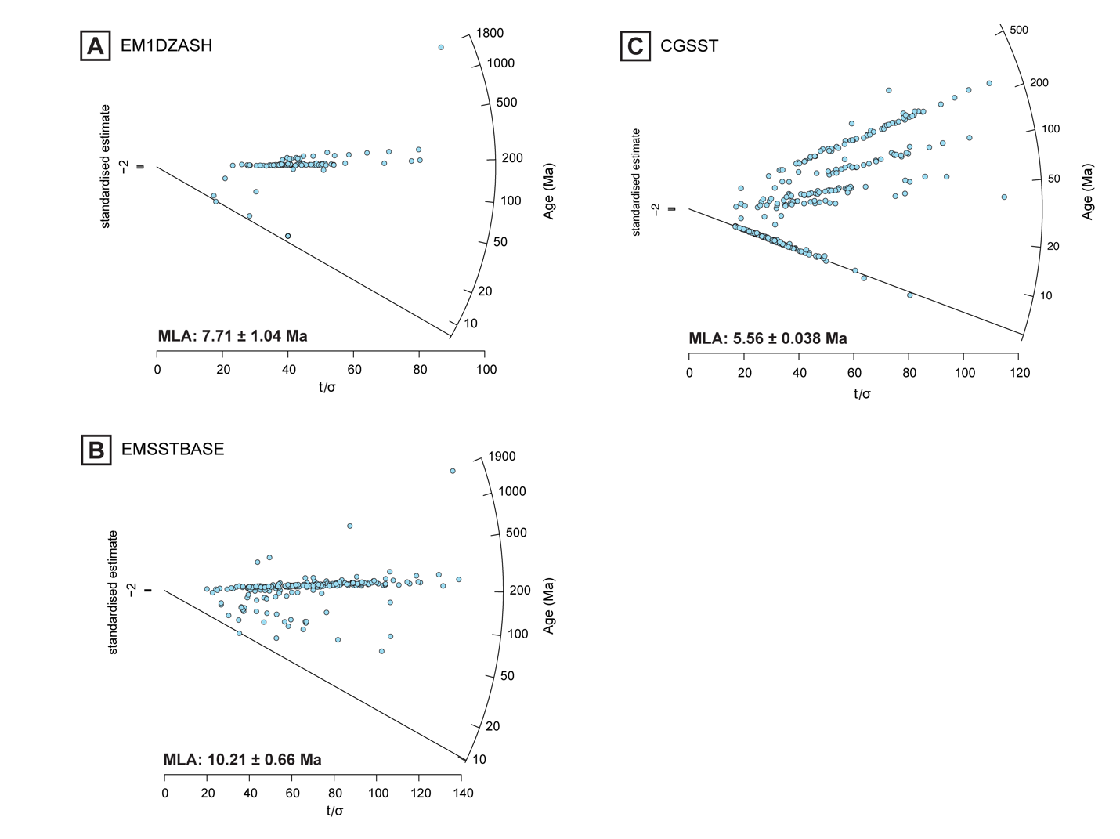

Figure S3. Radial plots showing zircon U‐Pb ages for samples from the Bahía Inglesa Formation at the El Morro locality (A–B) and Copiapó Gravels locality (C). Line shows ‘minimum’ discrete age peak defining MLA (Vermeesch, 2021a, 2021b). MLAs and 95% confidence intervals are annotated. Values are reported in Table 3 and appended to stratigraphic columns in Figure 2 of the main text.

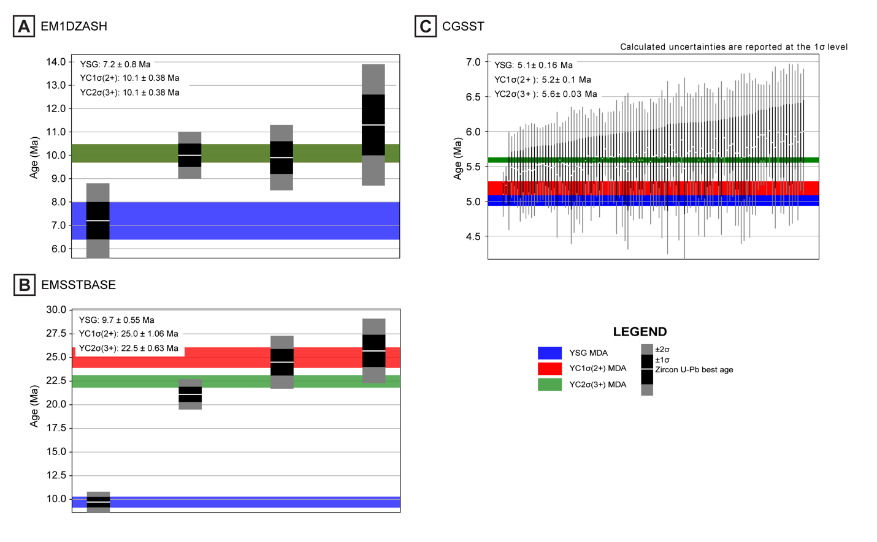
Figure S4. Plots of zircon maximum depositional ages (MDAs) for samples from the Bahía Inglesa Formation at the El Morro locality (A–B) and Copiapó Gravels locality (C) calculated via the youngest cluster of 3 or more ages overlapping at 2σ uncertainty [YC2σ(3+)], youngest cluster of 2 or more ages overlapping at 1σ uncertainty [YC1σ(2+)], and the youngest single grain. Values are reported in Table 3 of the main text.

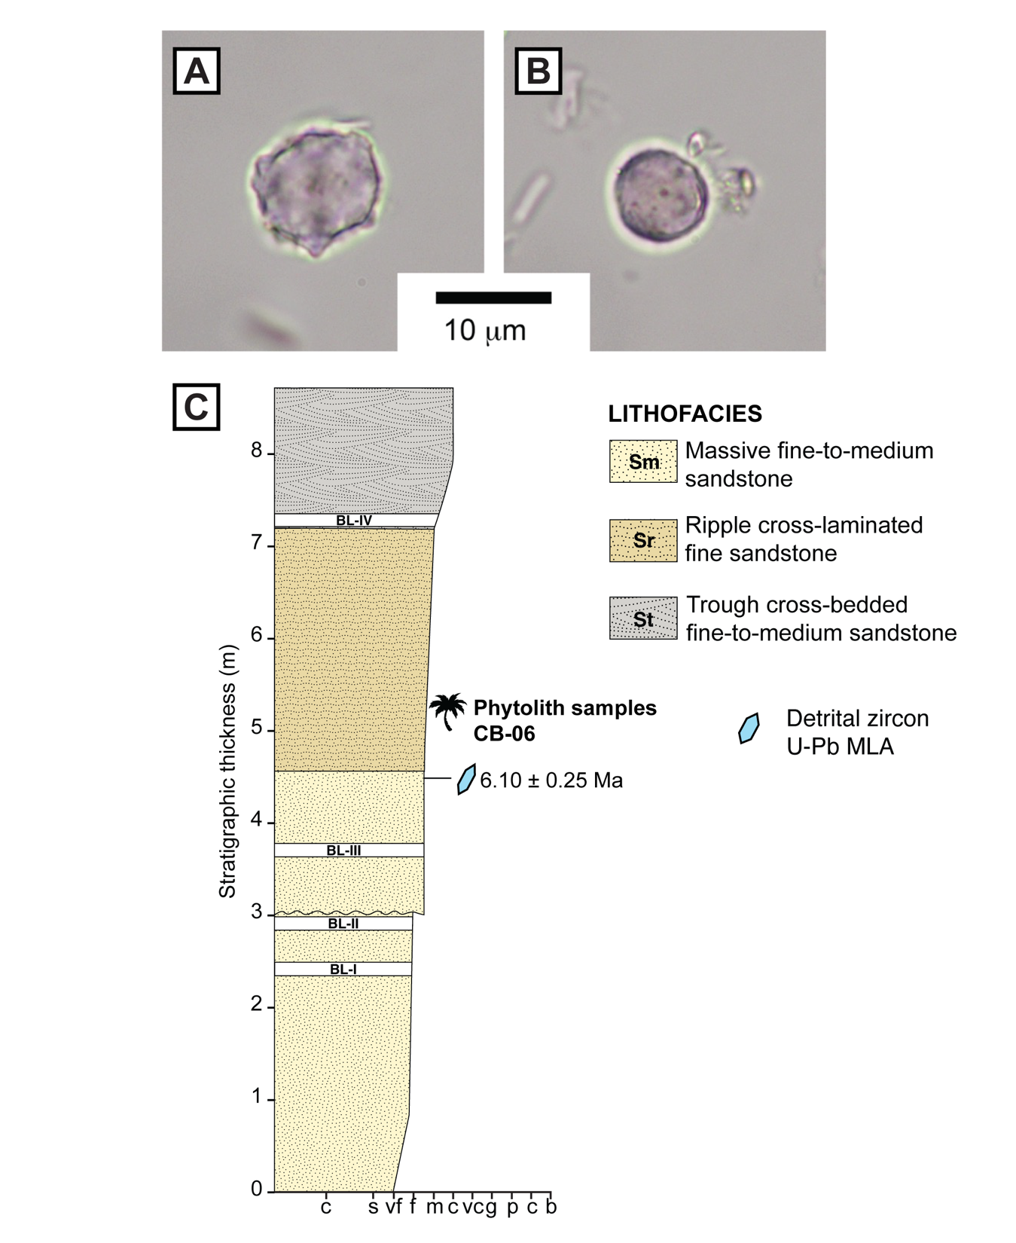
Figure S5. Representative phytoliths from CB-06 (UWBM PB 12778). A. Spheroid echinate, diagnostic of palms. B. Spheroid psilate, diagnostic of other forest indicators (e.g., woody dicots). C. Cerro Ballena stratigraphic column showing location of phytoliths from sample CB-06, modified from Martinez et al. [28]. BL: ‘Bone layers’ reported in Pyenson et al., [27].

