Supporting Information for
Drivers of the Asymmetric ITCZ Bias in Climate Models
Nakbin Choi^{1,2,*}, Xiao-Wei Quan^{3,4}, and Cristiana Stan¹
¹Department of Atmospheric, Oceanic and Earth Sciences, George Mason University, United States.
²Department of Civil, Urban, Earth, and Environmental Engineering, Ulsan National Institute of Science and Technology, Ulsan, South Korea.
³Cooperative Institute for Research in Environmental Sciences, University of Colorado, Boulder, Colorado, United States.
⁴NOAA/Physical Sciences Laboratory, Boulder, Colorado, United States.
*Corresponding author
E-mail: nbchoi21@unist.ac.kr

Contents of this file

Figures S1 to S7
Table S1 to S3

Introduction
This document provides supporting information for the manuscript “Drivers of the Asymmetric ITCZ Bias in Climate Models.” The supplementary content includes one diagnostic figure related to the single-column model (SCM) experiment and three sets of figures showing diagnostics from individual climate models.
Figures S1, S3 and S4 show January–May climatological fields and model biases for precipitation (Figure S1), sea surface temperature (Figure S3), and zonal mean virtual temperature (Figure S4), respectively. Each figure includes the multi-model ensemble mean as well as nine individual models analyzed in this study. These figures support the inter-model comparison presented in the main text and illustrate the diversity in model behavior relevant to the asymmetric ITCZ bias.
Figure S1 also shows regional precipitation biases outside the eastern Pacific, including positive biases near the Maritime Continent and Andes in many models, whereas biases over other regions, such as the Amazon, are less consistent across models.
Figure S2 is the same analysis as the main text, but using only Eastern Pacific (150°W–90°W) to match the virtual temperature anomaly.
The HighResMIP historical simulations used in this study begin in 1950 and include time-varying historical external forcing. In contrast, the UFS simulation is a multi-year free-running simulation initialized from a realistic atmospheric and oceanic state on January 1, 2000. It was conducted with atmospheric CO₂ fixed at its 2000 level and without aerosol forcing; therefore, it does not include a transient global warming signal driven by time-varying CO₂ and aerosol forcing. Figure S5a shows the global-mean SST time series over all available years for OISSTv2, UFS, and the eight HighResMIP models. To ensure consistency with the OISSTv2 record while minimizing the influence of the long-term warming trend in the HighResMIP simulations, we selected the common 25-year period of 1983-2007 for OISSTv2, GPCPv3.3, and HighResMIP. For UFS, the first five years of the simulation were excluded as model spin-up, and the subsequent 25-year period of 2005–2029 was analyzed. The global-mean SSTs over these selected periods are summarized in Figure S5b.
Figure S6 shows the climatology of monthly zonal mean precipitation from GPCP and the multi-model ensemble (MME). The precipitation bias in the Southern Hemisphere is largest during boreal winter to spring. Thus, this study focuses on the January–May period.
Figure S7 presents vertical profiles of the specific humidity tendency used to construct the moisture profiles in SCM experiments. The tendency was derived by sine fitting the vertical profile of the UFS specific humidity bias, and represents a simplified, observationally informed correction to the UFS model background state. This figure also includes the resulting specific humidity profiles from all experiments.
Table S1 contains information of asymmetric ITCZ index, averaged SST (15° S-0°, 85° W-150° W), virtual temperature (10° S-5° S, 150°W–85°W, 1000hPa - 850hPa) and specific humidity bias (10° S-5° S, 150°W–90°W, 1000hPa - 600hPa) for all used models. Also, the last row indicates a correlation coefficient between the asymmetric ITCZ index and biases.
Table S2 describes the experimental configuration of the CCPP Single Column Model (SCM). The experiments include (1) uniform SST perturbations of ±0.5°C and ±1.0°C, (2) modifications to the vertical moisture profile based on the UFS mean bias, and (3) a bias-corrected (BC) case combining a +0.3°C SST anomaly with a drier moisture profile. Moisture perturbations are derived using a sine fit to the UFS bias (see Supplementary Fig. 7). All experiments are forced with output from the UFS P8 simulation and evaluated using 10,000 bootstrap resamplings.
Table S3 lists the models used in this study along with their horizontal resolution and references. Short labels used in the main text are indicated in boldface.
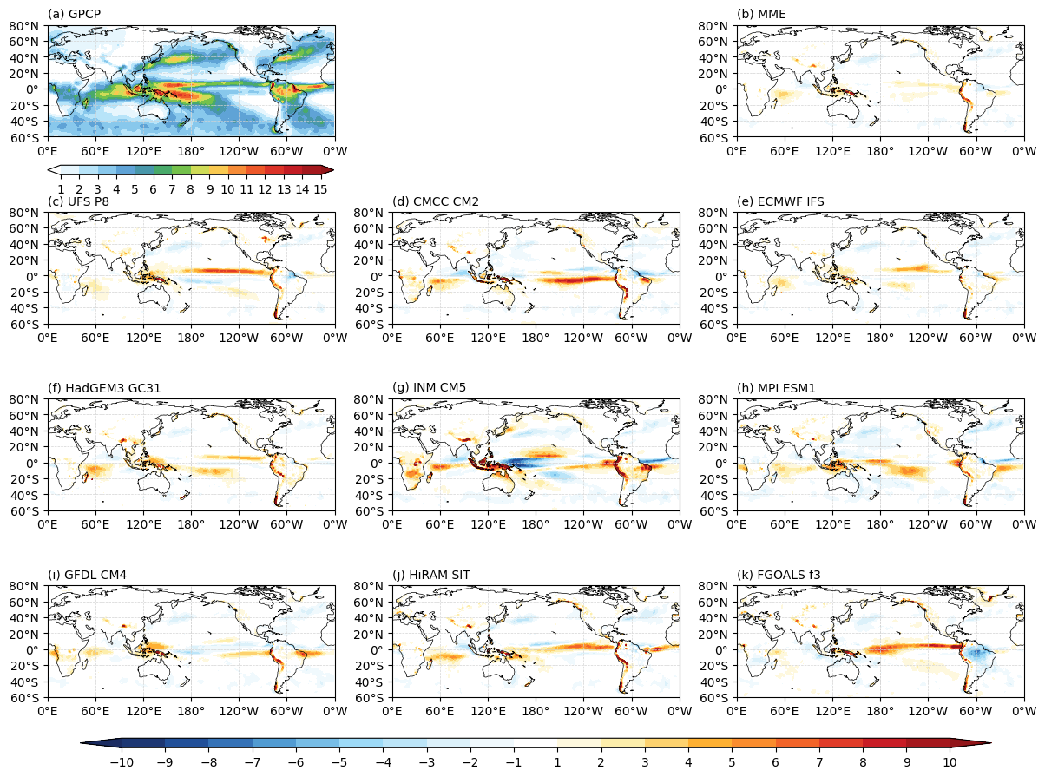
Figure S1. January–May mean precipitation (units: mm day⁻¹) from (a) GPCP and precipitation biases relative to GPCP for (b) the multi-model ensemble mean and (c-k) nine individual models

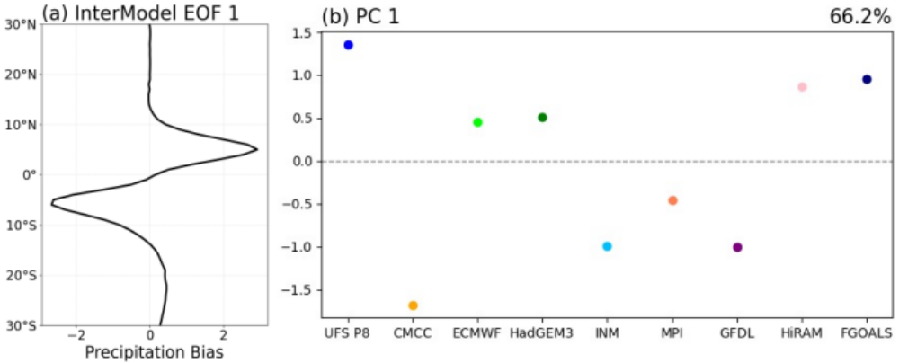
Figure S2. (a) The leading inter-model empirical orthogonal function (EOF) of the zonal mean precipitation biases relative to GPCP over 150°W–90°W (units: mm day⁻¹) and (b) the corresponding principal component (PC). The number shown on the left side of each panel indicates the percentage of variance explained.

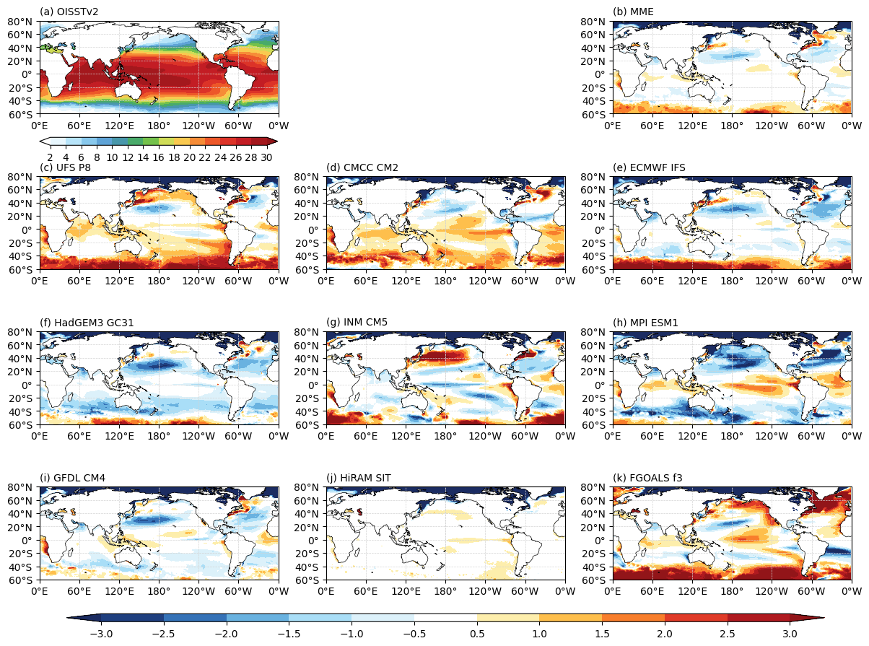
Figure S3. Same as Supplementary Figure 1, except for SST (units: K) from OISSTv2

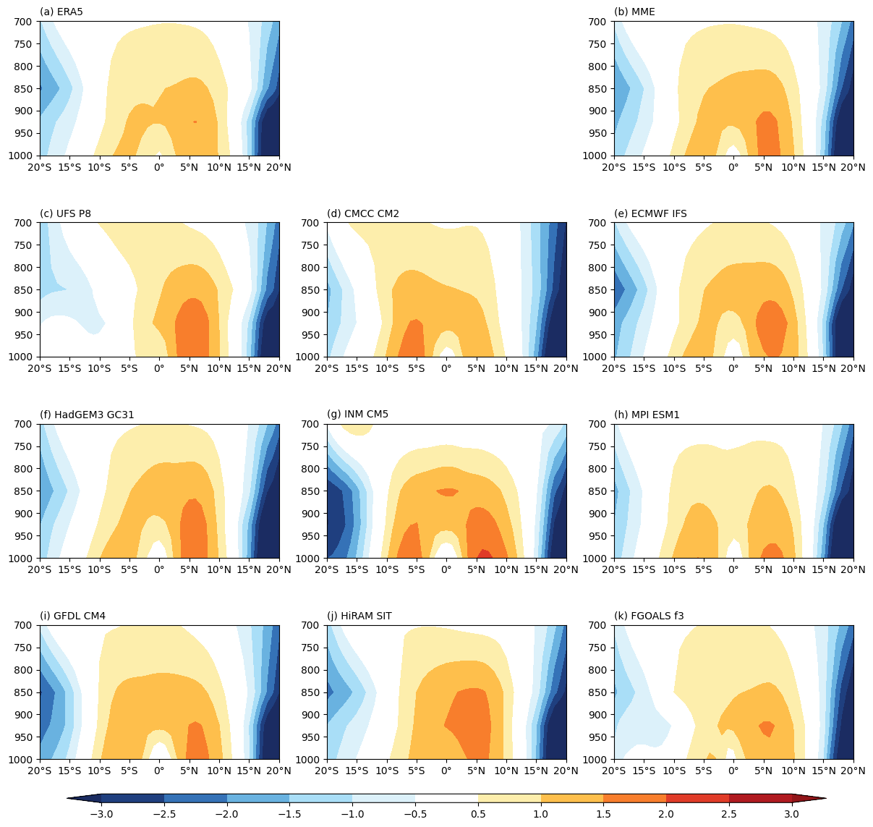
Figure S4. January–May means zonal mean virtual temperature anomaly (units: K) from (a) ERA5, (b) multi-model ensemble, and (c-k) nine individual models.

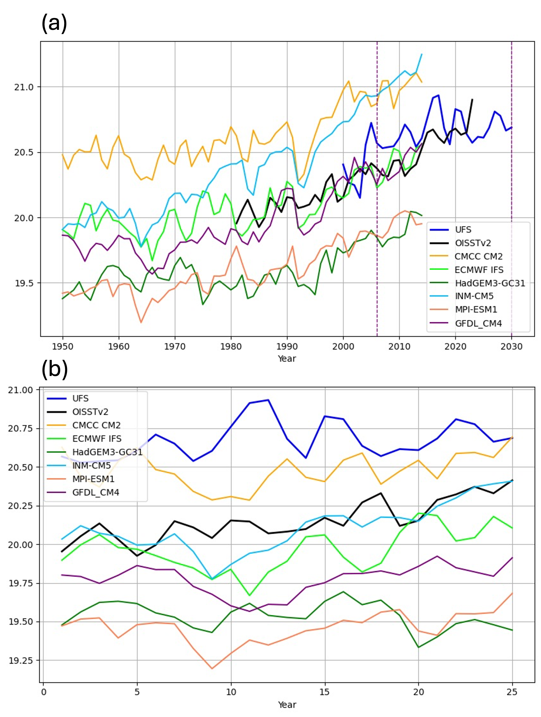
Figure S5. (a) Time series of global-mean SST from OISSTv2, UFS, and eight HighResMIP models over their respective available periods. (b) Global-mean SST during the selected 25-year periods: 1983–2007 for OISSTv2 and the HighResMIP models and 2005–2029 for UFS. The first five years of the UFS simulation (2000–2004) were excluded as model spin-up.

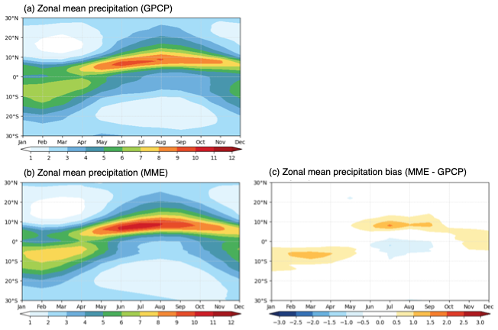
Figure S6. Zonal mean precipitation (mm day⁻¹) averaged over each month from (a) GPCP and (b) the multi-model ensemble (MME). (c) Bias of the zonal mean precipitation (MME minus GPCP).

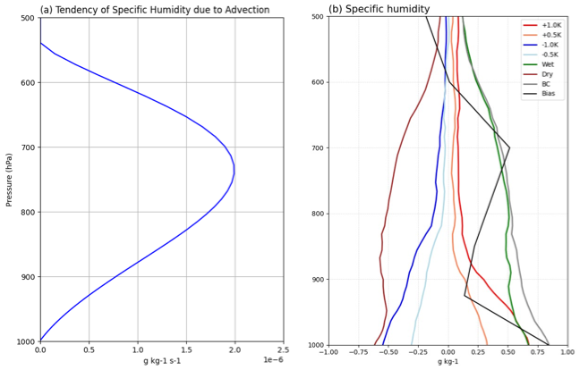
Figure S7. Vertical profiles of (a) the tendency of specific humidity (units: g kg⁻¹ s⁻¹) added or subtracted in the experiments, estimated by sine fitting to the regression pattern of specific humidity and (b) simulated specific humidity differences relative to the CTL simulation (units: g kg⁻¹). The black line indicates the specific humidity bias from the UFS climate simulation.

Table S1. Asymmetric ITCZ index and associated biases in individual models. The SST bias is averaged over 15°S–0°, 150°W–85°W. The virtual temperature bias is averaged over 10°S–5°S, 150°W–90°W, and from 1000 to 850 hPa. The specific humidity bias is averaged over the same horizontal domain but from 1000 to 600 hPa. The last row shows the correlation coefficient between the asymmetric ITCZ index and the bias of each variable across the models.

 | Asymmetric ITCZ index | SST  Bias (K) | Tv  Bias (K) | q  Bias (g kg⁻¹)
UFS-P8-v16C384 | 1.42 | -0.27 | -0.78 | -0.79
CMCC-CM2-VHR4 | -1.41 | 1.15 | 0.52 | 1.65
ECMWF-IFS-HR | 0.46 | -0.29 | 0.07 | -0.29
HadGEM3-GC31-HM | 0.34 | -0.47 | 0.16 | 0.18
INM-CM5-H | -1.33 | -0.11 | 0.46 | 0.77
MPI-ESM1-2-XR | -0.80 | 1.08 | 0.30 | 1.00
GFDL-CM4C192 | -0.56 | -0.02 | 0.35 | 0.48
HiRAM-SIT-HR | 0.65 | 0.18 | -0.11 | -0.90
FGOALS-f3-H | 1.24 | 0.28 | -0.28 | 0.06
Correlation |  | -0.51 | -0.92 | -0.86

Table S2. Experimental setting for CCPP Single Column Model
Experiments | Description
CTL | Forcing: UFS Climate Simulation (10 days)
W1.0 | Add 1°C SST
W0.5 | Add 0.5°C SST
C0.5 | Subtract 0.5°C SST
C1.0 | Subtract 1°C SST
Wet | Add Moisture Profile
Dry | Subtract Moisture Profile
BC | Mean Bias Corrected

Table S3. Models used in this study. Short labels used in the text are indicated in bold.
Model Name | Atmosphere / Land Resolution | Ocean / Sea Ice Resolution | Reference
UFS-P8-v16C384 | 25 km | 25 km | See the Text
ECMWF-IFS-HR | 25 km | 25 km | Roberts et al. (2017)
HadGEM3-GC31-HM | 50 km | 25 km | Roberts and Malcom (2019)
MPI-ESM1-2-XR | 50 km | 25 km | von Storch et al. (2018)
CMCC-CM2-VHR4 | 25 km | 25 km | Scoccimarro et al. (2018)
INM-CM5-H | 50 km | 50 km | Volodin et al. (2019)
GFDL-CM4C192 | 50 km | 25 km | Zhao et al. (2018)
HiRAM-SIT-HR | 25 km | 25 km | Tu (2020)
FGOALS-f3-H | 50 km | 50 km | YU (2020)

References
Roberts, Christopher David; Senan, Retish; Molteni, Franco; Boussetta, Souhail; Keeley, Sarah (2017). ECMWF ECMWF-IFS-HR model output prepared for CMIP6 HighResMIP hist-1950. https://doi.org/10.22033/ESGF/CMIP6.4981

Roberts, Malcolm (2018). MOHC HadGEM3-GC31-HM model output prepared for CMIP6 HighResMIP hist-1950. https://doi.org/10.22033/ESGF/CMIP6.6040

Scoccimarro, Enrico; Bellucci, Alessio; Peano, Daniele (2018). CMCC CMCC-CM2-VHR4 model output prepared for CMIP6 HighResMIP hist-1950. https://doi.org/10.22033/ESGF/CMIP6.3818

Tu, Chia-Ying (2020). AS-RCEC HiRAM-SIT-HR model output prepared for CMIP6 HighResMIP. https://doi.org/10.22033/ESGF/CMIP6.13301

Volodin, Evgeny; Mortikov, Evgeny; Gritsun, Andrey; Lykossov, Vasily; Galin, Vener; Diansky, Nikolay; Gusev, Anatoly; Kostrykin, Sergey; Iakovlev, Nikolay; Shestakova, Anna; Emelina, Svetlana (2019). INM INM-CM5-H model output prepared for CMIP6 HighResMIP hist-1950. https://doi.org/10.22033/ESGF/CMIP6.14050

von Storch, Jin-Song; Putrasahan, Dian; Lohmann, Katja; Gutjahr, Oliver; Jungclaus, Johann; Bittner, Matthias; Haak, Helmuth; Wieners, Karl-Hermann; Giorgetta, Marco; Reick, Christian; Esch, Monika; Gayler, Veronika; de Vrese, Philipp; Raddatz, Thomas; Mauritsen, Thorsten; Behrens, Jörg; Brovkin, Victor; Claussen, Martin; Crueger, Traute; Fast, Irina; Fiedler, Stephanie; Hagemann, Stefan; Hohenegger, Cathy; Jahns, Thomas; Kloster, Silvia; Kinne, Stefan; Lasslop, Gitta; Kornblueh, Luis; Marotzke, Jochem; Matei, Daniela; Meraner, Katharina; Mikolajewicz, Uwe; Modali, Kameswarrao; Müller, Wolfgang; Nabel, Julia; Notz, Dirk; Peters-von Gehlen, Karsten; Pincus, Robert; Pohlmann, Holger; Pongratz, Julia; Rast, Sebastian; Schmidt, Hauke; Schnur, Reiner; Schulzweida, Uwe; Six, Katharina; Stevens, Bjorn; Voigt, Aiko; Roeckner, Erich (2018). MPI-M MPI-ESM1.2-XR model output prepared for CMIP6 HighResMIP hist-1950. https://doi.org/10.22033/ESGF/CMIP6.10307

YU, Yongqiang (2020). CAS FGOALS-f3-H model output prepared for CMIP6 HighResMIP hist-1950. https://doi.org/10.22033/ESGF/CMIP6.3316

Zhao, Ming; Blanton, Chris; John, Jasmin G; Radhakrishnan, Aparna; Zadeh, Niki T.; McHugh, Colleen; Rand, Kristopher; Vahlenkamp, Hans; Wilson, Chandin; Ginoux, Paul; Malyshev, Sergey; Wyman, Bruce; Guo, Huan; Balaji, V; Held, Isaac M; Dunne, John P.; Winton, Michael; Adcroft, Alistair; Milly, P.C.D; Shevliakova, Elena; Knutson, Thomas; Ploshay, Jeffrey; Zeng, Yujin (2018). NOAA-GFDL GFDL-CM4C192 model output prepared for CMIP6 HighResMIP hist-1950. https://doi.org/10.22033/ESGF/CMIP6.8567

