Supporting information

Visible-light-driven photocatalytic degradation of diclofenac in water by nanoparticulate Cu₂ZnSnX₄ (X = S, Se) kesterites with kinetics, transformation products and ecotoxicity

Paula Salazar Nogales¹, Rodrigo Henríquez^{1*}, Ricardo Salazar Gonzalez², Galo Ramírez^{3,4}, Elena Navarrete-Astorga⁵, Enrique A. Dalchiele⁶

¹Instituto de Química, Facultad de Ciencias, Pontificia Universidad Católica de Valparaíso, Casilla 4059, Valparaíso, Chile.
²Instituto de Química, Facultad de Química y Farmacia, Pontificia Universidad Católica, Av. Vicuña Mackenna 4860, Santiago, Chile. Departamento de Química Inorgánica, ³Facultad de Química, Pontificia Universidad Católica de Chile, Av. Vicuña Mackenna 4860, Santiago, Chile.
⁴Millennium Institute on Green Ammonia as Energy Vector (MIGA), Av. Vicuña Mackenna 4860, Macul, Santiago 7820436, Chile.
⁵Universidad de Málaga, Departamentos de Física Aplicada I & Ingeniería Química, Laboratorio de Materiales y Superficies (Unidad Asociada al CSIC), E29071 Málaga, España.
⁶Instituto de Física, Facultad de Ingeniería, Herrera y Reissig 565, C.C. 30, 11000 Montevideo, Uruguay

- Diclofenac molecule

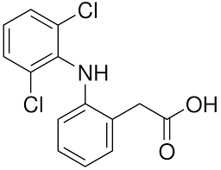
Figure S1. Chemical molecular structure of diclofenac.

- Solar Simulator Spectrum

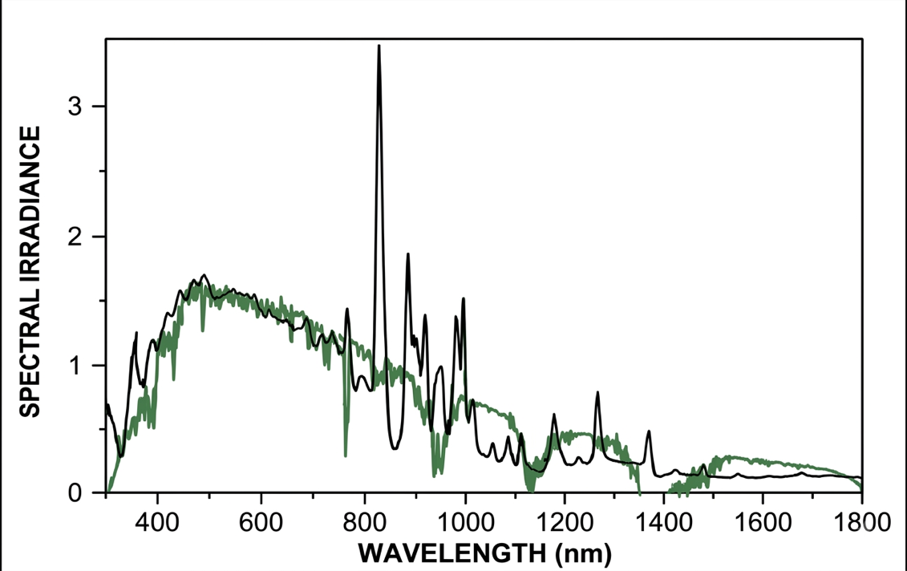
Figure S2. Spectral output curve of the Abet Technologies model 10500 Low Cost Solar Simulator (black) and standard AM 1.5G spectrum (blue) [1].

- Crystallite Size Determination Through the Scherrer Equation
The average crystallite size was calculated from full width at half maximum (FWHM) of XRD peaks by using the well-known Scherrer formula [2,3]:

$D=\frac{kλ}{βcosθ}$ (S1)

where D is the crystallite diameter, λ is the wavelength of the incident radiation, k = 0.89 is the shape factor, θ is the Bragg angle, and β is the full width at half maximum (FHWM) in radians.

4. Surface Chemical Study
Figure S3. (a) XPS survey spectrum for the synthesized particulate Cu₂ZnSnS₄ sample. X-ray photoelectron spectroscopy high-resolution spectra for: (b) Cu 2p, (c) Zn 2p, (d) Sn 3d, and (e) S 2p, for the Cu₂ZnSnS₄ sample. The short dashed black lines are the fit lines while the colored lines represent each individual component. The original spectra are represented as unfilled dots.

Figure S4. (a) XPS survey spectrum for the synthesized particulate Cu₂ZnSnSe₄ sample. X-ray photoelectron spectroscopy high-resolution spectra for: (b) Cu 2p, (c) Zn 2p, (d) Sn 3d, and (e) Se 3d, for the Cu₂ZnSnSe₄ sample. The short dashed black lines are the fit lines while the colored lines represent each individual component. The original spectra are represented as small open circles.

5. Raman study

Figure S5. Extended Raman spectra (λ_{exc} = 785 nm) of CZTS and CZTSe nanopowders,

6. EDS Mapping Analysis
Figure S6. (a) FE-SEM plane-view micrograph images of a typical hydrothermally synthesized nanoparticulate Cu₂ZnSnS₄ sample. EDX elemental mapping of Cu (violet), Zn (cyan), Sn (brown), and S (green) corresponding to this FE-SEM micrograph image is depicted in four panels in the lower part of this. (b) TEM micrograph image of a typical nanoparticulate Cu₂ZnSnSe₄ cluster and its corresponding EDX elemental mapping for Cu (green), Zn (magenta), Sn (red), and Se (yellow), as indicated.

7. Optical Bandgap Energy Determination
The bandgap (E_{g}) and optical transition type of nanoparticulate Cu₂ZnSnSe₄ samples have been determined from the Stern relation of near-edge absorption which is given as [4-7]:

$α=\frac{A_{0}{\left(hν-E_{g}\right)}^{n}}{hν}$ (S2)

where A₀ is a parameter related to the effective masses associated with the valence and conduction bands, and hν is the photon energy (where ν is the frequency, h is the Planck's constant). m depends on the nature of band transitions, i.e.: n = 1/2 or 2 for direct or indirect allowed transitions, respectively.

8. DCF absorbance spectroscopy measurements

Figure S7. UV-vis absorbance spectra of a 5 mg L⁻¹ DCF solution under AM 1.5 solar simulator illumination at different irradiation times, as indicated, in the presence of 35 mg L⁻¹ of the: (a) CZTS and (b) CZTSe photocatalysts, respectively.

9. Fundamentals of the Photocatalytic mechanism

As it has been schematically depicted in Fig. 5 of the MS, irradiation of the semiconductor photocatalyst with photons with energy higher than its bandgap generates h⁺ in its valence band and e– in the conduction band, process that can be presented by the following equation:

$SC Photocatalyst+hv→e_{CB}^{-}+h_{VB}^{+}$ (S3)

If their recombination is avoided, photogenerated-holes can oxidize organic pollutants (P) to their radical cation:

$P+h_{VB}^{+}⇆ P^{·+}$ (S4)

Photogenerated-holes can also react with adsorbed water (Eq. S5), or hydroxyl groups (OH⁻) (Eq. S6) to generate •OH:

${H_{2}O}_{ads}+h_{VB}^{+}→ {•OH}_{ads}$ (S5)

${OH^{-}}_{ads}+h_{VB}^{+}→ {•OH}_{ads}$ (S6)

These hydroxyl radicals can in turn oxidize the adsorbed pollutants [8, 9-12]:

$P+{•OH}_{ads }→ Oxidation products$ (S7)

On the other hand, photo-generated electrons reduce adsorbed molecular oxygen to form •O₂⁻:
${O_{2}}_{ads}+e_{CB}^{-}→{•O}_{2}^{-}$ (k = 1.9x10¹⁰ M⁻¹s⁻¹) (S8)

which participates in the acid–base equilibrium with its protonated form [8, 9-12]:

$•HO_{2}« H^{+}+{•O}_{2}^{-}$ (S9)

As the pKa of •HO₂ is 4.6, the acidic form of •O₂⁻ may be the most abundant species in our reaction system (pH = 6.5) [82,106–109]. Further, dismutation reactions of •HO₂ and •O₂⁻ generate H₂O₂ (Eq. S10) and O₂ (Eq. S11) [8,9-12]:

2$•HO_{2}→H_{2}O_{2}+O_{2}$ (S10)

$2•O_{2}^{-}+2H^{+}→H_{2}O_{2}+O_{2}$ (S11)

It must be pointed out that the generation of H₂O₂ during photocatalysis is a crucial step for further •OH formation in bulk water. Once formed, H₂O₂ can react with the photogenerated e– (Eq. S12), •O₂⁻ (Eq. S13) or be decomposed by photolysis (Eq. S14) to form •OH [8, 9-12]:

$H_{2}O_{2}+e_{CB}^{-}→{•OH}_{ads}+OH^{-}$ (S12)

$H_{2}O_{2}+•O_{2}^{-}→{•OH}_{ads,free}+O_{2}+OH^{-}$ (S13)

$H_{2}O_{2}+hv→{•OH}_{ads,free}+{•OH}_{ads,free}$ (S14)

It is important to emphasize that the reaction shown in Eq. S12 results solely in surface-adsorbed •OH, whereas the reactions in Eqs. S13 and S14 can generate both surface-adsorbed and free •OH [8,9-12]. Morever, the direct photolysis of H₂O₂ under visible light irradiation can be neglected due to its small molar absorption coefficient (< 1 M⁻¹cm⁻¹ above 300 nm) [13]. Finally, the interaction of the hydroxyl radicals with the adsorbed DCF molecules should lead to the degradation of this DCF pollutant:

$DCF+•OH→Oxidation products$ (S15)

In brief, •O₂⁻, •OH and h⁺ are the major reactive species responsible for the photo-oxidation of environmental pollutants under visible light irradiation [8,9-12]. •O₂⁻ is highly reactive due to the presence of a single unpaired electron, which makes it a potential oxidizing agent [8,9-12]. Among them, the reactivity of •OH is considerable high, and is often regarded as the most effective reactant for photo-catalytic decomposition [8,9-12].

10. Radical scavenging assay
Table S1. List of compounds selected as scavengers used for active species trapping experiments.

Type | Sacrifice Compound Reagent/Inhibitor | Abbreviation | References
Hole scavenger (h⁺) | Ethylenediaminetetraacetic acid | EDTA-2Na | [14-16]
Electron scavenger (e–) | Potassium dichromate | K₂Cr₂O₇ | [16]
•OH scavenger | Isopropanol alcohol | IPA | [15-19]
Elimination of the O₂ source of •O₂⁻ ROS generation | Argon | Ar | [16]

REFERENCES

- https://abet-technologies.com/wp-content/uploads/Low-cost-Solar-Simulators-2015.pdf.
- Cullity, B.D. Elements of X-Ray Diffraction, 2nd Edition. Addison-Wesley Publishing Co. Reading MA 1978, 100-105,277-279.
- Henríquez, R.; Vásquez, C.; Muñoz, E.; Grez, P.; Martín, F.; Ramos-Barrado, J.R.; Dalchiele, E.A. Phase-Pure Iron Pyrite (FeS₂) Micro- and Nano-Sized Crystals Synthesized by Simple One-Step Microwave-Assisted Hydrothermal Method. Physica E Low Dimens Syst Nanostruct 2020, 118, 113881, doi:https://doi.org/10.1016/j.physe.2019.113881.
- Kisch, H. Semiconductor Photocatalysis: Principles and Applications; Wiley-VCH, 2015; ISBN 978-3-527-33553-4.
- Henríquez, R.; Vásquez, C.; Muñoz, E.; Grez, P.; Martín, F.; Ramos-Barrado, J.R.; Dalchiele, E.A. Phase-Pure Iron Pyrite (FeS₂) Micro- and Nano-Sized Crystals Synthesized by Simple One-Step Microwave-Assisted Hydrothermal Method. Physica E Low Dimens Syst Nanostruct 2020, 118, 113881, doi:https://doi.org/10.1016/j.physe.2019.113881.
- Pankove, J.I.; Kiewit, D.A. Optical Processes in Semiconductors. J Electrochem Soc 1972, 119, 156Ca, doi:10.1149/1.2404256.
- Kumarage, W.G.C.; Wijesundera, R.P.; Seneviratne, V.A.; Jayalath, C.P.; Dassanayake, B.S. Tunable Optoelectronic Properties of CBD-CdS Thin Films via Bath Temperature Alterations. J Phys D Appl Phys 2016, 49, 95109, doi:10.1088/0022-3727/49/9/095109.
- Herrmann, J.-M. Heterogeneous photocatalysis: fundamentals and applications to the removal of various types of aqueous pollutants. Catal. Today 53, 115–129 (1999).
- Nosaka, Y. & Nosaka, A. Y. Generation and Detection of Reactive Oxygen Species in Photocatalysis. Chem. Rev. 117, 11302–11336 (2017).
- Banerjee, S. et al. New Insights into the Mechanism of Visible Light Photocatalysis. J. Phys. Chem. Lett. 5, 2543–2554 (2014).
- Leong, K. H., Sim, L. C., Pichiah, S. & Ibrahim, S. Light Driven Nanomaterials for Removal of Agricultural Toxins. in Nanoscience in Food and Agriculture 3 (eds. Ranjan, S. & Dasgupta, N.) 225–242 (Springer, Aix en Provemce, France, 2016).
- 12. Vital-Grappin, A. D. et al. The Role of the Reactive Species Involved in the Photocatalytic Degradation of HDPE Microplastics Using C,N-TiO2 Powders. Polymers (Basel). 13, (2021).
- Aliste, M. et al. Solar photo-Fenton with Fe3+-EDDS and Fe3+-NTA at neutral pH for removal of ibuprofen, diclofenac and their main transformation products in wastewater. Catal. Today 446, 115139 (2025).
- Sales, D. A. et al. Synergistic effects of Al3 +/La3+ co-doped ZnO photocatalysts for enhanced removal of Remazol red dye and Diclofenac in aqueous solutions. Colloids Surf. A Physicochem. Eng. Asp. 709, 136130 (2025).
- Deepa, K. G., Ramamurthy, P. C. & Singha, M. K. Mesoporous Cu2ZnSnS4 nanoparticle film as a flexible and reusable visible light photocatalyst. Opt. Mater. (Amst). 98, 109492 (2019).
- Chiu, Y.-H., Chang, T.-F. M., Chen, C.-Y., Sone, M. & Hsu, Y.-J. Mechanistic Insights into Photodegradation of Organic Dyes Using Heterostructure Photocatalysts. Catalysts 9, (2019).
- Javaid, A., Imran, M., Kanwal, F. & Latif, S. Antimony-doped cerium ferrite: a robust photocatalyst for the mitigation of diclofenac potassium, an emerging contaminant. Mater. Sci. Semicond. Process. 177, 108350 (2024).
- Zhang, X. et al. Newly constructed Z-scheme Cu2ZnSnS4/BiOBr heterostructure for high-efficient photocatalytic applications. Colloids Surf. A Physicochem. Eng. Asp. 663, 131123 (2023).
- Vital-Grappin, A. D. et al. The Role of the Reactive Species Involved in the Photocatalytic Degradation of HDPE Microplastics Using C,N-TiO2 Powders. Polymers (Basel). 13, (2021).

