Supplementary Information

Binding and toxicological insights into Direct Yellow 8 and bovine serum albumin: fluorescence Quenching and cytotoxicity Studies
Babita Bisht¹, Sangeeta², Pinki Dey³, Praveen K. Kujur⁴, Avinash Kumar Singh⁵, Mohan Singh Mehata^{6*}
¹Nazionale delle Ricerche, Istituto Nazionale di Ottica (INO), via Campi Flegrei, 34
Comprensorio A. Olivetti, 80078 Pozzuoli (Naples), Italy
²School of Computational and Integrated Sciences, Jawaharlal Nehru University, New Delhi-110067 India
³School of Biotechnology and Biomolecular Sciences, University of New South Wales, Sydney 2033, Australia
⁴Cancer Biology Laboratory, School of Life Sciences, Jawaharlal Nehru University, New Delhi-110067 India
⁵Department of Electrical and Computer Engineering, University of Houston, Houston, TX 77204-4005, U.S.A
⁶Laser Spectroscopy Laboratory, Department of Applied Physics, Delhi Technological University, Bawana Road, Delhi, 110042, India

Corresponding author: msmehata@gmail.com, babita.bisht@ino.cnr.it

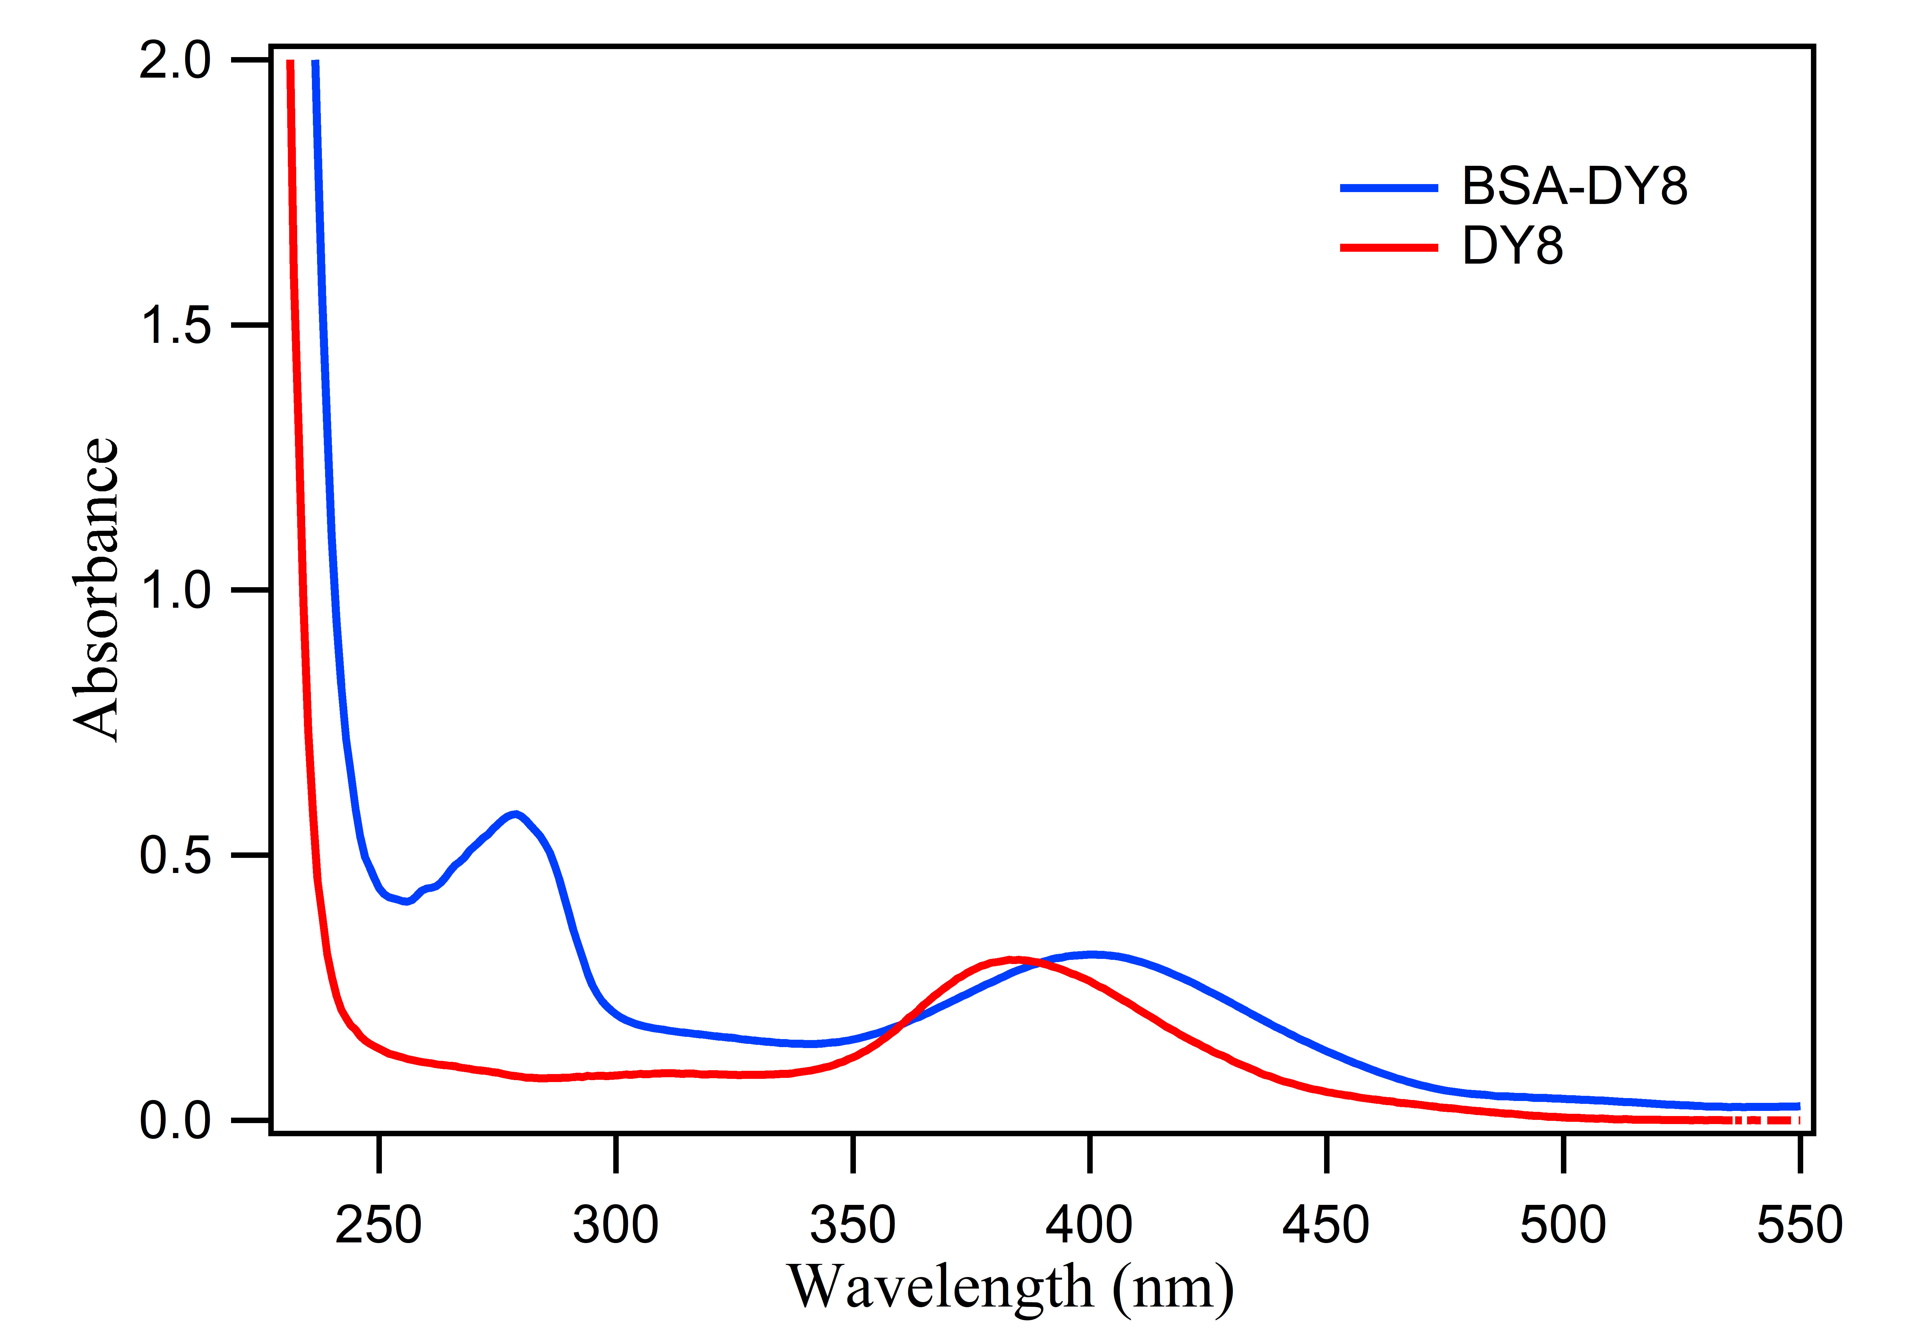
Figure S1: Absorption spectra of BSA-DY8 (blue) and DY8 (red) at 12 µM concentration.

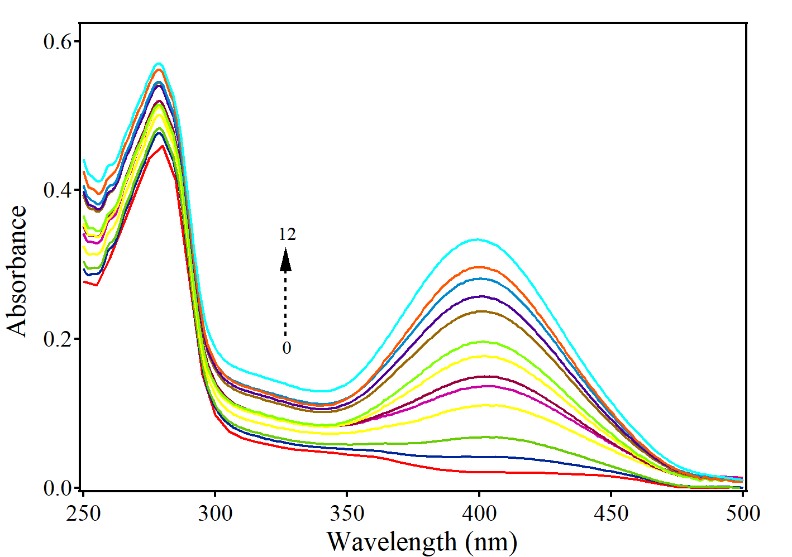
Figure S2: Absorption spectra of BSA (280 nm) in the presence of varying concentrations of DY8 (1 µM – 12 µM). A new band begins to appear at 385 nm, corresponding to the absorption band of DY8.

Figure S3: The plot of 1/(A-A₀) vs 1/ [DY8 µM] for the interaction of DY8 (1 µM to 12 µM) and BSA (10 µM) in buffer (pH = 7.4).

The association constant value given in the manuscript was calculated by using the following equation
$$\frac{1}{\left(A-A_{0}\right)}=\frac{1}{\left(A_{max}-A_{0}\right) K_{a}\left[BSA\right]}.\frac{1}{DY8}+\frac{1}{\left(A_{max}-A_{0}\right)}$$
Where, A is the absorbance of BSA in the presence of varying concentration of DY8 (0 µM to 12 µM). A₀ is the absorbance of free BSA. A_{max} is the absorbance of maximum concentration of DY8. K_{a} is the association constant in DY8-BSA system.

