Supplementary Materials
Table S1. Specific definitions of various diseases
Overweight/obesity | BMI ≥ 23 kg/m²
Abdominal obesity | Waist circumference ≥ 80/90 cm in female/male
Prediabetes | Fasting blood glucose 100–125 mg/dL or HbA1c 5.7%–6.4%, in the absence of self-reported diagnosis of diabetes or use of insulin or oral hypoglycemic agents
Diabetes | Fasting blood glucose ≥ 126 mg/dL, HbA1c ≥ 6.5%, self-reported diagnosis of diabetes, or use of insulin or oral hypoglycemic agents
Hypertension | SBP ≥ 130 mmHg, DBP ≥ 80 mmHg, self-reported diagnosis of hypertension, or use of antihypertensive medications
Chronic kidney disease | eGFR < 60 mL/min/1.73 m² or self-reported diagnosis of chronic kidney disease
Hypertriglyceridemia | Triglycerides ≥ 150 mg/dL
Metabolic syndrome | Presence of any three or more of the following five components:  ① Waist circumference ≥ 80/90 cm in female/male.  ② HDL-C < 50/40 mg/dL in female/male.  ③ Triglycerides ≥ 150 mg/dL.  ④ SBP ≥ 130 mm Hg or DBP ≥ 80 mm Hg or use of antihypertensive medications  ⑤ Fasting blood glucose ≥ 100 mg/dL
Clinical CVD | Self-reported diagnosis of heart disease (including angina, heart attack, congestive heart failure, and other heart problems) or stroke
Subclinical CVD | Framingham risk score ≥ 21.5/21.6 in female/male or eGFR < 30 mL/min/1.73 m², in the absence of clinical CVD

Table S2. Definition of CKM syndrome stages (0–3)
CKM stages | Diagnostic criteria
Stage 0 | All of the following criteria must be met:  (1) BMI < 23 kg/m²  (2) Waist circumference < 80/90 cm in female/male  (3) Fasting blood glucose < 100 mg/dL and HbA1c < 5.7% and without self-reported diagnosis of diabetes, use of insulin, or oral hypoglycemic agents  (4) SBP < 130 mm Hg and DBP < 80 mm Hg without self-reported diagnosis of hypertension or use of antihypertensive medications  (5) HDL-C ≥ 50/40 mg/dL in female/male  (6) TG < 150 mg/dL  (7) eGFR ≥ 60 mL/min/1.73 m² and without self-reported diagnosis of CKD  (8) No subclinical CVD or clinical CVD
Stage 1 | At least one of the following conditions is present:  (1) Overweight/obesity  (2) Abdominal obesity  (3) Prediabetes  And all of the following criteria must be met:  (1) SBP < 130 mmHg and DBP < 80 mmHg without self-reported diagnosis of hypertension or use of antihypertensive medications.  (2) Fasting blood glucose < 126 mg/dL and HbA1c < 6.5% and without self-reported diagnosis of diabetes, use of insulin, or oral hypoglycemic agents.  (3) HDL-C ≥ 50/40 mg/dL in female/male  (4) TG < 150 mg/dL  (5) eGFR ≥ 60 mL/min/1.73 m² and without self-reported diagnosis of CKD  (6) No subclinical CVD or clinical CVD
Stage 2 | At least one of the following conditions is present:  (1) Hypertriglyceridemia  (2) Hypertension  (3) Diabetes  (4) Metabolic syndrome  (5) eGFR 30–59 mL/min/1.73 m² or self-reported diagnosis of CKD  And no subclinical CVD or clinical CVD
Stage 3 | At least one of the following conditions is present:  (1) Subclinical CVD  (2) eGFR < 30 mL/min/1.73 m²  And at least one of the following conditions is present:  (1) Overweight/obesity  (2) Abdominal obesity  (3) Prediabetes  (4) Hypertriglyceridemia  (5) Hypertension  (6) Diabetes  (7) Metabolic syndrome  (8) eGFR 30–59 mL/min/1.73 m² or self-reported diagnosis of CKD  And no clinical CVD

Table S3. Comparison of baseline characteristics between included and excluded participants
Characteristic | Included participants¹ | Excluded participants¹ | P value² | SMD³
Age, years | 58 ± 8 (n=3,046) | 59 ± 10 (n=14,605) | <0.001 | 0.108
SBP, mmHg | 130 ± 20 (n=3,046) | 131 ± 22 (n=10,728) | 0.002 | 0.062
DBP, mmHg | 76 ± 12 (n=3,046) | 76 ± 12 (n=10,728) | 0.480 | 0.014
BMI, kg/m² | 23.6 ± 3.7 (n=3,045) | 23.4 ± 3.9 (n=10,568) | 0.117 | 0.032
TC, mg/dL | 196 ± 38 (n=3,046) | 192 ± 39 (n=8,609) | <0.001 | 0.104
TG, mg/dL | 103 (73, 156) (n=3,046) | 107 (77, 157) (n=8,610) | 0.005 | 0.020
HDL-C, mg/dL | 52 ± 15 (n=3,046) | 50 ± 15 (n=8,617) | <0.001 | 0.100
FPG, mg/dL | 103 (95, 113) (n=3,046) | 102 (94, 114) (n=8,590) | 0.128 | 0.008
HbA1c, % | 5.20 (4.90, 5.40) (n=3,046) | 5.10 (4.90, 5.40) (n=8,660) | <0.001 | 0.058
Creatinine, mg/dL | 0.75 (0.64, 0.86) (n=3,046) | 0.76 (0.66, 0.89) (n=8,588) | <0.001 | 0.124
eGFR, mL/min/1.73 m² | 94 ± 14 (n=3,046) | 91 ± 16 (n=8,555) | <0.001 | 0.177
Uric acid, mg/dL | 4.34 ± 1.20 (n=3,046) | 4.51 ± 1.29 (n=8,618) | <0.001 | 0.132
CRP, mg/L | 0.99 (0.53, 1.97) (n=3,046) | 1.06 (0.56, 2.29) (n=8,618) | <0.001 | 0.069
WBC, 10⁹/L | 6.20 ± 1.83 (n=3,020) | 6.27 ± 2.21 (n=8,508) | 0.098 | 0.033
PLT, 10⁹/L | 212 ± 72 (n=3,022) | 212 ± 76 (n=8,509) | 0.705 | 0.008
Gender |  |  | 0.051 | 0.039
Male | 1,409 (46%) (n=3,046) | 7,062 (48%) (n=14,646)
Female | 1,637 (54%) (n=3,046) | 7,584 (52%) (n=14,646)
Residence |  |  | <0.001 | 0.282
Rural | 2,636 (87%) (n=3,044) | 11,068 (76%) (n=14,629)
Urban | 408 (13%) (n=3,044) | 3,561 (24%) (n=14,629)
Education |  |  | <0.001 | 0.140
Below high school | 2,770 (91%) (n=3,046) | 12,637 (87%) (n=14,607)
High school or above | 276 (9.1%) (n=3,046) | 1,970 (13%) (n=14,607)
Marital status |  |  | <0.001 | 0.127
Married | 2,759 (91%) (n=3,046) | 12,658 (87%) (n=14,629)
Others | 287 (9.4%) (n=3,046) | 1,971 (13%) (n=14,629)
Smoking status |  |  | 0.021 | 0.056
Current smoker | 926 (30%) (n=3,041) | 3,936 (28%) (n=13,866)
Former smoker | 227 (7.5%) (n=3,041) | 1,190 (8.6%) (n=13,866)
Never smoker | 1,888 (62%) (n=3,041) | 8,740 (63%) (n=13,866)
Drinking status |  |  | 0.004 | 0.066
Current | 1,000 (33%) (n=3,043) | 4,383 (30%) (n=14,501)
Former | 220 (7.2%) (n=3,043) | 1,223 (8.4%) (n=14,501)
Never | 1,823 (60%) (n=3,043) | 8,895 (61%) (n=14,501)
CKD | 223 (7.3%) (n=3,046) | 1,239 (14%) (n=8,781) | <0.001 | 0.221
Hypertension | 1,725 (57%) (n=3,046) | 7,131 (61%) (n=11,677) | <0.001 | 0.090
Diabetes | 479 (16%) (n=3,046) | 1,852 (21%) (n=8,701) | <0.001 | 0.144
Cancer | 23 (0.8%) (n=3,039) | 157 (1.1%) (n=14,447) | 0.124 | 0.035
Baseline self-reported CVD | 0 (0%) (n=3,046) | 2,408 (17%) (n=14,414) | <0.001 | 0.633
¹Values were summarized using available baseline data. Continuous variables are shown as mean ± SD or median (IQR), with available sample sizes shown in parentheses. Categorical variables are shown as n (%) with available denominators shown in parentheses.
²P values were calculated using Student's t-test for normally distributed continuous variables, Wilcoxon rank-sum test for non-normally distributed continuous variables, and Pearson's chi-square test for categorical variables.
³SMD, standardized mean difference.

Table S4. Distribution of variables with missing data
Variables | Number of Missing | Missing proportion
Age | 0 | 0
Gender | 0 | 0
Residence | 2 | 0.07%
Education | 0 | 0
Marriage | 0 | 0
Smoking status | 5 | 0.16%
Drinking status | 3 | 0.1%
BMI | 0 | 0
Kidney disease | 0 | 0
Hypertension | 0 | 0
Diabetes | 0 | 0
Cancer | 7 | 0.23%
eGFR | 0 | 0
UA | 0 | 0
CRP | 0 | 0
WBC | 26 | 0.85%
PLT | 24 | 0.79%

Table S5. Evaluation of the optimal number of clusters for K-means clustering
Number of clusters (k) | Total within-cluster sum of squares | Gap statistic | Mean silhouette coefficient
2 | 3069.929 | 1.255 | 0.455
3 | 2101.721 | 1.246 | 0.413
4 | 1672.198 | 1.208 | 0.353

Table S6. Characteristics of CHG exposure patterns identified by K-means clustering
Cluster | N | CHG 2012, mean ± SD | CHG 2015, mean ± SD | Absolute change | Percentage change
Cluster 1 | 1300 | 4.99 ± 0.22 | 4.90 ± 0.19 | -0.10 | -1.7%
Cluster 2 | 1419 | 5.47 ± 0.23 | 5.29 ± 0.19 | -0.18 | -3.0%
Cluster 3 | 283 | 6.20 ± 0.48 | 5.87 ± 0.41 | -0.33 | -4.8%
K-means clustering was performed using standardized CHG values (z-score transformation) measured at Wave 1 (2012) and Wave 3 (2015). Cluster characteristics are presented using the original CHG values for clinical interpretation.

Table S7. Schoenfeld residual test of proportional hazards assumption
Variable | χ² | P value
Cumulative CHG | 0.65 | 0.419
Age | 0.04 | 0.840
Gender | 0.33 | 0.568
Residence | 1.29 | 0.257
Education | 0.49 | 0.485
Marriage | 0.46 | 0.499
Smoking status | 0.40 | 0.526
Drinking status | 0.03 | 0.871
BMI | 0.08 | 0.777
CKD | 0.86 | 0.354
Hypertension | 0.00 | 0.971
Diabetes | 0.34 | 0.562
Cancer | 3.41 | 0.065
eGFR | 0.33 | 0.563
UA | 0.04 | 0.848
CRP | 0.16 | 0.687
WBC | 0.08 | 0.776
PLT | 1.54 | 0.214

Table S8. Model comparison for restricted cubic spline models with different numbers of knots
Knots | AIC
3 | 8918.90
4 | 8920.92
5 | 8922.74
6 | 8924.43
Models were fitted using restricted cubic splines with 3 to 6 knots. Model fit was evaluated using the Akaike information criterion (AIC), with lower values indicating better fit.

Table S9. Baseline characteristics of the participants classified by CHG clusters
Characteristic | Overall  (N = 3,002) | Cluster 1  (N = 1,300) | Cluster 2  (N = 1,419) | Cluster 3  (N = 283) | p-value¹
Age, years | 58 ± 8 | 58 ± 8 | 59 ± 8 | 58 ± 8 | 0.069
BMI, kg/m² | 23.6 ± 3.8 | 22.3 ± 3.6 | 24.4 ± 3.7 | 25.6 ± 3.3 | <0.001
SBP, mmHg | 130 ± 20 | 126 ± 20 | 132 ± 20 | 136 ± 20 | <0.001
DBP, mmHg | 76 ± 12 | 74 ± 12 | 77 ± 12 | 79 ± 11 | <0.001
TC, mg/dL | 196 ± 38 | 182 ± 32 | 203 ± 36 | 224 ± 48 | <0.001
TG, mg/dL | 103 (73, 156) | 78 (61, 104) | 124 (89, 177) | 202 (139, 330) | <0.001
HDL-C, mg/dL | 52 ± 15 | 61 ± 15 | 47 ± 11 | 37 ± 12 | <0.001
FPG, mg/dL | 103 (95, 113) | 98 (92, 105) | 105 (98, 114) | 147 (118, 206) | <0.001
HbA1c, % | 5.20 (4.90, 5.40) | 5.10 (4.80, 5.30) | 5.20 (4.90, 5.50) | 5.90 (5.30, 7.60) | <0.001
eGFR, mL/min/1.73 m² | 94 ± 14 | 95 ± 13 | 93 ± 14 | 94 ± 15 | <0.001
Cr, mg/dL | 0.75 (0.64, 0.86) | 0.73 (0.64, 0.85) | 0.76 (0.64, 0.87) | 0.75 (0.64, 0.86) | 0.119
UA, mg/dL | 4.34 ± 1.20 | 4.17 ± 1.13 | 4.46 ± 1.19 | 4.51 ± 1.39 | <0.001
CRP, mg/L | 0.98 (0.53, 1.97) | 0.75 (0.45, 1.61) | 1.12 (0.61, 2.15) | 1.43 (0.82, 2.93) | <0.001
WBC, ×10⁹/L | 6.20 ± 1.83 | 5.96 ± 1.76 | 6.33 ± 1.88 | 6.64 ± 1.72 | <0.001
PLT, ×10⁹/L | 212 ± 72 | 207 ± 72 | 216 ± 72 | 220 ± 71 | 0.002
Cumulative CHG | 15.76 ± 1.11 | 14.83 ± 0.47 | 16.15 ± 0.44 | 18.10 ± 0.97 | <0.001
CHG (2012) | 5.33 ± 0.44 | 4.99 ± 0.22 | 5.47 ± 0.23 | 6.20 ± 0.48 | <0.001
CHG (2015) | 5.18 ± 0.37 | 4.90 ± 0.19 | 5.29 ± 0.19 | 5.87 ± 0.41 | <0.001
Gender |  |  |  |  | 0.007
Male | 1,388 (46%) | 637 (49%) | 639 (45%) | 112 (40%)
Female | 1,614 (54%) | 663 (51%) | 780 (55%) | 171 (60%)
Residence |  |  |  |  | 0.042
Rural | 2,605 (87%) | 1,151 (89%) | 1,214 (86%) | 240 (85%)
Urban | 397 (13%) | 149 (11%) | 205 (14%) | 43 (15%)
Education |  |  |  |  | 0.376
Below high school | 2,732 (91%) | 1,175 (90%) | 1,294 (91%) | 263 (93%)
High school or above | 270 (9.0%) | 125 (9.6%) | 125 (8.8%) | 20 (7.1%)
Marriage |  |  |  |  | 0.184
Married | 2,722 (91%) | 1,172 (90%) | 1,285 (91%) | 265 (94%)
Others | 280 (9.3%) | 128 (9.8%) | 134 (9.4%) | 18 (6.4%)
Smoking status |  |  |  |  | 0.010
Current smoker | 918 (31%) | 434 (33%) | 412 (29%) | 72 (25%)
Former smoker | 220 (7.3%) | 81 (6.2%) | 111 (7.8%) | 28 (9.9%)
Never smoker | 1,864 (62%) | 785 (60%) | 896 (63%) | 183 (65%)
Drinking status |  |  |  |  | 0.008
Current | 986 (33%) | 467 (36%) | 443 (31%) | 76 (27%)
Former | 219 (7.3%) | 82 (6.3%) | 111 (7.8%) | 26 (9.2%)
Never | 1,797 (60%) | 751 (58%) | 865 (61%) | 181 (64%)
Kidney disease |  |  |  |  | 0.062
Yes | 221 (7.4%) | 107 (8.2%) | 102 (7.2%) | 12 (4.2%)
No | 2,781 (93%) | 1,193 (92%) | 1,317 (93%) | 271 (96%)
Hypertension |  |  |  |  | <0.001
Yes | 1,700 (57%) | 623 (48%) | 872 (61%) | 205 (72%)
No | 1,302 (43%) | 677 (52%) | 547 (39%) | 78 (28%)
Diabetes |  |  |  |  | <0.001
Yes | 472 (16%) | 62 (4.8%) | 214 (15%) | 196 (69%)
No | 2,530 (84%) | 1,238 (95%) | 1,205 (85%) | 87 (31%)
Cancer |  |  |  |  | 0.812
Yes | 23 (0.8%) | 9 (0.7%) | 11 (0.8%) | 3 (1.1%)
No | 2,979 (99%) | 1,291 (99%) | 1,408 (99%) | 280 (99%)
CKM stage |  |  |  |  | <0.001
0 | 243 (8.1%) | 207 (16%) | 36 (2.5%) | 0 (0%)
1 | 482 (16%) | 327 (25%) | 153 (11%) | 2 (0.7%)
2 | 1,425 (47%) | 530 (41%) | 777 (55%) | 118 (42%)
3 | 852 (28%) | 236 (18%) | 453 (32%) | 163 (58%)
Continuous variables are presented as mean ± SD for normally distributed variables and median (IQR) for non-normally distributed variables; categorical variables are presented as n (%).
1P values were obtained using one-way ANOVA for normally distributed continuous variables, the Kruskal–Wallis test for non-normally distributed continuous variables, and χ2 test for categorical variables.

Table S10. Distribution of incident CVD events according to cumulative CHG quartiles and CHG clusters
Exposure | Category | N | Incident CVD events | Event rate, n (%)
Cumulative CHG quartiles | Q1 | 751 | 109 | 109 (14.5%)
 | Q2 | 751 | 124 | 124 (16.5%)
 | Q3 | 750 | 159 | 159 (21.2%)
 | Q4 | 750 | 177 | 177 (23.6%)
Cluster | Cluster 1 | 1,300 | 203 | 203 (15.6%)
 | Cluster 2 | 1,419 | 293 | 293 (20.6%)
 | Cluster 3 | 283 | 73 | 73 (25.8%)

Table S11. Incremental predictive performance of cumulative CHG for incident CVD
Outcome | ΔAUC | P value | NRI (95% CI) | P value | IDI (95% CI) | P value
3-year CVD | 0.003 (−0.000–0.013) | 0.136 | 0.083 (−0.018–0.197) | 0.096 | 0.001 (−0.000–0.007) | 0.072
5-year CVD | 0.005 (0.000–0.014) | 0.024 | 0.088 (−0.003–0.189) | 0.056 | 0.003 (0.000–0.008) | 0.012
Incremental predictive performance was evaluated by comparing models with and without cumulative CHG. The base model included age, gender, residence, education, marriage, smoking status, drinking status, BMI, CKD, and hypertension. NRI and IDI were calculated to assess reclassification and discrimination improvement after adding cumulative CHG to the base model.

Table S12. Sensitivity analysis of the association between cumulative CHG and incident CVD using multiple imputation
 | Model 1  HR (95% CI) | P value | Model 2  HR (95% CI) | P value | Model 3  HR (95% CI) | P value | Model 4 HR (95% CI) | P value
Cumulative CHG
Continuous | 1.20 (1.13–1.29) | <0.001 | 1.20 (1.12–1.28) | <0.001 | 1.19 (1.12–1.28) | <0.001 | 1.13 (1.03–1.23) | 0.007
Quartile
Q1 | 1 (Reference) |  | 1 (Reference) |  | 1 (Reference) |  | 1 (Reference)
Q2 | 1.15 (0.89–1.49) | 0.288 | 1.14 (0.88–1.47) | 0.328 | 1.13 (0.88–1.47) | 0.339 | 1.03 (0.79–1.33) | 0.841
Q3 | 1.54 (1.21–1.96) | <0.001 | 1.50 (1.17–1.91) | 0.001 | 1.48 (1.16–1.89) | 0.002 | 1.27 (0.99–1.64) | 0.060
Q4 | 1.74 (1.37–2.21) | <0.001 | 1.70 (1.34–2.16) | <0.001 | 1.68 (1.32–2.13) | <0.001 | 1.34 (1.02–1.75) | 0.034
P for trend |  | <0.001 |  | <0.001 |  | <0.001 |  | 0.013
Missing covariate data among the final analytical cohort were handled using multiple imputation by chained equations (MICE) under the missing-at-random assumption. Twenty imputed datasets were generated, and pooled hazard ratios (HRs) and 95% confidence intervals (CIs) were obtained according to Rubin’s rules.
Model 1 was unadjusted. Model 2 was adjusted for age, gender, residence, educational level, and marital status. Model 3 was further adjusted for smoking status, drinking status, and cancer. Model 4 was additionally adjusted for body mass index, kidney disease, hypertension, diabetes, estimated glomerular filtration rate, uric acid, C-reactive protein, white blood cell count, and platelet count.

Table S13. Sensitivity analysis with additional adjustment for medication use
 | Model 1  HR (95% CI) | P value | Model 2  HR (95% CI) | P value | Model 3  HR (95% CI) | P value | Model 3 + medications  HR (95% CI) | P value
Cumulative CHG
Continuous | 1.20 (1.12–1.29) | <0.001 | 1.19 (1.12–1.28) | <0.001 | 1.19 (1.11–1.27) | <0.001 | 1.10 (1.01–1.20) | 0.029
Quartile
Q1 | 1 (Reference) |  | 1 (Reference) |  | 1 (Reference) |  | 1 (Reference)
Q2 | 1.15 (0.89–1.49) | 0.287 | 1.14 (0.88–1.47) | 0.320 | 1.14 (0.88–1.47) | 0.329 | 1.03 (0.79–1.33) | 0.841
Q3 | 1.50 (1.18–1.92) | 0.001 | 1.46 (1.14–1.87) | 0.002 | 1.45 (1.13–1.85) | 0.003 | 1.24 (0.96–1.60) | 0.096
Q4 | 1.73 (1.36–2.19) | <0.001 | 1.68 (1.32–2.14) | <0.001 | 1.67 (1.31–2.12) | <0.001 | 1.29 (0.99–1.70) | 0.061
P for trend |  | <0.001 |  | <0.001 |  | <0.001 |  | 0.029
Hazard ratios (HRs) and 95% confidence intervals (CIs) were estimated using Cox proportional hazards models. Model 1 was unadjusted. Model 2 was adjusted for age, sex, residence, educational level, and marital status. Model 3 was further adjusted for smoking status, drinking status, and cancer, and was considered the main confounder-adjusted model. Model 3 + medications was additionally adjusted for antihypertensive, antidiabetic, and lipid-lowering medication use based on Model 3.

Table S14. Sensitivity analysis excluding participants using lipid-lowering or antidiabetic medications
 | Model 1  HR (95% CI) | P value | Model 2  HR (95% CI) | P value | Model 3  HR (95% CI) | P value
Cumulative CHG
Continuous | 1.14 (1.05–1.23) | 0.001 | 1.13 (1.05–1.23) | 0.002 | 1.13 (1.04–1.22) | 0.003
Quartile
Q1 | 1 (Reference) |  | 1 (Reference) |  | 1 (Reference)
Q2 | 1.11 (0.85–1.44) | 0.456 | 1.10 (0.84–1.44) | 0.470 | 1.11 (0.85–1.45) | 0.456
Q3 | 1.49 (1.16–1.92) | 0.002 | 1.45 (1.13–1.87) | 0.004 | 1.45 (1.12–1.86) | 0.004
Q4 | 1.57 (1.22–2.03) | <0.001 | 1.55 (1.20–2.01) | <0.001 | 1.54 (1.19–2.00) | <0.001
P for trend |  | <0.001 |  | <0.001 |  | <0.001
Hazard ratios (HRs) and 95% confidence intervals (CIs) were estimated using Cox proportional hazards models. Participants using lipid-lowering or antidiabetic medications were excluded. Model 1 was unadjusted. Model 2 was adjusted for age, sex, residence, educational level, and marital status. Model 3 was further adjusted for smoking status, drinking status, and cancer.

Table S15. Sensitivity analysis with additional adjustment for CKM stage
 | Model 1  HR (95% CI) | P value | Model 2  HR (95% CI) | P value | Model 3  HR (95% CI) | P value | Model 3 + CKM stage  HR (95% CI) | P value
Cumulative CHG
Continuous | 1.20 (1.12–1.29) | <0.001 | 1.19 (1.12–1.28) | <0.001 | 1.19 (1.11–1.27) | <0.001 | 1.11 (1.02–1.20) | 0.010
Quartile
Q1 | 1 (Reference) |  | 1 (Reference) |  | 1 (Reference) |  | 1 (Reference)
Q2 | 1.15 (0.89–1.49) | 0.287 | 1.14 (0.88–1.47) | 0.320 | 1.14 (0.88–1.47) | 0.329 | 1.03 (0.80–1.34) | 0.807
Q3 | 1.50 (1.18–1.92) | 0.001 | 1.46 (1.14–1.87) | 0.002 | 1.45 (1.13–1.85) | 0.003 | 1.22 (0.95–1.58) | 0.123
Q4 | 1.73 (1.36–2.19) | <0.001 | 1.68 (1.32–2.14) | <0.001 | 1.67 (1.31–2.12) | <0.001 | 1.30 (1.00–1.69) | 0.049
P for trend |  | <0.001 |  | <0.001 |  | <0.001 |  | 0.024
Hazard ratios (HRs) and 95% confidence intervals (CIs) were estimated using Cox proportional hazards models. Model 1 was unadjusted. Model 2 was adjusted for age, sex, residence, educational level, and marital status. Model 3 was further adjusted for smoking status, drinking status, and cancer, and was considered the main confounder-adjusted model. Model 3 + CKM stage was additionally adjusted for CKM stage based on Model 3.

Table S16. Sensitivity analysis excluding participants with CKM stage 3
 | Model 1  HR (95% CI) | P value | Model 2  HR (95% CI) | P value | Model 3  HR (95% CI) | P value
Cumulative CHG
Continuous | 1.19 (1.08–1.31) | <0.001 | 1.17 (1.06–1.29) | 0.001 | 1.17 (1.06–1.29) | 0.002
Quartile
Q1 | 1 (Reference) |  | 1 (Reference) |  | 1 (Reference)
Q2 | 1.23 (0.92–1.64) | 0.168 | 1.21 (0.90–1.62) | 0.211 | 1.20 (0.90–1.61) | 0.216
Q3 | 1.57 (1.18–2.09) | 0.002 | 1.51 (1.14–2.02) | 0.005 | 1.51 (1.13–2.02) | 0.005
Q4 | 1.61 (1.19–2.18) | 0.002 | 1.54 (1.13–2.09) | 0.006 | 1.52 (1.12–2.07) | 0.007
P for trend |  | <0.001 |  | 0.002 |  | 0.002
Hazard ratios (HRs) and 95% confidence intervals (CIs) were estimated using Cox proportional hazards models. Participants with CKM stage 3 were excluded. Model 1 was unadjusted. Model 2 was adjusted for age, sex, residence, educational level, and marital status. Model 3 was further adjusted for smoking status, drinking status, and cancer.

Table S17. Sensitivity analysis with additional adjustment for individual components of the CHG index
 | Model 3 + TC  HR (95% CI) | P | Model 3 + FPG HR (95% CI) | P | Model 3 + HDL-C HR (95% CI) | P
Cumulative CHG
Continuous | 1.17 (1.08–1.26) | <0.001 | 1.20 (1.09–1.31) | <0.001 | 1.18 (1.08–1.29) | <0.001
Quartile
Q1 | 1 (Reference) |  | 1 (Reference) |  | 1 (Reference)
Q2 | 1.11 (0.86–1.45) | 0.412 | 1.13 (0.87–1.46) | 0.368 | 1.12 (0.86–1.47) | 0.399
Q3 | 1.40 (1.09–1.79) | 0.009 | 1.42 (1.11–1.82) | 0.005 | 1.41 (1.08–1.86) | 0.013
Q4 | 1.57 (1.21–2.03) | <0.001 | 1.56 (1.21–2.03) | <0.001 | 1.61 (1.19–2.17) | 0.002
P for trend |  | <0.001 |  | <0.001 |  | <0.001
Cluster
Cluster 1 | 1 (Reference) |  | 1 (Reference) |  | 1 (Reference)
Cluster 2 | 1.27 (1.05–1.53) | 0.012 | 1.30 (1.08–1.56) | 0.005 | 1.26 (1.02–1.54) | 0.029
Cluster 3 | 1.56 (1.17–2.08) | 0.002 | 1.50 (1.08–2.10) | 0.017 | 1.55 (1.14–2.13) | 0.006
P for trend |  | <0.001 |  | 0.002 |  | 0.004
Hazard ratios (HRs) and 95% confidence intervals (CIs) were estimated using Cox proportional hazards models. Model 3 was additionally adjusted separately for total cholesterol (TC), fasting plasma glucose (FPG), or high-density lipoprotein cholesterol (HDL-C).

Table S18. Sensitivity analysis of the association between cumulative CHG and incident CVD using the Fine–Gray competing risk model
 | Model 1  sHR (95% CI) | P value | Model 2  sHR (95% CI) | P value | Model 3  sHR (95% CI) | P value | Model 4  sHR (95% CI) | P value
Cumulative CHG
Continuous | 1.19 (1.12–1.26) | <0.001 | 1.18 (1.11–1.25) | <0.001 | 1.17 (1.11–1.25) | <0.001 | 1.13 (1.04–1.22) | 0.004
Quartile
Q1 | 1 (Reference) |  | 1 (Reference) |  | 1 (Reference) |  | 1 (Reference)
Q2 | 1.17 (0.91–1.49) | 0.214 | 1.16 (0.90–1.48) | 0.246 | 1.14 (0.89–1.46) | 0.290 | 1.06 (0.82–1.36) | 0.663
Q3 | 1.53 (1.21–1.92) | <0.001 | 1.49 (1.18–1.87) | <0.001 | 1.45 (1.15–1.84) | 0.002 | 1.26 (0.99–1.60) | 0.063
Q4 | 1.70 (1.36–2.13) | <0.001 | 1.66 (1.32–2.09) | <0.001 | 1.63 (1.29–2.04) | <0.001 | 1.36 (1.05–1.74) | 0.018
P for trend |  | <0.001 |  | <0.001 |  | <0.001 |  | 0.007
Subdistribution hazard ratios (sHRs) and 95% confidence intervals (CIs) were estimated using the Fine–Gray competing risk model.
Model 1 was unadjusted. Model 2 was adjusted for age, gender, residence, educational level, and marital status. Model 3 was further adjusted for smoking status, drinking status, and cancer. Model 4 was additionally adjusted for body mass index, kidney disease, hypertension, diabetes, estimated glomerular filtration rate, uric acid, C-reactive protein, white blood cell count, and platelet count.
Table S19. Comparison of different CHG exposure metrics and their associations with incident CVD
Exposure metric | HR (95% CI) | P value | AIC | ΔAIC | C-index | ΔC-index | NRI | IDI
Baseline CHG | 1.14 (1.05–1.23) | 0.001 | 8909.25 | −8.09 | 0.621 | 0.006 | 0.115 | 0.003
Wave 3 CHG | 1.09 (1.01–1.19) | 0.030 | 8914.78 | −2.56 | 0.617 | 0.003 | 0.100 | 0.001
Mean CHG | 1.14 (1.05–1.23) | 0.002 | 8910.28 | −7.06 | 0.619 | 0.005 | 0.088 | 0.003
Cumulative CHG | 1.14 (1.05–1.23) | 0.002 | 8910.28 | −7.06 | 0.619 | 0.005 | 0.088 | 0.003
CHG change | 0.93 (0.86–1.00) | 0.060 | 8915.89 | −1.45 | 0.617 | 0.003 | 0.026 | 0.001
Hazard ratios (HRs) and 95% confidence intervals (CIs) were estimated using Cox proportional hazards models adjusted for age, gender, residence, educational level, marital status, smoking status, drinking status, body mass index, kidney disease, and hypertension. Model performance was assessed using Akaike information criterion (AIC), Harrell’s C-index, changes in C-index (ΔC-index), net reclassification improvement (NRI), and integrated discrimination improvement (IDI). ΔAIC and ΔC-index represent changes compared with the model without the corresponding CHG exposure metric. Because the intervals between CHG measurements were identical, cumulative CHG was proportional to mean CHG and therefore showed identical model performance estimates.

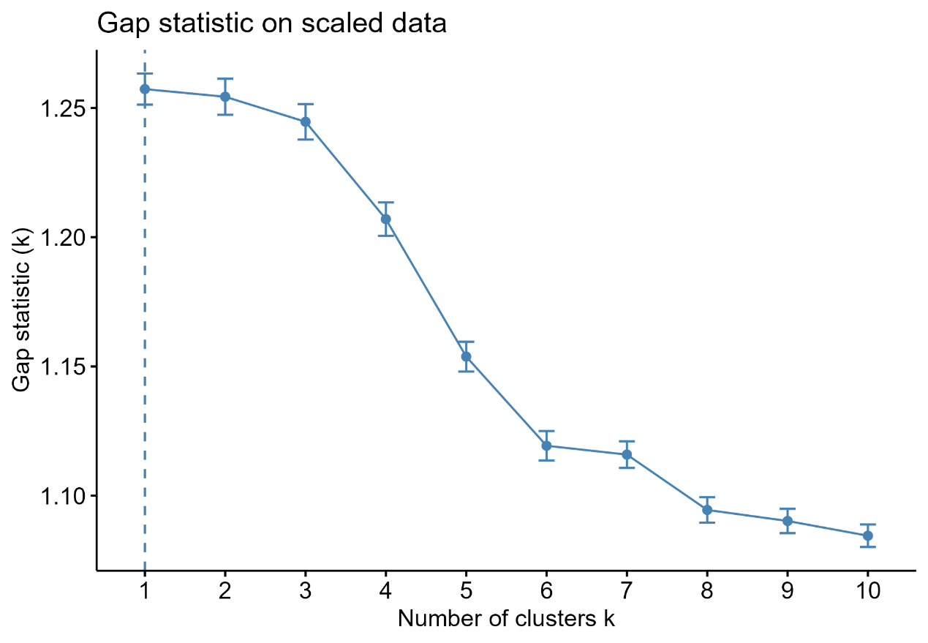
Fig. S1. Gap statistic analysis for determining the optimal number of clusters.
Gap statistic analysis was applied to assess the optimal number of clusters in the K-means model.

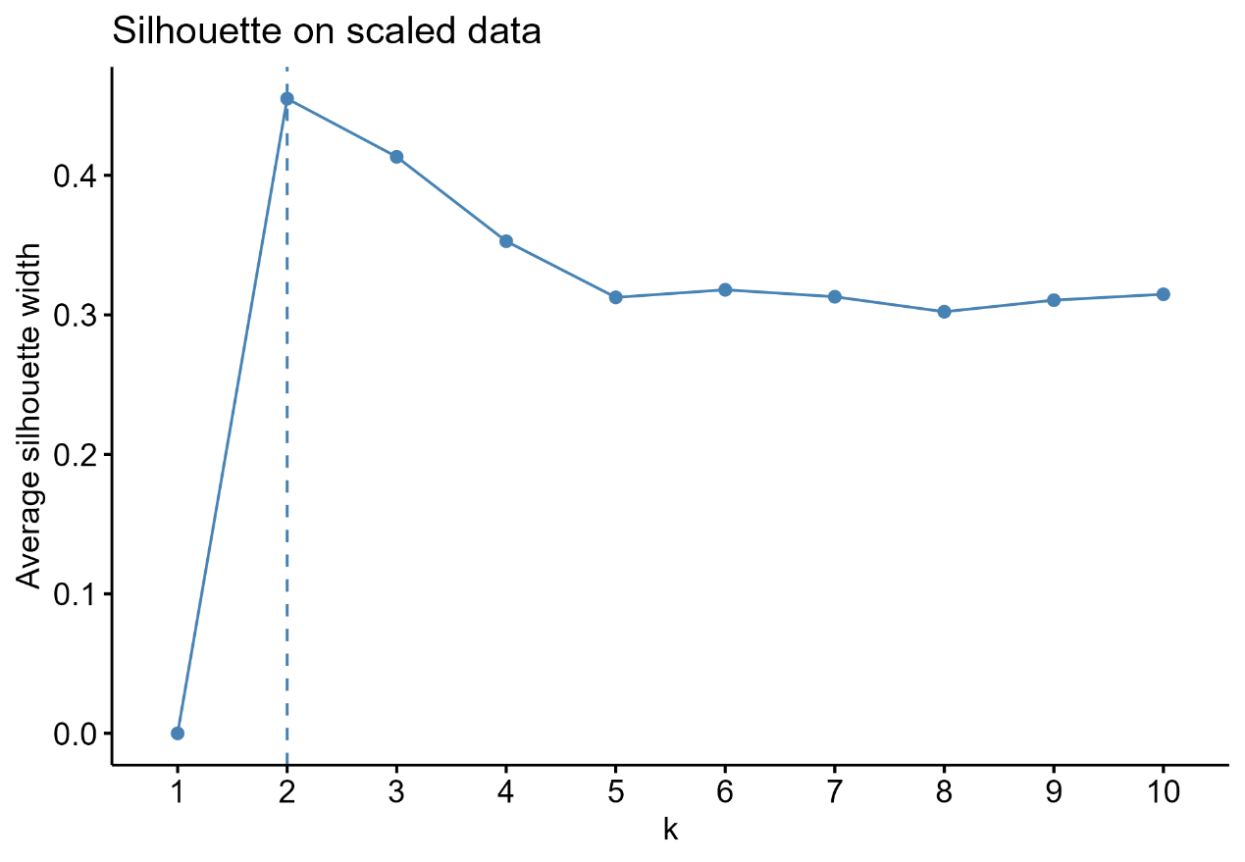
Fig. S2. Silhouette analysis for determining the optimal number of clusters.
Silhouette analysis was performed to evaluate clustering performance across different values of k using CHG values from 2012 and 2015.

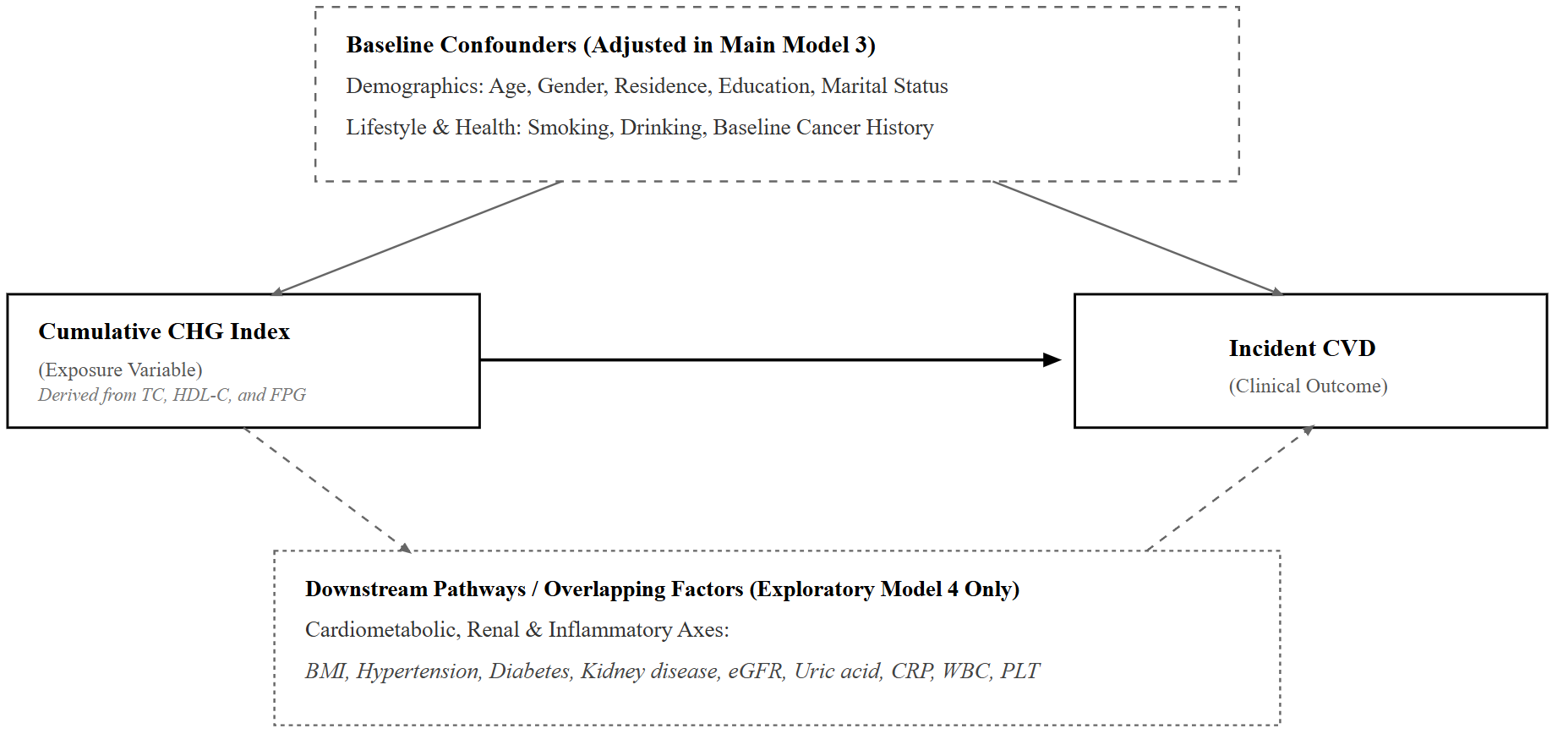
Fig. S3. Conceptual DAG-based framework for covariate adjustment.
This conceptual framework was used to clarify covariate adjustment in the association between cumulative CHG and incident CVD. Demographic, socioeconomic, lifestyle, and baseline health factors were included in the main confounder-adjusted model. Cardiometabolic, renal, and inflammatory factors were included only in the exploratory extended model because they may conceptually overlap with CHG components or CKM staging, or may lie on pathways linking CHG-related metabolic dysfunction to CVD. Solid arrows indicate the primary exposure–outcome association and confounding pathways. Dashed arrows indicate potential pathway-related or conceptual overlapping associations rather than definitive causal mechanisms.

