Gravure Secure Ink with Enhanced Anticounterfeiting Protection in Pharmaceutical Packaging
Anand P J^{a,b}, Rakshitha K Jainª, Dhanya Sunil^{a*}
ª Manipal Institute of Technology, Manipal Academy of Higher Education, Manipal, India.
^{b} Future Products Industrial Company, Dammam, Kingdom of Saudi Arabia.

*Corresponding author
Manipal Institute of Technology,
Manipal Academy of Higher Education,
Manipal-576104
Karnataka, India
Email: dhanyadss3@gmail.com, dhanya.s@manipal.edu

Contents
No. | Content | Page No.
SF 1 | PL spectra of red dye at λ_{ex} = 980 nm monitored in the visible and NIR regions. | 3
SF 2 | PL spectra of samples A, B and C at λ_{ex} = 980 nm. | 3
SF 3 | Photographs of gravure secure ink under a) daylight and b) 980 nm excitation. Photographs of control gravure ink under c) daylight and d) 980 nm excitation. | 3
SF 4 | PL spectra of gravure control print on blister foil at λ_{ex} = 980 nm: a) visible and b) NIR regions. | 4
SF 5 | Photographs of gravure control print on blister foil (2 cm × 5 cm) under a) daylight and b) 980 nm excitation. Photographs of secure gravure print on blister foil (2 cm × 5 cm) under c) daylight and d) 980 nm excitation. | 4
SF 6 | a) Line graph showing viscosity variation with storage days. Photographs of gravure secure ink and corresponding prints at b) day 1 and c) day 60. | 4
SF 7 | PL spectra at λex = 980 nm of gravure secure ink printed samples (n = 3) exposed to varying temperature for emissions between a) 450 nm to 500 nm and b) 640 nm to 660 nm. | 5
SF 8 | PL spectra at λ_{ex} = 980 nm of gravure secure ink printed samples (n = 3) exposed to different humidity conditions for emissions between a) 450 nm to 500 nm and b) 640 nm to 660 nm. | 5
SF 9 | PL spectra of unexposed and UV exposed gravure secure ink prints on foil recorded at λ_{ex} = 980 nm in a) 420 nm to 500 nm and b) 610 nm to 720 nm regions. | 5
Supplementary Table (ST) 1 | Colorimetric measurements of the security gravure prints on blister foil (n = 3). | 6
SF 10 | a) Bent and b) folded gravure secure print. | 6
SF 11 | PL spectra of gravure secure prints with and without UV-coating filter at λ_{ex} = 980 nm. | 7
SF 12 | Photographs of control gravure print on paper (2 cm × 5 cm) under a) daylight and b) 980 nm excitation. Photographs of secure gravure print on paper (2 cm × 5 cm) under a) daylight and b) 980 nm excitation. | 7
SF 13 | PL spectra of gravure secure print on paper at λ_{ex} = 980 nm: a) with emissions recorded in visible region, b) CIE diagram and c) emissions recorded in NIR region. | 7
ST 2 | Colorimetric measurements of the security gravure prints on paper, performed in triplicate (n = 3). | 8
SF 14 | a) PL spectra of unexposed and UV exposed gravure secure prints on paper recorded at λ_{ex} = 980 nm. CIELAB color space diagram with colorimetric values b) before & after UV exposure and c) before & after abrasion resistance tests of paper samples with gravure secure ink. | 8
SF 15 | a) PL spectra of unexposed and UV exposed gravure secure prints on paper recorded at λ_{ex} = 980 nm in the region a) 440 nm to 500 nm and b) 610 nm to 720 nm. | 9

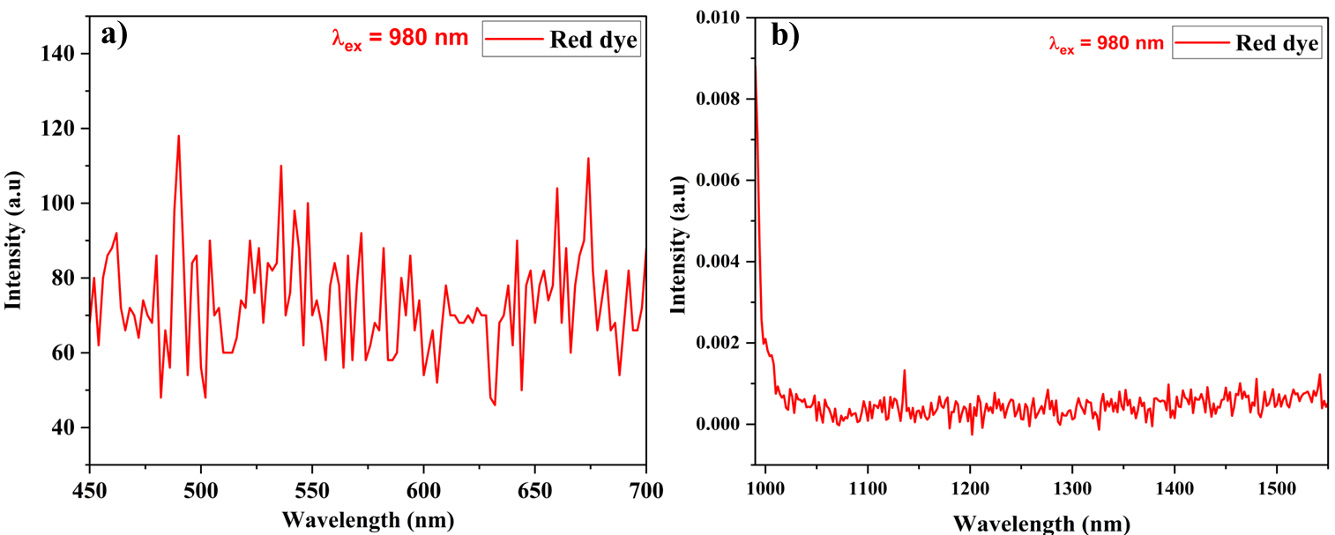
SF 1: PL spectra of red dye at λ_{ex} = 980 nm monitored in the a) visible and b) NIR regions.

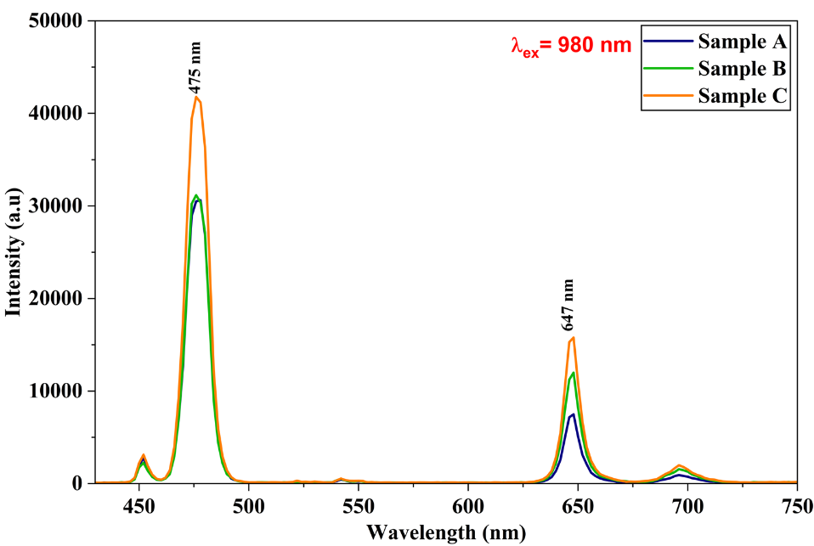
SF 2: PL spectra of samples A, B and C at λ_{ex} = 980 nm.

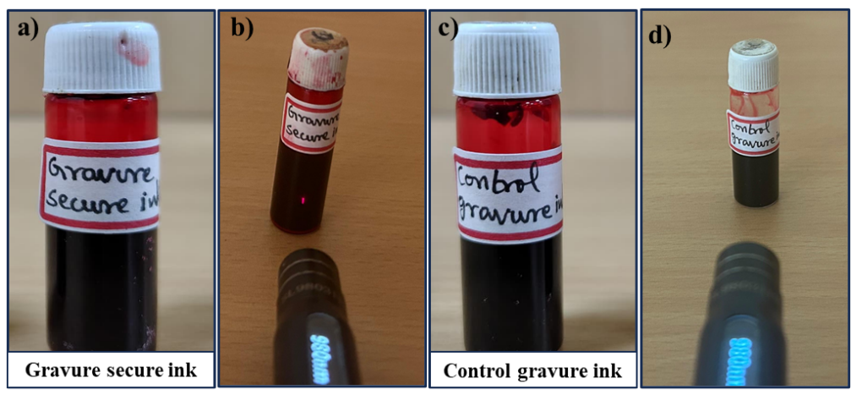
SF 3: Photographs of gravure secure ink under a) daylight and b) 980 nm excitation. Photographs of control gravure ink under c) daylight and d) 980 nm excitation.
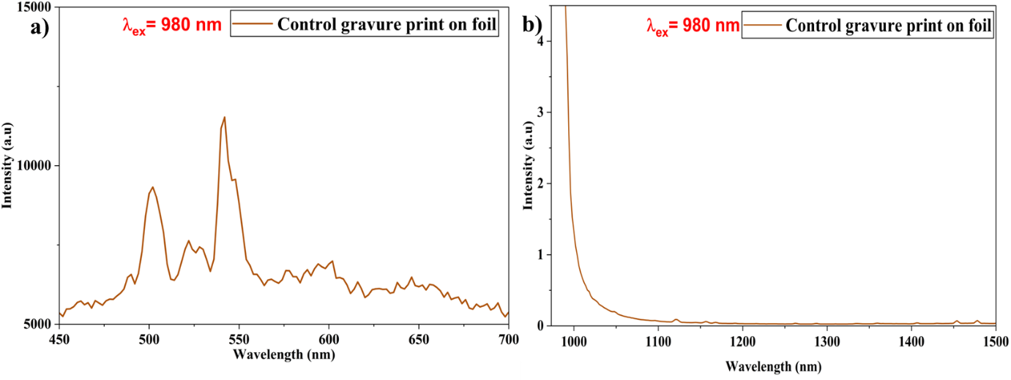
SF 4: PL spectra of gravure control print on blister foil at λ_{ex} = 980 nm in a) visible and b) NIR regions.

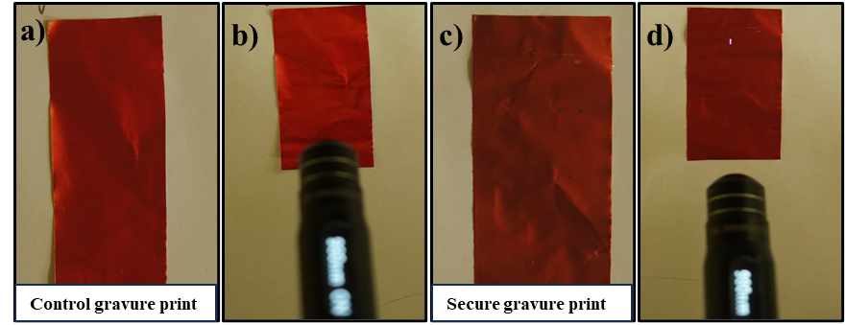
SF 5: Photographs of gravure control print on blister foil (2 cm × 5 cm) under a) daylight and b) 980 nm excitation. Photographs of secure gravure print on blister foil (2 cm × 5 cm) under c) daylight and d) 980 nm excitation.

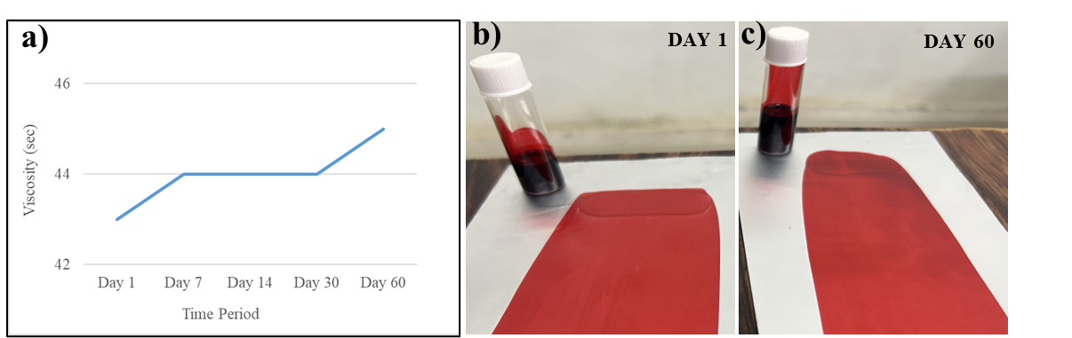
SF 6: a) Line graph showing viscosity variation with storage days. Photographs of secure gravure ink and corresponding prints at b) day 1 and c) day 60.

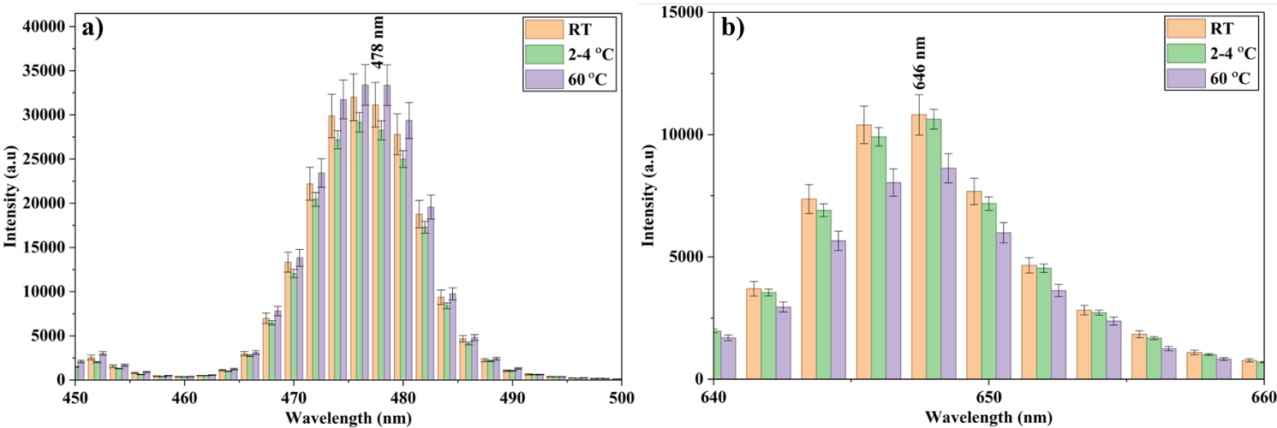
SF 7: PL spectra at λ_{ex} = 980 nm of gravure secure ink printed samples (n = 3) exposed to varying temperature for emissions between a) 450 nm to 500 nm and b) 640 nm to 660 nm.

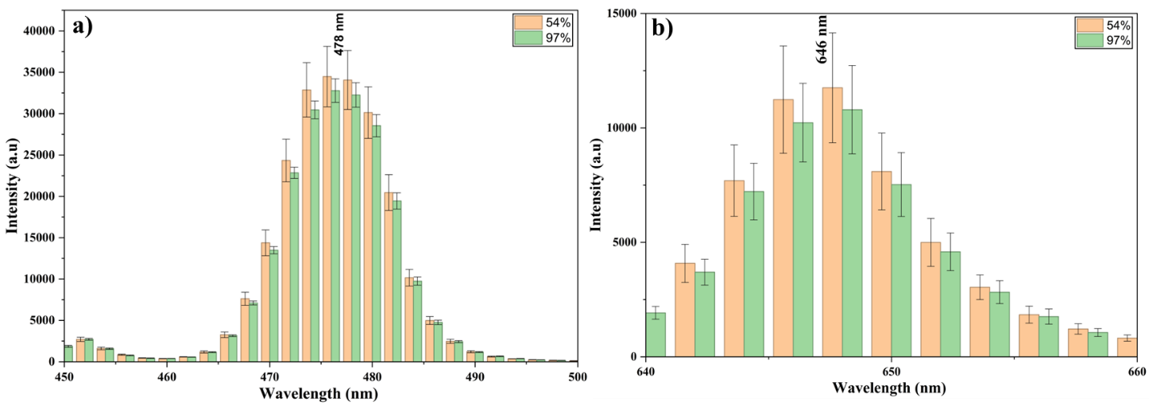
SF 8: PL spectra at λ_{ex} = 980 nm of gravure secure ink printed samples (n = 3) exposed to different humidity conditions for emissions between a) 450 nm to 500 nm and b) 640 nm to 660 nm.

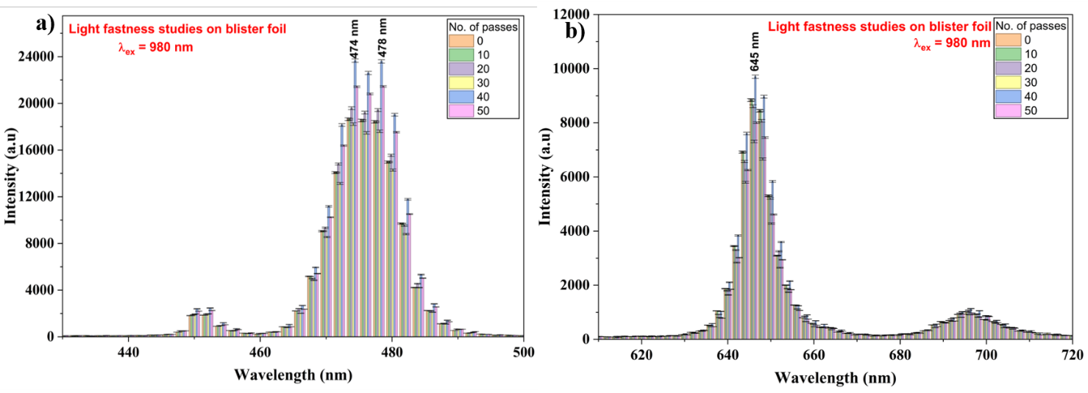
SF 9: PL spectra of unexposed and UV exposed gravure secure ink prints on foil recorded at λ_{ex} = 980 nm in a) 430 nm to 500 nm and b) 610 nm to 720 nm regions.
ST 1: Colorimetric measurements of the security gravure prints on blister foil (n = 3).
 | Trial -1 |  |  |  | Trial -2 |  |  |  | Trial -3
 | L | a* | b* | ΔE | L | a* | b* | ΔE | L | a* | b* | ΔE
Blank blister foil | 95.61 | 0.39 | 1.79 |  | 95.61 | 0.39 | 1.79 |  | 95.61 | 0.39 | 1.79
Printed | 51.44 | 63.48 | 36.28 |  | 52.09 | 63.55 | 36.11 |  | 51.56 | 63.13 | 35.87
10 passes | 51.32 | 60.12 | 33.37 | 4.45 | 51.40 | 60.22 | 33.63 | 4.21 | 51.50 | 60.33 | 33.42 | 4.26
20 passes | 51.99 | 59.68 | 34.27 | 4.33 | 51.67 | 59.75 | 34.34 | 4.21 | 51.41 | 59.56 | 34.31 | 4.39
30 passes | 52.91 | 59.25 | 34.56 | 4.80 | 52.73 | 59.38 | 34.88 | 4.39 | 51.05 | 59.39 | 34.54 | 4.46
40 passes | 53.11 | 59.45 | 34.17 | 4.85 | 52.97 | 59.12 | 34.45 | 4.81 | 52.81 | 59.76 | 34.04 | 4.55
50 passes | 53.13 | 58.96 | 34.11 | 5.29 | 53.25 | 58.81 | 34.56 | 5.12 | 53.45 | 58.92 | 34.54 | 5.28
Unrubbed blister foil print | 51.44 | 63.48 | 36.28 |  | 51.41 | 63.27 | 36.35 |  | 52.01 | 63.62 | 36.11
25 rubs | 49.27 | 60.12 | 32.70 | 5.37 | 49.01 | 60.01 | 32.85 | 5.45 | 49.77 | 60.34 | 32.91 | 4.90
50 rubs | 49.91 | 59.28 | 33.58 | 5.22 | 49.65 | 59.09 | 33.61 | 5.44 | 50.08 | 59.65 | 33.78 | 4.77
75 rubs | 50.79 | 58.75 | 33.87 | 5.35 | 50.54 | 58.53 | 33.69 | 5.66 | 50.65 | 58.54 | 33.52 | 5.71
100 rubs | 51.78 | 57.61 | 33.48 | 6.51 | 51.58 | 57.43 | 33.21 | 6.79 | 51.39 | 57.21 | 33.78 | 6.75

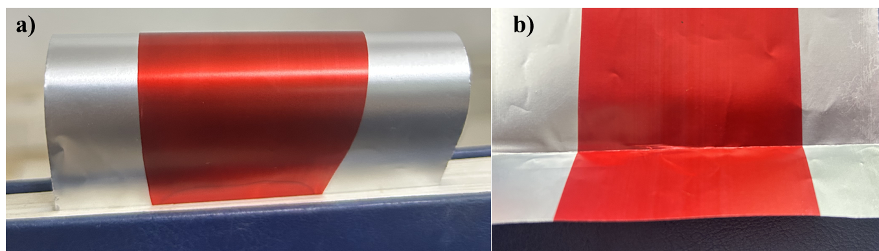
SF 10: a) Bent and b) folded gravure secure print.
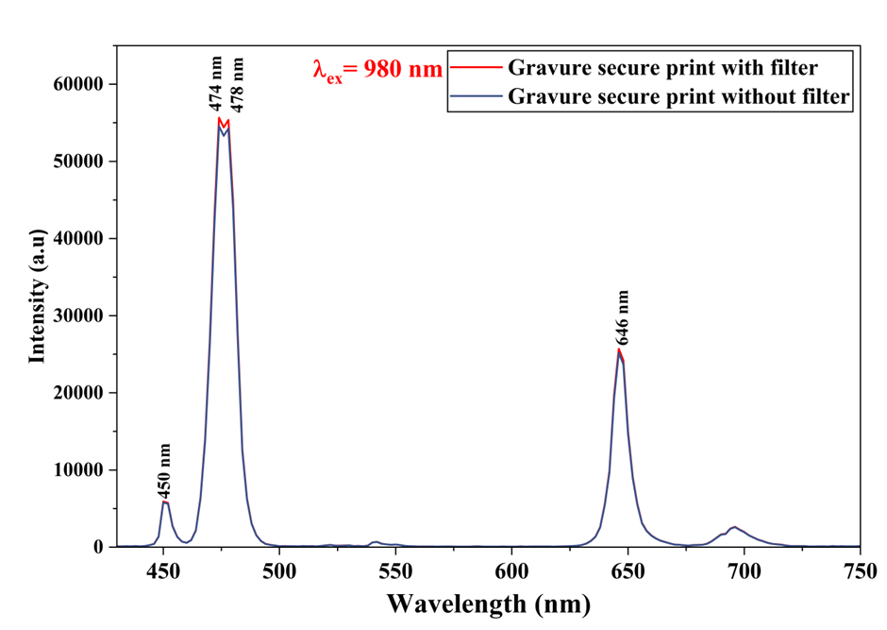
SF 11: PL spectra of gravure secure prints with and without UV-coating filter at λ_{ex} = 980 nm.

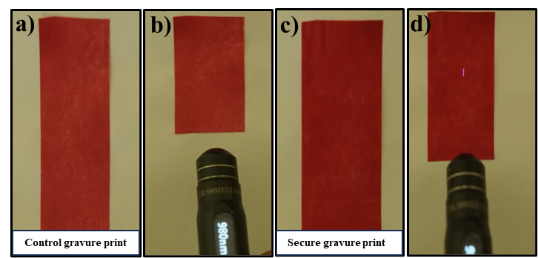
SF 12: Photographs of control gravure print on paper (2 cm × 5 cm) under a) daylight and b) 980 nm excitation. Photographs of secure gravure print on paper (2 cm × 5 cm) under a) daylight and b) 980 nm excitation.

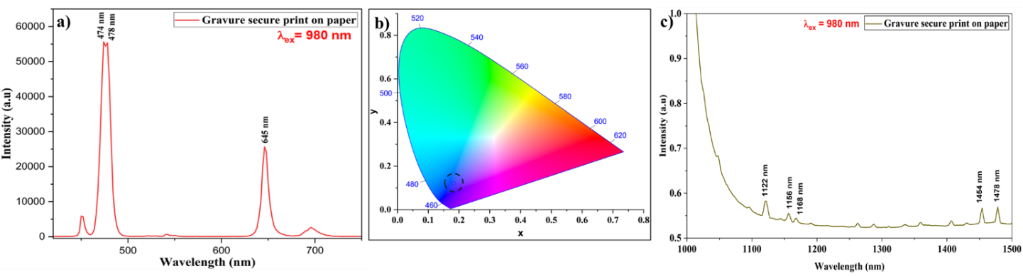
SF 13: PL spectra of gravure secure print on paper at λ_{ex} = 980 nm: a) with emissions recorded in visible region, b) CIE diagram and c) emissions recorded in NIR region.
ST 2: Colorimetric measurements of the security gravure prints on paper (n = 3).
 | Trial -1 |  |  |  | Trial -2 |  |  |  | Trial -3
 | L | a* | b* | ΔE | L | a* | b* | ΔE | L | a* | b* | ΔE
Blank paper | 92.36 | -0.17 | 2.78 |  | 92.36 | -0.17 | 2.78 |  | 92.36 | -0.17 | 2.78
Printed | 46.23 | 52.19 | 23.27 |  | 46.33 | 52.30 | 23.32 |  | 46.44 | 52.31 | 23.38
10 | 46.26 | 48.53 | 21.86 | 3.92 | 46.38 | 48.66 | 21.77 | 3.84 | 46.33 | 48.44 | 21.63 | 4.09
20 | 45.99 | 47.90 | 22.39 | 4.39 | 46.21 | 47.77 | 22.33 | 4.52 | 45.88 | 47.76 | 22.21 | 4.57
30 | 46.62 | 45.85 | 21.56 | 6.58 | 46.84 | 45.63 | 21.62 | 6.79 | 46.76 | 45.55 | 21.49 | 6.89
40 | 46.96 | 45.71 | 22.22 | 6.60 | 46.77 | 45.78 | 22.34 | 6.50 | 46.81 | 45.39 | 22.38 | 6.88
50 | 46.72 | 45.54 | 21.88 | 6.81 | 46.87 | 45.71 | 21.56 | 6.73 | 46.69 | 45.21 | 21.54 | 7.21
Unrubbed paper print | 44.84 | 50.62 | 22.57 |  | 44.35 | 50.55 | 22.33 |  | 44.76 | 50.02 | 22.51
25 rubs | 44.87 | 47.07 | 21.20 | 3.80 | 44.67 | 47.23 | 21.17 | 3.67 | 44.65 | 47.33 | 21.32 | 3.52
50 rubs | 45.07 | 46.94 | 21.93 | 3.74 | 45.01 | 46.67 | 21.77 | 4.03 | 45.21 | 46.75 | 21.87 | 3.95
75 rubs | 45.22 | 46.57 | 21.41 | 4.23 | 45.33 | 46.76 | 21.26 | 4.11 | 45.14 | 46.64 | 21.21 | 4.22
100 rubs | 45.55 | 46.42 | 21.95 | 4.30 | 45.69 | 46.33 | 21.73 | 4.45 | 45.69 | 46.53 | 21.87 | 4.24

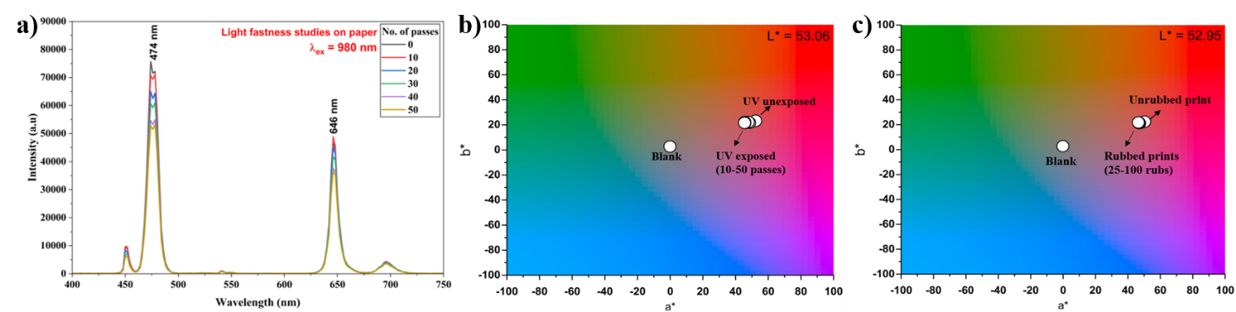
SF 14: a) PL spectra of unexposed and UV exposed gravure secure prints on paper recorded at λ_{ex} = 980 nm. CIELAB color space diagram with colorimetric values b) before & after UV exposure and c) before & after abrasion resistance tests of paper samples with gravure secure ink.
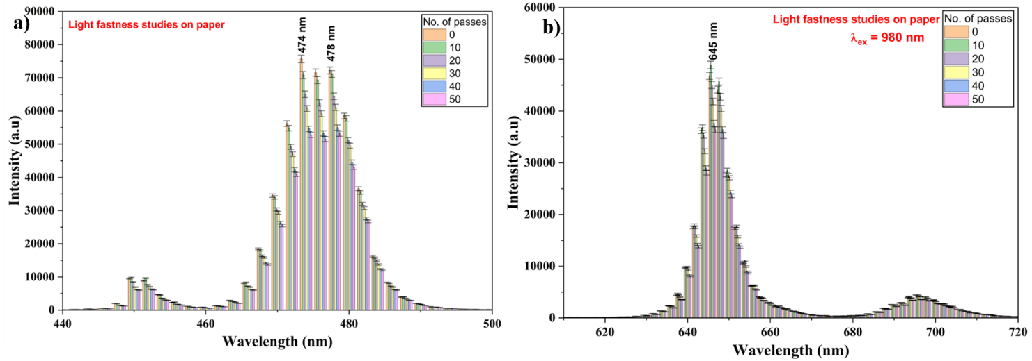
SF 15: a) PL spectra of unexposed and UV exposed gravure secure prints on paper recorded at λ_{ex} = 980 nm in the region a) 440 nm to 500 nm and b) 610 nm to 720 nm.

