Linking Molecular Antioxidant Activity to Polyurethane Foam Stability - The Case of Abies marocana Essential Oil
Mohamed El Bakkali¹, Dalal K. Thbayh^{2,3}, Dóra Mentes^{3,4}, László Farkas³,
Dávid Salamon^{3,4}, Anikó Csábrádiné Jordán^{3,4}, Béla Viskolcz^{3,4}, Amin Bouchfara¹,
Badredine Souhail¹, Mounir Nechar¹, Rehana Bano³, Béla Fiser^{3,4,5,*}
¹ Laboratory of Water, studies and Environmental Analysis, Faculty of Sciences, Tétouan, Abdelmalek Essaâdi University, Morocco
² Polymer Research Center, University of Basrah, Basrah, Iraq
³ Higher Education and Industrial Cooperation Centre, University of Miskolc, 3515 Miskolc-Egyetemváros, Hungary
⁴ Institute of Chemistry, University of Miskolc, 3515 Miskolc-Egyetemváros, Hungary
⁵ Department of Physical Chemistry, Faculty of Chemistry, University of Lodz, 90-236 Lodz, Poland
* Corresponding author: Béla Fiser, bela.fiser@uni-miskolc.hu

Supplementary Information
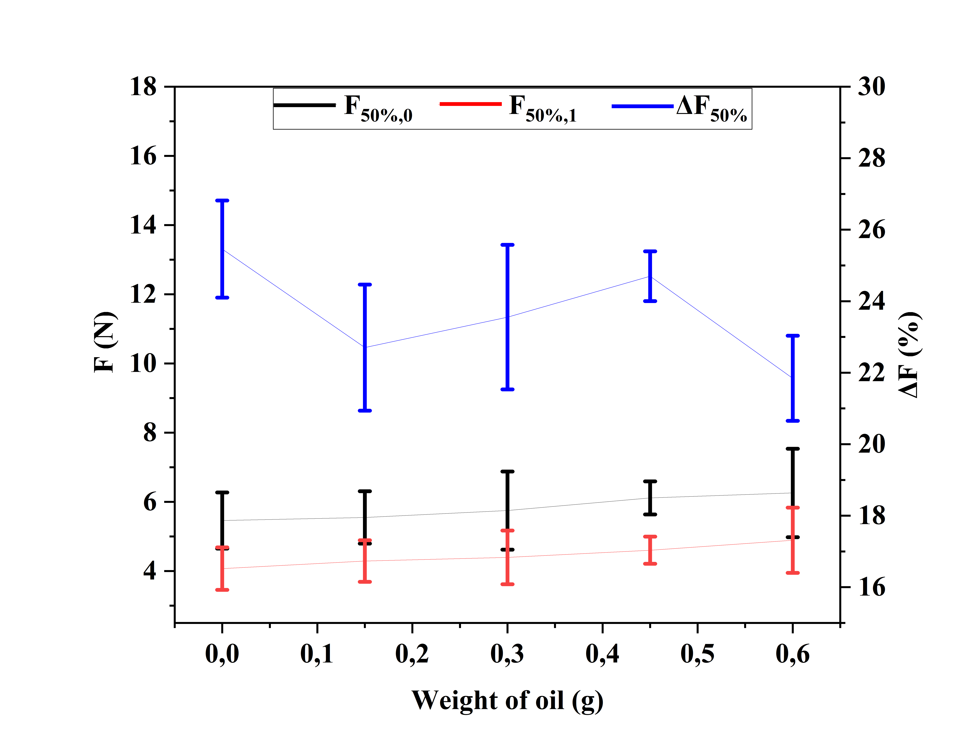
Figure S1. Experimental force values measured at 50% compression before (F_{50½,0}) and after (F_{50%,1}) dry heat ageing, and the corresponding calculated percentage force loss (ΔF_{50%}) as a function of AMEO concentration.

Figure S1. Raw FTIR spectra of the reference FPUF and FPUF/AMEO containing 0.15 g (AMEO1), 0.30 g (AMEO2), 0.45 g (AMEO3), and 0.60 g (AMEO4) of AMEO. For each formulation, Rep 1, Rep 2, and Rep 3 represent three independent replicate measurements.

Table S1. Raw replicate mechanical force (F₅_{₀%}) values measured at 50% compression before and after dry heat ageing and the corresponding percentage change (ΔF₅₀%(%)).
Sample ID | Weight of oil (g) | Before dry heat ageing (N) |  |  | Mean ± SD | After dry heat ageing (N) |  |  | Mean ± SD | ∆F_{50%} (%) ± SD
 |  | Rep1 | Rep2 | Rep3 |  | Rep1 | Rep2 | Rep3
Reference | 0.00 | 4.59 | 5.59 | 6.2 | 5.46 ± 0.81 | 3.45 | 4.08 | 4.68 | 4.07 ± 0.62 | 25.46 ± 1.36
AMEO1 | 0.15 | 4.76 | 5.62 | 6.27 | 5.55 ± 0.76 | 3.72 | 4.23 | 4.92 | 4.29 ± 0.60 | 22.70 ± 1.76
AMEO2 | 0.30 | 5.60 | 4.70 | 6.95 | 5.75 ± 1.13 | 4.23 | 3.72 | 5.24 | 4.39 ± 0.77 | 23.65 ± 2.02
AMEO3 | 0.45 | 6.50 | 6.26 | 5.58 | 6.11 ± 0.48 | 4.91 | 4.75 | 4.16 | 4.60 ± 0.39 | 24.70 ± 0.69
AMEO4 | 0.60 | 4.92 | 6.38 | 7.47 | 6.26 ± 1.28 | 3.92 | 4.95 | 5.8 | 4.89 ± 0.84 | 21.88 ± 1.28

Table S2. Raw replicate sample height measurements before and after dry heat ageing and the corresponding decrease in height (∆h (%)).
Sample ID | Weight of oil (g) | Initial height before compression (mm) |  |  | Mean ± SD | Height after dry heat ageing (mm) |  |  | Mean ± SD | ∆h (%) ± SD
 |  | Rep1 | Rep2 | Rep3 |  | Rep1 | Rep2 | Rep3
Reference | 0.00 | 28.97 | 29.39 | 30.23 | 29.53 ± 0.64 | 29.27 | 29.73 | 30.52 | 29.84 ± 0.63 | -1.05 ± 0.11
AMEO1 | 0.15 | 31.06 | 29.97 | 29.97 | 30.33 ± 0.63 | 31.29 | 30.11 | 30.11 | 30.5 ± 0.68 | -0.56 ± 0.15
AMEO2 | 0.30 | 29.40 | 29.40 | 29.93 | 29.58 ± 0.30 | 29.33 | 29.33 | 29.90 | 29.52 ± 0.33 | 0.20 ± 0.08
AMEO3 | 0.45 | 29.37 | 30.17 | 29.71 | 29.75 ± 0.40 | 28.93 | 29.71 | 29.32 | 29.32 ± 0.39 | 1.45 ± 0.12
AMEO4 | 0.60 | 30.89 | 29.23 | 29.23 | 29.78 ± 0.96 | 30.63 | 28.97 | 28.97 | 29.52 ± 0.96 | 0.87 ± 0.04

Cartesian coordinates of the optimized AMEO compounds calculated at the M06-2X/6-311+G(d,p) level of theory

β-pinene
C 1.07453100 -0.32762600 0.20743400
C 0.87245500 1.15313200 -0.24767200
C -0.12355400 -0.64111900 -0.75574400
C 0.31881100 0.59752600 -1.58432800
C -0.28082300 1.80916200 0.52348000
C -1.43689800 -0.27788600 -0.08919200
C 0.95024100 -0.66447100 1.68757300
C 2.39030100 -0.91154900 -0.30883200
C -1.50210300 0.91736800 0.49958600
C -2.56087800 -1.26724100 -0.13456100
H 1.75908200 1.79185900 -0.27551600
H -0.14877800 -1.62252800 -1.23561700
H 1.09935200 0.37805700 -2.30916100
H -0.48089700 1.16443100 -2.06259200
H -0.51403700 2.78423500 0.08037700
H 0.01813600 2.00679800 1.56048300
H 0.99735200 -1.74844700 1.83181400
H 0.02065800 -0.30748800 2.12860000
H 1.78540500 -0.22306900 2.24080000
H 2.56521100 -0.71353100 -1.36646300
H 2.40234200 -1.99604400 -0.16527300
H 3.23104000 -0.49266900 0.25235800
H -2.41192600 1.25611000 0.98690100
H -3.45339800 -0.88234600 0.36100200
H -2.26605300 -2.20141000 0.35502600
H -2.81599800 -1.51772200 -1.16920400
α-pinene
C 1.07453100 -0.32762600 0.20743400
C 0.87245500 1.15313200 -0.24767200
C -0.12355400 -0.64111900 -0.75574400
C 0.31881100 0.59752600 -1.58432800
C -0.28082300 1.80916200 0.52348000
C -1.43689800 -0.27788600 -0.08919200
C 0.95024100 -0.66447100 1.68757300
C 2.39030100 -0.91154900 -0.30883200
C -1.50210300 0.91736800 0.49958600
C -2.56087800 -1.26724100 -0.13456100
H 1.75908200 1.79185900 -0.27551600
H -0.14877800 -1.62252800 -1.23561700
H 1.09935200 0.37805700 -2.30916100
H -0.48089700 1.16443100 -2.06259200
H -0.51403700 2.78423500 0.08037700
H 0.01813600 2.00679800 1.56048300
H 0.99735200 -1.74844700 1.83181400
H 0.02065800 -0.30748800 2.12860000
H 1.78540500 -0.22306900 2.24080000
H 2.56521100 -0.71353100 -1.36646300
H 2.40234200 -1.99604400 -0.16527300
H 3.23104000 -0.49266900 0.25235800
H -2.41192600 1.25611000 0.98690100
H -3.45339800 -0.88234600 0.36100200
H -2.26605300 -2.20141000 0.35502600
H -2.81599800 -1.51772200 -1.16920400
Limonene
C -0.70647500 0.03719200 -0.27692100
C -0.04425100 -1.05524300 0.57808900
C 0.01848300 1.35909000 -0.02861800
C 1.41371000 -1.25614800 0.16573000
C 2.15723900 0.04240700 -0.03163500
C 1.51520400 1.20828500 -0.10744200
C -2.20710400 0.09662400 -0.07827200
C 3.65137500 -0.06858100 -0.14587800
C -2.95665000 -1.17595900 -0.38716900
C -2.85792400 1.18952400 0.31857700
H -0.54179300 -0.23952600 -1.32978700
H -0.58014000 -2.00253700 0.49111400
H -0.09718600 -0.74711500 1.62878800
H -0.25207600 1.74597700 0.96214400
H -0.31493600 2.10988800 -0.75186400
H 1.46331500 -1.83409900 -0.76700700
H 1.93781800 -1.85834200 0.91626400
H 2.09459100 2.11976900 -0.23369100
H 3.92546300 -0.74670600 -0.96063800
H 4.08048400 -0.48410300 0.77130700
H 4.11335100 0.90114600 -0.33539900
H -2.60974800 -1.61321200 -1.32836000
H -2.80201800 -1.92639800 0.39270200
H -4.02807500 -0.99038500 -0.46547900
H -3.93738200 1.18308900 0.42340800
H -2.35331200 2.11940700 0.54771400
Camphene
C 0.48489900 -1.11488600 0.47124800
C -0.83584600 -0.43909300 -0.00427700
C 1.03571200 1.07576200 0.39597400
C 1.05975700 -0.06008900 1.43840900
C 1.54671600 -1.06857600 -0.64315300
C 1.87074000 0.45075900 -0.75275500
C -0.41188900 1.03554500 -0.03170600
C -1.32594200 -0.91640800 -1.37559500
C -1.95586500 -0.67590600 1.01887000
C -1.17611200 2.06865200 -0.36569900
H 0.32038000 -2.11158600 0.88521800
H 1.37951300 2.05828200 0.71747000
H 2.07022900 -0.30598000 1.77403700
H 0.43305100 0.14348300 2.30711100
H 1.20803500 -1.50462000 -1.58233600
H 2.42959900 -1.62902100 -0.32788600
H 2.93457100 0.64101200 -0.59516300
H 1.59427400 0.87443100 -1.71979900
H -0.64957500 -0.62001300 -2.17853900
H -1.43164500 -2.00589900 -1.38962900
H -2.30406900 -0.48079000 -1.59447900
H -1.65522500 -0.39655300 2.02974700
H -2.83730000 -0.08470600 0.75925900
H -2.24217200 -1.73204000 1.02393100
H -2.20978600 1.93639700 -0.66976500
H -0.79290200 3.08304600 -0.34706400

