Synthesis, Crystal Structure, and Preliminary Acetylcholinesterase Inhibitory Evaluation of Hydantoin and Thiazolidine-2,4-dione Derivatives: An Experimental and Computational Study
Muhammad Naufal¹, Yusuf Eka Maulana², Elvira Hermawati², Ade Danova², Ika Wiani Hidayat¹, Ace Tatang Hidayat¹, Juliandri¹, and Jamaludin Al-Anshori^{1*}
¹Department of Chemistry, Faculty of Mathematics and Natural Sciences, Padjadjaran University, Jl. Raya Bandung-Sumedang Km. 21, Jatinangor, Sumedang 45363, Indonesia.
²Department of Chemistry, Faculty of Mathematics and Natural Sciences, Bandung Institute of Technology, Jl. Ganesha, 10, Bandung, 40132, Jawa Barat, Indonesia.
*corresponding email: jamaludin.al.anshori@unpad.ac.id

NMR Spectra Data
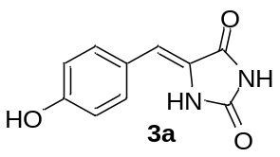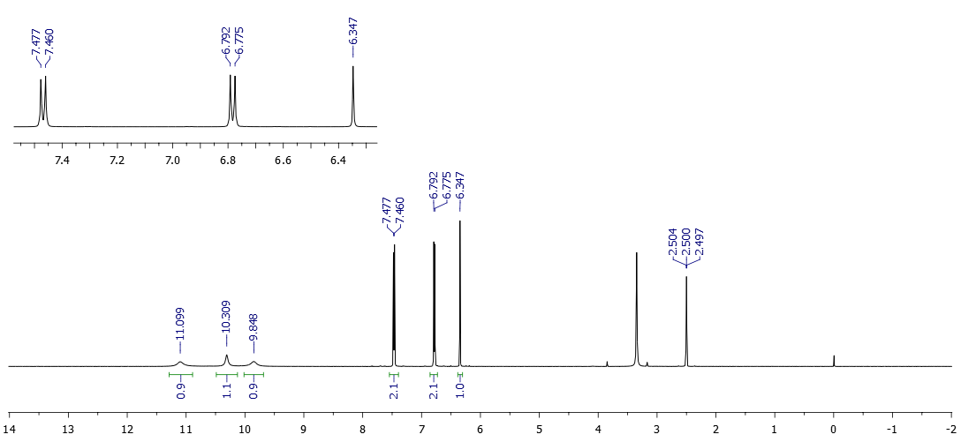
Figure S 1. ¹H-NMR spectrum of compound 3a.

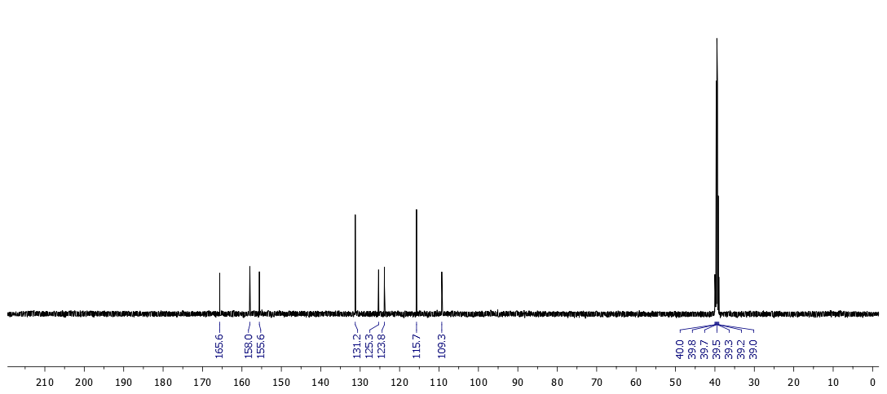
Figure S 2. ¹³C-NMR spectrum of compound 3a.
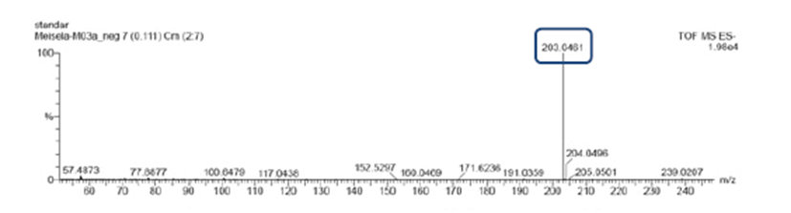
Figure S 3. Mass spectrometry of compound 3a.
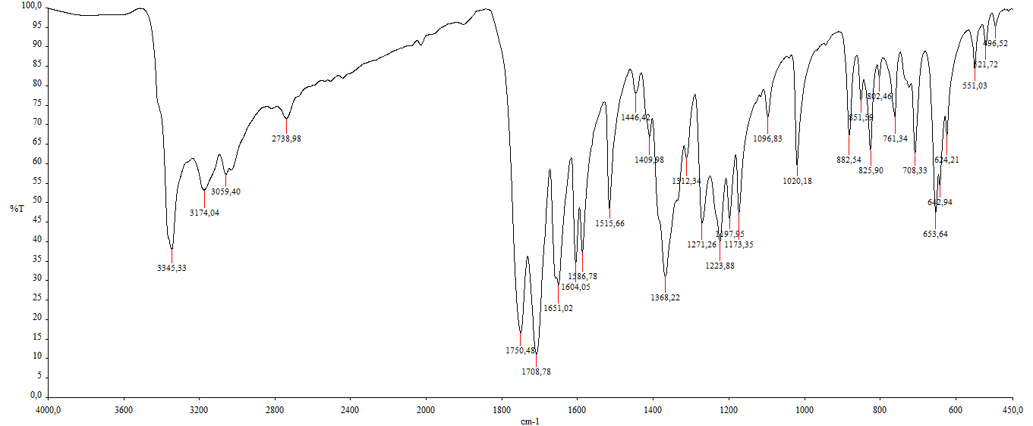
Figure S 4. FTIR of compound 3a.
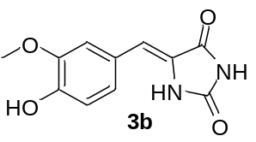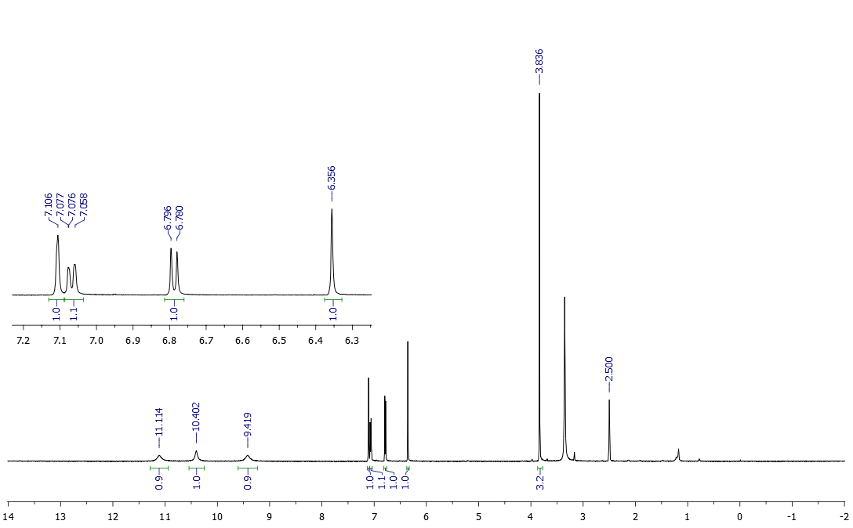
Figure S 5. ¹H-NMR spectrum of compound 3b.
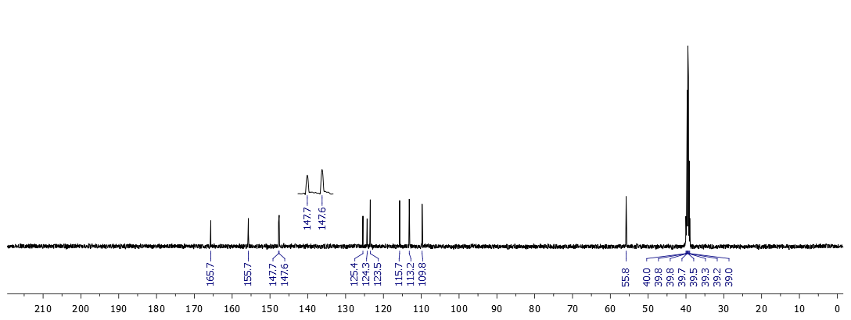
Figure S 6 ¹³C-NMR spectrum of compound 3b.
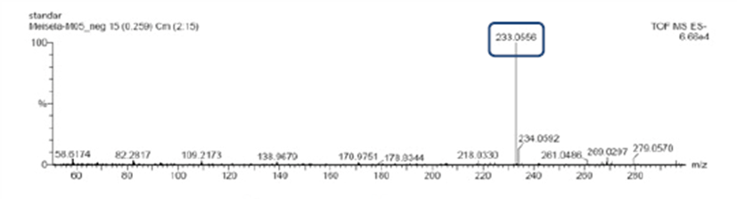
Figure S 7. Mass spectrometry of compound 3b.
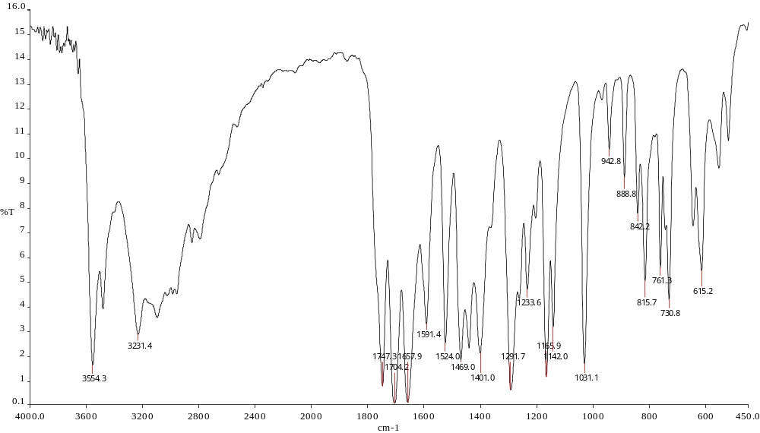
Figure S 8. FTIR of compound 3b.
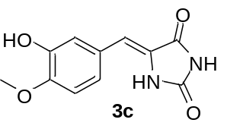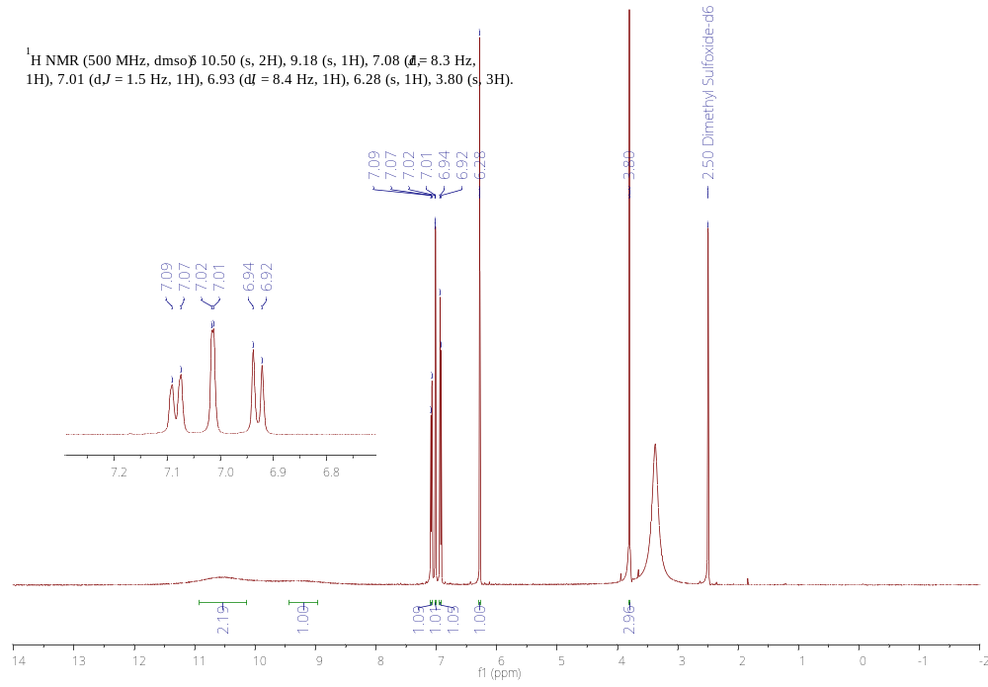
Figure S 9. ¹H-NMR spectrum of compound 3c.
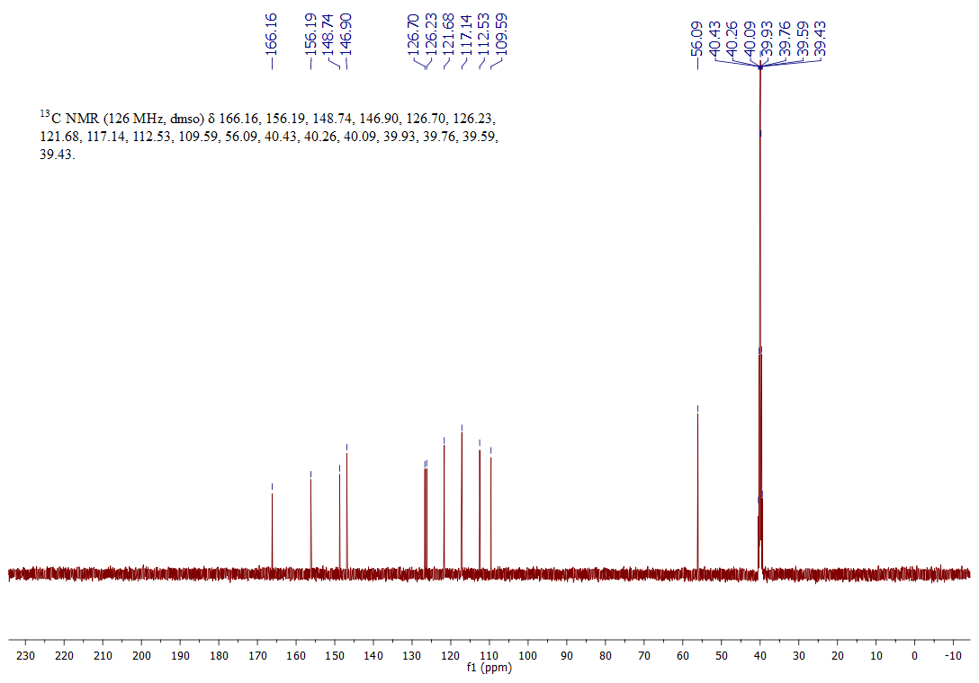
Figure S 10. ¹³C-NMR spectrum of compound 3c.
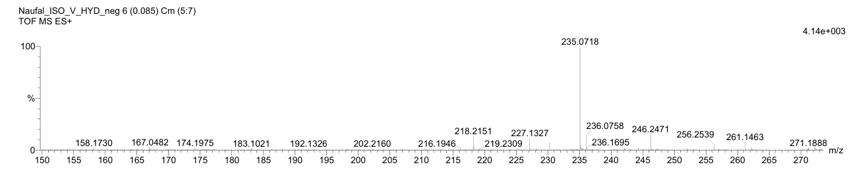
Figure S 11. Mass spectrometry of compound 3c.
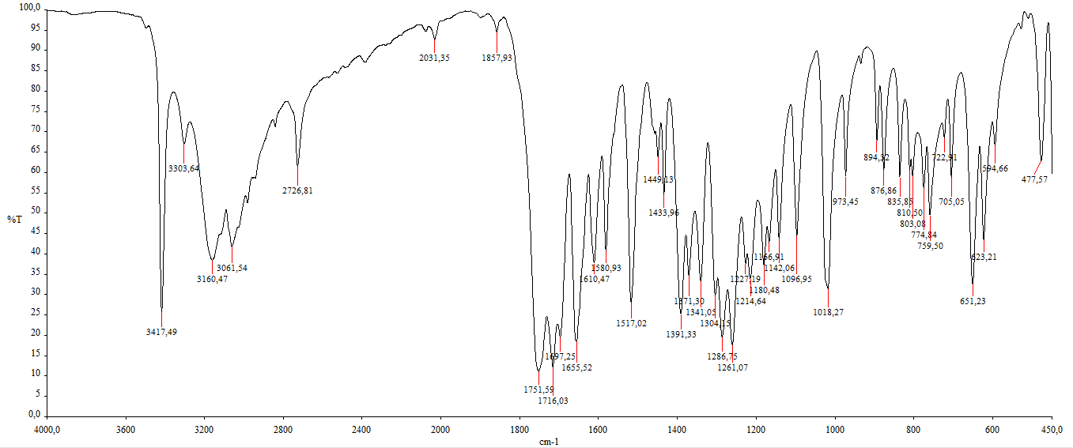
Figure S 12. FTIR of compound 3c.
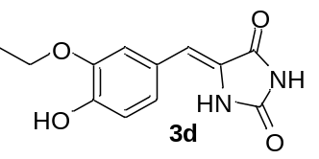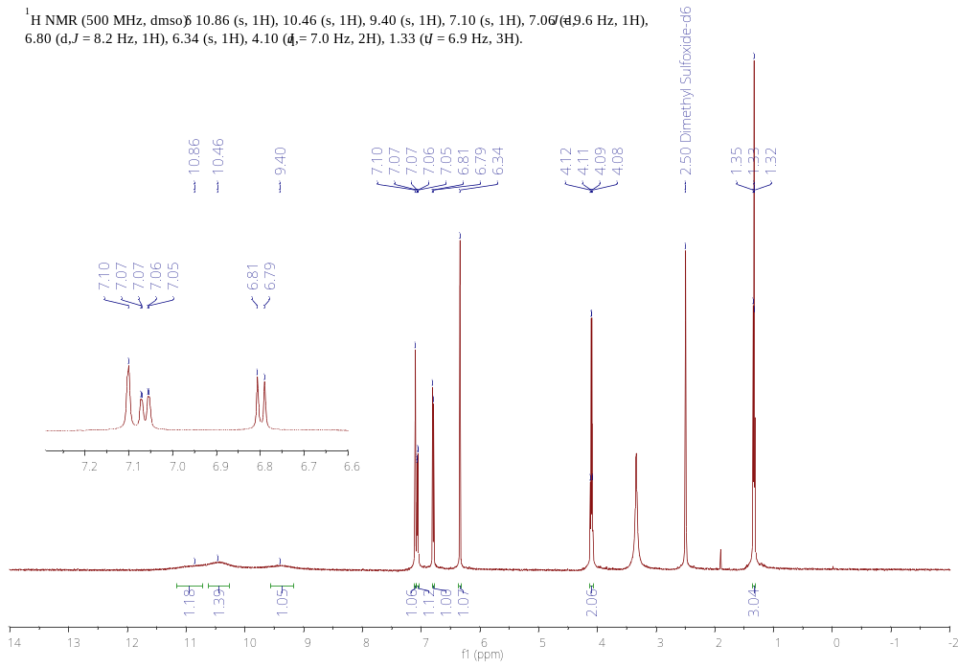
Figure S 13. ¹H-NMR spectrum of compound 3d.
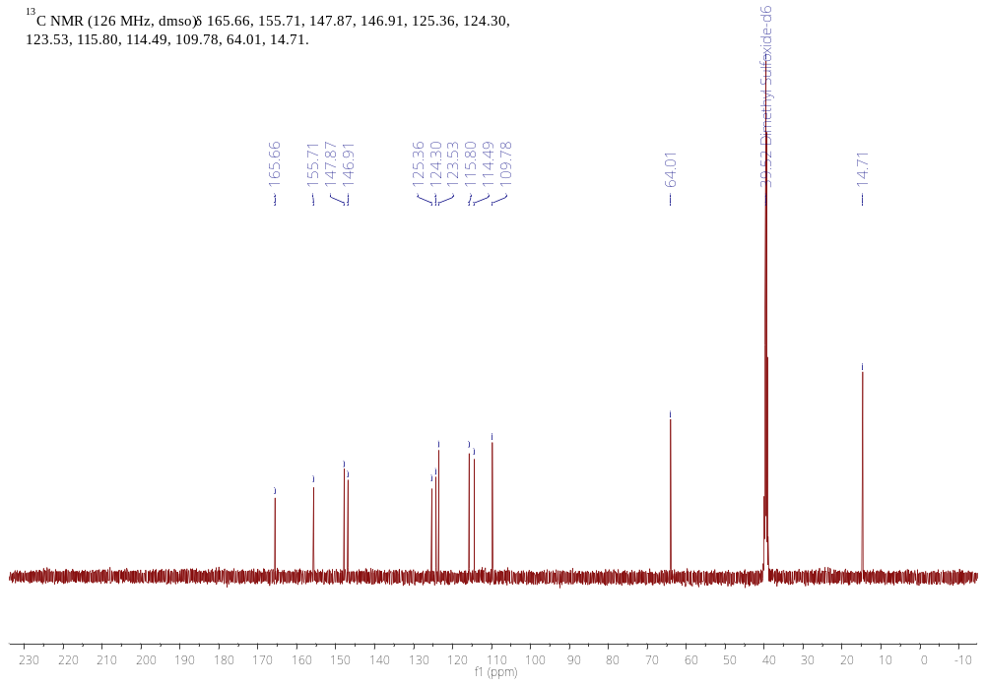
Figure S 14. ¹³C-NMR spectrum of compound 3d.
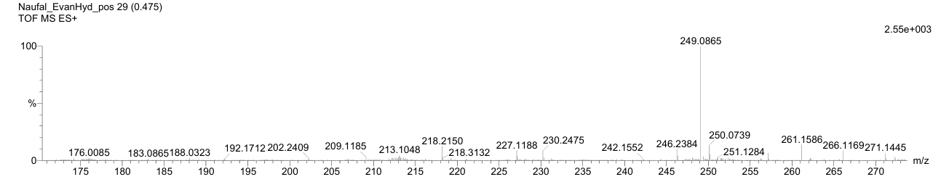
Figure S 15. Mass spectrometry of compound 3d.
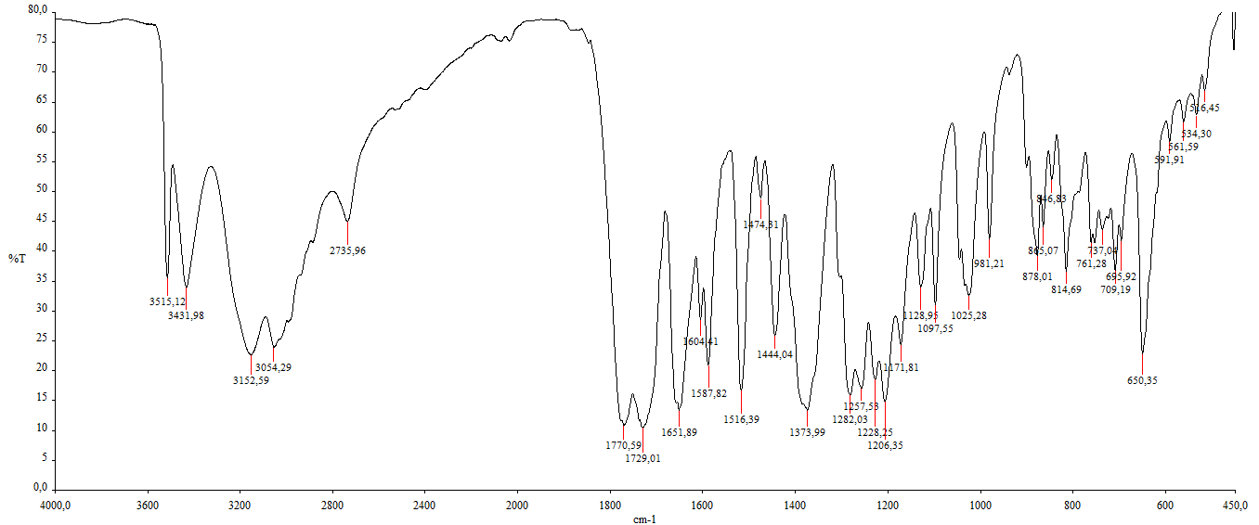
Figure S 16. FTIR of compound 3d.
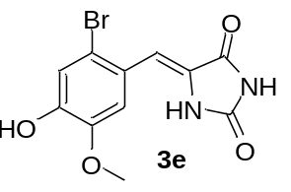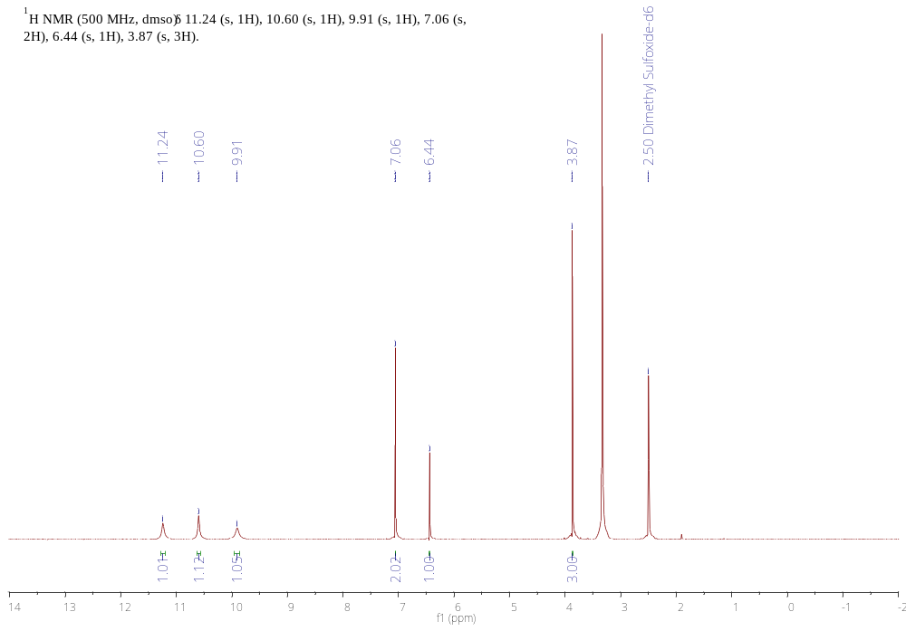
Figure S 17. ¹H-NMR spectrum of compound 3e.
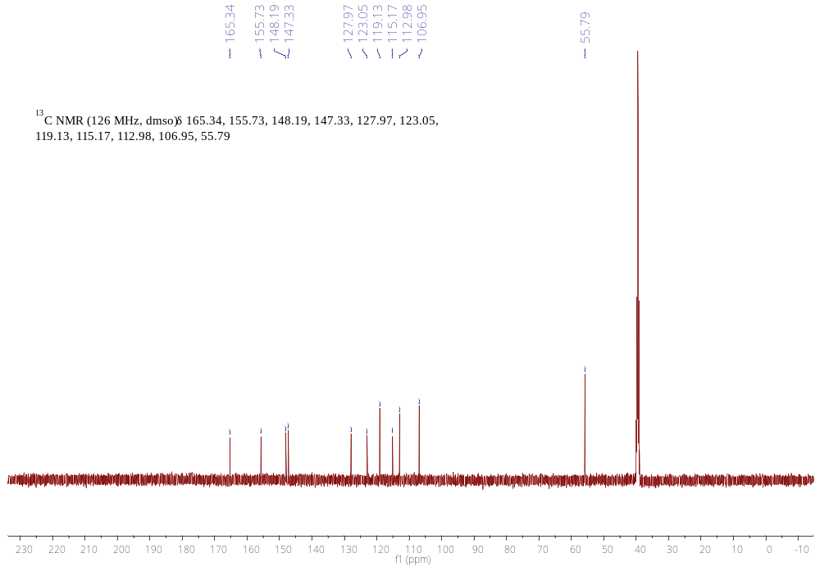
Figure S 18. ¹³C-NMR spectrum of compound 3e.
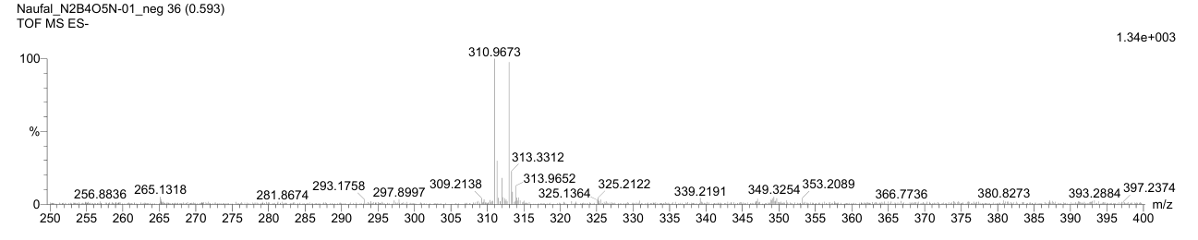
Figure S 19. Mass spectrometry of compound 3e.
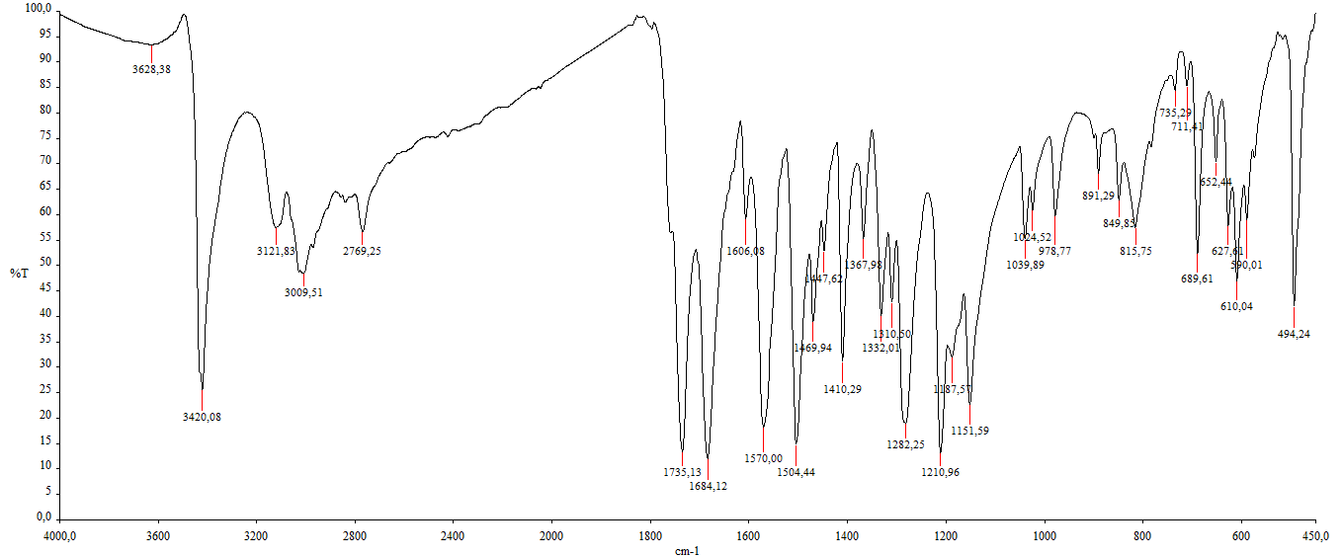
Figure S 20. FTIR of compound 3e.
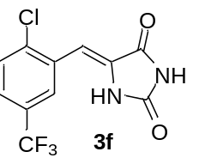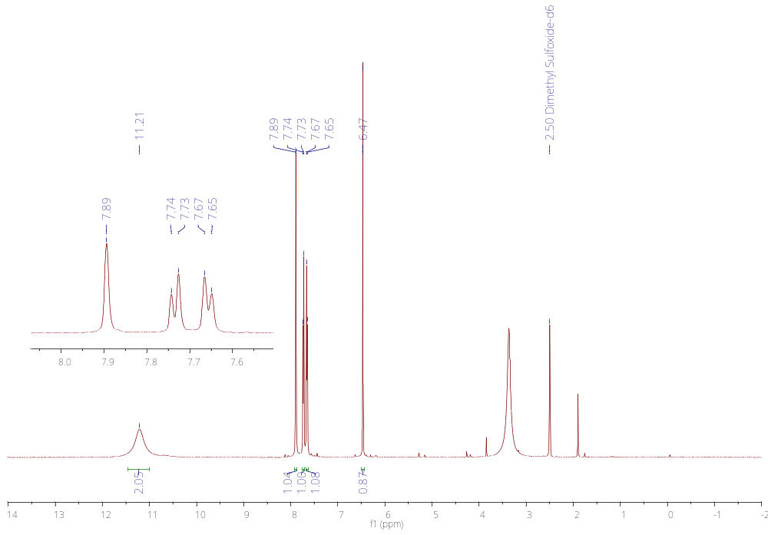
Figure S 21. ¹H-NMR spectrum of compound 3f.
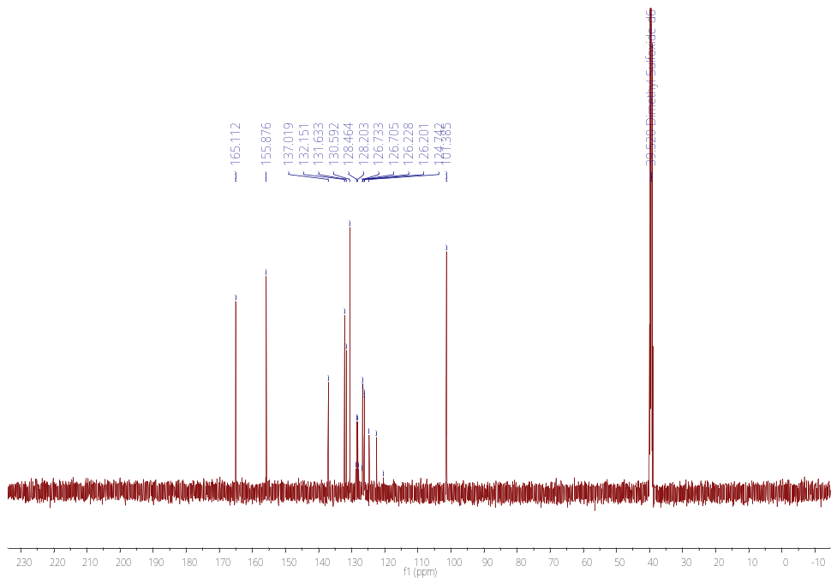
Figure S 22. ¹³C-NMR spectrum of compound 3f.
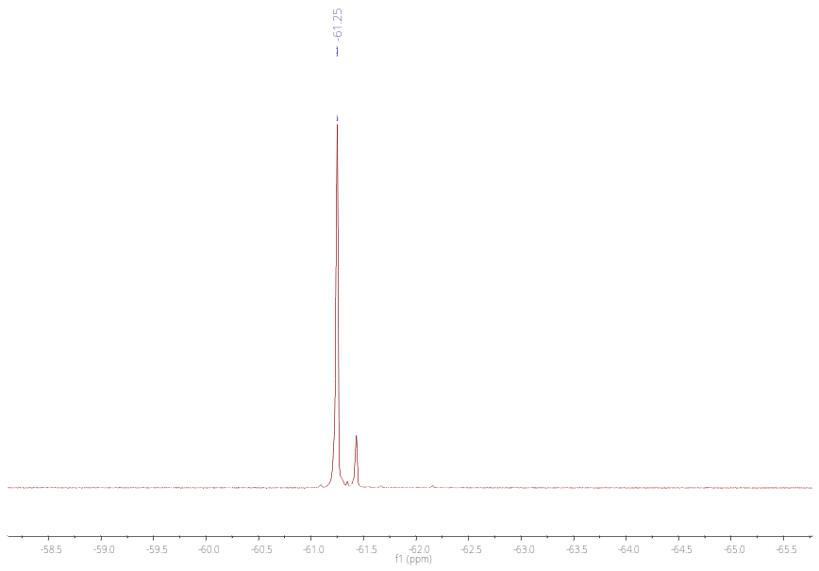
Figure S 23. ¹⁹F-NMR spectrum of compound 3f
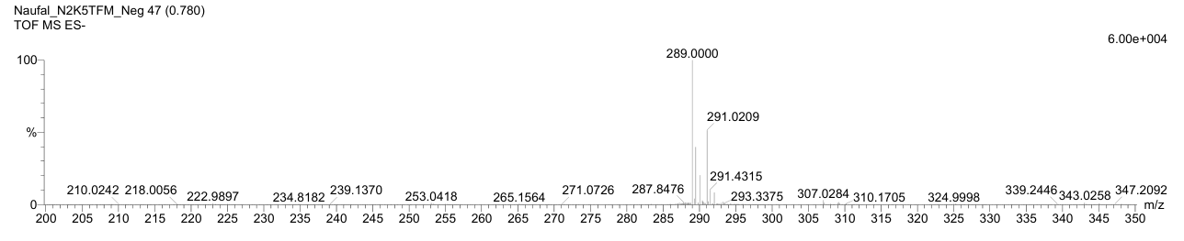
Figure S 24. Mass spectrometry of compound 3f.
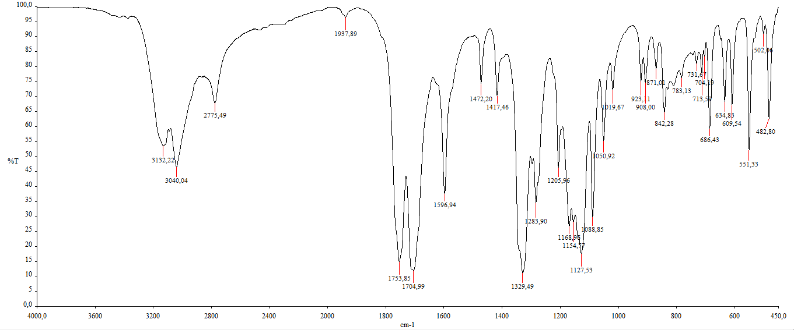
Figure S 25. FTIR of compound 3f.
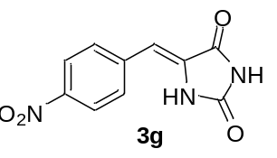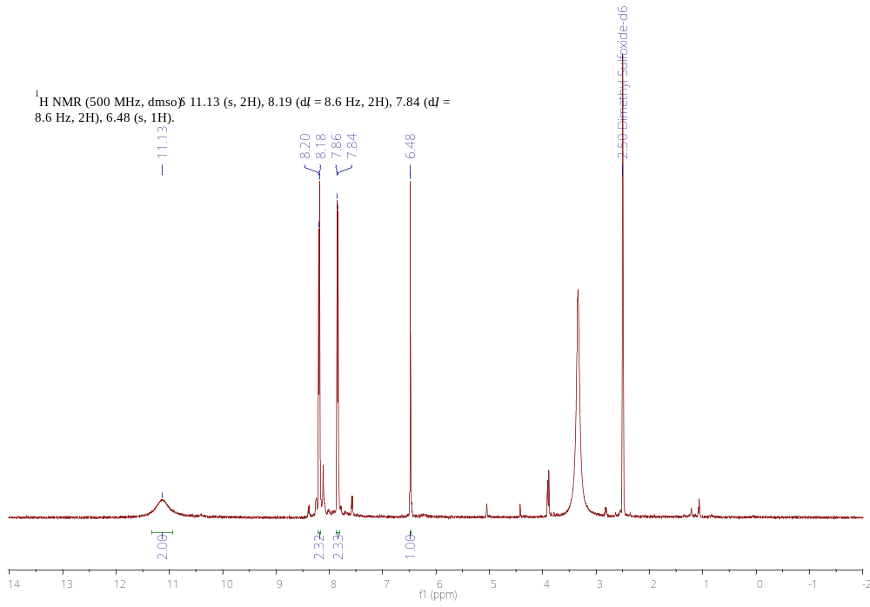
Figure S 26. ¹H-NMR spectrum of compound 3g.
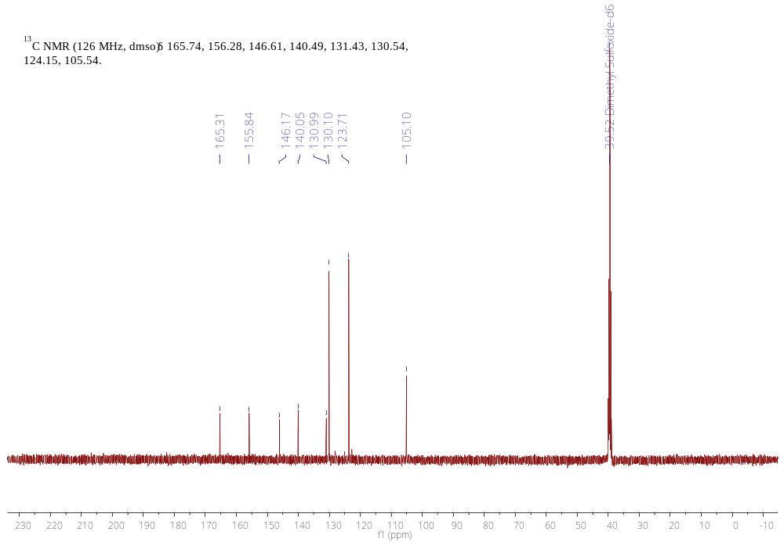
Figure S 27. ¹³C-NMR spectrum of compound 3g.
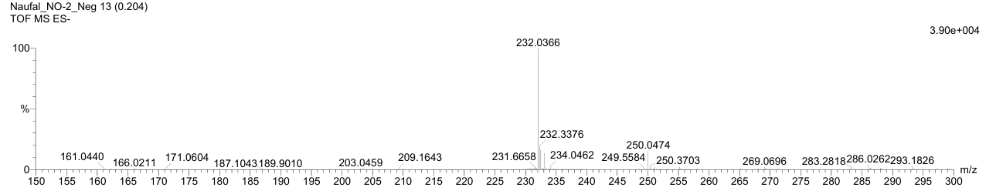
Figure S 28. Mass spectrometry of compound 3g.
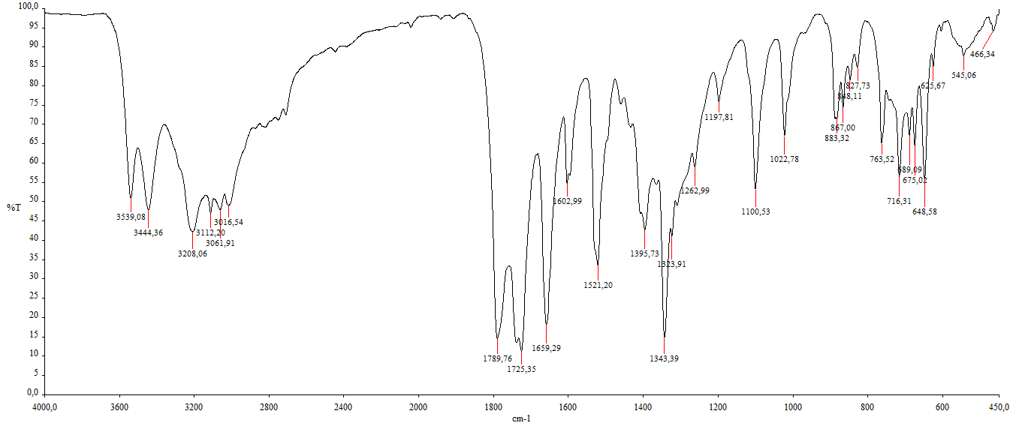
Figure S 29. FTIR of compound 3g.
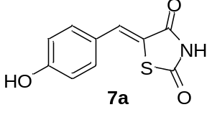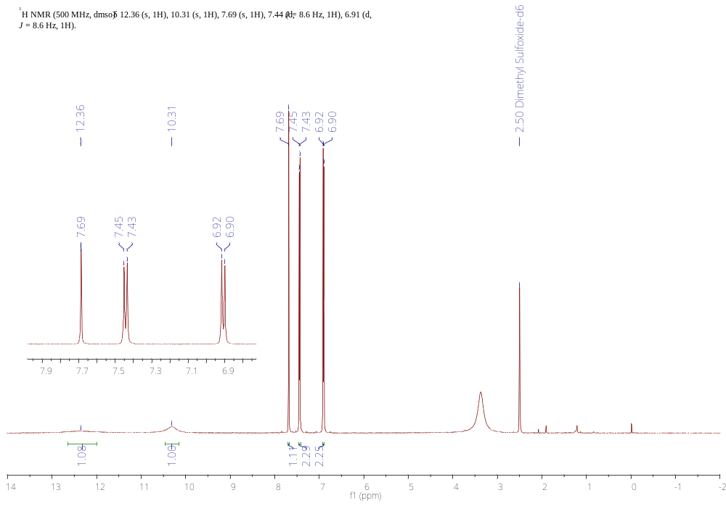
Figure S 30. ¹H-NMR spectrum of compound 7a.
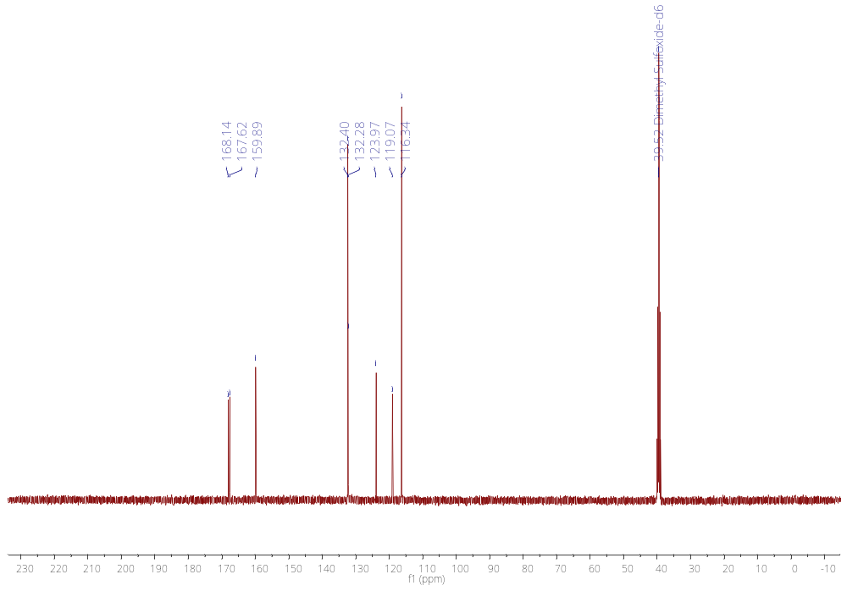
Figure S 31. ¹³C-NMR spectrum of compound 7a.
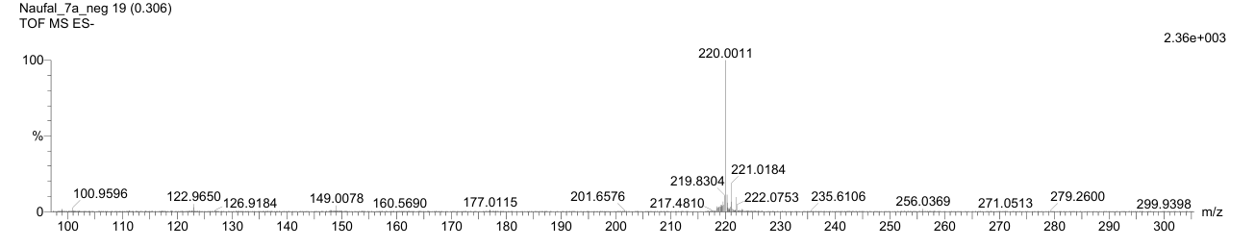
Figure S 32. Mass spectrometry of compound 7a.
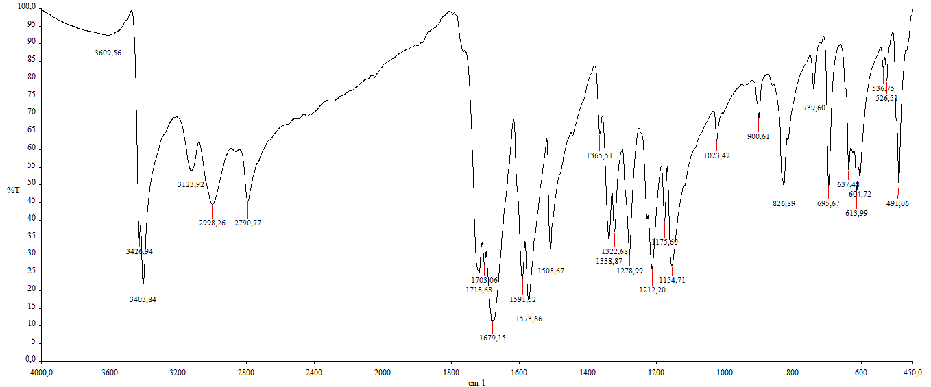
Figure S 33. FTIR of compound 7a.

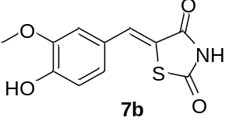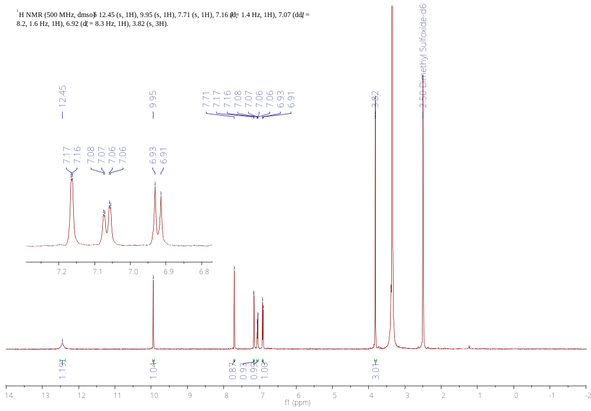
Figure S 34. ¹³H-NMR spectrum of compound 7b.
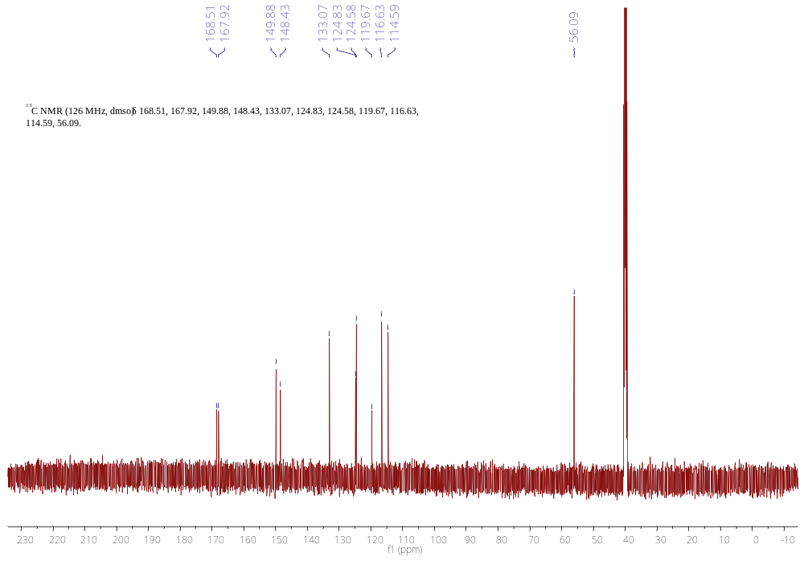
Figure S 35. ¹³C-NMR spectrum of compound 7b.
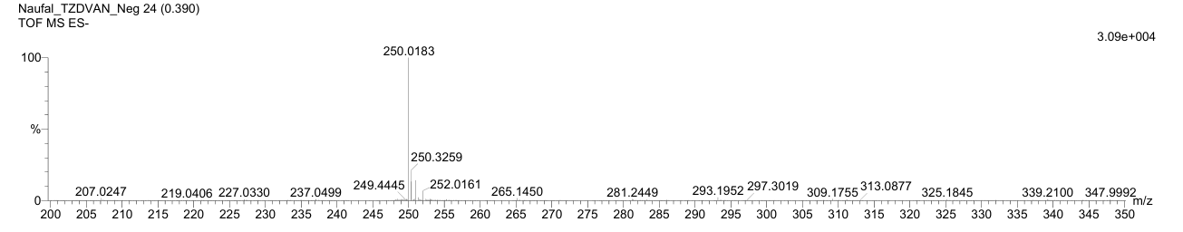
Figure S 36. Mass spectrometry of compound 7b.
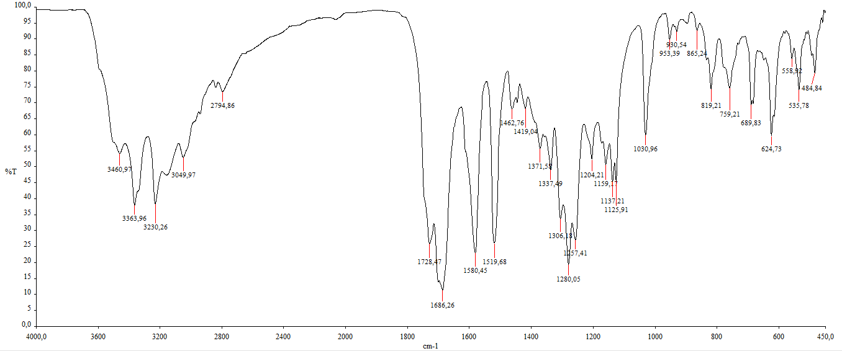
Figure S 37. FTIR of compound 7b.
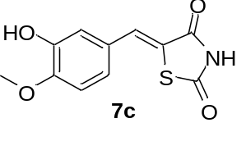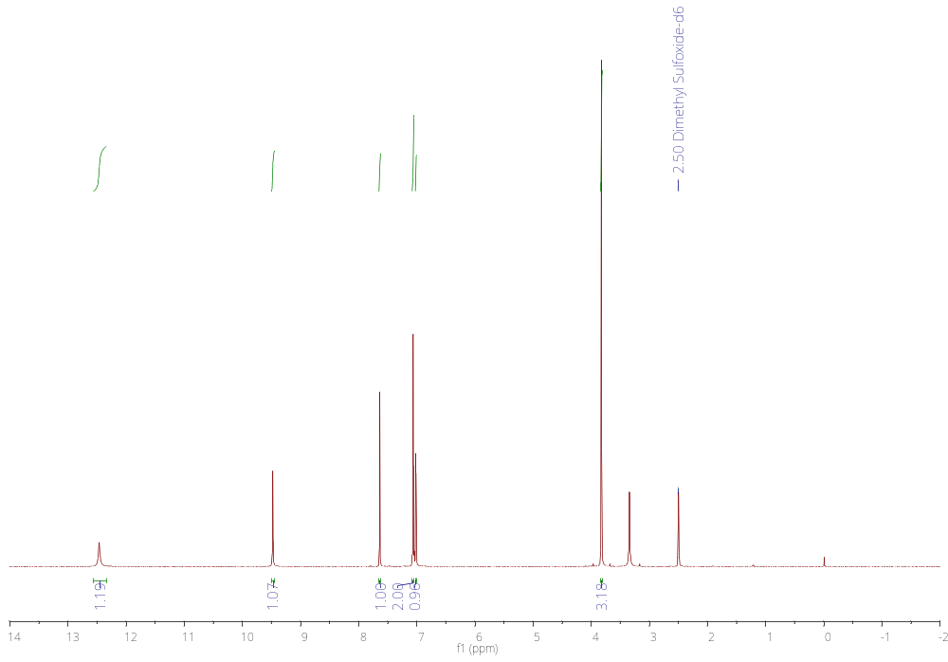
Figure S 38. ¹H-NMR spectrum of compound 7c.
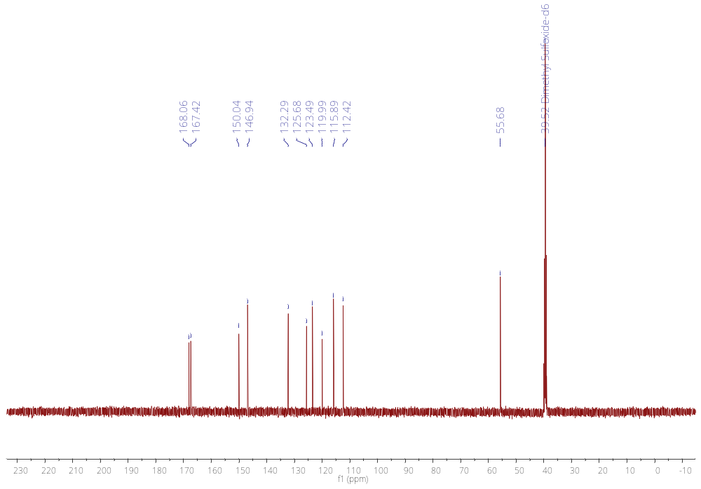
Figure S 39. ¹³C-NMR spectrum of compound 7c.
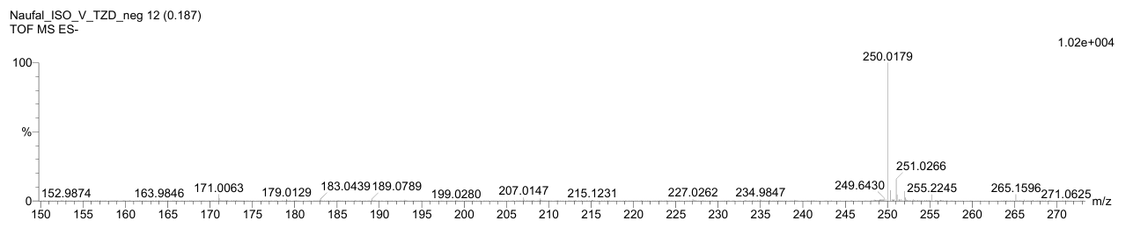
Figure S 40. Mass spectrometry of compound 7c.
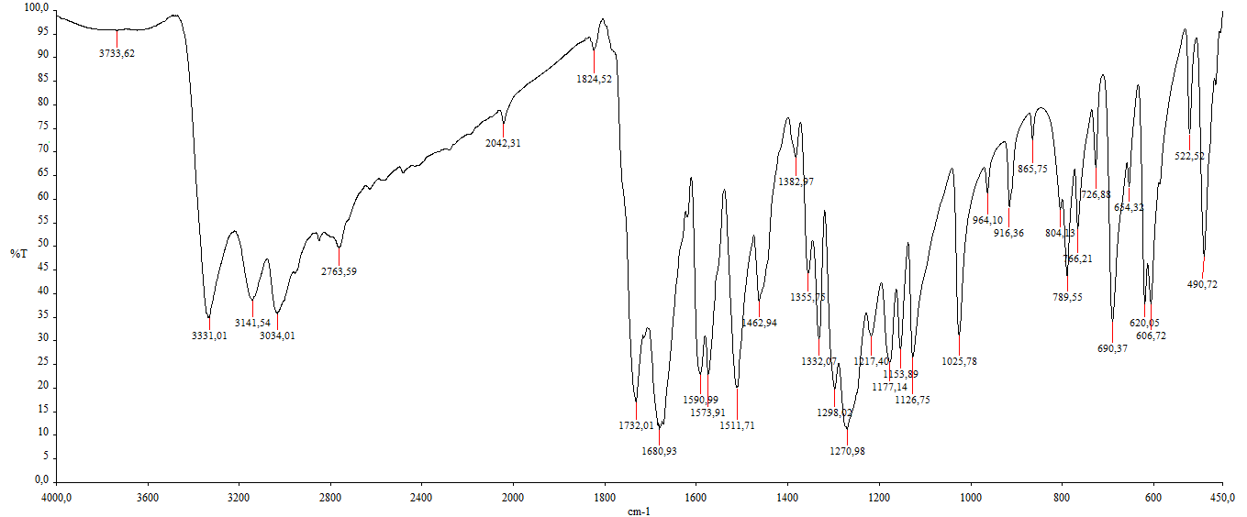
Figure S 41. FTIR of compound 7c.
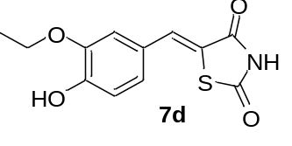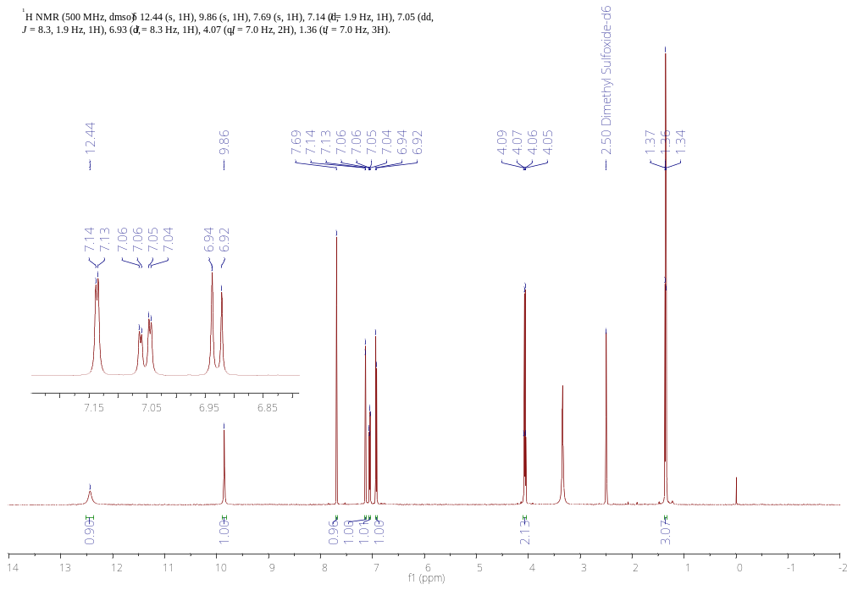
Figure S 42.¹H-NMR spectrum of compound 7d.
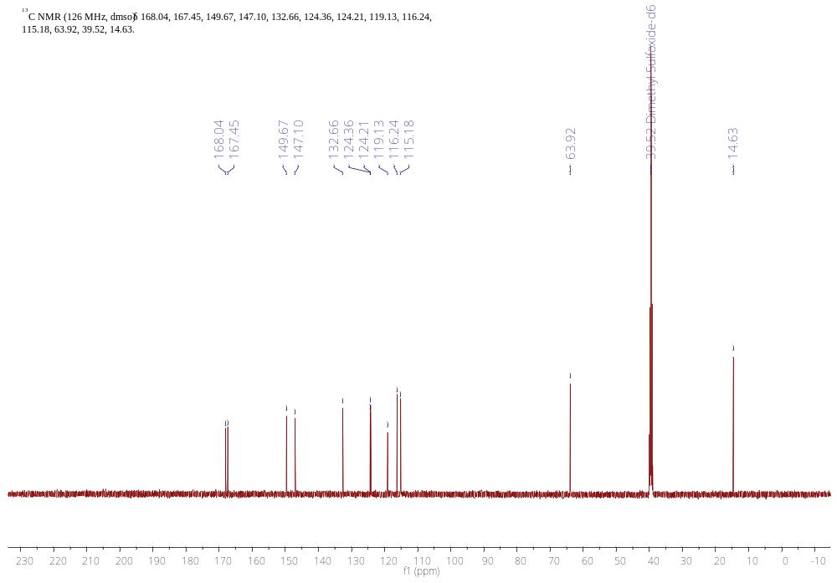
Figure S 43. ¹³C-NMR spectrum of compound 7d.
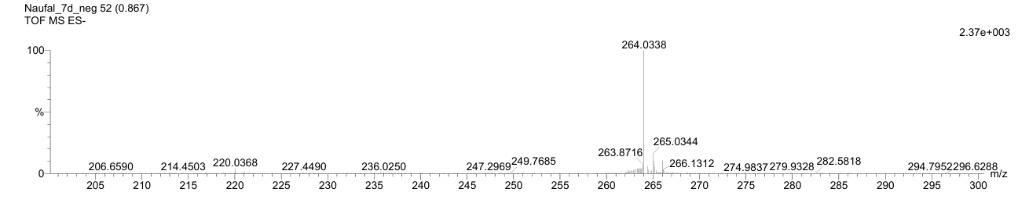
Figure S 44. Mass spectrometry of 7d.
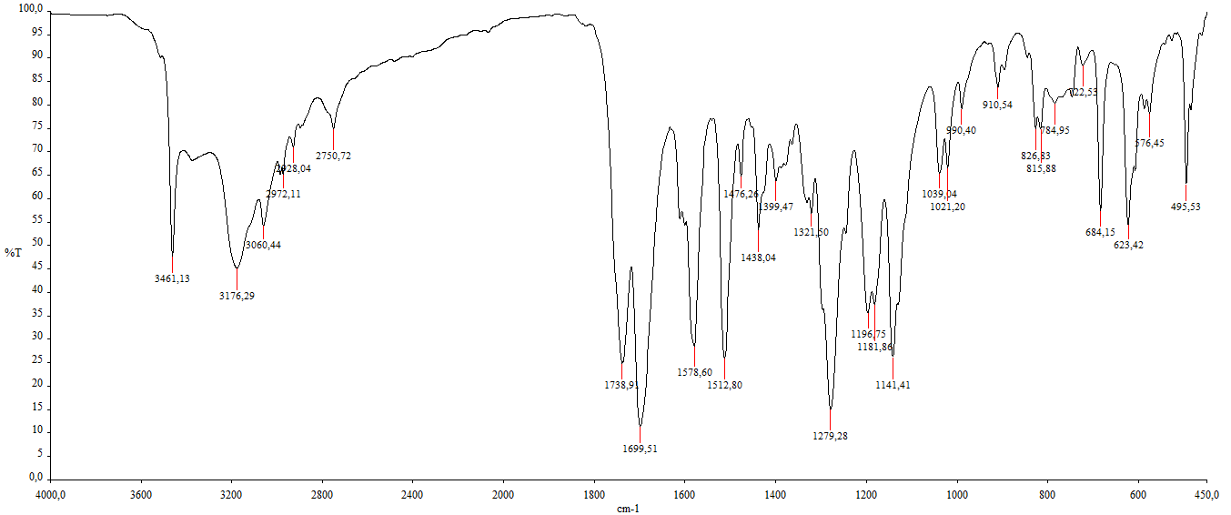
Figure S 45. FTIR of compound 7d.

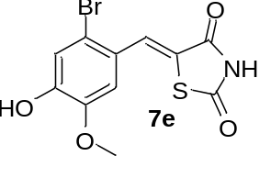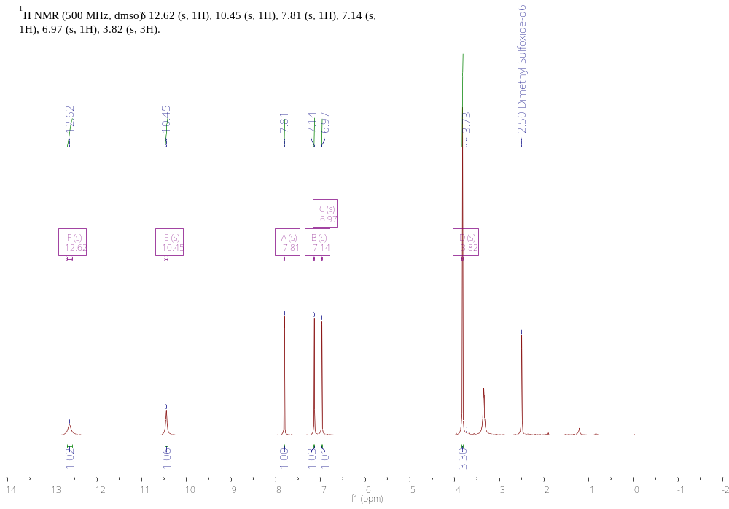
Figure S 46. ¹H-NMR spectrum of compound 7e.
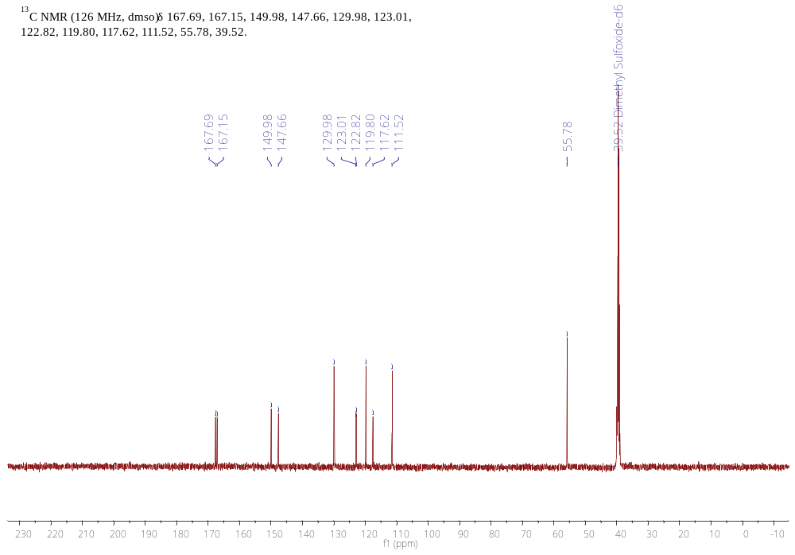
Figure S 47. ¹³C-NMR spectrum of compound 7e.
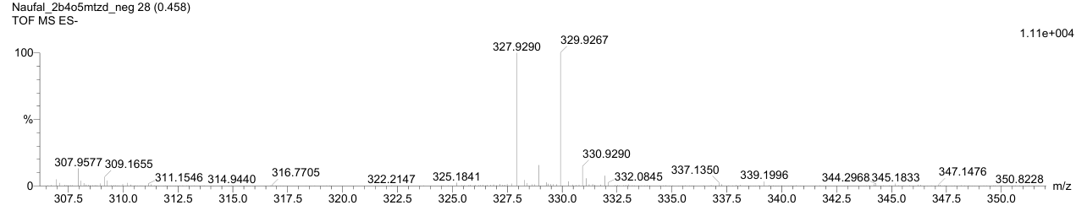
Figure S 48. Mass spectrometry of compound 7e.
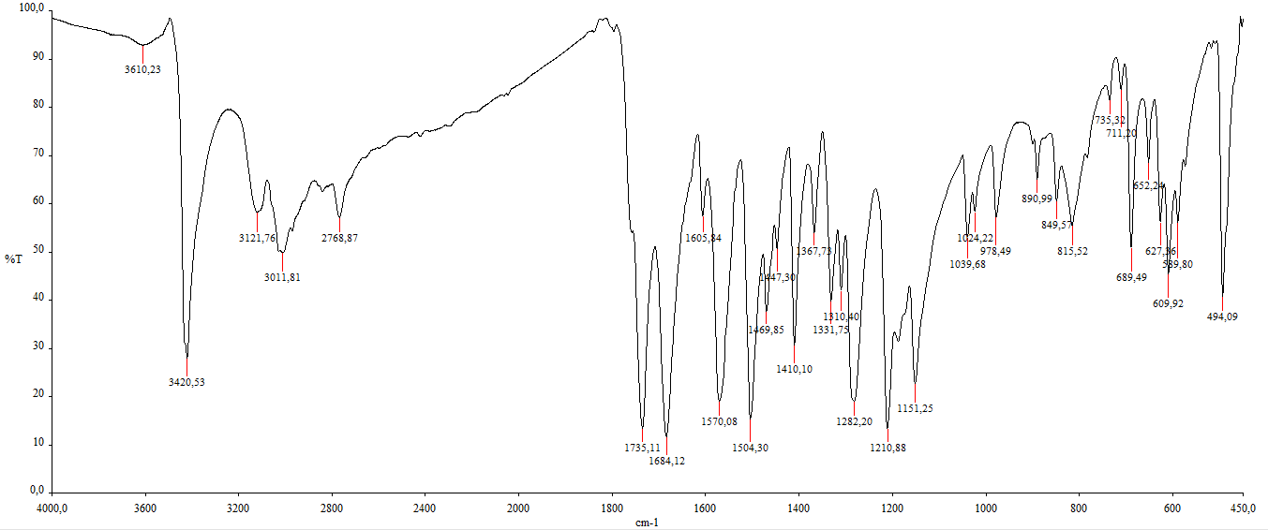
Figure S 49. FTIR of compound 7e.
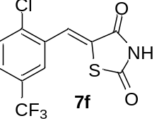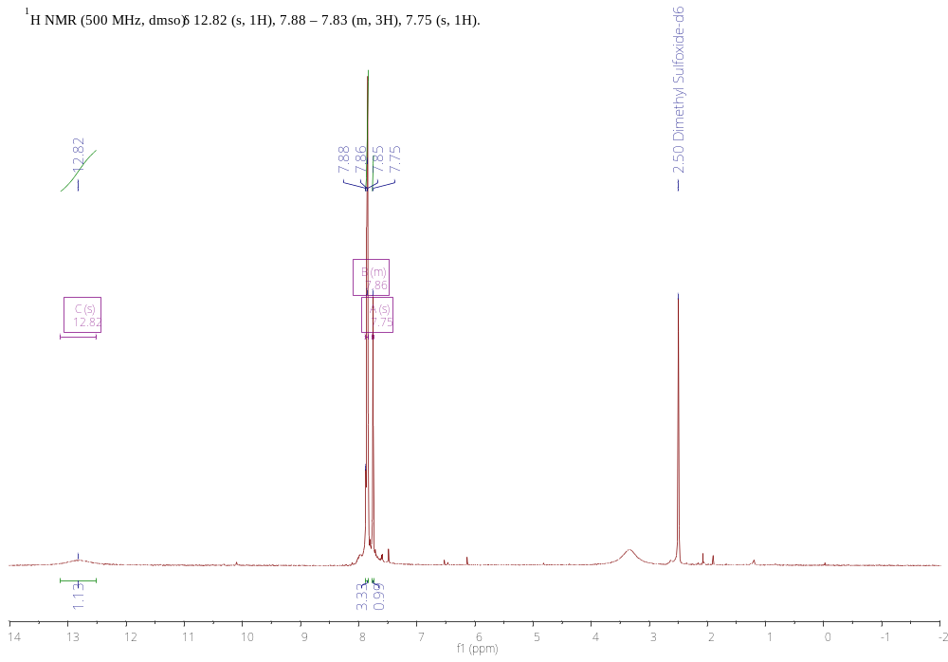
Figure S 50. ¹H-NMR spectrum of compound 7f.
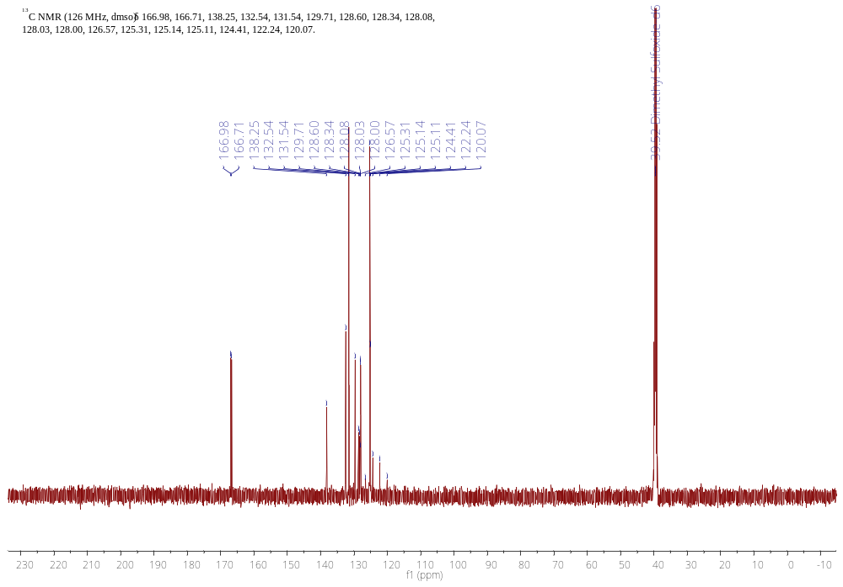
Figure S 51. ¹³C-NMR spectrum of compound 7f.
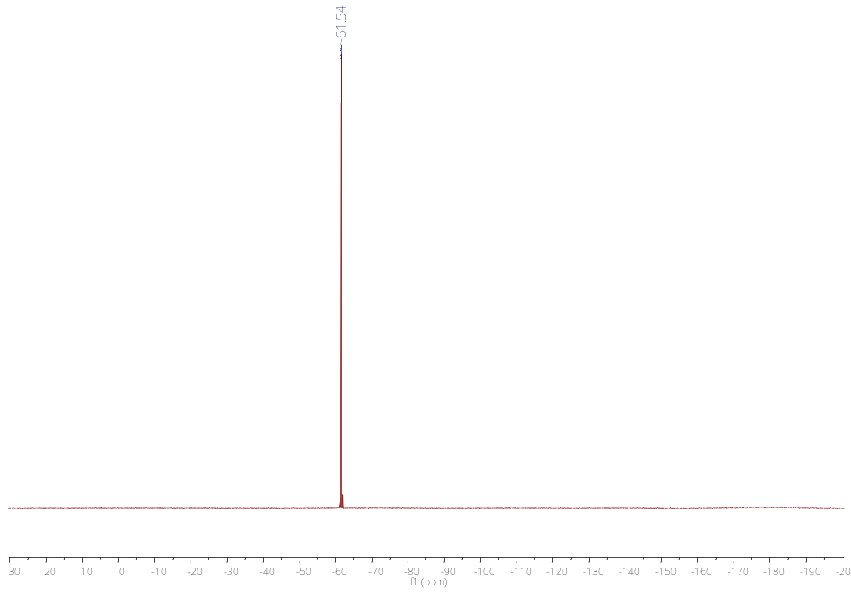
Figure S 52. ¹⁹F-NMR spectrum of compound 7f.
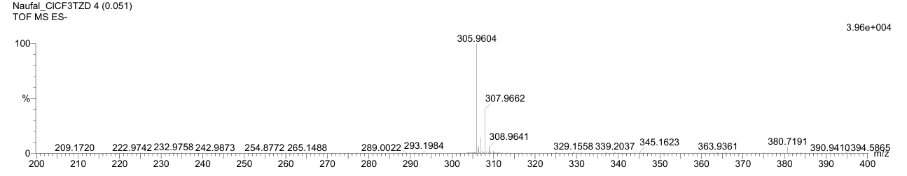
Figure S 53. Mass spectrometry of compound 7f.
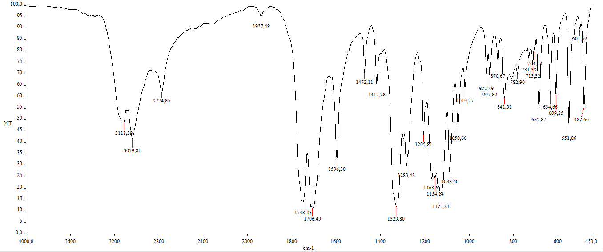
Figure S 54. FTIR of compound 7f.
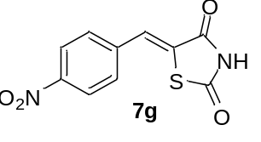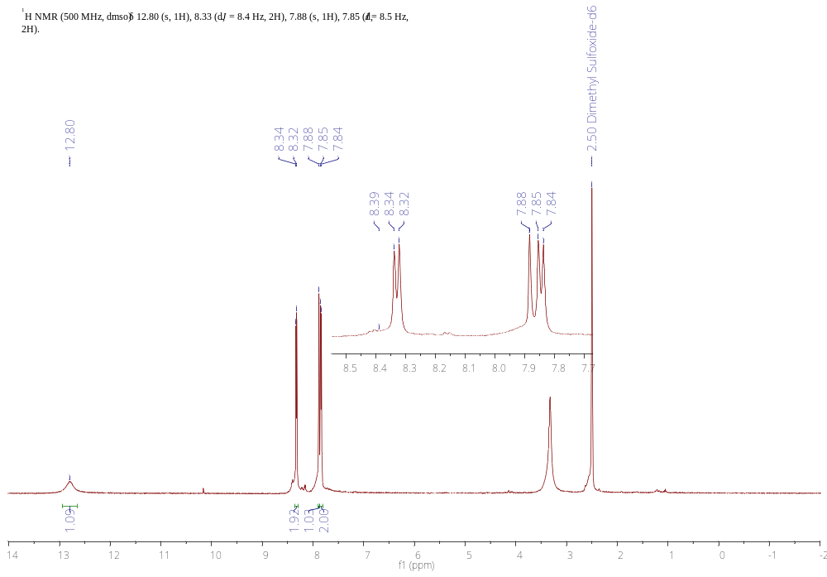
Figure S 55. ¹H-NMR spectrum of compound 7g.
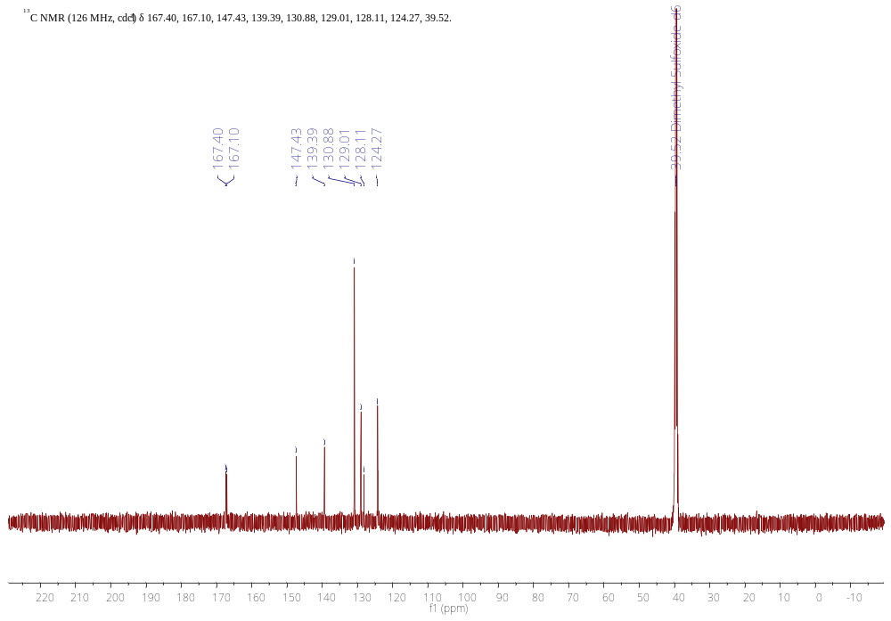
Figure S 56. ¹³C-NMR spectrum of compound 7g.
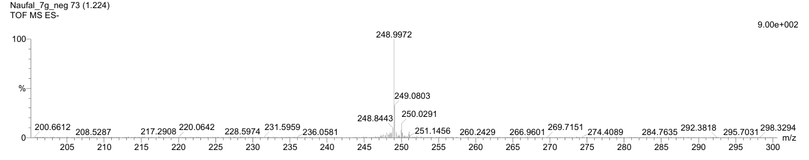
Figure S 57.Mass spectrometry of compound 7g.
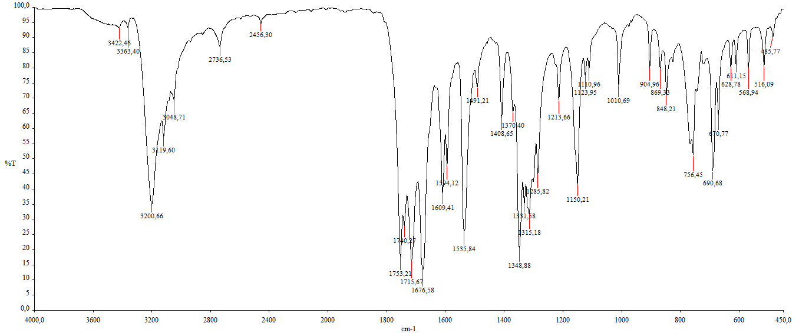
Figure S 58. FTIR of compound 7g.
SC-XRD
Table 1. Data collection and structure refinement of 3f
CCDC number
Empirical formula | C₁₁H₆ClF₃N₂O₂
Formula weight | 290.63
Temperature [K] | 107(2)
Crystal system | triclinic
Space group (number) | $P\overline{1}$ (2)
a [Å] | 7.7805(15)
b [Å] | 9.5512(17)
c [Å] | 15.554(3)
α [°] | 76.341(7)
β [°] | 89.252(7)
γ [°] | 76.119(7)
Volume [Å³] | 1089.2(4)
Z | 4
ρ_{calc} [gcm⁻³] | 1.772
μ [mm⁻¹] | 0.392
F(000) | 584
Crystal size [mm³] | 0.02×0.125×0.15
Crystal colour | colourless
Crystal shape | plate
Radiation | MoK_{α} (λ=0.71073 Å)
2θ range [°] | 4.53 to 50.05 (0.84 Å)
Index ranges | −9 ≤ h ≤ 9  −11 ≤ k ≤ 11  −18 ≤ l ≤ 18
Reflections collected | 36465
Independent reflections | 3867  R_{int} = 0.1635  R_{sigma} = 0.1088
Completeness to  θ = 25.023° | 100.0
Data / Restraints / Parameters | 3867 / 0 / 343
Goodness-of-fit on F² | 1.112
Final R indexes  [I≥2σ(I)] | R₁ = 0.0788  wR₂ = 0.1928
Final R indexes  [all data] | R₁ = 0.1088  wR₂ = 0.2084
Largest peak/hole [eÅ⁻³] | 0.41/−0.55

Table 2. Atomic coordinates and Ueq [Å²] for 3f.
Atom | x | y | z | U_{eq}
Cl1 | 0.57262(19) | 1.00013(15) | 0.11450(9) | 0.0276(4)
Cl2 | 0.08076(19) | 1.02074(16) | 0.11471(10) | 0.0272(4)
F1 | 0.6437(4) | 0.2805(4) | 0.2762(2) | 0.0313(8)
F2 | 0.7765(4) | 0.2721(4) | 0.1542(2) | 0.0294(8)
F3 | 0.9173(4) | 0.2848(4) | 0.2685(2) | 0.0315(8)
F4 | 0.2772(4) | 0.2785(4) | 0.2407(2) | 0.0320(8)
F5 | 0.4165(4) | 0.3176(4) | 0.1198(2) | 0.0312(8)
F6 | 0.1387(4) | 0.3291(4) | 0.1138(2) | 0.0292(8)
O1 | 0.6222(5) | 0.6061(4) | 0.5868(2) | 0.0264(9)
O2 | 0.2519(5) | 1.0051(4) | 0.3986(3) | 0.0290(10)
O3 | 0.1494(5) | 0.5753(4) | 0.5746(3) | 0.0285(10)
O4 | −0.2289(5) | 0.9749(4) | 0.3924(2) | 0.0275(10)
N1 | 0.5762(6) | 0.6755(5) | 0.4341(3) | 0.0223(11)
H1 | 0.652024 | 0.600422 | 0.420308 | 0.027
N2 | 0.4199(6) | 0.8212(5) | 0.5122(3) | 0.0228(11)
H2 | 0.378680 | 0.855731 | 0.558093 | 0.027
N3 | 0.1091(6) | 0.6539(5) | 0.4222(3) | 0.0246(11)
H3 | 0.189822 | 0.583265 | 0.406928 | 0.030
N4 | −0.0557(6) | 0.7913(5) | 0.5031(3) | 0.0253(11)
H4 | −0.098112 | 0.823354 | 0.549515 | 0.030
C1 | 0.4714(7) | 0.7925(6) | 0.3724(4) | 0.0207(12)
C2 | 0.5486(7) | 0.6896(6) | 0.5184(4) | 0.0220(13)
C3 | 0.3651(8) | 0.8904(6) | 0.4263(4) | 0.0234(13)
C4 | 0.4632(7) | 0.8276(6) | 0.2837(4) | 0.0217(12)
H4A | 0.384412 | 0.918868 | 0.254907 | 0.026
C5 | 0.5647(7) | 0.7380(6) | 0.2268(4) | 0.0223(12)
C6 | 0.6103(7) | 0.5823(6) | 0.2496(3) | 0.0187(12)
H6 | 0.573817 | 0.530815 | 0.303999 | 0.022
C7 | 0.7073(7) | 0.5027(6) | 0.1944(4) | 0.0217(12)
C8 | 0.7609(7) | 0.5760(6) | 0.1135(4) | 0.0231(13)
H8 | 0.827538 | 0.520704 | 0.075642 | 0.028
C9 | 0.7166(7) | 0.7278(7) | 0.0895(4) | 0.0239(13)
H9 | 0.751987 | 0.778538 | 0.034628 | 0.029
C10 | 0.6204(7) | 0.8074(6) | 0.1451(4) | 0.0232(13)
C11 | 0.7605(8) | 0.3371(7) | 0.2230(4) | 0.0264(13)
C12 | −0.0022(7) | 0.7719(6) | 0.3619(4) | 0.0206(12)
C13 | 0.0772(7) | 0.6616(6) | 0.5082(4) | 0.0228(13)
C14 | −0.1125(7) | 0.8628(6) | 0.4173(4) | 0.0244(13)
C15 | −0.0143(7) | 0.8139(7) | 0.2731(4) | 0.0231(13)
H15 | −0.100838 | 0.902781 | 0.248186 | 0.028
C16 | 0.0893(7) | 0.7400(6) | 0.2094(4) | 0.0210(12)
C17 | 0.1373(7) | 0.5864(6) | 0.2193(4) | 0.0221(12)
H17 | 0.109461 | 0.522989 | 0.271617 | 0.026
C18 | 0.2247(7) | 0.5253(6) | 0.1539(4) | 0.0234(13)
C19 | 0.2697(7) | 0.6176(6) | 0.0764(4) | 0.0233(13)
H19 | 0.331929 | 0.575425 | 0.031970 | 0.028
C20 | 0.2225(7) | 0.7694(7) | 0.0657(4) | 0.0244(13)
H20 | 0.250844 | 0.832812 | 0.013436 | 0.029
C21 | 0.1341(7) | 0.8288(6) | 0.1311(4) | 0.0221(12)
C22 | 0.2652(7) | 0.3635(7) | 0.1588(4) | 0.0258(13)

Table 3. Bond lengths and angles for 3f.
Atom–Atom | Length [Å]
Cl1–C10 | 1.737(6)
Cl2–C21 | 1.736(6)
F1–C11 | 1.344(7)
F2–C11 | 1.348(7)
F3–C11 | 1.343(6)
F4–C22 | 1.330(7)
F5–C22 | 1.344(6)
F6–C22 | 1.359(7)
O1–C2 | 1.222(7)
O2–C3 | 1.220(7)
O3–C13 | 1.205(7)
O4–C14 | 1.210(7)
N1–C2 | 1.358(7)
N1–C1 | 1.382(7)
N2–C3 | 1.366(7)
N2–C2 | 1.391(7)
N3–C13 | 1.373(7)
N3–C12 | 1.398(7)
N4–C14 | 1.372(7)
N4–C13 | 1.396(7)
C1–C4 | 1.340(8)
C1–C3 | 1.497(7)
C4–C5 | 1.467(7)
C5–C6 | 1.401(8)
C5–C10 | 1.403(8)
C6–C7 | 1.378(7)
C7–C8 | 1.399(8)
C7–C11 | 1.493(8)
C8–C9 | 1.367(8)
C9–C10 | 1.380(8)
C12–C15 | 1.341(8)
C12–C14 | 1.486(7)
C15–C16 | 1.472(7)
C16–C17 | 1.396(8)
C16–C21 | 1.402(8)
C17–C18 | 1.382(8)
C18–C19 | 1.409(8)
C18–C22 | 1.485(8)
C19–C20 | 1.378(8)
C20–C21 | 1.378(8)
Atom–Atom–Atom | Angle [°]
C2–N1–C1 | 112.3(5)
C3–N2–C2 | 111.7(4)
C13–N3–C12 | 111.7(4)
C14–N4–C13 | 112.2(4)
C4–C1–N1 | 132.2(5)
C4–C1–C3 | 123.1(5)
N1–C1–C3 | 104.6(4)
O1–C2–N1 | 127.8(5)
O1–C2–N2 | 125.8(5)
N1–C2–N2 | 106.3(5)
O2–C3–N2 | 128.1(5)
O2–C3–C1 | 126.8(5)
N2–C3–C1 | 105.1(4)
C1–C4–C5 | 126.0(5)
C6–C5–C10 | 116.6(5)
C6–C5–C4 | 123.1(5)

