Supplemental Information

Section I: Firefly Vocabulary Calculations

In the Firefly Vocabulary Algorithm developed in (Nguyen et al., 2022), a flash sequence of length $L$ is defined as a binary sequence of 1s and 0s where an instance of 1 would represent that the sequence is “on or “flashing” and 0 depicting that the sequence is “off or not flashing.” Such that:

$$\begin{aligned}{{(a}_{n})}_{n=1}^{L}, a_{n} ∈\left\{0,1\right\} \#\left(S1\right)\end{aligned}$$

The cost function which drives the creation of flash sequences in the algorithm is influenced by two features that are believed to strongly shape the influence the flash sequences fireflies use to communicate. These two features being their distinguishability to other species’ flash patterns, and predation risk (the likelihood that the flash pattern attracts unwanted attention from a predator):

$$\begin{aligned}C\left({{(a}_{n})}_{n=1}^{L}\right)=w_{s}s+w_{p}p \#\left(S2\right)\end{aligned}$$

The average similarity between the flash sequence and all other species’ sequences, $s$, and the predation risk of the flash sequence,$p,$ are affected by weights, $w_{s},$and $w_{p}$. The relative values of these weights can be augmented to adjust the ratio of average similarity influence to predation risk influence, $\frac{w_{s}}{w_{p}} ,$to reflect environmental conditions and thereby affect the features of the evolved flash sequence.

The similarity between two flash sequences, ${{(a}_{m})}_{m=1}^{L})$and ${{(a}_{n})}_{n=1}^{L}$ is expressed as the length of the longest common substring under cyclic permutation:

$$\begin{aligned}LCS\left({{(a}_{m})}_{m=1}^{L}, {{(a}_{n})}_{n=1}^{L}\right)\#\left(S3\right)\end{aligned}$$

This represents the maximal possible overlap between the sequences that accounts for all cyclical permutations since there is no guarantee that two firefly species will begin flashing at the same time or a constant offset.

$$\begin{aligned}LCS\left({{(a}_{m})}_{m=1}^{L}, {{(a}_{n})}_{n=1}^{L}\right)=\max_{0≤k≤L-1}{f({{(a}_{m})}_{m=1}^{L}}-{\left(a_{n}→a_{n+k\left(mod L\right)}\right)}_{n=1}^{L}) \#\left(S4\right)\end{aligned}$$
In the equation above, $a_{n}→a_{n+k}$ represents moving the $nth$ term of the flash sequence $k$ places to account for cyclical permutations and the function $f{(a_{n})}_{n=1}^{L}$ computes the length of the longest consecutive subsequence of zeros in the sequence. The averaged similarity value$, s$ , is found by averaging the $LCS$of all sequence pairs and normalizing by the length of the binary flash sequences so that s is a value between 0 and 1.

The predation risk, $p,$ is expressed as the fraction of bits in the “on state” of the entire sequence length that will also result in a value between 0 and 1.
$$\begin{aligned}p=\sum_{n=1}^{L}{\frac{a_{n}}{L}} \#\left(S5\right)\end{aligned}$$

Consequently, a predation risk, $p$, of 1 would indicate high predation risk and a predation risk, $p$, of 0 would indicate no predation risk. This is done as it is presumed that flashing more frequently or for longer durations is more likely to alert a predator to the flash sequence creator’s presence and location thus increasing the risk of being preyed upon.

Section II: Firefly ETI Model Pulsar Data Set & User Defined Parameters

The pulsar data that the Firefly ETI Model utilizes to generate the pulsar background is retrieved from the Australia Telescope National Facility (ATNF, version 2.8.1) pulsar database (Manchester et al., 2005) utilizing an interface developed by Pitkin (Pitkin, 2018). This interface functions as a python module called psrqpy which allows users to query the ATNF pulsar catalogue as a script instead of having to download and analyze the text tables generated by the ATNF’s web interface to access the pulsar information. The ATNF has information on 3724 pulsars, which can be filtered according to several parameters in the web interface and thus by extension by the psrqpy python module as well. For the purposes of the Firefly ETI Model, the parameters used to filter the pulsar data were the following: galactic position, the radio frequency of interest, and the minimum mean flux density of the pulsars.

To determine the appropriate pulsar background to use to generate the evolved artificial signal, the Firefly ETI Model prompts the user to enter a central location using galactic coordinates in kiloparsecs where Earth is defined at the origin (0,0,0), as well as a search area radius (in kpc). The model will then filter through the ATNF catalogue and select only the pulsars with galactic coordinates that fall within the search radius from the central location the user defined.

Pulsars emit over a large range of radio and x-ray frequencies, however differences in where within the pulsars these emissions occur, and how different frequencies are affected when travelling through the interstellar medium can affect the brightness and width of the pulses when received by our telescopes. Thus, the model will prompt the user to define the radio frequency of interest in order to focus on the pulsar characteristics at the specified frequency.

Mean flux density describes the average amount of energy per unit area per unit frequency per unit time over the duration of a pulsar’s rotation period, and as such can be used to quantify the amount of energy emitted by a pulsar or its “brightness” at specific frequencies. As such the Firefly ETI model will use the minimum mean flux density provided by the user to filter out pulsars from the ATNF database that have mean flux density’s lower than the given value and as such would be considered “too dim” at the selected search frequency.

Section III: Firefly ETI Model Parameter Space Definition & Resolution

In the Firefly ETI Model, the boundaries of the signal structure parameter space and chosen resolution affect the number and specific signal structures explored by the model as well as the structure and cost of the lowest cost artificial signal ultimately produced by the model. The parameter space boundaries are defined by the normal distribution of the periods and absolute duty cycles of the pulsar background being investigated. As such the upper limit on the period and absolute duty cycle is placed 2 standard deviations above the mean period and mean absolute duty cycle respectively, $(μ+2σ)$. Similarly, the lower limit of the period and absolute duty cycle of potential artificial signals is placed 2 standard deviations below the mean period and mean absolute duty cycle $(μ-2σ)$. The resolution provided by the user then defines the number of points between the upper and lower bounds that will be investigated as potential features of the artificial signal. In this paper, we used a resolution of 100 x 100 and thus explored 10,000 combinations of the 100 periods and 100 absolute duty cycles within the normal distribution of the pulsar background for the artificial signal structure with the lowest cost value accounting for the $w_{s}$value assigned.

The effect of the chosen resolution on the specific signal structures explored by the Firefly ETI Model is noticeable; however, these effects do not appear to significantly alter the cost or the structure of the artificial signal produced by the model. For example, changing the resolution from 50x50 to 100x100 only decreased the cost value of the produced artificial signal by approximately 0.05%, and the signal structure occupied roughly the same location in the parameter space. This makes sense as the parameter space regarding the actual structures of pulsars is not incredibly dense and as such, increasing the resolution of the investigation does not yield significantly different results.

The boundaries of this parameter space on the other hand have a pronounced effect on the signal structures explored by the Firefly ETI Model, and consequently the cost of the artificial signal produced. The Firefly ETI Model operates by searching for the artificial signal structure that has the lowest cost value and thus consequently is the most dissimilar from the pulsar background while accounting for any energy requirements as defined by $w_{s}$value. Consequently, as the boundaries of the parameter space are expanded further away from that typical of most pulsars, the signal structures that are created at these boundaries become increasingly atypical of pulsars and thus also increasingly distinct from pulsars. Identifying this, the model then produces an artificial signal with a structure towards these boundaries that are inherently atypical of the pulsar population. Thus, changing the boundaries of the parameter space can have a significant effect on the structure and cost of the artificial signal and becomes more notable as the change increases.

Section IV: Firefly ETI Model Data & Results

Using the 158 pulsars in the pulsar population within 5kpc of the Earth with mean flux densities greater than 1mJy, and a parameter space resolution of 100x100, the Firefly ETI Model produced a pulse signal that displayed evolved distinguishability from the pulsar background for each assigned $w_{s}$ value. The signal structure of the artificial signals produced when $w_{s}=0.0$, $w_{s}=0.2$, $w_{s}=0.5$, and $w_{s}=0.8$ were all identical having a period of 24.704 ms and an absolute duty cycle of 0.004. When $w_{s}=1.0$, the optimized pulse signal still had a period of 24.704 ms but instead had an absolute duty cycle of 0.368. The costs of these signals were 0.400 %, 2.139 %, 4.747%, 7.355% and 8.526% respectively.
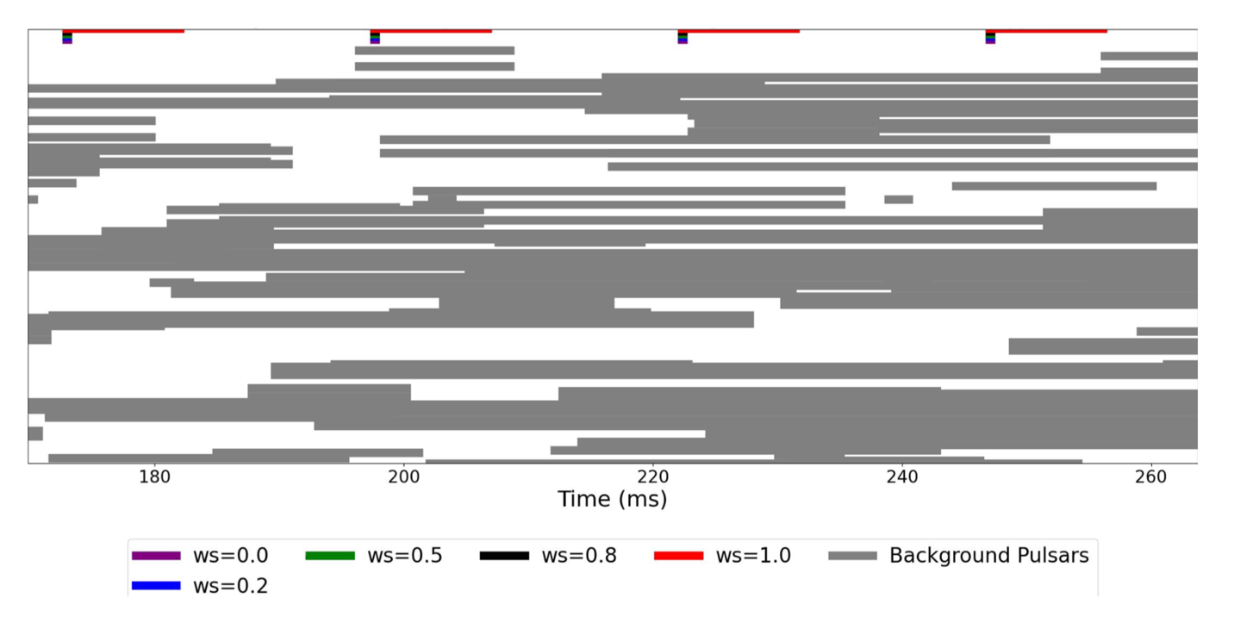Supplementary Figure 1: Visualization of artificial signals (colored) and the 158 pulsars that make up our target background (in grey). The rectangles depict the length of the absolute duty cycle of each signal. The similarity and energy weights have a large influence on the structure of the artificial signal produced, with the absolute duty cycle decreasing by a factor of 92 when $w_{s}$ decreases from 1.0 to 0.8.

When these costs were compared to the normal distribution of pulsar costs attained by applying the Firefly ETI Model’s cost function to each pulsar of the background at each $w_{s}$ value, it was discovered that at $w_{s}=0.0$ the artificial pulse signal had a cost lower than 84.30 % of background pulsar costs, at $w_{s}=0.2$ the artificial pulse signal was lower than 96.50% of the background distribution, at $w_{s}=0.5$ it was lower than 99.94% of the background, at $w_{s}=0.8$, it was less than 99.87% of background pulsar costs, and when $w_{s}=1.0$ the cost of the artificial pulse signal’s structure was less than 99.69% of the pulsar background. The reason the artificial signal structure at $w_{s}=1.0$ was not as distinguished from the background pulsar costs as the artificial signal structure under the $w_{s}=0.8$ conditions is a result of the inclusion of the two millisecond pulsars in the background. The structure of these pulsars is naturally atypical of a pulsar and as such, when energy constraints are not considered, these pulsars had costs lower than that of the artificial signal produced at $w_{s}=1.0$within the normal distribution of the pulsar background’s periods and absolute duty cycles. This affected the distribution of background pulsar costs, skewing the mean cost lower than it would have been otherwise, thus reducing the percentage of the normal distribution of costs that the artificial signal’s cost was lower than.

Section V: Sensitivity to Pulsed vs. Mean Flux Density
The primary analysis selected pulsars using their catalogued mean flux density. For a periodic source, however, mean flux density averages the received emission across both the on-pulse and off-pulse portions of the period. Pulsars with narrow pulse profiles may therefore have flux densities during the on-pulse interval that are substantially greater than their catalogued mean values. Because repeated pulses can be coherently or incoherently folded using the known pulsar period, this concentrated pulsed emission may be more relevant to practical detectability than the period-averaged value alone. We therefore conducted a sensitivity analysis in which an effective pulsed flux density was used in place of mean flux density.
For computational convenience, each pulsar was approximated as emitting a square-wave pulse with period $x$ and width $W_{50}$ (i.e., the pulse width measured at 50% of the peak intensity). The approximate duty cycle is:
$$\begin{aligned}d= \frac{W_{50}}{x} \#\left(S6\right)\end{aligned}$$
Under the square-wave approximation, the mean and pulsed flux densities are related by:
$$\begin{aligned}F_{mean}= \frac{d}{F_{pulsed}} \#\left(S7\right)\end{aligned}$$
and therefore:
$$\begin{aligned}F_{pulsed}= \frac{F_{mean}}{d}=F_{mean}\frac{W_{50}}{x} \#\left(S8\right)\end{aligned}$$
Note that the ATNF Pulsar Catalogue reports $x$ in seconds and $W_{50}$ in milliseconds.
For example, a pulsar with $\frac{W_{50}}{x}$= 0.05, corresponding to an approximate 5% duty cycle, receives a pulsed-flux boost of 20. Thus, a pulsar with a mean flux density of 0.1 mJy would have an estimated effective pulsed flux density of approximately 2 mJy under this approximation.
The quantity $F_{pulsed}$ should not be interpreted as a precise measurement of the pulsar’s pulsed peak flux density. $W_{50}$ describes the width of the observed profile at half-maximum, and real pulsar profiles may contain multiple components, asymmetric pulse shapes, and extended emission outside this interval. The approximation instead provides a consistent and computationally tractable measure of the flux concentrated within the nominal pulse window.
The Firefly ETI analysis was repeated after replacing the mean-flux-density criterion with the effective pulsed-flux-density criterion. Pulsars were retained when $F_{pulsed}$ > 1 mJy. The pulsed-flux-density values were also used when generating the corresponding pulse profiles. This procedure increased the number of pulsars in the model background from 158 in the original mean-flux-selected sample to 803 in the pulsed-flux-selected sample. This increase occurs because pulsars with mean flux densities below 1 mJy can nevertheless exceed the threshold during their comparatively narrow on-pulse intervals. The revised sample therefore represents a less conservative background with respect to periodic-source detectability.
The expanded background did not substantially alter the principal behavior of the Firefly ETI model. The optimized signal costs recovered at each value of the similarity weighting parameter $w_{s}$remained close to those obtained using the original mean-flux-selected background, and the variation in cost across $w_{s}$followed the same general trend.
All tested values below $w_{s}$= 1.0 converged on the same optimized artificial signal. The signal obtained at $w_{s}$ = 1.0 retained the same period but exhibited an absolute duty cycle approximately 104 times greater than that of the common optimum recovered for the remaining $w_{s}$ values. In the original mean-flux analysis, the corresponding factor was approximately 92.
The cost landscapes obtained at $w_{s}$= 0.0) and $w_{s}$= 1.0) were also qualitatively almost identical to those generated using the smaller mean-flux-selected background (see Supplementary Figure 2). In particular, the locations and relative structures of the principal minima were retained despite the more than fivefold increase in the number of background pulsars. These results indicate that the model’s central conclusions are robust to whether the pulsar background is selected using mean flux density or an approximate pulsed flux density. Mean-flux selection yields a smaller and more conservative background, but it does not appear to generate the observed optimization behavior artificially.

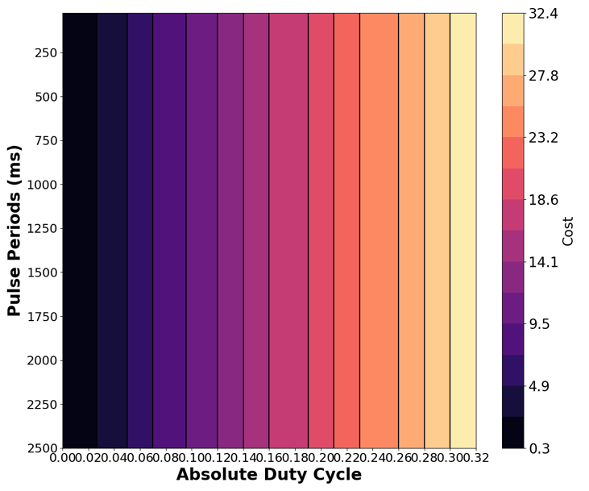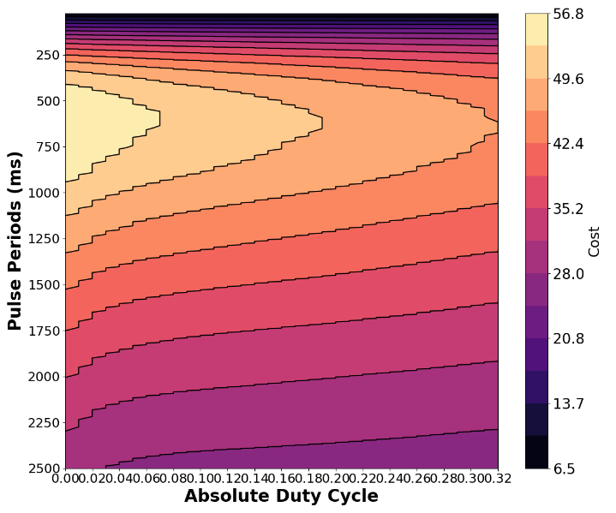
Supplementary Figure 2: Companion of Figure 4, considering pulsed flux density instead of mean flux density. Cost landscape of artificial signals defined by the period and absolute duty cycle of pulse sequences, for a similarity weight of a) $w_{s}=0.0$ (i.e. energy limitation as the sole factor)—signals with lower costs congregate around the lowest absolute duty cycle boundary, with a uniform increase in artificial cost as the absolute duty cycle increases—and b) $w_{s}=1.0$ (i.e., no energy limitations)—signals with lower costs congregate around the period boundaries. The resulting background contains 803 pulsars. The landscape retains the qualitative structure obtained using the original mean-flux-selected background.

