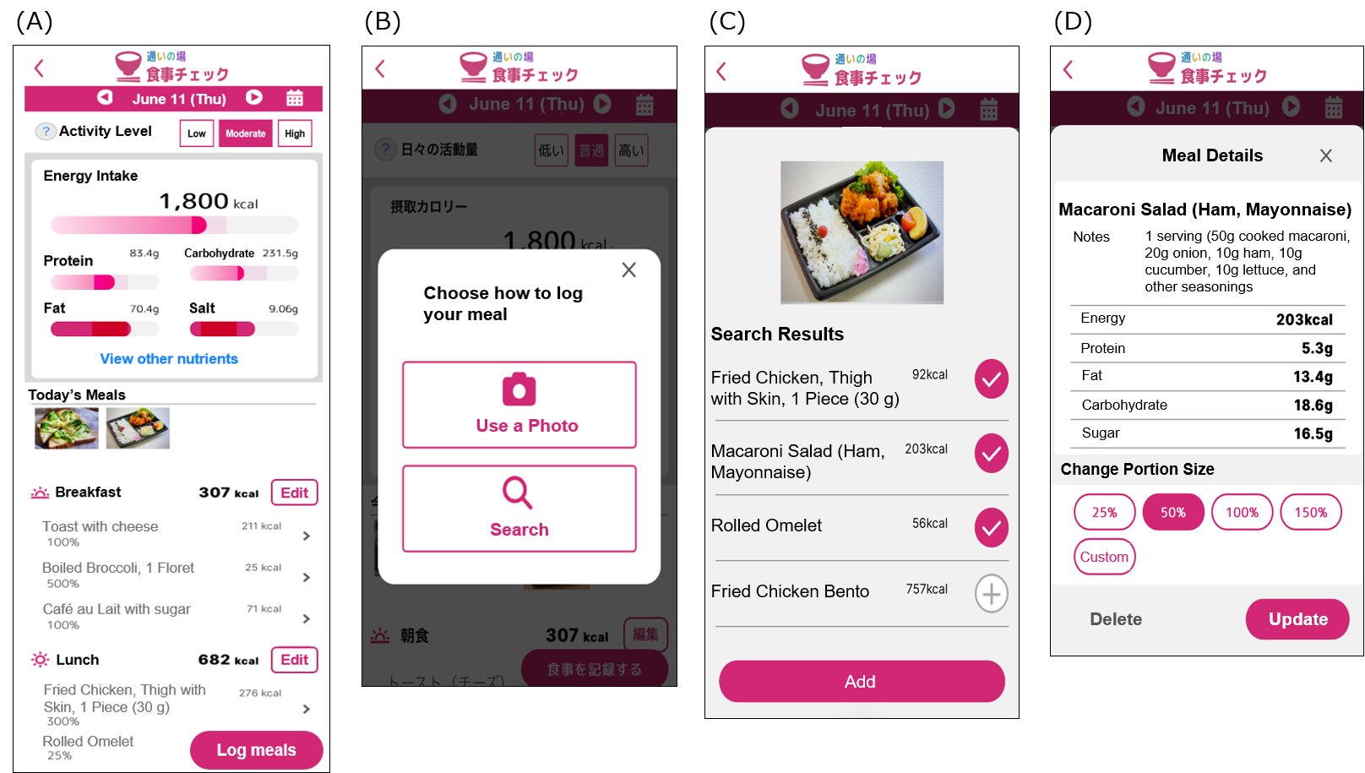
Supplementary Figure 1. User interface of the meal-check feature of the online Kayoinoba application. (A) Home screen. (B) Screen for selecting the meal-recording method, either by uploading a meal photograph or manually searching for a dish or food item. (C) Image-recognition results showing candidate dishes and food items identified from the uploaded meal photograph. Users can select appropriate items or add other candidate meals. (D) Meal-detail screen allowing users to confirm the details of the selected item, modify the portion size, or delete the selected item.

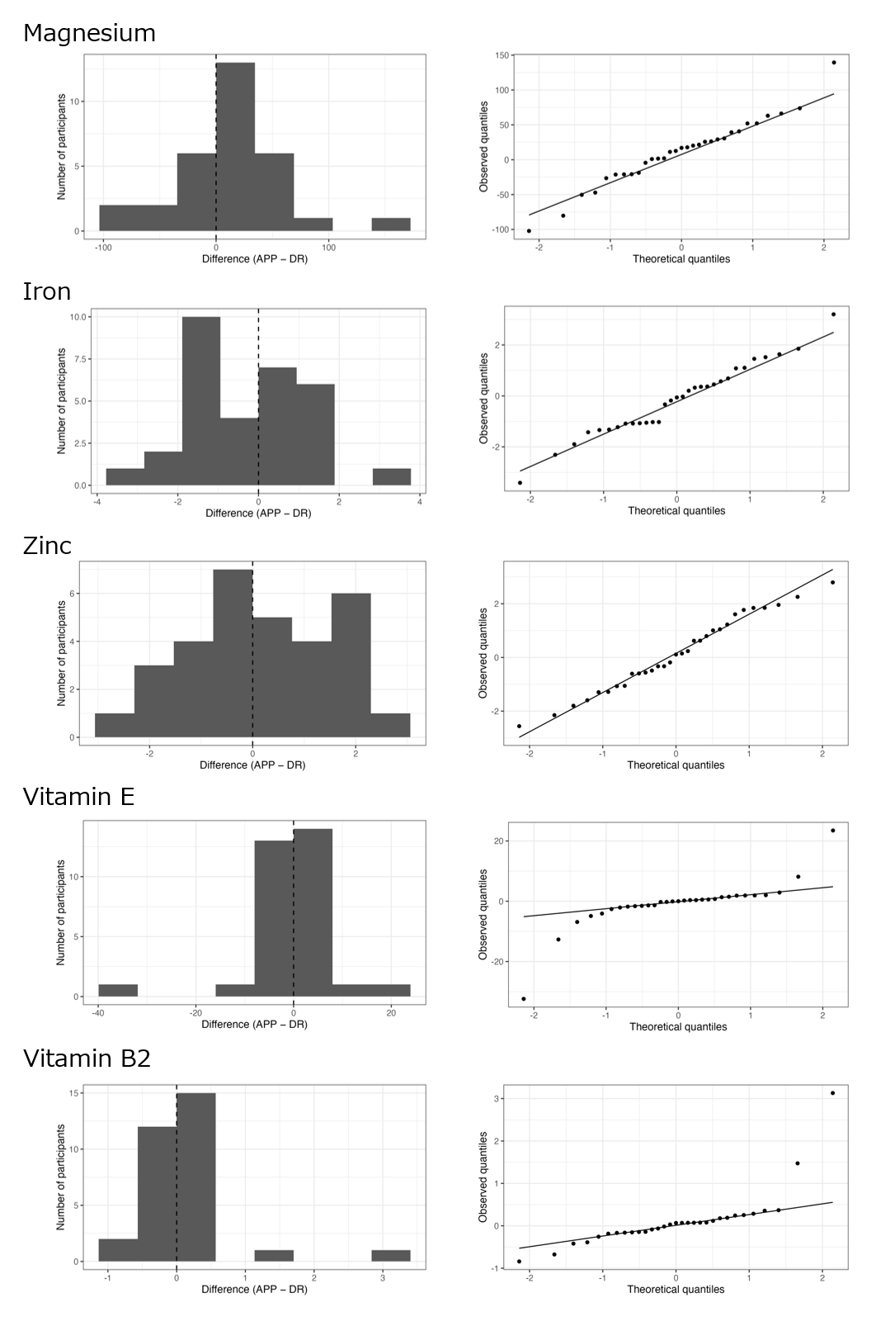
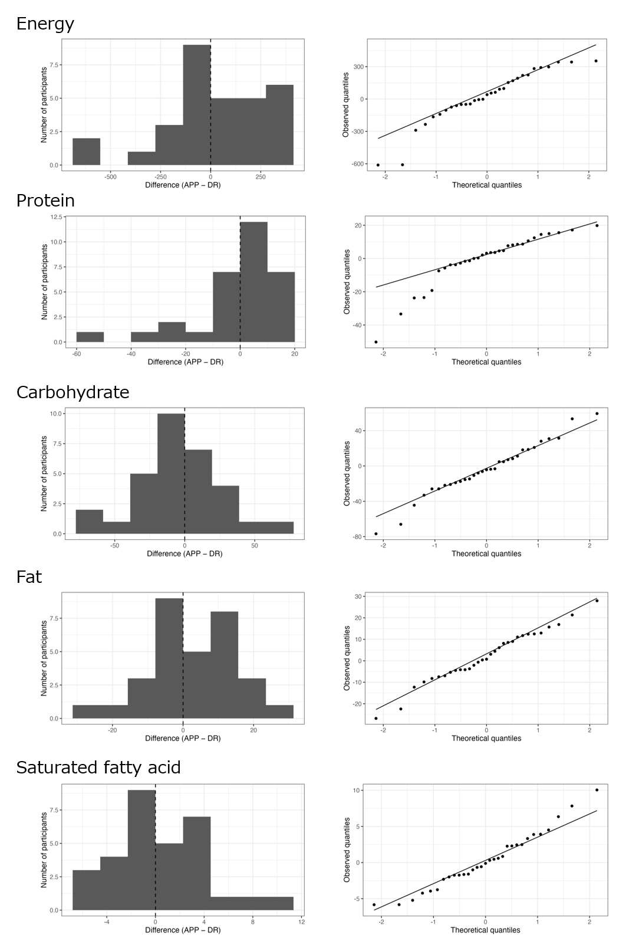
Supplementary Figure 2. Histograms and Q–Q plots of within-participant differences in nutrient intake estimates between the Meal-check feature of the Online Kayoinoba app and the reference method (weighed dietary record).

