Repeatability and behavioral relationships of acuity, contrast sensitivity, form, and motion perception measurements using a novel tablet-based vision test tool
Jonathan Green ¹, Jan Skerswetat *^{2,3}, Peter J. Bex ³, Gunnar Schmidtmann ¹

¹School of Health Professions, University of Plymouth, Plymouth, United Kingdom
²Department of Ophthalmology and Vision Sciences, University of California, 850 Health Sciences Road, Irvine, California, 9269, United States of America
³Department of Psychology, Northeastern University, 360 Huntington Ave, Boston, Massachusetts, 02115, United States of America

*Corresponding author
Emails: jon.green@plymouth.ac.uk, jskerswe@hs.uci.edu, p.bex@northeastern.edu, gunnar.schmidtmann@plymouth.ac.uk
Jonathan Green: https://orcid.org/0000-0001-5738-7515
Jan Skerswetat: https://orcid.org/0000-0002-2470-8404
Peter J. Bex: https://orcid.org/0000-0001-7561-7695
Gunnar Schmidtmann: https://orcid.org/0000-0001-8180-7751

Supplementary Appendix
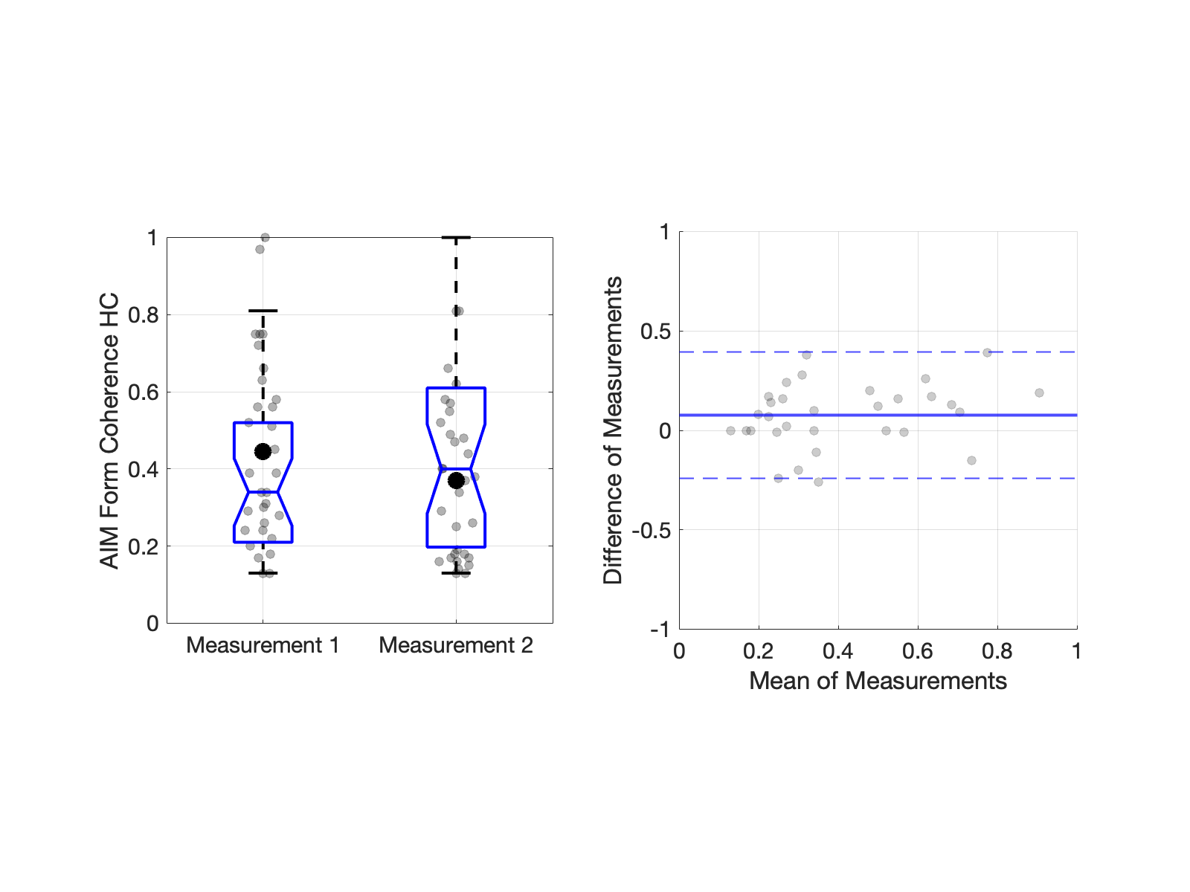
Figure A1. Left: Example data showing Box and Whisker plots with individual data (grey data points) and the mean (black solid data point) for the AIM Form Coherence test (coherence thresholds are expressed in %, 0-1). Right: Bland-Altman plots for AIM Form Coherence. Figures for all tests can be found in the Supplementary Material (Bland_Altman_plots.pdf).

Comparison between horizontal, expanding and circular form and motion
The results from the AIM and FInD Form and Motion tests have implications regarding the visual processing of global texture and motion. There is ample psychophysical and physiological evidence for the hypothesis that the representation of objects and shapes is achieved by a hierarchical feedforward process along the ventral pathway, e.g., [52-55]. A key question in vision science is how local information detected in the early visual areas (primary visual cortex) is integrated to represent more complex, behaviorally relevant stimuli (e.g., faces, objects) at subsequent stages. Psychophysically, this has been tested in different ways. One approach, also employed in the Form and Motion tests, is to determine the minimum number of signal elements required to detect the presence of a global pattern embedded in an array of noise elements (coherence thresholds). This measurement of coherence thresholds has been used in many studies of motion [57-58], texture [58-61], and contour perception [56, 59, 62-63]. Coherence thresholds in Glass patterns [42-43] have been employed to investigate signal integration in texture perception [58, 60-61, 64-65]. Models of Glass pattern detection propose a two-stage process, in which the first stage extracts local orientation information while the second stage integrates the orientation information in order to extract the global structure [60-61], see Schmidtmann et al. [59] for a revised model). This model is supported by physiological data showing that neither the classical receptive fields nor surround mechanisms in early visual areas (V1, V2) are sufficient to process the Glass patterns [66-67]. Some previous psychophysical studies found no difference in sensitivities for detecting circular and radial structure, e.g., see [59-60, 68-72], while others reported a significantly increased sensitivity of human observers for circular, followed by radial, spiral, and parallel structure [50, 59-60, 69, 71], suggesting that the global structure in Glass patterns is processed by specialized detectors for circular and radial textures. However, there is also contradictory evidence. For instance, Dakin and Bex [58] found that the advantage for circular Glass patterns was only evident if the stimulus was presented within a circular window as opposed to a square window. Similarly, Schmidtmann et al. [59] were not able to replicate the above mentioned hierarchy. Their results showed that detection sensitivity was independent of texture type; hence, no evidence for specialized detectors for circular structure.
The results presented here also do not show the clear sensitivity hierarchy (i.e., circular > expanding > horizontal) described above. Figure A2 shows Box and Whisker plots comparing coherence thresholds achieved for horizontal, expanding and circular structure for the FInD Form, FInD Form HC, FInD Motion, and FInD Motion HC tests. Following Shapiro-Wilk tests for normality, which showed that some of the conditions were not normally distributed, the data were analyzed using a non-parametric Friedman ANOVA (Durbin-Conover) across all conditions. This analysis revealed a statistically significant global effect (𝝌²(119) = 11, p<.001). Subsequent pairwise comparisons (Bonferroni-corrected for multiple comparisons) showed that for the FInD Form paradigms, sensitivity was largely independent of texture type, except for a statistically significant increase in thresholds (i.e. decrease in sensitivity) between FInD Form HC horizontal and FInD Form HC circular. In general, performance for the FInD Motion paradigms was slightly (sometimes significantly better; see Table A1) compared to the static FInD Form stimuli. Results show that sensitivity for FInD Motion horizontal and FInD Motion expanding stimuli was significantly lower compared to FInD Motion circular. Finally, sensitivity for FInD Motion HC expanding was significantly lower compared to FInD Motion HC circular and FInD Motion HC horizontal. No superior performance for circular motion is evident.
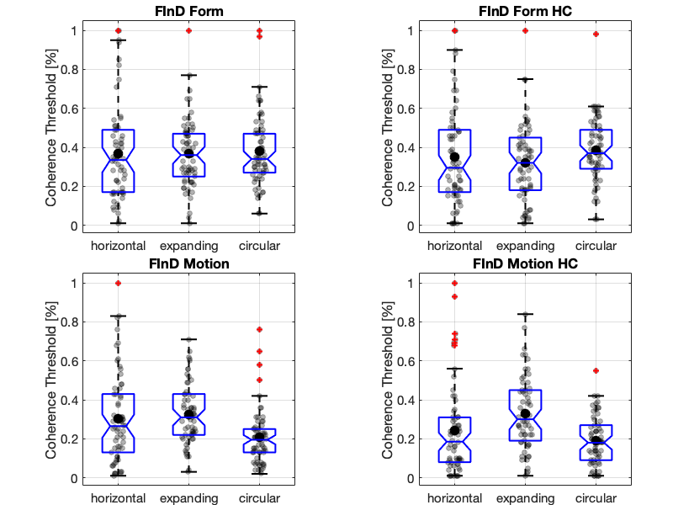
Figure A2. Box and Whisker plots with individual data (grey data points) and the mean (black solid data point) for the FInD Form (top left), FInD Form HC (top right), FInD Motion (bottom left) and FInD Motion HC (bottom right) tests (coherence thresholds are expressed in %, 0-1). The outliers (red diamonds) with coherence thresholds of ~1 (~100%) were from two subjects who could not do the task, independent of global structure.
Table A1. Non-parametric Friedman ANOVA pairwise comparison (Durbin-Conover). Statistically significant conditions are indicated by *.
Pairwise Comparisons (Durbin-Conover) |  | Statistic | p
FInD Form circ | FInD Motion HC circ | 7.0448 | < .001*
FInD Form HC hori | FInD Form HC exp | 0.218 | 0.827
FInD Form HC hori | FInD Form HC circ | 2.8615 | 0.004*
FInD Form HC hori | FInD Motion hori | 0.1635 | 0.87
FInD Form HC hori | FInD Motion exp | 1.022 | 0.307
FInD Form HC hori | FInD Motion circ | 4.2923 | < .001*
FInD Form HC hori | FInD Motion HC hori | 3.2431 | 0.001*
FInD Form HC hori | FInD Motion HC exp | 1.4308 | 0.153
FInD Form HC hori | FInD Motion HC circ | 4.5784 | < .001*
FInD Form HC exp | FInD Form HC circ | 2.6435 | 0.008*
FInD Form HC exp | FInD Motion hori | 0.3815 | 0.703
FInD Form HC exp | FInD Motion exp | 0.804 | 0.422
FInD Form HC exp | FInD Motion circ | 4.5103 | < .001*
FInD Form HC exp | FInD Motion HC hori | 3.4611 | < .001*
FInD Form HC exp | FInD Motion HC exp | 1.2127 | 0.226
FInD Form HC exp | FInD Motion HC circ | 4.7965 | < .001*
FInD Form HC circ | FInD Motion hori | 3.025 | 0.003*
FInD Form HC circ | FInD Motion exp | 1.8396 | 0.066
FInD Form HC circ | FInD Motion circ | 7.1538 | < .001*
FInD Form HC circ | FInD Motion HC hori | 6.1046 | < .001*
FInD Form HC circ | FInD Motion HC exp | 1.4308 | 0.153
FInD Form HC circ | FInD Motion HC circ | 7.44 | < .001*
FInD Motion hori | FInD Motion exp | 1.1855 | 0.236
FInD Motion hori | FInD Motion circ | 4.1288 | < .001*
FInD Motion hori | FInD Motion HC hori | 3.0795 | 0.002*
FInD Motion hori | FInD Motion HC exp | 1.5943 | 0.111
FInD Motion hori | FInD Motion HC circ | 4.4149 | < .001*
FInD Motion exp | FInD Motion circ | 5.3143 | < .001*
FInD Motion exp | FInD Motion HC hori | 4.265 | < .001*
FInD Motion exp | FInD Motion HC exp | 0.4088 | 0.683
FInD Motion exp | FInD Motion HC circ | 5.6004 | < .001*
FInD Motion circ | FInD Motion HC hori | 1.0492 | 0.294
FInD Motion circ | FInD Motion HC exp | 5.7231 | < .001*
FInD Motion circ | FInD Motion HC circ | 0.2862 | 0.775
FInD Motion HC hori | FInD Motion HC exp | 4.6738 | < .001*
FInD Motion HC hori | FInD Motion HC circ | 1.3354 | 0.182
FInD Motion HC exp | FInD Motion HC circ | 6.0092 | < .001*
Table A2. Test-retest results for slope values.
Slopes | Test (m₁)  Mean ±𝜎 | Retest (m₂)  Mean ±𝜎 | SEM | CoR | Mean Bias | Mean Bias p
AIM-VA | 0.12 ±0.12 | 0.12 ±0.13 | 0.13 | 0.35 | -0.01 | p=.8694
AIM CSF+ (3 charts) | 0.34 ±0.11 | 0.26 ±0.14 | 0.12 | 0.33 | 0.08 | p=.0169*
AIM-Form Coh. | 0.20 ±0.15 | 0.17 ±0.13 | 0.13 | 0.35 | 0.03 | p=.3597
AIM-Form Coh. HC | 0.23 ±0.18 | 0.21 ±0.17 | 0.14 | 0.40 | 0.01 | p=.6926
AIM-Motion Coh. | 0.16 ±0.16 | 0.12 ±0.11 | 0.12 | 0.33 | 0.04 | p=.2310
AIM-Motion Coh. HC | 0.16 ±0.13 | 0.14 ±0.12 | 0.13 | 0.35 | 0.02 | p=.4814
FInD-Form Coh. - Horizontal | 1.94 ±1.32 | 1.82 ±1.33 | 1.36 | 3.77 | 0.12 | p=.7282
FInD-Form Coh. - Expanding | 2.65 ±1.32 | 2.28 ±1.28 | 1.10 | 3.04 | 0.37 | p=.1975
FInD-Form Coh. - Circular | 2.63 ±1.22 | 2.16 ±1.22 | 0.92 | 2.54 | 0.47 | p=.0520
FInD-Form Coh. - Horizontal HC | 1.99 ±1.14 | 1.71 ±1.29 | 1.40 | 3.89 | 0.28 | p=.4380
FInD-Form Coh. - Expanding HC | 2.31 ±1.41 | 1.88 ±1.34 | 1.31 | 3.63 | 0.43 | p=.2064
FInD-Form Coh. - Circular HC | 2.55 ±1.24 | 2.79 ±1.35 | 1.30 | 3.61 | -0.24 | p=.4704
FInD-Motion Coh. - Horizontal | 2.34 ±1..49 | 2.55 ±1.47 | 1.38 | 3.83 | -0.20 | p=.5656
FInD-Motion Coh. - Expanding | 2.55 ±1.24 | 3.03 ±1.13 | 1.14 | 3.16 | -0.49 | p=.1033
FInD-Motion Coh. - Circular | 2.27 ±1.40 | 2.48 ±1.21 | 1.37 | 3.80 | -0.22 | p=.5349
FInD-Motion Coh. - Horizontal HC | 1.95 ±1.33 | 2.14 ±1.39 | 1.48 | 4.11 | -0.19 | p=.6260
FInD-Motion Coh. - Expanding HC | 2.84 ±1.15 | 2.78 ±1.43 | 1.14 | 3.15 | 0.06 | p=.8306
FInD-Motion Coh. - Circular HC | 2.61 ±1.29 | 2.53 ±1.34 | 1.09 | 3.02 | 0.08 | p=.7628

Table A3. Test-retest results for minimum report error values.
Errors [°] | Test (m₁)  Mean ±𝜎 | Retest (m₂)  Mean ±𝜎 | SEM | CoR | Mean Bias | Mean  Bias p
AIM-VA | 12.05 ±5.77 | 11.43 ±5.65 | 5.7 | 15.70 | 0.62 | p=.6695
AIM CSF+ | 8.32 ±3.14 | 8.41 ±3.01 | 2.5 | 7.04 | -0.09 | p=.8900
AIM-Form Coh. | 10.10 ±6.74 | 12.36 ±7.58 | 5.9 | 16.40 | -2.26 | p=.1430
AIM-Form Coh. HC | 9.41 ±7.87 | 11.14 ±8.89 | 7.1 | 19.50 | -1.73 | p=.3410
AIM-Motion Coh. | 15.94 ±15.71 | 15.40 ±15.80 | 12.2 | 33.8 | 0.54 | p=.8631
AIM-Motion Coh. HC | 16.29 ±13.39 | 13.25 ±15.78 | 13.7 | 38.0 | 3.04 | p=.3894

Declared Health Conditions and Screening for traits indicative of Autism and Attention Deficit Hyperactivity Disorder (ADHD)

This study of test repeatability in an undifferentiated population of adults who self-declared as having normal, or corrected to normal, vision. Therefore, self-declaration of medical history or evidence of neurodivergent traits, which may or may not be associated with deficits of visual function, are highly unlikely to affect our analysis. However, in future work, we aim to investigate whether performance is affected by autism, attention deficit hyperactivity disorder (ADHD) or other health conditions.
Participants were screened for traits indicative of some neurodivergent conditions that may affect vision by completing the Adult ADHD Self-Report Scale (ASRS) [72] and the Autism-Spectrum Quotient (AQ) [73] questionnaires (see Table A4 caption for details). The scores of one participant were highly indicative of both conditions. We subsequently calculated Pearson’s linear correlation coefficients between all tests and the ASRS and AQ scores. The correlation plots, including the correlation coefficients and p-values for all tests, can be found in Figure 3 of the Supplementary Material (ASRS_AQ_correlations.pdf). None of these correlations was significant in our sample.
Participants also provided information regarding their medical history. Three participants reported a history of hemiplegic migraine or concussion. By definition, these conditions induce neurological impairments which are reversible. Subcategories of sufferers may have some residual impairment and no identifiable physical correlates, but they are a small minority [74]. We therefore believe that the likelihood of the test performance of these participants being affected by these aspects of their medical history is low. One participant reported anxiety, emotional dysregulation, and depression, and another had a diagnosis of dyslexia. None of these conditions was considered sufficient grounds for exclusion, and their frequencies were less than or similar to those found in the wider population [73-76]. Reported ocular conditions (e.g., myopia, astigmatism) did not affect participant eligibility, as all tests were conducted with appropriate visual correction. Likewise, reported colour vision deficiencies were not considered exclusionary, since none of the tasks involved coloured stimuli.
Table A4. Self-reported participant demographic and medical details. Ethnicity: White (UK, Irish) includes English, Welsh, Scottish, Irish, British. Sex: f = female; m = male. ADHD & Autism Thresholds: Adler's Adult ADHD Self-Report Scale (ASRS-v1.1). Part A (screener) ≥ 4 grey boxes = highly consistent with ADHD; Baron-Cohen's Autism Spectrum Quotient (AQ): ≥32 = Clinically significant (80% of those diagnosed with autism, but <2% of controls), ≥ 26 = Potential traits.

ID | Age | Ethnicity | Sex | Medical history | Ocular conditions | ASRS | AQ
1 | 48 | White (UK, Irish) | m |  | Myopia | 0 | 20
2 | 44 | White (UK, Irish) | m |  |  | 0 | 14
3 | 48 | White (UK, Irish) | m | Hemiplegic migraine | Astigmatism | 1 | 23
4 | 22 | Black | m |  |  | 0 | 11
5 | 44 | White (UK, Irish) | f |  |  | 0 | 7
6 | 35 | White (UK, Irish) | f |  |  | 2 | 15
7 | 42 | White (UK, Irish) | m | Concussion |  | 1 | 18
8 | 49 | White (UK, Irish) | m |  |  | 0 | 23
9 | 39 | White (UK, Irish) | m |  |  | 0 | 11
10 | 29 | White (UK, Irish) | f | Anxiety, Emotional dysregulation, Depression |  | 3 | 10
11 | 28 | White (UK, Irish) | m |  |  | 2 | 22
12 | 23 | Asian | m |  | Color-Vision-Defect | 0 | 12
13 | 20 | Black | f |  |  | 0 | 17
14 | 28 | White (UK, Irish) | f |  |  | 2 | 10
15 | 28 | White (UK, Irish) | m |  |  | 5 | 39
16 | 48 | White (UK, Irish) | m |  |  | 2 | 21
17 | 26 | Asian | m |  |  | 2 | 25
18 | 32 | White (UK, Irish) | m | Concussion |  | 3 | 28
19 | 29 | White (UK, Irish) | m | Concussion |  | 2 | 21
20 | 19 | White (UK, Irish) | f |  |  | 2 | 12
21 | 57 | White (UK, Irish) | f |  |  | 0 | 11
22 | 54 | White (any other) | f |  |  | 0 | 10
23 | 48 | White (UK, Irish) | f | Dyslexia |  | 2 | 14
24 | 43 | White (UK, Irish) | m |  |  | 2 | 20
25 | 58 | White (UK, Irish) | f |  |  | 1 | 15
26 | 35 | White (UK, Irish) | m |  |  | 0 | 8
27 | 50 | White (UK, Irish) | f |  | Astigmatism | 0 | 15
28 | 55 | White (UK, Irish) | f |  |  | 2 | 24
29 | 46 | White other) | m |  |  | 0 | 13
30 | 51 | White (UK, Irish) | f |  |  | 0 | 10
31 | 40 | mixed | m |  |  | 0 | 30

Functional relationship between psychometric outcomes

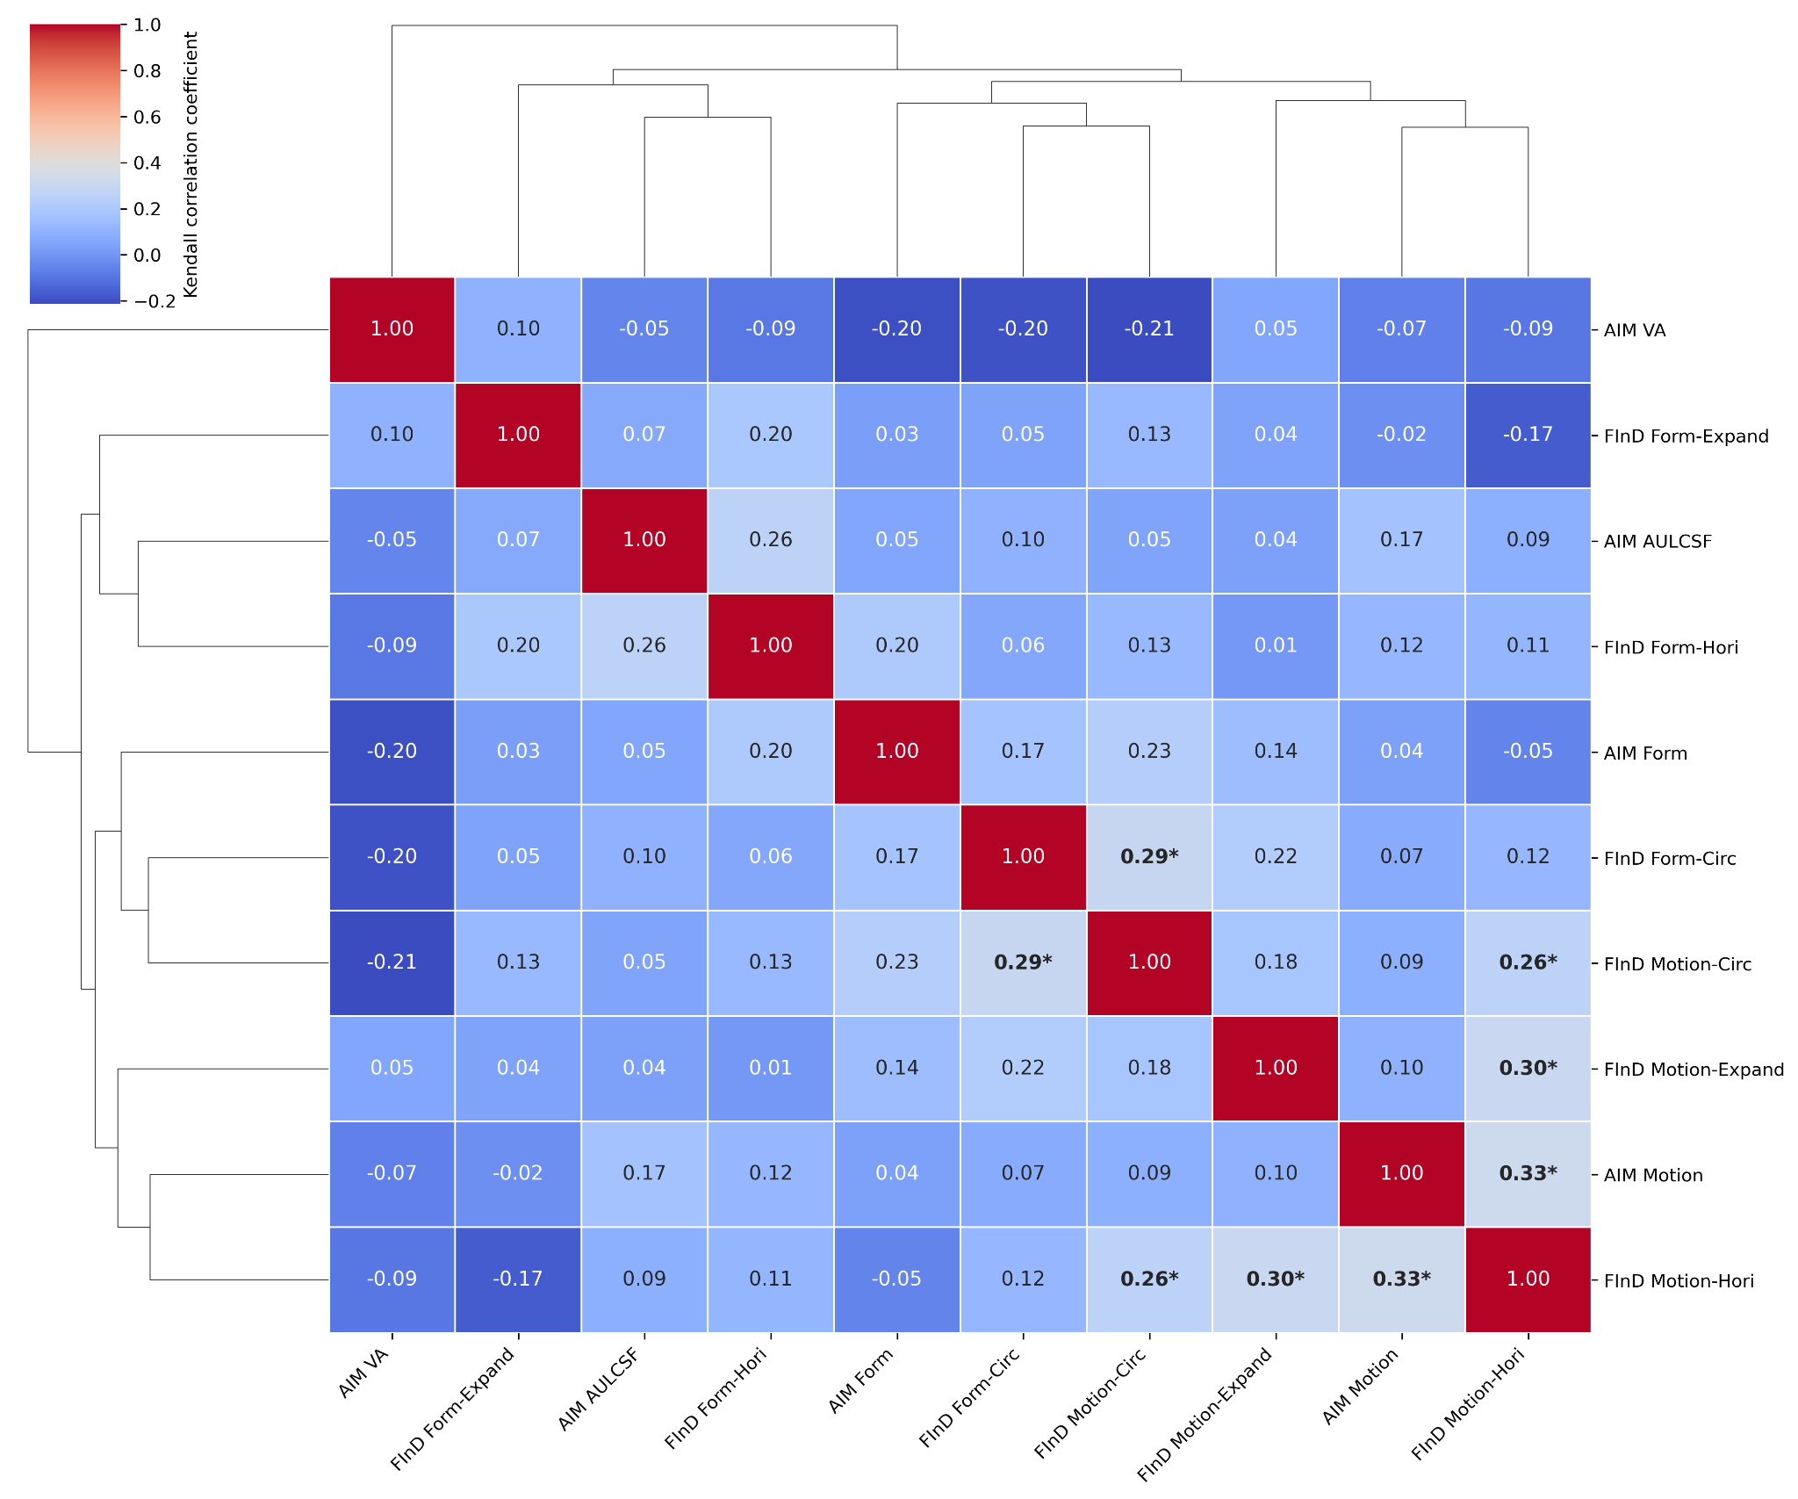
Figure A3: Uncorrected Kendall correlation matrix and hierarchical cluster analysis using Ward's minimum variance linkage. Asterisks indicate correlations significant at p<0.05, uncorrected for multiple comparisons.

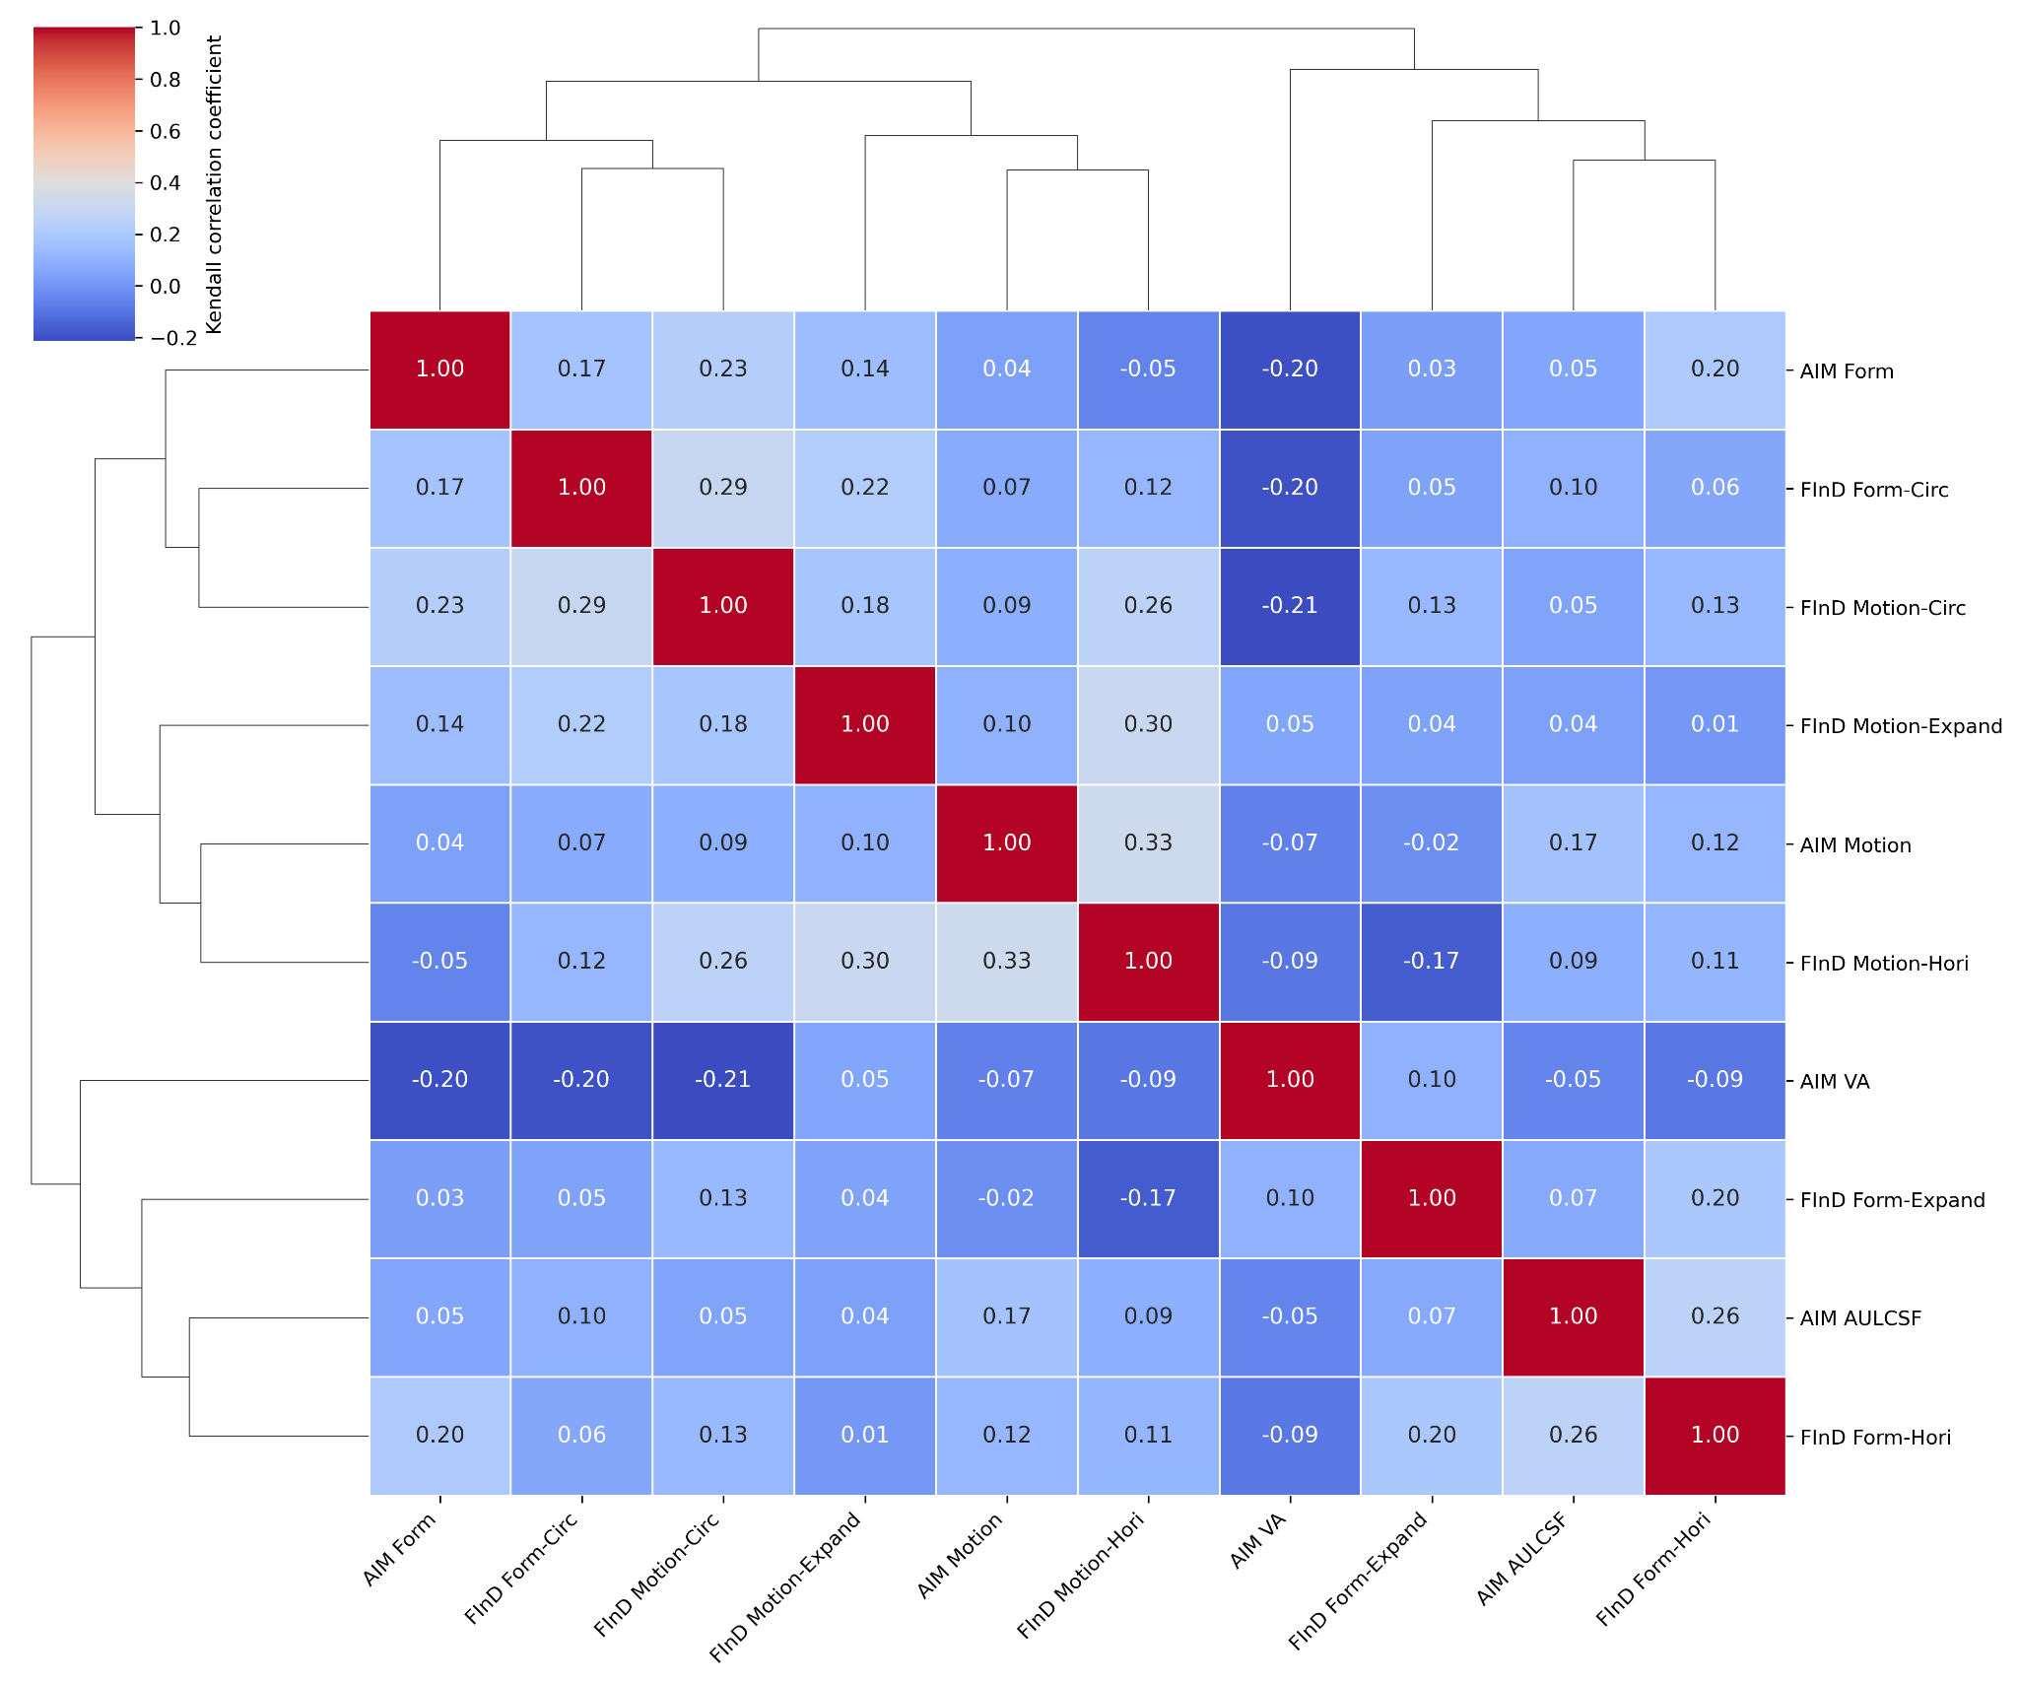
Figure A4: Kendall correlation matrix and hierarchical cluster analysis using Ward's minimum variance linkage, with p-values corrected for multiple comparisons using the Benjamini-Hochberg false discovery rate procedure.
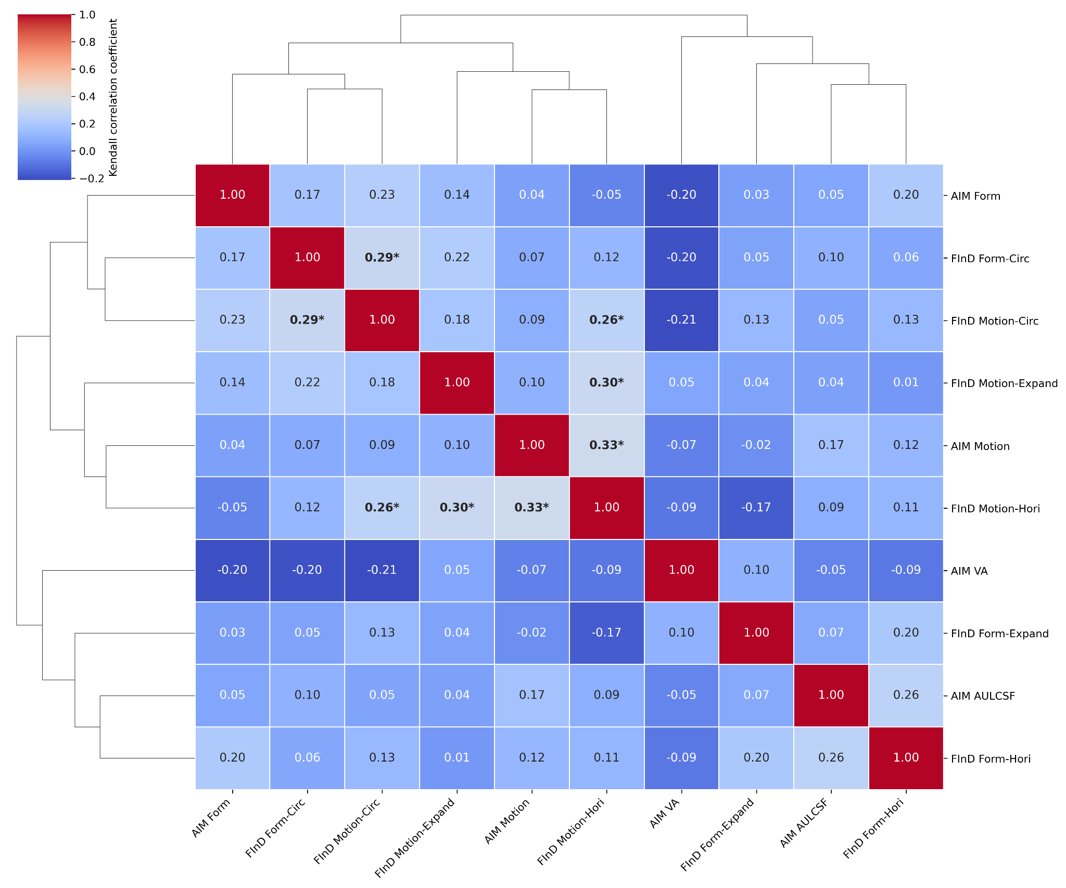
Figure A5: Uncorrected Kendall correlation matrix and hierarchical cluster analysis using average linkage. Asterisks indicate correlations significant at p<0.05, uncorrected for multiple comparisons.

Supplementary Appendix References
52. Cadieu, C. et al. A model of V4 shape selectivity and invariance. J. Neurophysiol. 98 (3), 1733-1750, DOI: https://doi.org/10.1152/jn.01265.2006 (2007).
53. Serre, T. et al. A theory of object recognition: computations and circuits in the feedforward path of the ventral stream in primate visual cortex. CSAIL Technical Report at: http://hdl.handle.net/1721.1/36407 (2005).
54. Serre, T., Oliva, A. & Poggio, T. A feedforward architecture accounts for rapid categorization. Proc. Natl. Acad. Sci. U.S.A. 104 (15), 6424-6429, DOI: https://doi.org/10.1073/pnas.0700622104 (2007).
55. Van Essen, D. C., Anderson, C. H. & Felleman, D. J. Information processing in the primate visual system: An integrated systems perspective. Science 255, 419-423, DOI: https://doi.org/10.1126/science.1734518 (1992).
56. Braddick, O. J., O’Brien, J. M., Wattam-Bell, J., Atkinson, J. & Turner, R. Form and motion coherence activate independent, but not dorsal/ventral segregated, networks in the human brain. Curr. Biol. 10, 731-734, DOI: https://doi.org/10.1016/s0960-9822(00)00540-6 (2000).
57. Newsome, W. T. & Pare, E. B. A selective impairment of motion perception following lesions of the middle temporal visual area (MT). J. Neurosci. 8 (6), 2201-2211, DOI: https://doi.org/10.1523/JNEUROSCI.08-06-02201.1988 (1998).
58. Dakin, S. C. & Bex, P. J. Summation of concentric orientation structure: Seeing the Glass or the window? Vision Res. 42, 2013-2020, DOI: https://doi.org/10.1016/S0042-6989(02)00057-3 (2002).
59. Schmidtmann, G., Jennings, B. J., Bell, J. & Kingdom, F. A. A. Probability, not linear summation, mediates the detection of concentric orientation-defined textures. J. Vis. 15 (16), 6, DOI: https://doi.org:10.1167/15.16.6 (2015).
60. Wilson, H. R. & Wilkinson, F. Detection of global structure in Glass patterns: Implications for form vision. Vision Res. 38, 2933-2947, DOI: https://doi.org/10.1016/S0042-6989(98)00109-6 (1998).
61. Wilson, H. R., Wilkinson, F. & Asaad, W. Concentric orientation summation in human form vision. Vision Res. 37, 2325-2330, DOI: https://doi.org/10.1016/s0042-6989(97)00104-1 (1997).
62. Achtman, R. L., Hess, R. F. & Wang, Y. Z. Sensitivity for global shape detection. J. Vis. 37 (17), 2325-2330, DOI: https://doi.org/10.1167/3.10.4 (2003).
63. Schmidtmann, G., Gordon, G. E., Bennett, D. M. & Loffler, G. Detecting shapes in noise: tuning characteristics of global shape mechanisms. Front. Comput. Neurosci. 7, 37 DOI: https://doi.org/10.3389/fncom.2013.00037 (2013).
64. Dakin, S. C. The detection of structure in glass patterns: Psychophysics and computational models. Vision Res. 37, 2227-2246, DOI: https://doi.org/10.1016/S0042-6989(97)00038-2 (1997).
65. Dickinson, J. E., Broderick, C. & Badcock, D. R. Selective attention contributes to global processing in vision. J. Vis. 9 (2), 6, DOI: https://doi.org/10.1167/9.2.6 (2009).
66. Smith, M. A., Bair, W. & Movshon, J. A. Signals in macaque striate cortical neurons that support the perception of glass patterns. J. Neurosci. 22 (18), 8334-8345, DOI: https://doi.org/10.1523/JNEUROSCI.22-18-08334.2002 (2002).
67. Smith, M. A., Kohn, A., Movshon, J. A. & Movshon, J. A. Glass pattern responses in macaque V2 neurons. J. Vis. 7 (3), 5, DOI: https://doi.org/10.1167/7.3.5 (2007).
68. Kelly, D. M., Bischof, W. F., Wong-Wylie, D. R. & Spetch, M. L. Detection of glass patterns by pigeons and humans: Implications for differences in higher-level processing. Psychol. Sci. 12 (4), 338-342, DOI: https://doi.org/10.1111/1467-9280.00362 (2001).
69. Kurki, I. & Saarinen, J. Shape perception in human vision: Specialized detectors for concentric spatial structures? Neurosci. Lett. 360 (1), 100-102, DOI: https://doi.org/10.1016/j.neulet.2004.01.053 (2004).
70. Pei, F., Pettet, M. W., Vildavski, V. Y. & Norcia, A. M. Event-related potentials show configural specificity of global form processing. NeuroReport 16 (13), 1427-1430, DOI: https://doi.org/10.1097/01.wnr.0000177003.12322.9b (2005).
71. Seu, L. & Ferrera, V. P. Detection thresholds for spiral Glass patterns. Vision Res., 3785-3790, DOI: https://doi.org/10.1016/s0042-6989(01)00235-8 (2001).
72. Kessler, R.C., Adler, L., Ames, M., Demler, O., Faraone, S., Hiripi, E., Howes, M.J., Jin, R., Secnik, K., Spencer, T., Ustun, T.B. & Walters, E.E. The World Health Organization Adult ADHD Self-Report Scale (ASRS): a short screening scale for use in the general population. Psychol. Med. 35 (2), 245-256, DOI: https://doi.org/10.1017/s0033291704002892 (2005).
73. Baron-Cohen, S., Wheelwright, S., Skinner, R., Martin, J. & Clubley, E. The autism-spectrum quotient (AQ): Evidence from asperger syndrome/high-functioning autism, males and females, scientists and mathematicians. Autism Dev. Disord. 31, 5-17, DOI: https://doi.org/10.1023/A:1005653411471 (2001).
74. Ciuffreda, K. J., Ludlam, D. P., Thiagarajan, P., Yadav, N. K. & Capo-Aponte, J. Proposed Objective Visual System Biomarkers for Mild Traumatic Brain Injury. Mil. Med. 179 (11), 1212-1217, DOI: https://doi.org/10.7205/MILMED-D-14-00059 (2014).
75. Ayano, G., Tsegay, L., Gizachew, Y., Necho, M., Yohannes, K., Abraha, M., Demelash, S., Anbesaw, T. & Alati, R. Prevalence of attention deficit hyperactivity disorder in adults: Umbrella review of evidence generated across the globe. Psychiatry Res. 328, DOI: https://doi.org/10.1016/j.psychres.2023.115449 (2023).
76. National Center for Health Statistics (US). Symptoms of Anxiety and Depression Among Adults: United States, 2019 and 2022. 2024 Nov 7. In: National Health Statistics Reports [Internet]. Hyattsville (MD): National Center for Health Statistics (US); 2024 Jul-. Number 213 https://www.ncbi.nlm.nih.gov/books/NBK609621/?utm_source=chatgpt.com doi: 10.15620/cdc/64018 (2024).

