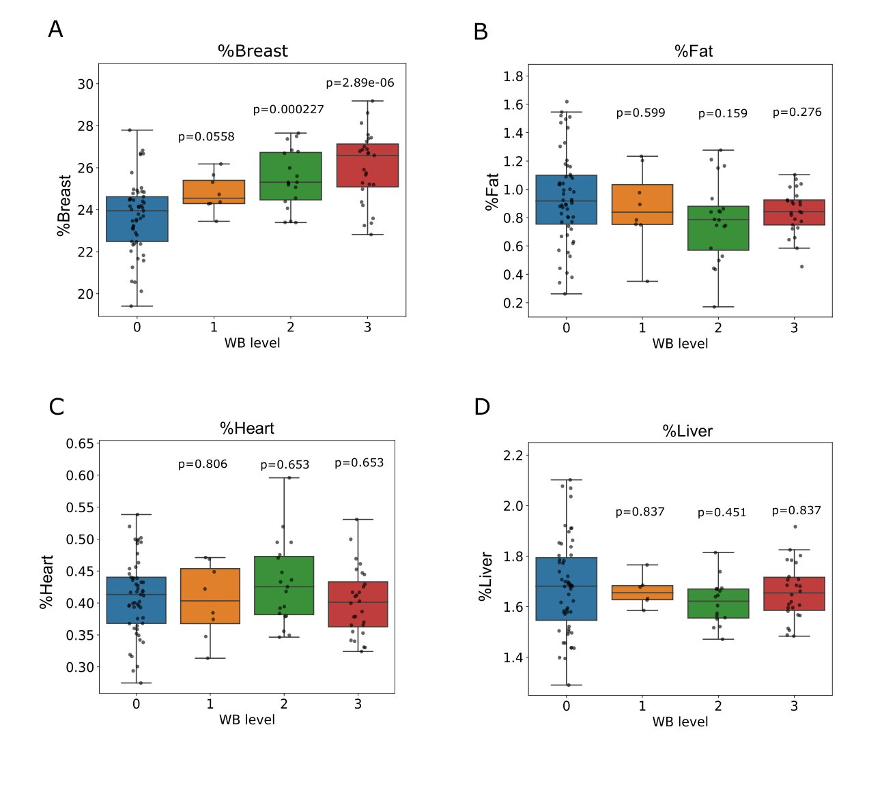

Supplementary Figure 1. Phenotypic markers of WB pathology associate breast muscle hypertrophy with deformed breast muscle structure. Stratification by WB severity levels further indicates that the breast muscle is the only tissue exhibiting disproportionate hypertrophic growth. A-D. Percentage of breast, fat, heart, and liver of the total weight presented as boxplots. Only the breast muscle exhibits a significant higher proportion of the total weight relative to non-WB (Mann-Whitney U-test). This non-allometric scaling of the breast muscle is shown for all WB+ levels.

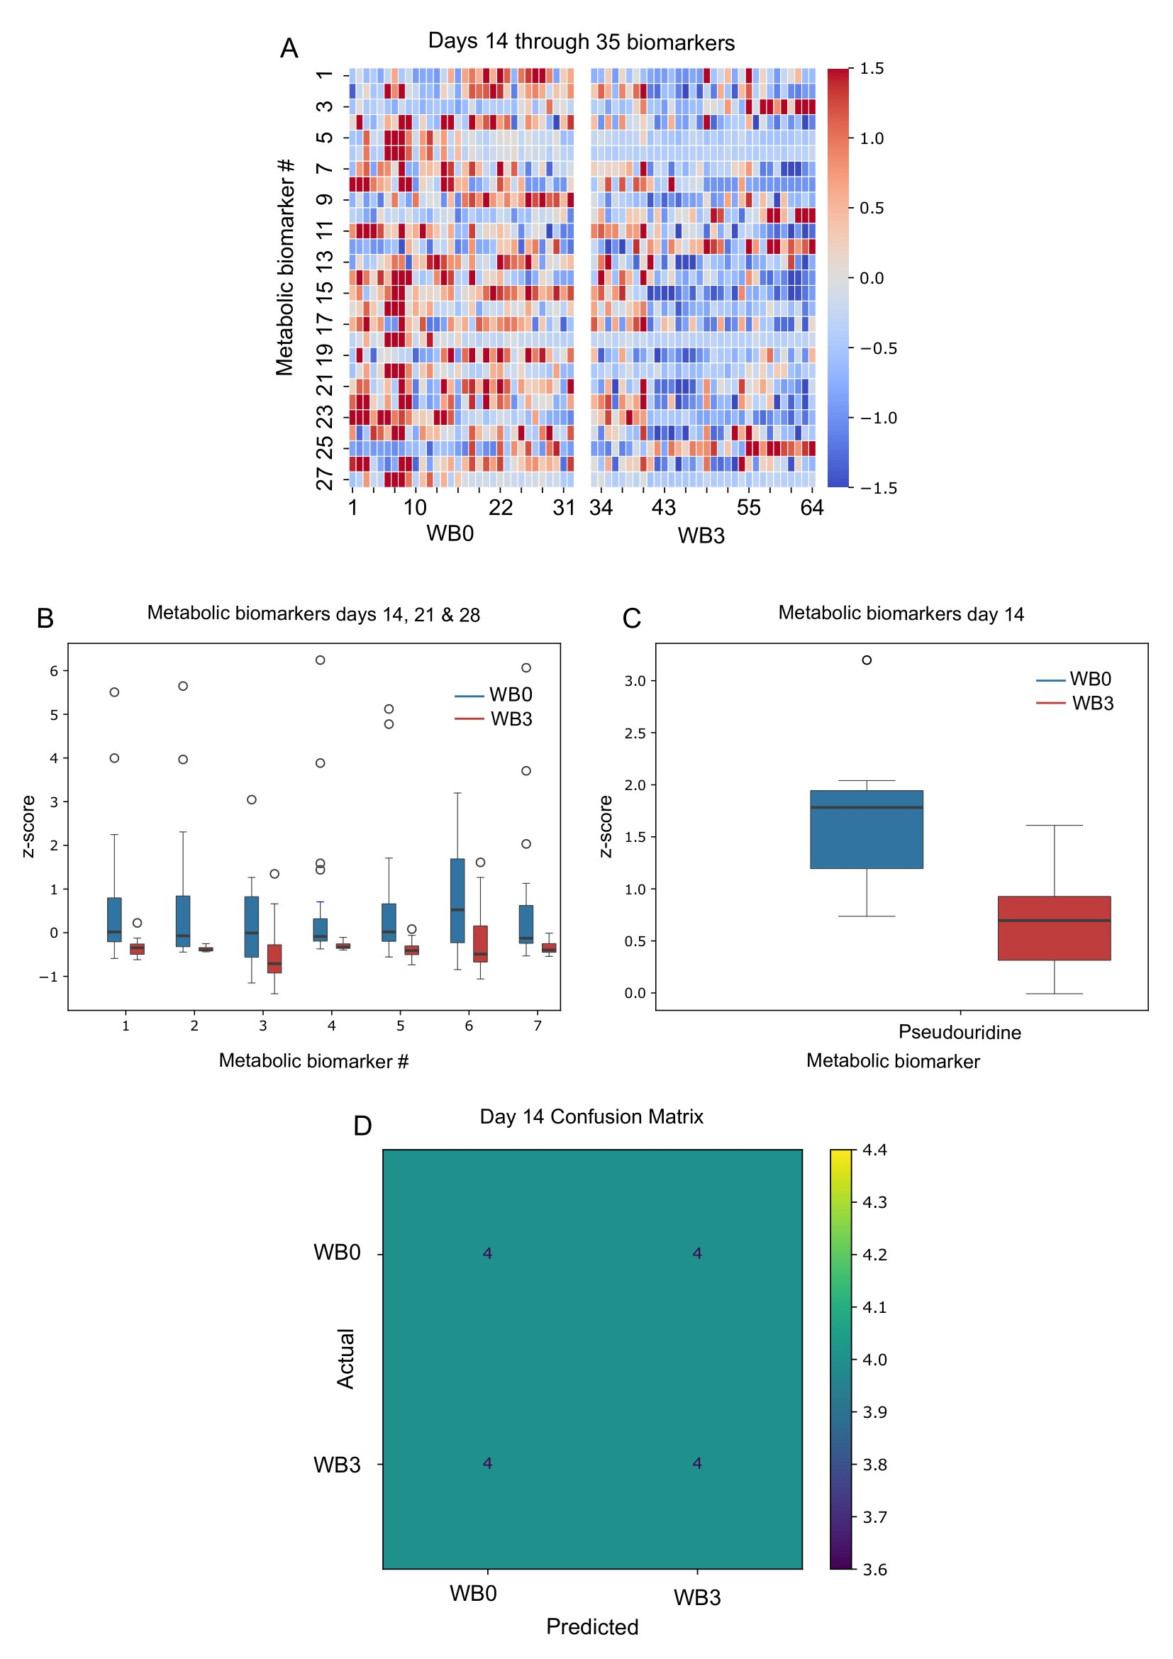
Supplementary Figure 2. Illustration of metabolic biomarkers at four, three, or one time points. A. Metabolic values of all four time points and 16 broilers, eight of the healthy cohort and eight of the WB3, for the 27 biomarkers, are shown as heatmap. Each row represents a biomarker, and each column represents an animal at its corresponding time point. Namely, column 1 represents animal number one of the healthy group at day 14. Column 9 represents the same animal at day 21, the second time point. Column 33 represents the first animal of the WB3 cohort at day 14, and column 41 represents the same animal at day 21. Subsequently, for each group, healthy or WB3, there are 8X4 (eight animals, four time points) columns, for a total of 64 columns for the whole heatmap. The colors on the map represents the values of each marker using z-score normalization. Z-score was calculated independently for each row. The actual names of the markers are given in Table 1, and the full metabolic data is given in Supplementary Table 1.
B, C. Differences in z-scores between healthy (blue) and level 3 pathologies (red) are presented as boxplots of the seven significant biomarkers for days 14-21-28, or for Pseudouridine, the sole marker of day 14. Each box represents the values of eight animals and three time points (B, 8X3 values per box) or eight broilers at one time point (C, eight values per box). The actual names of the seven markers in panel B are given In Table 1. The values of the biomarkers are presented as z-scores on the y-axis.
D. Based on the values of Pseudouridine from panel C, a confusion matrix demonstrates prediction of the correct cohort for healthy or WB3 groups. Using a single biomarker resulted in 50% accuracy, similar to the performance of a random guess. The matrix is based on a random forest classifier algorithm, and the profiled animals were either healthy or at level 3 pathology.

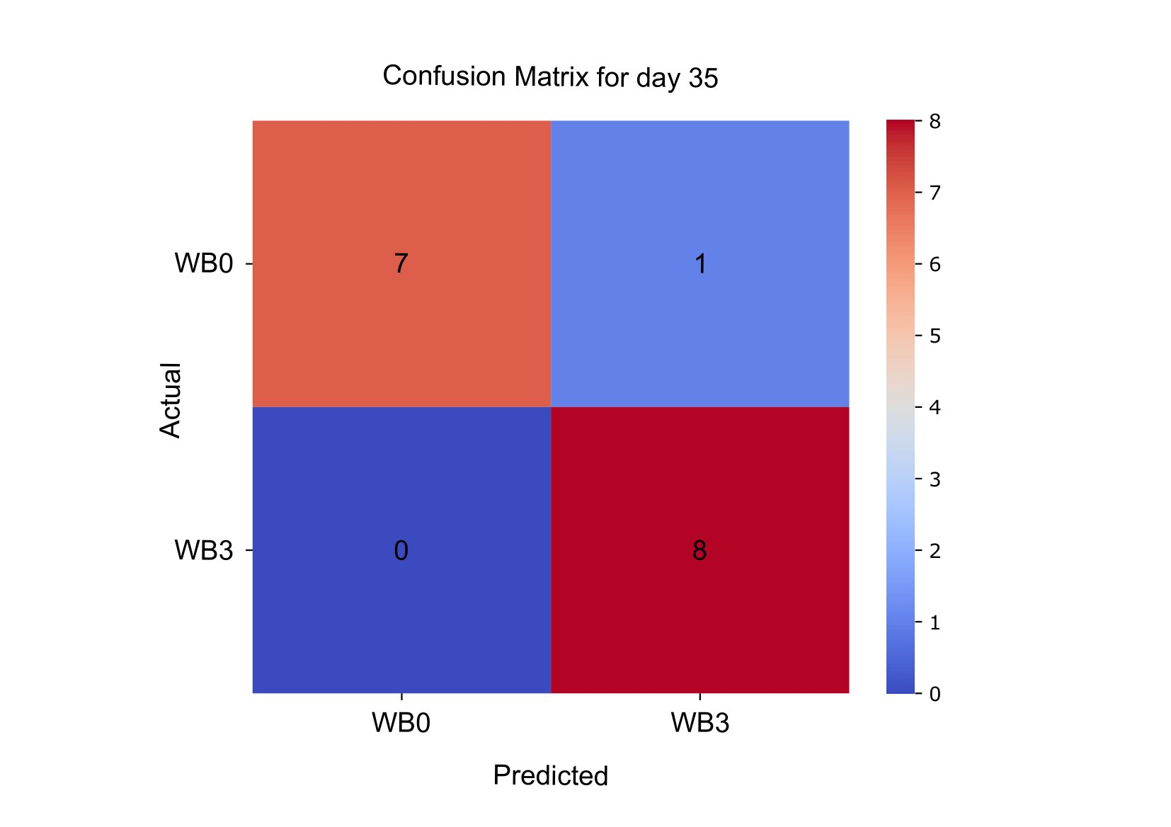
Supplementary Figure 3. Based on the values of the biomarkers exclusively from day 35 (Figure 1E, Supplementary Table 2), a confusion matrix demonstrates prediction of the correct cohort for 15 out of 16 animals. The matrix is based on a random forest classifier algorithm, and the profiled animals were either healthy (WB0) or at level 3 pathology.

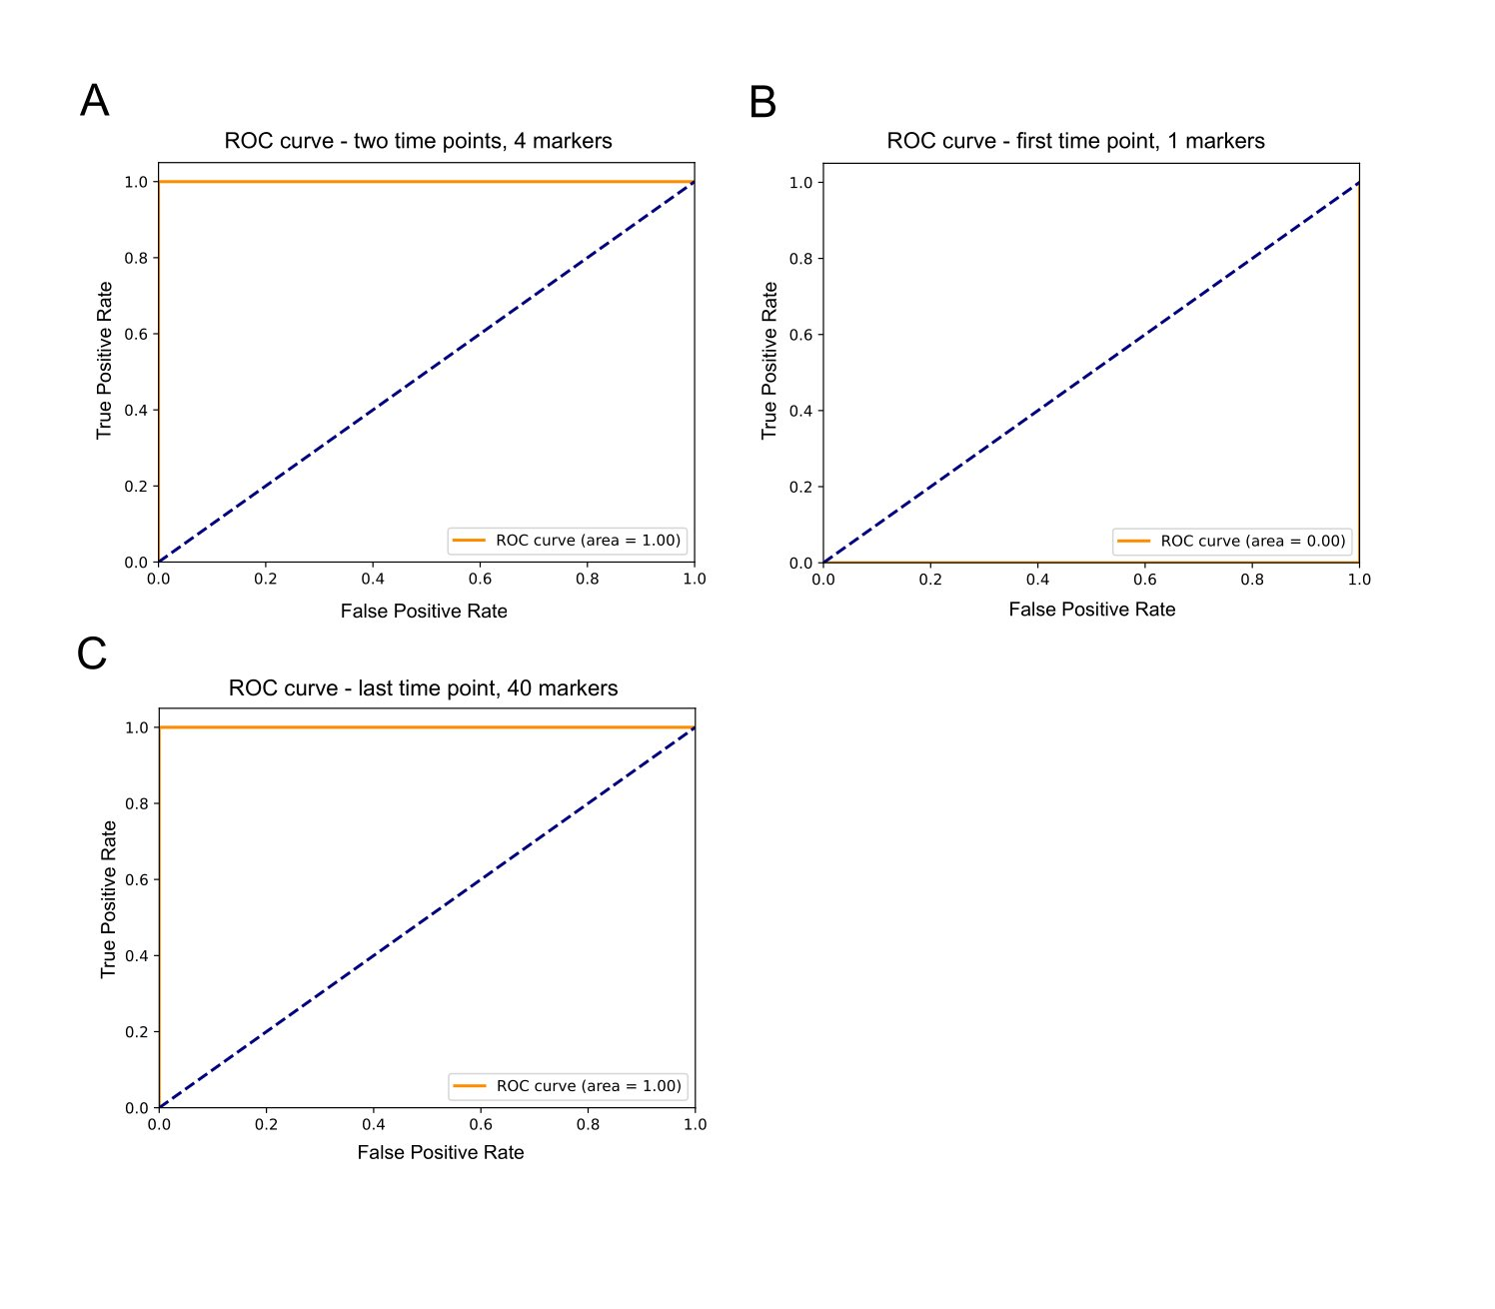
Supplementary Figure 4. Multi-class receiver operating characteristic (ROC) curves illustrate the strength of the classifier. A, C. At two time points (or more) or exclusively at the last time point, the corresponding biomarkers discriminate well between the healthy and WB3 groups. This is illustrated by the classifier curves as well as the area under the curve being well above the random model (dashed black line). B. Using exclusively the first time point, namely at day 14, there is no discrimination, and the area under the graph is zero.

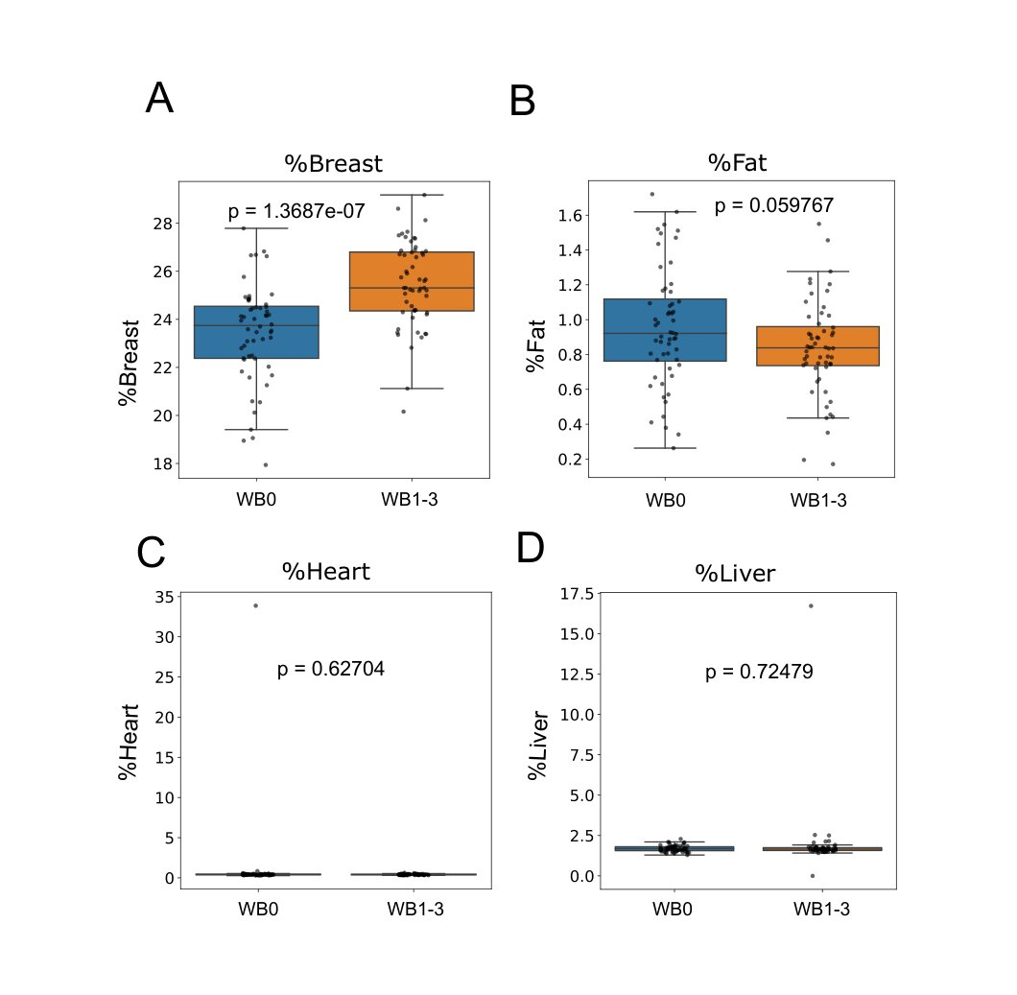
Supplementary Figure 5. Physiological markers of WB pathology associate breast muscles hypertrophy with deformed breast muscle structure. A-D. Percentage of breast, fat, heart, and liver of the total weight. Only the breast muscle exhibits a significantly higher proportion of the total weight for WB+ broilers relative to non-WB (Mann-Whitney U-test).

