SUPPLEMENTARY INFORMATION

Earliest-diverging rhynchocephalian from Gondwana: a new sphenodontian from the Upper Triassic Los Colorados Formation (northwestern Argentina)

L. C. GAETANO, J. C. SOTOMAYOR CHACÓN, M. R. ARCARIA, N. VEGA, J. M. LEARDI, F. D. SEOANE, and A. OTERO

INDEX
1. Geological setting …………………………………………………………………… 3
2. Institutional abbreviations ………...……………………………………………….... 4
3. Comparative description …………………………………………………………….. 4
4. Phylogenetic analyses …………………………………………………………….... 21
5. Synapomorphy list …………………………………………………………………. 33
6. Biogeographic analyses ……………………………………………………………. 39
7. Morphological disparity analyses…………………………………………………... 48
8. References …………………………………………………………………………. 52

FIGURES AND TABLES INDEX
Figure S1. Geographic location of Los Colorados Formation fossiliferous outcrops, showing the type locality of Coloradosphenodon lahni. ………………………………. 3
Figure S2. Anatomical details of the skull and lower jaw of Coloradosphenodon lahni ………………………………………………………………………………………….. 7
Figure S3. Anatomical details of the dentition of Coloradosphenodon lahni……….... 10
Figure S4. Anatomical details of the palatine of Coloradosphenodon lahni …………. 14
Figure S5. Strict consensus of 288 MPTs (L= 717) using an equally weighted parsimony analysis …………………………………………………………………………….…. 21
Figure S6. Strict consensus of 288 MPTs (L= 717) using an equally weighted parsimony analysis ignoring the alternative positions of unstable taxa ……………………..…… 22
Figure S7. Bremer supports …………………………………………………………... 23
Figure S8. Bootstrap supports …………………………………..……………………. 24
Figure S9. Jackknife supports ………………………………………………………... 25
Figure S10. MPT obtained with the implied weighting protocol (k= 3) …………….. 26
Figure S11. Strict consensus of 3 MPTs (obtained with the implied weighting protocol (k= 6) …………………………………………………………………………………. 27
Figure S12. Strict consensus of 3 MPTs obtained with the implied weighting protocol (k= 9) …………………………………………………………………………………. 28
Figure S13. Strict consensus of 3 MPTs obtained with the implied weighting protocol (k= 12) ………………………………………………………..………………………. 29
Figure S14. Strict consensus of 3 MPTs obtained with the implied weighting protocol (k= 15) ………………………………………………………………………………... 30
Figure S15. Strict consensus of 18 MPTs obtained with the implied weighting protocol (k= 25) ………………………………………………………………………………... 31
Figure S16. Common synapomorphies plotted on the strict consensus including all taxa ……………………………………………………………………………………….... 32
Figure S17. Reference tree for the ambiguous synapomorphy mapping .……………. 33
Figure S18. Result of the DEC+J analysis in RASP …………………………………. 44
Figure S19. Results of the BAYAREALIKE+J and DIVALIKE+J analyses in RASP ………………………………………………………………………………………… 45
Figure S20. Result of the BBM analysis in RASP ………………………………….... 46
Figure S21. Result of the DEC+J analysis in RASP including Taytalura alcoberi …... 47
Figure S22. Morphological disparity analysis (WMPD) considering all cranial characters from the phylogenetic data matrix …………………………….…………... 48
Figure S23. Morphological disparity analyses (WMPD) considering only lower and upper marginal dentition characters from the phylogenetic data matrix ………………48
Figure S24. Morphological disparity analyses (WMPD) considering only lower jaw characters from the phylogenetic data matrix ……………………………………….... 49
Figure S25. Morphological disparity analyses (WMPD) considering only lower jaw plus mandibular teeth characters from the phylogenetic data matrix ……………………….50
Figure S26. Morphological disparity analyses (WMPD) considering only cranial characters from the phylogenetic data matrix ………………...………………………. 51
Figure S27. Morphological disparity analyses (WMPD) considering only cranial plus upper dentition characters from the phylogenetic data matrix ……………………….. 52
Table S1. Main references employed for comparisons …………………………………. 5
Table S2. Dentary measurements of selected sphenodontians ………………………... 18
Table S3. Event matrix, event route, and probability for each node obtained by DEC+J analysis in RASP ………………………………………………..……………………. 39

1. Geological setting
The Norian Los Colorados Formation (Kent et al., 2014; Desojo et al., 2020), located in the Ischigualasto-Villa Unión Basin, Argentina (Fig. S1 a-b) (Caselli et al., 2001), represents the last postrift stage (Milana and Alcober, 1994; Santi Malnis et al., 2020) of a major rift event occurred between the Middle and Late Triassic (Milana and Alcober, 1994). The 600 to 1000 meters-thick unit is composed by fluvial deposits that changes toward the upper levels, from a meandering system at the base, followed by braided channels flanked by wide floodplains, to a transversal distributive fluvial system at the top of the unit (Santi Malnis et al., 2020).
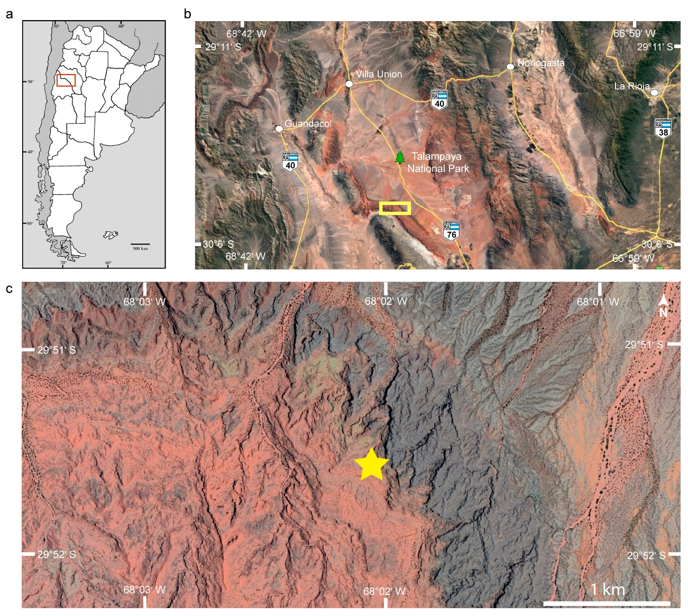
Figure S1. Geographic location of Los Colorados Formation fossiliferous outcrops, showing the type locality of Coloradosphenodon lahni. a. Argentinean map. b. Satellite image of north-western Argentina depicting the study area (yellow line rectangle) at the Talampaya National Park, La Rioja Province. c. Satellite image depicting the outcrops of ‘La Esquina’ locality where the remains of Coloradosphenodon lahni were recovered (yellow star). Figure modified from Gaetano et al., 2022. Map drawn with Adobe Illustrator CC 18 (https://www.adobe.com/products/illustrator. html). Satellite images from Google Earth, accessed August 2025.

The paleontological relevance of the Los Colorados Formation is derived from its exceptional tetrapod fossil record (Arcucci et al., 2004), which contributes to the otherwise scarce knowledge of Norian faunal assemblages (e.g., Gaetano et al., 2022). The highest diversity and abundance are found at the top of the formation, particularly at the “La Esquina” locality at the Talampaya National Park (La Rioja Province, Argentina) (Fig. S1 c). The upper faunal assemblage, represented in the upper third of the unit, is dominated by archosaurs (Bonaparte, 1981; Desojo and Báez, 2005; Ezcurra, 2017; Leardi et al., 2020; von Baczko et al., 2020; Pol et al., 2021) but also includes representatives of Cynodontia, Rhynchocephalia, and Testudinata (e.g. Bonaparte, 1980; Rougier et al., 1995; Martínez et al., 2015; Gaetano et al., 2022). Since 2014, new explorations led by our team have contributed with new findings, expanding the record of the faunal diversity of this formation.

2. Institutional abbreviations
AUP, Aberdeen University, Scotland, UK; IVPP-V, Institute of Vertebrate Paleontology and Paleoanthropology, Academia Sinica, Beijing, China; MCN-PV, Coleção de Paleovertebrados do Museu de Ciências Naturais da Fundação Zoobotânica do Rio Grande do Sul, Porto Alegre, Brazil; NHMUK-PV-R, Palaeovertebrate Collection, Natural History Museum, London, UK; NSM, Nova Scotia Museum, Halifax, Nova Scotia, Canada; PULR-V, Museo de Ciencias Naturales, Universidad Nacional de La Rioja, La Rioja, Argentina; PVL, Paleontología de Vertebrados, Fundación Miguel Lillo, Tucumán, Argentina; SAM-K, Iziko South African Museum, Cape Town, South Africa; UFRGS-PV, Paleovertebrate Collection, Universidade Federal do Rio Grande do Sul, Porto Alegre, Rio Grande do Sul, Brazil; UFSM-PV, Paleovertebrate Collection, Universidade Federal de Santa Maria, Rio Grande do Sul, Brazil.

3. Comparative description
We describe herein the anatomy of Coloradosphenodon lahni in a comparative framework with relevant taxa, mostly from the Triassic but also considering some Jurassic species when deemed pertinent. Comparisons between Coloradosphenodon lahni and the modern Sphenodon have not been included because they differ in many characters of the teeth and skull bones. Main references employed for comparisons are summarized in Table S1. The skull and lower jaws of Coloradosphenodon lahni are only partially preserved. The anteorbital region is approximately 6 mm long and the horizontal ramus of the dentary from the anterior tip of the symphysis to the beginning of the coronoid process measures 13.2 mm. This makes Coloradosphenodon lahni notably smaller than Sphenotitan leyesi from the Quebrada del Barro Formation (Marayes-El Carrizal Basin; Martínez et al., 2013). Compared with the three sphenodontian species from the Riograndia Asemblage Zone, Coloradosphenodon lahni is only slightly larger than Clevosaurus brasiliensis and Microsphenodon bonapartei whereas Lanceirosphenodon ferigoloi is a much smaller form (Bonaparte and Sues, 2006; Romo de Vivar Martínez et al., 2020; Chambi-Trowell et al., 2021).

Table S1. Main references employed for comparisons.
Taxon | Reference | Observations
Diphydontosaurus avonis | Whiteside, 1986; Foffa et al., 2014 | Early-diverging
Gephyrosaurus bridensis | Evans, 1980 | Early-diverging
Microsphenodon bonapartei | Chambi-Trowell et al., 2021 | Early-diverging
Parvosaurus harudensis | Freisem et al., 2024 | Early-diverging
Planocephalosaurus robinsonae | Fraser, 1982 | Early-diverging
Polysphenodon mulleri | Fraser and Benton, 1989 | Early-diverging
Wirtembergia hauboldae | Jones et al., 2013; Sues and Schoch, 2023 | Early-diverging
Opisthiamimus gregory | DeMar et al., 2022 | Early-diverging
Brachyrhinodon taylori | Fraser and Benton, 1989 | Clevosauridae
Clevosaurus bairdi | Sues et al., 1994 | Clevosauridae
Clevosaurus brasiliensis | Bonaparte and Sues, 2006; Hsiou et al., 2015; Romo de Vivar Martínez and Soares, 2015; Chambi-Trowell et al., 2021 | Clevosauridae
Clevosaurus cambrica | Keeble et al., 2018; Chambi-Trowell et al., 2019, 2020 | Clevosauridae
Clevosaurus convallis | Säilä, 2005 | Clevosauridae
Clevosaurus hadroprodon | Hsiou et al., 2019 | Clevosauridae
Clevosaurus hudsoni | Robinson, 1973; Fraser, 1988; O’Brien et al., 2018; Chambi-Trowell et al., 2019, 2020 | Clevosauridae
Clevosaurus mcgilli | Wu, 1994; Jones, 2006 | Clevosauridae
Clevosaurus minor | Fraser, 1988 | Clevosauridae
Clevosaurus sectumsemper | Klein et al., 2015 | Clevosauridae
Clevosaurus sp. SAM K7890 | Sues and Reisz, 1995 | Clevosauridae
Clevosaurus wangi | Wu, 1994; Jones, 2006 | Clevosauridae
Sigmala sigmala | Fraser, 1986 | Clevosauridae
Lanceirosphenodon ferigoloi | Romo de Vivar Martínez et al., 2020 | Neosphenodontia
Rebbanasaurus jaini | Evans et al., 2001 | Neosphenodontia
Palaeopleurosaurus posidoniae | Carroll, 1985; Dupret, 2004; Klein and Scheyer, 2016 | Opistodontia
Pleurosaurus goldfussi | Cocude-Michel, 1963; Dupret, 2004 | Opistodontia
Sphenotitan leyesi | Martínez et al., 2013 | Opistodontia
Tingitana anoualae | Evans and Sigogneau-Russell, 1997 | Opistodontia
Vadasaurus herzogi | Bever and Norell, 2017 | Opistodontia

Premaxilla
Both premaxillae are partially preserved, with the left one being more complete (Fig. 1a,b; Fig. S2 a,b). The bases of three small (~0.5 mm in mesiodistal length), simple teeth are present on its ventral margin, in line with the maxillary dentition (Fig. S2 b). However, what appears to be the root of a large anterior tooth (approximately 50% larger than the other premaxillary teeth; ~0.75 mm in mesiodistal length) is observable due to breakage deep into the premaxilla (Fig. S2 b). Unlike in Coloradosphenodon lahni, the early rhynchocephalian Gephyrosaurus bridensis present eight to 10 premaxillary teeth (Evans, 1980) and early sphenodontians depict a variable number of discrete premaxillary teeth: five to seven in Diphydontosaurus avonis, four in Planocephalosaurus robinsonae and Wirtembergia hauboldae, two in Polyspohenodon mulleri (Fraser, 1982; Whiteside, 1986; Fraser and Benton, 1989; Sues and Schoch, 2023). In Diphydontosaurus avonis and Planocephalosaurus robinsonae, the premaxillary teeth are approximately the same size whereas in Wirtembergia hauboldae they become progressively smaller posteriorly, thus differing from the condition observed in Coloradosphenodon lahni (Fraser, 1982; Whiteside, 1986; Fraser and Benton, 1989; Sues and Schoch, 2023). The premaxillary teeth of Brachyrhinodon taylori have been reported to merge into a single cutting structure in some specimens (Fraser and Benton, 1989), thus differing from Coloradosphenodon lahni. Fraser (1988) described the alternative presence of three or four premaxillary teeth in Clevosaurus hudsoni. However, unlike in Coloradosphenodon lahni, the posteriormost element in Clevosaurus hudsoni is distinctly larger than the more anterior ones (Fraser, 1988). Clevosaurus convalis is interpreted to bear four small conical premaxillary teeth, the last two of them being then replaced by a larger element (Säilä, 2005). Clevosaurus sectumsemper has two or three small premaxillary teeth, similar to the specimens of Clevosaurus hudsoni from Tytherington (Whiteside, 1986, Klein et al., 2015). Conversely, a single tooth is present in the premaxillae of Clevosaurus bairdi, Clevosaurus brasiliensis, and Sphenotitan leyesi (Sues et al., 1994; Martínez et al., 2013; Chambi-Trowell et al., 2021). Hence, these taxa also differ from Coloradosphenodon lahni.
Figure S2. Holotype of Coloradosphenodon lahni, gen. et sp. nov (PULR-V264). (a) Photograph and line drawing of the specimen in left lateral view; (b) detail of the anterior region of the snout in left lateral view; (c) detail of the maxilla and orbital region in left lateral view; (c) 3D model and line drawing of the left dentary in lateral view. c p, coronoid process, c th, caniniform tooth, d, dentary, ed, edentulous region, en, external nares, fl th, flanged teeth, f p mx, facial process of the maxilla, ht th, hatching teeth, j, jugal, mx, maxilla, mx add th, maxillary additional teeth, mx ht th, maxillary hatching teeth, mx p pmx, maxillary process of the premaxilla, n, nasal, n p, nasal process, pmx, premaxilla, pmx p mx, premaxillary process of the maxilla, pmx th, premaxillary teeth, p p mx, posterior process of the maxilla, prf, prefrontal, r th?, tooth root?, v p prf, ventral process of the prefrontal. Scale bars a: 10 mm; b-d: 1 mm.

The nasal process is not preserved. The maxillary process is as tall as the maxilla; hence, it is interpreted to have surpassed the height of the nasal process (Fig. S2 a,b). Dorsally, the maxillary process is bulbous and bifurcated (Fig. S2 a,b). The presence of two maxillary processes is shared with species of the genus Clevosaurus (Fraser 1988; Sues and Reisz, 1995; Klein et al., 2015; Keeble et al., 2018; Chambi-Trowell et al., 2021) except for Clevosaurus convallis (Säilä, 2005) which lacks the secondary maxillary process altogether. The secondary maxillary process is much less developed than the primary one and obscured from the external lateral view by the maxilla, similarly to Clevosaurus brasiliensis. The lateral exposure of the premaxilla is relatively broad and expands dorsally in Coloradosphenodon lahni, with the maxillary facet restricted to the posterior margin of the bone. As a result, the premaxillae excluded the maxillae for the external nares (Fig. S2 a,b), a trait shared with more derived forms such as Clevosaurus spp., Opisthiamimus gregory, Vadasaurus herzogi, and Sphenotitan leyesi (Martínez et al., 2013; Bever and Norell, 2017). The maxilla contributes to the narial opening in early sphenodontians (e.g., Diphydontosaurus avonis, Planocephalosaurus robinsonae, Polyspohenodon mulleri, Wirtembergia hauboldae; Fraser, 1982; Whiteside, 1986; Fraser and Benton, 1989; Sues and Schoch, 2023) and also in some relatively more derived forms (e.g., Rebbanasaurus jaini, Palaeopleurosaurus posidoniae, Pleurosaurus goldfussi; Carroll and Wild, 1994; Evans et al., 2001; Beccari et al., 2024), thus differing from Coloradosphenodon lahni.

Maxilla
The facial process of the maxilla (dorsal process elsewhere) is dorsoventrally high (approximately twice the height of the posterior process) and slightly posteriorly oriented (Fig. 1 a-c; Fig. S2 a,c), similar to Gephyrosaurus bridensis, Parvosaurus harudensis, Clevosaurus bairdi, Clevosaurus sp. SAM-K7890, and Microsphenodon bonapartei (Evans, 1980; Sues et al., 1994; Sues and Reisz, 1995; Chambi-Trowell et al., 2021; Freisem et al., 2024). Conversely, the facial process is curved posteriorly in Clevosaurus cambrica (Chambi-Trowell et al., 2019, 2020) and the long axis of this process is approximately vertically oriented in early sphenodontians (e.g., Diphydontosaurus avonis, Planocephalosaurus robinsonae, Polyspohenodon mulleri, and Wirtembergia hauboldae), Clevosaurus brasiliensis, Clevosaurus hudsoni, and Opisthiamimus gregory (Fraser, 1982; Whiteside, 1986; Fraser and Benton, 1989; O’Brien et al., 2018; Chambi-Trowell et al., 2019, 2021; DeMar et al., 2022; Sues and Schoch, 2023). Unlike Coloradosphenodon lahni, Vadasaurus herzogi shows a relatively lower facial process of the maxilla which is triangular in outline and approximately vertically oriented (Bever and Norell, 2017), the pleurosaurs Palaeopleurosaurus posidoniae and Pleurosaurus goldfussi have a posteriorly positioned, low facial process of the maxilla (Carroll and Wild, 1994; Beccari et al., 2024), and in Sphenotitan leyesi the facial process of the maxilla is not developed (Martínez et al., 2013).
A premaxillary process is only very poorly developed in Coloradosphenodon lahni (Fig. 1 a-c; Fig. S2 a-c), as in Clevosaurus spp. (C. bairdi, C. brasiliensis, C. cambrica, C. hudsoni, Clevosaurus sp. SAM-K7890), and Opisthiamimus gregory (Sues et al., 1994; Sues and Reisz, 1995; O’Brien et al., 2018; Chambi-Trowell et al., 2019, 2020, 2021); DeMar et al., 2022), opposite to the condition observed in many other taxa (e.g., early sphenodontians, Microsphenodon bonapartei, pleurosaurs; Fraser, 1982; Whiteside, 1986; Carroll and Wild, 1994; Chambi-Trowell et al., 2021; Sues and Schoch, 2023; Beccari et al., 2024; Freisem et al., 2024). In the stem pleurosaur Vadasaurus herzogi, the maxilla extends anteriorly with respect to the apex of the facial process of the maxilla, but the premaxillary process is inconspicuous (Bever and Norel, 2017). The posterior process is of uniform dorsoventral height until the end of the penultimate tooth. Then, it curves inward, embracing ventrally the jugal (Fig. S2 a,c).
The maxillary teeth do not have roots or root-like structures (Fig. S3 a-c). The CT images do not show that they continue into the maxillary bone (Fig. S3 b-c). Despite some missing elements from the right and left maxillae, nine teeth are inferred to have been present. The teeth become larger posteriorly until the penultimate tooth whereas the last tooth is slightly smaller (Fig. S 3a). There is no separation between adjacent teeth, and they are subsequently more labially positioned; hence, the tooth row is oriented laterally as observed in occlusal view (Fig. 1 e-f).

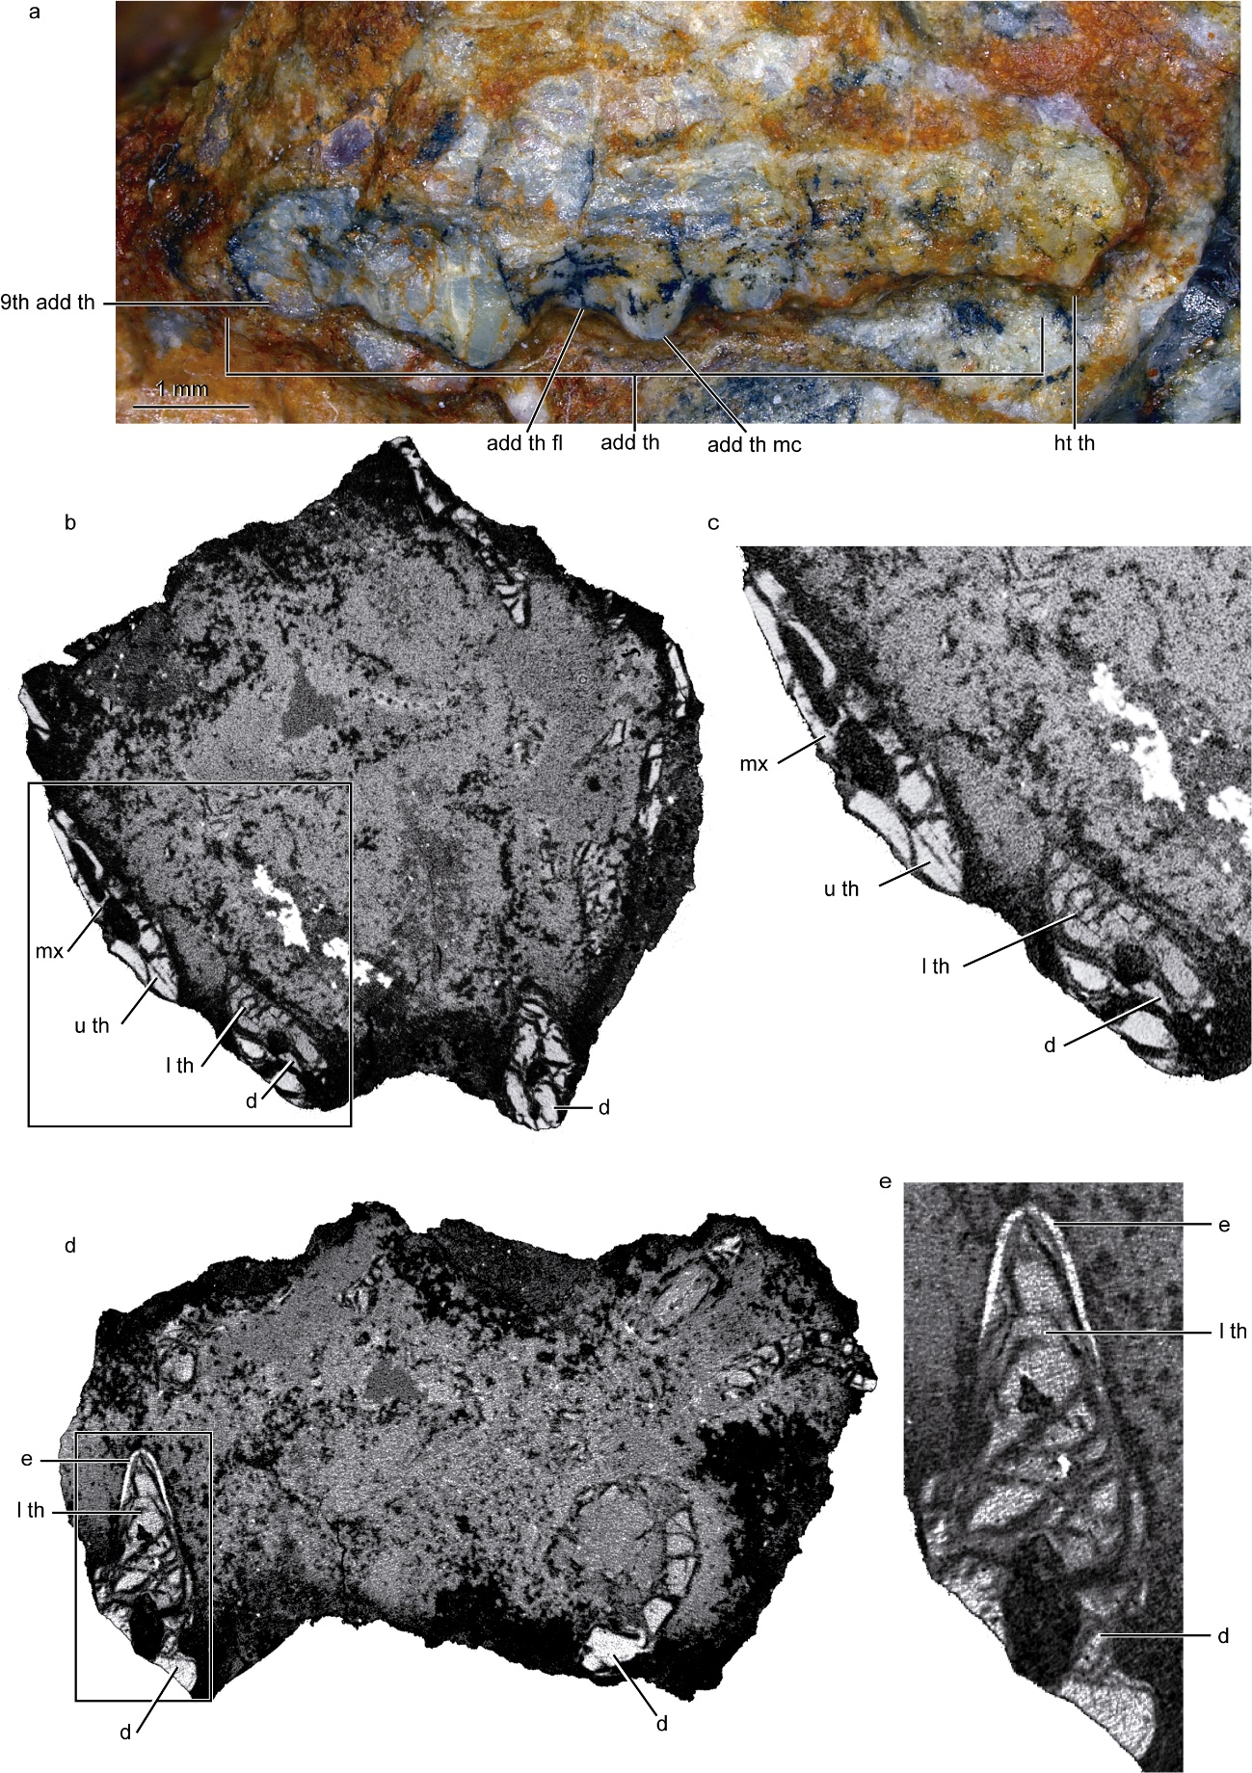
Figure S3. Holotype of Coloradosphenodon lahni, gen. et sp. nov (PULR-V264). (a) Detail of the right maxillary dentition in lateral view; (b-e) tomographic cross-sections of the specimen; (c) and (e) close ups of the boxes in b and d, respectively. add th, maxillary additional teeth, add th fl, flange of additional maxillary tooth, add th mc, main cusp of additional maxillary tooth, d, dentary, e, enamel, ht th, maxillary hatching tooth, l th, lower tooth, mx, maxilla, up th, upper tooth, 9th add th, 9th additional maxillary tooth. Scale bar a: 1 mm.

Only the most anterior maxillary tooth is a simple element, bearing a single, relatively low and mesiodistally long cusp with convex mesial and distal margins in lateral view (Fig. S3 a). More posterior teeth exhibit a similar ‘flanged’ structure (Fig. S3 a). They are labiolingually compressed and mesiodistally long when compared to their height or width. The crown is sharp covered by a thin layer of enamel. The main mesial cusp is followed distally by a flange that, in some teeth, is shaped as a low and mesiodistally long cusp (Fig. S3 a). As a result of teeth disposition and morphology, they form a continuous cutting edge along the entire margin of the maxilla. The combination of a reduced number of simple teeth (i.e., ‘hatchling dentition’), an elevated number of ‘flanged’ teeth (i.e., ‘additional teeth’; at least eight), and the absence of simple teeth posteriorly in the dental series (i.e., ‘posterior teeth’) distinguish Coloradosphenodon lahni from other sphenodontians (e.g., Robinson, 1973; Fraser, 1982, 1988; Fraser and Benton, 1989; Wu, 1994; Evans et al., 2001; Säilä, 2005; Bonaparte and Sues, 2006; Arantes et al., 2009; Romo de Vivar Martínez and Soares, 2015; Hsiou et al., 2015, 2019; O’Brien et al., 2018; Keeble et al., 2018; Chambi-Trowell et al., 2019, 2020, 2021; Freisem et al., 2024). Similar to Coloradosphenodon lahni, Clevosaurus cambrica and Vadasaurus herzogi also lack posterior conical teeth (Bever and Norell, 2017; Keeble et al., 2018). However, unlike these taxa, Coloradosphenodon lahni presents a single conical maxillary tooth anteriorly in the tooth row whereas anterior simple teeth are lacking in Clevosaurus cambrica (Keeble et al., 2018: Chambi-Trowell et al., 2019) and many simple teeth are present in Vadasaurus herzogi. In addition, Coloradosphenodon lahni has more flanged teeth than Clevosaurus cambrica (i.e., at least eight vs. six). As in Coloradosphenodon lahni, the holotype of Opisthiamimus gregory also shows a reduced number of simple maxillary teeth anteriorly (i.e., one) followed by eight additional teeth. However, whereas in Coloradosphenodon lahni additional teeth become larger posteriorly, in Opisthiamimus gregory, the larger additional tooth is the fifth element. Unlike Coloradosphenodon lahni, in Opisthiamimus gregory the last additional tooth is tiny and lacks a distolingual flange. In addition, in Coloradosphenodon lahni, the long axis of the flanged teeth is in line with the long axis of the tooth row whereas in Opisthiamimus gregory, the axis of the teeth and tooth row are oblique to each other.

Nasal
The nasal protrudes anteriorly, with the nasal process forming a gentle curve directed towards the nasal process of the premaxilla (not preserved) (Fig. 1 a-c; Fig. S2 a,b). The nasal is well exposed laterally (Fig. S2 a,b) in Coloradosphenodon lahni as in Gephyrosaurus bridensis, Brachyrhinodon taylori, Diphydontosaurus avonis, Parvosaurus harudensis, Planocephalosaurus robinsonae, Microsphenodon bonapartei, Clevosaurus cambrica, Clevosaurus hudsoni, Opisthiamimus gregory, and Vadasaurus herzogi (Evans, 1980; Fraser, 1982; Fraser and Benton, 1989; Whiteside, 1986; Sues et al., 1994; Bever and Norell, 2017; O’Brien et al., 2018; Chambi-Trowell et al., 2019, 2020, 2021; DeMar et al., 2022; Freisem et al., 2024). In specimens UFRGS-PV-0974-T (Chambi-Trowell et al., 2021) and MCN-PV 2852 (Hsiou et al., 2015) of Clevosaurus brasiliensis, the nasal extends well anterior to the prefrontal as in the above-mentioned species. In contrast, the nasal is almost completely obscured from the lateral view by the maxilla and the prefrontal in Clevosaurus brasiliensis type specimen (UFRGS-PV-0748-T) and the referred material UFSM-PV-0131 (Chambi-Trowell et al., 2021). In these specimens, unlike in Coloradosphenodon lahni, the nasal is short and barely exceeds the prefrontal anteriorly. In Clevosaurus bairdi, whereas the nasals project well anterior to the prefrontals, it is the dorsally extended maxilla the one which restricts to a dorsal strip of bone the exposure of the nasal in the lateral view (Sues et al., 1994). Unlike Coloradosphenodon lahni and other sphenodontians, the nasal bone of pleurosaurs does not reach anteriorly the tip of snout (Carroll and Wild, 1994; Beccari et al., 2024).

Prefrontal
The prefrontal forms the anterior margin of the orbit (Fig. 1 a-c; Fig. S2 a,c). Its short ventral process only constitutes the anterior region of the ventral margin of the orbit. This process contacts the jugal (Fig. S2 a,c), as in Clevosaurus bairdi, Clevosaurus brasiliensis, Clevosaurus mcgilli, Clevosaurus sp. SAM-K7890, Opisthiamimus gregory, Vadasaurus herzogi, and Pleurosaurus goldfussi (Carroll and Wild, 1994; Sues et al., 1994; Wu, 1994; Sues and Reisz, 1995; Bonaparte and Sues, 2006; Bever and Norell, 2017; Chambi-Trowell et al., 2021; DeMar et al., 2022; but see Beccari et al., 2024: figure 5j for an alternative interpretation of Pleurosaurus goldfussi) and unlike Gephyrosaurus bridensis, early sphenodontians (Diphydontosaurus avonis, Planocephalosaurus robinsonae, Parvosaurus harudensis, Microsphenodon bonapartei), Clevosaurus hudsoni, Clevosaurus wangi, and Palaeopleurosaurus posidoniae (Evans, 1980; Fraser, 1982, 1988, Whiteside, 1986; Carroll and Wild, 1994; Wu, 1994; Chambi-Trowell et al., 2021; Freisem et al., 2024). A large lacrimal foramen is observed on the right side of the skull, rimmed anteroventrally by the maxilla and posterodorsally by the prefrontal (Fig. 1 a). The dorsoposterior process of the prefrontal is not preserved.
Coloradosphenodon lanhi differs from Clevosaurus brasiliensis specimens UFRGS-PV-0748-T (type) and UFSM-PV-0131 (Chambi-Trowell et al., 2021), in which the prefrontal reaches the anterior region of the maxilla. Alternatively, the prefrontal of Coloradosphenodon lanhi is relatively more posteriorly placed (Fig. S2 a,c), a condition shared with Clevosaurus brasiliensis specimens UFRGS-PV-0974-T (Chambi-Trowell et al., 2021) and MCN-PV 2852 (Hsiou et al., 2015) as well as with other species of Clevosaurus such as Clevosaurus bairdi, Clevosarus cambrica, Clevosaurus hudsoni, Clevosaurus mcgilli, Clevosaurus wangi, and Clevosaurus sp. SAM-K7890 (Fraser, 1988; Sues et al., 1994; Wu, 1994; Sues and Reisz, 1995; Chambi-Trowell et al., 2019). A relatively posteriorly positioned prefrontal is also observed in Opisthiamimus gregory, Vadasaurus herzogi, pleurosaurids, and in the early taxa Gephyrosaurus bridensis, Diphydontosaurus avonis, Planocephalosaurus robinsonae, Parvosaurus harudensis, and Microsphenodon bonapartei but not in Brachyrhinodon taylori (Evans, 1980; Fraser, 1982; Carroll and Wild, 1994; Bever and Norell, 2017; Chambi-Trowell et al., 2021; DeMar et al., 2022; Freisem et al., 2024).

Jugal
The jugal is represented by its anterior process. It forms almost the entire ventral margin of the orbit, contacting the prefrontal anteriorly (Fig. 1 b,c; Fig. S2 a,c). As observed dorsally, the anterior process of the jugal is triangular in outline, becoming mediolaterally broader posteriorly.

Palatine
Both palatines are partially preserved (Fig. 1 e,f). The palatine is a relatively broad, rectangular bone bearing large, similar-sized, conical teeth (Fig. 1 e,f; Fig. S4). There is a row of at least six teeth along the lateral margin of the palatine extending through almost the complete length of the bone. In addition, in the medial region of the palatine, there are two groups of diagonally oriented tooth rows, oriented at approximately 45° to the lateral row. There are three teeth in the most anterior row and two in most posterior one. Anteriorly, the palatine forms the posterior border of the internal nares and there is extensive contact with the maxilla through a laterally projected maxillary process. The palatine extends posteriorly almost to the same level as the maxilla (Fig. 1 e,f; Fig. S4).

Figure S4. Holotype of Coloradosphenodon lahni, gen. et sp. nov (PULR-V264). 3D model of the right palatine in ventral view. in, internal nares, lr, lateral row of palatine teeth, mar, anterior medial row of palatine teeth, mpr, posterior medial row of palatine teeth, mxp, maxillary process of the palatine, vc, area for contact with the vomer. Scale bar a: 1 mm.

The outline of the palatine of Coloradosphenodon lahni (Fig. 1 e,f; Fig. S4) resembles that of the early sphenodontian Planocephalosaurus robinsonae which is broad and not so triangular as in other early forms such as Gephyrosaurus bridensis and Diphydontosaurus avonis (Evans, 1980; Fraser, 1982; Whiteside, 1986). The outline of the palatine of Coloradosphenodon lahni is also reminiscent of that of Opisthiamimus gregory. Parvosaurus harudensis probably also shared a broad, quadrangular palatine, but it is too incomplete to ensure (Freisem et al., 2024). In contrast, unlike Coloradosphenodon lahni, Planocephalosaurus robinsonae displays a lateral row of 10 teeth that decrease in height posteriorly and two additional parallel medially placed rows of numerous small teeth (Fraser, 1982). Many rows of numerous teeth are also present in the palatine of Gephyrosaurus bridensis and Diphydontosaurus avonis, together with additional teeth randomly scattered. Several small teeth are also recognized laterally in the palatine of Parvosaurus harudensis (see Freisem et al., 2024). Unlike in Coloradosphenodon lahni, there is only an isolated medial tooth in Opisthiamimus gregory. Brachyrhinodon taylori, Godavarisaurus lateefi, Microsphenodon bonapartei, Polysphenodon mulleri, Rebbanasaurus jaini, Sigmala sigmala, Clevosaurus ssp., and Sphenotitan leyesi show lateromedially much narrower palatines (Fraser, 1986, 1988; Fraser and Benton 1989; Wu, 1994; Sues and Reisz, 1995; Evans et al., 2001; Säilä, 2005; Jones, 2006; Martínez et al., 2013; Hsiou et al., 2015; Klein et al., 2015; Chambi-Trowell et al., 2019, 2021). These taxa share a main row of relatively large lateral teeth that may be accompanied by a smaller medially placed tooth. In some cases (i.e., Microsphenodon bonapartei; Rebbanasaurus jaini, and specimen AUP11158 of Clevosaurus hudsoni), there is also a medially placed row of teeth. In Microsphenodon bonapartei, the medial tooth row is angled at about 45º to the lateral row and is composed of two teeth, similar to that of Coloradosphenodon lahni but more anteriorly placed. The medial row in Rebbanasaurus jaini forms a circa 25º angle to the lateral row and is integrated by three teeth, differing in orientation and number of teeth from that of Coloradosphenodon lahni but sharing a similar position relative to the lateral tooth row. The presence of a row of three teeth on the anteromedial region of the palatine appears to be only shared by Coloradosphenodon lahni and a single specimen of Clevosaurus hudsoni (AUP11158). In AUP11158, this secondary tooth row has been described (but not illustrated) with its long axis anteroposteriorly directed, aligned with the pterygoid lateral tooth row, not oblique as in Coloradosphenodon lahni. The presence of three clearly defined tooth rows bearing large teeth differentiates Coloradosphenodon lahni from other known taxa (Fig. 1 e,f; Fig. S4).

Pterygoid
The pterygoid is almost completely preserved (Fig. 1 e,f). The lateromedially narrow palatal ramus of the pterygoid extends anteriorly to the vomer (not preserved) and contacted the palatine laterally (Fig. 1 e,f). The palatal rami appear to be separated from each other along their almost entire length, giving place to a long, narrow interpterygoid vacuity, which was partially occupied by the thin cultriform process of the parasphenoid. This morphology of the interpterygoid vacuity is reminiscent of the one observed in Palaeopleurosaurus posidoniae (Carroll and Wild 1994: figure 4.6). On the contrary, the interpterygoid vacuity is comparatively short and restricted to the posterior region of the palatal rami of the pterygoid in Microsphenodon bonapartei, Clevosaurus ssp. (e.g., C. braziliensis, C. cambrica, C. hudsoni, and C. sectumsemper), Opisthiamimus gregory, and Pleurosaurus goldfusi. In other early sphenodontians (e.g., Gephyrosaurus bridensis, Diphydontosaurus avonis, Parvosaurus harudensis, and Planorocephalus robinsonae), this fossa is long as in Coloradosphenodon lahni but wider and triangular shaped, except in Brachyrhynodon taylori and Polysphenodon mulleri where it is reconstructed as not triangular in outline (Fraser and Benton, 1989: figures 1 and 7). Relatively small teeth forming a single tooth row is present in Coloradosphenodon lahni (Fig. 1 e,f) unlike in Gephyrosaurus bridensis, early sphenodontians (e.g., Brachyrhynodon taylori, Diphydontosaurus avonis, Microsphenodon bonapartei, Planorocephalus robinsonae, and Polysphenodon mulleri), Clevosaurus ssp., and Opisthiamimus gregory. A single tooth row is also observable in the pterygoid of Parvosaurus harudensis (Freisem et al., 2024: figure 1); however, according to Freisem et al. (2024) the number of pterygoid tooth rows cannot be ascertained.
In Coloradosphenodon lahni, the transverse flange projects anterolaterally to contact the ectopterygoid (Fig. 1 e,f), similar to Gephyrosaurus bridensis, Diphydontosaurus avonis, Planorocephalus robinsonae, Microsphenodon bonapartei, and pleurosaurs. The posterior projection of the transverse flange observed in Brachyrhynodon taylori, Parvosaurus harudensis, and Clevosaurus ssp. is not developed in Coloradosphenodon lahni. Posteriorly, the articulation area for the parasphenoid is concave and expanded dorsoventrally. The quadrate ramus is poorly preserved. It is projected posterolaterally and relatively robust and long (Fig. 1 e,f).

Ectopterygoid
The ectopterygoid bears an approximately cylindrical, short shaft and anteroposteriorly expanded lateral and medial regions set at right angles (Fig. 1 e,f). It would have contacted the palatine and pterygoid (medially) and the jugal and maxilla (laterally). Medially, it is more posteroventrally projected whereas laterally the anterior region is the more projected one. An anterolateral contact with the palatine as described in Clevosaurus hudsoni and Opisthiamimus gregory (Fraser, 1988; DeMar et al., 2022) is not preserved in Coloradosphenodon lahni. The ectopterygoid’s general morphology is reminiscent of that of Clevosaurus ssp. (e.g., C. bairdi, C. brasiliensis, C. cambrica, C. hudsoni) (Fraser, 1988; Sues et al., 1994; Chambi-Trowell et al., 2019, 2021) and also the early sphenodontians Diphydontosaurus avonis and Microsphenodon bonapartei (Whiteside, 1986; Chambi-Trowell et al., 2021). Other early forms (e.g., Gephyrosaurus bridensis, Diphydontosaurus avonis, Parvosaurus harudensis, and Planocephalosaurus robinsonae) apparently lacked a palatine-ectopterygoid contact posterolaterally (Evans, 1980; Fraser, 1982; Whiteside, 1986; Freisem et al., 2024). This contact is also absent in Palaeopleurosaurus posidoniae and Pleurosaurus goldfussi (Carroll and Wild, 1994: figure 4.6). In Parvosaurus harudensis, the contact with the jugal is also missing (Freisem et al., 2024).

Parabasisphenoid
Only the basipterygoid and the cultriform processes are preserved (Fig. 1 e,f) in the holotype of Coloradosphenodon lahni. The basipterygoid process are anteroventrally oriented and relatively long, similar to the condition observed in Gephyrosaurus bridensis, early sphenodontians (i.e., Diphydontosaurus avonis, Parvosaurus harudensis, and Planocephalosaurus robinsonae) (Evans, 1980; Fraser, 1982; Whiteside, 1986; Freisem et al., 2024), species of the genus Clevosaurus (e.g., C. brasiliensis, C. cambrica, C. hudsoni), and Microsphenodon bonapartei (Fraser, 1988; Chambi-Trowell et al., 2019, 2021). Conversely, pleurosaurs such as Palaeopleurosaurus posidoniae and Pleurosaurus goldfussi have a very short basipterygoid process (Carroll and Wild, 1994: figure 4.6). The cultriform process is very thin (Fig. 1 e,f) and its poor preservation makes it impossible to ascertain its anterior extension.

Dentary
The dentary is dorsoventrally shallow (Fig. 1 a-c, Fig. S2 a,c). The proportion between the maximum height of the horizontal ramus of the dentary (2.4 mm) and its length from the anterior tip of the symphysis to the beginning of the coronoid process (13.2 mm) is 0.18, very similar to that reported for Lanceirosphenodon (0.17). Proportions between 0.11 and 0.25 are observed in Pleurosaurus goldfussa (0.11), Parvosaurus harudensis (0.13), Diphydontosaurus sp. NHMUK-PV-R37024 (0.15), Palaeopleurosaurus posidoniae (0.15), Planocephalosaurus robinsonae (0.2), Clevosaurus hudsoni NHMUK-PV-R37271 (0.2), Microsphenodon bonapartei (0.2), Clevosaurus sp. SAM-K7890 (0.21), Vadasaurus herzogi (0.21) Clevosaurus bairdi NSM988 GF1.1 (0.22), Clevosaurus hudsoni NHMUK-PV-R37270 (0.22) and NHMUK-PV-R37272 and NHMUK-PV-R36832 (0.24), Clevosaurus cambrica NHMUK-PV-R37015 (0.23), and Clevosaurus mcgilli IVPP-V8273 (0.25). Clevosaurus brasiliensis has a more robust dentary (0.33 in UFRGS-PV0748-T; 0.36 in MCN-PV 2852 and UFRGS-PV0974, and 0.47 in UFRGS-PV0131) (Table S2).

Table S2. Dentary measurements of selected sphenodontians.
Taxon | horizontal ramus maximum height (mm) | horizontal ramus length (mm) | Proportion (height/length) | Source
Coloradosphenodon lahni | 2.4 | 13.2 | 0.18 | This paper
Parvosaurus harudensis | 1 | 7.84 | 0.13 | Freisem et al., 2024: fig. 20
Diphydontosaurus sp. NHMUK-PV-R37024 | 1.54 | 10.3 | 0.15 | Whiteside, 1986: fig. 4
Lanceirosphenodon ferigoloi CAPPA/UFSM02226 | 1.2 | 7.1 | 0.17 | Romo de Vivar et al., 2020: fig. 3
Planocephalosaurus robinsonae | 2.14 | 10.75 | 0.2 | Fraser, 1982: fig. pl. 70.
Clevosaurus hudsoni NHMUK-PV-R37271 | 2.19 | 11 | 0.2 | Fraser, 1988: fig. 19
Microsphenodon bonapartei UFRGS-PV-0972-T | 2.31 | 11.58 | 0.2 | Chambi-Trowell et al., 2021: fig. 10
Clevosaurus sp. SAM-K7890 | 0.37 | 1.79 | 0.21 | Sues and Reiz, 1995: fig. 1
Clevosaurus bairdi NSM 988 GF1.1 | 1.81 | 8.36 | 0.22 | Sues et al., 1994: fig. 1
Clevosaurus hudsoni NHMUK-PV-R37270 | 2.88 | 13.08 | 0.22 | Chambi-Trowell et al., 2019: fig. 3
Clevosaurus cambrica NHMUK-PV-R37015 | 2.22 | 9.72 | 0.23 | Keeble et al., 2018: fig. 5
Clevosaurus sectumsemper (composite) | 1.99 | 8.7 | 0.23 | Klein et al., 2015: fig. 4
Clevosaurus hudsoni NHMUK-PV-R37272 | 3.54 | 14.88 | 0.24 | Chambi-Trowell et al., 2019: fig. 3
Clevosaurus hudsoni NHMUK-PV-R36832 | 2.15 | 9.12 | 0.24 | Chambi-Trowell et al., 2019: fig. 3
Clevosaurus mcgilli IVPP-V8273 | 2.93 | 11.51 | 0.25 | Wu, 1994: fig. 3.12
Clevosaurus brasiliensis UFRGS-PV0748-T | 3.67 | 11.12 | 0.33 | Chambi-Trowell et al., 2021: fig. 2
Clevosaurus brasiliensis MCN-PV 2852 | 1.75 | 4.92 | 0.36 | Hsiou et al., 2015: fig. 4
Clevosaurus brasiliensis UFRGS-PV0974 | 2.87 | 7.97 | 0.36 | Chambi-Trowell et al., 2021: sup. fig. 1
Clevosaurus brasiliensis UFRGS-PV0131 | 5.42 | 11.56 | 0.47 | Chambi-Trowell et al., 2021: sup. fig. 2

The external appearance of the symphysis as seen in lateral view is low, forming a ~130º angle with the horizontal (Fig. 1 a-c, Fig. S2 a,c). A relatively low-angled symphysis is also present in Microsphenodon bonapartei, Parvosaurus harudensis, Clevosaurus convalis, Vadasaurus herzogi, and pleurosaurs (Carroll and Wild, 1994; Säilä, 2005; Bever and Norell, 2017; Chambi-Trowell et al., 2021; Beccari et al., 2024; Freisem et al., 2024). Additionally, Coloradosphenodon lahni and these taxa share the lack of a mentonian process with Diphydontosaurus avonis and Fraserosphenodon latidens (Whiteside, 1986; Herrera-Flores et al., 2018).
Coloradosphenodon lahni dentary has a straight ventral margin in lateral view, lacks mentonian foramina, and presents a high coronoid process (Fig. 1 a-c, Fig. S2 a,c). The Meckelian groove is open, positioned ventrally, wide posteriorly and narrow anteriorly. It does not reach the symphysis. There is a long edentulous region posterior to the last lower tooth as in Diphydontosaurus avonis, Microsphenodon bonapartei, Planocephalosaurus robinsonae, Parvosaurus harudensis, Sigmala sigmala, Opisthiamimus gregory, Clevosaurus brasiliensis, and Palaeopleurosaurus posidoniae (Fraser, 1982, 1986; Whiteside, 1986; Carroll and Wild, 1994; Romo de Vivar Martínez and Soares, 2015; Chambi-Trowell et al., 2021; Freisem et al., 2024). In contrast, a relatively short (less than a tooth in length) edentulous region is observed in Clevosaurus cambrica, Clevosaurus convalis, Clevosaurus sectumsemper, Lanceirosphenodon ferigoloi, Vadasaurus herzogi, and Pleurosaurus goldfussi (Carroll and Wild, 1994; Säilä, 2005; Klein et al., 2015; Bever and Norell, 2017; Keeble et al., 2018; Romo de Vivar Martínez et al., 2020; Beccari et al., 2024).
Dentary teeth lack roots and show an acrodont-type implantation (Fig. S3 b-e). The anterior dentition is not well preserved. There is a caniniform tooth anteriorly but separated from the anteriormost tip of the dentary (Fig. S2 d). There is no evidence of successional teeth anterior to the caniniform element. It is followed by poorly preserved, relatively small teeth (i.e., ‘hatchling teeth’). At least six hatchling teeth are interpreted to be present. They are triangular in side-view. Posteriorly, three notably larger teeth (i.e., ‘additional teeth’) complete the lower dentition (Fig. S2 d). Hatching and additional teeth become higher posteriorly and they are longer mesiodistally than labiolingually broad. The first additional tooth is the mesiodistally longest lower tooth. Additional teeth are not in contact with each other and there is no interlocking mechanism present. They are lanceolate in occlusal view, tapering mesially, and asymmetrical in side-view. The mesial margin of the crown is concave in side-view and gives place to an anterior flange. In the first and third additional teeth, the distal margin of the crown is straight to somewhat convex whereas it is slightly concave in the second additional tooth. The enamel lacks evidence of longitudinal ridges (apicobasal ridges).
Coloradosphenodon lahni shares with Microsphenodon bonapartei, some species of Clevosaurus, Lanceirosphenodon ferigoloi, Opisthiamimus gregory, and Tingitana anouale (Evans and Sigogneau-Russell, 1997; Säilä, 2005; Klein et al., 2015; Keeble et al., 2018; Romo de Vivar Martínez et al., 2020; Chambi-Trowell et al., 2021; DeMar et al., 2022) the presence of an anterior flange in the additional teeth. In Coloradosphenodon lahni the anterior flange is more developed than in Microsphenodon bonapartei or Lanceirosphenodon ferigoloi. In addition, the additional teeth of Coloradosphenodon lahni do not alternate in size and are not symmetrical in side-view with convex mesial and distal margins as in Lanceirosphenodon ferigoloi (Romo de Vivar Martínez et al., 2020: figure 4). On the contrary, Coloradosphenodon lahni lacks the much more developed and anterolabially projected flange of the lower teeth of Clevosaurus ssp., Opisthiamimus gregory, and Tingitana anouale, that results in imbricated teeth.

4. Phylogenetic analyses
Herein we present the cladograms obtained through the different searching strategies as described in the methodological section. For the operational taxonomic units names please refer to Chambi-Trowell et al. (2021) and the Methods section.
Figure S5. Strict consensus of 288 MPTs (L= 717) using an equally weighted parsimony analysis.

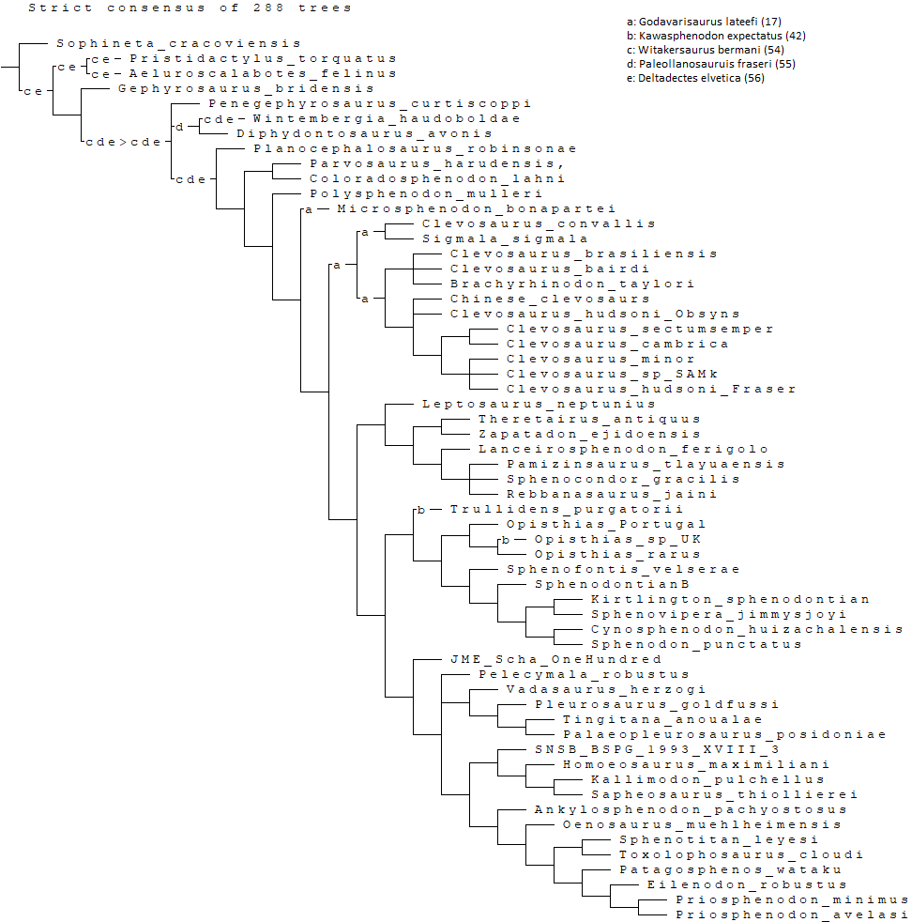
Figure S6. Strict consensus of 288 MPTs (L= 717) using an equally weighted parsimony analysis ignoring the alternative positions of unstable taxa (a, Godavisaurus lateefi; b, Kawasphenodon expectatus; c, Witakersaurus bermani; d, Paleollanosaurus fraseri; e, Deltadectes elvetica).

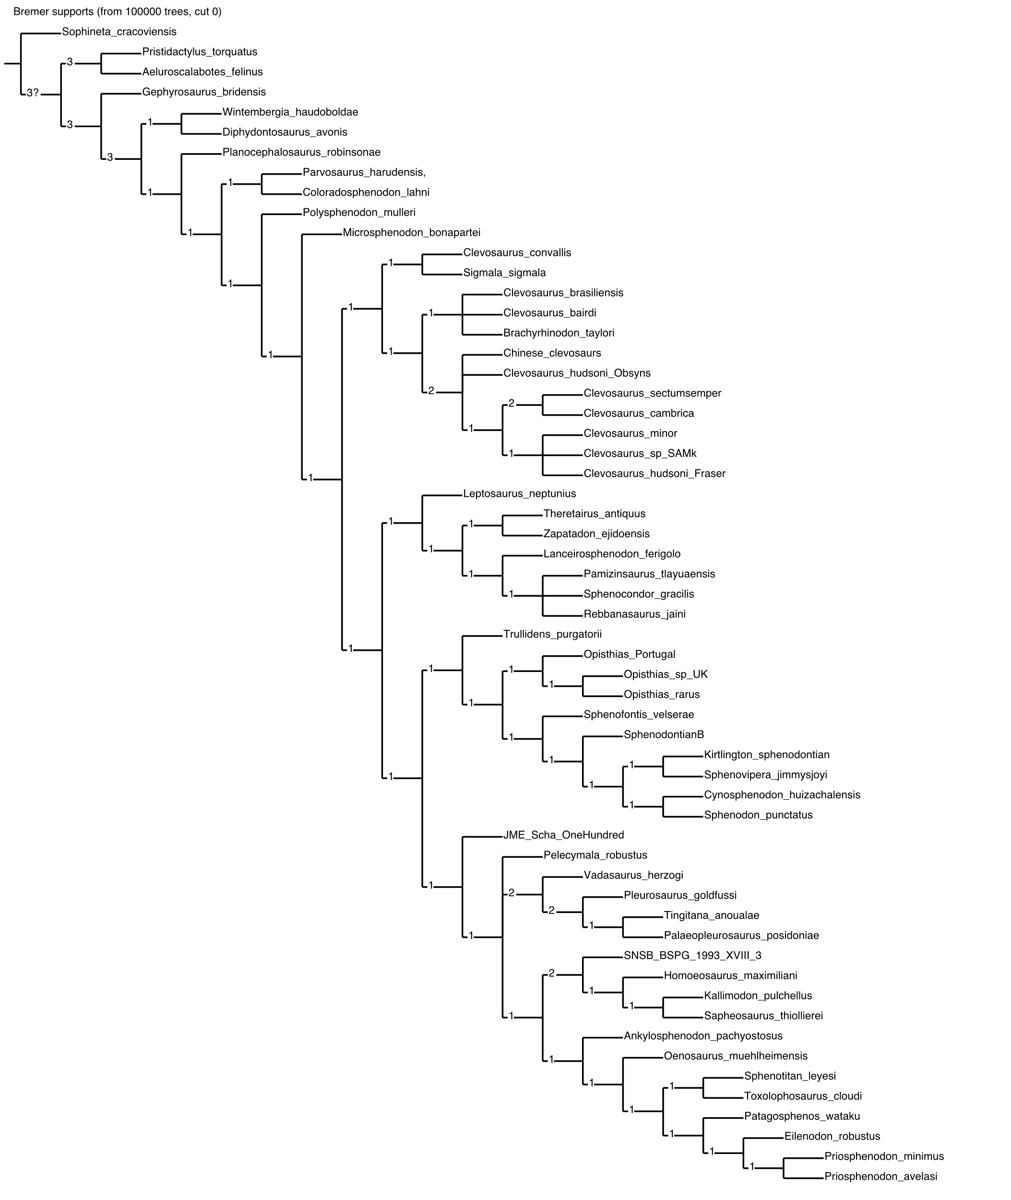
Figure S7. Bremer supports calculated by keeping suboptimal trees up to 3 steps longer (L+3) and keeping up to 100,000 trees in memory. The alternative placings of unstable taxa identified by IterPCR (Godavisaurus lateefi; Kawasphenodon expectatus; Witakersaurus bermani; Paleollanosaurus fraseri; and Deltadectes elvetica) was ignored for support calculations.

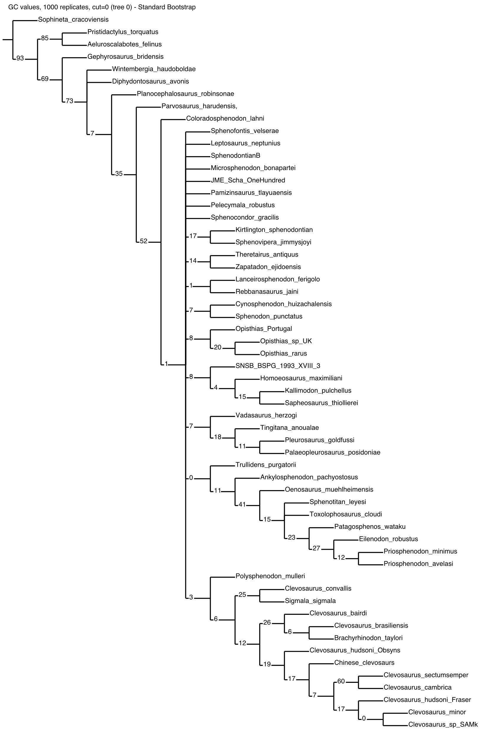
Figure S8. Bootstrap supports (GC values) calculated after 1000 replications. The alternative placings of unstable taxa identified by IterPCR (Godavisaurus lateefi; Kawasphenodon expectatus; Witakersaurus bermani; Paleollanosaurus fraseri; and Deltadectes elvetica) was ignored for support calculations.

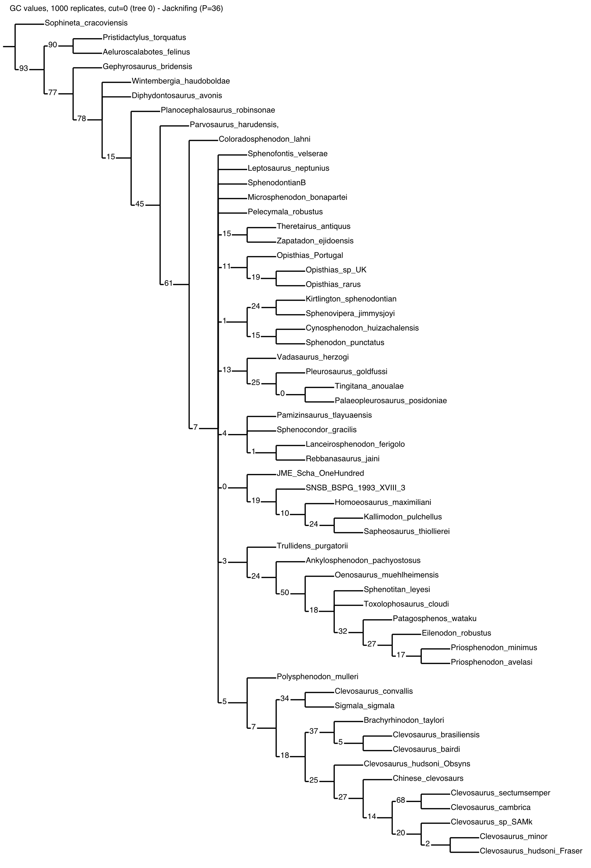
Figure S9. Jacknife supports (GC values) calculated after 1000 replications. The alternative placings of unstable taxa identified by IterPCR (Godavisaurus lateefi; Kawasphenodon expectatus; Witakersaurus bermani; Paleollanosaurus fraseri; and Deltadectes elvetica) was ignored for support calculations.

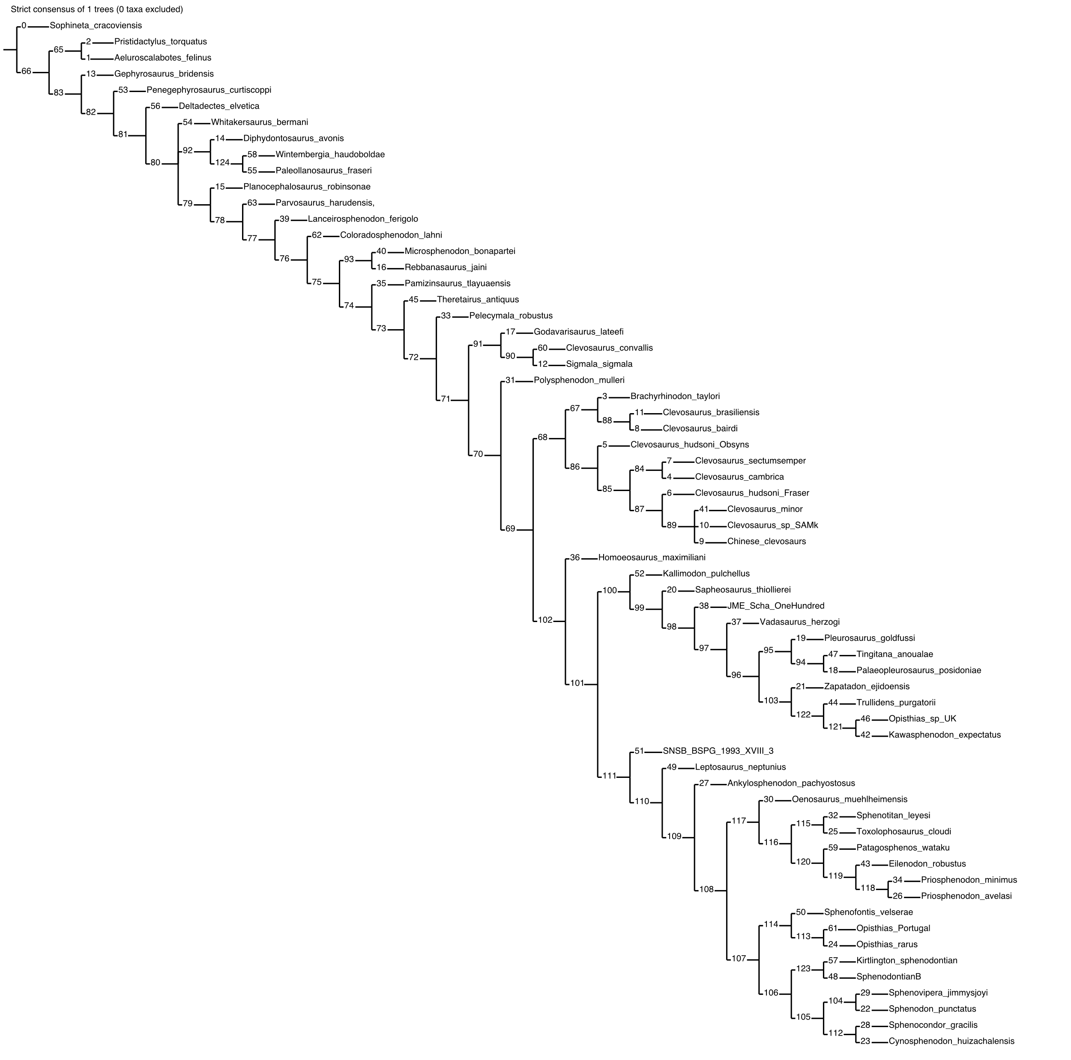
Figure S10. MPT obtained with the implied weighting protocol (k= 3; fit= 69.32432; CI= 0.266; RI= 0.596). Node numbers indicate internal reference used in TNT software.

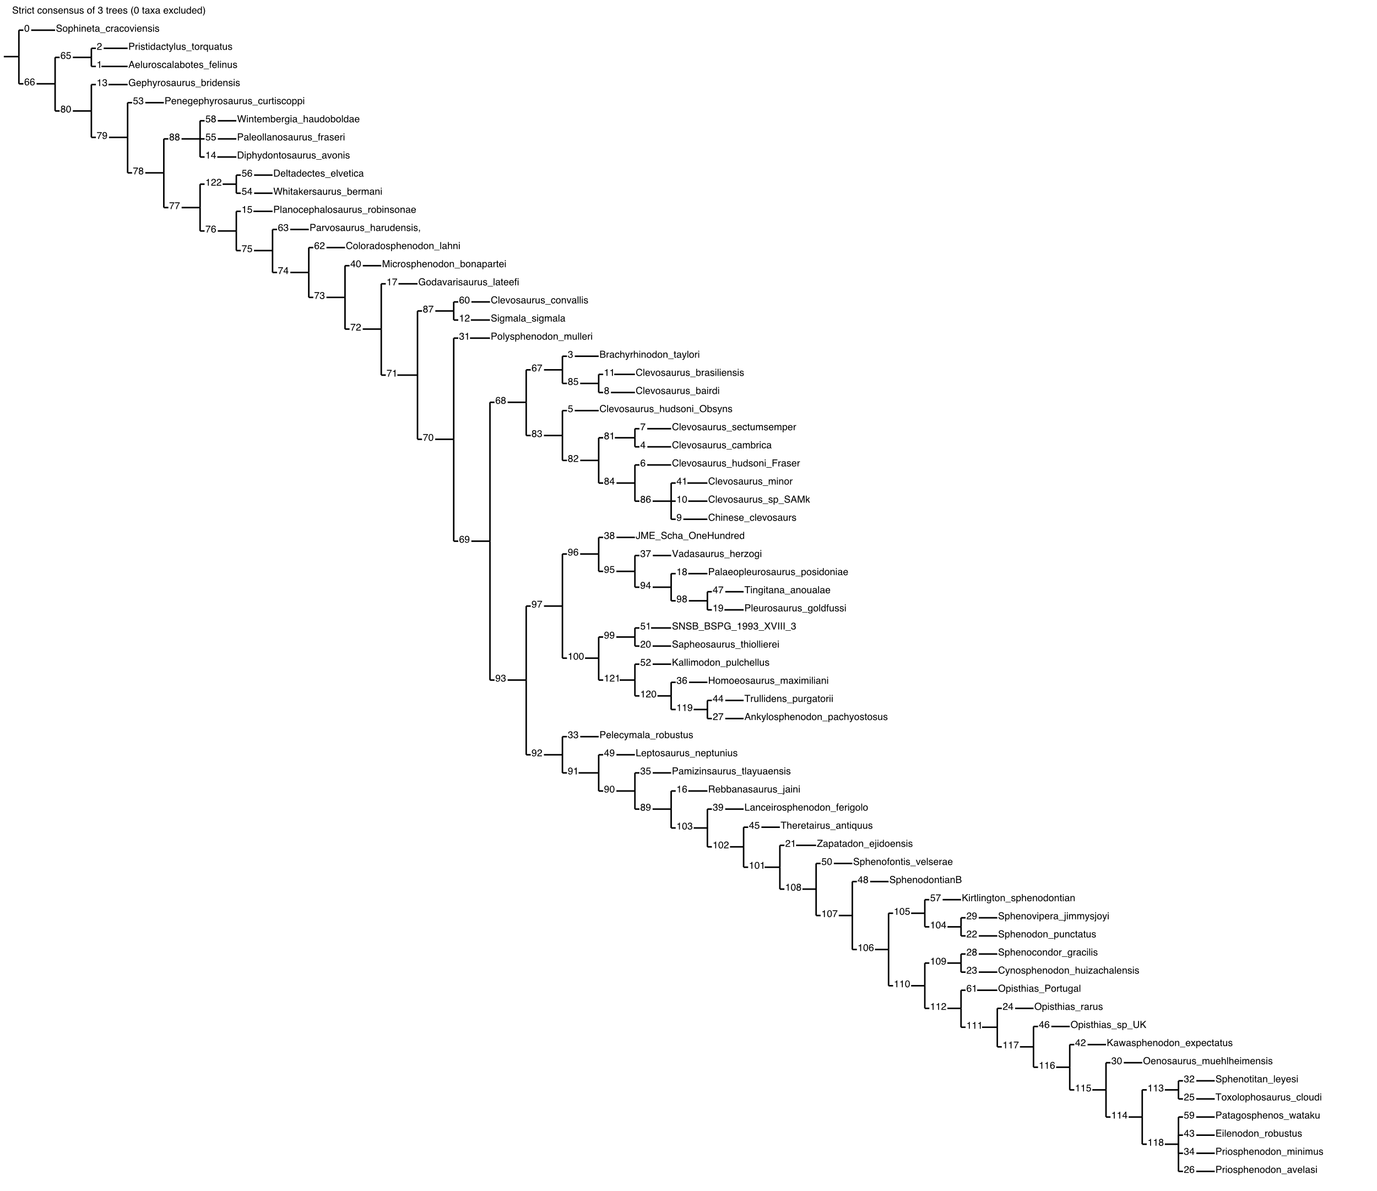
Figure S11. Strict consensus of 3 MPTs (obtained with the implied weighting protocol (k= 6; fit= 48.52020; CI= 0.274; RI= 0.610). Node numbers indicate internal reference used in TNT software.

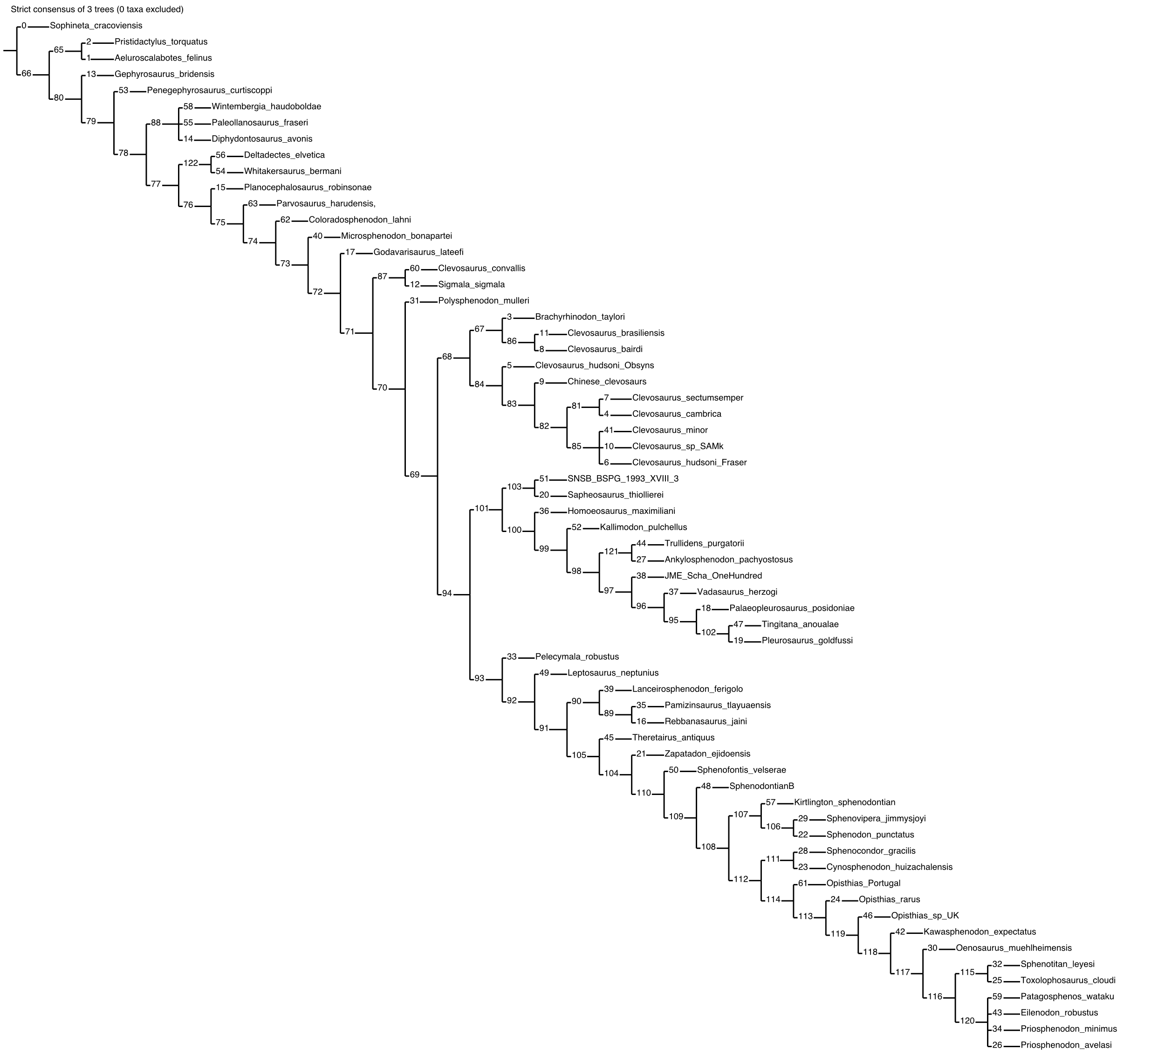
Figure S12. Strict consensus of 3 MPTs obtained with the implied weighting protocol (k= 9; fit= 37.52413; CI= 0.276; RI= 0.612). Node numbers indicate internal reference used in TNT software.

Figure S13. Strict consensus of 3 MPTs obtained with the implied weighting protocol (k= 12; fit= 30.68222; CI= 0.276; RI= 0.612). Node numbers indicate internal reference used in TNT software.

Figure S14. Strict consensus of 3 MPTs obtained with the implied weighting protocol (k= 15; fit= 26.00074; CI= 0.276; RI= 0.612). Node numbers indicate internal reference used in TNT software.

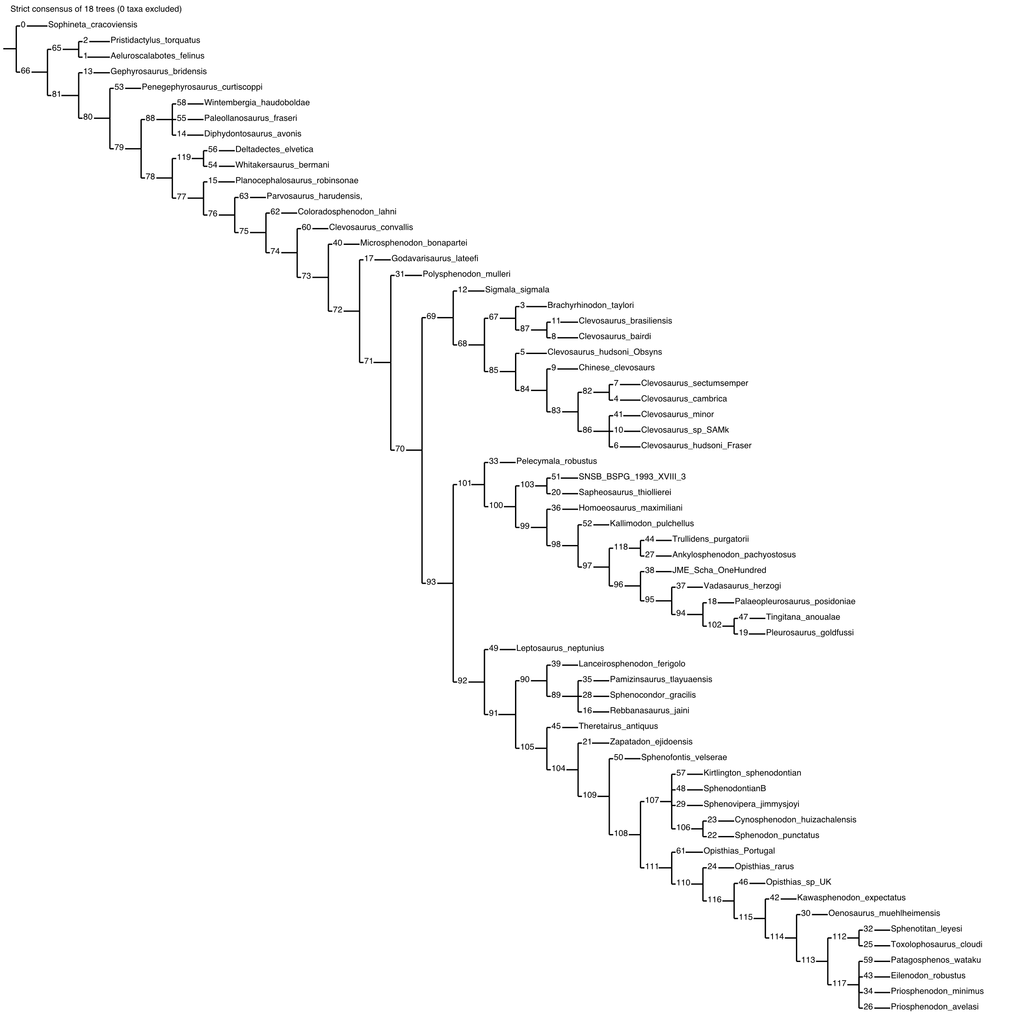
Figure S15. Strict consensus of 18 MPTs obtained with the implied weighting protocol (k= 25; fit= 17.26436; CI= 0.277; RI= 0.614). Node numbers indicate internal reference used in TNT software.

Figure S16. Common synapomorphies plotted on the strict consensus including all taxa. Numbers in the nodes represent character transformations.

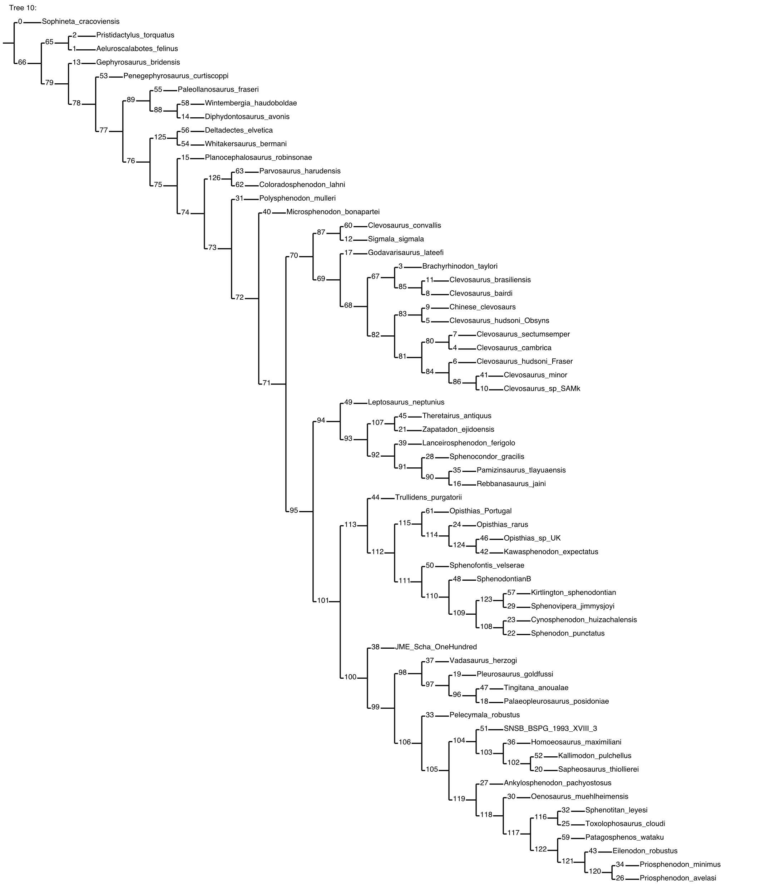Figure S17. Reference tree for the ambiguous synapomorphy mapping using the script apolistamb.run (Bravo et al., 2025). Numbers in the nodes are used for reference (see list below).

5. Synapomorphy list
It follows the synapomorphy list as obtained through ambiguous synapomorphy mapping using the script apolistamb.run (Bravo et al., 2025) in TNT software. Character numbered from 0 (zero). For node number reference see Figure S17.

Node 65:
5
7
27
29
33 (ambiguous)
37 (ambiguous)
55 (ambiguous)
58 (ambiguous)
59 (ambiguous)
73 (ambiguous)
76 (ambiguous)
77 (ambiguous)
88 (ambiguous)
90 (ambiguous)
126 (ambiguous)
130 (ambiguous)
135 (ambiguous)
155 (ambiguous)
_
Node 66:
26 (ambiguous)
31 (ambiguous)
_
Node 67:
15
83
135 (ambiguous)
_
Node 68:
2 (ambiguous)
30
44 (ambiguous)
46
76 (ambiguous)
84 (ambiguous)
92
97
108 (ambiguous)
109 (ambiguous)
135 (ambiguous)
_
Node 69:
0 (ambiguous)
1
8
21 (ambiguous)
55 (ambiguous)
91
95
116 (ambiguous)
132 (ambiguous)
142 (ambiguous)
145 (ambiguous)
155 (ambiguous)
_
Node 70:
6
107 (ambiguous)
109 (ambiguous)
_
Node 71:
0 (ambiguous)
55 (ambiguous)
88
115
142 (ambiguous)
145 (ambiguous)
149 (ambiguous)
155 (ambiguous)
_
Node 72:
21 (ambiguous)
34
35 (ambiguous)
39
40 (ambiguous)
54 (ambiguous)
58 (ambiguous)
78
89 (ambiguous)
107 (ambiguous)
127
158 (ambiguous)
_
Node 73:
13 (ambiguous)
23
29
50 (ambiguous)
63 (ambiguous)
68 (ambiguous)
76 (ambiguous)
109 (ambiguous)
129 (ambiguous)
159
160 (ambiguous)
161 (ambiguous)
_
Node 74:
13 (ambiguous)
15
26
31
35 (ambiguous)
40 (ambiguous)
43
44 (ambiguous)
45
48
58 (ambiguous)
63 (ambiguous)
67
68 (ambiguous)
69
117 (ambiguous)
123
_
Node 75:
0
3
12
54 (ambiguous)
55
59
60
65
74
76 (ambiguous)
82
89 (ambiguous)
102
109 (ambiguous)
117 (ambiguous)
119
121 (ambiguous)
155 (ambiguous)
158 (ambiguous)
160 (ambiguous)
161 (ambiguous)
_
Node 76:
16 (ambiguous)
18 (ambiguous)
29
50 (ambiguous)
70
81
87
96
97 (ambiguous)
101
118
125 (ambiguous)
129 (ambiguous)
144 (ambiguous)
_
Node 77:
21 (ambiguous)
30 (ambiguous)
33 (ambiguous)
39 (ambiguous)
77 (ambiguous)
90 (ambiguous)
107 (ambiguous)
114
117
128 (ambiguous)
130 (ambiguous)
140 (ambiguous)
145 (ambiguous)
_
Node 78:
16 (ambiguous)
18 (ambiguous)
19
21 (ambiguous)
30 (ambiguous)
39 (ambiguous)
107 (ambiguous)
122
124
128 (ambiguous)
132 (ambiguous)
140 (ambiguous)
_
Node 79:
44 (ambiguous)
49
51
55 (ambiguous)
58 (ambiguous)
59 (ambiguous)
71 (ambiguous)
73 (ambiguous)
76 (ambiguous)
94
97 (ambiguous)
106
126 (ambiguous)
159
160
_
Node 80:
15 (ambiguous)
18
27 (ambiguous)
34 (ambiguous)
46 (ambiguous)
88
135 (ambiguous)
138
_
Node 81:
4 (ambiguous)
15 (ambiguous)
83
106
124
_
Node 82:
10 (ambiguous)
12 (ambiguous)
99
109 (ambiguous)
_
Node 83:
4 (ambiguous)
10 (ambiguous)
24
43 (ambiguous)
63 (ambiguous)
71
125 (ambiguous)
149 (ambiguous)
_
Node 84:
38 (ambiguous)
101
102 (ambiguous)
110 (ambiguous)
111
115
155
_
Node 85:
12 (ambiguous)
15 (ambiguous)
_
Node 86:
10
83
107 (ambiguous)
108
124
_
Node 87:
16 (ambiguous)
17 (ambiguous)
22 (ambiguous)
26
113
_
Node 88:
86
103 (ambiguous)
_
Node 89:
93 (ambiguous)
98
107 (ambiguous)
129 (ambiguous)
_
Node 90:
83
89
104 (ambiguous)
107 (ambiguous)
118
131 (ambiguous)
_
Node 91:
3 (ambiguous)
17
48 (ambiguous)
80
113 (ambiguous)
_
Node 92:
2
3 (ambiguous)
50 (ambiguous)
69 (ambiguous)
101
102
_
Node 93:
18
25 (ambiguous)
32
33 (ambiguous)
37
38 (ambiguous)
65
71
72 (ambiguous)
75 (ambiguous)
77 (ambiguous)
79 (ambiguous)
86
118
139 (ambiguous)
141 (ambiguous)
144
_
Node 94:
23 (ambiguous)
37 (ambiguous)
43 (ambiguous)
45 (ambiguous)
107
111
131 (ambiguous)
137 (ambiguous)
141 (ambiguous)
_
Node 95:
6
13
14
33 (ambiguous)
35
52 (ambiguous)
61
89
126
132
133
135
147
150
152
154
155
161
_
Node 96:
2
15
20
28 (ambiguous)
40
41
48
49 (ambiguous)
69
99 (ambiguous)
106
109
123 (ambiguous)
130 (ambiguous)
146 (ambiguous)
_
Node 97:
1
12 (ambiguous)
25 (ambiguous)
29 (ambiguous)
44 (ambiguous)
53 (ambiguous)
115
123 (ambiguous)
137
149 (ambiguous)
158 (ambiguous)
_
Node 98:
12 (ambiguous)
14
15 (ambiguous)
29 (ambiguous)
44 (ambiguous)
63 (ambiguous)
132 (ambiguous)
138
139 (ambiguous)
141 (ambiguous)
146 (ambiguous)
149 (ambiguous)
158 (ambiguous)
_
Node 99:
15 (ambiguous)
21 (ambiguous)
36
38 (ambiguous)
52
53 (ambiguous)
75 (ambiguous)
77 (ambiguous)
95
106
107 (ambiguous)
157
_
Node 100:
16 (ambiguous)
29 (ambiguous)
70
87
114 (ambiguous)
151
158 (ambiguous)
_
Node 101:
33 (ambiguous)
35 (ambiguous)
61 (ambiguous)
106
128 (ambiguous)
131 (ambiguous)
137
_
Node 102:
24 (ambiguous)
61 (ambiguous)
68
111
116
123 (ambiguous)
132
144
_
Node 103:
50 (ambiguous)
79 (ambiguous)
114
123 (ambiguous)
146 (ambiguous)
148 (ambiguous)
153 (ambiguous)
_
Node 104:
47 (ambiguous)
50 (ambiguous)
63 (ambiguous)
76 (ambiguous)
131 (ambiguous)
153 (ambiguous)
_
Node 105:
59 (ambiguous)
85
102 (ambiguous)
108 (ambiguous)
113 (ambiguous)
120 (ambiguous)
121 (ambiguous)
_
Node 106:
1 (ambiguous)
15 (ambiguous)
83 (ambiguous)
95
_
Node 107:
66 (ambiguous)
87
128 (ambiguous)
131 (ambiguous)
_
Node 108:
1 (ambiguous)
3 (ambiguous)
47 (ambiguous)
66 (ambiguous)
76 (ambiguous)
89
131 (ambiguous)
137
140 (ambiguous)
145 (ambiguous)
_
Node 109:
2
17 (ambiguous)
74 (ambiguous)
83 (ambiguous)
93 (ambiguous)
95
106
132 (ambiguous)
133 (ambiguous)
134 (ambiguous)
135 (ambiguous)
_
Node 110:
7 (ambiguous)
8 (ambiguous)
15 (ambiguous)
59 (ambiguous)
64 (ambiguous)
80
93 (ambiguous)
104 (ambiguous)
105
120
_
Node 111:
7 (ambiguous)
8 (ambiguous)
24 (ambiguous)
42 (ambiguous)
43 (ambiguous)
51 (ambiguous)
59 (ambiguous)
64 (ambiguous)
74 (ambiguous)
85
104 (ambiguous)
128 (ambiguous)
133 (ambiguous)
134 (ambiguous)
135 (ambiguous)
150 (ambiguous)
_
Node 112:
88
_
Node 113:
6 (ambiguous)
10 (ambiguous)
87
102 (ambiguous)
111
_
Node 114:
7 (ambiguous)
9 (ambiguous)
25 (ambiguous)
28 (ambiguous)
30 (ambiguous)
31 (ambiguous)
44 (ambiguous)
65 (ambiguous)
92 (ambiguous)
109
131 (ambiguous)
_
Node 115:
2 (ambiguous)
6 (ambiguous)
8 (ambiguous)
10 (ambiguous)
22 (ambiguous)
36 (ambiguous)
54 (ambiguous)
59 (ambiguous)
63 (ambiguous)
64
71 (ambiguous)
80 (ambiguous)
125 (ambiguous)
130
161 (ambiguous)
_
Node 116:
2 (ambiguous)
42 (ambiguous)
57 (ambiguous)
62 (ambiguous)
80 (ambiguous)
83
88
123 (ambiguous)
161 (ambiguous)
_
Node 117:
6 (ambiguous)
8 (ambiguous)
10 (ambiguous)
36 (ambiguous)
54 (ambiguous)
57 (ambiguous)
59 (ambiguous)
62 (ambiguous)
76 (ambiguous)
85
91
92 (ambiguous)
110
131 (ambiguous)
134
138 (ambiguous)
139 (ambiguous)
143 (ambiguous)
155 (ambiguous)
_
Node 118:
11 (ambiguous)
22 (ambiguous)
33 (ambiguous)
42 (ambiguous)
47 (ambiguous)
49 (ambiguous)
50 (ambiguous)
71 (ambiguous)
87
_
Node 119:
12 (ambiguous)
63 (ambiguous)
88 (ambiguous)
92 (ambiguous)
111
_
Node 120:
4 (ambiguous)
11 (ambiguous)
12 (ambiguous)
49 (ambiguous)
50 (ambiguous)
56
88 (ambiguous)
100
105
155 (ambiguous)
160 (ambiguous)
_
Node 121:
16 (ambiguous)
63 (ambiguous)
82
83 (ambiguous)
97 (ambiguous)
111 (ambiguous)
_
Node 122:
92
_
Node 123:
17 (ambiguous)
101 (ambiguous)
111
113
115 (ambiguous)
_
Node 124:
101 (ambiguous)
106
107 (ambiguous)
115 (ambiguous)
_
Node 125:
11 (ambiguous)
18 (ambiguous)
94 (ambiguous)
102
124
_
Node 126:
2 (ambiguous)
7
10 (ambiguous)
17
24 (ambiguous)
39 (ambiguous)
61 (ambiguous)
71 (ambiguous)
94 (ambiguous)
95 (ambiguous)
107
124
_

6. Biogeographic analyses
The DEC+J model-based analysis indicates that the paleobiogeographic history of Rhynchocephalia was dominated by dispersive and vicariance events equally (26), without extinction event. Additionally, the result indicates that there were 26 sympatric events in area K (different basins in Europe), two sympatric events in area B (Argentine Patagonia), and one sympatric event in area I (central and eastern Mexico). Therefore, the paleobiogeographic history of Rhynchocephalia can be explained by 26 dispersal events, 26 vicariance events, and 29 sympatric events (Table S3; Supplementary Appendix S2).

TABLE S3. Event matrix, event route, and probability for each node obtained by DEC+J analysis in RASP. Abbreviations: D, dispersion; E, extinction; S, sympatry; V, vicariance.
Node | Event matrix |  |  |  | Event route | Probability
Node | D | V | E | S | Event route | Probability
57 | 0 | 0 | 0 | K:1 | KK^KK|K | 0.9995
58 | 1 | 1 | 0 | 0 | KKAK|A | 0.9540
59 | 0 | 0 | 0 | K:1 | KK^KK|K | 1.0000
60 | 1 | 1 | 0 | 0 | KKJK|J | 0.9496
61 | 1 | 1 | 0 | 0 | KCKC|K | 0.8865
62 | 0 | 0 | 0 | K:1 | KK^KK|K | 1.0000
63 | 1 | 1 | 0 | 0 | DDKD|K | 0.5875
64 | 1 | 1 | 0 | 0 | KKDK|D | 0.5793
65 | 0 | 0 | 0 | K:1 | KK^KK|K | 0.9860
66 | 1 | 1 | 0 | 0 | LLKL|K | 0.5562
67 | 1 | 1 | 0 | 0 | KKLK|L | 0.5486
68 | 0 | 0 | 0 | K:1 | KK^KK|K | 0.9181
69 | 0 | 0 | 0 | K:1 | KK^KK|K | 0.9963
70 | 1 | 1 | 0 | 0 | HHIH|I | 0.9917
71 | 1 | 1 | 0 | 0 | FFIF|I | 0.5698
72 | 1 | 1 | 0 | 0 | BBFB|F | 0.4366
73 | 1 | 1 | 0 | 0 | CCBC|B | 0.4176
74 | 1 | 1 | 0 | 0 | HCHC|H | 0.3353
75 | 1 | 1 | 0 | 0 | KKHK|H | 0.6003
76 | 1 | 1 | 0 | 0 | HHKH|K | 0.8111
77 | 0 | 0 | 0 | K:1 | KK^KK|K | 0.7988
78 | 1 | 1 | 0 | 0 | IGIG|I | 0.9799
79 | 1 | 1 | 0 | 0 | KIKI|K | 0.6143
80 | 0 | 0 | 0 | I:1 | II^II|I | 0.4695
81 | 1 | 1 | 0 | 0 | EEIE|I | 0.3785
82 | 1 | 1 | 0 | 0 | KKEK|E | 0.4705
83 | 0 | 0 | 0 | K:1 | KK^KK|K | 0.9493
84 | 1 | 1 | 0 | 0 | KHKH|K | 0.9570
85 | 1 | 1 | 0 | 0 | EKEK|E | 0.9512
86 | 0 | 0 | 0 | K:1 | KK^KK|K | 0.9487
87 | 0 | 0 | 0 | K:1 | KK^KK|K | 0.9962
88 | 0 | 0 | 0 | K:1 | KK^KK|K | 1.0000
89 | 0 | 0 | 0 | K:1 | KK^KK|K | 1.0000
90 | 0 | 0 | 0 | K:1 | KK^KK|K | 1.0000
91 | 1 | 1 | 0 | 0 | HHAH|A | 0.7070
92 | 0 | 0 | 0 | B:1 | BB^BB|B | 0.9998
93 | 1 | 1 | 0 | 0 | BHBH|B | 0.4893
94 | 0 | 0 | 0 | B:1 | BB^BB|B | 0.4274
95 | 1 | 1 | 0 | 0 | HBHB|H | 0.3970
96 | 1 | 1 | 0 | 0 | KKHK|H | 0.6063
97 | 1 | 1 | 0 | 0 | KIKI|K | 0.9004
98 | 0 | 0 | 0 | K:1 | KK^KK|K | 0.9534
99 | 0 | 0 | 0 | K:1 | KK^KK|K | 0.9983
100 | 0 | 0 | 0 | K:1 | KK^KK|K | 0.9987
101 | 0 | 0 | 0 | K:1 | KK^KK|K | 0.9999
102 | 0 | 0 | 0 | K:1 | KK^KK|K | 0.9591
103 | 0 | 0 | 0 | K:1 | KK^KK|K | 0.9567
104 | 0 | 0 | 0 | K:1 | KK^KK|K | 0.9903
105 | 1 | 1 | 0 | 0 | KCKC|K | 0.9782
106 | 0 | 0 | 0 | K:1 | KK^KK|K | 0.9768
107 | 0 | 0 | 0 | K:1 | KK^KK|K | 0.9432
108 | 0 | 0 | 0 | K:1 | KK^KK|K | 0.9828
109 | 0 | 0 | 0 | K:1 | KK^KK|K | 0.9818
110 | 0 | 0 | 0 | K:1 | KK^KK|K | 0.9702
111 | 0 | 0 | 0 | K:1 | KK^KK|K | 0.8999
Total | 26 | 26 | 0 | 29

The DEC+J analysis (Fig. S18) suggests that Rhynchocephalia (node 111), Sphenodontia (node 109), Acrosphenodontia (node 108), Eusphenodontia (node 106), Clevosauridae (node 69), Neosphenodontia (node 103), Sphenodontidae (node 84), Sphenodontinae (node 82), Opisthodontia (node 101), Pleurosauridae (node 87), and Sapheosauridae (node 88) originated in Europe (area K). According to the geographic provenance of the fossils (Supplementary Appendix S2), the region comprising the UK, France, and Germany is the most probable. In the case of non-Clevosauridae and non-Neosphenodontia Rhynchocephalia, Sphenodontia, Acrosphenodontia, and Eusphenodontia, their origin and diversification occurred in Europe. There were only two dispersal events, which were followed by instances of vicariance: one to Argentina (node 58, Coloradosphenodon lahni gen. et sp. nov.) and one to Brazil (node 105, Microsphenodon bonapartei). Clevosauridae also originated and diversified in Europe (node 69, area K), with dispersals and vicariant events to Brazil (node 61, Clevosaurus brasiliensis), Canada (node 60, Clevosaurus bairdi), China (node 67, Chinese Clevosaurus), and South Africa (node 64, Clevosaurus sp. SAMk).
Neosphenodontia has the origin in Europe (node 103, area K), but some groups have their diversification in other areas. The clade that includes Leptosaurus neptunius and Pamizinsaurus tlayuaensis (node 75) quickly dispersed outside to Europe, towards the USA (node 74, area H). From there, there were dispersals to Mexico (node 70, Zapatadon ejidoensis) and Brazil (node 73, area C). From Brazil, there was a dispersive event to the Argentine Patagonia (node 72, area B) and, finally, they returned to the Northern Hemisphere toward Canada and Mexico (node 71, Rebbanasaurus jaini and Pamizinsaurus tlayuaensis).
Sphenodontidae originated in Europe (node 84, area K) and had dispersal events to the USA (node 84 and 76, area H, Trullidens purgatorii and Ophistias rarus, respectively). Sphenodontinae also originated in Europe (node 82, area K), but their diversification occurred outside this area. They dispersed to Morocco (node 81, area E, Sphenodontian B) and later Mexico (node 80, area I). Finally, from Mexico, they reached New Zealand (node 78, area G, Sphenodon punctatus) and returned to Europe (node 79, area K, Kirtlington sphenodontian).
Ophistodontia also originated and diversified in Europe (node 101, area K), like Sapheosauridae (node 88). Pleurosauridae had the same origin (node 87, area K) but ended with a dispersion to Morocco (node 85, area E, Tingitana anoualae).
Only Eilenodontinae had its origin outside Europe, being the USA the most probable ancestral area (node 95, area H). From this area, there was a dispersion to the Argentine Patagonia (node 95, area B) and to north-western Argentina (node 91, area A, Sphenotitan leyesi). Finally, from southern Argentine (Patagonia), there was a second dispersive event towards the USA (node 93, area H, Eilenodon robustus).
The BAYAREALIKE+J and DIVALIKE+J analyses indicated the same result, both in the reconstructions of ancestral areas and in the quantity and types of events that explain the paleobiogeographic history of rhynchocephalids (Fig. S19). These analyses differ from the DEC+J in that they have one more dispersive and vicariance event (27) and one less sympatric event (28) (Supplementary Appendix S2). This occurs because of the reconstruction of node 93, where DEC+J infers area B as the most likely ancestor (Fig. S18), but the other two analyses infer area H (Fig. S19). The BBM analyses resulted in a similar paleobiogeographic reconstruction, although this method amplifies the reconstruction of Europe as an ancestral area (Fig. S20). Nodes 63, 66, 74, 81, and 95, have Europe (area K) as most probable ancestral area in the BBM analysis, and the other three methods recognized other areas. The BBM analysis revealed a paleobiogeographic history characterized by 21 dispersal and vicariance events, along with three extinction events, which are identified at nodes 95, 81, and 74. Additionally, the analysis required a higher occurrence of sympatric speciation events in Europe, totaling 31 events, while only two such events are recognized in Argentine Patagonia (area B) and other one in Mexico (area I). The reconstruction obtained using the BBM method is more parsimonious, as it does not imply dispersal followed by vicariance, followed by a subsequent return to the same area with another vicariance event (e.g., nodes 66 and 63 in the DEC+J analysis; Fig. S18). However, the studies performed using the BioGeoBEARS package in RASP include a table of dispersal probabilities between areas according to the paleogeographic reconstruction for each period (Supplementary Appendix S5). The BBM analysis does not consider this type of information, and perhaps this is why the differences in the results are due.
In order to consider the biogeographic implications of the stem-lepidosaur of Taytalura alcoberi from the Ischigualasto Formation in Argentina (Martínez et al., 2021), we included this taxon in the aforementioned DEC+J model-based analysis. This analysis suggests that a region represented by centro-western Argentina and Europe (areas A+K) was the most probable ancestral area of the clade integrated by Taytalura alcoberi + Rhynchocephalia (Fig. S21).
Figure S18. Result of the DEC+J analysis in RASP. For better graphical representation, branch lengths are not represented. *Remaining areas with <5% ancestral area probability.
Figure S19. Results of the BAYAREALIKE+J and DIVALIKE+J analyses in RASP. For better graphical representation, branch lengths are not represented. *Remaining areas with <5% ancestral area probability.
Figure S20. Result of the BBM analysis in RASP. For better graphical representation, branch lengths are not represented. *Remaining areas with <5% ancestral area probability.
Figure S21. Result of the DEC+J analysis in RASP including Taytalura alcoberi. For better graphical representation, branch lengths are not represented. *Remaining areas with <5% ancestral area probability.
7. Morphological disparity analyses
Figure S22. Morphological disparity analysis (WMPD) considering all cranial characters from the phylogenetic data matrix.

Figure S23. Morphological disparity analyses (WMPD) considering only lower and upper marginal dentition characters from the phylogenetic data matrix.
Figure S24. Morphological disparity analyses (WMPD) considering only lower jaw characters from the phylogenetic data matrix.
Figure S25. Morphological disparity analyses (WMPD) considering only lower jaw plus mandibular teeth characters from the phylogenetic data matrix.
Figure S26. Morphological disparity analyses (WMPD) considering only cranial characters from the phylogenetic data matrix (excluding lower jaw, lower dentition, and upper marginal dentition characters).
Figure S27. Morphological disparity analyses (WMPD) considering only cranial plus upper dentition characters from the phylogenetic data matrix (excluding lower jaw and lower teeth characters).

8. References
Arantes, B. de A., Soares, M. B. & Schultz, C. L. Clevosaurus brasiliensis (Lepidosauria, sphenodontia) do Triássico Superior do Rio Grande do Sul: anatomía pós-craniana e relaçŏnes filogenéticas. Rev. Bras. Paleontol. 12, 43–54. 10.4072/rbp.2009.1.04 (2009).
Arcucci, A. B., Marsicano, C. A. & Caselli, A. T. Tetrapod association and palaeoenvironment of the Los Colorados Formation (Argentina): a significant sample from western Gondwana at the end of the Triassic. Geobios 37, 557–568. 10.1016/j.geobios.2003.04.008 (2004).
Beccari, V. et al. A juvenile pleurosaurid (Lepidosauria: Rhynchocephalia) from the Tithonian of the Mörnsheim Formation, Germany. Anat. Rec. 308(3), 844–867. 10.1002/ar.25545 (2024).
Bever, G. S. & Norell, M. A. A new rhynchocephalian (Reptilia: Lepidosauria) from the Late Jurassic of Solnhofen (Germany) and the origin of the marine Pleurosauridae. R. Soc. Open Sci. 4, 170570. 10.1098/rsos.170570 (2017).
Bonaparte, J. F. El primer Ictidosaurio (Reptilia-Therapsida) de América del Sur, Chaliminia musteloides, del Triásico Superior de la Rioja, República Argentina. Actas II Congr. Argent. Palaeont. Bioestratig. I Congr. Latinoamer. Paleont. Buenos Aires, 123–133 (1980).
Bonaparte, J. F. Descripción de 'Fasolasuchus tenax' y su significado en la sistemática y evolución de los Thecodontia. Rev. Mus. Argent. Cienc. Nal., Palaeontol. 3, 55–101 (1981).
Bonaparte, J. F. & Sues, H. D. A new species of Clevosaurus (Lepidosauria: Rhynchocephalia) from the Upper Triassic of Rio Grande do Sul, Brazil. Palaeontology. 449, 917–923 (2006).
Bravo, G. G. et al. A new notosuchian crocodyliform from the Paleocene of Patagonia and the survival of a large-bodied terrestrial lineage across the K–Pg mass extinction [Dataset]. Dryad; https://doi.org/10.5061/dryad.8kprr4xxr (2025).
Carroll, R. L. A pleurosaur from the Lower Jurassic and the taxonomic position of the Sphenodontida. Palaeontographica, Abteilung Band A 189, 1–28 (1985).
Carroll, R. L. & Wild, R. Marine members of Sphenodontia in The shadow of dinosaurs (eds. Fraser, N. C. and Sues, H. D.) 70–83 (Cambridge University Press, 1994).
Caselli, A. T., Marsicano, C. A. & Arcucci, A. B. Sedimentology and palaeontology of Los Colorados Formation. Upper Triassic (La Rioja and San Juan provinces, Argentina). Rev. Asoc. Geol. Argent. 56(2), 173–188 (2001).
Chambi-Trowell, S. A. V., Whiteside, D. I. & Benton, M. J. Diversity in rhynchocephalian Clevosaurus skulls based on CT reconstruction of two Late Triassic species from Great Britain. Acta Palaeontol. Pol. 64(1), 41–64 (2019).
Chambi-Trowell, S. A. V., Whiteside, D. I., Benton, M. J. & Rayfield, E. Biomechanical properties of the jaws of two species of Clevosaurus and reanalysis of rhynchocephalian dentary morphospace. Palaeontology 63, 919–939 (2020).
Chambi-Trowell, S. A. V. et al. The diversity of Triassic South American sphenodontians: a new basal form, clevosaurs, and a revision of rhynchocephalian phylogeny. J. Syst. Paleontol. 19(11), 787–820. 10.1080/14772019.2021.1976292 (2021).
Cocude-Michel, M. Les Rhynchocéphales et les Sauriens des Calcaires lithographiques (Jurassique supérieur) d’Europe occidentale. Nouvelles Archives du Muséum d’Histoire Naturelle de Lyon, 7, 1–187 (1963).
DeMar, Jr, D. G., Jones, M.E.H. & Carrano, M. T. A nearly complete skeleton of a new eusphenodontian from the Upper Jurassic Morrison Formation, Wyoming, USA, provides insight into the evolution and diversity of Rhynchocephalia (Reptilia: Lepidosauria). J. Syst. Palaeontol. 20(1), 1–64 (2022).
Desojo, J. B. & Báez, A. M. El esqueleto postcraneano de Neoaetosauroides (Archosauria: Aetosauria) del Triásico Superior del centro-oeste de Argentina. Ameghiniana 42, 115–126 (2005).
Desojo, J. B. et al. The Late Triassic Ischigualasto Formation at Cerro Las Lajas (La Rioja, Argentina): fossil tetrapods, high-resolution chronostratigraphy, and faunal correlations. Sci. Rep. 10, 12782. 10.1038/s41598-020-67854-1 (2020).
Dupret, V. The pleurosaurs: anatomy and phylogeny. Revue de Paléeobiologie, 9, 61–80 (2004).
Evans, S. E. The skull of a new eosuchian reptile from the Lower Jurassic of South Wales. Zool. J. Linn. Soc. 70, 203–264 (1980).
Evans, S. E., Prasad, G. V. R. & Manhas, B. K. Rhynchocephalians (Diapsida: Lepidosauria) from the Jurassic Kota Formation of India. Zool. J. Linn. Soc. 133, 309–334. 10.1006/zjls.2000.0266 (2001).
Evans, S. E. & Sigogneau-Russell, D. New Sphenodontians (Diapsida: Lepidosauria: Rhynchocephalia) from the Early Cretaceous of North Africa. J. Vertebr. Paleontol. 17(1), 45–51 (1997).
Ezcurra, M. D. A new early coelophysoid neotheropod from the Late Triassic of Northwestern Argentina. Ameghiniana 54, 506–538. 10.5710/AMGH.04.08.2017.3100 (2017).
Foffa, D., Whiteside, D. I., Viegas, P. A. & Benton. M. J. Vertebrates from the Late Triassic Thecodontosaurus-bearing rocks of Durdham Down, Clifton (Bristol, UK). Proc. Geol. Assoc. 125, 317–328 (2014).
Fraser, N. C. A new rhynchocephalian from the British Upper Triassic. Palaeontology 25, 709–725 (1982).
Fraser, N. C. New Triassic sphenodontids from south-west England and a review of their classification. Palaeontology 29(1), 165–186 (1986).
Fraser, N. C. The osteology and relationships of Clevosaurus (Reptilia: Sphenodontia). Phylos. Trans. R. Soc. London, Ser. B. 321, 125–178 (1988).
Fraser, N. C. & Benton, M. J. The Triassic reptiles Brachyrhinodon and Polysphenodon and the relationships of the sphenodontids. Zool. J. Linn. Soc. 96, 413–445 (1989).
Freisem, L. S., Müller, J., Sues, H. D. & Sobral, G. A new sphenodontian (Diapsida: Lepidosauria) from the Upper Triassic (Norian) of Germany and its implications for the mode of sphenodontian evolution. BMC Ecol. Evol. 24, 35. 10.1186/s12862-024-02218-1 (2024).
Gaetano, L. C. et al. A new cynodont from the Upper Triassic Los Colorados Formation (Argentina, South America) reveals a novel paleobiogeographic context for mammalian ancestors. Sci. Rep. 12, 6451. 10.1038/s41598-022-10486-4 (2022).
Herrera-Flores, J. A., Stubbs, T. L., Elsler, A. & Benton, M. J. Taxonomic reassessment of Clevosaurus latidens Fraser, 1993 (Lepidosauria, Rhynchocephalia) and rhynchocephalian phylogeny based on parsimony and Bayesian inference. J. Paleontol. 92(4), 734–742 (2018).
Hsiou, A. S., Gallo De França, M. A. & Ferigolo, J. New Data on the Clevosaurus (Sphenodontia: Clevosauridae) from the Upper Triassic of Southern Brazil. PLoS ONE 10(9), e0137523. 10.1371/journal.pone.0137523 (2015).
Hsiou, A. S. et al. A new clevosaurid from the Triassic (Carnian) of Brazil and the rise of Sphenodontians in Gondwana. Sci. Rep. 9, 11821. 10.1038/s41598-019-48297-9 (2019).
Jones, M. E. The Early Jurassic clevosaurs from China (Diapsida: Lepidosauria). New Mex. Mus. Nat. Hist. Sci. Bull. 37, 548–562. (2006)
Jones, M. E. H. et al. Integration of molecules and new fossils supports a Triassic origin for Lepidosauria (lizards, snakes, and tuatara). BMC Evol. Biol. 13, 208. doi:10.1186/1471-2148-13-208 (2013).
Keeble, E., Whiteside, D. I. & Benton, M. J. The terrestrial fauna of the Late Triassic Pant-y-ffynnon Quarry fissures, South Wales, UK and a new species of Clevosaurus (Lepidosauria: Rhynchocephalia). Proc. Geol. Assoc. 129, 99–119. 10.1016/j.pgeola.2017.11.001 (2018).
Kent, D. V., Santi M. P., Colombi, C. E., Alcober, O. A. & Martínez, R. N. Age constraints on the dispersal of dinosaurs in the Late Triassic from magnetochronology of the Los Colorados Formation (Argentina). Proc. Natl. Acad. Sci. 111, 7958–7963. 10.1073/pnas.1402369111 (2014).
Klein, N. & Scheyer, T. M. Microanatomy and life history in Palaeopleurosaurus (Rhynchocephalia: Pleurosauridae) from the Early Jurassic of Germany. Sci. Nat. 104, 4. 10.1007/s00114-016-1427-3 (2016).
Klein, C. G., Whiteside, D. I., Selles de Lucas, V., Viegas, P. A. & Benton, M. J. A distinctive Late Triassic microvertebrate fissure fauna and a new species of Clevosaurus (lepidosauria: Rhynchocephalia) from Woodleaze Quarry, Gloucestershire, UK. Proc. Geol. Assoc. 126, 402–416. 10.1016/j.pgeola.2015.05.003 (2015).
Leardi, J. M., Yañez, I. & Pol, D. South American crocodylomorphs (Archosauria; Crocodylomorpha): A review of the early fossil record in the continent and its relevance on under-standing the origins of the clade. J. South Am. Earth Sci. 104, 102780. 10.1016/j.jsames.2020.102780 (2020).
Martínez, R. N. et al. A new sphenodontian (Lepidosauria: Rhynchocephalia) from the Late Triassic of Argentina and the early origin of the herbivore opisthodontians. Proc. R. Soc. London. Ser. B. 280, 1–7, 20132057. 10.1098/rspb.2013.2057 (2013).
Martínez, R. N. et al. New Late Triassic Vertebrate Assemblage from Northwestern Argentina. Ameghiniana 52(4), 379–390. 10.5710/AMGH.27.04.2015.2889 (2015).
Martínez, R. N., Simões, T. R., Sobral, G. & Apesteguía, S. A Triassic stem lepidosaur illuminates the origin of lizard-like reptiles. Nature. 597, 235–238. 10.1038/s41586-021-03834-3 (2021)
Milana, J. P. & Alcober, O. Modelo tectosedimentario de la cuenca Triásica de Ischigualasto (San Juan, Argentina). Rev. Asoc. Geol. Argent. 49, 217–235 (1994).
O’Brien, A., Whiteside, D. I. & Marshall, J. E. A. Anatomical study of two previously undescribed specimens of Clevosaurus hudsoni (Lepidosauria: Rhynchocephalia) from Cromhall Quarry, UK, aided by computed tomography, yields additional information on the skeleton and hitherto undescribed bones. Zool. J. Linn. Soc. 183, 163–195 (2018).
Pol, D., Otero, A., Apaldetti, C. & Martínez, R. Triassic sauropodomorph dinosaurs from South America: The origin and diversification of dinosaur dominated herbivorous faunas. J. South Am. Earth Sci. 107, 103145. 10.1016/j. jsames.2020.103145 (2021).
Robinson, P. L. A problematic reptile from the British Upper Trias. J. Geol. Soc. London 129, 457–479 (1973).
Romo de Vivar Martínez, P. R. & Soares, M. B. Dentary morphological variation in Clevosaurus brasiliensis (Rhynchocephalia, Clevosauridae) from the Upper Triassic of Rio Grande do Sul, Brazil. PLoS ONE 10(3), e0119307. 10.1371/journal.pone.0119307 (2015).
Romo de Vivar Martínez, P. R., Martinelli, A. G., Hsiou, A. S. & Soares, M. B. A new rhynchocephalian from the Late Triassic of southern Brazil enhances eusphenodontian diversity. J. Syst. Paleontol. 18(13), 1103–1126. 10.1080/14772019.2020.1732488 (2020).
Rougier, G. W., Fuente, M. S. & Arcucci, A. B. Late Triassic turtles from South America. Science 268, 855–58. 10.1126/science.268.5212.855 (1995).
Säilä, L. K. Clevosaurus from the Lower Jurassic of South Wales. Palaeontology 48, 817–831 (2005).
Santi Malnis, P., Colombi, C. E., Rothis, L. M. & Alcober, O. Fluvial architecture and paleoenvironmental evolution of the Los Colorados Formation (Norian): Postrift stage of the Ischigualasto–Villa Unión Basin, NW Argentina. J. Sediment. Res. 90(10), 1436–1462. 10.2110/jsr.2020.65 (2020).
Sues, H. D., Shubin, N. H. & Olsen, P. E. A New Sphenodontian (Lepidosauria: Rhynchocephalia) from the Mccoy Brook Formation (Lower Jurassic) of Nova Scotia, Canada. J. Vertebr. Paleontol. 14, 327–340 (1994).
Sues, H. D. & Reisz, R. R. First Record of the Early Mesozoic Sphenodontian Clevosaurus (Lepidosauria: Rhynchocephalia) from the Southern Hemisphere. J. Vertebr. Paleontol. 69, 123–126 (1995).
Sues, H. D. & Schoch, R. R. The oldest known rhynchocephalian reptile from the Middle Triassic (Ladinian) of Germany and its phylogenetic position among Lepidosauromorpha. Anat. Rec. 307, 776–790. 10.1002/ar.25339 (2023).
von Baczko, M. B., Desojo, J. B. & Ponce, D. Postcranial anatomy and osteoderm histology of Riojasuchus tenuisceps and a phylogenetic update on ornithosuchidae (Archosauria, Pseudosuchia). J. Vertebr. Paleontol. 39, e1693396. 10.1080/02724634.2019.1693396 (2020).
Whiteside, D. I. The head skeleton of the Rhaetian sphenodontid Diphydontosaurus avonis gen. et sp. nov. and the modernizing of a living fossil. Phil. Trans. R. Soc. Lond. B. 312, 379–430. 10.1098/rstb.1986.0014 (1986).
Wu, X. C. Late Triassic-Early Jurassic sphenodontians from China and the phylogeny of the Sphenodontia in In the shadow of dinosaurs (eds. Fraser, N. C. and Sues, H. D.) 38–69 (Cambridge University Press, 1994).

