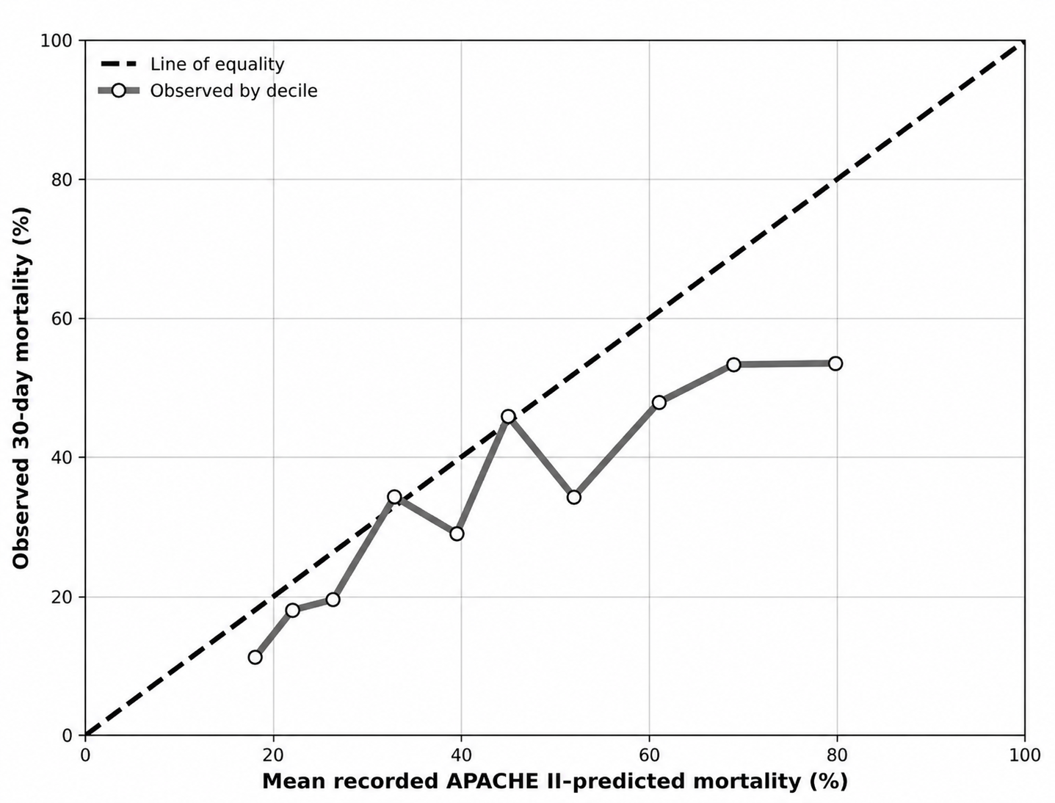

Supplementary Figure S1. Descriptive agreement plot comparing locally recorded APACHE II–predicted mortality probabilities with observed 30-day all-cause mortality. Patients were grouped into deciles according to the recorded APACHE II–predicted mortality probability. For each decile, the mean recorded predicted mortality probability was plotted against the observed 30-day all-cause mortality proportion. The diagonal line represents equality between recorded predicted and observed mortality. As detailed in the Data collection subsection of the Methods, these locally recorded probabilities could not be centrally reconstructed. This descriptive agreement plot does not constitute formal APACHE II validation or recalibration.

