Supplementary information for:

A genome-wide association study based on plasma high-throughput untargeted metabolomic profiles expands the number of genetically influenced metabolites in pigs

Samuele Bovo^{1,*}, Matteo Bolner¹, Giuseppina Schiavo¹, Francesca Bertolini¹, Maurizio Gallo², Luca Fontanesi^{1,*}

¹ Animal and Food Genomics Group, Division of Animal Sciences, Department of Agricultural and Food Sciences, University of Bologna, Viale Fanin 46, 40127 Bologna, Italy
² Associazione Nazionale Allevatori Suini, Via Nizza 53, 00198 Roma, Italy

*Corresponding authors: Samuele Bovo and Luca Fontanesi
Emails: samuele.bovo@unibo.it, luca.fontanesi@unibo.it

Figure S1. Principal component analysis (PCA) of the genomic relationship matrix. The first two principal components (PC1 and PC2) are shown, together with the percentage of variance explained by each component. Each dot represents one animal.
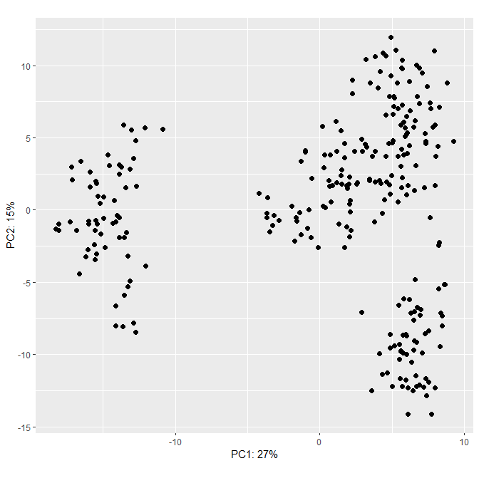
Table S1. Super-pathways, sub-pathways, and metabolites included in the study.
[Spreadsheet]

Table S2. Narrow-sense (h²_{A}) and genomic (h²_{G}) heritability estimates for plasma metabolites in Italian Duroc pigs.
[Spreadsheet]

Table S3. Cross-platform comparison of heritability estimates for metabolites shared between the Biocrates and Metabolon platforms. Biocrates-based estimates were obtained from Bovo et al. [20].
[Spreadsheet]

Table S4. Genomic inflation factors (λ).
[Spreadsheet]

Table S5. Overview of significant mQTL regions identified in the study. Detailed association statistics are available in Supplementary Tables S6-S8.
[Spreadsheet]

Table S6. Genome-wide significant associations identified by single-metabolite mGWAS.
[Spreadsheet]

Table S7. Novel significant associations identified by conditional single-metabolite mGWAS.
[Spreadsheet]

Table S8. Genome-wide significant associations identified by metabolite ratio-based mGWAS.
[Spreadsheet]

Table S9. Biological functions of candidate genes underlying significant mQTL regions.
[Spreadsheet]

