Supplementary Information for

Computer modeling of new tBRCT inhibitors of the BRCA1
Boris P. Gladkikh^{1,2}
¹Volzhsky Polytechnic Institute (Branch), Volgograd State Technical University (VSTU), 42a Engels Street, Volzhsky 404121, Russia
²Volgograd State Technical University (VSTU), Lenin Avenue, 28, Volgograd 400005, Russia
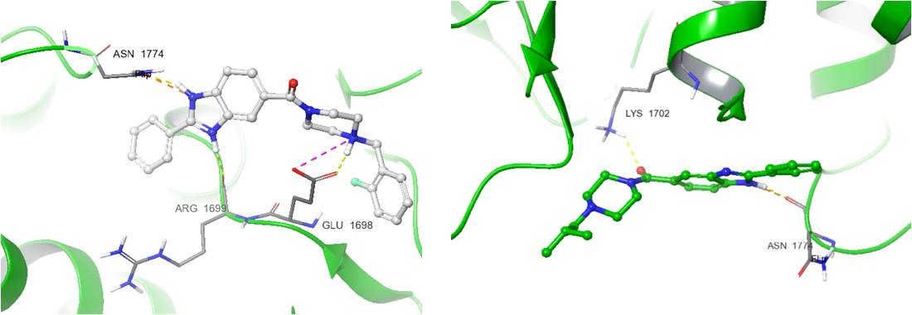
Figure S1. The best IFD poses of Bractoppin and CCBT2047 with tBRCT domain. The yellow dotted line indicates the hydrogen bond; the purple dotted line indicates the halogen bond.
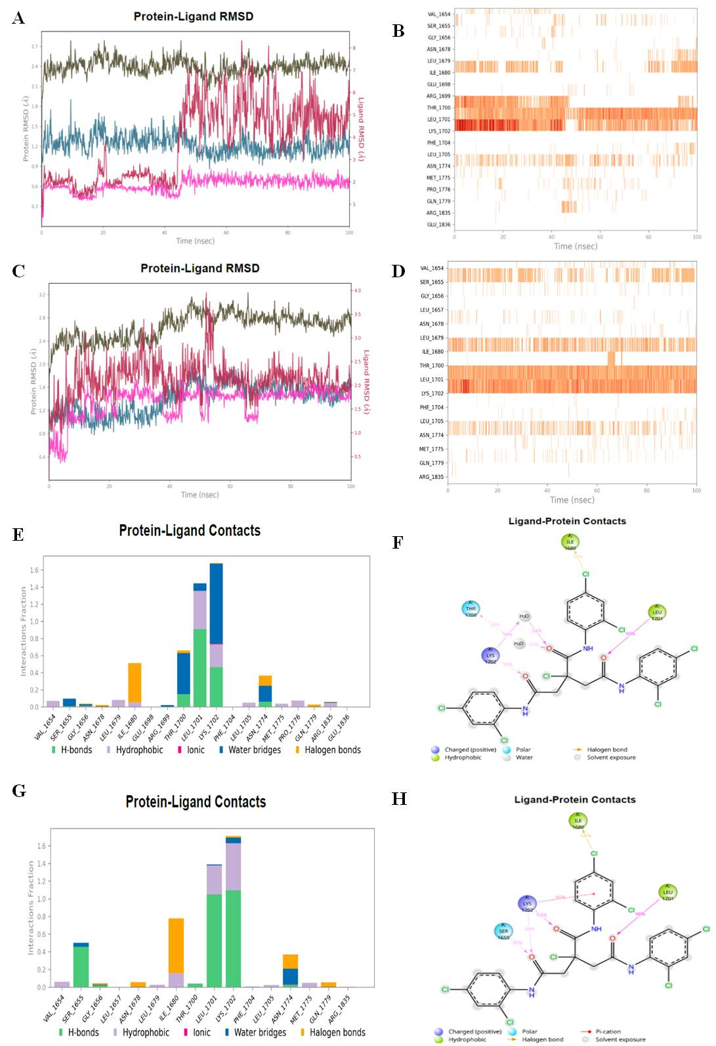
Figure S2. RMSD and protein-ligand interactions (PLI) of complexes 13 with tBRCT domain. A, B – RMSD and PLI of complex 13 (seed 42). C,D – RMSD and PLI of complex 13 (seed 12345). E,F – Protein-Ligand Contacts (PLC) and Ligand-protein Contacts (LPC) of complex 13 (seed 42). G,H – Protein-Ligand Contacts (PLC) and Ligand-protein Contacts (LPC) of complex 13 (seed 12345).
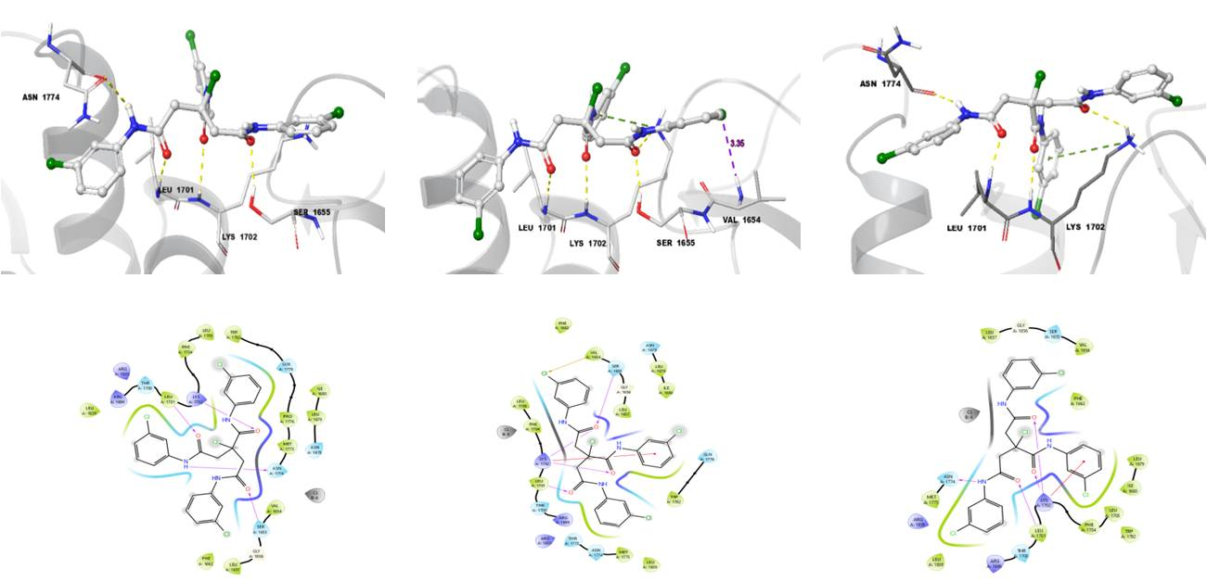
Figure S3. The best IFD poses of compound 12 with tBRCT domain. The yellow dotted line indicates the hydrogen bond; the purple dotted line indicates the halogen bond.
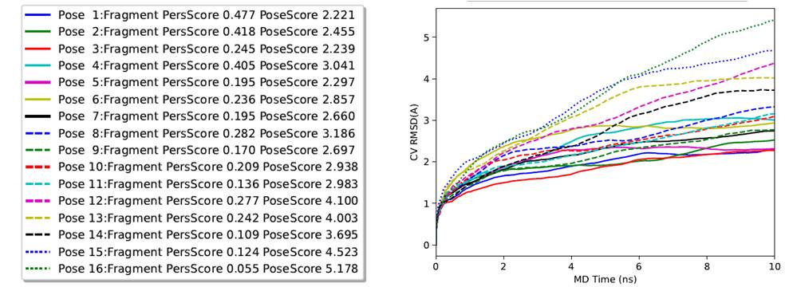
Figure S4. BPMD of 16 IFD poses of compound 12.
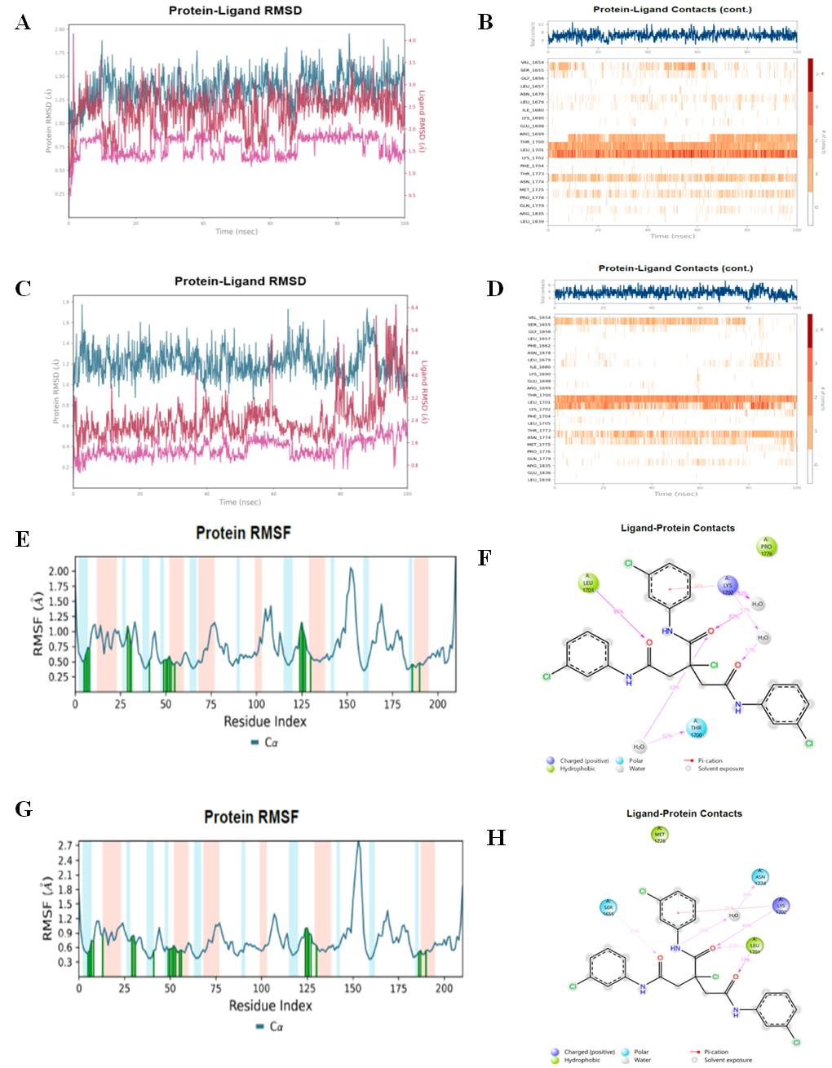
Figure S5. Pose 1 of BPMD of complexes 12 with tBRCT domain. A, B – RMSD and PLI of complex 12 (seed 42). C,D – RMSD and PLI of complex 12 (seed 12345). E,F – RMSF and Ligand-protein Contacts (LPC) of complex 12 (seed 42). G,H – RMSF and Ligand-protein Contacts (LPC) of complex 12 (seed 12345).
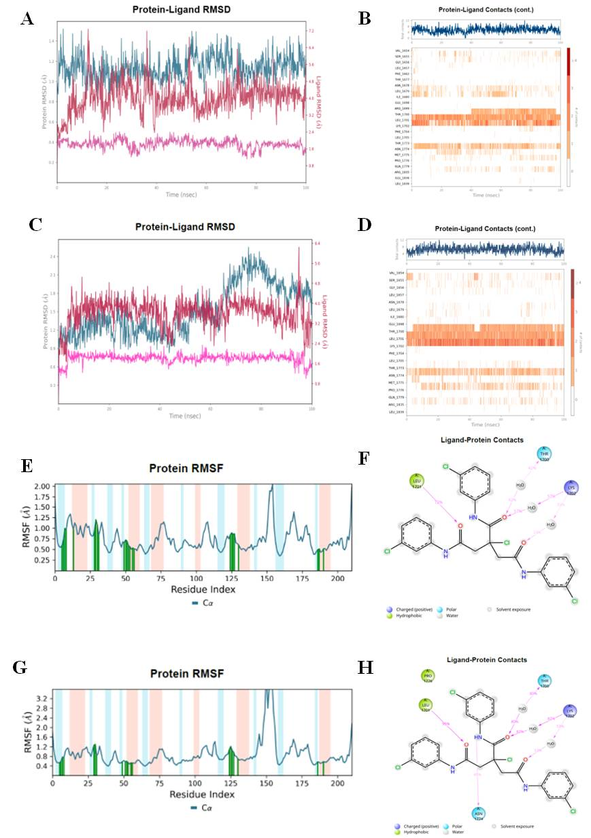
Figure S6. Pose 2 of BPMD of complexes 12 with tBRCT domain. A, B – RMSD and PLI of complex 12 (seed 42). C,D – RMSD and PLI of complex 12 (seed 12345). E,F – RMSF and Ligand-protein Contacts (LPC) of complex 12 (seed 42). G,H – RMSF and Ligand-protein Contacts (LPC) of complex 12 (seed 12345).
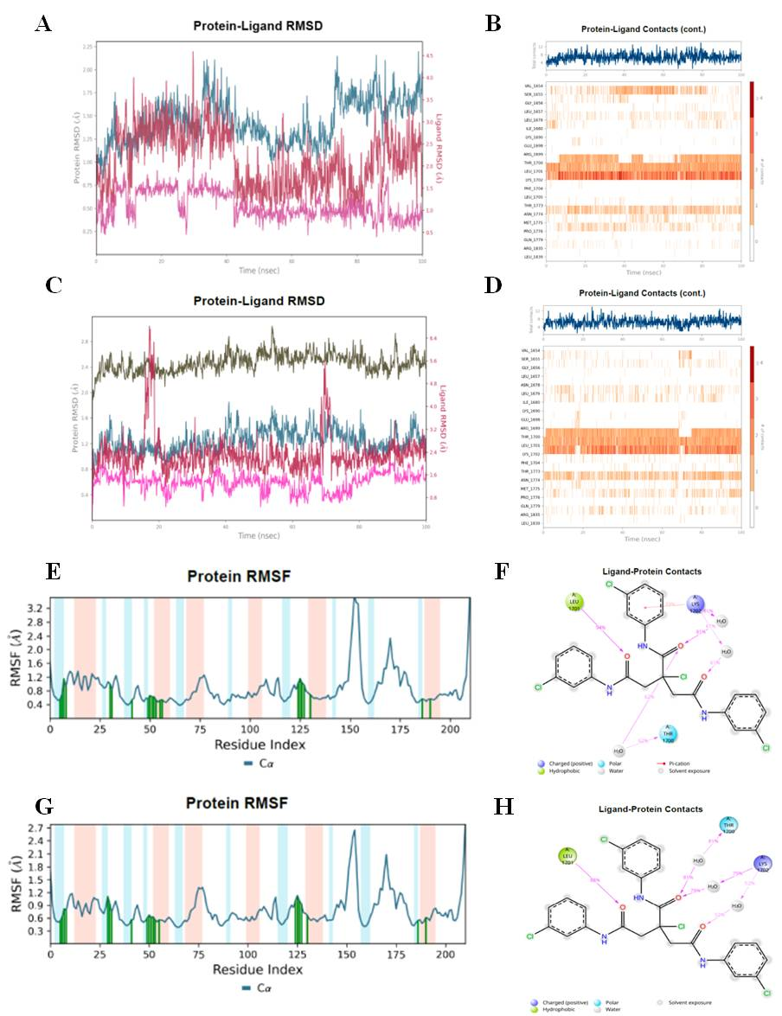
Figure S7. Pose 3 of BPMD of complexes 12 with tBRCT domain. A, B – RMSD and PLI of complex 12 (seed 42). C,D – RMSD and PLI of complex 12 (seed 12345). E,F – RMSF and Ligand-protein Contacts (LPC) of complex 12 (seed 42). G,H – RMSF and Ligand-protein Contacts (LPC) of complex 12 (seed 12345).
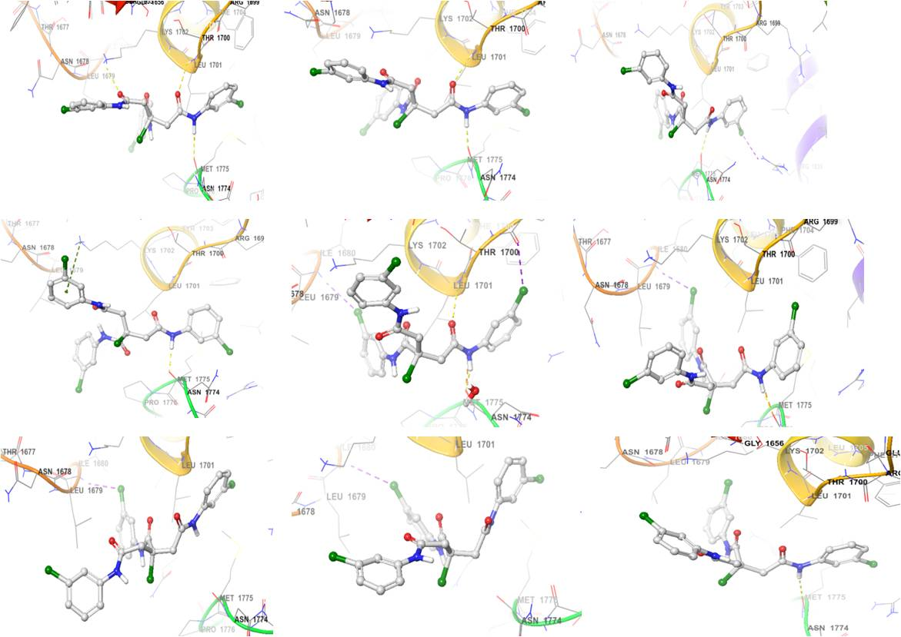
Figure S8. Snapshots of the position of ligand 12 during fluctuations, showing local rearrangement of the molecule (seed 2007).
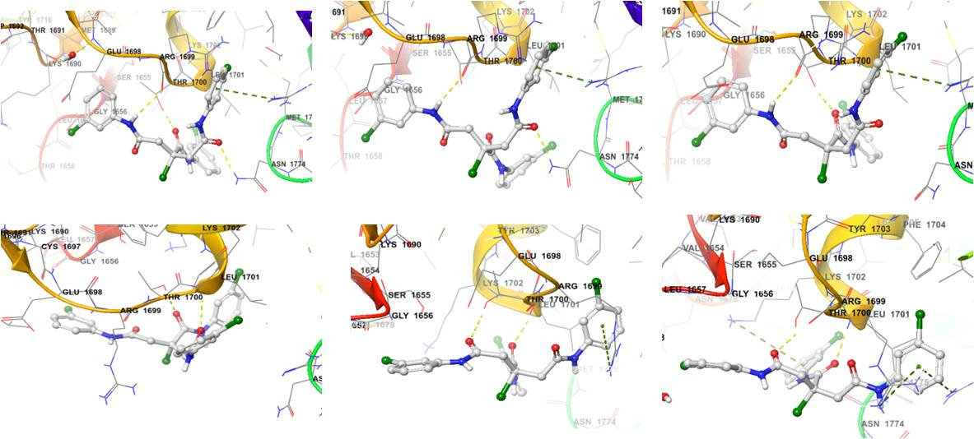
Figure S9. Snapshots of the Pose 3 of BPMD of ligand 12 during fluctuations, showing local rearrangement of the molecule (seed 2007).
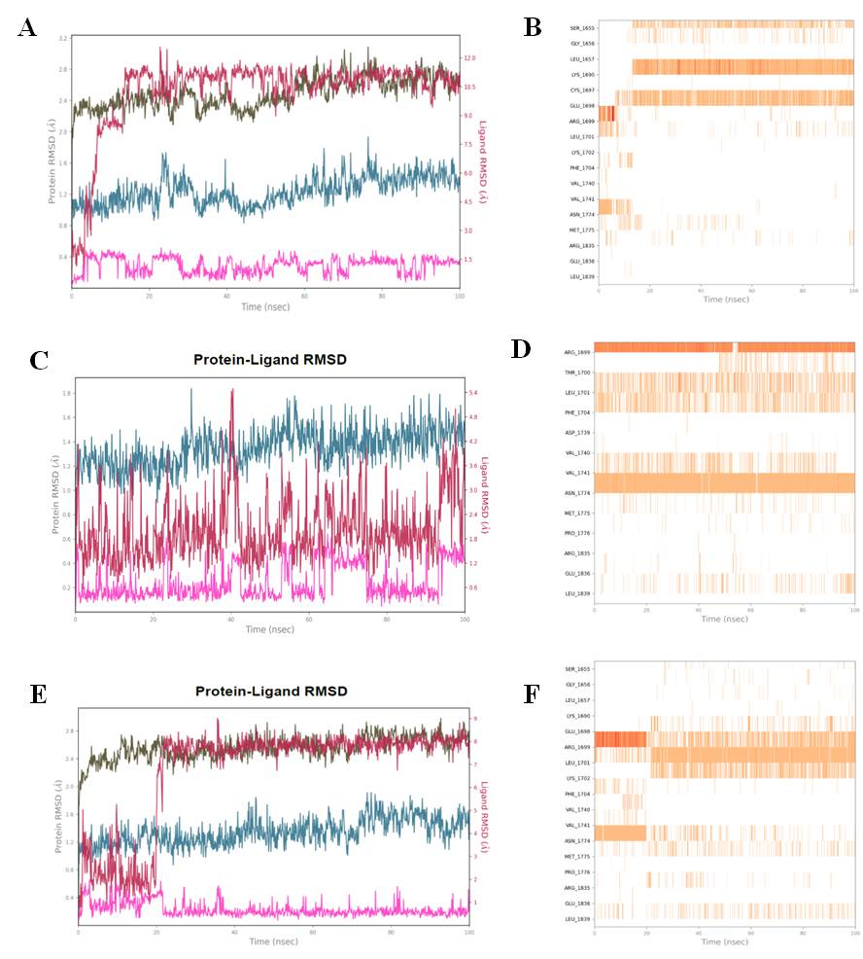
Figure S10. MD-simulation of Bractoppin with tBRCT domain. A, B – RMSD and PLI of complex Bractoppin-BRCT (seed 42). C,D – RMSD and PLI of complex Bractoppin-BRCT (seed 2007). E,F – RMSD and PLI of complex Bractoppin-BRCT (seed 12345).
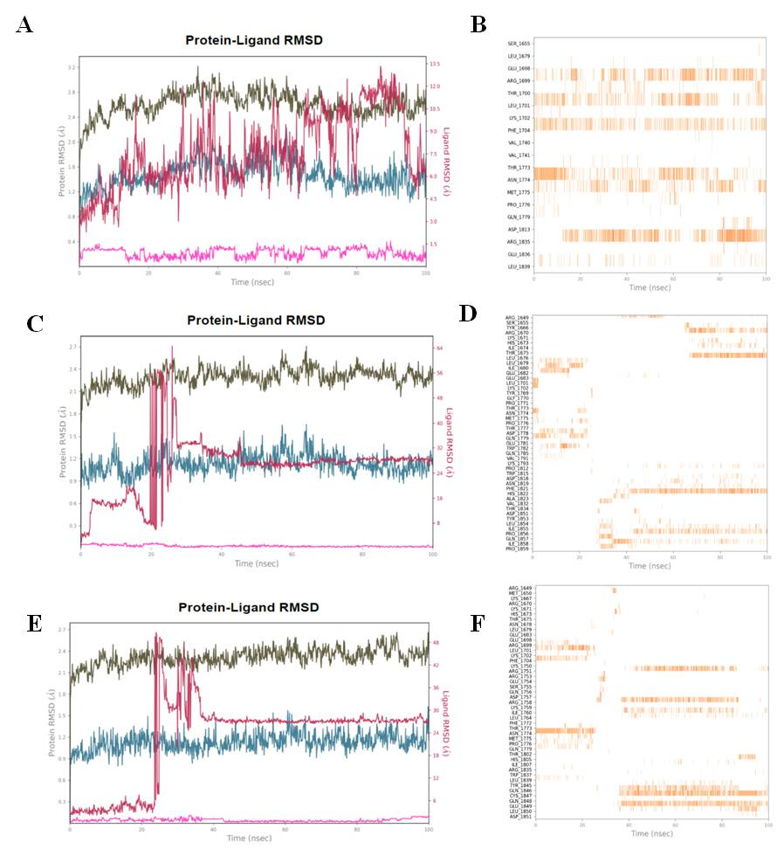
Figure S11. MD-simulation of CCBT2047 with tBRCT domain. A, B – RMSD and PLI of complex CCBT2047-BRCT (seed 42). C,D – RMSD and PLI of complex CCBT2047-BRCT (seed 2007). E,F – RMSD and PLI of complex CCBT2047-BRCT (seed 12345).
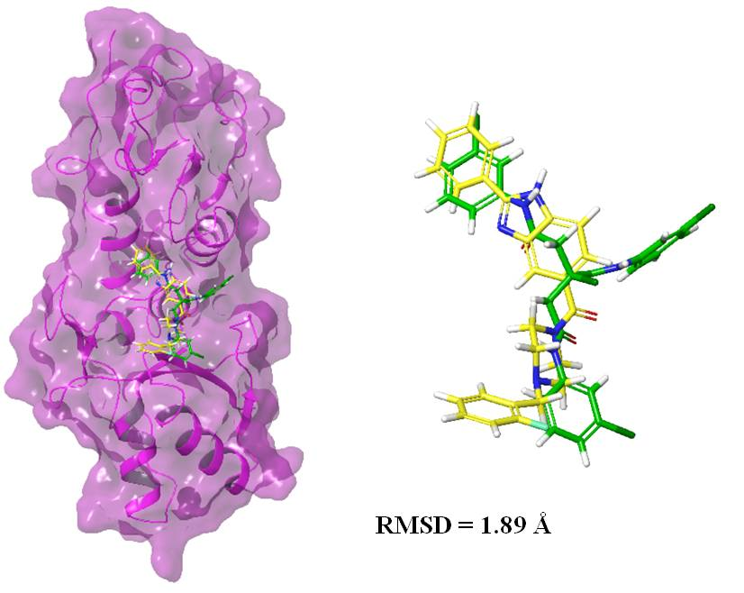
Figure S12. RMSD representation of the Bractoppin (yellow) and the best IFD docking pose (green) in the 12.

Figure S13. Alchemical systems of the protein-ligand complexes: A – Bractoppin; B – compound 12; C – compound 13; The yellow dotted line indicates the hydrogen bond.

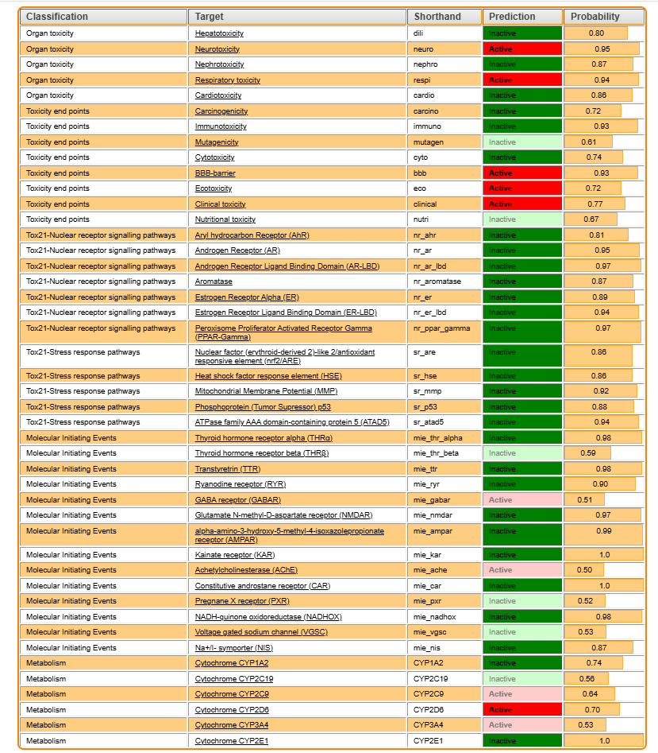
Figure S14. Prediction of bractoppin toxicity using the ProTox3.0 web service.
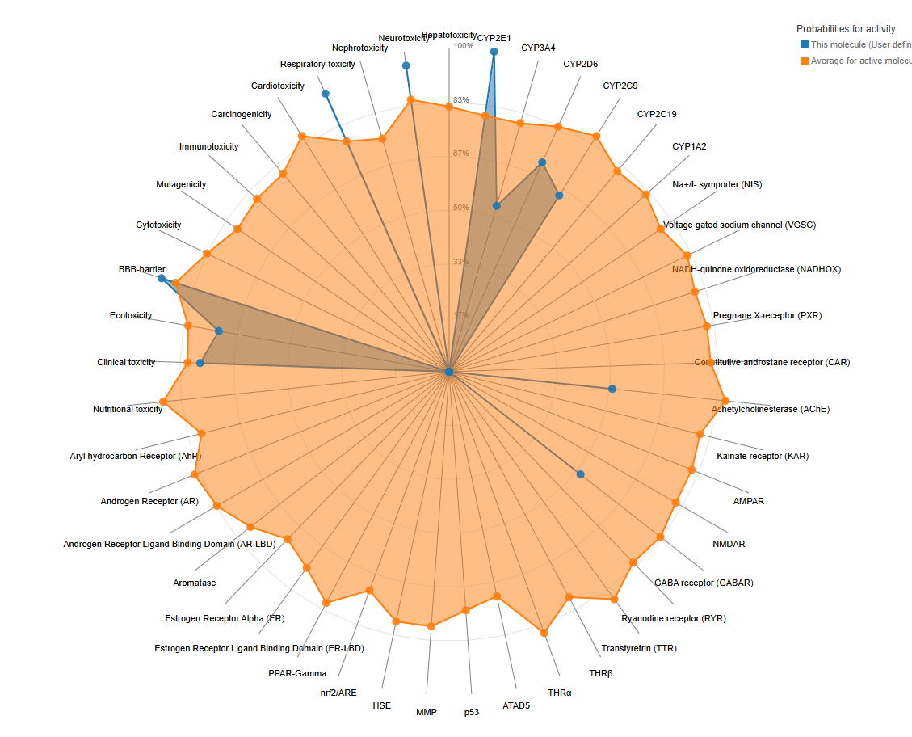
Figure S15. Predicted toxicity diagram Bractoppin.

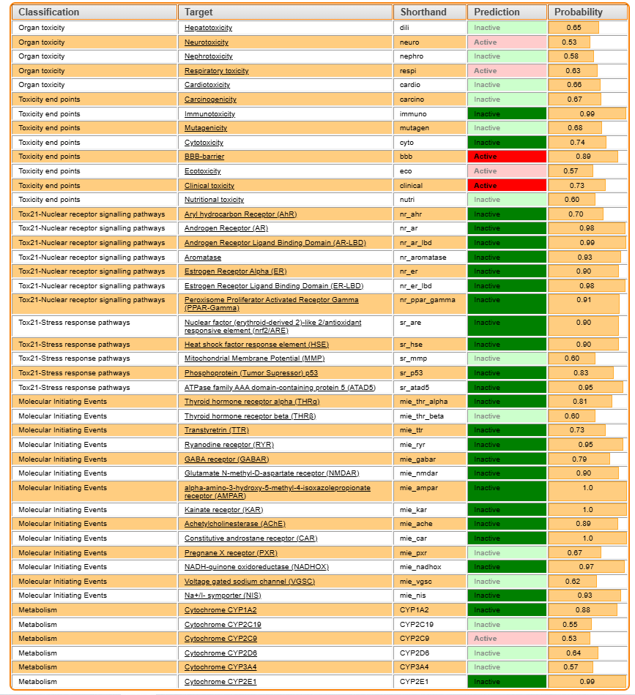
Figure S16. Prediction of compound 12 toxicity using the ProTox3.0 web service.

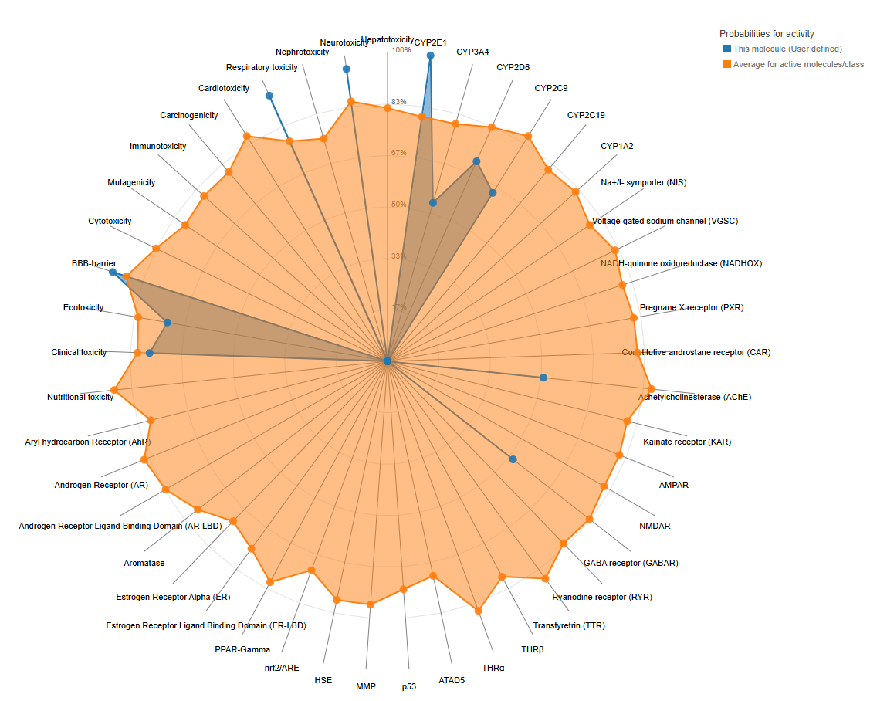
Figure S17. Predicted toxicity diagram compound 12.

