Supporting information
Comparative Study of Crystal Violet Adsorption: Phosphorylated Microcrystalline Cellulose vs. Phosphorylated Date Seeds Powder: Isotherms, Kinetics, Mechanisms, and Thermodynamics
Ghada M. Taha*¹, and Eman S. Mansor²
¹ Textile Research and Technology Institute, National Research Centre, Egypt, ²Environmental and Climate Change Research Institute, National Research Centre, Egypt.
*Corresponding author, email address: Ghadasci@yahoo.com

Figure S1. The isotherm models fitting of CV adsorption onto PMCC
Figure S2. The isotherm models fitting of CV adsorption onto PDSP

Figure S3. The isotherm models fitting of CV adsorption onto PMCC

Figure S4. The isotherm models fitting of CV adsorption onto PDSP

Figure S5. The isotherm models fitting of CV adsorption on PMCC

Figure S6. The isotherm models fitting of CV adsorption on PDSP

Figure S7. The kinetic models fitting of CV adsorption onto PMCC

Figure S8. The kinetic models fitting of CV adsorption onto PDSP

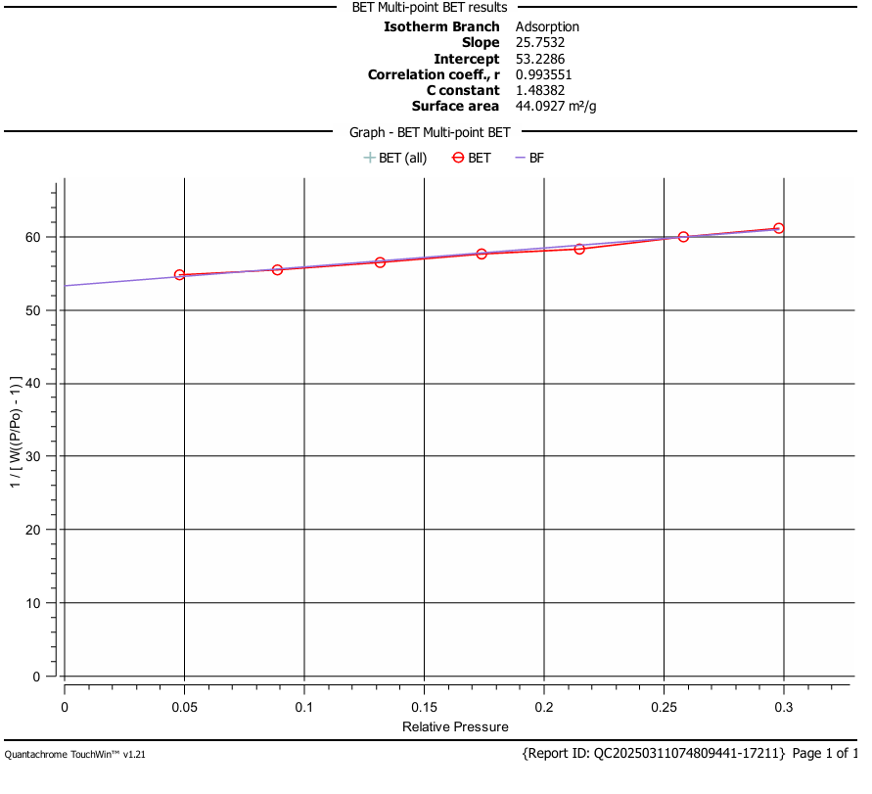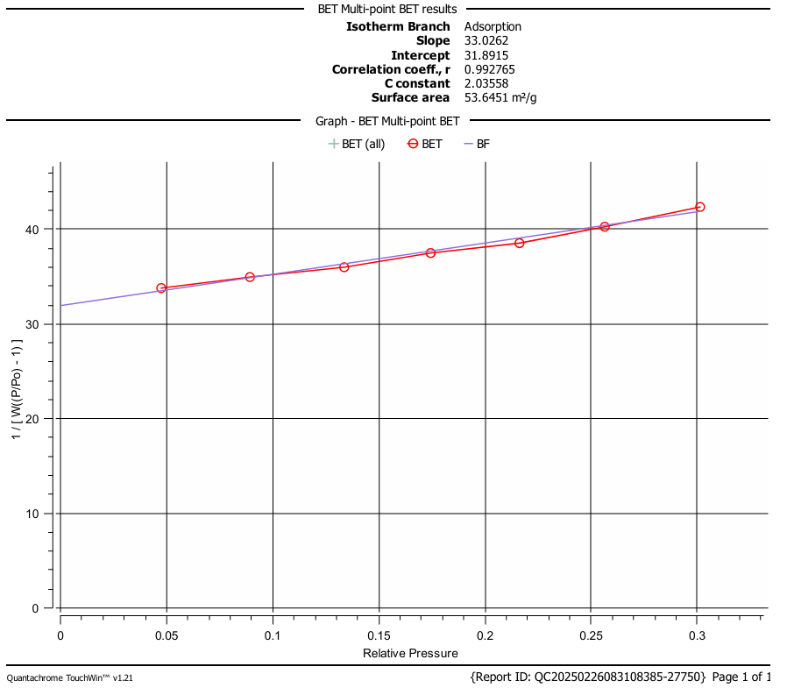
DSP
MCC
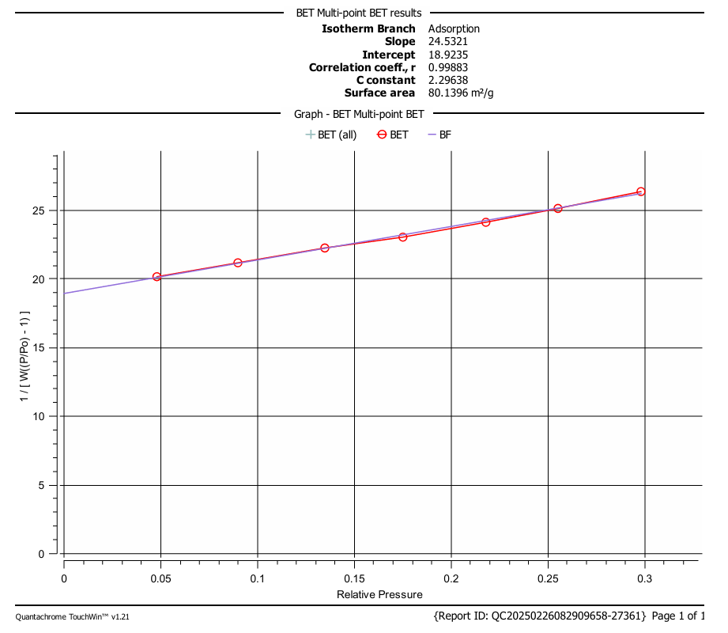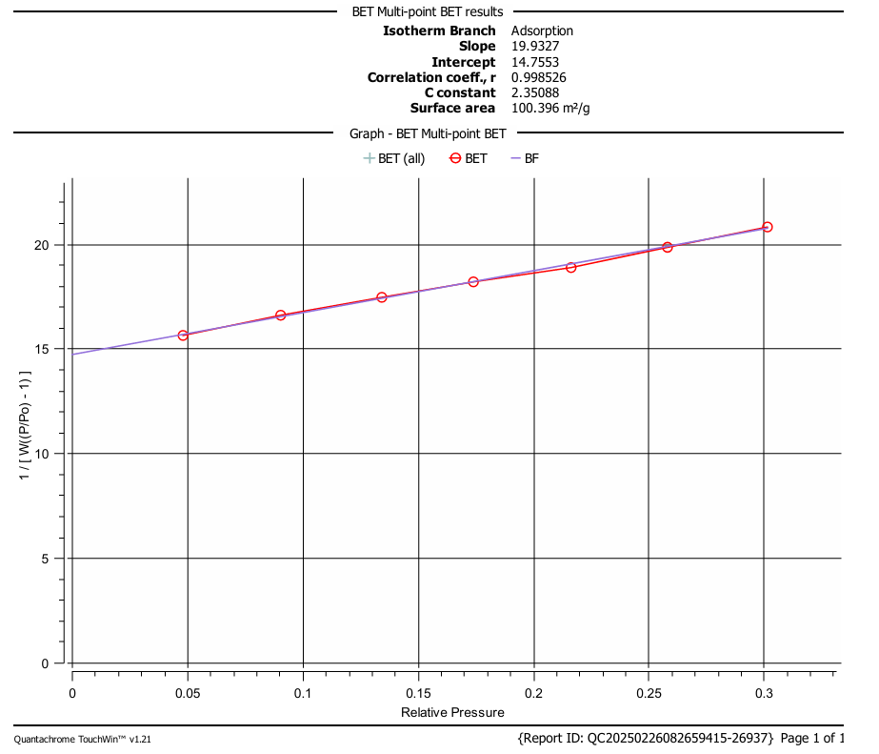
PDSP
PMCC

Figure S9. The bet surface area for the studied materials

