Supplementary table 1. Combined summary of Bland-Altman agreement analyses across cohorts.
Analysis/Variable | Korean cohort | Vietnamese cohort
 | Mean difference (95% LOA) | Mean difference (95% LOA)
Test-retest reliability
FVC (L) | −0.007 (−0.459 to 0.444) | −0.010 (−0.224 to 0.205)
FEV₁ (L) | −0.009 (−0.409 to 0.391) | −0.013 (−0.231 to 0.206)
FEF₂₅₋₇₅ (L/s) | −0.014 (−1.345 to 1.316) | −0.034 (−1.271 to 1.201)
PEF (L/s) | 0.072 (−1.934 to 2.078) | −0.035 (−0.674 to 0.606)
Concurrent validity
FVC (L) | 0.175 (−0.337 to 0.687) | 0.192 (−0.259 to 0.642)
FEV₁ (L) | 0.132 (−0.402 to 0.665) | 0.046 (−0.338 to 0.430)
FEF₂₅₋₇₅ (L/s) | −0.240 (−1.547 to 1.066) | −0.766 (−1.837 to 0.305)
PEF (L/s) | 0.310 (−1.480 to 2.094) | −0.220 (−2.124 to 1.679)
LOA, limits of agreement; FVC, forced vital capacity; FEV1, forced expiratory volume in 1 second; FEF25–75, forced expiratory flow at 25%–75% of FVC; PEF, peak expiratory flow.

For the test–retest reliability analyses, mean differences were calculated as the first Spirokit test value minus the second Spirokit retest value. For the concurrent validity analyses, mean differences were calculated as the reference spirometer value minus the Spirokit value. The reference spirometers were Vmax Encore 22 in the Korean cohort and KoKo in the Vietnamese cohort.

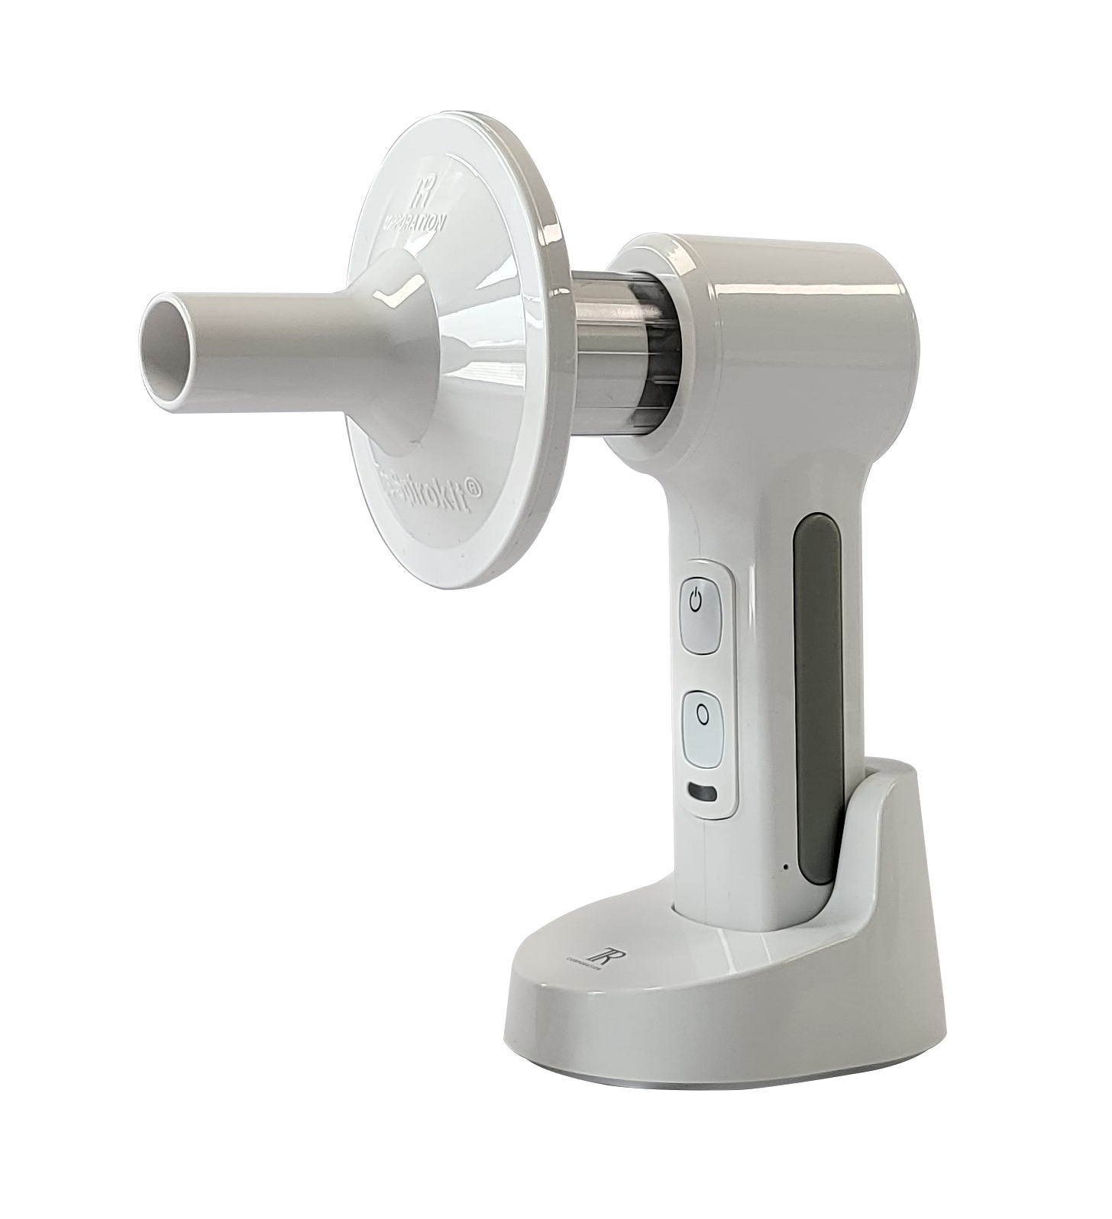

Supplementary figure 1. The Spirokit handheld smart spirometry system. The device is operated with one hand and paired with a tablet that provides real-time flow–volume and volume–time curves and step-by-step visual and voice guidance during the forced expiratory maneuver. A replaceable turbine mouthpiece and a compact tabletop charging cradle are shown.

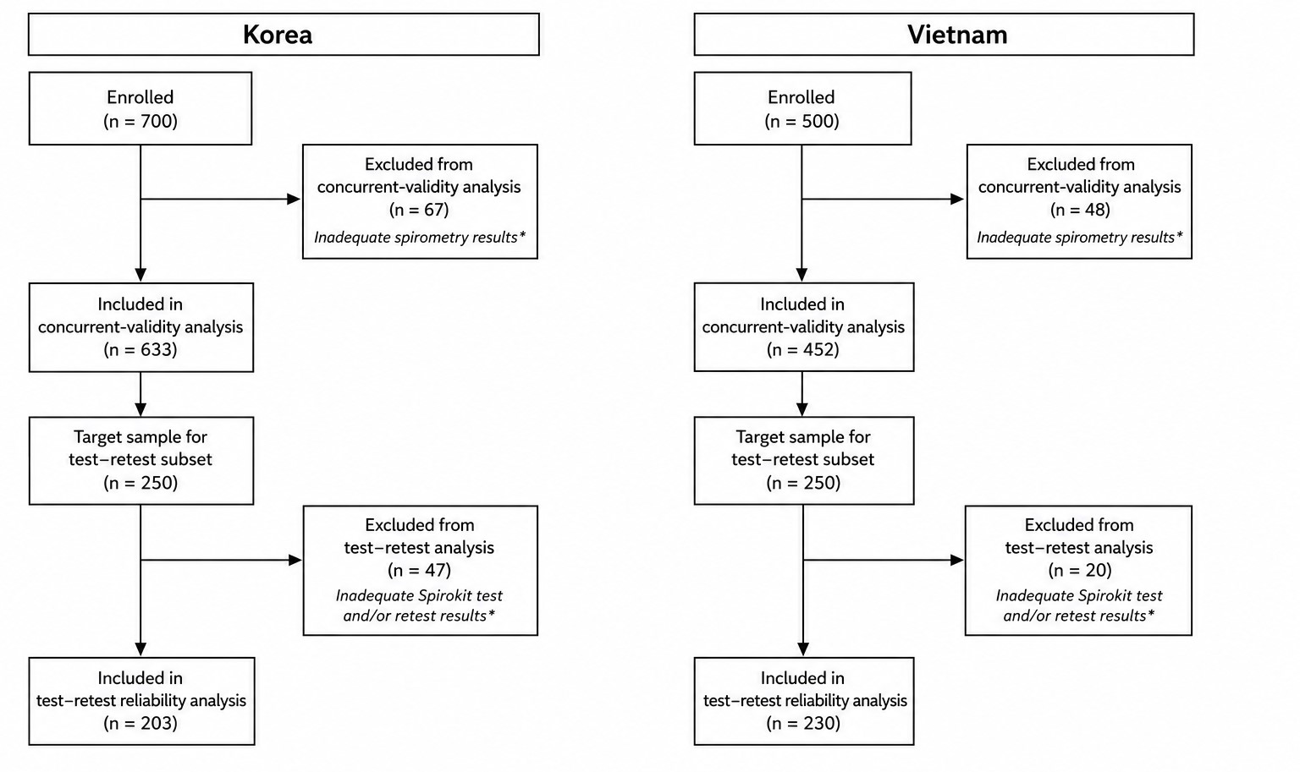
Supplementary figure 2. Participant flow for the concurrent-validity and test–retest reliability analyses. The flow diagram shows participant enrollment, exclusions, and the final numbers included in the concurrent-validity and test–retest reliability analyses in Korea and Vietnam. Inadequate spirometry results were defined as failure to meet the prespecified acceptability and quality criteria, including fewer than three acceptable maneuvers, FEV₁ or FVC <0.5 L, test duration <6 s, or device malfunction.

