Supplementary materials for:
Persistence of organic compounds extended through ocean transport and air–sea exchange
Karolina Cysneiros de Carvalho^{1*}, Kimberly A. Prather^{2†}, William C. Porter¹, Kelley C. Barsanti^{3*}

¹Department of Environmental Sciences, University of California Riverside; Riverside, CA, 92521, USA.
²Scripps Institution of Oceanography, University of California San Diego; La Jolla, CA 92037, USA.
†Department of Chemistry, University of California San Diego; La Jolla, CA, 92093, USA.
³Atmospheric Chemistry Observations & Modeling Laboratory, NSF National Center for Atmospheric Research; Boulder, CO, 80305, USA.

*Corresponding Author: Karolina Cysneiros de Carvalho (karolinc@ucr.edu)
*Corresponding Author: Kelley C. Barsanti (barsanti@ucar.edu)

This file includes:
Text S1
Figs. S1-S9
Tables S1-S6

Text S1. Sensitivity analysis of the September 9 early-morning DMTS observation at SIO
To evaluate whether the observed reduction in atmospheric DMTS abundance at SIO following the September 10, 2024, diversion was disproportionately influenced by the elevated early-morning observation collected on September 9 (05:30 LT), the pre-/post-diversion comparison was repeated after excluding this measurement. Removal of the September 9 observation reduced the estimated mean decline in DMTS from 86% to 56%; however, the difference between the pre- and post-diversion periods remained statistically significant (Wilcoxon rank-sum test, p = 0.035, effect size r = 0.49), compared with the analysis including all observations (p = 0.014, r = 0.56). Thus, although the September 9 observation influenced the estimated magnitude of the reduction, it did not account for the observed post-diversion decrease.
The September 9 observation was also evaluated to determine whether it represented an anomalous measurement. The elevated DMTS abundance coincided with meteorological conditions favorable for near-surface accumulation, including a shallow atmospheric boundary layer (~42 m) and weak winds (~0.64 m s⁻¹). These conditions provide a physically plausible explanation for the elevated abundance by limiting atmospheric mixing and dispersion, suggesting that the observation reflects a meteorologically driven high-abundance event rather than an unexplained statistical outlier. Accordingly, the observation was retained in the primary analysis.
Fig. S1: Seasonal and interannual variability in Tijuana River (TR) discharge.
Top panels show daily TR discharge (ML d⁻¹) during the dry season (May–September, left) and wet season (November–April, right) for 2004–2024. The shaded region highlights 2021–2024, which is expanded in the bottom panel to show monthly distributions of instantaneous discharge (L min⁻¹). Boxplots indicate medians (center lines), interquartile ranges (boxes), 9th–91st percentile ranges (whiskers), and 95% confidence intervals around the median (notches); points denote means.

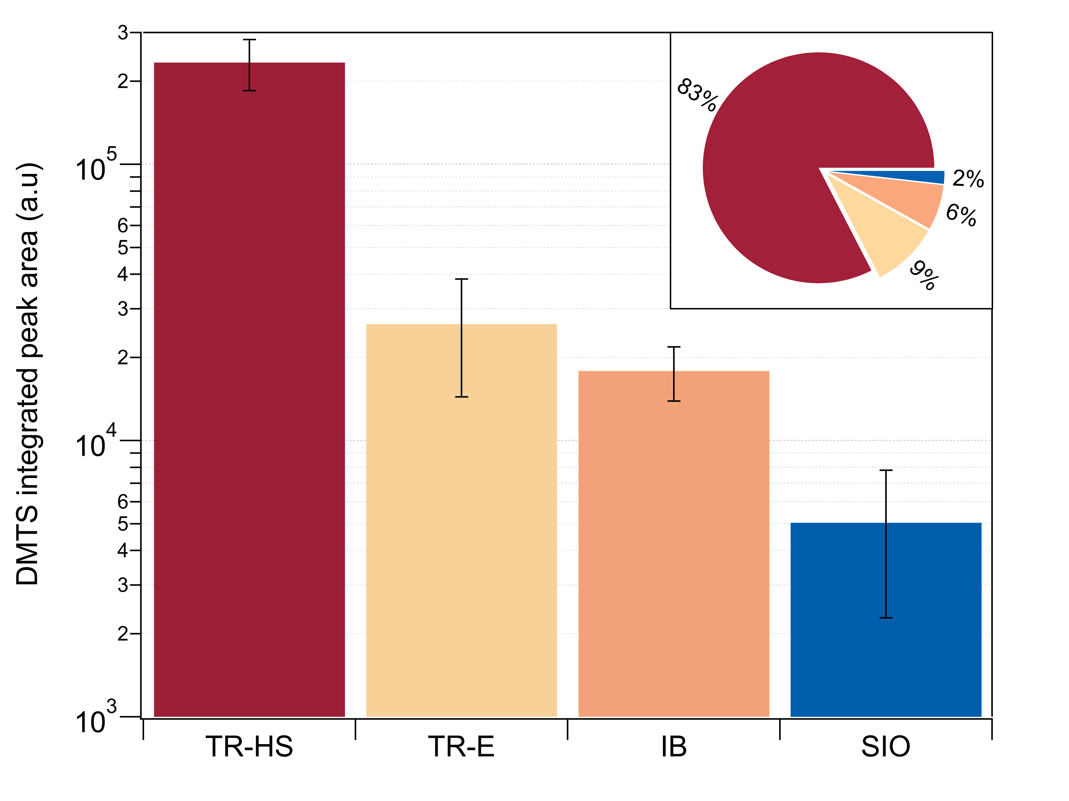
Fig. S2: Mean dimethyl trisulfide abundance across sampling sites.
Bar plots of the mean integrated dimethyl trisulfide (DMTS) peak area (a.u.) measured at TR-HS, TR-E, IB, and SIO (Fig. 1). Error bars indicate the standard error of the mean calculated from replicate measurements at each site. The inset pie chart shows the relative contribution of each site to the total mean DMTS abundance, based on site-averaged values. TR-HS accounted for the majority of the total signal (~83%), followed by TR-E (~9%), IB (~6%), and SIO (~2%).

Fig. S3: Temporal distributions of VOC fractional abundances before and after Tijuana River (TR) diversion.
(a) TR-coupled species and (b) TR-non-coupled species at SIO, grouped based on Kendall’s τ_{b} association with dimethyl trisulfide and TR-dominance fraction (see Methods). Fractional abundance is defined as the proportion of each compound’s total signal distributed across samples. Boxplots show medians (center lines), interquartile ranges (boxes), and whiskers spanning the full data range (minimum to maximum). Triangles denote outliers (>1.5× IQR) and squares denote far outliers (>3× IQR), following Tukey’s method. The vertical dashed line marks the diversion event, separating pre- and post-diversion periods.

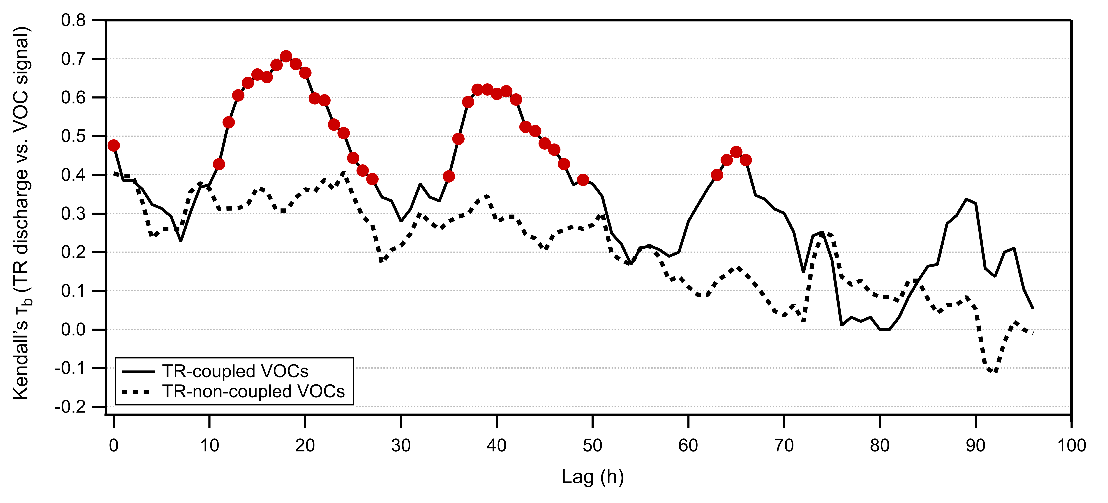Fig. S4: Lagged coherence between Tijuana River (TR) discharge and grouped VOC signal at SIO.
Kendall’s τ_{b} correlation between TR discharge and the aggregated TR-coupled (solid line) and TR-non-coupled (dotted line) VOC signal at the SIO site is shown as a function of lag (0–96 h). Red circles indicate statistically significant coherence (q < 0.05). The non-TR VOC signature exhibited no significant coherence at any point across the lag window.

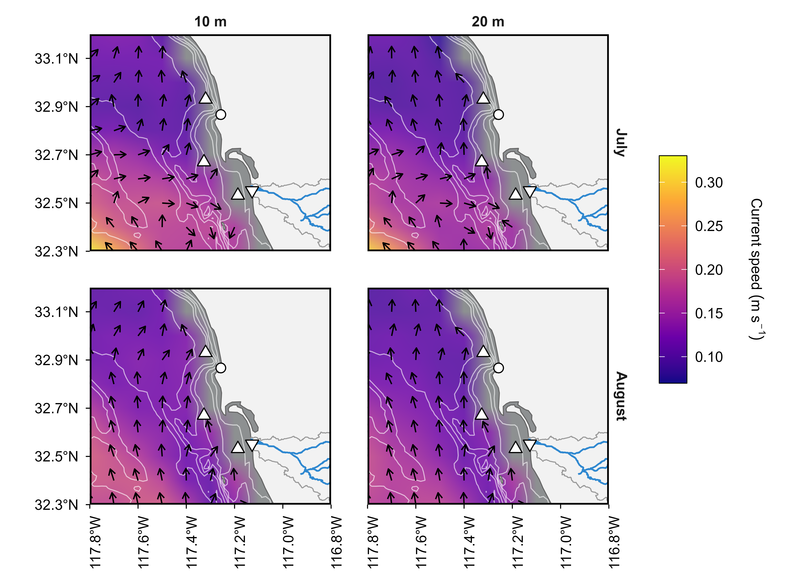
Fig. S5: Regional circulation patterns during July and August 2024.
Spatial distributions of modeled current speed (color shading, in m s⁻¹) and direction (vectors) from the West Coast Regional Ocean Modeling System (ROMS) at depths of 10 m (left) and 20 m (right) for July (top row) and August (bottom row). Oceanographic moorings are denoted by triangles (see Fig. 1 for definitions), the SIO pier by a circle, and the Tijuana River mouth by an inverted triangle.

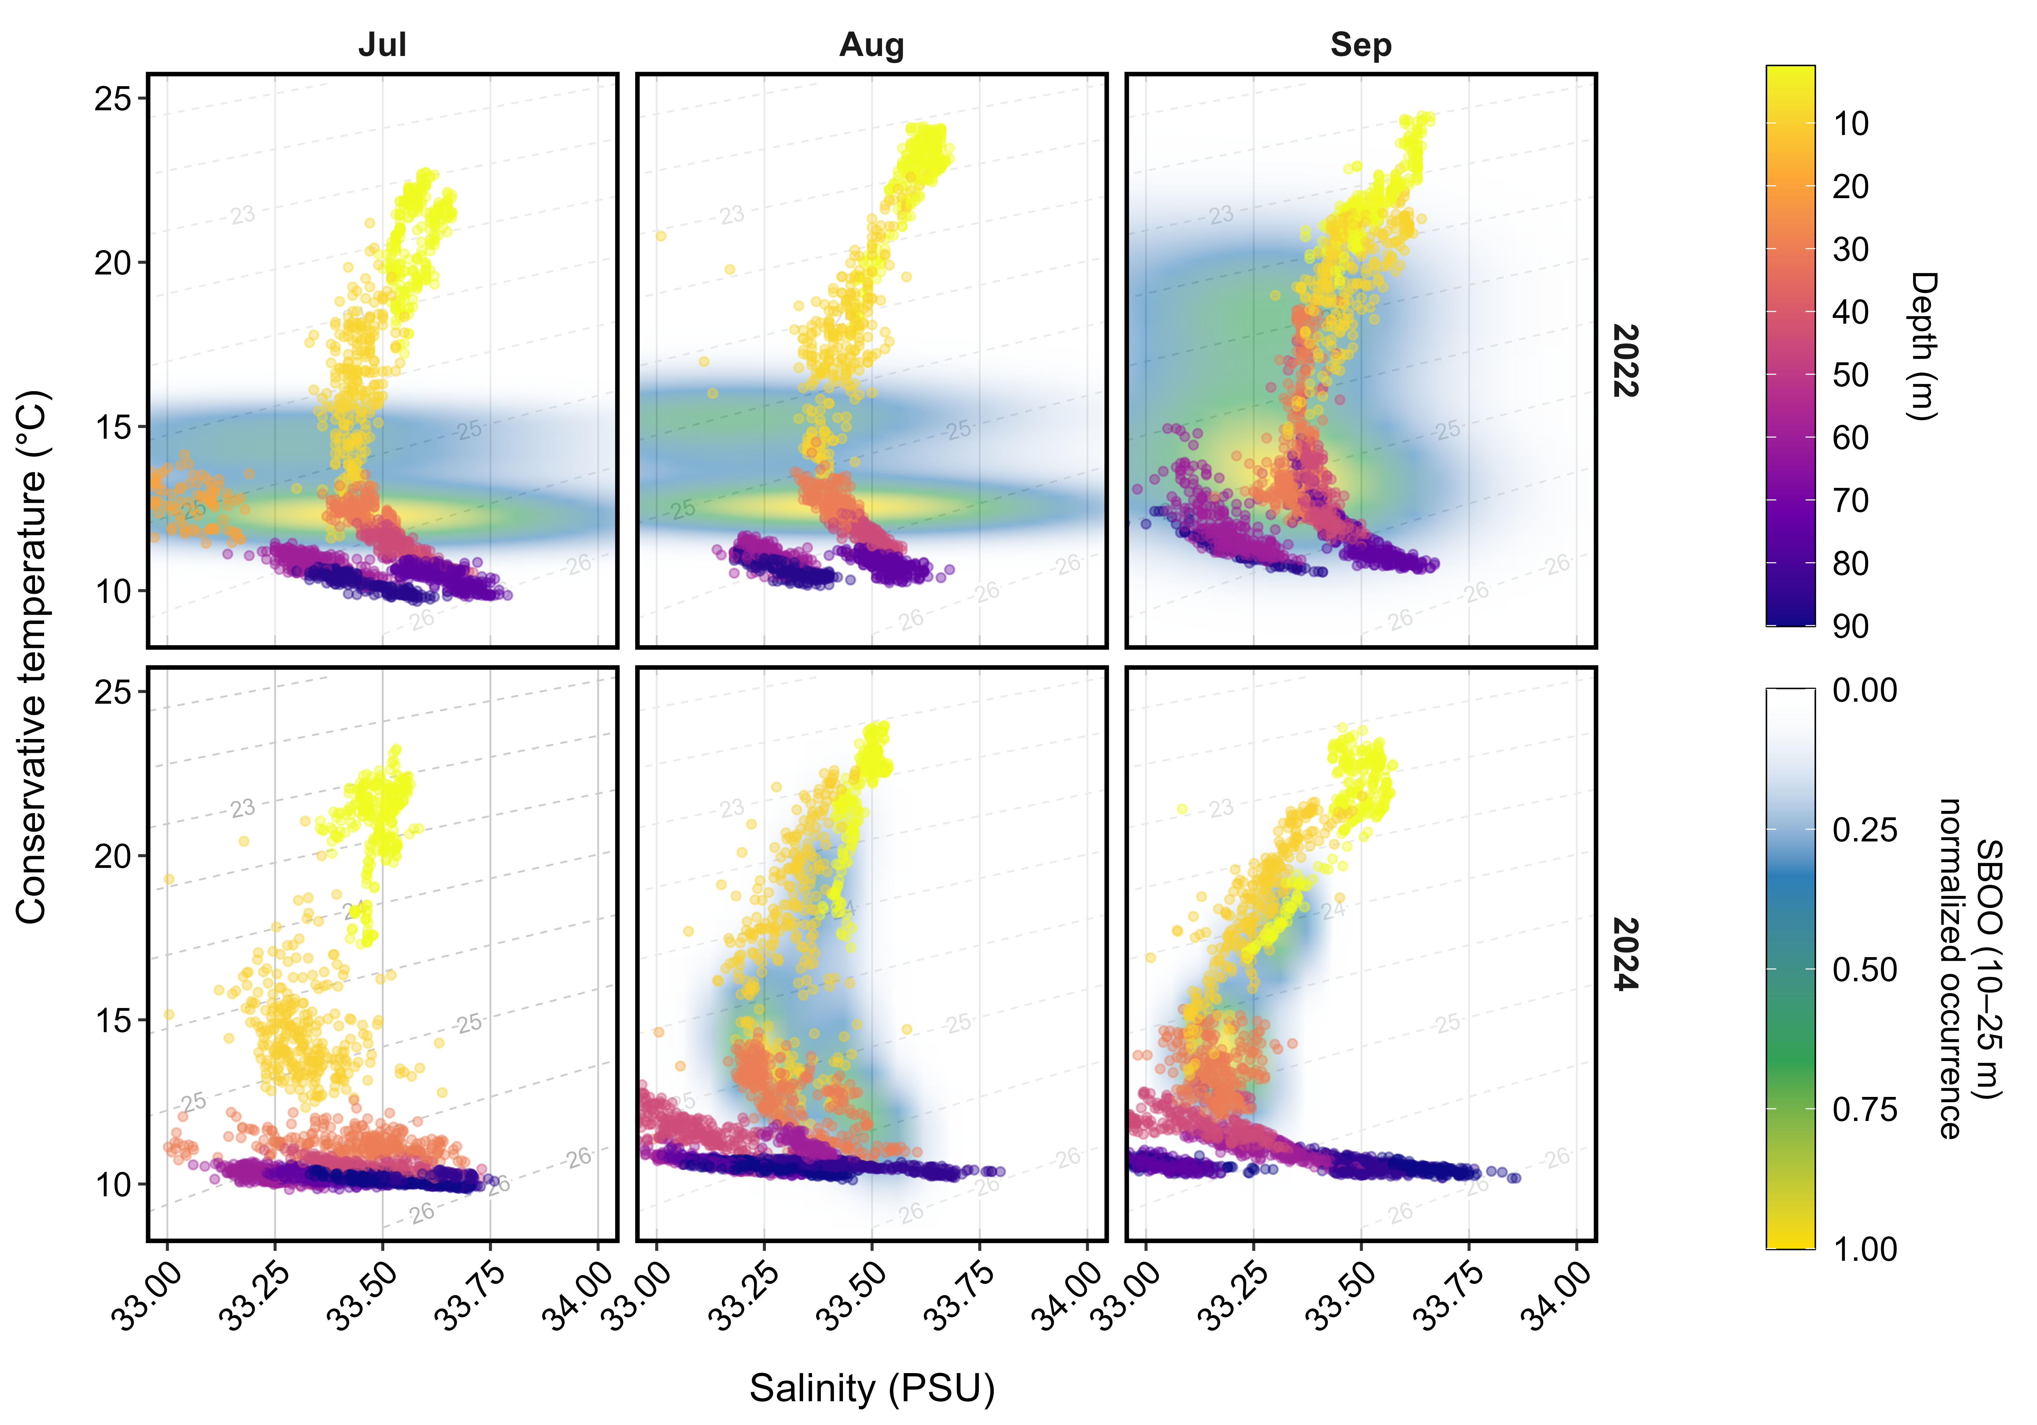
Fig. S6: Temperature–salinity structure of coastal waters at the Southern California Bight.
Temperature–salinity (T–S) distributions at Point Loma Ocean Outfall (PLOO, 1–90 m) for July–September in 2022 and 2024, alongside South Bay Ocean Outfall (SBOO, 10–25 m). PLOO observations are color-coded by depth, while SBOO water masses are shown as normalized kernel-estimated probability density functions in T–S space, indicating the likelihood of encountering water parcels with particular temperature–salinity combinations and providing a continuous depiction of the source-region hydrographic state. Dashed contours indicate potential density isopycnals, highlighting surfaces of constant density in T–S space. In the 10–25 m layer at PLOO, a freshening is evident from 2022 to 2024, with low-salinity water parcels increasingly aligned with the SBOO T–S distribution.
Fig. S7: Regional precipitation and watershed discharge in the Southern California Bight.
(a) Monthly cumulative precipitation for San Diego County (Jan 2021–Dec 2024, wet season, blue, dry season, red). (b–d) Monthly discharge (L min⁻¹) from May–Sep 2021–2024 for the San Diego River (~12 km south of SIO, B), Los Peñasquitos Canyon (~7 km north of SIO, C), and South Bay Ocean Outfall (~35 km north of SIO, D). Vertical axes are scaled to concurrent TR discharge (Fig. S1). Boxplots show medians (center lines), interquartile ranges (boxes), 9th–91st percentiles (whiskers), and 95% confidence intervals (notches); points indicate means.
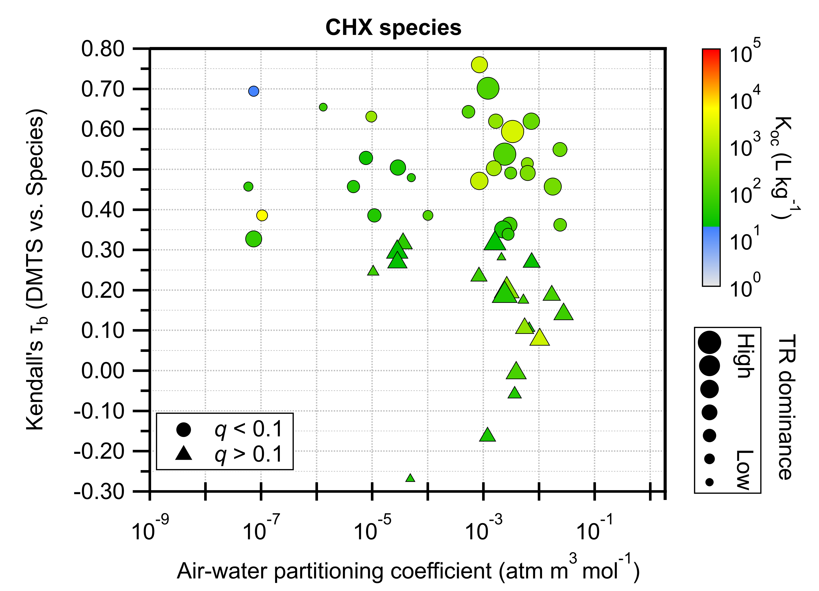
Fig S8: Thermodynamic controls on Tijuana River (TR)-derived VOC transport to SIO.
Correlations between dimethyl trisulfide (DMTS) and CHX species. Marker size indicates TR dominance, marker shape denotes FDR significance (q-values), and marker color shows organic carbon–water partitioning (K_{oc}, L kg⁻¹, log scale). The x-axis represents air–water partitioning (H, atm m³ mol⁻¹) and the y-axis shows Kendall’s τ_{b} correlation with DMTS.

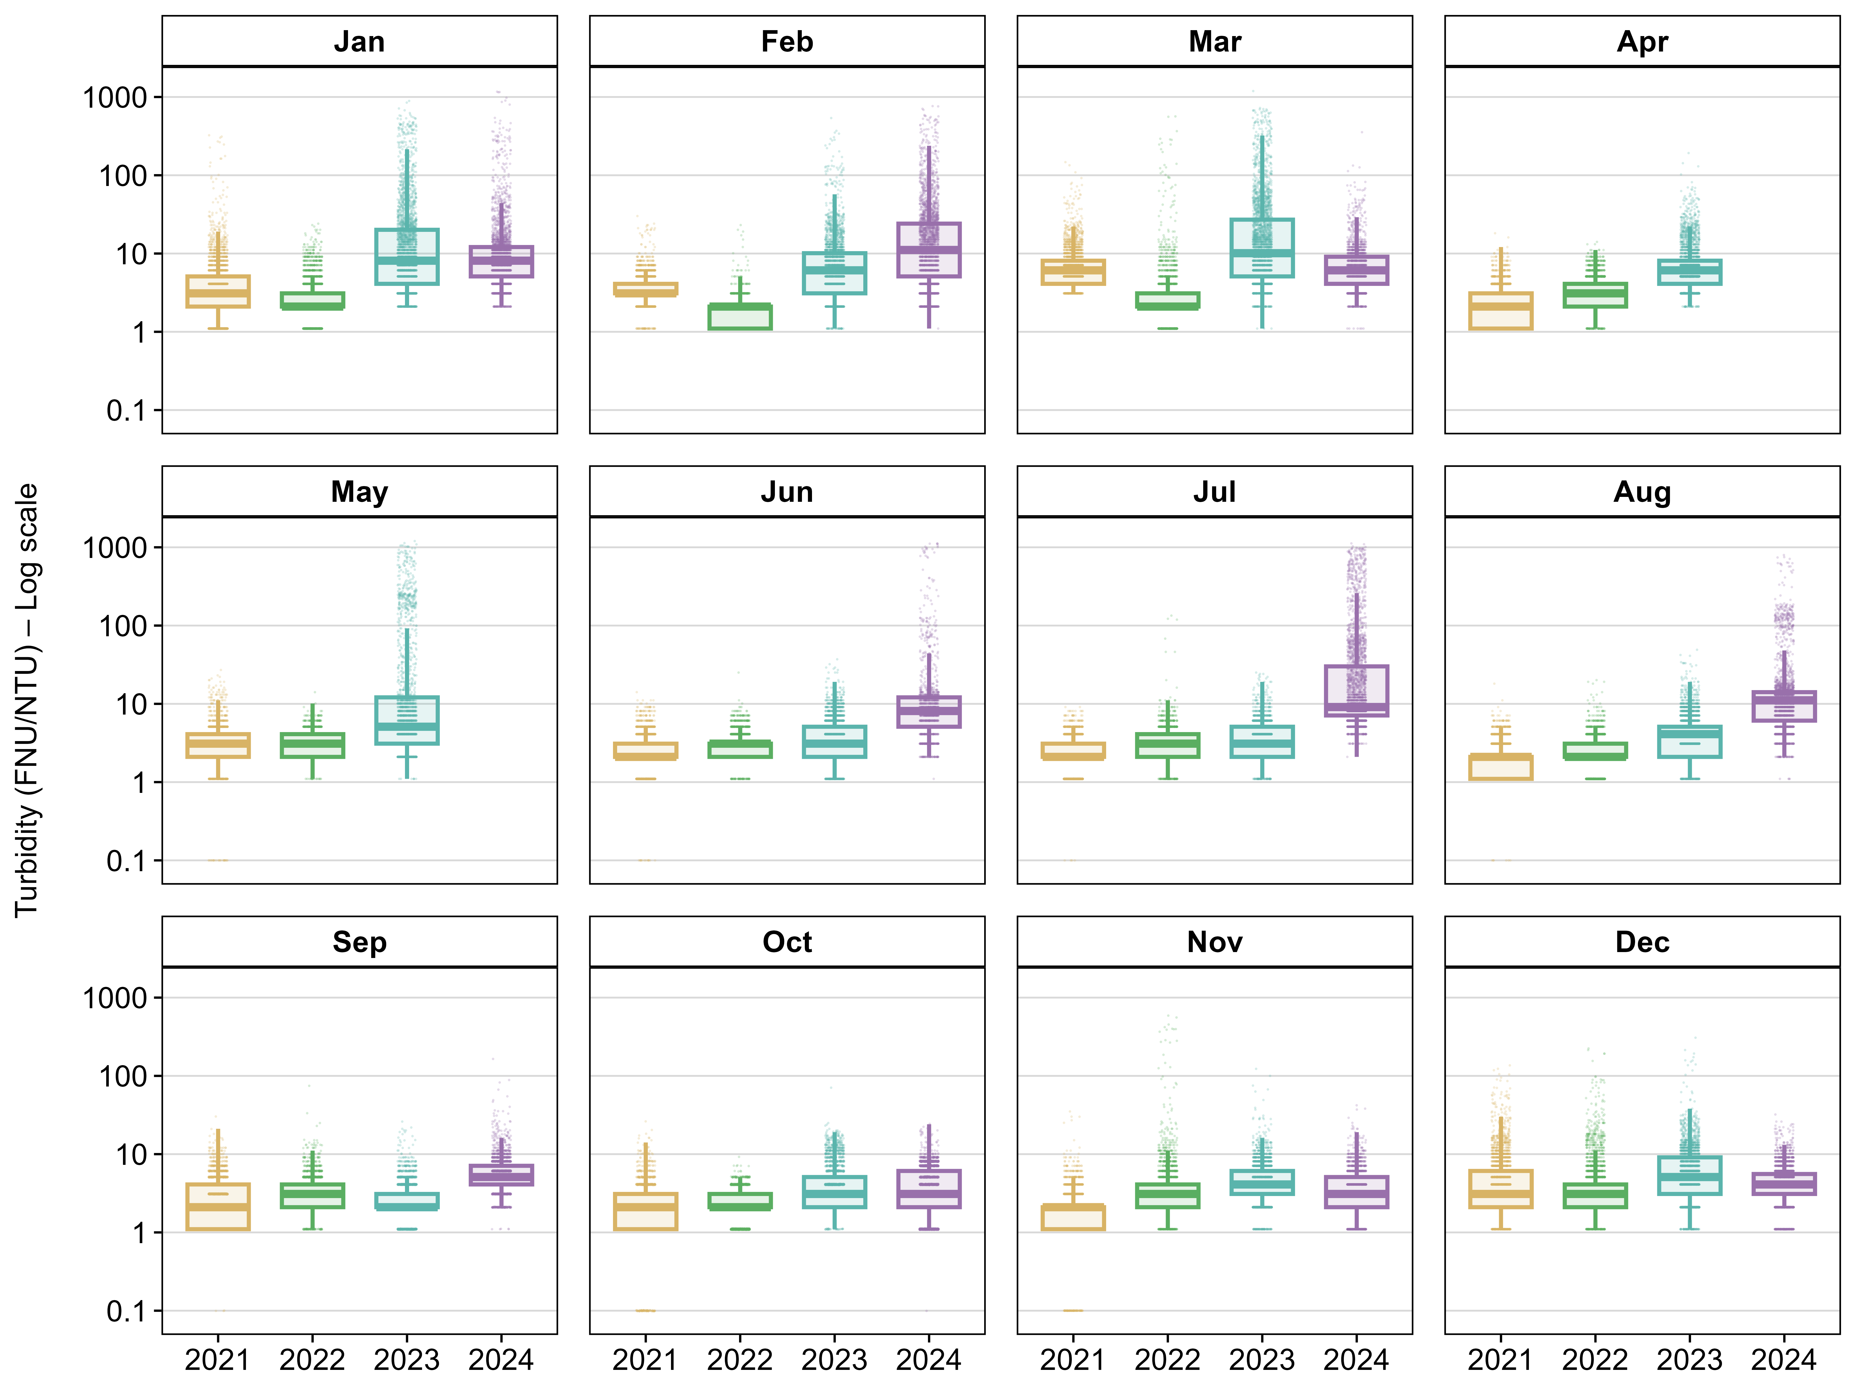
Fig. S9: Seasonal and interannual variability in estuarine turbidity from 2021–2024.
Monthly distributions of turbidity (FNU/NTU) for January–December across 2021–2024. Boxplots show medians (center lines), interquartile ranges (boxes), and whiskers spanning 1.5× the interquartile range following Tukey’s method. Overlaid points represent individual observations. Turbidity is displayed on a logarithmic scale to accommodate strong right-skewness and episodic high-turbidity events. A constant of 0.1 was added prior to log transformation to accommodate zero values.

Table S1. Summary of discrete atmospheric VOC sampling events conducted across all study sites during the pre-diversion and post-diversion monitoring periods.
Date | Period | Site | Start Collection | End Collection
8/26/2024 | Pre-diversion | TR-HS | 15:30:00 | 16:30:00
8/28/2024 | Pre-diversion | TR-HS | 15:30:00 | 16:00:00
9/14/2024 | Post-diversion | TR-HS | 06:15:00 | 06:45:00
9/15/2024 | Post-diversion | TR-HS | 06:10:00 | 06:40:00
9/15/2024 | Post-diversion | TR-HS | 16:50:00 | 17:20:00
9/15/2024 | Post-diversion | TR-HS | 23:15:00 | 23:55:00
9/16/2024 | Post-diversion | TR-HS | 06:00:00 | 06:40:00
9/9/2024 | Pre-diversion | TR-E | 06:30:00 | 07:30:00
9/10/2024 | Pre-diversion | TR-E | 06:30:00 | 07:30:00
9/11/2024 | Post-diversion | TR-E | 06:30:00 | 07:30:00
9/12/2024 | Post-diversion | TR-E | 06:30:00 | 07:30:00
9/13/2024 | Post-diversion | TR-E | 09:00:00 | 10:00:00
8/26/2024 | Pre-diversion | IB | 09:00:00 | 10:00:00
8/26/2024 | Pre-diversion | IB | 14:00:00 | 15:00:00
8/26/2024 | Pre-diversion | IB | 19:00:00 | 20:00:00
8/27/2024 | Pre-diversion | IB | 03:00:00 | 04:00:00
8/27/2024 | Pre-diversion | IB | 09:00:00 | 10:00:00
8/27/2024 | Pre-diversion | IB | 14:00:00 | 15:00:00
8/27/2024 | Pre-diversion | IB | 19:00:00 | 20:00:00
8/28/2024 | Pre-diversion | IB | 03:00:00 | 04:00:00
8/28/2024 | Pre-diversion | IB | 09:00:00 | 10:00:00
8/28/2024 | Pre-diversion | IB | 14:00:00 | 15:00:00
8/28/2024 | Pre-diversion | IB | 19:00:00 | 20:00:00
8/29/2024 | Pre-diversion | IB | 03:00:00 | 04:00:00
8/29/2024 | Pre-diversion | IB | 09:00:00 | 10:00:00
8/29/2024 | Pre-diversion | IB | 14:00:00 | 15:00:00
8/29/2024 | Pre-diversion | IB | 19:00:00 | 20:00:00
8/30/2024 | Pre-diversion | IB | 09:00:00 | 10:00:00
8/30/2024 | Pre-diversion | IB | 14:00:00 | 15:00:00
8/30/2024 | Pre-diversion | IB | 19:00:00 | 20:00:00
8/31/2024 | Pre-diversion | IB | 09:00:00 | 10:00:00
8/31/2024 | Pre-diversion | IB | 14:00:00 | 15:00:00
8/31/2024 | Pre-diversion | IB | 19:00:00 | 20:00:00
9/1/2024 | Pre-diversion | IB | 09:00:00 | 10:00:00
9/1/2024 | Pre-diversion | IB | 14:00:00 | 15:00:00
9/1/2024 | Pre-diversion | IB | 19:00:00 | 20:00:00
9/9/2024 | Pre-diversion | IB | 05:00:00 | 06:00:00
9/10/2024 | Pre-diversion | IB | 05:00:00 | 06:00:00
9/11/2024 | Post-diversion | IB | 05:00:00 | 06:00:00
9/12/2024 | Post-diversion | IB | 05:00:00 | 06:00:00
9/13/2024 | Post-diversion | IB | 06:30:00 | 07:30:00
9/9/2024 | Pre-diversion | SIO | 05:30:00 | 06:30:00
9/9/2024 | Pre-diversion | SIO | 09:30:00 | 10:30:00
9/9/2024 | Pre-diversion | SIO | 14:30:00 | 15:30:00
9/10/2024 | Pre-diversion | SIO | 05:30:00 | 06:30:00
9/10/2024 | Pre-diversion | SIO | 09:30:00 | 10:30:00
9/10/2024 | Pre-diversion | SIO | 14:30:00 | 15:30:00
9/11/2024 | Post-diversion | SIO | 05:30:00 | 06:30:00
9/11/2024 | Post-diversion | SIO | 09:30:00 | 10:30:00
9/11/2024 | Post-diversion | SIO | 14:30:00 | 15:30:00
9/12/2024 | Post-diversion | SIO | 05:30:00 | 06:30:00
9/12/2024 | Post-diversion | SIO | 09:30:00 | 10:30:00
9/12/2024 | Post-diversion | SIO | 14:30:00 | 15:30:00
9/13/2024 | Post-diversion | SIO | 01:30:00 | 02:30:00
9/13/2024 | Post-diversion | SIO | 05:30:00 | 06:30:00
9/13/2024 | Post-diversion | SIO | 09:30:00 | 10:30:00
9/13/2024 | Post-diversion | SIO | 14:30:00 | 15:30:00
9/14/2024 | Post-diversion | SIO | 01:30:00 | 02:30:00
9/14/2024 | Post-diversion | SIO | 05:30:00 | 06:30:00
9/14/2024 | Post-diversion | SIO | 09:30:00 | 10:30:00
9/14/2024 | Post-diversion | SIO | 14:30:00 | 15:30:00
Note. Site coordinates (latitude, longitude) are as follows: TR-HS, 32.86694, −117.25694; TR-E, 32.55972, −117.09278; IB, 32.56939, −117.12272; SIO, 32.57028, −117.13222. See Figure 1 for geographic context.
Abbreviations: TR-HS, Tijuana River Hotspot; TR-E, Tijuana River Estuary; IB, Imperial Beach; SIO, Scripps Institution of Oceanography.

Table S2. TR–coupled VOCs defined by TR-dominance and DMTS correlation metrics.
Match Score | CAS | Formula | Name | Exact Mass  (g mol⁻¹)
834 | 1629-58-9 | C5H8O | 1-Penten-3-one | 84.12
875 | 625-33-2 | C5H8O | 3-Penten-2-one, (E)- | 84.12
939 | 624-92-0 | C2H6S2 | Disulfide, dimethyl | 94.2
848 | 3208-16-0 | C6H8O | Furan, 2-ethyl- | 96.13
819 | 628-73-9 | C6H11N | Hexanenitrile | 97.16
901 | 6728-26-3 | C6H10O | 2-Hexenal | 98.14
945 | 616-44-4 | C5H6S | Thiophene, 3-methyl- | 98.17
909 | 592-77-8 | C7H14 | 2-Heptene | 98.19
887 | 565-69-5 | C6H12O | 3-Pentanone, 2-methyl- | 100.16
869 | 111-27-3 | C6H14O | 1-Hexanol | 102.17
933 | 107-39-1 | C8H16 | 1-Pentene, 2,4,4-trimethyl- | 112.21
802 | 1487-99-6 | C8H10O | Oxepine, 2,7-dimethyl- | 122.16
868 | 65378-76-9 | C9H16 | 1,2,4,4-Tetramethylcyclopentene | 124.22
868 | 4312-99-6 | C8H14O | 1-Octen-3-one | 126.2
903 | 2548-87-0 | C8H14O | 2-Octenal, (E)- | 126.2
941 | 111-13-7 | C8H16O | 2-Octanone | 128.21
852 | 106-68-3 | C8H16O | 3-Octanone | 128.21
846 | 3391-86-4 | C8H16O | 1-Octen-3-ol | 128.21
923 | 111-87-5 | C8H18O | 1-Octanol | 130.23
930 | 7399-49-7 | C10H12 | o-Isopropenyltoluene | 132.2
816 | 629-06-1 | C7H15Cl | Heptane, 1-chloro- | 134.65
876 | 123-35-3 | C10H16 | a-Myrcene | 136.23
916 | 3777-69-3 | C9H14O | Furan, 2-pentyl- | 138.21
825 | 18829-56-6 | C9H16O | 2-Nonenal, (E)- | 140.22
815 | 16580-26-0 | C10H20 | Cyclohexane, 1-isopropyl-1-methyl- | 140.27
860 | 872-05-9 | C10H20 | 1-Decene | 140.27
891 | 62933-90-8 | C11H10 | 1H-Indene, 1-ethylidene- | 142.2
870 | 821-55-6 | C9H18O | 2-Nonanone | 142.24
889 | 6682-71-9 | C11H14 | 1H-Indene, 2,3-dihydro-4,7-dimethyl- | 146.23
921 | 85-44-9 | C8H4O3 | Phthalic anhydride | 148.11
882 | 119-36-8 | C8H8O3 | Methyl salicylate | 152.15
890 | 98-55-5 | C10H18O | Terpineol | 154.25
844 | 3913-71-1 | C10H18O | 2-Decenal, (Z)- | 154.25
879 | 4861-58-9 | C9H14S | Thiophene, 2-pentyl- | 154.27
894 | 693-54-9 | C10H20O | 2-Decanone | 156.26
818 | 93-04-9 | C11H10O | Naphthalene, 2-methoxy- | 158.2
947 | 127-18-4 | C2Cl4 | Tetrachloroethylene | 165.8
895 | 92-51-3 | C12H22 | 1,1'-Bicyclohexyl | 166.3
906 | 101-84-8 | C12H10O | Diphenyl ether | 170.21
833 | 112-12-9 | C11H22O | 2-Undecanone | 170.29
938 | 112-40-3 | C12H26 | Dodecane | 170.33
819 | 1002-69-3 | C10H21Cl | Decane, 1-chloro- | 176.72
812 | 66324-47-8 | C13H24 | 1,1'-Bicyclohexyl, 2-methyl-, cis- | 180.33
944 | 629-50-5 | C13H28 | Tridecane | 184.36
888 | 17301-27-8 | C13H28 | Undecane, 2,10-dimethyl- | 184.36
882 | 17312-57-1 | C13H28 | Dodecane, 3-methyl- | 184.36
868 | 17301-26-7 | C13H28 | Undecane, 2,9-dimethyl- | 184.36
824 | 2473-03-2 | C11H23Cl | 1-Chloroundecane | 190.75
842 | 1795-15-9 | C14H28 | Cyclohexane, octyl- | 196.37
966 | 629-59-4 | C14H30 | Tetradecane | 198.39
911 | 1560-96-9 | C14H30 | Tridecane, 2-methyl- | 198.39
917 | 6418-41-3 | C14H30 | Tridecane, 3-methyl- | 198.39
887 | 13287-21-3 | C14H30 | Tridecane, 6-methyl- | 198.39
846 | 25117-31-1 | C14H30 | Tridecane, 5-methyl- | 198.39
909 | 469-61-4 | C15H24 | 1H-3a,7-Methanoazulene, 2,3,4,7,8,8a-hexahydro-3,6,8,8-tetramethyl- | 204.35
860 | 546-28-1 | C15H24 | 1H-3a,7-Methanoazulene, octahydro-3,8,8-trimethyl-6-methylene- | 204.35
806 | 112-52-7 | C12H25Cl | Dodecane, 1-chloro- | 204.78
809 | 2883-02-5 | C15H30 | n-Nonylcyclohexane | 210.4
892 | 13360-61-7 | C15H30 | Pentadecene | 210.4
855 | 1560-95-8 | C15H32 | Tetradecane, 2-methyl- | 212.41
882 | 13286-73-2 | C15H32 | Tridecane, 3-ethyl- | 212.41
894 | 31295-56-4 | C15H32 | Dodecane, 2,6,11-trimethyl- | 212.41
938 | 3891-98-3 | C15H32 | Dodecane, 2,6,10-trimethyl- | 212.41
888 | 74645-98-0 | C15H32 | Dodecane, 2,7,10-trimethyl- | 212.41
816 | 18435-22-8 | C15H32 | Tetradecane, 3-methyl- | 212.41
823 | 25117-24-2 | C15H32 | Tetradecane, 4-methyl- | 212.41
940 | 629-62-9 | C15H32 | Pentadecane | 212.41
880 | 4537-11-5 | C16H26 | Benzene, (1-butylhexyl)- | 218.38
863 | 4621-36-7 | C16H26 | Benzene, (1-ethyloctyl)- | 218.38
876 | 629-73-2 | C16H32 | Cetene | 224.42
891 | 6165-40-8 | C16H34 | Pentadecane, 7-methyl- | 226.44
948 | 544-76-3 | C16H34 | Hexadecane | 226.44
850 | 2882-96-4 | C16H34 | Pentadecane, 3-methyl- | 226.44
838 | 4537-15-9 | C17H28 | Benzene, (1-butylheptyl)- | 232.4
869 | 4536-87-2 | C17H28 | Benzene, (1-ethylnonyl)- | 232.4
843 | 4536-86-1 | C17H28 | Benzene, (1-propyloctyl)- | 232.4
851 | 4536-88-3 | C17H28 | Benzene, (1-methyldecyl)- | 232.4
891 | 25117-26-4 | C17H36 | Hexadecane, 4-methyl- | 240.5
914 | 6418-43-5 | C17H36 | Hexadecane, 3-methyl- | 240.5
930 | 629-78-7 | C17H36 | Heptadecane | 240.5
868 | 2400-00-2 | C18H30 | Benzene, (1-ethyldecyl)- | 246.4
874 | 2719-63-3 | C18H30 | Benzene, (1-butyloctyl)- | 246.4
849 | 7206-19-1 | C18H36 | 3-Octadecene, (E)- | 252.5
916 | 593-45-3 | C18H38 | Octadecane | 254.5
880 | 3892-00-0 | C18H38 | Pentadecane, 2,6,10-trimethyl- | 254.5
832 | 4534-49-0 | C19H32 | Benzene, (1-pentyloctyl)- | 260.5
Note. Mass spectrum match scores were obtained by comparison with the National Institute of Standards and Technology (NIST) Mass Spectral Search Program. Some compounds may correspond to isomers, as identifications were based solely on mass spectra and retention times. Compounds are listed in order of increasing molecular mass.

Table S3. TR–non–coupled VOCs defined by TR-dominance and DMTS correlation metrics.
Match Score | CAS | Formula | Name | Exact Mass  (g mol⁻¹)
889 | 78-94-4 | C4H6O | Methyl vinyl ketone | 70.09
890 | 646-06-0 | C3H6O2 | 1,3-Dioxolane | 74.08
879 | 75-65-0 | C4H10O | 2-Propanol, 2-methyl- | 74.12
931 | 110-86-1 | C5H5N | Pyridine | 79.1
854 | 96-54-8 | C5H7N | 1H-Pyrrole, 1-methyl- | 81.12
822 | 1120-62-3 | C6H10 | Cyclopentene, 3-methyl- | 82.14
915 | 6108-61-8 | C6H10 | (Z),(Z)-2,4-Hexadiene | 82.14
801 | 2787-43-1 | C6H10 | 1,3-Pentadiene, 3-methyl-, (E)- | 82.14
904 | 1487-15-6 | C5H8O | Furan, 2,3-dihydro-5-methyl- | 84.12
818 | 1576-87-0 | C5H8O | 2-Pentenal, (E)- | 84.12
911 | 592-41-6 | C6H12 | 1-Hexene | 84.16
818 | 96-48-0 | C4H6O2 | Butyrolactone | 86.09
882 | 431-03-8 | C4H6O2 | 2,3-Butanedione | 86.09
909 | 110-62-3 | C5H10O | Pentanal | 86.13
818 | 630-19-3 | C5H10O | Propanal, 2,2-dimethyl- | 86.13
874 | 497-26-7 | C4H8O2 | 1,3-Dioxolane, 2-methyl- | 88.11
943 | 141-78-6 | C4H8O2 | Ethyl Acetate | 88.11
829 | 74-83-9 | CH3Br | Methane, bromo- | 94.94
823 | 17108-52-0 | C6H10O | Furan, 2,3-dihydro-2,5-dimethyl- | 98.14
814 | 4376-23-2 | C6H10O | 3-Hexen-2-one | 98.14
832 | 5362-50-5 | C6H10O | 3-Pentenal, 4-methyl- | 98.14
884 | 592-76-7 | C7H14 | 1-Heptene | 98.19
872 | 107-06-2 | C2H4Cl2 | Ethane, 1,2-dichloro- | 98.96
803 | 600-14-6 | C5H8O2 | 2,3-Pentanedione | 100.12
905 | 80-62-6 | C5H8O2 | Methyl methacrylate | 100.12
864 | 589-34-4 | C7H16 | Hexane, 3-methyl- | 100.2
833 | 592-84-7 | C5H10O2 | Formic acid, butyl ester | 102.13
827 | 77-76-9 | C5H12O2 | Propane, 2,2-dimethoxy- | 104.15
946 | 1569-02-4 | C5H12O2 | 1-Ethoxy-2-propanol | 104.15
944 | 108-38-3 | C8H10 | Benzene, 1,3-dimethyl- | 106.16
963 | 95-47-6 | C8H10 | o-Xylene | 106.16
963 | 106-42-3 | C8H10 | p-Xylene | 106.16
833 | 4229-91-8 | C7H10O | Furan, 2-propyl- | 110.15
831 | 98-03-3 | C5H4OS | 2-Thiophenecarboxaldehyde | 112.15
812 | 5166-53-0 | C7H12O | 3-Hexen-2-one, 5-methyl- | 112.17
859 | 78-87-5 | C3H6Cl2 | Propane, 1,2-dichloro- | 112.98
886 | 695-06-7 | C6H10O2 | 2(3H)-Furanone, 5-ethyldihydro- | 114.14
934 | 111-71-7 | C7H14O | Heptanal | 114.19
901 | 565-80-0 | C7H14O | 3-Pentanone, 2,4-dimethyl- | 114.19
893 | 123-76-2 | C5H8O3 | Levulinic acid | 116.11
873 | 766-82-5 | C9H8 | 3-Methylphenylacetylene | 116.16
800 | 25136-55-4 | C6H12O2 | 1,4-Dioxane, 2,5-dimethyl- | 116.16
921 | 123-42-2 | C6H12O2 | 2-Pentanone, 4-hydroxy-4-methyl- | 116.16
854 | 110-19-0 | C6H12O2 | Isobutyl acetate | 116.16
904 | 123-86-4 | C6H12O2 | Acetic acid, butyl ester | 116.16
853 | 111-70-6 | C7H16O | 1-Heptanol | 116.2
909 | 271-89-6 | C8H6O | Benzofuran | 118.13
896 | 111-76-2 | C6H14O2 | Ethanol, 2-butoxy- | 118.17
912 | 496-11-7 | C9H10 | Indane | 118.18
850 | 67-66-3 | CHCl3 | Trichloromethane | 119.37
870 | 104-87-0 | C8H8O | Benzaldehyde, 4-methyl- | 120.15
889 | 620-23-5 | C8H8O | Benzaldehyde, 3-methyl- | 120.15
908 | 122-78-1 | C8H8O | Benzeneacetaldehyde | 120.15
905 | 98-82-8 | C9H12 | Benzene, (1-methylethyl)- | 120.19
911 | 103-65-1 | C9H12 | Benzene, propyl- | 120.19
927 | 622-96-8 | C9H12 | Benzene, 1-ethyl-4-methyl- | 120.19
828 | 544-10-5 | C6H13Cl | Hexane, 1-chloro- | 120.62
878 | 4466-24-4 | C8H12O | 2-n-Butyl furan | 124.18
927 | 933-12-0 | C9H16 | Cyclohexene, 3,5,5-trimethyl- | 124.22
829 | 1703-51-1 | C7H12O2 | 3,6-Heptanedione | 128.17
942 | 124-13-0 | C8H16O | Octanal | 128.21
804 | 4265-25-2 | C9H8O | Benzofuran, 2-methyl- | 132.16
870 | 108-65-6 | C6H12O3 | 1-Methoxy-2-propyl acetate | 132.16
801 | 767-58-8 | C10H12 | Indan, 1-methyl- | 132.2
828 | 77-73-6 | C10H12 | Dicyclopentadiene | 132.2
809 | 71-55-6 | C2H3Cl3 | Ethane, 1,1,1-trichloro- | 133.4
900 | 538-93-2 | C10H14 | Benzene, (2-methylpropyl)- | 134.22
902 | 93-58-3 | C8H8O2 | Benzoic acid, methyl ester | 136.15
842 | 74-88-4 | CH3I | Methane, iodo- | 141.939
928 | 124-19-6 | C9H18O | Nonanal | 142.24
851 | 135-19-3 | C10H8O | 2-Naphthalenol | 144.17
813 | 761-65-9 | C9H19NO | Formamide, N,N-dibutyl- | 157.25
817 | 1009-61-6 | C10H10O2 | Ethanone, 1,1'-(1,4-phenylene)bis- | 162.18
827 | 112-34-5 | C8H18O3 | Ethanol, 2-(2-butoxyethoxy)- | 162.23
900 | 939-97-9 | C11H14O | 4-(t-Butyl)benzaldehyde | 162.23
831 | 75-27-4 | CHBrCl2 | Methane, bromodichloro- | 163.83
821 | 643-58-3 | C13H12 | 1,1'-Biphenyl, 2-methyl- | 168.23
808 | 1636-44-8 | C12H26 | Decane, 4-ethyl- | 170.33
814 | 74-95-3 | CH2Br2 | Methane, dibromo- | 173.83
854 | 135531-25-8 | CHBrClNO2 | Bromochloronitromethane | 174.38
911 | 119-61-9 | C13H10O | Benzophenone | 182.22
840 | 6175-49-1 | C12H24O | 2-Dodecanone | 184.32
872 | 3796-70-1 | C13H22O | 5,9-Undecadien-2-one, 6,10-dimethyl-, (E)- | 194.31
869 | 118-60-5 | C15H22O3 | 2-Ethylhexyl salicylate | 250.33
866 | 118-79-6 | C6H3Br3O | Phenol, 2,4,6-tribromo- | 330.8
Note. Mass spectrum match scores were obtained by comparison with the National Institute of Standards and Technology (NIST) Mass Spectral Search Program. Some compounds may correspond to isomers, as identifications were based solely on mass spectra and retention times. Compounds are listed in order of increasing molecular mass.

Table S4. List of compounds in the CH chemical class.
Match Score | CAS | Formula | Name | Exact Mass  (g mol⁻¹)
850 | 628-41-1 | C6H8 | 1,4-Cyclohexadiene | 80.13
817 | 926-54-5 | C6H10 | 1,3-Pentadiene, 2-methyl-, (E)- | 82.14
822 | 1120-62-3 | C6H10 | Cyclopentene, 3-methyl- | 82.14
915 | 6108-61-8 | C6H10 | (Z),(Z)-2,4-Hexadiene | 82.14
913 | 592-45-0 | C6H10 | 1,4-Hexadiene | 82.14
801 | 2787-43-1 | C6H10 | 1,3-Pentadiene, 3-methyl-, (E)- | 82.14
911 | 592-41-6 | C6H12 | 1-Hexene | 84.16
813 | 2146-38-5 | C7H12 | 1-Ethylcyclopentene | 96.17
846 | 591-47-9 | C7H12 | Cyclohexene, 4-methyl- | 96.17
909 | 592-77-8 | C7H14 | 2-Heptene | 98.19
814 | 5750-02-7 | C7H14 | Butane, 2-cyclopropyl- | 98.19
884 | 592-76-7 | C7H14 | 1-Heptene | 98.19
864 | 589-34-4 | C7H16 | Hexane, 3-methyl- | 100.2
956 | 100-42-5 | C8H8 | Styrene | 104.15
944 | 108-38-3 | C8H10 | Benzene, 1,3-dimethyl- | 106.16
963 | 95-47-6 | C8H10 | o-Xylene | 106.16
963 | 106-42-3 | C8H10 | p-Xylene | 106.16
909 | 7642-04-8 | C8H16 | 2-Octene, (Z)- | 112.21
933 | 107-39-1 | C8H16 | 1-Pentene, 2,4,4-trimethyl- | 112.21
908 | 111-65-9 | C8H18 | Octane | 114.23
873 | 766-82-5 | C9H8 | 3-Methylphenylacetylene | 116.16
881 | 98-83-9 | C9H10 | a-Methylstyrene | 118.18
838 | 300-57-2 | C9H10 | Benzene, 2-propenyl- | 118.18
912 | 496-11-7 | C9H10 | Indane | 118.18
905 | 98-82-8 | C9H12 | Benzene, (1-methylethyl)- | 120.19
911 | 103-65-1 | C9H12 | Benzene, propyl- | 120.19
937 | 95-63-6 | C9H12 | Benzene, 1,2,4-trimethyl- | 120.19
921 | 620-14-4 | C9H12 | Benzene, 1-ethyl-3-methyl- | 120.19
927 | 622-96-8 | C9H12 | Benzene, 1-ethyl-4-methyl- | 120.19
938 | 108-67-8 | C9H12 | Mesitylene | 120.19
941 | 526-73-8 | C9H12 | Benzene, 1,2,3-trimethyl- | 120.19
868 | 65378-76-9 | C9H16 | 1,2,4,4-Tetramethylcyclopentene | 124.22
927 | 933-12-0 | C9H16 | Cyclohexene, 3,5,5-trimethyl- | 124.22
869 | 124-11-8 | C9H18 | 1-Nonene | 126.24
952 | 91-20-3 | C10H8 | Naphthalene | 128.17
874 | 3221-61-2 | C9H20 | Octane, 2-methyl- | 128.25
930 | 7399-49-7 | C10H12 | o-Isopropenyltoluene | 132.2
801 | 767-58-8 | C10H12 | Indan, 1-methyl- | 132.2
883 | 119-64-2 | C10H12 | Naphthalene, 1,2,3,4-tetrahydro- | 132.2
828 | 77-73-6 | C10H12 | Dicyclopentadiene | 132.2
897 | 874-35-1 | C10H12 | 1H-Indene, 2,3-dihydro-5-methyl- | 132.2
900 | 824-22-6 | C10H12 | 1H-Indene, 2,3-dihydro-4-methyl- | 132.2
900 | 538-93-2 | C10H14 | Benzene, (2-methylpropyl)- | 134.22
941 | 535-77-3 | C10H14 | Benzene, 1-methyl-3-(1-methylethyl)- | 134.22
886 | 488-23-3 | C10H14 | Benzene, 1,2,3,4-tetramethyl- | 134.22
849 | 104-51-8 | C10H14 | Benzene, n-butyl- | 134.22
921 | 1074-43-7 | C10H14 | Benzene, 1-methyl-3-propyl- | 134.22
837 | 1074-55-1 | C10H14 | Benzene, 1-methyl-4-propyl- | 134.22
904 | 135-98-8 | C10H14 | Benzene, (1-methylpropyl)- | 134.22
922 | 99-87-6 | C10H14 | p-Cymene | 134.22
902 | 2870-04-4 | C10H14 | Benzene, 2-ethyl-1,3-dimethyl- | 134.22
915 | 1758-88-9 | C10H14 | Benzene, 2-ethyl-1,4-dimethyl- | 134.22
913 | 934-80-5 | C10H14 | Benzene, 4-ethyl-1,2-dimethyl- | 134.22
876 | 123-35-3 | C10H16 | a-Myrcene | 136.23
921 | 508-32-7 | C10H16 | Tricyclo[2.2.1.0(2,6)]heptane, 1,7,7-trimethyl- | 136.23
933 | 5989-54-8 | C10H16 | Cyclohexene, 1-methyl-4-(1-methylethenyl)-, (S)- | 136.23
874 | 6004-38-2 | C10H16 | 4,7-Methano-1H-indene, octahydro- | 136.23
815 | 16580-26-0 | C10H20 | Cyclohexane, 1-isopropyl-1-methyl- | 140.27
860 | 872-05-9 | C10H20 | 1-Decene | 140.27
898 | 1678-93-9 | C10H20 | Cyclohexane, butyl- | 140.27
891 | 62933-90-8 | C11H10 | 1H-Indene, 1-ethylidene- | 142.2
876 | 91-57-6 | C11H10 | Naphthalene, 2-methyl- | 142.2
889 | 6682-71-9 | C11H14 | 1H-Indene, 2,3-dihydro-4,7-dimethyl- | 146.23
900 | 3877-19-8 | C11H14 | Naphthalene, 1,2,3,4-tetrahydro-2-methyl- | 146.23
906 | 538-68-1 | C11H16 | Benzene, pentyl- | 148.24
902 | 4706-90-5 | C11H16 | Benzene, 1,3-dimethyl-5-(1-methylethyl)- | 148.24
817 | 1595-16-0 | C11H16 | Benzene, 1-methyl-4-(1-methylpropyl)- | 148.24
856 | 2049-95-8 | C11H16 | Benzene, (1,1-dimethylpropyl)- | 148.24
883 | 2958-76-1 | C11H20 | Naphthalene, decahydro-2-methyl- | 152.28
875 | 92-52-4 | C12H10 | Biphenyl | 154.21
860 | 6975-98-0 | C11H24 | Decane, 2-methyl- | 156.31
886 | 4994-16-5 | C12H14 | Benzene, 3-cyclohexen-1-yl- | 158.24
846 | 1077-16-3 | C12H18 | Benzene, hexyl- | 162.27
806 | 54410-74-1 | C12H18 | Benzene, 1-methyl-2-(1-ethylpropyl)- | 162.27
895 | 92-51-3 | C12H22 | 1,1'-Bicyclohexyl | 166.3
828 | 101-81-5 | C13H12 | Diphenylmethane | 168.23
863 | 644-08-6 | C13H12 | 1,1'-Biphenyl, 4-methyl- | 168.23
808 | 643-93-6 | C13H12 | 1,1'-Biphenyl, 3-methyl- | 168.23
821 | 643-58-3 | C13H12 | 1,1'-Biphenyl, 2-methyl- | 168.23
860 | 4292-75-5 | C12H24 | Cyclohexane, hexyl- | 168.32
921 | 112-41-4 | C12H24 | 1-Dodecene | 168.32
938 | 112-40-3 | C12H26 | Dodecane | 170.33
808 | 1636-44-8 | C12H26 | Decane, 4-ethyl- | 170.33
880 | 1632-70-8 | C12H26 | Undecane, 5-methyl- | 170.33
930 | 17312-44-6 | C12H26 | 2,3-Dimethyldecane | 170.33
812 | 66324-47-8 | C13H24 | 1,1'-Bicyclohexyl, 2-methyl-, cis- | 180.33
944 | 629-50-5 | C13H28 | Tridecane | 184.36
875 | 17301-32-5 | C13H28 | Undecane, 4,7-dimethyl- | 184.36
888 | 17301-27-8 | C13H28 | Undecane, 2,10-dimethyl- | 184.36
882 | 17312-57-1 | C13H28 | Dodecane, 3-methyl- | 184.36
868 | 17301-26-7 | C13H28 | Undecane, 2,9-dimethyl- | 184.36
935 | 17301-23-4 | C13H28 | Undecane, 2,6-dimethyl- | 184.36
844 | 17312-77-5 | C13H28 | Undecane, 2,3-dimethyl- | 184.36
842 | 1795-15-9 | C14H28 | Cyclohexane, octyl- | 196.37
966 | 629-59-4 | C14H30 | Tetradecane | 198.39
911 | 1560-96-9 | C14H30 | Tridecane, 2-methyl- | 198.39
917 | 6418-41-3 | C14H30 | Tridecane, 3-methyl- | 198.39
887 | 13287-21-3 | C14H30 | Tridecane, 6-methyl- | 198.39
846 | 25117-31-1 | C14H30 | Tridecane, 5-methyl- | 198.39
909 | 469-61-4 | C15H24 | 1H-3a,7-Methanoazulene, 2,3,4,7,8,8a-hexahydro-3,6,8,8-tetramethyl- | 204.35
860 | 546-28-1 | C15H24 | 1H-3a,7-Methanoazulene, octahydro-3,8,8-trimethyl-6-methylene- | 204.35
894 | 475-20-7 | C15H24 | Longifolene | 204.35
830 | 26137-53-1 | C16H18 | Naphthalene, 1,2,3-trimethyl-4-propenyl-, (E)- | 210.31
812 | 3075-84-1 | C16H18 | 1,1'-Biphenyl, 2,2',5,5'-tetramethyl- | 210.31
809 | 2883-02-5 | C15H30 | n-Nonylcyclohexane | 210.4
892 | 13360-61-7 | C15H30 | Pentadecene | 210.4
855 | 1560-95-8 | C15H32 | Tetradecane, 2-methyl- | 212.41
882 | 13286-73-2 | C15H32 | Tridecane, 3-ethyl- | 212.41
894 | 31295-56-4 | C15H32 | Dodecane, 2,6,11-trimethyl- | 212.41
938 | 3891-98-3 | C15H32 | Dodecane, 2,6,10-trimethyl- | 212.41
888 | 74645-98-0 | C15H32 | Dodecane, 2,7,10-trimethyl- | 212.41
816 | 18435-22-8 | C15H32 | Tetradecane, 3-methyl- | 212.41
823 | 25117-24-2 | C15H32 | Tetradecane, 4-methyl- | 212.41
940 | 629-62-9 | C15H32 | Pentadecane | 212.41
880 | 4537-11-5 | C16H26 | Benzene, (1-butylhexyl)- | 218.38
863 | 4621-36-7 | C16H26 | Benzene, (1-ethyloctyl)- | 218.38
876 | 629-73-2 | C16H32 | Cetene | 224.42
891 | 6165-40-8 | C16H34 | Pentadecane, 7-methyl- | 226.44
856 | 55045-12-0 | C16H34 | Tetradecane, 4,11-dimethyl- | 226.44
948 | 544-76-3 | C16H34 | Hexadecane | 226.44
895 | 1560-93-6 | C16H34 | Pentadecane, 2-methyl- | 226.44
850 | 2882-96-4 | C16H34 | Pentadecane, 3-methyl- | 226.44
838 | 4537-15-9 | C17H28 | Benzene, (1-butylheptyl)- | 232.4
869 | 4536-87-2 | C17H28 | Benzene, (1-ethylnonyl)- | 232.4
843 | 4536-86-1 | C17H28 | Benzene, (1-propyloctyl)- | 232.4
851 | 4536-88-3 | C17H28 | Benzene, (1-methyldecyl)- | 232.4
858 | 3910-35-8 | C18H20 | 1H-Indene, 2,3-dihydro-1,1,3-trimethyl-3-phenyl- | 236.4
891 | 25117-26-4 | C17H36 | Hexadecane, 4-methyl- | 240.5
914 | 6418-43-5 | C17H36 | Hexadecane, 3-methyl- | 240.5
930 | 629-78-7 | C17H36 | Heptadecane | 240.5
868 | 2400-00-2 | C18H30 | Benzene, (1-ethyldecyl)- | 246.4
874 | 2719-63-3 | C18H30 | Benzene, (1-butyloctyl)- | 246.4
849 | 7206-19-1 | C18H36 | 3-Octadecene, (E)- | 252.5
808 | 1560-89-0 | C18H38 | Heptadecane, 2-methyl- | 254.5
916 | 593-45-3 | C18H38 | Octadecane | 254.5
851 | 26429-11-8 | C18H38 | Heptadecane, 4-methyl- | 254.5
880 | 3892-00-0 | C18H38 | Pentadecane, 2,6,10-trimethyl- | 254.5
832 | 4534-49-0 | C19H32 | Benzene, (1-pentyloctyl)- | 260.5
856 | 4534-51-4 | C19H32 | Benzene, (1-propyldecyl)- | 260.5
849 | 1560-88-9 | C19H40 | Octadecane, 2-methyl- | 268.5
Note. Mass spectrum match scores were obtained by comparison with the National Institute of Standards and Technology (NIST) Mass Spectral Search Program. Some compounds may correspond to isomers, as identifications were based solely on mass spectra and retention times. Compounds are listed in order of increasing molecular mass.

Table S5. List of compounds in the CHO chemical class.
Match Score | CAS | Formula | Name | Exact Mass  (g mol⁻¹)
889 | 78-94-4 | C4H6O | Methyl vinyl ketone | 70.09
904 | 78-93-3 | C4H8O | 2-Butanone | 72.11
890 | 646-06-0 | C3H6O2 | 1,3-Dioxolane | 74.08
879 | 75-65-0 | C4H10O | 2-Propanol, 2-methyl- | 74.12
825 | 930-27-8 | C5H6O | Furan, 3-methyl- | 82.1
831 | 922-63-4 | C5H8O | 2-Ethylacrolein | 84.12
834 | 1629-58-9 | C5H8O | 1-Penten-3-one | 84.12
871 | 110-87-2 | C5H8O | 2H-Pyran, 3,4-dihydro- | 84.12
875 | 625-33-2 | C5H8O | 3-Penten-2-one, (E)- | 84.12
901 | 120-92-3 | C5H8O | Cyclopentanone | 84.12
904 | 1487-15-6 | C5H8O | Furan, 2,3-dihydro-5-methyl- | 84.12
884 | 497-03-0 | C5H8O | 2-Butenal, 2-methyl- | 84.12
818 | 1576-87-0 | C5H8O | 2-Pentenal, (E)- | 84.12
818 | 96-48-0 | C4H6O2 | Butyrolactone | 86.09
882 | 431-03-8 | C4H6O2 | 2,3-Butanedione | 86.09
879 | 563-80-4 | C5H10O | 2-Butanone, 3-methyl- | 86.13
912 | 107-87-9 | C5H10O | 2-Pentanone | 86.13
805 | 590-86-3 | C5H10O | Butanal, 3-methyl- | 86.13
909 | 110-62-3 | C5H10O | Pentanal | 86.13
840 | 96-17-3 | C5H10O | Butanal, 2-methyl- | 86.13
818 | 630-19-3 | C5H10O | Propanal, 2,2-dimethyl- | 86.13
874 | 497-26-7 | C4H8O2 | 1,3-Dioxolane, 2-methyl- | 88.11
943 | 141-78-6 | C4H8O2 | Ethyl Acetate | 88.11
834 | 1487-18-9 | C6H6O | 2-Vinylfuran | 94.11
848 | 3208-16-0 | C6H8O | Furan, 2-ethyl- | 96.13
900 | 930-68-7 | C6H8O | 2-Cyclohexen-1-one | 96.13
915 | 108-94-1 | C6H10O | Cyclohexanone | 98.14
901 | 6728-26-3 | C6H10O | 2-Hexenal | 98.14
839 | 1567-75-5 | C6H10O | Methyl 1-methylcyclopropyl ketone | 98.14
823 | 17108-52-0 | C6H10O | Furan, 2,3-dihydro-2,5-dimethyl- | 98.14
814 | 4376-23-2 | C6H10O | 3-Hexen-2-one | 98.14
832 | 5362-50-5 | C6H10O | 3-Pentenal, 4-methyl- | 98.14
803 | 600-14-6 | C5H8O2 | 2,3-Pentanedione | 100.12
905 | 80-62-6 | C5H8O2 | Methyl methacrylate | 100.12
891 | 591-78-6 | C6H12O | 2-Hexanone | 100.16
887 | 565-69-5 | C6H12O | 3-Pentanone, 2-methyl- | 100.16
898 | 66-25-1 | C6H12O | Hexanal | 100.16
882 | 108-10-1 | C6H12O | Methyl Isobutyl Ketone | 100.16
860 | 123-15-9 | C6H12O | Pentanal, 2-methyl- | 100.16
833 | 7326-46-7 | C5H10O2 | 2-Furanol, tetrahydro-2-methyl- | 102.13
833 | 592-84-7 | C5H10O2 | Formic acid, butyl ester | 102.13
869 | 111-27-3 | C6H14O | 1-Hexanol | 102.17
827 | 77-76-9 | C5H12O2 | Propane, 2,2-dimethoxy- | 104.15
946 | 1569-02-4 | C5H12O2 | 1-Ethoxy-2-propanol | 104.15
948 | 100-52-7 | C7H6O | Benzaldehyde | 106.12
833 | 4229-91-8 | C7H10O | Furan, 2-propyl- | 110.15
812 | 5166-53-0 | C7H12O | 3-Hexen-2-one, 5-methyl- | 112.17
886 | 695-06-7 | C6H10O2 | 2(3H)-Furanone, 5-ethyldihydro- | 114.14
820 | 123-19-3 | C7H14O | 4-Heptanone | 114.19
916 | 110-43-0 | C7H14O | 2-Heptanone | 114.19
934 | 111-71-7 | C7H14O | Heptanal | 114.19
901 | 565-80-0 | C7H14O | 3-Pentanone, 2,4-dimethyl- | 114.19
846 | 105-45-3 | C5H8O3 | Methyl acetoacetate | 116.11
893 | 123-76-2 | C5H8O3 | Levulinic acid | 116.11
800 | 25136-55-4 | C6H12O2 | 1,4-Dioxane, 2,5-dimethyl- | 116.16
856 | 4359-46-0 | C6H12O2 | 1,3-Dioxolane, 2-ethyl-4-methyl- | 116.16
921 | 123-42-2 | C6H12O2 | 2-Pentanone, 4-hydroxy-4-methyl- | 116.16
854 | 110-19-0 | C6H12O2 | Isobutyl acetate | 116.16
904 | 123-86-4 | C6H12O2 | Acetic acid, butyl ester | 116.16
853 | 111-70-6 | C7H16O | 1-Heptanol | 116.2
909 | 271-89-6 | C8H6O | Benzofuran | 118.13
893 | 1569-01-3 | C6H14O2 | 2-Propanol, 1-propoxy- | 118.17
896 | 111-76-2 | C6H14O2 | Ethanol, 2-butoxy- | 118.17
942 | 98-86-2 | C8H8O | Acetophenone | 120.15
870 | 104-87-0 | C8H8O | Benzaldehyde, 4-methyl- | 120.15
889 | 620-23-5 | C8H8O | Benzaldehyde, 3-methyl- | 120.15
908 | 122-78-1 | C8H8O | Benzeneacetaldehyde | 120.15
907 | 90-02-8 | C7H6O2 | Benzaldehyde, 2-hydroxy- | 122.12
802 | 1487-99-6 | C8H10O | Oxepine, 2,7-dimethyl- | 122.16
878 | 4466-24-4 | C8H12O | 2-n-Butyl furan | 124.18
868 | 4312-99-6 | C8H14O | 1-Octen-3-one | 126.2
903 | 2548-87-0 | C8H14O | 2-Octenal, (E)- | 126.2
920 | 110-93-0 | C8H14O | 5-Hepten-2-one, 6-methyl- | 126.2
829 | 1703-51-1 | C7H12O2 | 3,6-Heptanedione | 128.17
941 | 111-13-7 | C8H16O | 2-Octanone | 128.21
852 | 106-68-3 | C8H16O | 3-Octanone | 128.21
868 | 123-05-7 | C8H16O | Hexanal, 2-ethyl- | 128.21
846 | 3391-86-4 | C8H16O | 1-Octen-3-ol | 128.21
899 | 928-68-7 | C8H16O | 2-Heptanone, 6-methyl- | 128.21
942 | 124-13-0 | C8H16O | Octanal | 128.21
871 | 104-76-7 | C8H18O | 1-Hexanol, 2-ethyl- | 130.23
923 | 111-87-5 | C8H18O | 1-Octanol | 130.23
804 | 4265-25-2 | C9H8O | Benzofuran, 2-methyl- | 132.16
870 | 108-65-6 | C6H12O3 | 1-Methoxy-2-propyl acetate | 132.16
893 | 111-90-0 | C6H14O3 | Ethanol, 2-(2-ethoxyethoxy)- | 134.17
863 | 106-62-7 | C6H14O3 | 1-Propanol, 2-(2-hydroxypropoxy)- | 134.17
810 | 108-61-2 | C6H14O3 | 1-Propanol, 2,2'-oxybis- | 134.17
880 | 123-11-5 | C8H8O2 | Benzaldehyde, 4-methoxy- | 136.15
902 | 93-58-3 | C8H8O2 | Benzoic acid, methyl ester | 136.15
916 | 3777-69-3 | C9H14O | Furan, 2-pentyl- | 138.21
825 | 18829-56-6 | C9H16O | 2-Nonenal, (E)- | 140.22
837 | 104-50-7 | C8H14O2 | 2(3H)-Furanone, 5-butyldihydro- | 142.2
870 | 821-55-6 | C9H18O | 2-Nonanone | 142.24
859 | 116-02-9 | C9H18O | Cyclohexanol, 3,3,5-trimethyl- | 142.24
928 | 124-19-6 | C9H18O | Nonanal | 142.24
851 | 135-19-3 | C10H8O | 2-Naphthalenol | 144.17
910 | 143-08-8 | C9H20O | 1-Nonanol | 144.25
921 | 85-44-9 | C8H4O3 | Phthalic anhydride | 148.11
843 | 140-11-4 | C9H10O2 | Acetic acid, phenylmethyl ester | 150.17
882 | 119-36-8 | C8H8O3 | Methyl salicylate | 152.15
821 | 770-35-4 | C9H12O2 | 1-Phenoxypropan-2-ol | 152.19
932 | 464-49-3 | C10H16O | (+)-2-Bornanone | 152.23
890 | 98-55-5 | C10H18O | Terpineol | 154.25
844 | 3913-71-1 | C10H18O | 2-Decenal, (Z)- | 154.25
887 | 470-82-6 | C10H18O | Eucalyptol | 154.25
837 | 104-61-0 | C9H16O2 | 2(3H)-Furanone, dihydro-5-pentyl- | 156.22
894 | 693-54-9 | C10H20O | 2-Decanone | 156.26
925 | 2216-51-5 | C10H20O | Levomenthol | 156.26
910 | 112-31-2 | C10H20O | Decanal | 156.26
898 | 18479-58-8 | C10H20O | 7-Octen-2-ol, 2,6-dimethyl- | 156.26
813 | 97-72-3 | C8H14O3 | Propanoic acid, 2-methyl-, anhydride | 158.19
818 | 93-04-9 | C11H10O | Naphthalene, 2-methoxy- | 158.2
817 | 1009-61-6 | C10H10O2 | Ethanone, 1,1'-(1,4-phenylene)bis- | 162.18
827 | 112-34-5 | C8H18O3 | Ethanol, 2-(2-butoxyethoxy)- | 162.23
900 | 939-97-9 | C11H14O | 4-(t-Butyl)benzaldehyde | 162.23
906 | 101-84-8 | C12H10O | Diphenyl ether | 170.21
833 | 112-12-9 | C11H22O | 2-Undecanone | 170.29
944 | 112-44-7 | C11H22O | Undecanal | 170.29
837 | 72218-58-7 | C10H20O2 | 3-Methylheptyl acetate | 172.26
911 | 119-61-9 | C13H10O | Benzophenone | 182.22
840 | 6175-49-1 | C12H24O | 2-Dodecanone | 184.32
941 | 112-54-9 | C12H24O | Dodecanal | 184.32
854 | 112-53-8 | C12H26O | 1-Dodecanol | 186.33
873 | 2500-83-6 | C12H16O2 | 4,7-methano-1H-inden-5-ol, 3a,4,5,6,7,7a-hexahydro-, acetate | 192.25
872 | 3796-70-1 | C13H22O | 5,9-Undecadien-2-one, 6,10-dimethyl-, (E)- | 194.31
844 | 32210-23-4 | C12H22O2 | 4-tert-Butylcyclohexyl acetate | 198.3
882 | 10486-19-8 | C13H26O | Tridecanal | 198.34
818 | 96-76-4 | C14H22O | 2,4-Di-tert-butylphenol | 206.32
883 | 77-68-9 | C12H24O3 | Propanoic acid, 2-methyl-, 3-hydroxy-2,2,4-trimethylpentyl ester | 216.32
933 | 84-66-2 | C12H14O4 | Diethyl Phthalate | 222.24
847 | 6259-76-3 | C13H18O3 | n-Hexyl salicylate | 222.28
829 | 77-53-2 | C15H26O | Cedrol | 222.37
852 | 6938-51-8 | C15H22O2 | 2-Octyl benzoate | 234.33
869 | 118-60-5 | C15H22O3 | 2-Ethylhexyl salicylate | 250.33
846 | 110-27-0 | C17H34O2 | Isopropyl myristate | 270.5
890 | 6846-50-0 | C16H30O4 | 2,2,4-Trimethyl-1,3-pentanediol diisobutyrate | 286.41
Note. Mass spectrum match scores were obtained by comparison with the National Institute of Standards and Technology (NIST) Mass Spectral Search Program. Some compounds may correspond to isomers, as identifications were based solely on mass spectra and retention times. Compounds are listed in order of increasing molecular mass.
Table S6. List of compounds in the CHX chemical class.
Match Score | CAS | Formula | Name | Exact Mass  (g mol⁻¹)
943 | 75-18-3 | C2H6S | Dimethyl sulfide | 62.14
953 | 68-12-2 | C3H7NO | Formamide, N,N-dimethyl- | 73.09
931 | 110-86-1 | C5H5N | Pyridine | 79.1
854 | 96-54-8 | C5H7N | 1H-Pyrrole, 1-methyl- | 81.12
862 | 625-28-5 | C5H9N | Butanenitrile, 3-methyl- | 83.13
879 | 18936-17-9 | C5H9N | Butanenitrile, 2-methyl- | 83.13
892 | 110-02-1 | C4H4S | Thiophene | 84.14
869 | 108-99-6 | C6H7N | Pyridine, 3-methyl- | 93.13
939 | 624-92-0 | C2H6S2 | Disulfide, dimethyl | 94.2
829 | 74-83-9 | CH3Br | Methane, bromo- | 94.94
819 | 628-73-9 | C6H11N | Hexanenitrile | 97.16
945 | 616-44-4 | C5H6S | Thiophene, 3-methyl- | 98.17
923 | 554-14-3 | C5H6S | Thiophene, 2-methyl- | 98.17
872 | 107-06-2 | C2H4Cl2 | Ethane, 1,2-dichloro- | 98.96
892 | 617-84-5 | C5H11NO | Formamide, N,N-diethyl- | 101.15
916 | 100-47-0 | C7H5N | Benzonitrile | 103.12
865 | 543-59-9 | C5H11Cl | Pentane, 1-chloro- | 106.59
895 | 5910-89-4 | C6H8N2 | Pyrazine, 2,3-dimethyl- | 108.14
831 | 98-03-3 | C5H4OS | 2-Thiophenecarboxaldehyde | 112.15
829 | 108-90-7 | C6H5Cl | Benzene, chloro- | 112.55
859 | 78-87-5 | C3H6Cl2 | Propane, 1,2-dichloro- | 112.98
954 | 632-22-4 | C5H12N2O | Urea, tetramethyl- | 116.16
850 | 67-66-3 | CHCl3 | Trichloromethane | 119.37
828 | 544-10-5 | C6H13Cl | Hexane, 1-chloro- | 120.62
859 | 3173-53-3 | C7H11NO | Cyclohexane, isocyanato- | 125.17
854 | 100-44-7 | C7H7Cl | Benzyl chloride | 126.58
813 | 766-93-8 | C7H13NO | Formamide, N-cyclohexyl- | 127.18
809 | 71-55-6 | C2H3Cl3 | Ethane, 1,1,1-trichloro- | 133.4
816 | 629-06-1 | C7H15Cl | Heptane, 1-chloro- | 134.65
907 | 95-16-9 | C7H5NS | Benzothiazole | 135.19
842 | 74-88-4 | CH3I | Methane, iodo- | 141.939
958 | 541-73-1 | C6H4Cl2 | Benzene, 1,3-dichloro- | 147
819 | 111-85-3 | C8H17Cl | Octane, 1-chloro- | 148.67
932 | 56-23-5 | CCl4 | Carbon Tetrachloride | 153.8
879 | 4861-58-9 | C9H14S | Thiophene, 2-pentyl- | 154.27
813 | 761-65-9 | C9H19NO | Formamide, N,N-dibutyl- | 157.25
842 | 2473-01-0 | C9H19Cl | Nonane, 1-chloro- | 162.7
831 | 75-27-4 | CHBrCl2 | Methane, bromodichloro- | 163.83
947 | 127-18-4 | C2Cl4 | Tetrachloroethylene | 165.8
814 | 74-95-3 | CH2Br2 | Methane, dibromo- | 173.83
854 | 135531-25-8 | CHBrClNO2 | Bromochloronitromethane | 174.38
819 | 1002-69-3 | C10H21Cl | Decane, 1-chloro- | 176.72
932 | 98-56-6 | C7H4ClF3 | Benzene, 1-chloro-4-(trifluoromethyl)- | 180.55
824 | 2473-03-2 | C11H23Cl | 1-Chloroundecane | 190.75
875 | 111-83-1 | C8H17Br | Octane, 1-bromo- | 193.12
806 | 112-52-7 | C12H25Cl | Dodecane, 1-chloro- | 204.78
803 | 67-72-1 | C2Cl6 | Ethane, hexachloro- | 236.7
845 | 75-25-2 | CHBr3 | Methane, tribromo- | 252.73
870 | 87-68-3 | C4Cl6 | 1,3-Butadiene, 1,1,2,3,4,4-hexachloro- | 260.8
866 | 118-79-6 | C6H3Br3O | Phenol, 2,4,6-tribromo- | 330.8
Note. Mass spectrum match scores were obtained by comparison with the National Institute of Standards and Technology (NIST) Mass Spectral Search Program. Some compounds may correspond to isomers, as identifications were based solely on mass spectra and retention times. Compounds are listed in order of increasing molecular mass.

