Machine-learning classification of myocardial infarction and ST/T-change ECG phenotypes across complementary evaluation settings
Mingfeng Jin¹, Xiang Tang², Xia Sun¹, Yan Lei³
- Department of Cardiology, Affiliated Hospital of Jiangsu University, Zhenjiang, Jiangsu 212000, China.
- Department of Endocrinology and Metabolism, Affiliated Hospital of Jiangsu University, Zhenjiang, Jiangsu 212000, China.
- Institute of International Education of Jilin Normal University, International Education College of Jilin Normal University, 1301 Haifeng Street, Tiexi District, Siping City, Jilin Province, China. Postal Code: 136000.
Corresponding author: Xia Sun, E-mail address: xiasu161@gmail.com

This Supplementary Information contains one supplementary figure (Supplementary Fig. S1) and nine supplementary tables (Supplementary Tables S1–S9). Supplementary Fig. S1 and Supplementary Table S7 are included directly in this Supplementary Information document and are not supplied as separate files.
Supplementary Tables S1–S6, S8, and S9 are supplied separately as spreadsheet files because they contain extended numerical information. Five Supplementary Data workbooks are also supplied separately and contain derived analytical outputs supporting the results reported in the main manuscript.

The supplementary files accompanying this document are:
Item | File supplied with the submission
Supplementary Fig. S1 | Included in this Supplementary Information document
Supplementary Table S1 | Supplementary Table S1.csv
Supplementary Table S2 | Supplementary Table S2.csv
Supplementary Table S3 | Supplementary Table S3.csv
Supplementary Table S4 | Supplementary Table S4.csv
Supplementary Table S5 | Supplementary Table S5.csv
Supplementary Table S6 | Supplementary Table S6.csv
Supplementary Table S7 | Included in this Supplementary Information document
Supplementary Table S8 | Supplementary Table S8.xlsx
Supplementary Table S9 | Supplementary Table S9.csv
Supplementary Data 1 | Supplementary Data 1.xlsx
Supplementary Data 2 | Supplementary Data 2.xlsx
Supplementary Data 3 | Supplementary Data 3.xlsx
Supplementary Data 4 | Supplementary Data 4.xlsx
Supplementary Data 5 | Supplementary Data 5.xlsx

These materials contain derived analytical outputs and do not redistribute raw ECG waveforms, trained model objects, transformed MiniRocket features, patient identifiers, ECG-record identifiers, internal array indices, private processing caches, or original file paths. Where applicable, “NA” indicates that a value is not applicable to the corresponding analysis or row type.
Supplementary Figure
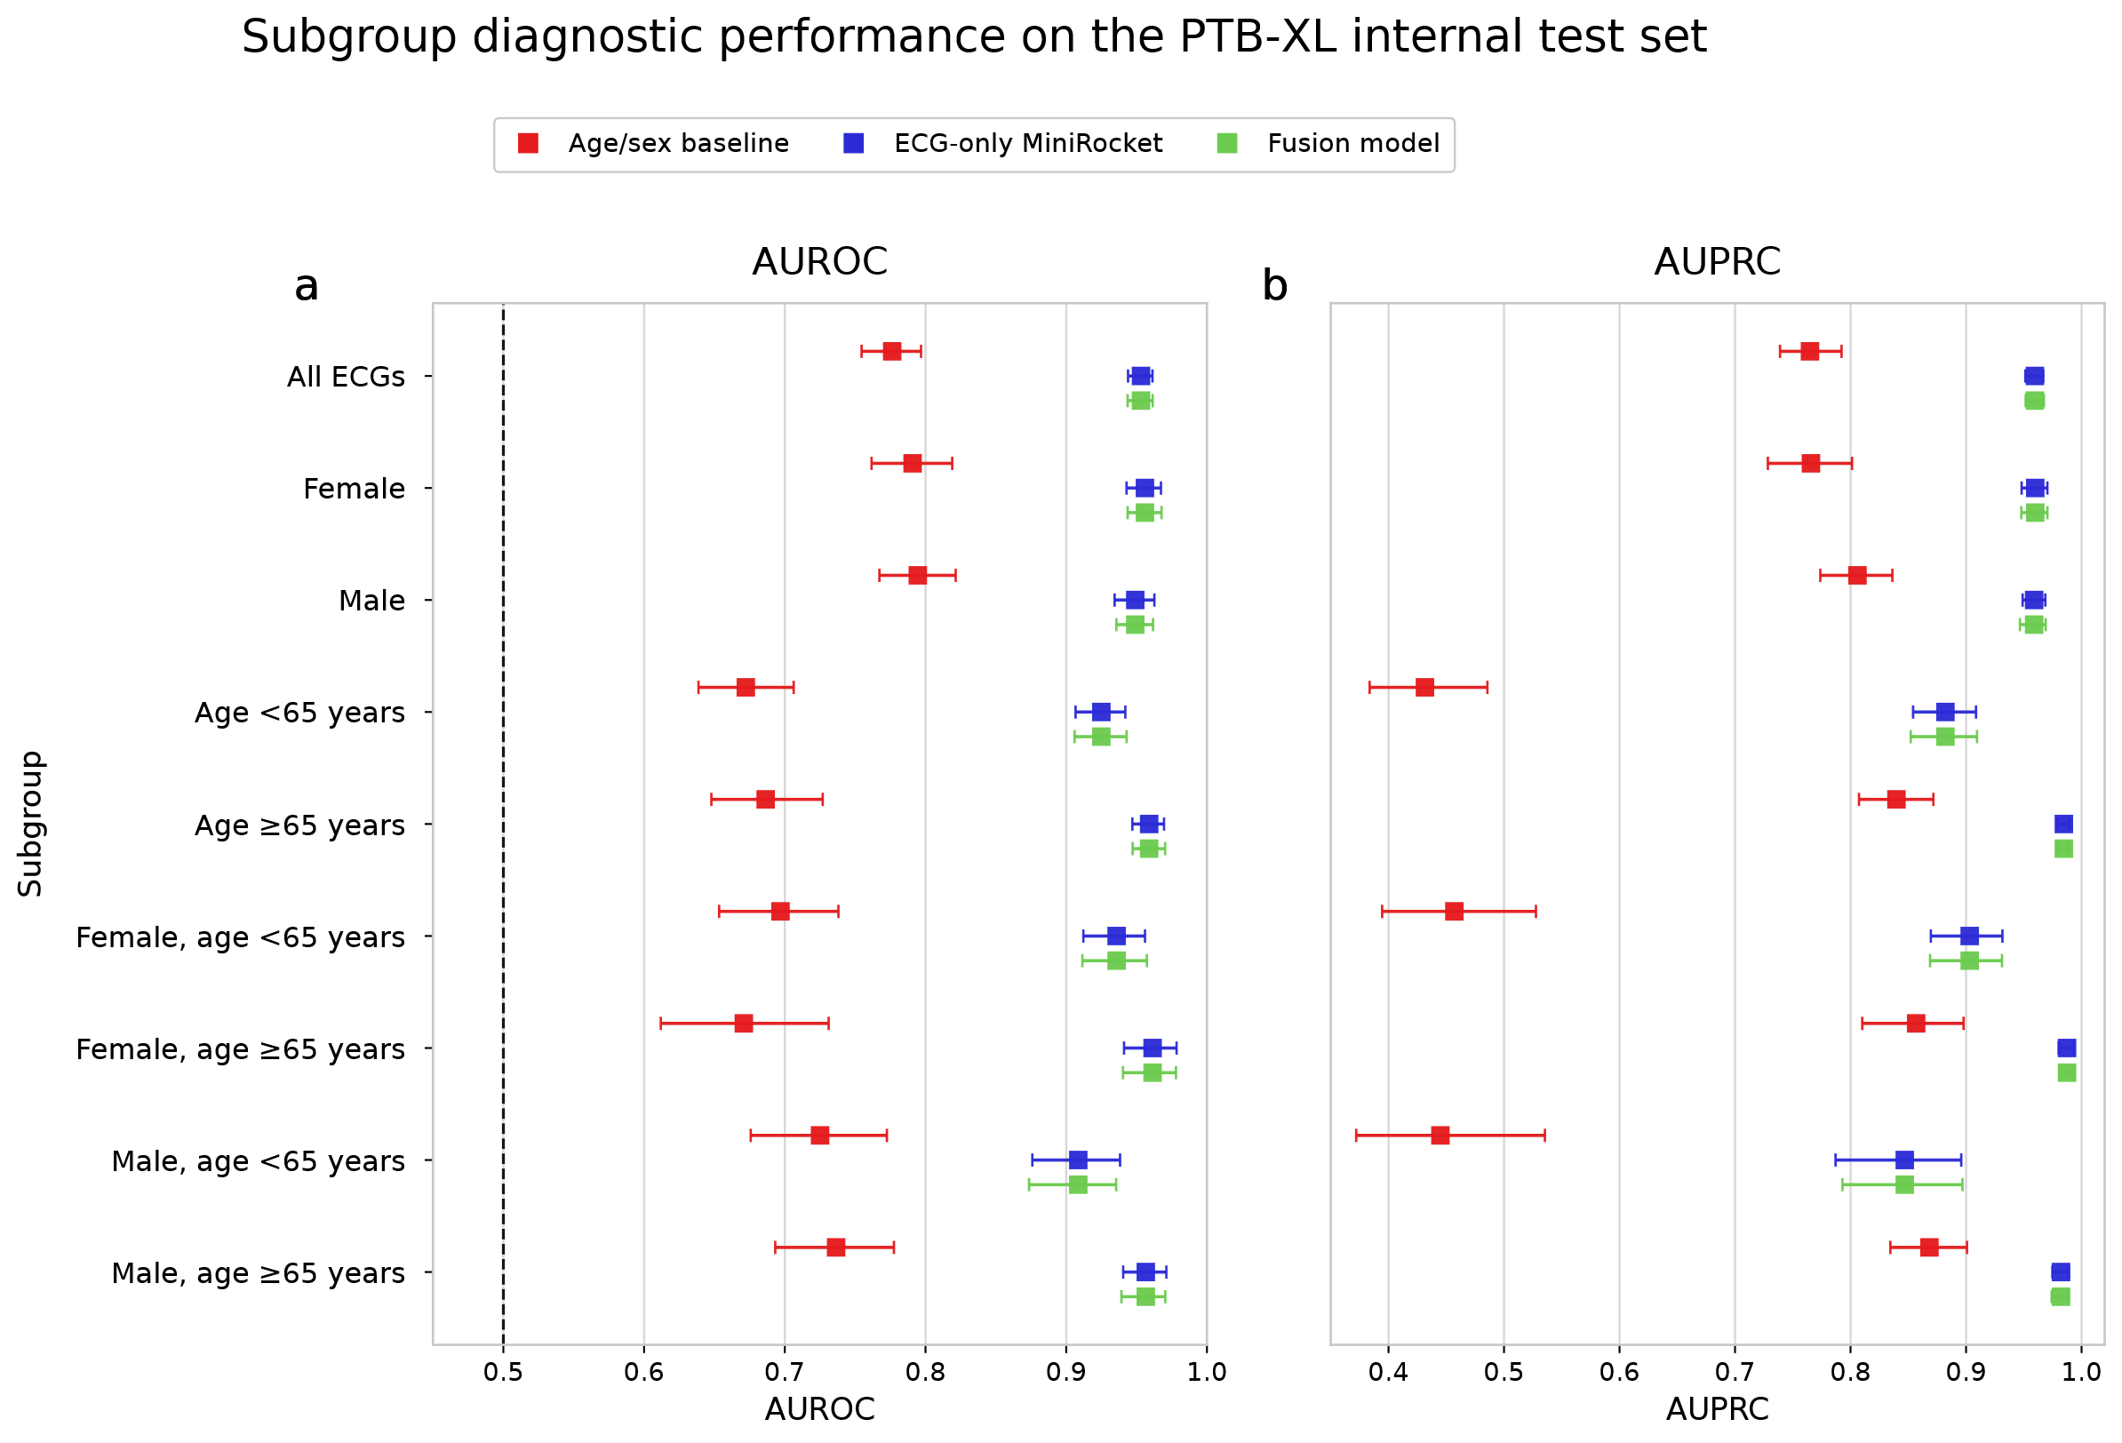
Supplementary Fig. S1. Demographic subgroup performance in the PTB-XL internal test set. Performance was evaluated across prespecified demographic subgroups in the PTB-XL primary held-out test set. a, AUROC for the age/sex baseline, MiniRocket–ridge model, and fusion model. b, AUPRC for the same models and subgroups. Points indicate point estimates, and horizontal error bars indicate 95% patient-cluster bootstrap confidence intervals. The dashed vertical line in panel a indicates the AUROC of a random classifier. Subgroups comprised the full held-out test set, sex-specific groups, age-specific groups, and combined age–sex strata. MiniRocket–ridge and the fusion model maintained higher discrimination than the age/sex baseline across the evaluated subgroups, whereas the fusion model provided little improvement over MiniRocket–ridge.

Supplementary Tables
Supplementary Table S1. Performance of the primary PTB-XL MiniRocket model across positive-label subgroups
Exploratory performance of the primary PTB-XL MiniRocket–ridge model was evaluated across three mutually exclusive positive-label groups: myocardial infarction without ST/T-change, ST/T-change without myocardial infarction, and myocardial infarction with ST/T-change. The table reports ECG-record and patient counts, AUROC and AUPRC with patient-cluster bootstrap confidence intervals, sensitivity and specificity at the fixed probability threshold of 0.5, and positive-class probability distributions.
Note: MI, myocardial infarction; NORM, normal diagnostic superclass; AUROC, area under the receiver operating characteristic curve; AUPRC, area under the precision–recall curve; CI, confidence interval; IQR, interquartile range. Each positive-label subgroup was compared separately with the same 960 NORM-labelled ECGs from 879 patients using unchanged calibrated probabilities from the composite-trained MiniRocket model. Confidence intervals were estimated using 1,000 patient-cluster bootstrap resamples. No subgroup-specific model fitting, probability calibration, threshold selection, or formal pairwise comparison was performed. The subgroup definitions were mutually exclusive at the ECG-record level; patient counts across subgroups were not necessarily mutually exclusive.
File: Supplementary Table S1.csv

Supplementary Table S2. Comparative performance of waveform models in internal and external validation
The table compares the downsampled-waveform logistic-regression model, compact one-dimensional residual network, and MiniRocket–ridge model in the PTB-XL primary composite held-out test set, the PTB-XL MI-only held-out test set, and the PTB Diagnostic external-validation cohort. Reported measures include sample size, outcome prevalence, AUROC, AUPRC, Brier score, accuracy, sensitivity, specificity, positive predictive value, negative predictive value, and confusion-matrix counts.
Results are reported at the fixed probability threshold of 0.5 and at model-specific thresholds selected by maximizing the Youden index in the corresponding PTB-XL validation partition. For external validation, the validation-derived thresholds were applied unchanged to the PTB Diagnostic ECG Database without external threshold selection or recalibration.
Note: AUROC, area under the receiver operating characteristic curve; AUPRC, area under the precision–recall curve; CI, confidence interval; PPV, positive predictive value; NPV, negative predictive value; MI, myocardial infarction. PTB-XL results were calculated at the ECG-record level. PTB Diagnostic results were calculated at the record level after mean aggregation of 10-s window probabilities. Confidence intervals were estimated using 1,000 patient- or subject-cluster bootstrap resamples, with all corresponding ECG records retained within each resample. AUROC, AUPRC, and Brier score are threshold-independent and may therefore be unchanged across rows representing different threshold strategies. PPV and NPV should be interpreted in relation to outcome prevalence. None of the evaluated probability thresholds was considered clinically validated.
File: Supplementary Table S2.csv

Supplementary Table S3. Paired bootstrap differences between MiniRocket and waveform benchmark models
The table reports paired differences in AUROC and AUPRC between MiniRocket–ridge and each waveform benchmark in the PTB-XL primary held-out test set, the PTB-XL MI-only held-out test set, and the PTB Diagnostic external-validation cohort.
Note: Differences are defined as MiniRocket minus the comparator model. Positive differences therefore favour MiniRocket, whereas negative differences favour the comparator. Confidence intervals were estimated using 1,000 paired patient- or subject-cluster bootstrap resamples, retaining all corresponding ECG records within each resampled individual. A confidence interval containing zero was interpreted as providing no clear evidence of a difference and was not interpreted as evidence of model equivalence.
File: Supplementary Table S3.csv
Supplementary Table S4. Selection and transport of fixed and validation-derived probability thresholds
The table documents the two threshold strategies evaluated for each model. A probability threshold of 0.5 was retained as a common descriptive reference. A second, model-specific threshold was selected by maximizing the Youden index in the corresponding PTB-XL validation partition. Validation-derived thresholds were subsequently applied unchanged to the held-out PTB-XL test set and, for the MI-only models, to the PTB Diagnostic ECG Database.
Note: No threshold was selected, adjusted, or recalibrated using held-out test or external outcomes. The fixed probability threshold of 0.5 was included for transparent descriptive comparison and was not assumed to be optimal across datasets or prevalence settings. Validation-derived thresholds represent threshold transport from the PTB-XL validation partition rather than external threshold optimization. Differences in outcome prevalence can affect accuracy, PPV, and NPV even when an unchanged threshold is applied. None of the reported thresholds should be interpreted as a clinically validated decision threshold.
File: Supplementary Table S4.csv

Supplementary Table S5. Model-probability distributions according to coexisting PTB-XL diagnostic superclasses
The table summarizes model-probability distributions among positive PTB-XL held-out ECGs according to the presence or absence of coexisting conduction-disturbance and/or hypertrophy diagnostic superclasses. Reported measures include ECG-record and patient counts, the proportion of positive ECGs represented by each group, median probability with interquartile range, and the number and proportion of ECGs with predicted probabilities of at least 0.5.
Note: MI, myocardial infarction; CD, conduction disturbance; HYP, hypertrophy; IQR, interquartile range. Probabilities were generated using the unchanged primary PTB-XL MiniRocket model and its validation-fitted probability calibration. Records carrying both NORM and MI and/or ST/T-change were treated as label-conflicting and excluded from these comparisons. No subgroup-specific model fitting, recalibration, or threshold selection was performed.
File: Supplementary Table S5.csv

Supplementary Table S6. Exploratory sensitivity analyses for coexisting diagnostic superclasses in the PTB-XL held-out test fold
The table reports exploratory analyses assessing whether discrimination of the primary composite phenotype was dependent on ECGs carrying coexisting conduction-disturbance or hypertrophy labels. The first analysis compared positive ECGs without either of these coexisting superclasses with the NORM reference group. The second evaluated separation from an abnormal challenge set comprising ECGs carrying conduction disturbance and/or hypertrophy without MI, ST/T-change, or NORM.
Note: AUROC, area under the receiver operating characteristic curve; AUPRC, area under the precision–recall curve; MI, myocardial infarction; NORM, normal diagnostic superclass. Confidence intervals were estimated using 1,000 patient-cluster bootstrap resamples. All analyses used unchanged calibrated probabilities from the primary MiniRocket model and the unchanged probability threshold of 0.5. The abnormal challenge set was exploratory and was not intended to represent a clinically comprehensive non-ischemic control population. No model fitting, recalibration, or additional threshold selection was performed.
File: Supplementary Table S6.csv

Supplementary Table S7. Patient- and ECG-record-level partition-overlap audit for the PTB-XL cohorts
Cohort | Partition comparison | Patient-ID overlap, n | ECG-record-ID overlap, n
Primary composite | Training versus validation | 0 | 0
Primary composite | Training versus held-out test | 0 | 0
Primary composite | Validation versus held-out test | 0 | 0
MI-only | Training versus validation | 0 | 0
MI-only | Training versus held-out test | 0 | 0
MI-only | Validation versus held-out test | 0 | 0
Note: PTB-XL predefined folds 1–8 were assigned to training, fold 9 to validation, and fold 10 to held-out testing. Overlap was assessed by set intersection of patient identifiers and ECG-record identifiers within each analytical cohort. No patient or ECG record appeared in more than one partition.

Supplementary Table S8. Preprocessing and harmonization sensitivity analyses in PTB Diagnostic and STAFF III
Panel A summarizes PTB Diagnostic external-validation results after alternative signal-quality exclusions and resampling. Panel B summarizes STAFF III paired probability changes after quality-control exclusions, use of measured rather than reconstructed lead III, alternative resampling, and the combination of these preprocessing changes. The fitted MiniRocket transformers, ridge classifiers, training-derived normalization parameters, validation-fitted probability calibrators, and probability thresholds were unchanged in all analyses.
Panel A. PTB Diagnostic record-level sensitivity analyses
The table reports the number of retained 10-s windows and ECG records together with AUROC, AUPRC, Brier score, accuracy, sensitivity, and specificity for the primary polyphase-resampling analysis, structural quality control, extended quality control, and alternative zero-phase FIR decimation.
Panel B. STAFF III paired sensitivity analyses
The table reports the number of complete baseline–occlusion pairs, mean and median occlusion-minus-baseline probability changes, and the number of pairs with a higher model probability during occlusion for the primary analysis and evaluated preprocessing alternatives.
Note: Structural quality control required all signal values to be finite, a within-segment standard deviation of at least 10⁻⁴ mV in every lead, and a peak-to-peak amplitude of at least 10⁻⁴ mV in every lead. The extended quality-control screen additionally required the maximum absolute amplitude within a segment to be no greater than 5 mV. The 5-mV criterion was exploratory and was not treated as a clinically validated signal-quality threshold. PTB Diagnostic performance was calculated after record-level mean aggregation of retained window probabilities. Alternative STAFF III analyses were restricted to complete pairs for which both the baseline and occlusion segments contained finite values. Positive STAFF III probability changes indicate higher model probability during balloon occlusion than during the corresponding baseline or pre-inflation segment. FIR, finite impulse response; QC, quality control.
The record-level PTB Diagnostic predictions and paired STAFF III probability outputs underlying these analyses are provided in Supplementary Data 5.
File: Supplementary Table S8.xlsx

Supplementary Table S9. MiniRocket–ridge training, model-selection, calibration, and reproducibility settings
Supplementary Table S9 reports the complete implementation, model-selection, calibration, and reproducibility settings for the primary PTB-XL composite MiniRocket pipeline and the separate PTB-XL MI-only MiniRocket pipeline.
The table includes the transformer implementation, training-cohort size, input dimensions, requested kernel count, resulting number of transformed features, maximum number of dilations per kernel, random state, parallel-processing configuration, complete ridge-regularization search grid, validation-based selection criterion, selected α value, validation AUROC, ridge-classifier settings, probability-calibration settings, and saved-object audit information.
The complete ridge-regularization grid was:
α ∈ {0.001, 0.00464159, 0.0215443, 0.1, 0.464159, 2.15443, 10, 46.4159, 215.443, 1,000}.
The selected value was α = 46.4159 for the primary composite model, with a validation AUROC of 0.9604, and α = 10.0 for the MI-only model, with a validation AUROC of 0.9676.
Note: The primary and MI-only MiniRocket pipelines were developed during separate modelling stages using the aeon and sktime multivariate implementations, respectively. Backend choice was not treated as an experimental comparison, and numerical equivalence between the implementations was not assumed. Each fitted transformer, ridge classifier, and validation-fitted Platt calibrator was retained and applied without refitting within its corresponding development and evaluation pipeline. The reported aeon and sktime versions describe the final saved-object audit environment; the exact original training-time backend versions were not retained in the archived metadata.
File: Supplementary Table S9.csv

Supplementary Data
Supplementary Data 1. Internal PTB-XL model results and figure source data
Supplementary Data 1 contains derived source data for the PTB-XL internal-validation analyses. The workbook includes performance summaries for the prespecified models, demographic subgroup results, descriptive threshold-dependent operating characteristics, calibration information, receiver operating characteristic and precision–recall source data, patient-cluster bootstrap results, and de-identified held-out prediction outputs supporting the internal-validation analyses.
The evaluated models include the age/sex logistic-regression baseline, downsampled-waveform logistic-regression benchmark, compact one-dimensional residual network, MiniRocket–ridge model, and fusion model. Classification results use a probability threshold of 0.5 unless another threshold is explicitly specified.
The workbook contains derived analytical outputs only. Raw ECG waveforms, patient identifiers, ECG-record identifiers, internal array indices, private processing paths, and trained model objects are not included.
File: Supplementary Data 1.xlsx

Supplementary Data 2. De-identified STAFF III paired model-probability changes during coronary occlusion
Supplementary Data 2 contains de-identified paired model probabilities for STAFF III baseline/pre-inflation and coronary-occlusion ECG segments. Reported fields include an anonymous pair identifier, baseline source type, baseline model probability, occlusion model probability, occlusion-minus-baseline probability change, direction of change, and absolute probability change.
These data support the exploratory analysis of baseline-dependent changes in model probability during controlled coronary balloon occlusion. The analysis characterizes paired probability changes and should not be interpreted as an estimate of individual-level diagnostic accuracy for acute ischemia.
Raw ECG waveforms, patient identifiers, original record identifiers, internal array indices, and source file paths are not included.
File: Supplementary Data 2.xlsx

Supplementary Data 3. Extended threshold-dependent operating characteristics and uncertainty estimates
Supplementary Data 3 contains extended internal and external operating characteristics across low- and high-probability thresholds. Reported measures include sensitivity, specificity, positive predictive value, negative predictive value, accuracy, threshold-specific classification counts, and error counts.
The workbook also contains two-sided 95% exact Clopper–Pearson binomial confidence intervals for specificity and positive predictive value at the PTB Diagnostic high-probability thresholds. Specificity intervals use the 80 non-MI records as the denominator, whereas PPV intervals use the number of records classified above the corresponding threshold.
The results represent descriptive operating characteristics of the evaluated cohorts. None of the reported thresholds should be interpreted as a clinically validated rule-out, rule-in, or triage threshold. The workbook contains derived analytical outputs only and does not include raw ECG waveforms, patient identifiers, ECG-record identifiers, or other source-level identifiers.
File: Supplementary Data 3.xlsx

Supplementary Data 4. Source data for the MiniRocket perturbation-sensitivity analysis
Supplementary Data 4 contains aggregate source data supporting Fig. 8. Separate worksheets report complete-lead mean-replacement perturbations across all 12 ECG leads, temporal mean-replacement perturbations across ten non-overlapping 1-s intervals, and the 12 × 10 lead-by-time perturbation analysis.
For the lead-level and temporal analyses, the workbook includes mean absolute changes in calibrated probability, changes in model-performance measures, and patient-cluster bootstrap confidence intervals. The lead-by-time grid is summarized descriptively.
Because the ECG inputs were standardized using training-derived parameters, replacing standardized values with zero corresponds to replacement with the training-set mean for the affected lead. These analyses quantify model sensitivity to mean replacement and do not establish causal, anatomical, physiological, or clinical importance.
Raw ECG waveforms, patient identifiers, ECG-record identifiers, trained model objects, and private perturbation caches are not included.
File: Supplementary Data 4.xlsx
Supplementary Data 5. Source data for preprocessing and harmonization sensitivity analyses
Supplementary Data 5 contains the source data underlying Supplementary Table S8. The workbook comprises four worksheets: a README describing the analysis definitions and data structure; a sensitivity-summary worksheet containing aggregate PTB Diagnostic and STAFF III results; a PTB Diagnostic worksheet containing de-identified record-level probabilities under four preprocessing scenarios; and a STAFF III worksheet containing de-identified baseline, occlusion, and paired probability-change outputs under four preprocessing scenarios.
The PTB Diagnostic scenarios comprise the primary polyphase-resampling analysis, structural quality control, extended quality control, and alternative zero-phase FIR decimation. The STAFF III scenarios comprise the primary analysis using reconstructed lead III, use of measured lead III, alternative zero-phase FIR decimation, and the combination of measured lead III with FIR decimation. No model was retrained, recalibrated, reselected, or externally optimized for these analyses.
Original PTB Diagnostic record and subject labels were replaced with sequential study-specific indices. STAFF III outputs are indexed by paired comparison. The source sensitivity output did not retain the mapping of the 80 paired comparisons to the 58 original subjects; therefore, no unsupported subject-level identifier was added.
The workbook does not contain raw ECG waveforms, trained model objects, transformed MiniRocket features, original source file paths, private processing caches, or identifiable information.
File: Supplementary Data 5.xlsx

