Supplementary material
Supplementary material 1. The full, uncropped Western blot membranes

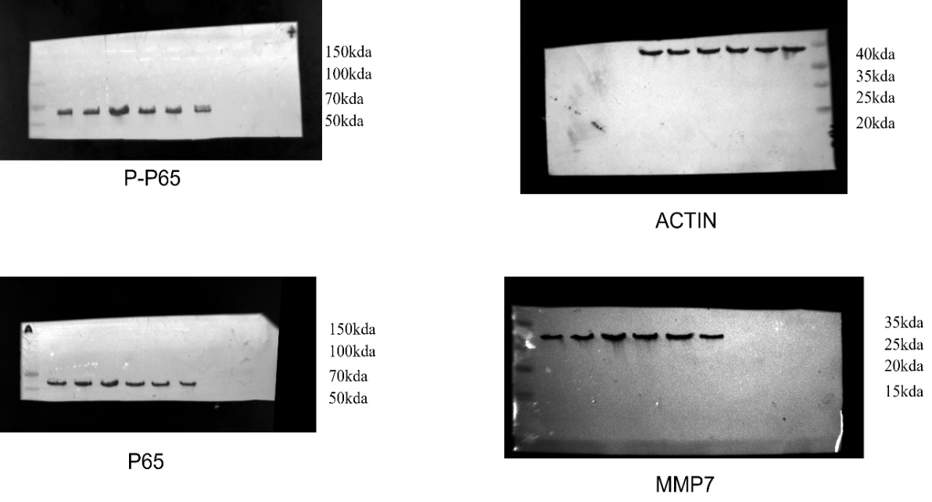
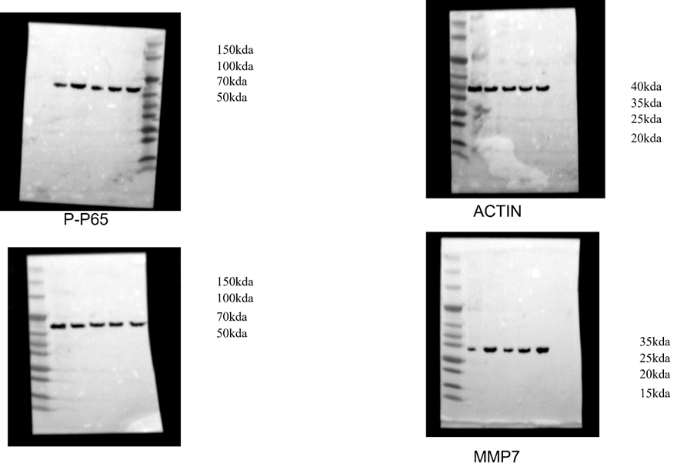
Figure 5 (F)
Figure 6 (C)

