Supporting Information
Computational Exploration of 1H-1,2,3-Triazole Derivatives as TGF-β Pathway Targeted Therapeutics for Oral Squamous Cell Carcinoma
Sadananda Mal^{1,2}, Raunak Kumar Das^{1*}
¹Centre for Biomaterials, Cellular and Molecular Theranostics (CBCMT), Vellore Institute of Technology (VIT), ALM Block, 4th floor, Vellore, Tamil Nadu, 632014, India
²School of Biosciences and Technology, Vellore Institute of Technology (VIT), Vellore, Tamil Nadu, 632014, India
*Correspondence: Raunak Kumar Das (raunakkumardas@vit.ac.in)

Table of contents
1 | Supplementary figure 1
2 | Supplementary figure 2
2 | Supplementary Table1
3 | Supplementary table 2

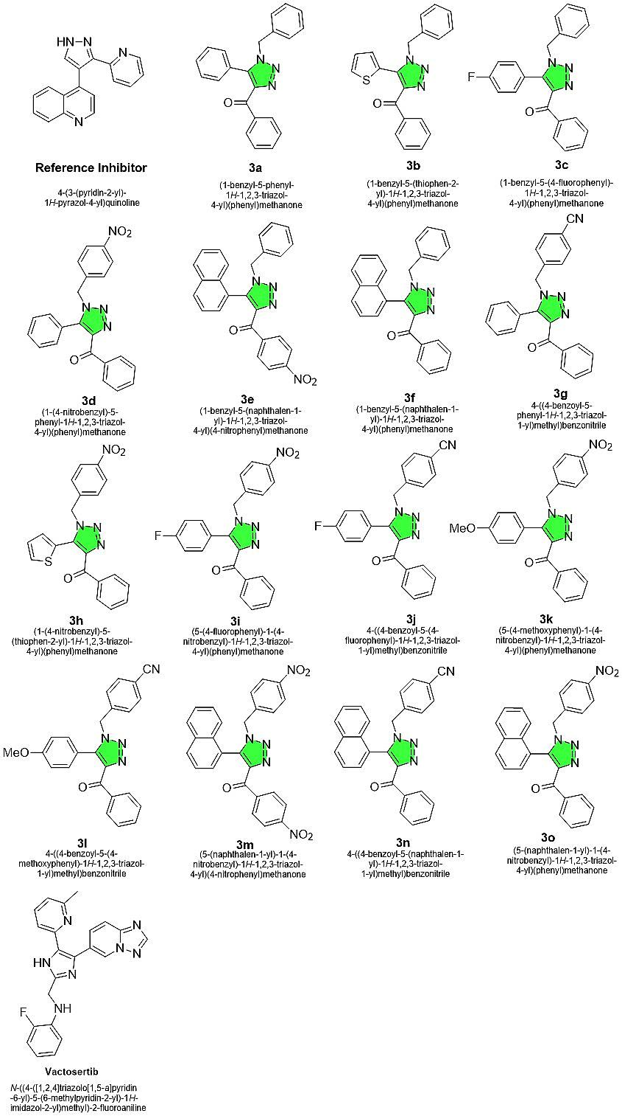
Supplementary figure 1: Chemical structures and names of the compounds used for the study
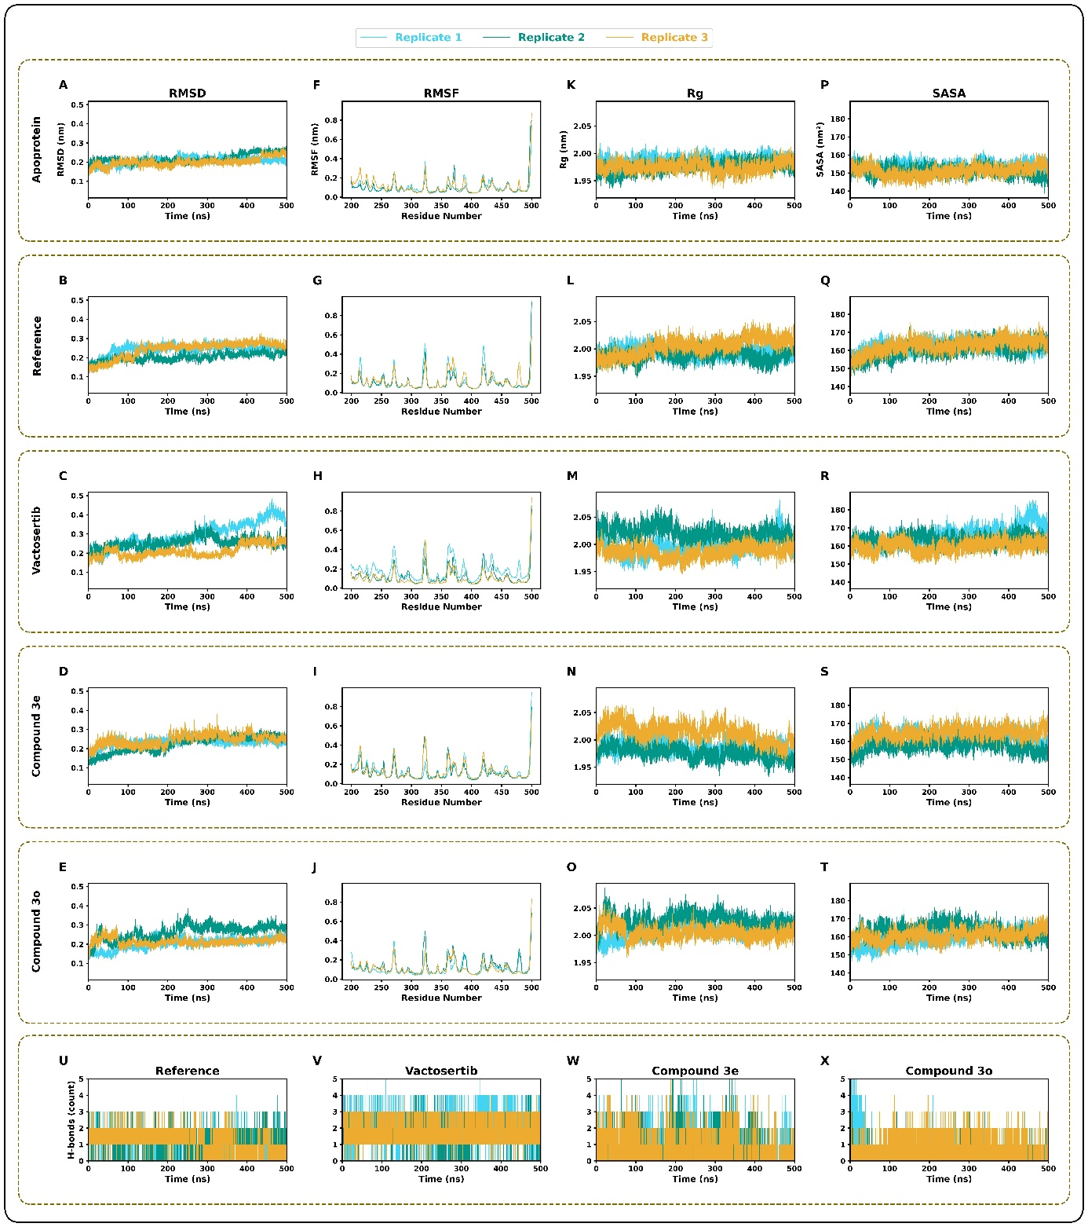
Supplementary figure 2: (A-E) Per replicate RMSD of apoprotein (A), reference inhibitor (B), vactosertib (C), compound 3e (D), and compound 3o (E). (F-J) Per replicate RMSF of apoprotein (F), reference inhibitor (G), vactosertib (H), compound 3e (I), and compound 3o (J). (K-O) Per replica RG of apoprotein (K), reference inhibitor (L), vactosertib (M), compound 3e (N), and compound 3o (O). (P-T) Per replica SASA of apoprotein (P), reference inhibitor (Q), vactosertib (R), compound 3e (S), and compound 3o (T). (U-X) Per replica H-bond analysis of reference inhibitor (U), vactosertib (V), compound 3e (W), and compound 3o (X).

Supplementary Table 1: Molecular docking results showing binding energy (BE), inhibitory constant (Ki), and intermolecular energy (IE) of the selected compound library, vactosertib and the reference inhibitor.
Sl no. | Compound | BE (kcal/mol) | Ki (nM) | IE (kcal/mol)
1 | Reference Inhibitor | -8.98 | 263.26 | -9.57
2 | Vactosertib | -10.31 | 27.94 | -11.80
3 | 3a | -9.48 | 112.25 | -10.97
4 | 3b | -8.85 | 326.86 | -10.34
5 | 3c | -9.51 | 107.01 | -11
6 | 3d | -10.35 | 25.90 | -12.14
7 | 3e | -12.1 | 1.36 | -13.89
8 | 3f | -11.44 | 4.14 | -12.93
9 | 3g | -10.13 | 37.35 | -11.62
10 | 3h | -9.67 | 81.28 | -11.46
11 | 3i | -10.1 | 39.74 | -11.89
12 | 3j | -10.02 | 45.17 | -11.51
13 | 3k | -11.04 | 8.13 | -13.12
14 | 3l | -9.11 | 209.85 | -10.9
15 | 3m | -11.64 | 2.92 | -13.73
16 | 3n | -12.07 | 1.43 | -13.56
17 | 3o | -12.1 | 1.34 | -13.89

Supplementary Table 2: Detailed ADMET analysis of reference inhibitor, vactosertib, compound 3e and compound 30
Parameter |  |  | Molecule
 |  | Reference ligand | Vactosertib | Compound 3e | Compound 3o
Physicochemical properties | Formula | C₁₇H₁₂N₄ |  | C₂₆H₁₈N₄O₃ | C₂₆H₁₈N₄O₃
Physicochemical properties | MW (g/mol) | 272.3 | 399.433 | 434.45 | 434.45
Physicochemical properties | #Rotatable bonds | 2 | 5 | 6 | 6
Physicochemical properties | #H-bond acceptors | 3 | 5 | 5 | 5
Physicochemical properties | #H-bond donors | 1 | 2 | 0 | 0
Physicochemical properties | MR | 82.56 | 112.52 | 127.41 | 127.41
Physicochemical properties | TPSA (Å²) | 54.46 | 83.79 | 90.92 | 93.6
Lipophilicity | iLOGP | 2.07 | 3.522 | 3.03 | 3.18
Lipophilicity | XLOGP3 | 2.74 | 3.19 | 5.7 | 5.7
Lipophilicity | WLOGP | 3.69 | 4.32 | 5.81 | 5.81
Lipophilicity | MLOGP | 1.74 | 2.39 | 2.96 | 2.96
Lipophilicity | Silicos-IT Log P | 3.97 | 2.85 | 3.49 | 3.49
Lipophilicity | Consensus Log P | 2.84 | 3.19 | 4.2 | 4.23
Absorption | Water solubility (log mol/L) | -2.917 | -4.64 | -6.92 | -7.106
Absorption | Caco2 permeability (log Papp in 10-6 cm/s) | 1.345 | 0.819 | 0.232 | 0.23
Absorption | Intestinal absorption (human) | 94.644 % | 97.45% | 98.30 % | 97.912 %
Absorption | Skin Permeability (log Kp) | -2.736 | -2.735 | -2.735 | -2.735
Absorption | P-glycoprotein substrate | No | Yes | No | Yes
Absorption | P-glycoprotein I inhibitor | No | No | Yes | Yes
Absorption | P-glycoprotein II inhibitor | Yes | Yes | Yes | Yes
Distribution | VDss (human) (log L/kg) | 0.548 | -0.11 | -0.738 | -0.736
Distribution | Fraction unbound (human) (Fu) | 0.301 | 0.232 | 0.305 | 0.306
Distribution | BBB permeability | 0.682 | -1.988 | 0.137 | 0.03
Distribution | CNS permeability (log PS) | -2.035 | -2.537 | -1.807 | -1.764
Metabolism | CYP2D6 substrate | No | No | No | No
Metabolism | CYP3A4 substrate | Yes | No | Yes | Yes
Metabolism | CYP1A2 inhibitior | Yes | Yes | No | No
Metabolism | CYP2C19 inhibitior | Yes | Yes | Yes | Yes
Metabolism | CYP2C9 inhibitior | No | Yes | Yes | Yes
Metabolism | CYP2D6 inhibitior | No | No | No | No
Metabolism | CYP3A4 inhibitior | Yes | No | Yes | No
Excretion | Total Clearance (log ml/min/kg) | 0.359 | 0.822 | 0.188 | 0.194
Excretion | Renal OCT2 substrate | No | No | No | No
Toxicity | AMES toxicity | Yes | Yes | Yes | Yes
Toxicity | Max. tolerated dose (human) ((log mg/kg/day)) | 0.443 | 0.458 | 0.533 | 0.529
Toxicity | hERG I inhibitor | No | No | No | No
Toxicity | hERG II inhibitor | Yes | No | No | Yes
Toxicity | Oral Rat Acute Toxicity (LD50) (mol/kg) | 2.914 | 2.471 | 2.752 | 2.704
Toxicity | Oral Rat Chronic Toxicity (LOAEL) (log mg/kg_bw/day) | 1.859 | -1.259 | -0.083 | 0.36
Toxicity | Hepatotoxicity | Yes | Yes | Yes | Yes
Toxicity | Skin Sensitisation | No | No | No | No
Toxicity | T.Pyriformis toxicity (log ug/L) | 0.287 | 0.285 | 0.285 | 0.285
Toxicity | Minnow toxicity (log mM) | 0.853 | 0.514 | -1.166 | -2.166
Druglikeness | QED | 0.605 | 0.462 | 0.206 | 0.206
Druglikeness | SAscore | Easy | 2.741 | Easy | Easy
Druglikeness | GASA | Easy | Easy | Easy | Easy
Druglikeness | Fsp3 | 0 | 0.091 | 0.038 | 0.038
Druglikeness | MCE-18 | 18 | 25 | 26 | 26
Druglikeness | NPscore | -1.044 | -1.920 | -1.246 | -1.228
Druglikeness | Lipinski Rule | Accepted | Accepted | Accepted | Accepted
Druglikeness | Pfizer Rule | Accepted | Accepted | Accepted | Accepted
Druglikeness | GSK Rule | Accepted | Accepted | Rejected | Rejected
Druglikeness | GoldenTriangle | Accepted | Accepted | Accepted | Accepted
Druglikeness | PAINS | 0 | 0 | 0 | 0

