Supplementary material

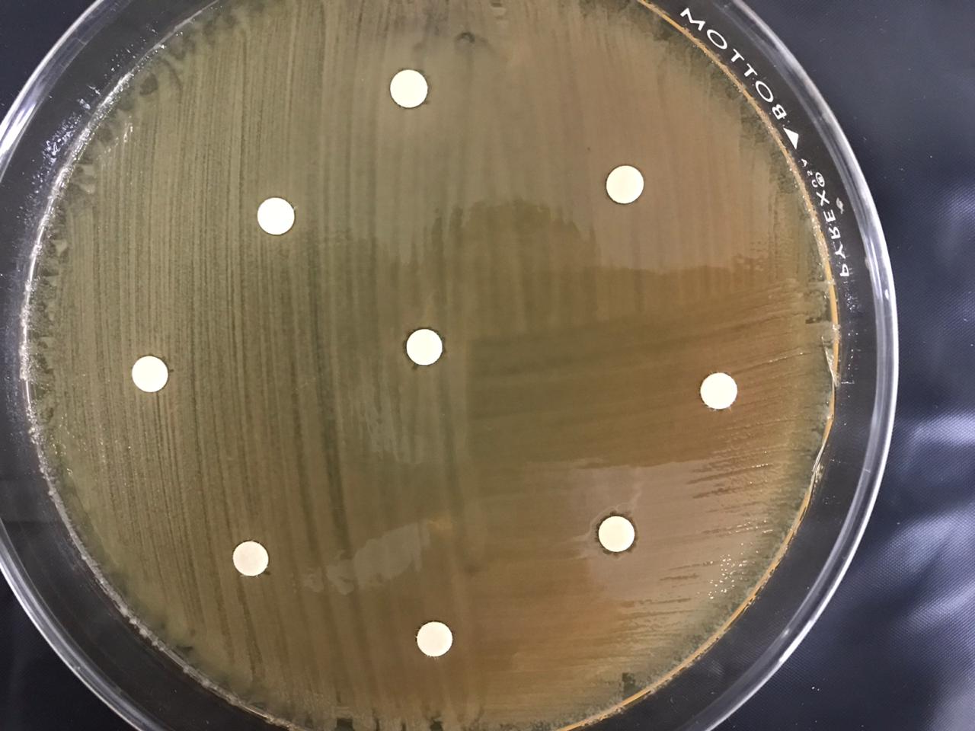
A. cascaia
control
A. cascaia
A. cascaia
A. cascaia
A. cascaia
control
Figure 1. Representative image of the disk diffusion susceptibility test, with application of Anthopleura cascaia venom or without any treatment (control), to evaluate the inhibition halos of Klebsiella pneumoniae. Below the zoomed image.

A
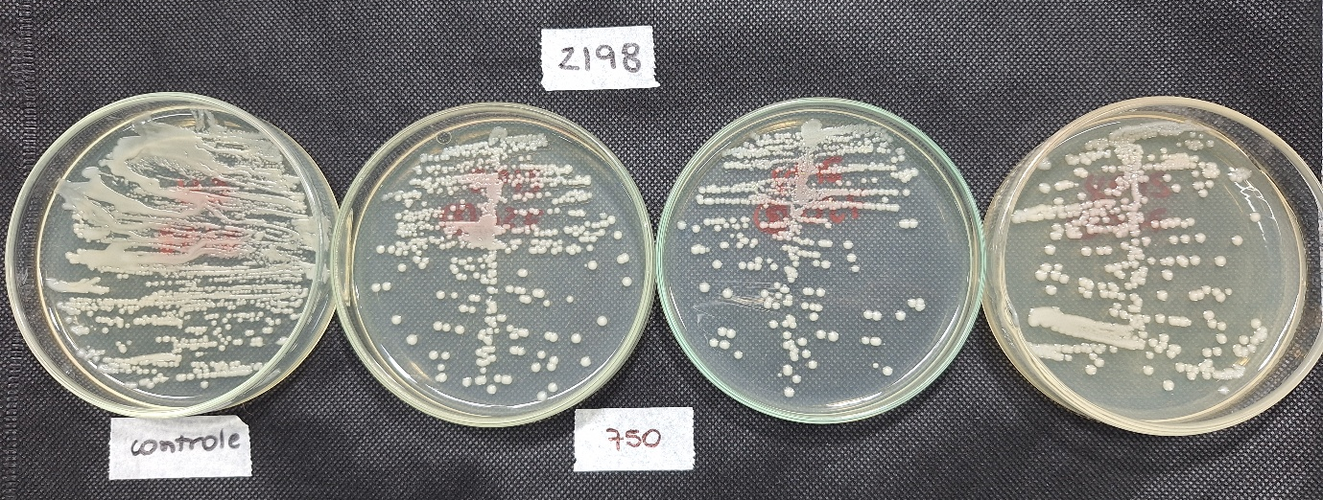

B
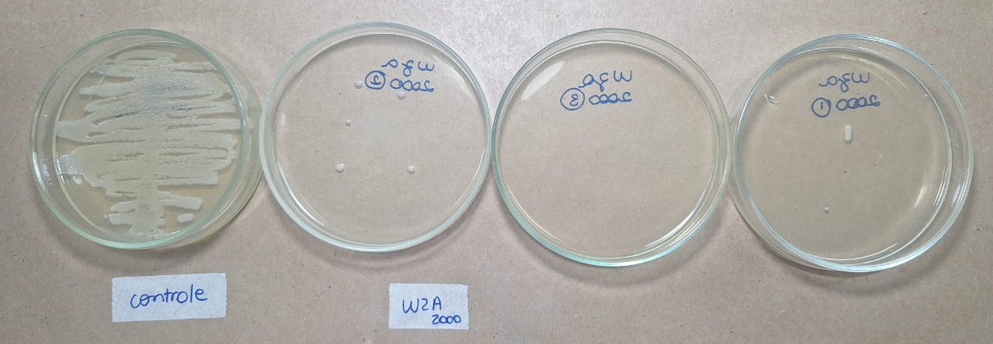
Figure 2. Representative image of the biocide assay. (A) 2198 clinical isolate, to compare control, without TBA (left plate) and with 750 μg/mL TBA. (B) KP07107 in the control of growth (left plate) with 2000 μg/mL TBA.

