Genomic diversity reveals breeding pools in Brazilian tetraploid potato germplasm

Givanildo Rodrigues da Silva¹, Gustavo Nandi¹, Marcio F. R. Resende², Tiago de Souza Marçal³, Thiago Leandro Factor⁴, Fernando Angelo Piotto^{1*}

¹ Genetics Department, Luiz de Queiroz College of Agriculture, University of São Paulo, Piracicaba, São Paulo, Brazil
² Horticultural Sciences Department, University of Florida, Gainesville, Florida, USA
³ Department of Biology, University of Lavras, Lavras, Minas Gerais, Brazil
⁴ Horticulture Center, Agronomic Institute (IAC), Campinas, São Paulo, Brazil
*Corresponding author: fpiotto@usp.br

Supplementary Figures

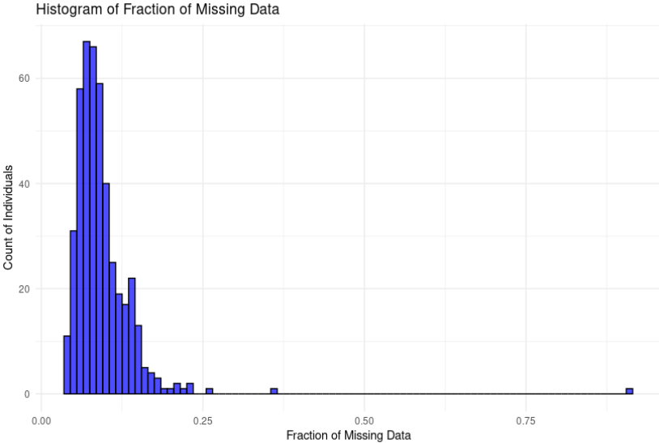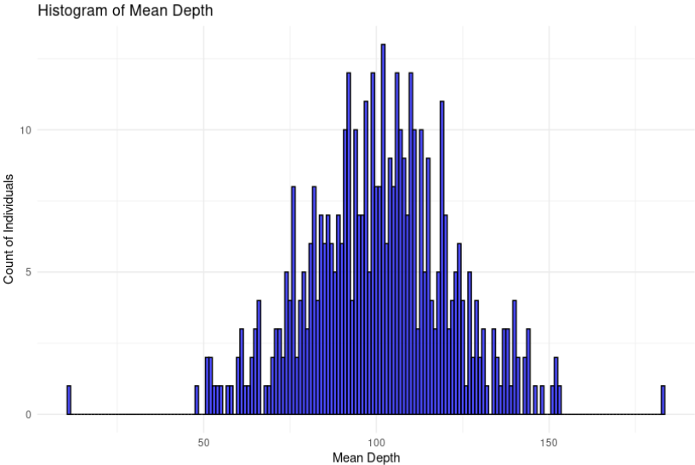
Supplementary Figure S1. Fraction of missing data and depth obtained from Flex-Seq genotyping platform. The .vcf file was used as input for plot elaborations. The arrow indicates the advanced clone CBM16-16.
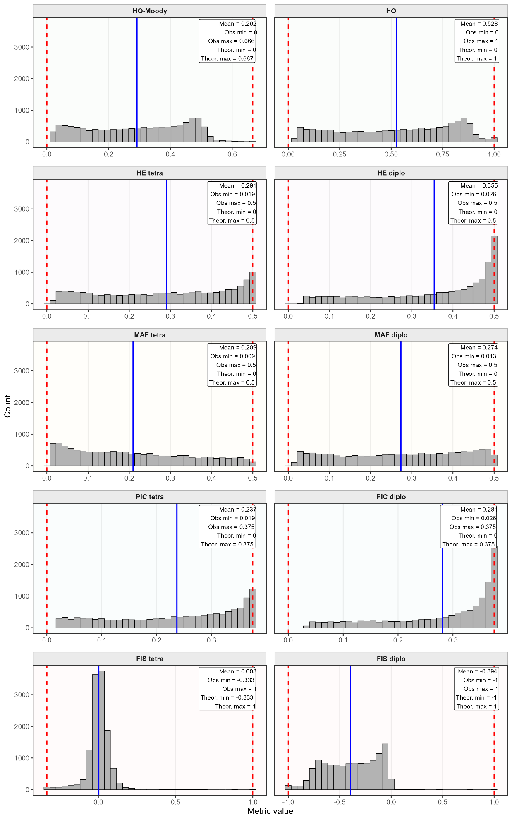
Supplementary Figure S2. Patterns of diversity parameters estimated in the LMH panel considering allele-dosage aware.

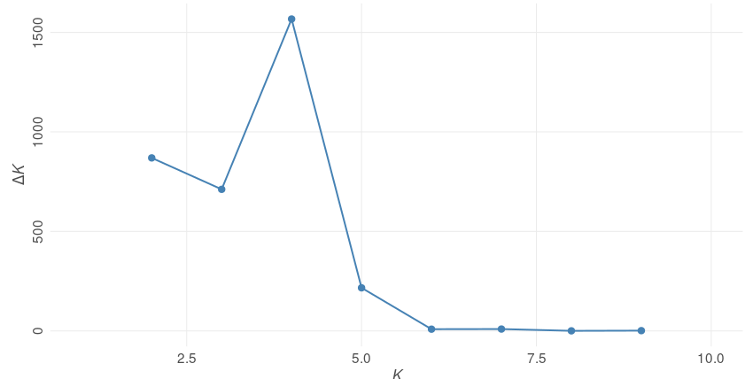Supplementary Figure S3. STRUCTURE analysis revealed four subpopulations in the LMH germplasm panel based on a pruned SNP dataset (7,455 SNPs). The maximum ΔK determined was K= 4.

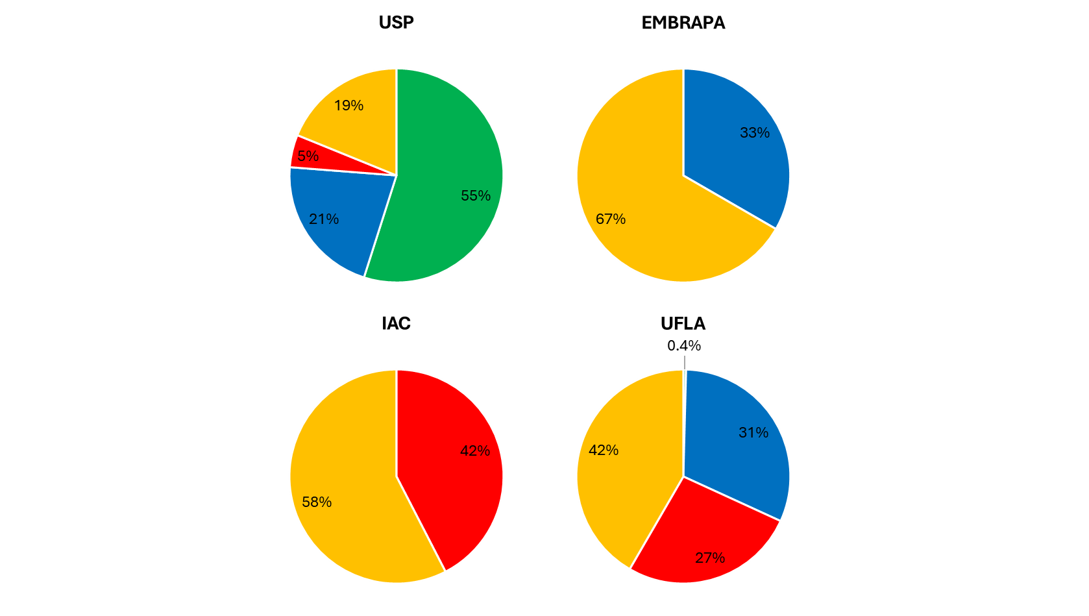
Supplementary Figure S4. The percentage of each genetic cluster across the national potato breeding program (Brazilian population). University of São Paulo (USP, n=122), Agronomical Institute of Campinas (IAC, n=33), Brazilian Agricultural Research Corporation (EMBRAPA, n=3), and Federal University of Lavras (UFLA, n=245).

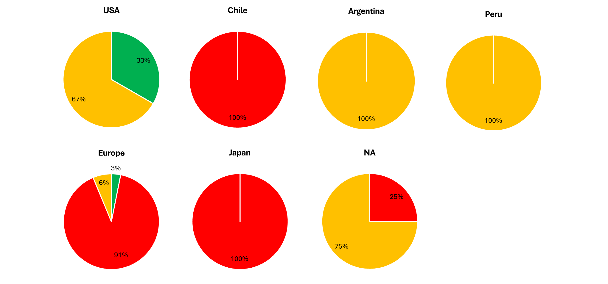
Supplementary Figure S5. The percentage of each genetic cluster across Foreign origin population. 47 foreign clones from United State of America (n=3), Chile (1), Argentina (1), Peru (1), Europe (32), Japan (1), and not available (NA, 8).

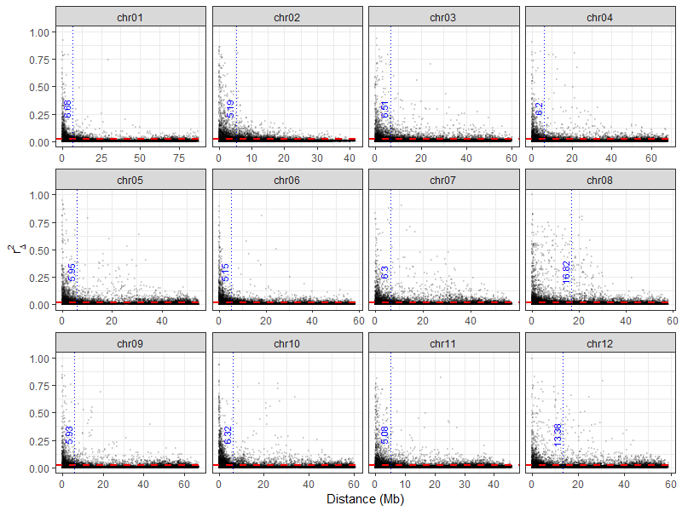
Supplementary Figure S6. Linkage disequilibrium ($r_{∆}^{2}$) decay estimate across the twelve potato chromosomes. The red line indicates the $r_{∆}^{2}$ = 0.02, and the blue indicates the bp distance at this point.

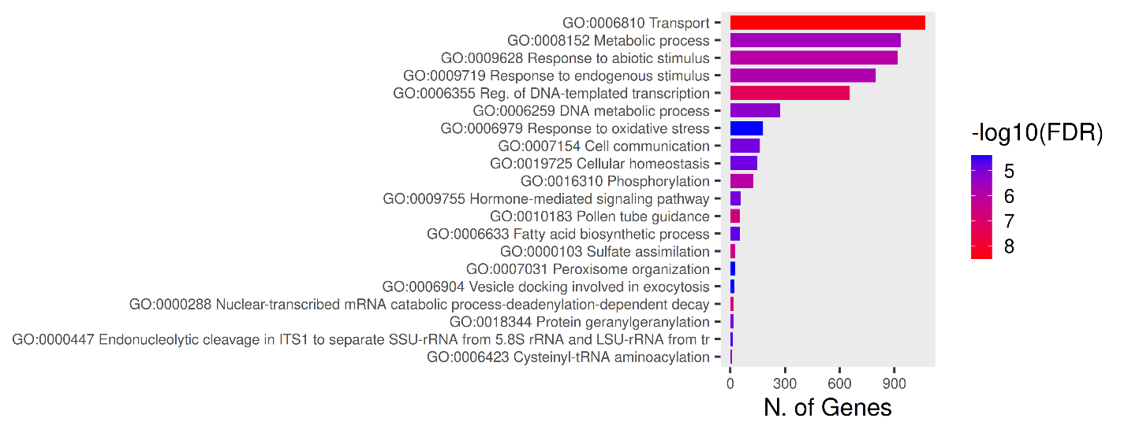
Supplementary Figure S7. Significant Gene Ontology (GO) categories for biological process of 10,673 genes annotated within the regions putatively under selection.

