Metabolic switching between inorganic and organic phosphorus sustains microbial activity in an ultraoligotrophic ocean
Supplementary Information

Table S1: Summary of the sampling locations in the eastern Mediterranean Sea.
Cruise | Date | Station name | Lat. (N) | Lon. (E) | Sampling depths (m) | Key measurements/ activities
HS43 | Mar. 2021 | HS15 | 32.84 | 35.01 | Surface to bottom (15 m) | ³³PO₄&AT³³P turnover, concentration, and kinetics experiments
HS43 | Mar. 2021 | HS25 | 32.88 | 34.96 | Surface to bottom (25 m)
HS43 | Mar. 2021 | H01 | 32.90 | 34.91 | Surface to bottom (60 m)
HS43 | Mar. 2021 | H02 | 32.92 | 34.88 | 1-300
HS43 | Mar. 2021 | H03 | 32.93 | 34.84 | 1-300
HS43 | Mar. 2021 | H04 | 32.95 | 34.75 | 1-300
HS43 | Mar. 2021 | H05 | 33.00 | 34.49 | 1-300
HS43 | Mar. 2021 | H06 | 33.15 | 34.16 | 1-300
M197 | Jan.-Feb. 2024 | 2 | 33.36 | 32.38 | Surface | Indirect DOP uptake*, microcosm experiments
M197 | Jan.-Feb. 2024 | 3 | 33.36 | 32.38 | Surface | Indirect DOP uptake*, microcosm experiments
M197 | Jan.-Feb. 2024 | 9 | 34.13 | 32.36 | Surface | Indirect DOP uptake*, microcosm experiments
M197 | Jan.-Feb. 2024 | 16 | 34.06 | 34.15 | Surface | Indirect DOP uptake*, microcosm experiments
M197 | Jan.-Feb. 2024 | 24 | 34.07 | 32.68 | Surface | Indirect DOP uptake*, microcosm experiments
*Derived from APA measurements.

Table S2: Ancillary data showing daily PO₄ uptake and APA-derived DOP hydrolysis rates normalized to CTC-positive cells (i.e., Figure 4) and to total microbial cells comprising heterotrophic prokaryotes, Synechococcus, Prochlorococcus, picoeukaryotes, and nanoeukaryotes.
Station | Water type | Total microbial cells  (cells mL⁻¹) | CTC-positive cells (cells mL⁻¹) | CTC-positive  (% of total) | PO₄ uptake per CTC-positive cell (fmol P cell⁻¹ d⁻¹) | PO₄ uptake per total cell (fmol P cell⁻¹ d⁻¹) | DOP hydrolysis per CTC-positive cell (fmol P cell⁻¹ d⁻¹) | DOP hydrolysis per total cell (fmol P cell⁻¹ d⁻¹)
2 | Anticyclone | 9.06E+05 | 9.89E+04 | 10.9 | 0.052 | 0.006 | 0.133 | 0.015
3 | Border of anticyclone | 1.42E+06 | 2.82E+05 | 19.8 | 0.003 | 0.001 | 0.015 | 0.003
9 | Uninfluenced by eddy circulation | 1.68E+06 | 5.18E+05 | 30.9 | 0.007 | 0.002 | 0.008 | 0.002
16 | Cyclone | 1.81E+06 | 4.21E+05 | 23.2 | 0.002 | 0.000 | 0.011 | 0.003
24 | Anticyclone | 1.80E+06 | 3.64E+05 | 20.2 | 0.012 | 0.002 | 0.027 | 0.005

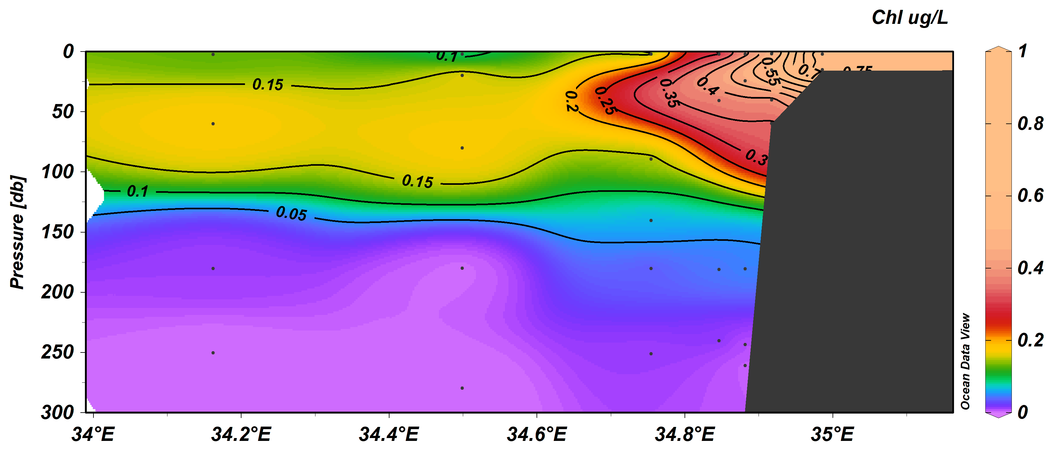
Figure S1: Spatial and vertical distribution of chlorophyll.a in the easternmost Mediterranean Sea during cruise HS43 held in winter 2021.
Dust leaching experiment during the R.V Meteor cruise M197
PM10 aerosols were collected by a high-volume collector located at the monkey island of the R.V Meteor (upstream to the smoking area, Figure S1). Air flow rate was set at 67.8 m³ h⁻¹ and aerosols were collected on to Whatman 41 filters (acid-cleaned, 203 mm x 254 mm). The sampling of the Saharan dust event as presented by the air mass back trajectories and Skiron forecast model (Figure S2) started on 8 January 2024 05:25 (UTC) and ended on 9 January 2024 17:35 (UTC).
Leaching experiments were conducted onboard using pieces of 1 or 2.25 cm² PM10 filter representing the dust even (Figure S1) into pre-cleaned tubes with low nutrient aged seawater (LNSW) filtered through 0.2 µm filter and autoclaved. The samples/tubes were stored in dark (covered with aluminum foil) at room temperature for 22 hours and were vortex a few times during incubation. Sub-samples were collected at 2 h and 22 h, filtered through 0.2 µm and run onboard for PO₄ and NO_{x} (NO₃+NO₂) analysis (Figure S3). Blanks were 6% for PO₄ and <1% for NO_{x} of the sample reads.

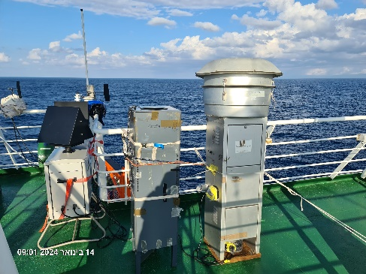
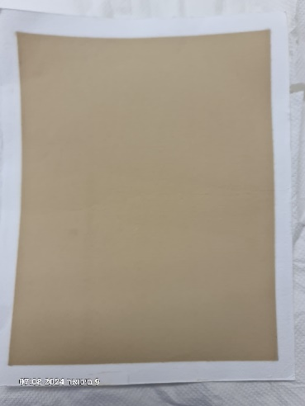

Figure S2: Pictures of the Whatman 41 filter representing the Sharan dust event (8-9.1.2024) and of the high-volume collector located on the monkey island of the R.V. Meteor during cruise M197.

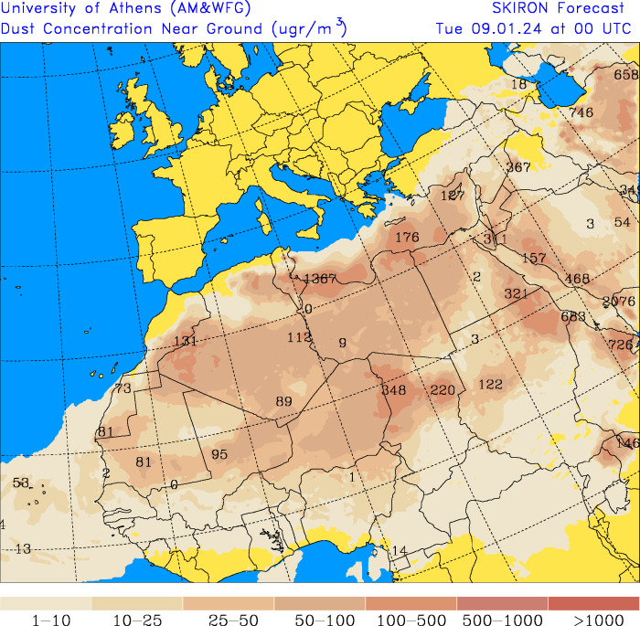
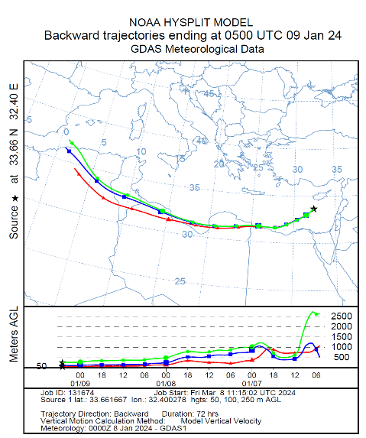
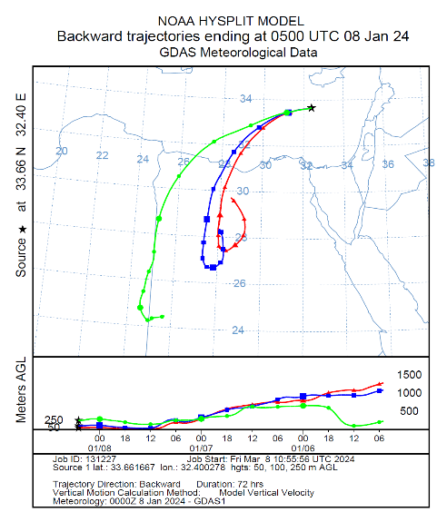

Figure S3: Upper panels: Air mass backward trajectories for the 8 and 9 January 2024 showing the Sharan origin of the dust event. The Hybrid Single-Particle Lagrangian Integrated Trajectory (HYSPLIT) model was run through the web-based READY interface (http://ready.arl.noaa.gov/HYSPLIT_traj.php) to assess air-mass trajectories [1]. Lower panel: A Skiron dust concentration forecast model for 9.1.2024 [2].

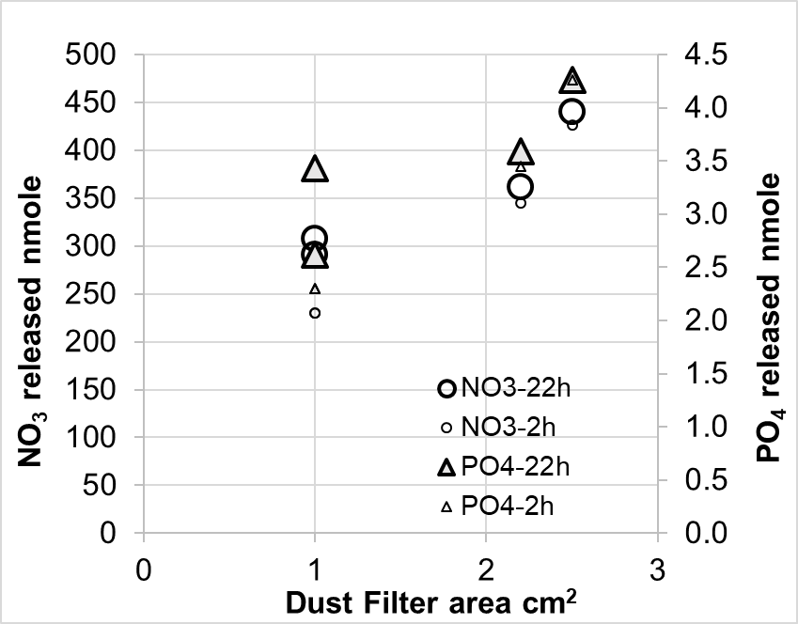
Figure S4: Relationships between PM10 filter size (Saharan dust event 8 - 9 January 2024) and the amount of PO₄ and NO₃ (NO₃+NO₂) released into aged low nutrient filtered through 0.2 um and sterilized seawater.

The number of total and viable prokaryotes was assessed in the different microcosm bottles at T0 (before any amendment was made). These read abundances were used to normalize the PO4 of DOP direct uptake by viable prokaryotes and presented in Figure 4. The staining approaches used to quantify viable and total prokaryote are described in full in the main manuscript subsection 2.7 and the raw results are presented below (Figure S4).

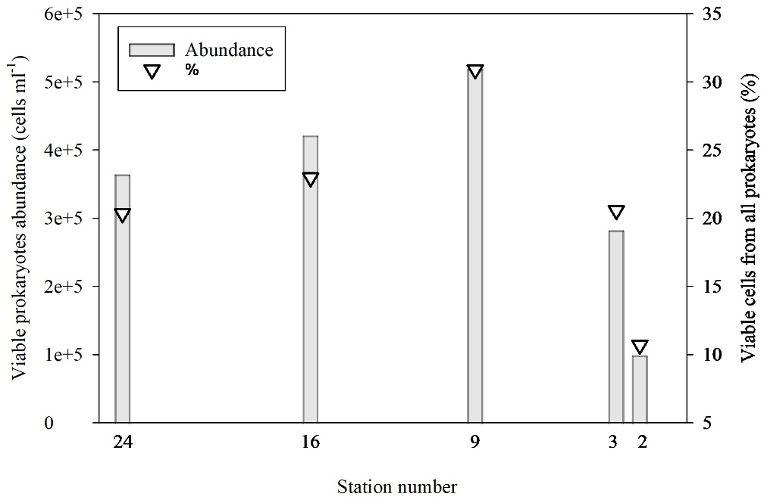
Figure S5: The number of viable cells (bars) and their percentage from total prokaryotes abundance (triangle) in the surface water of the Eastern Mediterranean Sea during January 2024. Viable cells were detected with CTC staining. CTC-positive cells represent the detectably respiring fraction of the microbial community. These values may underestimate total viable-cell abundance because cells with low respiratory activity, dormant cells, or cells below the assay detection threshold may not reduce CTC.

Thalassiosira pseudonana bloom simulations across the cruise track
Locally isolated diatom Thalassiosira pseudonana was used to simulate artificial bloom-like conditions. The culture was grown in sterile transparent flasks (Crystalgen), and 1 mL of the culture was added to each experimental bottle, resulting in a final abundance of ~1×10⁴ cells mL⁻¹. Final added cell abundances are reported in Table 1. The same inoculation procedure was used across the different experiments, and the added cell abundances were similar among treatments. The exact physiological growth phase of the culture at the time of addition was not determined.

References
1. Rolph, G., Stein, A. & Stunder, B. Real-time Environmental Applications and Display sYstem: READY. Environ. Model. Softw. 95, 210–228 (2017).
2. Nickovic, S., Kallos, G., Papadopoulos, A. & Kakaliagou, O. A model for prediction of desert dust cycle in the atmosphere. J. Geophys. Res. Atmos. 106, 18113–18129 (2001).

