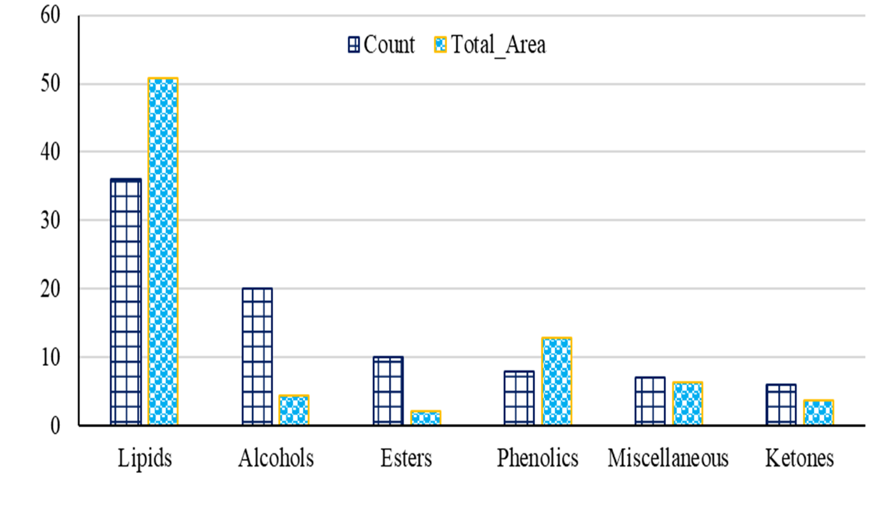
Figure S1: GC–MS-based profiling of the Metarhizium anisopliae fungal extract, showing the number and relative abundance (%) of identified secondary metabolites across different chemical classes.

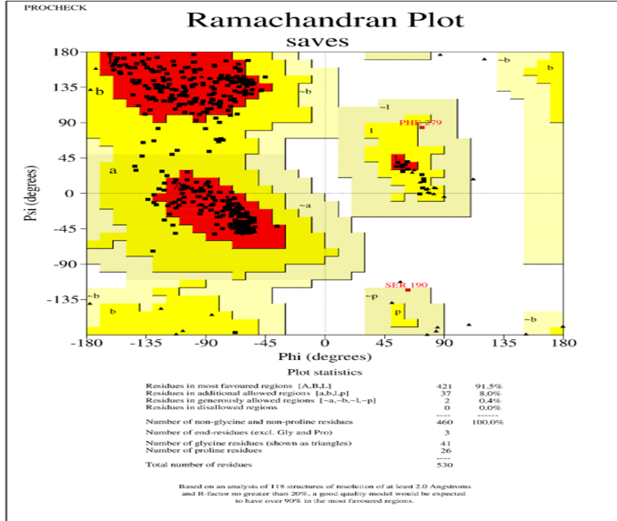  A | 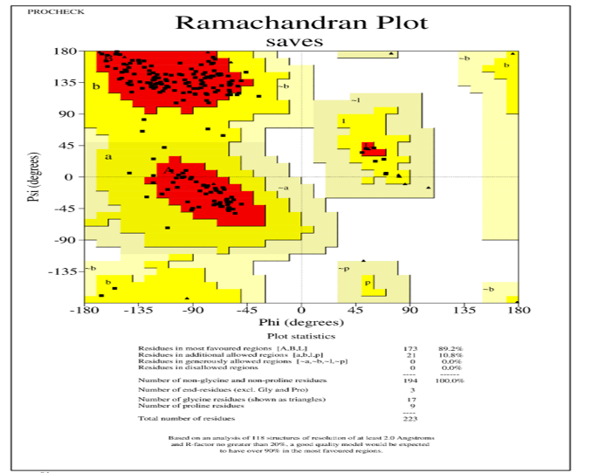  B
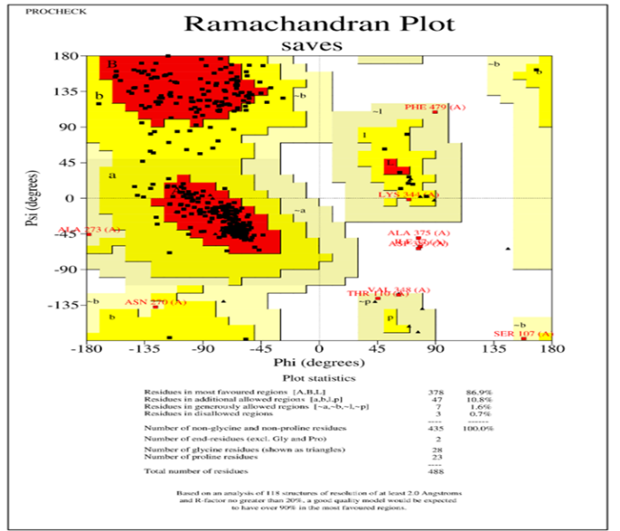  C | 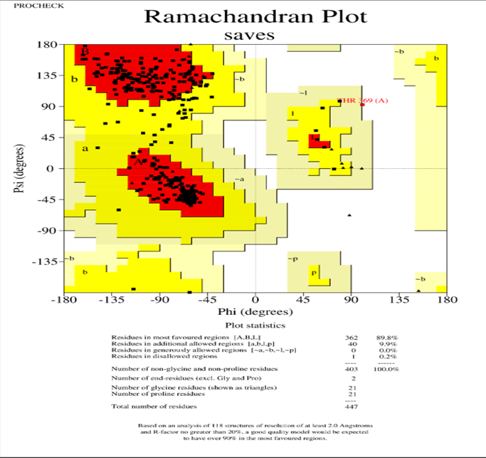  D
Figure S2: PROCHECK plot and statistics analysis of receptors models. A: carboxylesterase, B: trypsin-like serine protease, C: cytochrome P450, and D: glutamate-gated chloride channel.

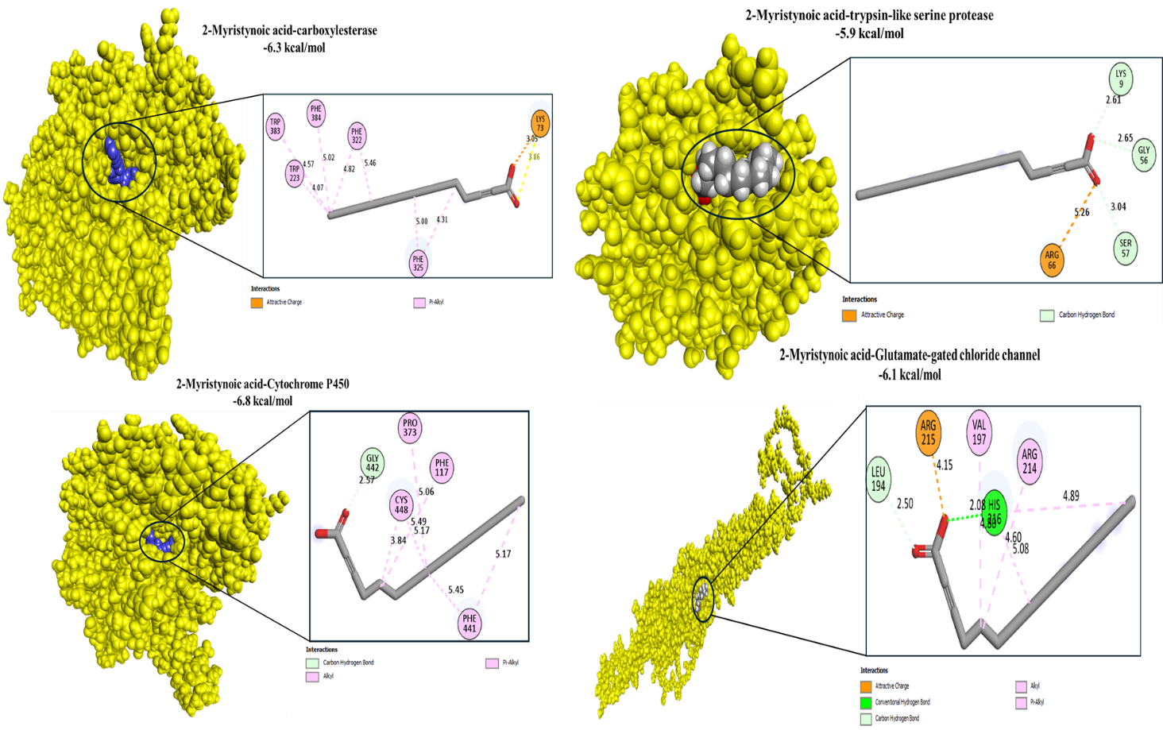
Figure S3: Molecular docking interaction of 2-myristynoic acid with the target protein active sides

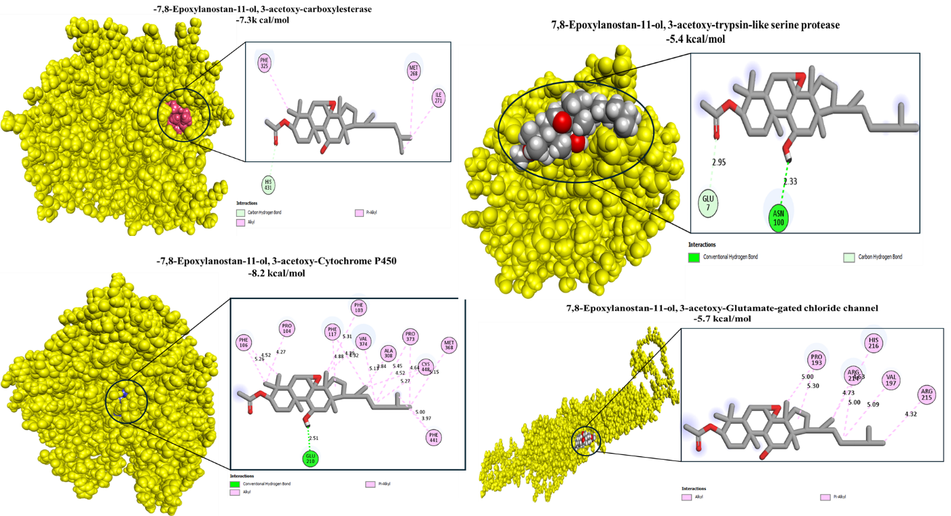
Figure S4: Molecular docking interaction of 7,8-Epoxylanostan-11-ol, 3-acetoxy with the target protein active sides

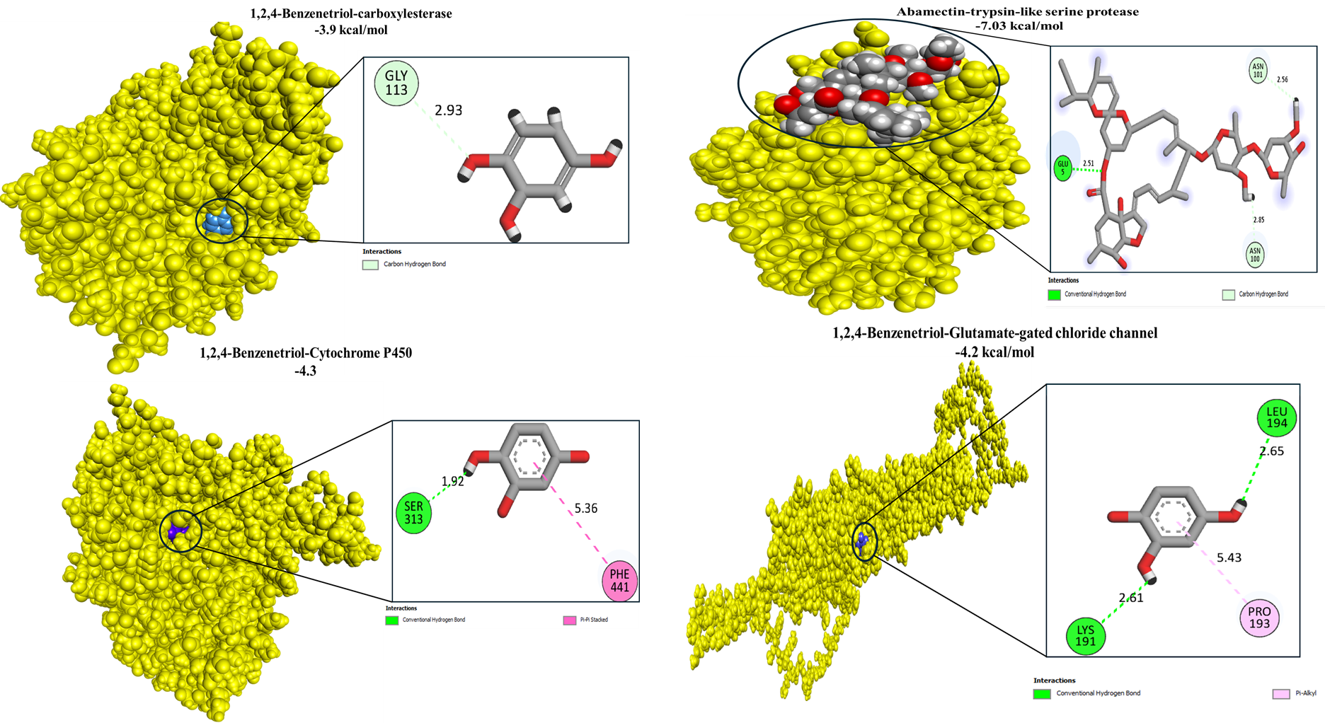
Figure S5: Molecular docking interaction of 1,2,4-benzenetriol with the target protein active sides

Table S1. GC–MS-based phytochemical profiling of Metarhizium anisopliae fungal extract

RT | Compound | Area (%) |  |  | Formula |  | MW |  | CAS
6.02 | Cycloheptanepentanoic acid, 2-oxo- | 0.84 |  |  | C₁₂H₂₀O₃ |  | 212 |  | 33371-95-8
8.31 | Undecanoic acid, 11-amino- | 0.3 |  |  | C₁₁H₂₃NO₂ |  | 201 |  | 2432-99-7
18.3 | 2-Myristynoic acid | 0.43 |  |  | C₁₄H₂₄O₂ |  | 224 |  | 67587-19-3
19.29 | Camphoric Acid | 0.45 |  |  | C₁₀H₁₆O₄ |  | 200 |  | NA
22.51 | Tetradecanoic Acid | 0.81 |  |  | C₁₄H₂₈O₂ |  | 228 |  | 544-63-8
24.81 | 9-Octadecenoic Acid (Z)- | 0.92 |  |  | C₁₈H₃₄O₂ |  | 282 |  | 112-80-1
25.35 | Hexadecanoic acid, methyl ester | 4.84 |  |  | C₁₇H₃₄O₂ |  | 270 |  | 112-39-0
26.04 | Oleic Acid | 1.41 |  |  | C₁₈H₃₄O₂ |  | 282 |  | 112-80-1
26.71 | Hexadecanoic Acid | 7.22 |  |  | C₁₆H₃₂O₂ |  | 256 |  | 57-10-3
28.55 | 10-Octadecenoic acid, methyl ester | 10.53 |  |  | C₁₉H₃₆O₂ |  | 296 |  | 13481-95-3
29.89 | trans-13-Octadecenoic acid | 15.19 |  |  | C₁₈H₃₄O₂ |  | 282 |  | 693-71-0
30.28 | Octadecanoic Acid | 2.21 |  |  | C₁₈H₃₆O₂ |  | 284 |  | 57-11-4
30.56 | Linoleic acid ethyl ester | 1.46 |  |  | C₂₀H₃₆O₂ |  | 308 |  | 544-35-4
32.93 | cis-13-Eicosenoic acid | 1.12 |  |  | C₂₀H₃₈O₂ |  | 310 |  | 17735-94-3
35.23 | Oleic acid, eicosyl ester | 1.54 |  |  | C₃₈H₇₄O₂ |  | 562 |  | 22393-88-0
44.28 | Ursodeoxycholic acid | 1.82 |  |  | C₂₄H₄₀O₄ |  | 392 |  | 128-13-2
19.36 | Dihydroartemisinin | 0.26 |  |  | C₁₃H₂₂O₃ |  | 250 |  | 90935-14-1
Alcohols
7.70 | Undecanal |  | 0.49 | C₁₁H₂₂O |  | 170 |  | 112-44-7
41.84 | 7,8-Epoxylanostan-11-ol, 3-acetoxy- |  | 2.56 | C₃₂H₅₄O₄ |  | 502 |  | NA
Esters
40.49 | Glycidyl oleate |  | 0.16 | C₂₁H₃₈O₃ |  | 338 |  | NA
41.02 | Ethyl iso-alcoholate |  | 2.13 | C₂₆H₄₄O₅ |  | 436 |  | NA
Furans
4.22 | 2-Furanmethanol |  | 6.71 | C₅H₆O₂ |  | 98 |  | 98-00-0
7.39 | Furaneol |  | 3.18 | C₆H₈O₃ |  | 128 |  | 3658-7
Ketones
4.78 | 6-Oxa-bicyclo[3.1.0]hexan-3-one |  | 1.17 | C₅H₆O₂ |  | 98 |  | 74017-10-1
5.38 | Oxacyclododecan-2-one |  | 0.27 | C₁₁H₂₀O₂ |  | 184 |  | 1725-0
5.68 | Oxecan-2-one |  | 0.41 | C₉H₁₆O₂ |  | 156 |  | 6008-2
10.85 | 1-Acetoxy-p-menth-3-one |  | 0.87 | C₁₂H₂₀O₃ |  | 212 |  | 58315-8
11.97 | 7-Ethyl-4-decen-6-one |  | 0.76 | C₁₂H₂₂O |  | 182 |  | NA
19.36 | Pyrrolizidine-3-one, 5-hexyloxy- |  | 0.26 | C₁₃H₂₃NO₂ |  | 225 |  | NA
Phenolics
5.00 | 2-[bis-(Phenylthio)methyl]  pent-3-en-2-ol |  | 1.25 | C₁₈H₂₀OS₂ |  | 316 |  | 104115-30-2
6.87 | Naphthalene |  | 0.76 | C₁₀H₈ |  | 128 |  | 91-20-3
11.28 | Benzenethiol, 4-methoxy- |  | 3.37 | C₇H₈OS |  | 140 |  | 696-63
15.83 | 1,2,4-Benzenetriol |  | 8.68 | C₆H₆O3 |  | 126 |  | 533-73
Others
4.53 | Cis-4-Decanal |  | 1.19 | C₁₀H₁₈O |  | 719 |  | 21662-9-9
6.09 | 1,10-Decane-1,1,10,10-D4-diol |  | 0.9 | C₁₀H₁₈D₄O₂ |  | 178 |  | 67986-0
7.58 | 1-Tetradecanol |  | 0.44 | C₁₄H₃₀O |  | 214 |  | 112-72
8.53 | 2-Myristynoyl pantetheine |  | 0.47 | C₂₅H₄₄N₂O₅S |  | 484 |  | NA
9.28 | 1,3-Diazacyclooctane-2-thione |  | 2.63 | C₆H₁₂N₂S |  | 144 |  | 5269-8
44.55 | 1-Heptatriacotanol |  | 0.77 | C₃₇H₇₆O |  | 536 |  | 105794

Table S2. Gene expression profiles of interleukin-6 (IL-6), tumor necrosis factor-α (TNF-α), cytochrome P450 genes (SFCYP1, SFCYP2, SFCYP3), and ryanodine receptor (SfRyR) in red palm weevil following exposure to ZnO, CuO, and Ag nanoparticles, abamectin (ABM), and fungal extract (FE) at 6, 24, and 48 h.
TRT | Time (hrs) | IL6 | ±SD | TNF | ±SD | SFCYP1 | ±SD | SFCYP2 | ±SD | SFCYP3 | ±SD | SFRY R | ±SD
ZnONPs | 6 | 0.0007 | 0.0004 | 0.991 | 0.0079 | 70.036 | 0.485 | 15.243 | 0.2113 | 57.283 | 0.397 | 0.008 | 0.0011
ZnONPs | 24 | 0.0442 | 0.0011 | 7.194 | 0.1448 | 0.017 | 0.002 | 4.480 | 0.0946 | 53.200 | 0.213 | 1.173 | 0.0292
ZnONPs | 48 | 14.2224 | 0.1972 | 4.579 | 0.2793 | 11.446 | 0.199 | 0.000 | 0.0000 | 65.346 | 0.453 | 50.214 | 0.3481
CuONPs | 6 | 0.0055 | 0.0002 | 60.271 | 0.6392 | 1.343 | 0.179 | 40.134 | 0.5809 | 55.459 | 0.222 | 0.123 | 0.0173
CuONPs | 24 | 4.8060 | 0.2648 | 23.211 | 0.2453 | 0.536 | 0.080 | 1.240 | 0.1074 | 58.351 | 0.233 | 1.498 | 0.0159
CuONPs | 48 | 0.0498 | 0.0031 | 1.050 | 0.0073 | 23.664 | 2.334 | 4.181 | 0.1167 | 2.053 | 0.091 | 0.036 | 0.0064
AgNPs | 6 | 0.0016 | 0.0003 | 23.593 | 0.5924 | 0.914 | 0.162 | 0.003 | 1.2E-6 | 55.333 | 0.662 | 40.225 | 0.2788
AgNPs | 24 | 0.0005 | 9.3E-6 | 0.181 | 0.0060 | 0.740 | 0.124 | 50.331 | 0.5338 | 64.148 | 0.257 | 5.030 | 0.1743
AgNPs | 48 | 0.0001 | 1.8E-6 | 0.977 | 0.0208 | 3.419 | 0.027 | 0.673 | 0.0893 | 30.206 | 0.437 | 60.271 | 0.6392
ABM | 6 | 31.3420 | 0.2172 | 10.449 | 0.6640 | 0.167 | 0.024 | 0.002 | 0.0001 | 45.256 | 0.314 | 0.521 | 0.0789
ABM | 24 | 0.0023 | 0.0002 | 1.500 | 0.0897 | 5.135 | 0.129 | 24.028 | 0.0960 | 1.085 | 0.063 | 0.040 | 0.0065
ABM | 48 | 0.0009 | 0.0003 | 2.272 | 0.0813 | 72.171 | 0.289 | 0.006 | 0.0003 | 60.549 | 0.420 | 2.200 | 0.0726
M. anisopliae Extract | 6 | 27.4126 | 0.3968 | 1.159 | 0.0123 | 54.198 | 0.989 | 0.014 | 0.0004 | 65.194 | 0.261 | 0.135 | 0.0258
M. anisopliae Extract | 24 | 2.4725 | 0.1811 | 0.357 | 0.0170 | 11.082 | 0.202 | 4.539 | 0.3052 | 55.331 | 0.384 | 0.198 | 0.0338
M. anisopliae Extract | 48 | 2.3784 | 0.0839 | 5.532 | 0.2812 | 2.026 | 0.218 | 62.251 | 0.4315 | 65.346 | 0.453 | 0.002 | 0.0003

Table S3. interaction affinity score ( kcal/mol), RMSDValue (Å) of Molecular interactions between Abamectin and Metarhizium anisopliae metabolites with the active-site residues of target proteins

Ligand |  | Carboxylesterase | Trypsin-like serine protease | Cytochrome P450 | Glutamate-gated chloride channel
 |  | interaction affinity score ( kcal/mol), RMSDValue (Å)
Abamectin | 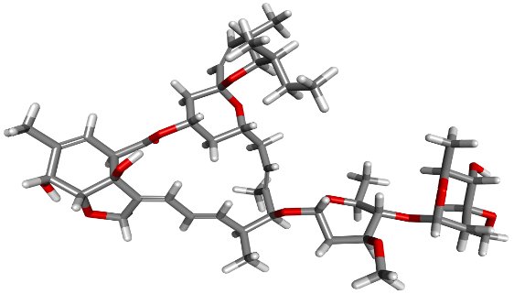 | -11.3, 1.8 | -7.03, 2.01 | -12.1, 1.9 | -7.16, 2.1
Oleic Acid | 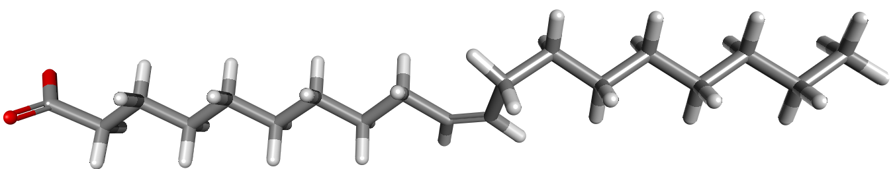 | -7.6, 1.4 | -6.07, 1.27 | -8.5, 1.7 | -6.5, 2.0
Linoleic acid ethyl ester | 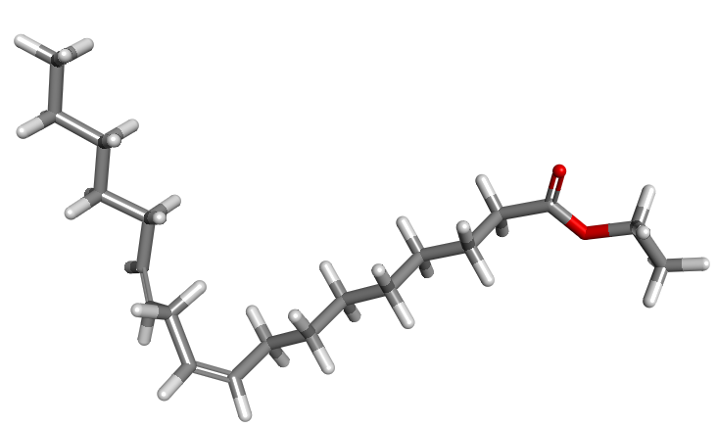 | -7.01, 1.2 | -6.41, 1.5 | -8.4, 1.5 | -6.6, 1.5
2-Myristynoic acid | 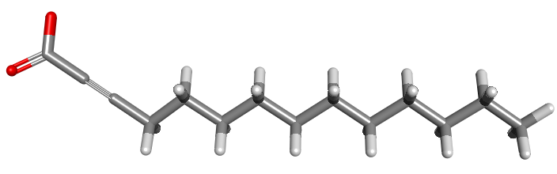 | -6.3, 0.8 | -5.9, 1.1 | -6.8, 1.4 | -6.1, 1.3
-7,8-Epoxylanostan-11-ol, 3-acetoxy | 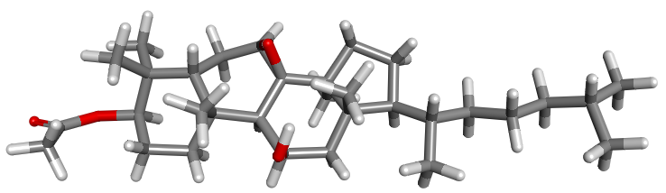 | -7.3, 1.2 | -5.4, 1.6 | -8.2, 1.6 | -5.7, 2.1
1,2,4-Benzenetriol | 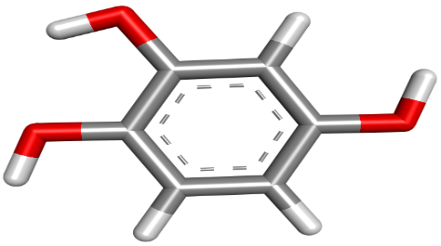 | -3.9, 1.17 | -4.05, 0.8 | -4.3, 0.6 | -4.5, 0.29
Table S4. Interactions between Abamectin and Metarhizium anisopliae metabolites with the active-site residues of target proteins
Ligand | Carboxylesterase | Trypsin-like serine protease | Cytochrome P450 | Glutamate-gated chloride channel
Ligand | (interactions), (Hydrogen bonds?: amino acids involved in Hydrogen bonds: distance of hydrogen bond Å)
Abamectin | (Carbon hydron bond, Alkyl, Pi-Alkyl), (yes: TYR120: 2.0; GLY107: 2.2) | (Carbon hydron bond), (yes: Glu 5: 2.5) | (Carbon hydron bond, Alkyl, Pi-Alkyl), (yes: GLU210: 2.1; LYS232: 2.4; HIS61:2.7) | (Carbon hydron bond, Alkyl, Pi-Alkyl), (yes: ASP192: 2.3; PRO196: 1.7)
Oleic Acid | (Salt bridge, Alkyl, Pi-Alkyl), No | (Carbon hydron bond, Alkyl), (yes: Glu 56: 2.8) | (Carbon hydron bond, Alkyl, Pi-Alkyl), (No) | (Carbon hydron bond, Alkyl, Pi-Alkyl, attractive charge), (yes: HIS216: 2.04)
Linoleic acid ethyl ester | (Carbon hydron bond, Alkyl, Pi-Alkyl), (yes: TYR343: 2.3) | (Carbon hydron bond, Alkyl), (yes: GLY6: 1.8) | (Alkyl, Pi-Alkyl), (No) | (Carbon hydron bond, Alkyl, Pi-Alkyl), (No)
2-Myristynoic acid | (Attractive charge, Pi-Alkyl), (No) | (Attractive charge, Carbon hydron bond), (No) | (Carbon hydron bond, Alkyl, Pi-Alkyl), (No) | (Carbon hydron bond, Alkyl, Pi-Alkyl, attractive charge ), (yes: HIS216: 2.04)
7,8-Epoxylanostan-11-ol, 3-acetoxy | (Carbon hydron bond, Alkyl, Pi-Alkyl), (No) | (Carbon hydron bond), (yes: ASN100: 2.3) | (Alkyl, Pi-Alkyl), (yes: GLU210: 2.5) | (Alkyl, Pi-Alkyl)
1,2,4-Benzenetriol | (Carbon hydron bond), (No) | (Pi-Alkyl), (yes: SER57:2.6; LYS9:2.5; GLY56: 2.1; GLN4: 2.4) | (Pi-Pi Stached), (yes: SER313: 1.9) | (Pi-Alkyl), (yes: LYS191: 2.6; LEU194: 2.6)

