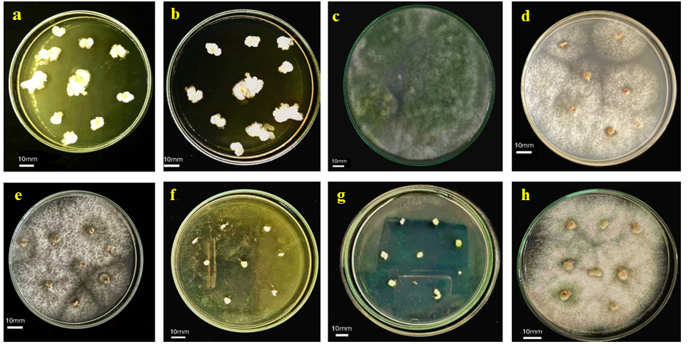
Fig S1: To evaluate microbial colonization of plant roots, root segments were at the 55 dpi (a) Bacillus, (b) BaBa.BS, (c) Trichoderma (TZ), (d) BS.TZ, (e) BaBa.TZ, (f) control for bacteria, (g) control for fungi, (h) BaBa.BS.TZ.

