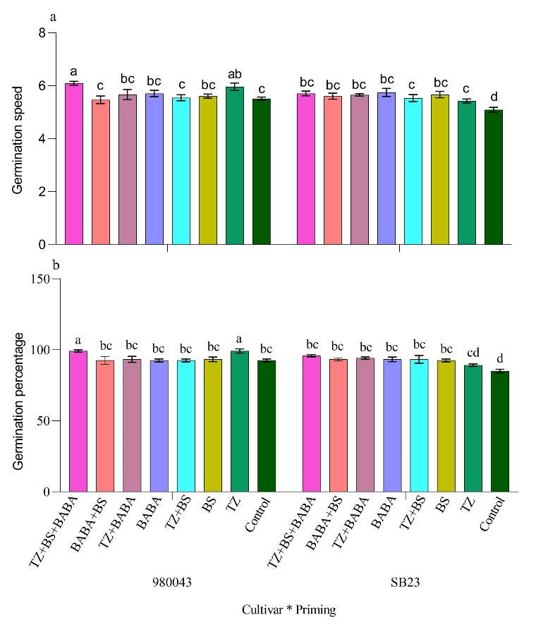

Fig S3: a: Seed germination speed of sugar beet, b: Seed germination percentage of sugar beet. Data are means of 12 replicates ± SE. Bars marked with different letters differ significantly (Duncan test, P ≤ 0.05).

