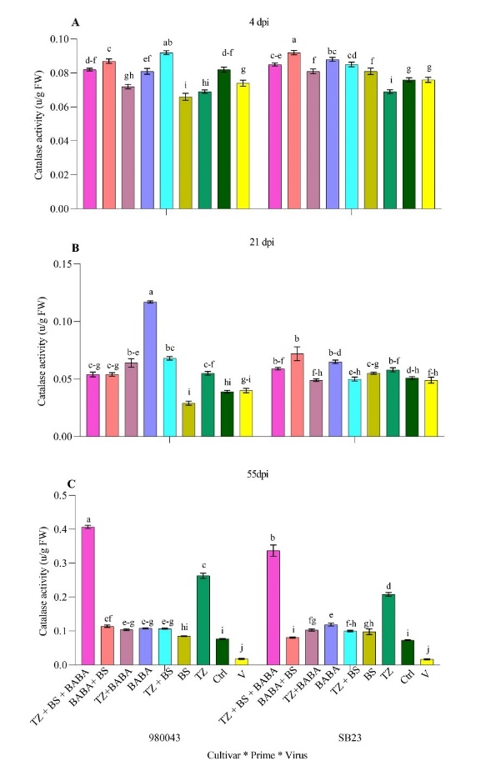
b
a
Fig. S6. The effects of genotypes, priming agents (BABA+BS+TZ, BABA+BS, BABA, BABA+TZ, BS+TZ, BS, TZ) and BCTIV-inoculation on sugar beet catalase (CAT) activity. Priming agents and the virus increased CAT content in primed plants compared to their respective controls. Thirty- five day-old plants (four true leaves stage) were inoculated with BCTIV (OD600 = 0.2). Treatments were: inoculated with BCTIV only (V), other treatments, priming agent + BCTIV . For BS and TZ, the concentration is expressed in CFU/ml, and for BABA, it is expressed in mM. Data are means of four biological replicates and two technical replicates. Different letters indicate significant differences (LSD test, P ≤ 0.05). The data are presented as the mean, with error bars showing the standard deviation.

