First-principles insights into site-dependent hydrogen and oxygen evolutions using azo-bridged C₃N₅ for water splitting

Maria A. Alhaboudalª, Sajjad Hussain^{a,b}, Abdulaziz A. Al-Saadi^{a,b,*}
ª Department of Chemistry, King Fahd University of Petroleum & Minerals, Dhahran 31261, Saudi Arabia
^{b} Interdisciplinary Research Center for Refining and Advanced Chemicals, King Fahd University of Petroleum & Minerals, Dhahran 31261, Saudi Arabia
*Corresponding author: asaadi@kfupm.edu.sa

Supplementary Information

Figure S1. Convergence tests of the ground-state energy of C₃N₅ with respect to (a) the k-point sampling and (b) the plane-wave energy cutoff.

Figure S2. Calculated partial density of states (PDOS) of C₃N₅.

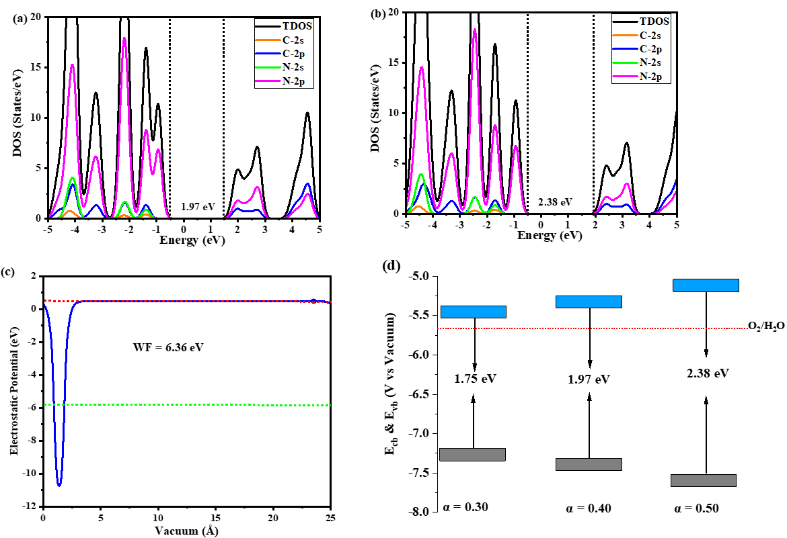

Figure S3. Band gaps of the C₃N₅ sheet calculated using the HSE06 functional and mixing coefficients of (a) 0.40 and (b) 0.50. (c) Planar-averaged Hartree electrostatic potential with dipole correction used to determine the work function of the sheet. (d) The corresponding band alignments showing the VB and CB edge positions referenced to the vacuum level.

Figure S4: The hydrogen adsorption at the N1, N2, N3, and C3 sites of the C₃N₅ sheet.
Figure S5. Average electrostatic potential profiles for the (a) monolayer pristine C₃N₅, and for H-adsorbed C₃N₅ at the (b) N1, (c) N2, (d) N3, and (e) C3 sites. The extracted work function (WF) values are also shown.
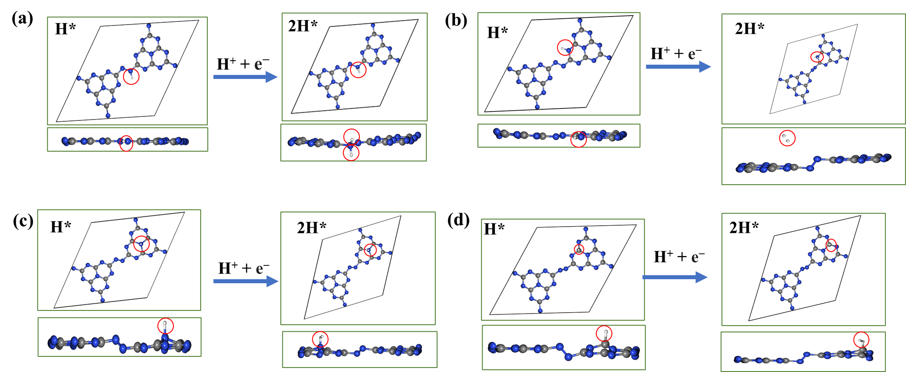
Figure S6. Optimized geometries of adsorbed H* and 2H* on the (a) N1, (b) N2, (c) N3, and (d) C3 sites of the C₃N₅ monolayer along the Volmer-Heyrovsky pathway. The adsorbed H atoms are highlighted by enclosing them in red circles.

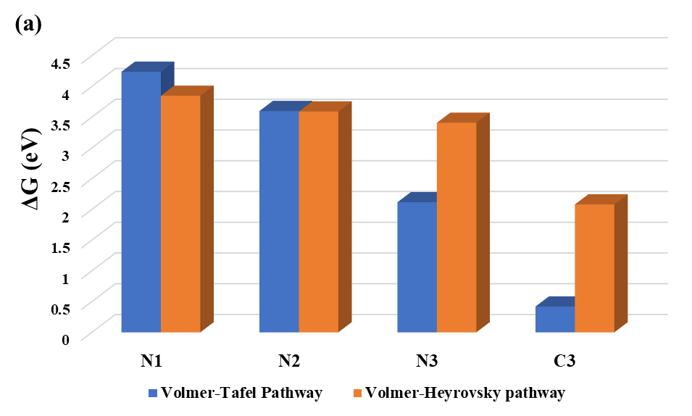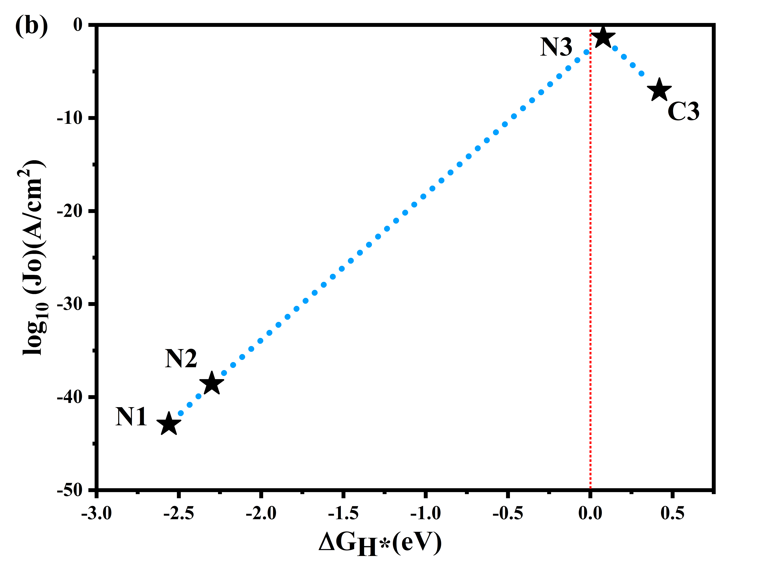
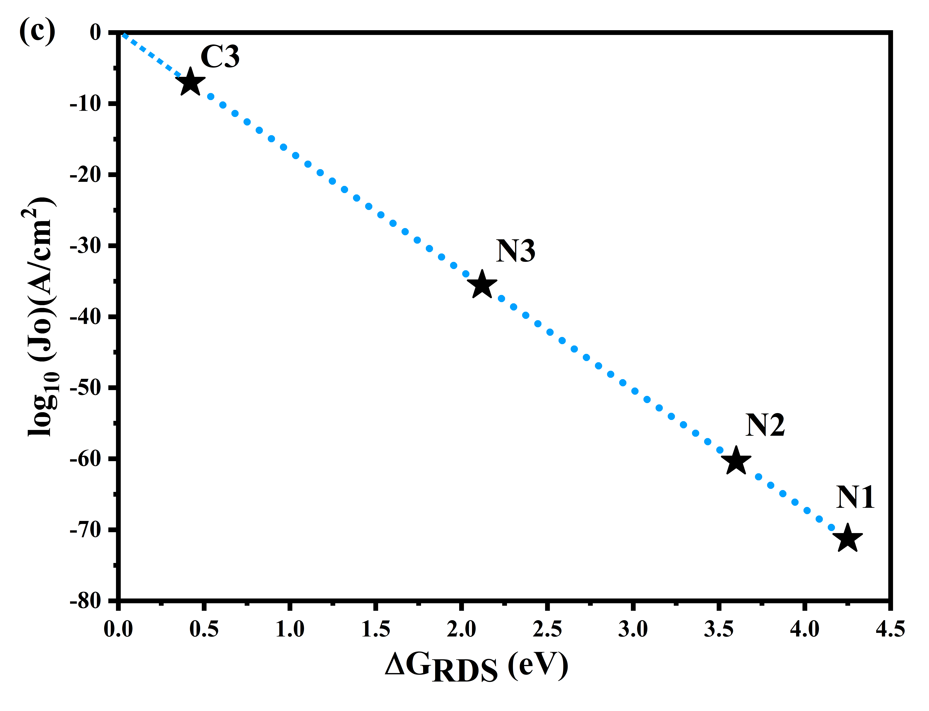
Figure S7. (a) Comparison of the thermodynamic free-energy requirements for the Volmer-Tafel and Volmer-Heyrovsky HER pathways at the N1, N2, N3, and C3 sites. Exchange current density as a function of (b) the hydrogen adsorption free energy ΔG_{H*} and (c) the thermodynamic free-energy requirement of the rate-determining step (ΔG_{RDS}) along the Volmer-Tafel pathway.

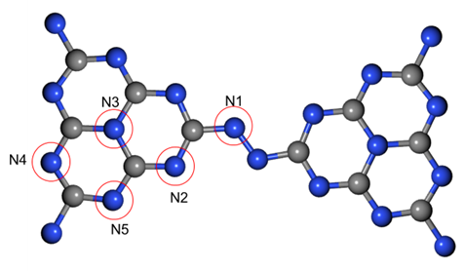
Figure S8: The most promising adsorption sites (N1, N2, N3, N4, and N5) towards the OH* species on the C₃N₅ sheet.

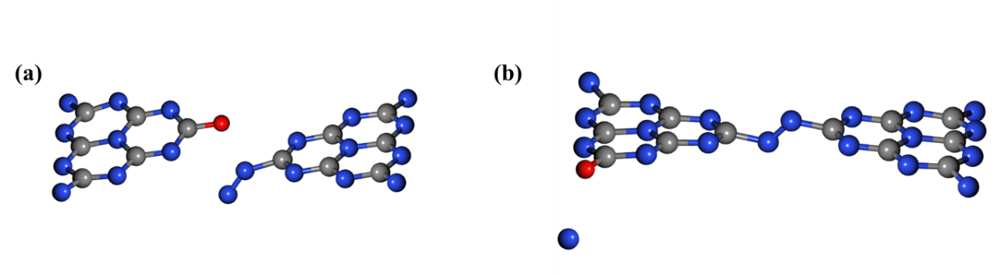
Figure S9: Structural distortion of C₃N₅ sheet upon the adsorption of O atom on the (a) C1 and (b) C2 sites, where red, blue and gray spheres represent oxygen, nitrogen and carbon atoms, respectively.

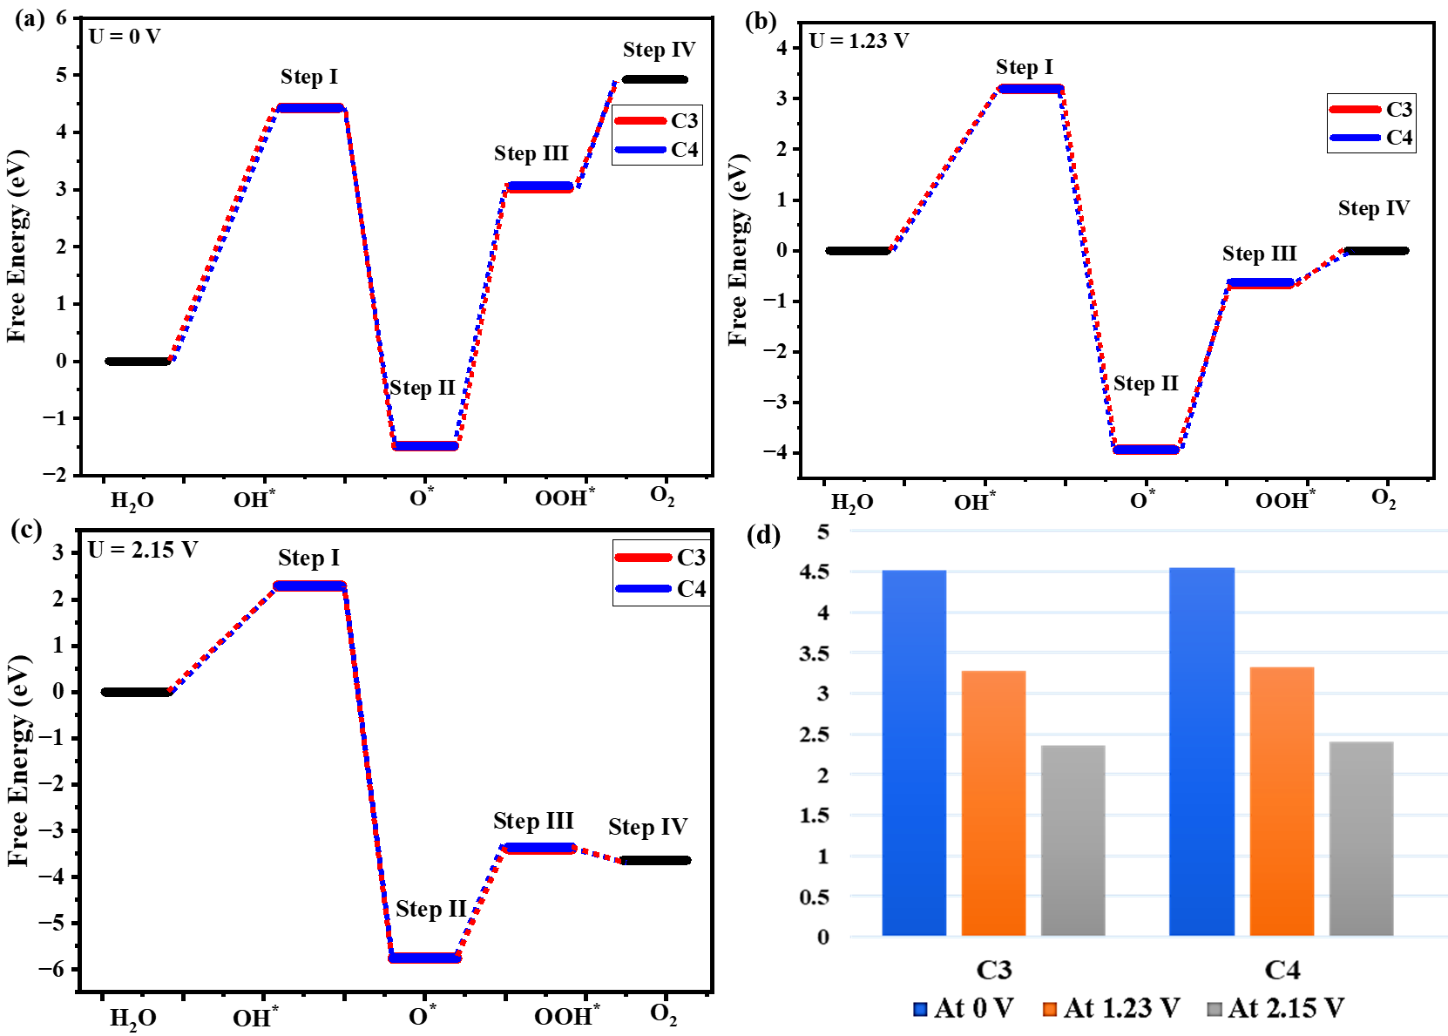
Figure S10. Free-energy diagrams for the four elementary OER steps at the C3 to C4 sites of C₃N₅: (a) at 0 V, (b) equilibrium potential of 1.23 V, and (c) under the applied potential of 2.15 V. (d) Comparison of the rate-determining thermodynamic free-energy requirements and the applied potentials for the C3 and C4 sites.

.

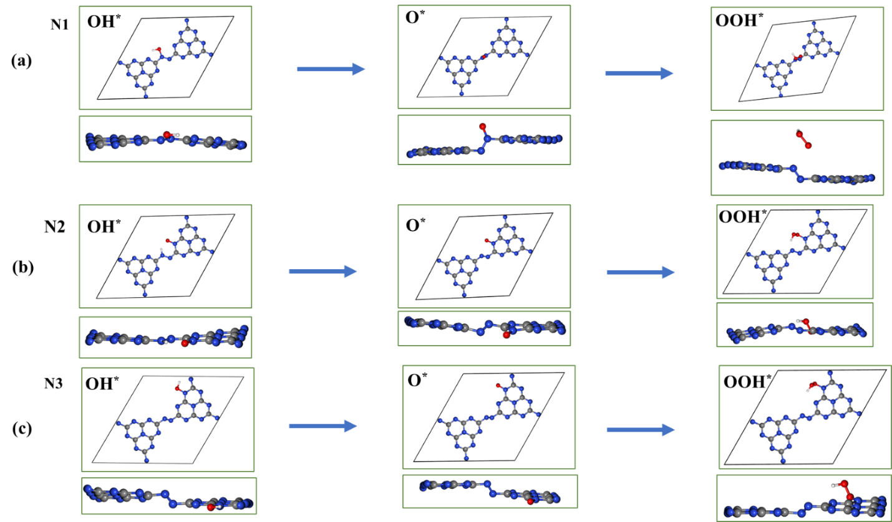
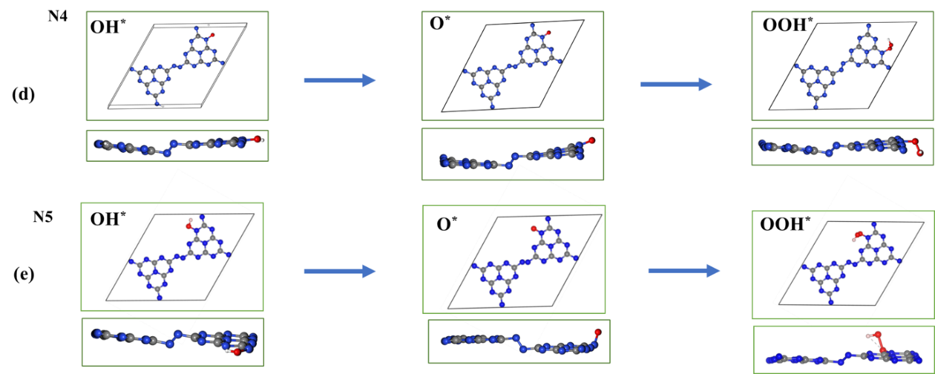
Figure S11. Optimized geometries of the adsorbed OER intermediates (O*, OH*, and OOH*) at the (a) N1, (b) N2, (c) N3, (d) N4, and (e) N5 sites of the C₃N₅ monolayer.

Table S1: Calculated structural parameters and computational details for the optimized C₃N₅ unit cell.
Lattice parameter | Space  group | Kinetic energy cutoff | Vacuum thickness | Force thresholds | k-points | Ref.
a = b = 15.04 Å  α = β = 90°, γ = 120° | P6/m | 520 eV | 20 Å | 0.01 eV/ Å | 3 × 3 × 1 | [1]
a = b =15.16 Å  α= β= 90^{ᵒ}, γ=120^{ᵒ} | P6/m | 750 eV | 20 Å | 0.01 eV/Å | 5 × 5 × 1 | [2]
a = b =15.13 Å  α= β= 90^{ᵒ,} γ=120^{ᵒ} | P6/m | 816 eV | 20 Å | 0.01 eV/ Å | 8 × 8 × 1 | This Work
a = b =15.13 Å  α= β= 90^{ᵒ,} γ=120^{ᵒ} | P6/m | 410 eV, 510 eV | 20 Å | 0.01 eV/ Å | 8 × 8 × 1 | This Work
a = b =15.128 Å  α= β= 90^{ᵒ,} γ=120^{ᵒ} | P6/m | 816 eV | 20 Å | 0.01 eV/ Å | 3 × 3× 1  5 × 5 × 1 | This Work

- Y. Qiang, X.H. Cai, Y. Pang, M. Wang, The effects of strain and charge doping on the electronic properties of graphitic C₃N₅, Int. J. Quantum Chem.120 (2020) e26378
- S. Singh, P. Anees, S. Chandra, and T. K. Ghanty, Strain engineering of 2D-C₃N₅ monolayer and its application in overall water-splitting: a hybrid density functional study, J. Phys. Chem. 126 (19) (2022) 8436–8449

Adsorption site | Optimized structure | ΔG_{Volmer} (eV)
N1 | 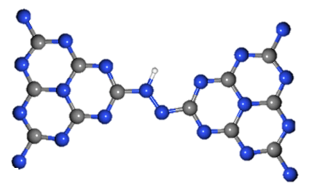 | -2.557
N2 | 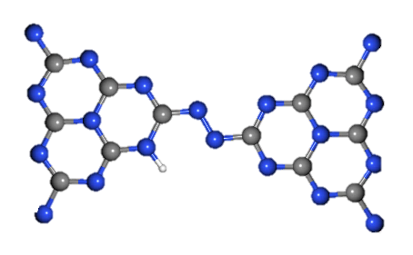 | -2.301
N3 | 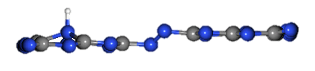 | 0.078
C1 | 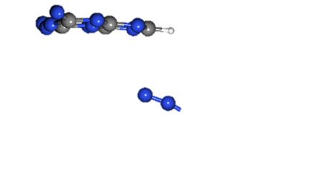 | 1.153
C2 | 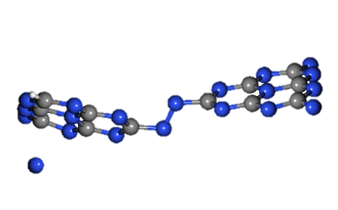 | 1.115
C3 | 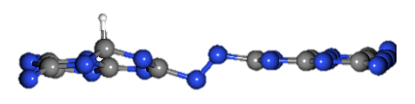 | 0.419
Table S2: Calculated Gibbs free-energy changes for the Volmer step (ΔG_{Volmer}) and the corresponding optimized structures of H-adsorbed C₃N₅ sheet at the N1, N2, N3, C1, C2 and C3 sites. The other screened sites (N4, N5, and N6) converged to one of the six optimized sites listed in the table.

Table S3: The variations in bond lengths and bond angles of C₃N₅ during the hydrogen evolution reaction at the four key adsorption sites. Figures are shown within the tables to show the calculated parameters.
Structural features | Pristine C₃N₅ | H@N1
Bond length | 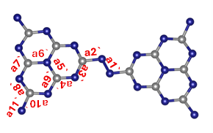  a1`(N$-$N) = 1.254(0) Å  a2`(N$-$C) = 1.447(0) Å  a3`(C$-$N) = 1.338(0) Å  a4`(N$-$C) = 1.329(0) Å  a5`(C$-$N) = 1.409(0) Å  a6`(N$-$C) =1.409(0) Å  a7`(C$-$N) = 1.329(0) Å  a8`(N$-$C) = 1.338(0) Å  a9`(N$-$C) = 1.333(0) Å  a10`(C$-$N) = 1.342(0) Å  a11`(C$-$N) = 1.448(0) Å | 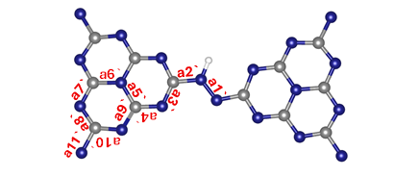  a1`(N$-$N) = 1.294(0) Å  a2`(N$-$C) = 1.392(0) Å  a3`(C$-$N) = 1.333(0) Å  a4`(N$-$C) = 1.334(0) Å  a5`(C$-$N) = 1.416(0) Å  a6`(N$-$C) =1.409(0) Å  a7`(C$-$N) = 1.335(0) Å  a8`(N$-$C) = 1.329(0) Å  a9`(N$-$C) = 1.329(0) Å  a10`(C$-$N) = 1.334(0) Å  a11`(C$-$N) = 1.334(0) Å  (N$-$H) = 1.035(0) Å
Bond angles | 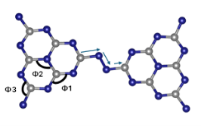  Ф1=121.4$°$  Ф2=120$.0°$  Ф3=119.9$°$  Dihedral $°$=180.0$°$ | 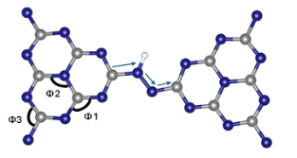  Ф1= 120.3$°$  Ф2= 122.5$°$  Ф3= 116.9$°$  Dihedral $°$= 178.4$°$
 | H@N2 | H@N3
Bond length | 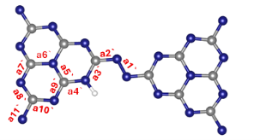  a1`(N$-$N) = 1.294(0) Å  a2`(N$-$C) = 1.362(0) Å  a3`(C$-$N) = 1.400(0) Å  a4`(N$-$C) = 1.359(0) Å  a5`(C$-$N) = 1.386(0) Å  a6`(N$-$C) = 1.416(0) Å  a7`(C$-$N) = 1.338(0) Å  a8`(N$-$C) =1.323(0) Å  a9`(N$-$C) = 1.313(0) Å  a10`(C$-$N) = 1.359(0) Å  a11`(C$-$N) = 1.417(0) Å  (N$=$H) = 1.02568(0) Å | 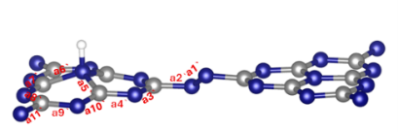  a1`(N$-$N) = 1.248(0) Å  a2`(N$-$C) = 1.398(0) Å  a3`(C$-$N) = 1.335(0) Å  a4`(N$-$C) = 1.309(0) Å  a5`(C$-$N) = 1.565(0) Å  a6`(N$-$C) = 1.563(0) Å  a7`(C$-$N) = 1.309(0) Å  a8`(N$-$C) = 1.336(0) Å  a9`(N$-$C) = 1.346(0) Å  a10`(C$-$N) = 1.300(0) Å  a11`(C$-$N) = 1.398(0) Å  (N$-$H) = 1.031(0) Å
Bond angles | 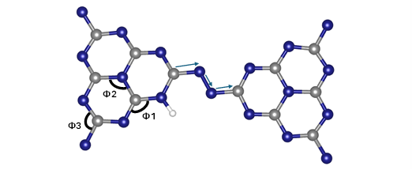  Ф1= 123.1$°$  Ф2= 118.8$°$  Ф3= 116.7$°$  Dihedral $°$= 178.2$°$ | 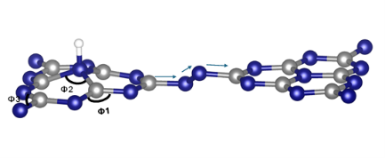  Ф1= 126.7$°$  Ф2= 111.2$°$  Ф3= 118.7$°$  Dihedral $°$= 39.7$°$
 | H@C3
Bond length | 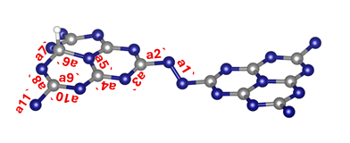  a1`(N$-$N) =1.233(0) Å  a2`(N$-$C) = 1.429(0) Å  a3`(C$-$N) = 1.320(0) Å  a4`(N$-$C) = 1.350(0) Å  a5`(C$-$N) = 1.391(0) Å  a6`(N$-$C) = 1.513(0) Å  a7`(C$-$N) = 1.429(0) Å  a8`(N$-$C) = 1.284(0) Å  a9`(N$-$C) = 1.352(0) Å  a10`(C$-$N) = 1.320(0) Å  a11`(C$-$N) = 1.457(0) Å  (C$-$H) = 1.109(0) Å
Bond angles | 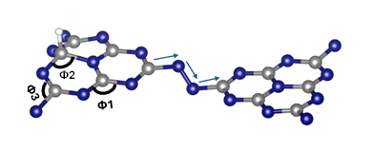  Ф1=121.2$°$  Ф2=111.7$°$  Ф3=115.6$°$  Dihedral $°$=64.3$°$

Table S4: The variations in bond lengths and bond angles of C₃N₅ during the oxygen evolution reaction at five key adsorption sites. Figures are shown within the tables to show the calculated parameters.
Structural features | OH@N1 | OH@N2
Bond length | 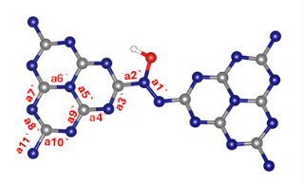 | 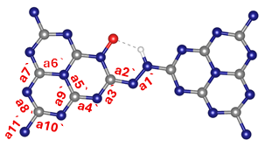
Bond length | a1`(N$-$N) = 1.278(0) Å  a2`(N$-$C) = 1.421(0) Å  a3`(C$-$N) = 1.324(0) Å  a4`(N$-$C) = 1.339(0) Å  a5`(C$-$N) = 1.422(0) Å  a6`(N$-$C) = 1.412(0) Å  a7`(C$-$N) = 1.333(0) Å  a8`(N$-$C) = 1.333(0) Å  a9`(N$-$C) = 1.327(0) Å  a10`(C$-$N) = 1.339(0) Å  a11`(C$-$N) = 1.420(0) Å  (C$-$O) = 1.384(0) Å  (O$-H$) = 1.024(0) Å | a1`(N$-$N) = 1.315(0) Å  a2`(N$-$C) = 1.329(0) Å  a3`(C$-$N) = 1.343(0) Å  a4`(N$-$C) = 1.301(0) Å  a5`(C$-$N) = 1.423(0) Å  a6`(N$-$C) = 1.420(0) Å  a7`(C$-$N) = 1.318(0) Å  a8`(N$-$C) = 1.345(0) Å  a9`(N$-$C) = 1.342(0) Å  a10`(C$-$N) = 1.315(0) Å  a11`(C$-$N) = 1.424(0) Å  (N$-$O) = 1.301(0) Å  (N$-H$) = 1.045(0) Å
Bond angles | 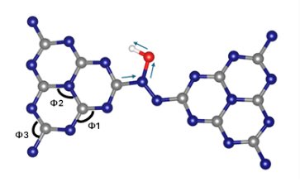 | 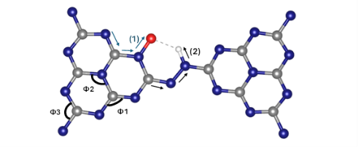
Bond angles | Ф1=122.4$°$  Ф2=120.4$°$  Ф3=116.5$°$  Dihedral $°$=3.9$°$ | Ф1= 121.5$°$  Ф2= 120.2$°$  Ф3=114.1$°$  Dihedral $°$= 1.0$°$
 | OH@N3 | OH@N4
Bond length | 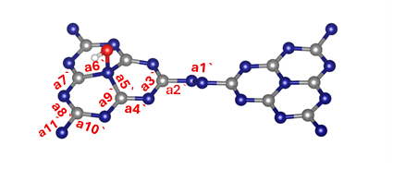 | 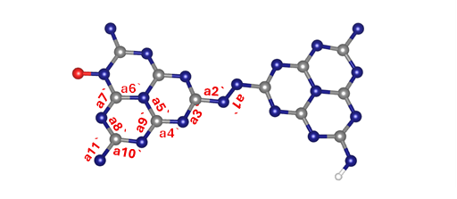
Bond length | a1`(N$-$N) = 1.249(0) Å  a2`(N$-$C) = 1.407(0) Å  a3`(C$-$N) = 1.330(0) Å  a4`(N$-$C) = 1.318(0) Å  a5`(C$-$N) =1.526(0) Å  a6`(N$-$C) = 1.523(0) Å  a7`(C$-$N) = 1.322(0) Å  a8`(N$-$C) = 1.333(0) Å  a9`(N$-$C) = 1.310(0) Å  a10`(C$-$N) = 1.344(0) Å  a11`(C$-$N) =1.406(0) Å  (C$-$O) = 1.515(0) Å  (O$-H$) = 0.987(0) Å | a1`(N$-$N) = 1.249(0) Å  a2`(N$-$C) = 1.413(0) Å  a3`(C$-$N) =1.346(0) Å  a4`(N$-$C) = 1.316(0) Å  a5`(C$-$N) =1.422(0) Å  a6`(N$-$C) = 1.381(0) Å  a7`(C$-$N) = 1.314(0) Å  a8`(N$-$C) = 1.347(0) Å  a9`(N$-$C) =1.343(0) Å  a10`(C$-$N) = 1.323(0) Å  a11`(C$-$N) = 1.419(0) Å  (N$-$O) = 1.301(0) Å  (N$-H$) =1.045(0) Å
Bond angles | 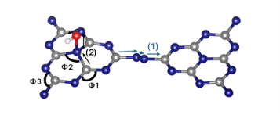 | 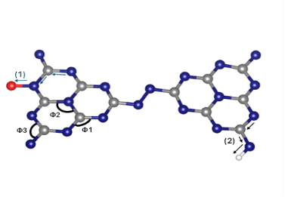
Bond angles | Ф1=125.0$°$  Ф2=112.7$°$  Ф3=113.1$°$  Dihedral (1) $°$= 178.5$°$  Dihedral (2) $°$= 63.1$°$ | Ф1=122.0$°$  Ф2=118.6$°$  Ф3=114.5$°$  Dihedral (1) $°$= 179.1$°$  Dihedral (2) $°$= 176.3$°$
 | OH@N5
Bond lengths | 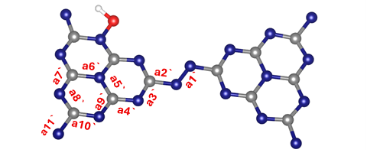
Bond lengths | a1`(N$-$N) = 1.251(0)Å  a2`(N$-$C) = 1.405(0) Å  a3`(C$-$N) =1.331(0) Å  a4`(N$-$C) =1.332(0) Å  a5`(C$-$N) =1.419(0) Å  a6`(N$-$C) = 1.427(0) Å  a7`(C$-$N) = 1.427(0) Å  a8`(N$-$C) = 1.336(0) Å  a9`(N$-$C) =1.329(0) Å  a10`(C$-$N) = 1.337(0) Å  a11`(C$-$N) = 1.421(0) Å  (N$-$O) =1.375(0) Å  (O$-H$) =1.019(0) Å
Bond angles | 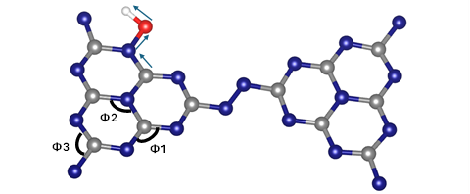
Bond angles | Ф1=121.9$°$  Ф2=120.5$°$  Ф3=113.1$°$  Dihedral $°$= 174.7 $°$

Table S5: Calculated relative Gibbs free energies of the OER intermediates at an applied equilibrium potential of 1.23 V at the five nitrogen sites of the C₃N₅ sheet. All values are referenced to the initial state of H₂O + * state.
Adsorbate  specie | Adsorption site
Adsorbate  specie | N1 | N2 | N3 | N4 | N5
OH* | 2.25 | 2.33 | 2.77 | 2.14 | 2.62
O* | -1.40 | -0.99 | -0.30 | -2.35 | -0.71
OOH* | 0.62 | -1.06 | -0.76 | 0.63 | -0.43

Table S6: Calculated zero-point energy (ZPE) and entropy (TS) corrections, in eV, for the key reaction intermediates at room temperature.
Intermediate | ZPE | TS (at 298.15 K) | ZPE – TS | Site
H₂O | 0.570 | 0.670 | -0.100
H₂ | 0.270 | 0.400 | -0.130
H* | 0.330 | 0.002 | 0.328 | N3
H₂* (Heyrovsky Step) | 0.324 | 0.087 | 0.237 | N3
H* + H* (Tafel Step) | 0.620 | 0.008 | 0.612 | N3
H* | 0.331 | 0.001 | 0.329 | C3
H₂* (Heyrovsky Step) | 0.337 | 0.120 | 0.217 | C3
H* + H* (Tafel Step) | 0.621 | 0.008 | 0.612 | C3
OH* | 0.399 | 0.058 | 0.341 | N4
O* | 0.095 | 0.029 | 0.065 | N4
OOH* | 0.474 | 0.149 | 0.325 | N4

